Brokering License Requirements – ITAR Part 129.6
- Cover Page
  - Transaction ID (optional)
  - Documents
    - No drop-down list of options for documents. User can enter a description/title of the document and attach what they want.
- Block 1 - 2 – Basic Information
  - Date Prepared (auto populated and required)
  - Applicant Information
    - Registration Code (required)
Business Rule – Registration Code must be a K Code.
    - Name (required)
    - Attention (required)
    - Address (required)
    - City (required)
    - State
    - Zip/Postal Code
    - Country (required)
- Block 3 - Certification Statement
  - Select appropriate statement(s) (required)
    - A
    - B
    - C
    - D
- Block 4 - Describe Brokering Activity
  - Action to be taken by the applicant to facilitate the manufacture, export, import, or transfer of a defense article or defense service (which may be referred to as a “defense article or defense service transaction”)
- Block 5 - Persons who may participate in brokering activity
  - Brokering Participants: (at least 1 required)
    - Name (required)
    - Address (required)
    - City (required)
    - State
    - Zip/Postal Code
    - Country (required)
    - Nationality (required)
    - Place of Business Information:
      - Name (required)
      - Address (required)
      - City (required)
      - State
      - Zip/Postal Code
      - Country (required)
  - Add
- Block 6 - 9 - Description of Defense Article or Defense Services that may be involved
  - 6. Commodity Information (at least 1 required)
    - USML Category (required)
    - USML Sub Category (required)
    - Is defense article significant military equipment (SME)?
    - Name or Military Nomenclature (required)
    - Estimated Quantity (required)
    - Estimated U.S. dollar value (required)
    - Line Item total (auto calculated)
    - Security Classification (required)
    - Add (ability to add multiple commodities)
  - 7. Total Value (auto calculated)
  - 8. End User (at least 1 required)
    - Name (required)
    - Address (required)
    - City (required)
    - Country (required)
    - Add (ability to add multiple end users)
  - 9. End Use (required)
- Block 10 – Related to direct commercial sale or FMS program (required)
  - Statement whether brokering activities are related to a sale through direct commercial sale or under the U.S. Foreign Military Sales program or other activity in support of the U.S. Government
- Block 11 - Empowered Certification Statement (required)
  - Certification that the request is complete and accurate
    - If at the time of submission certain information required in Block 4, 5, 6, 7, 8, 9 or 10 is not yet available, this fact must be stated and explained in the certification required.
  - Signature (Empowered official)

On successful submission, assign case number. Numbering convention is BA-L###-YY. Number resets yearly back to 001.

Follow same rules for internal business rule validation...
- Verify registration code is valid (exists, name and code match and not expired)
- Run names through watchlist
- Flag any licensing warnings (countries)
- Assign case based on USML category

screen shots as of 3/17
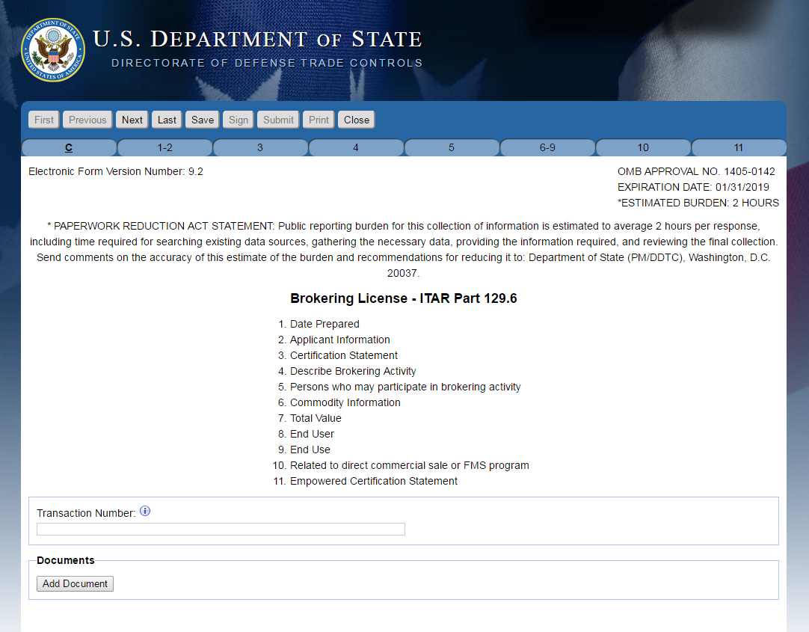
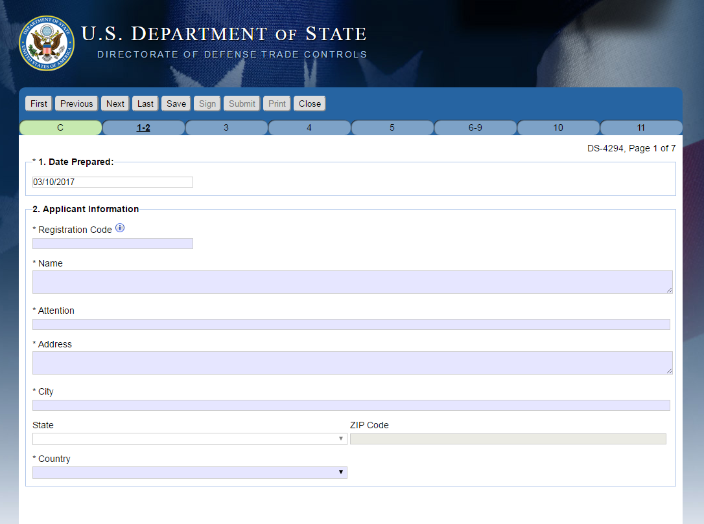

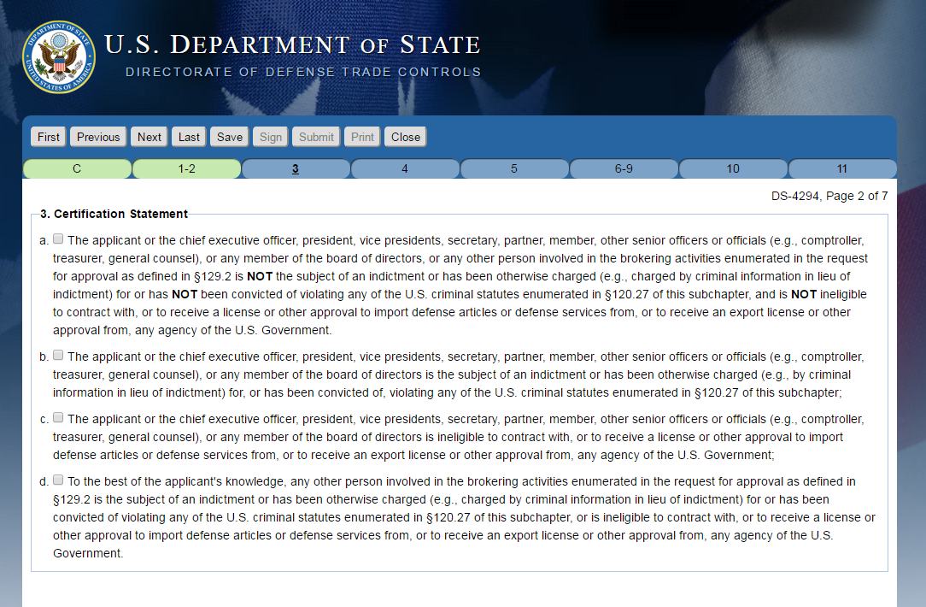

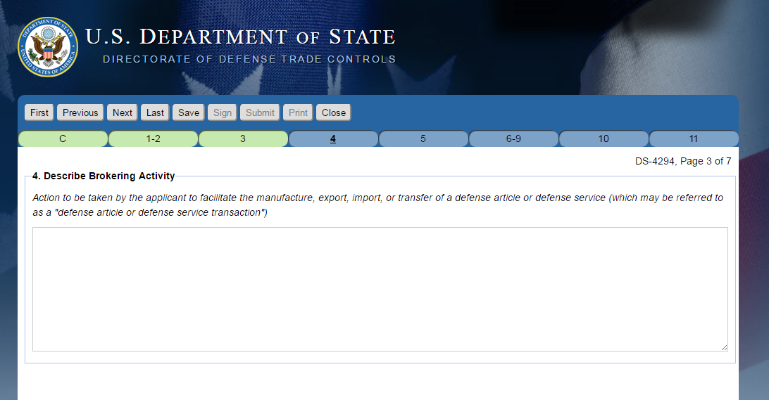
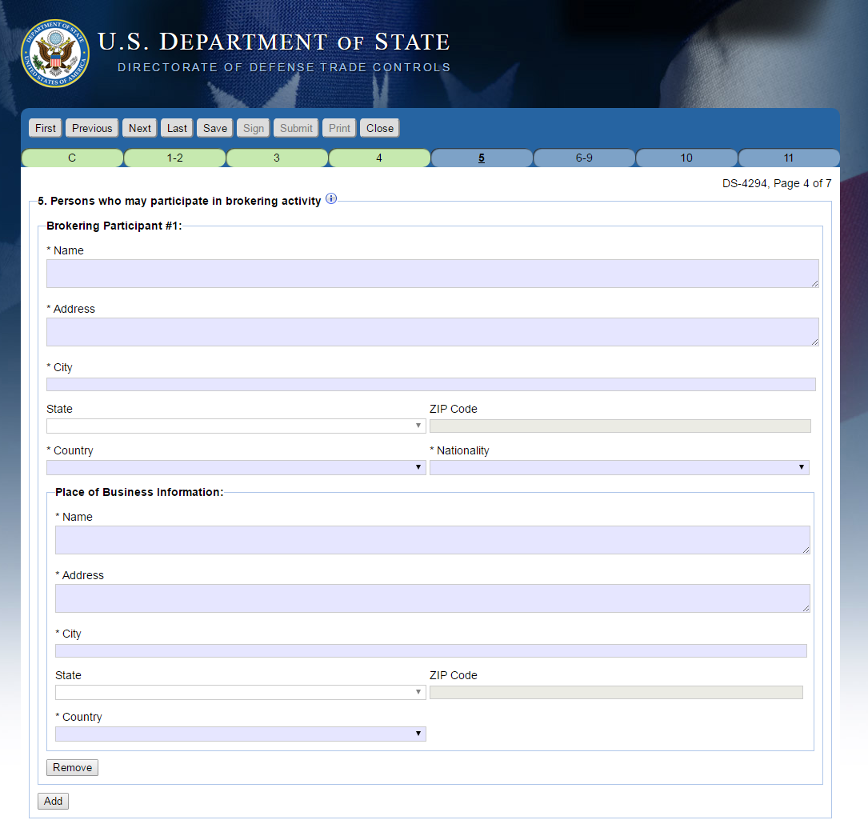
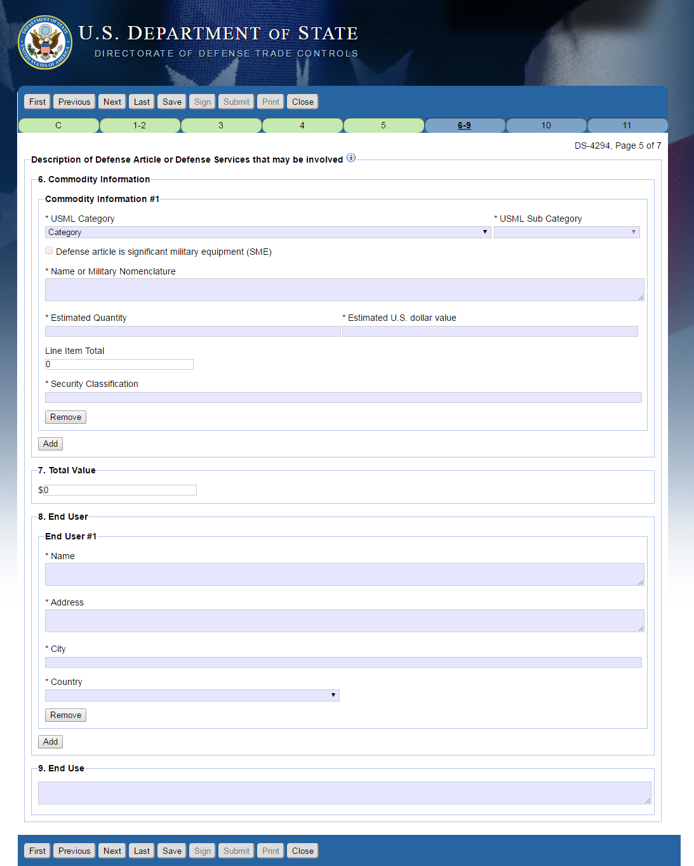

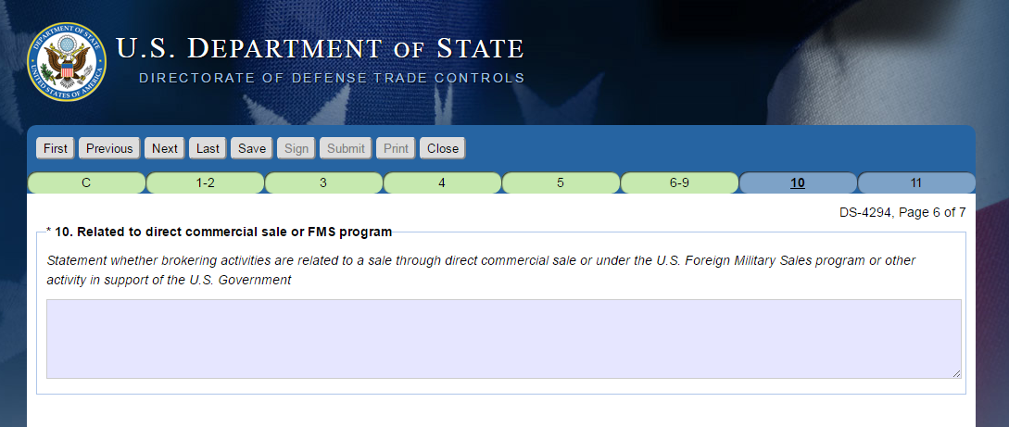

Incomplete block 5 and 10, therefore explanation text box is required.
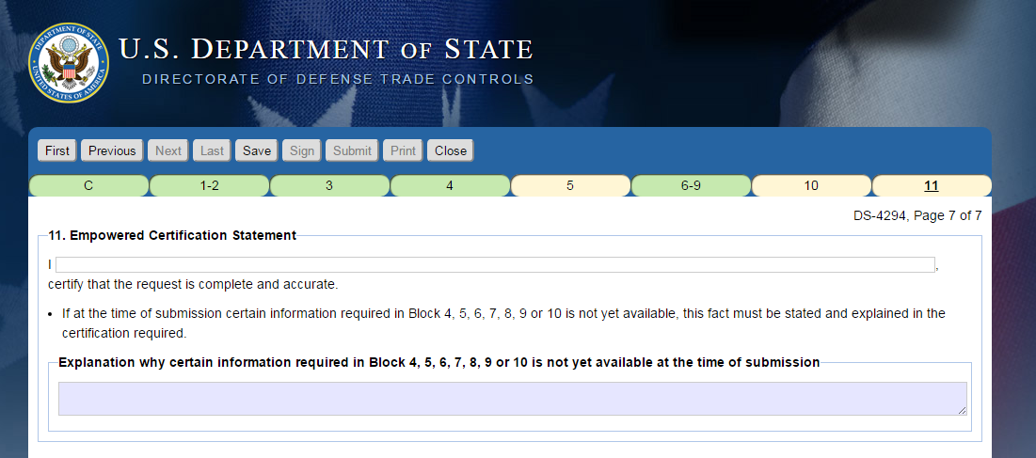

Complete and valid Blocks 4 -10 information, therefore explanation block disabled.
