**PERMITS ONLINE (PONL) SCREENSHOTS**

**Application for New Alcohol Fuel Plant (Small, Medium, or Large)**

(Equivalent to TTB F 5110.74, Application for Fuel Producer under 26 U.S.C. 5181)

**General PONL Log-on Screen:**

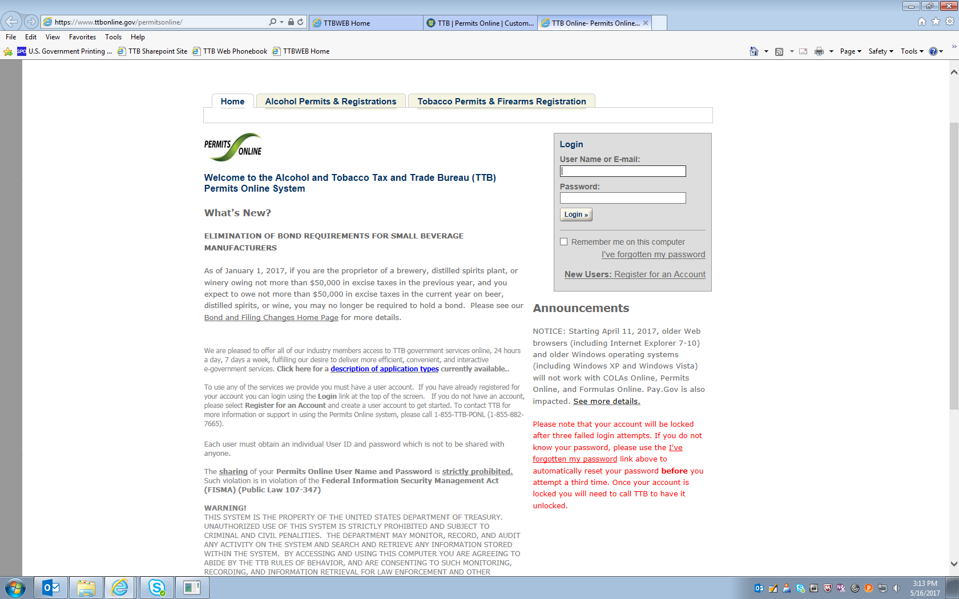

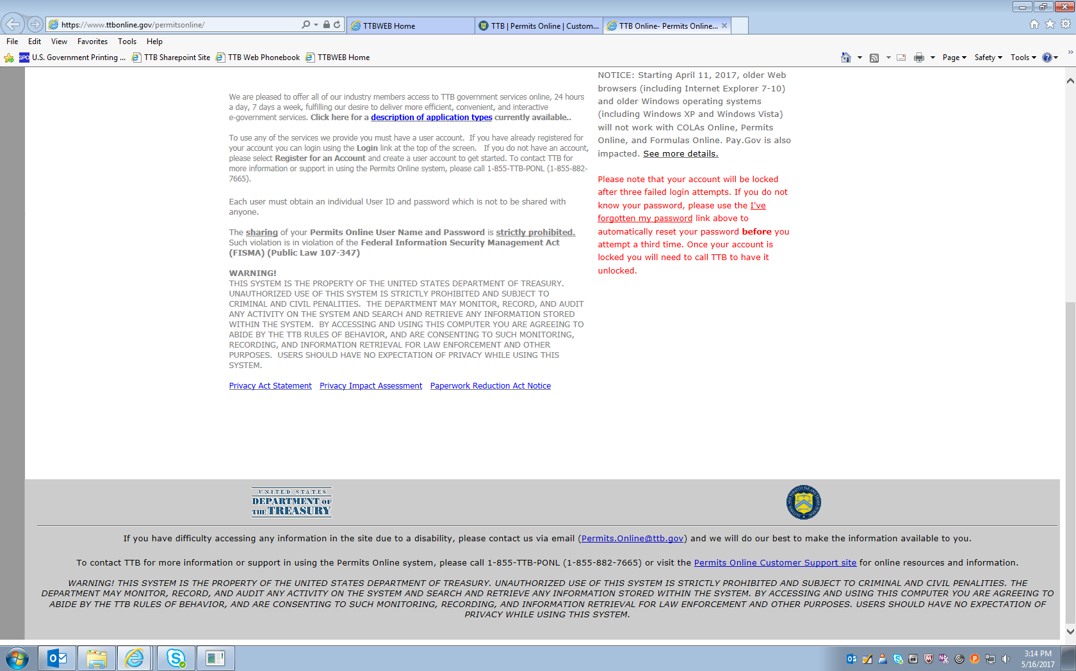

**PONL — Application for New Alcohol Fuel Plant (Small, Medium, or Large)**

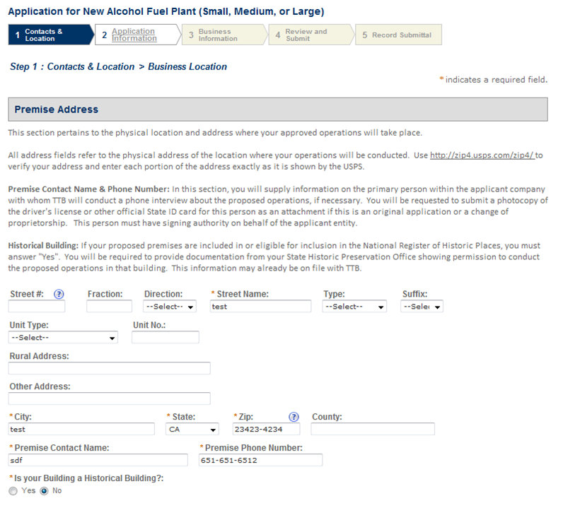

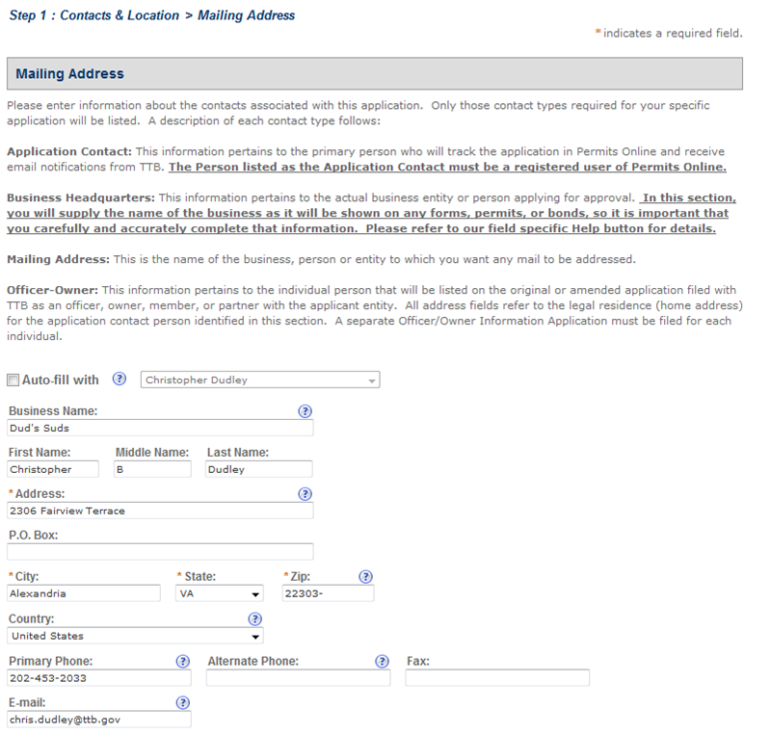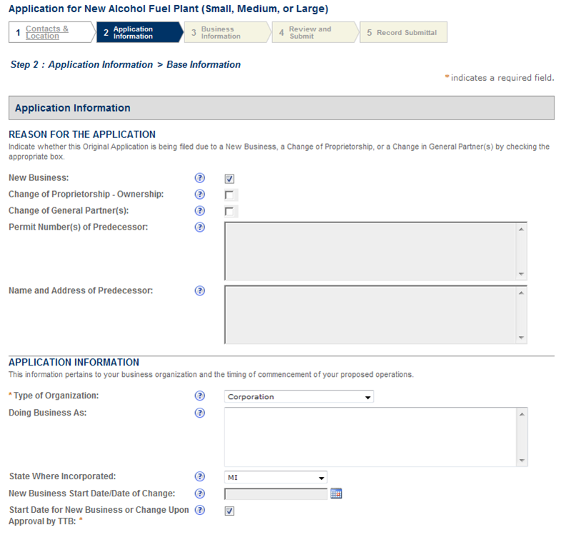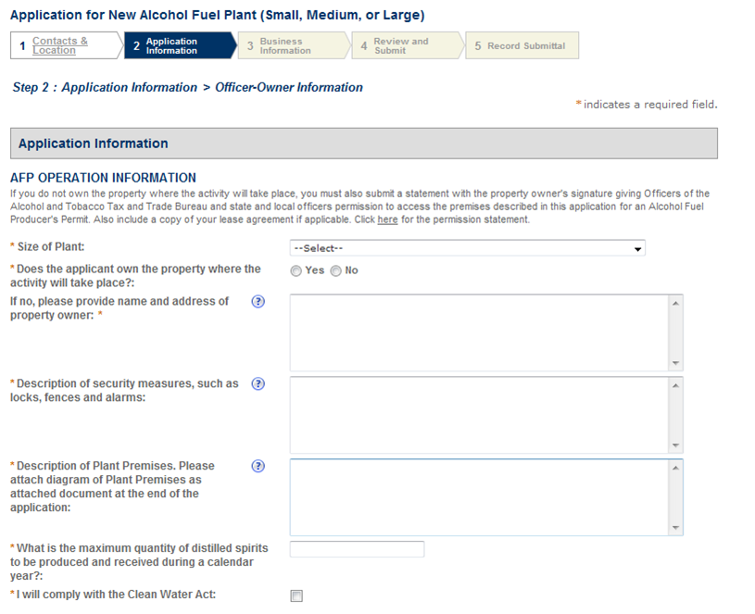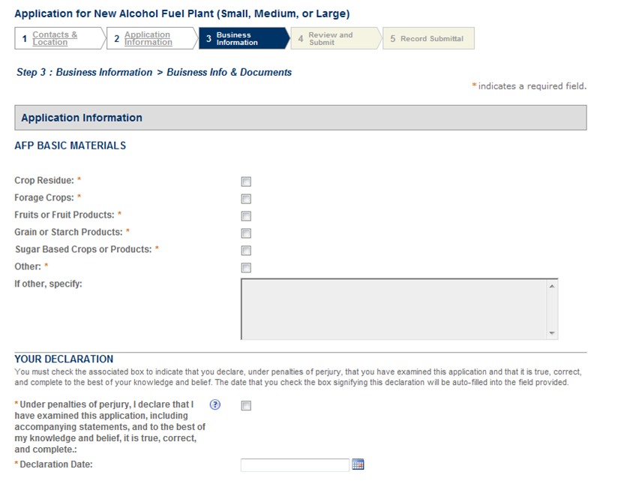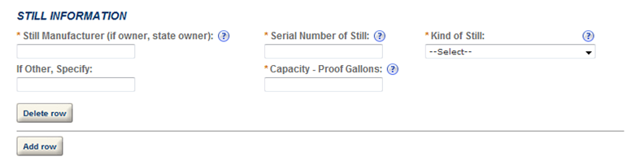

**==== END ====**