PERMITS ONLINE (PONL) SCREENSHOTS
Application for New Alcohol Fuel Plant (Small, Medium, or Large)
(Equivalent to TTB F 5110.74, Application for Fuel Producer under 26 U.S.C. 5181)

General PONL Log-on Screen:
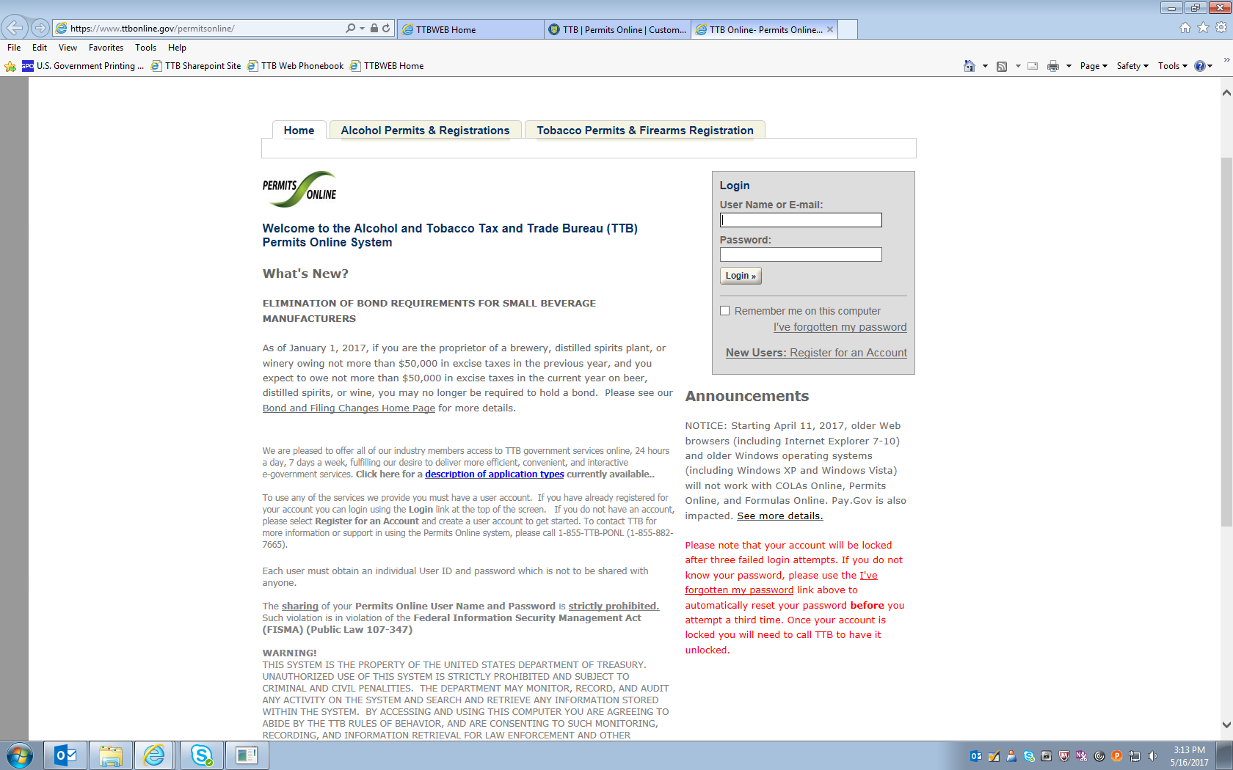
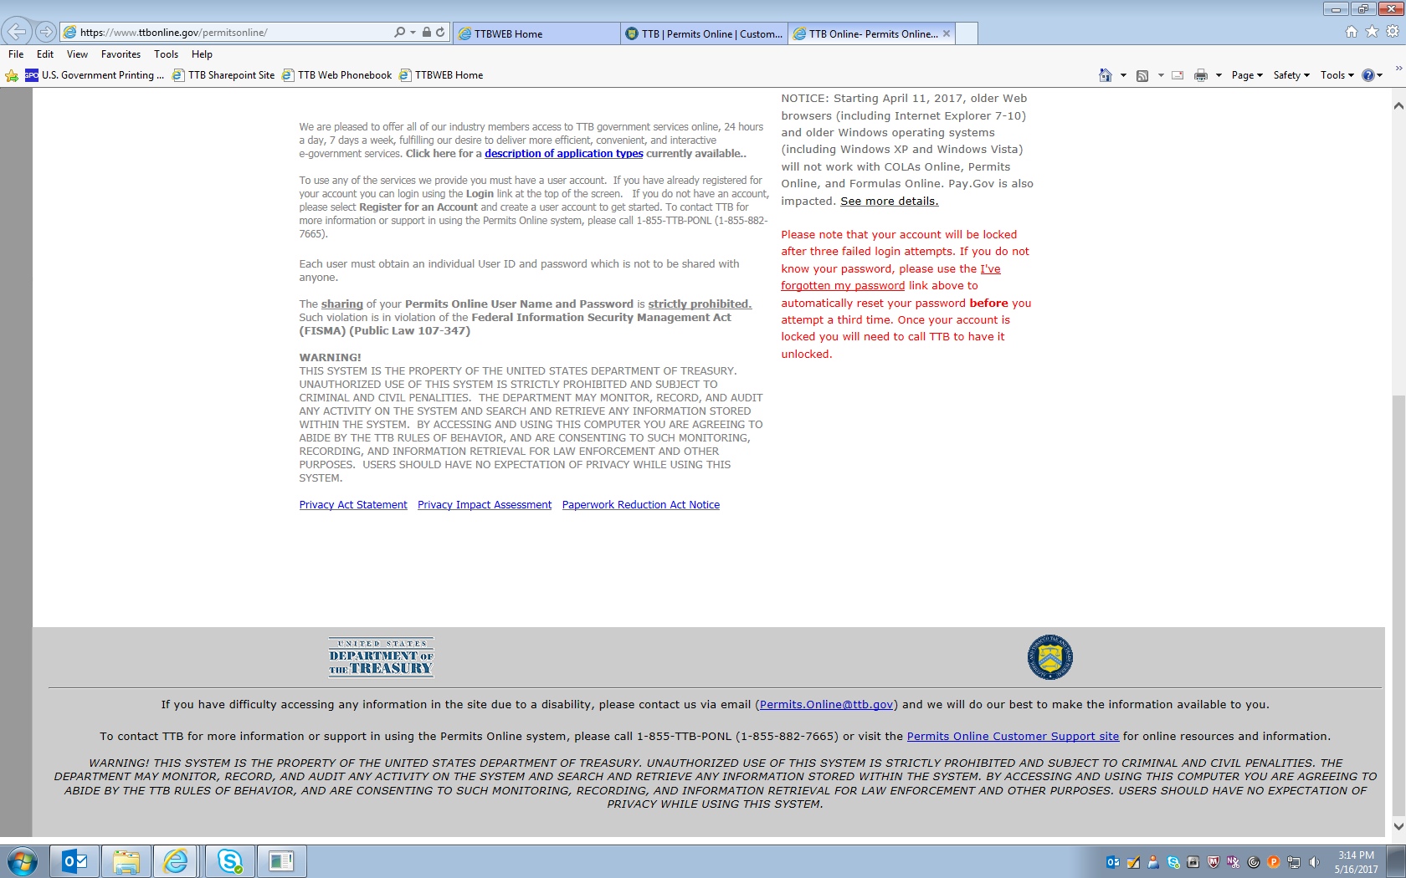

PONL — Application for New Alcohol Fuel Plant (Small, Medium, or Large)
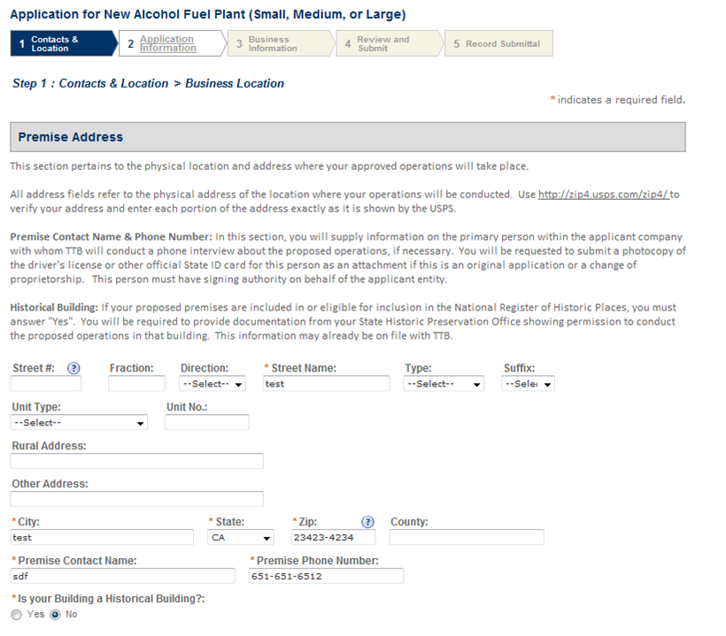
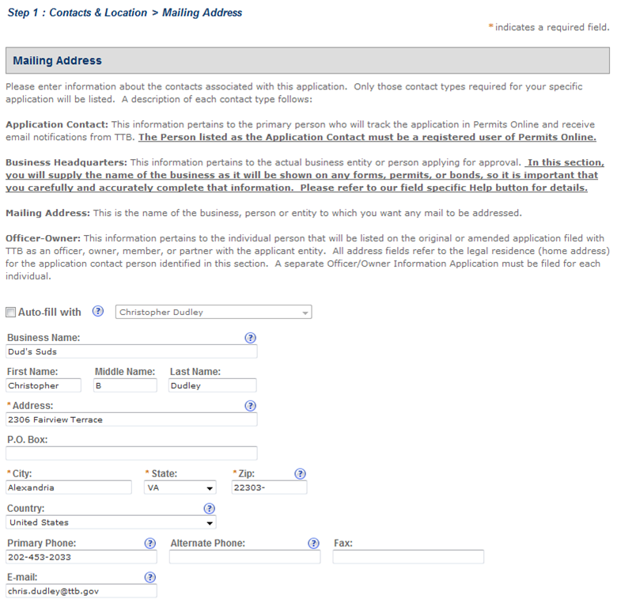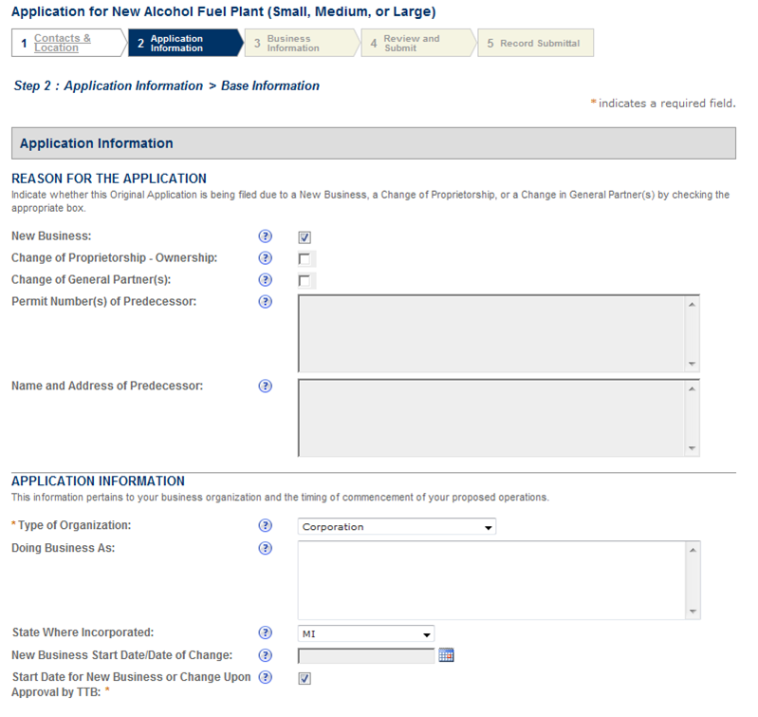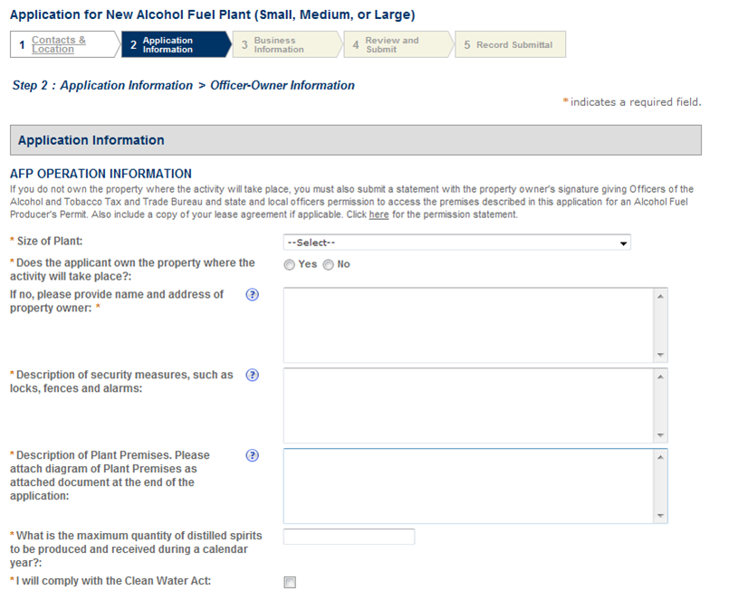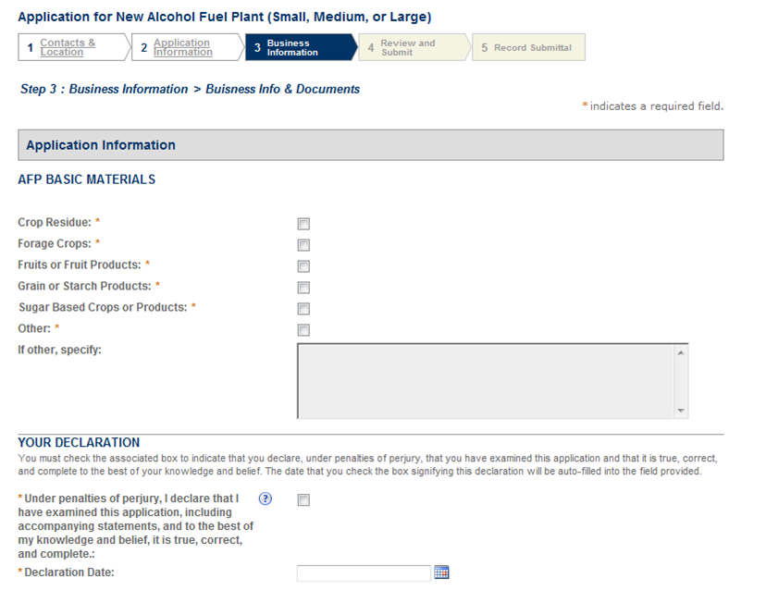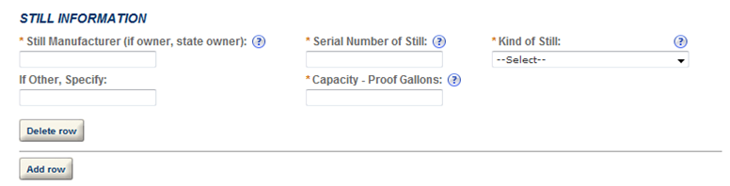
==== END ====

