Project 1-05-12-2-018E

Internal Revenue Service
W&I Research Group 1
1222 Spruce Street, Stop 1090STL
St. Louis, MO 63103
Attention: Customer Service Survey
Month xx, 2020

<<Control Number>>
<<Name>>
<<Street Address>>
<<City>>, <<State>> <<Zip Code>>

Dear <<taxpayer’s name>>:

Thank you for agreeing to join in our discussion group about your experience authenticating your identity with the IRS. We are interested in your thoughts and ideas about how this process worked, and if it can be improved. We hope you find the group both interesting and educational.

The Paperwork Reduction Act requires us to provide you with the OMB approval number which is 1545-1349. If you have any comments regarding this study, please write to:

IRS
Special Services Committee
SE:W:CAR:MP:T:M:S – Room 6129
1111 Constitution Avenue, NW
Washington, DC 20224

Remember to include the OMB approval number in all correspondence.

Your discussion group is scheduled for:

DATE: | TBD
TIME: | 6:00 p.m. to 8:00 p.m.
PLACE: | LITC office
 | Street address
 | City, State Zip

Please arrive 15-30 minutes earlier than the time noted above so that we can sign you in and prepare to begin on time. It is very important that you arrive before the group begins because we are unable to admit late arrivals. The group will last about 2 hours. At the end of the group discussion, you will receive a check for $75 to pay you for your time and help. Remember to bring some type of photo identification as proof of your identity.

Identity Theft Authentication Focus Group
Month xx, 2020
Page 2

Enclosed is a map with directions to the facility. We look forward to meeting you on date. Since there are only a small number of people invited to this group, your participation is very important to us. Please contact us toll free at 1-877-275-8271, if you have an emergency and are unable to attend. Please do not send anyone else in your place as we will only be able to pay you. If you wear glasses to read, watch TV or drive, please bring them with you. Again, thank you for agreeing to participate.

Sincerely,
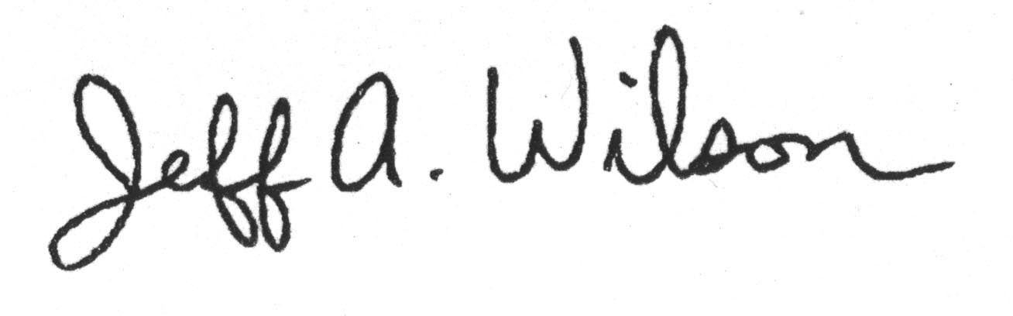
Jeff A. Wilson
Senior Advisor to the National Taxpayer Advocate
Taxpayer Advocate Service

Enclosures

