<<Control Number>>
Project 1-05-12-2-018E

<<Name>> Internal Revenue Service
<<Street Address>> W&I Research Group 1
<<City>>, <<State>> <<Zip Code>> Attention: Customer Service Survey
1222 Spruce Street, Stop 1090STL
St. Louis, MO 63103

Month, day, 2020

Dear Taxpayer:

Thank you for responding to our previous letter and offering to participate in a discussion group about your experience authenticating your identity to the IRS. We appreciate your interest and willingness to participate.

In conducting these discussions, we meet with only a small group of taxpayers. We received a large number of responses and the group is full. Thank you again for offering to participate.

Sincerely,
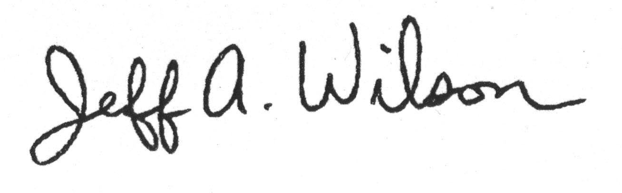
Jeff A. Wilson
Senior Advisor to the National Taxpayer Advocate
Taxpayer Advocate Service

Enclosures

