2008/18 BACCALAUREATE AND BEYOND (B&B:08/18) FIELD TEST

Appendix C
Sample Member Communication Materials

OMB # 1850-0729 v. 11

Submitted by
National Center for Education Statistics
U.S. Department of Education

January 2017
revised May 2017

Contents
Contacts Calendar 3
Draft Brochure Text 4
Draft Website Text 6
Initial Contact Letter 10
Data Collection Announcement Letter 12
Mini Survey Letter 14
Mini Survey Letter – Replacement Questionnaire 16
Reminder Postcard 1 18
Reminder Postcard 2 20
Reminder Postcard 3 22
Reminder Postcard 4 24
Incentive Selection Card 26
Reminder Postcard 5 29
Reminder Postcard 6 31
Initial Contact Email 33
Data Collection Announcement Email 34
Reminder Email 1* 35
Reminder Email 2* 36
Reminder Email 3* 36
Reminder Email 4* 37
Reminder Email 5* 37
Reminder Email 6* 38
Reminder Email 7* 39
Reminder Email 8* 40
Reminder Email 9* 41
Reminder Email 10* 42
Reminder Email 11* 43
Reminder Email 12* 44
Reminder Email 13* 45
Reminder Email 14* 46
Text Message Reminders 47
Résumé Only, Initial Email* 48
Résumé Only, Reminder Email 1* 48
Résumé Only, Reminder Email 2* 49
Thank You Letter 50
Thank You Email* 52
Résumé Reminder Email 1* 53
Re-Interview, Initial Letter 54
Re-Interview, Initial Email 56
Re-Interview, Reminder Email 1 56
Re-Interview, Reminder Email 2 57
FS Panel Maintenance Postcard 58
FS Panel Maintenance Email* 61

*Email is part of the Source and Signatory Experiment
Note: Emails and letters providing similar content to those shown in this appendix will be sent throughout data collection to encourage participation. In addition, sample members who request follow-up reminders via text message will receive text message prompts to complete the survey. The materials included in this appendix reference the field test study to be conducted in 2017 and will be updated for use during for the full-scale study. Known updates include removing any references to the field test, updating reference dates, updating incentive amounts, and eliminating the reinterview contacting materials.

Contacts Calendar

Contact Name | Data Collection Phase | Type | Approximate Date
Initial contact letter | Full survey | Letter | 6/1/2017
Initial contact email | Full survey | Email | 6/1/2017
DC Announcement Letter | Full survey | Letter | 07/14/17
Data collection announcement email | Full survey | Email | 07/17/17
Reminder text 1 | Full survey | Text | 07/17/17
Reminder email 1* | Full survey | Email | 07/25/17
Reminder postcard 1 | Full survey | Postcard | 08/01/17
Reminder email 2* | Full survey | Email | 08/02/17
Reminder email 3* | Full survey | Email | 08/10/17
Reminder email 4* | Full survey | Email | 08/18/17
Reminder postcard 2 | Full survey | Postcard | 08/18/17
Reminder text 2 | Full survey | Text | 08/21/17
Reminder text 3 | Full survey | Text | 08/25/17
Reminder email 5* | Full survey | Email | 08/26/17
Reminder postcard 3 | Full survey | Postcard | 08/28/17
Reminder email 6* | Full survey | Email | 09/04/17
Mini survey letter | Mini survey | Letter | 09/08/17
Reminder email 7* | Mini survey | Email | 09/11/17
Reminder text 4 | Mini survey | Text | 09/12/17
Reminder postcard 4 | Mini survey | Postcard | 09/14/17
Reminder email 8* | Mini survey | Email | 09/19/17
Reminder email 9* | Mini survey | Email | 09/27/17
Reminder email 10* | Mini survey | Email | 10/05/17
Reminder email 11* | Mini survey | Email | 10/11/17
Reminder postcard 5 | Mini survey | Postcard | 10/20/17
Reminder text 5 | Mini survey | Text | 10/16/17
Reminder email 12* | Mini survey | Email | 10/21/17
Reminder email 13* | Mini survey | Email | 10/26/17
Reminder email 14* | Mini survey | Email | 10/30/17
Reminder postcard 6 | Résumé | Postcard | 10/30/17
Résumé only initial email* | Résumé | Email | 10/31/17
Résumé only reminder email 1* | Résumé | Email | 11/02/17
Reminder text 6 | Résumé | Text | 11/05/17
Résumé only reminder email 2* | Résumé | Email | 11/06/17
Thank you letter | Post | Letter | Rolling
Thank you email* | Post | Email | Rolling
Résumé reminder email 1* | Post | Email | Rolling
Initial re-interview letter | Re-Interview | Letter | Rolling
Initial re-interview email | Re-Interview | Email | Rolling
Re-interview reminder email 1 | Re-Interview | Email | Rolling
Re-interview reminder email 2 | Re-Interview | Email | Rolling
FS Panel maintenance email* | Post | Email | 11/15/17
FS Panel maintenance postcard | Post | Postcard | 11/15/17

*Email is part of the Source and Signatory Experiment

Draft Brochure Text
What is B&B?
The Baccalaureate and Beyond Longitudinal Study (B&B) Field Test is a national study of approximately 1,600 graduates from U.S. colleges and universities who will be asked about their experiences in the 10 years since completing a bachelor’s degree.

The study will collect information on graduate and other education, experiences in the labor market, earnings and expenses, family status, and personal and professional goals. In addition to survey responses, we collect related information from other sources, such as student loan and enrollment databases. There is a particular focus on careers in teaching and other employment outcomes.

Why am I being asked to participate?
You have been asked to participate in B&B because you completed the requirements for your bachelor’s degree 10 years ago, during the 2006-07 academic year.

Why is my participation important?
Your survey responses help educators, researchers, and policymakers at the local, state, and national levels understand the experiences of recent college graduates. Your experiences are unique, and if you choose not to participate in B&B, no one else can be substituted for you.

What have we learned from previous rounds of B&B?
The National Center for Education Statistics (NCES) has conducted only one previous 10-year follow-up with baccalaureate graduates – the Class of ’93 was surveyed in 2003 as part of B&B:93/03.

About three-fifths of 1992-93 bachelor’s degree recipients, surveyed 10 years later, reported that the quality of instruction they received as undergraduates (61 percent) and their undergraduate major field (58 percent) remained very important to their lives.

Within 10 years of completing a bachelor’s degree, 25 percent of 1992–93 bachelor’s degree recipients obtained an occupational license and 30 percent obtained a professional certification.

In 2003, 45 percent of 1992-93 graduates had participated in work-related training and 18 percent had taken personal enrichment classes in the prior year.

What happens to the results?
Results from the current study are scheduled to be released in 2019 and will be posted on the NCES website (https://nces.ed.gov/surveys/b&b/) along with results from previous B&B studies. Your responses will be combined with those of other students and will be presented in summary form only. No individually identifying information will be published.

Who is conducting B&B?
The 2008/18 Baccalaureate and Beyond Longitudinal Study (B&B:08/18) is conducted by the National Center for Education Statistics (NCES), in the U.S. Department of Education’s Institute for Education Sciences, with data collection being carried out under contract by RTI International, a U.S.-based nonprofit research organization.
NCES is authorized to conduct B&B by the Education Sciences Reform Act of 2002 (ESRA 2002, 20 U.S.C. §9543) and to collect students’ education records from educational agencies or institutions for the purposes of evaluating federally supported education programs under the Family Educational Rights and Privacy Act (FERPA, 34 CFR §§ 99.31(a)(3)(iii) and 99.35). All of the information you provide may be used only for statistical purposes and may not be disclosed, or used, in identifiable form for any other purpose except as required by law (20 U.S.C. §9573 and 6 U.S.C. §151).

How will my information be protected?
NCES is required to follow strict procedures to protect personal information in the collection, reporting, and publication of data. All of the information you provide may be used only for statistical purposes and may not be disclosed, or used, in identifiable form for any other purpose except as required by law (20 U.S.C. §9573 and 6 U.S.C. §151).

Data security procedures for B&B are reviewed and approved by NCES data security staff. Your answers are secured behind firewalls and are encrypted during internet transmission using Secure Sockets Layer (SSL) protocol. All data entry modules are password protected and require the user to log in before accessing the data. NCES employees and contractors are subject to large fines or imprisonment if individual responses are disclosed.

How do I participate?
You can complete the B&B interview online or over the phone.

ONLINE
Log on to the study website at https://surveys.nces.ed.gov/bb/ using the Study ID and password provided in your welcome letter. The survey is mobile-optimized, so it can be easily completed on a mobile device.

OVER THE PHONE
Call our Help Desk at 1-877-262-4440 to speak to one of our professional interviewers.

Contact Us

B&B HELP DESK
1-877-262-4440

bbemail@rti.org
https://surveys.nces.ed.gov/bb/

Ted Socha
B&B Project Officer (NCES)
Ted.Socha@ed.gov
202-245-7071
Melissa Cominole
B&B Project Director (RTI)
mcominole@rti.org
800-723-8942

Draft Website Text

HOME PAGE:

Welcome to the 2008/18 Baccalaureate and Beyond Longitudinal Study (B&B:08/18) Field Test

GET STARTED!
Study ID:
Password:
□ Show me what I’ve typed

LOG IN
Need your Study ID number or password? (hyperlink)

Paperwork Reduction Act:
All of the information you provide may be used only for statistical purposes and may not be disclosed, or used, in identifiable form for any other purpose except as required by law (20 U.S.C. §9573 and 6 U.S.C. §151).
According to the Paperwork Reduction Act of 1995, no persons are required to respond to a collection of information unless it displays a valid OMB control number. The valid OMB control number for this voluntary information collection is 1850-0729. The time required to complete this information collection is estimated to average approximately <<time>> minutes per response, including the time to review instructions, gather the data needed, and complete and review the information collection. If you have any comments concerning the accuracy of the time estimate, suggestions for improving this survey, or any comments or concerns regarding the status of your individual submission of this survey, please write directly to: The 2008/18 Baccalaureate and Beyond Longitudinal Study (B&B:08/18), National Center for Education Statistics, Potomac Center Plaza, 550 12th St., SW, 4th floor, Washington, DC 20202. OMB Clearance No: 1850-0729. Expiration Date: 5/31/2020.

UPDATE CONTACT INFO
Click on the fields below to enter the information

Study ID
First Name
Middle Name
Last Name
Suffix (drop-down)
Former Name
Address is an international address (check box)
Address
Address Line 2
City Select State (drop-down) Zip Code
Email Address
Secondary Email Address

Would you like us to send you a text message reminder about participating in the survey?
(Please note: standard text messaging rates may apply.)
Yes
No

CONTACT US
If you need assistance accessing the web survey or wish to complete the survey by phone, call the B&B Help Desk:
1-877-262-4440
bbemail@rti.org

Help Desk staff is available at the following times to assist you:
Monday-Thursday | 9:00 a.m. – Midnight
Friday | 9:00 a.m. – 11:00 p.m.
Saturday | 9:30 a.m. – 9:00 p.m.
Sunday | 1:00 p.m. – 11:00 p.m.

All times are Eastern Time (ET).

Who should I contact if I have additional questions or concerns?
B&B project staff is available to respond to your questions Monday through Friday between 9:00 a.m. and 5:00 p.m. ET.

B&B Staff
RTI Project Director | Melissa Cominole
 | mcominole@rti.org
 | 800-723-8942
NCES Project Officer | Ted Socha
 | Ted.Socha@ed.gov
 | 1-202-245-7071
WHAT TO EXPECT
How can I complete the B&B survey?
You may complete the B&B survey on the Web – simply log in from the home page by entering your Study ID number and password, which are provided in the B&B letter or e-mail you received. You can even complete it on your mobile device. If you need assistance accessing the survey on the website, or if you want to complete the survey by telephone, contact the B&B Help Desk by calling 1-877-262-4440 or sending an e-mail to bbemail@rti.org.

How long will the survey take?
For most people, we expect the survey will take about 45 minutes, on average, but could take more or less time depending on your answers. You do not need to complete the survey in one session. You can get started and, if you choose, you can easily log out and resume at a later time. If you are asked to provide a résumé, the time to submit the résumé is estimated to average 10 minutes, including time to locate your file, review it, and load it to the website.

Do I have to participate?
Participation in this study is voluntary; however, your involvement is very important to the success of this study. By participating, you have the opportunity to help policymakers, researchers, and others better understand the experiences of bachelor’s degree recipients.

Can I refuse to answer a question?
You may refuse to answer any question at any time. If you choose not to answer or are unable to answer a particular question, you may still continue with the rest of the survey.

How do I know your website is secure?
The B&B website is protected by Secure Sockets Layer (SSL; 128-bit encryption) technology. Your survey responses are collected over a secure server that is also protected by SSL.

Should I use a particular web browser to take the web survey?
To run the survey, your browser needs to support HTML5 and JavaScript, so the latest versions of Firefox, Chrome, or Safari will work, as will Internet Explorer 9 and later. If you are having any trouble completing the survey, please call our Help Desk at 1-877-262-4440 and we will be happy to assist you.

PREVIOUS RESULTS
YOUR PARTICIPATION COUNTS!
Data collected from B&B will help researchers and policymakers better understand how earning a bachelor’s degree impacts choices for additional education and employment paths. As with all prior B&B studies, results will be presented in summary form only; no individual results will be published.

HERE ARE A FEW THINGS WE’VE LEARNED FROM B&B STUDIES…
The National Center for Education Statistics (NCES) has conducted only one previous 10-year follow-up with baccalaureate graduates – the Class of ’93 was surveyed in 2003 as part of B&B:93/03.

About three-fifths of 1992-93 bachelor’s degree recipients, surveyed 10 years later, reported that the quality of instruction they received as undergraduates (61 percent) and their undergraduate major field (58 percent) remained very important to their lives.

Within 10 years of completing a bachelor’s degree, 25 percent of 1992–93 bachelor’s degree recipients obtained an occupational license and 30 percent obtained a professional certification.

In 2003, 45 percent of 1992-93 graduates had participated in work-related training and 18 percent had taken personal enrichment classes in the prior year.

CONFIDENTIALITY
The National Center for Education Statistics (NCES) is required to follow strict procedures to protect personal information in the collection, reporting, and publication of data. All of the information you provide may be used only for statistical purposes and may not be disclosed, or used, in identifiable form for any other purpose except as required by law (20 U.S.C. §9573 and 6 U.S.C. §151).
Data security procedures for B&B are reviewed and approved by NCES data security staff. Your answers are secured behind firewalls and are encrypted during internet transmission using Secure Sockets Layer (SSL) protocol. All data entry modules are password protected and require the user to log in before accessing any data. NCES employees and contractors are subject to large fines or imprisonment if they knowingly publish or communicate any individually identifiable information.

Congress has authorized the National Center for Education Statistics (NCES) of the U.S. Department of Education’s Institute of Education Sciences to collect data about the costs of postsecondary education because policymakers at all levels need reliable and current national data in order to make decisions about postsecondary education.
NCES is authorized to conduct the 2008/18 Baccalaureate and Beyond Longitudinal Study (B&B:08/18) by the Education Sciences Reform Act of 2002 (ESRA 2002, 20 U.S.C. §9543) and to collect students’ education records from educational agencies or institutions for the purposes of evaluating federally supported education programs under the Family Educational Rights and Privacy Act (FERPA, 34 CFR §§ 99.31(a)(3) and 99.35).

The study has been approved by the U.S. Office of Management and Budget (OMB). The valid OMB control number for this voluntary information collection is 1850-0729. The expiration date is 5/31/2020.

ABOUT B&B
The 2008/18 Baccalaureate and Beyond Longitudinal Study (B&B) Field Test (B&B:08/18) is a national study of approximately 1,600 graduates from U.S. colleges and universities who will be asked about their experiences since completing a bachelor’s degree.

The study will collect information on graduate and other education, experiences in the labor market, earnings and expenses, family status, and personal and professional goals. In addition to survey responses, we collect related information from sources such as student loan and enrollment databases. There is a particular focus on careers in teaching and other employment outcomes.

B&B:08/18 is the third follow-up survey from a cohort of students who completed their bachelor’s degree requirements during the 2006-07 academic year. Most study participants were first surveyed in 2007 as part of the National Postsecondary Student Aid Study (NPSAS).

B&B:08/18 is conducted by the National Center for Education Statistics (NCES), in the U.S. Department of Education’s Institute of Education Sciences, with data collection being carried out under contract by RTI International, a U.S.-based nonprofit research organization.

Initial Contact Letter

«date»

«fname» «mname» «lname» «suffix» Study ID: «caseid»
«addr1»
«addr2»
«city», «state» «zip» «zip4»

Dear «fname» «lname»:

You have been selected to participate in the third round of the Baccalaureate and Beyond Longitudinal Study (B&B), conducted by the National Center for Education Statistics (NCES) in the U.S. Department of Education’s Institute of Education Sciences. B&B is interested in your personal experience since you graduated from college during the 2006–07 school year. Data collected from B&B will help researchers and policymakers better understand how earning a bachelor’s degree in majors such as «[major]» impacts choices for additional education and employment paths.

Before B&B data collection begins, we need to ensure we have the most up to date contact information for you. Please update your contact information online:

https://surveys.nces.ed.gov/bb/
Your Study ID: <<caseID>>

B&B begins in July of 2017. At that time, you will receive a letter in a large white envelope that will provide specific information about how to participate. To say thanks, you will receive $«IncAmt» when you complete the survey.

NCES has contracted with RTI International, a U.S.-based nonprofit research organization, to collect data for B&B on its behalf. The enclosed brochure provides a brief description of B&B, findings from past studies, and a summary of our confidentiality procedures. If you have additional questions or concerns about the study after reviewing this material, please call the RTI study director, Melissa Cominole at 1-800-723-8942.

We thank you in advance for your participation in this important study.

Sincerely,

Signature
National Center for Education Statistics

The 2008/18 Baccalaureate and Beyond Longitudinal Study (B&B:08/18) is conducted by the National Center for Education Statistics (NCES). Under contract with NCES, RTI International, a U.S.-based nonprofit research organization, administers B&B:08/18 on behalf of NCES. NCES is authorized to conduct B&B:08/18 by the Education Sciences Reform Act of 2002 (ESRA 2002, 20 U.S.C. §9543) and to collect students’ education records from education agencies or institutions for the purposes of evaluating federally supported education programs under the Family Educational Rights and Privacy Act (FERPA, 34 CFR §§ 99.31(a)(3) and 99.35). All of the information you provide may be used only for statistical purposes and may not be disclosed, or used, in identifiable form for any other purpose except as required by law (20 U.S.C. §9573 and 6 U.S.C. §151).

According to the Paperwork Reduction Act of 1995, no persons are required to respond to a collection of information unless it displays a valid OMB control number. The valid OMB control number for this voluntary information collection is 1850-0729. The time required to complete this information collection is estimated to average approximately <<time>> minutes per response, including the time to review instructions, gather the data needed, and complete and review the information collection. If you have any comments concerning the accuracy of the time estimate, suggestions for improving this survey, or any comments or concerns regarding the status of your individual submission of this survey, please write directly to: The 2008/18 Baccalaureate and Beyond Longitudinal Study (B&B:08/18), National Center for Education Statistics, Potomac Center Plaza, 550 12th St., SW, Room 4004, Washington, DC 20202.

Data Collection Announcement Letter

«date»

«fname» «mname» «lname» «suffix» Study ID: «caseid»
«addr1»
«addr2»
«city», «state» «zip» «zip4»

Dear «fname» «lname»:

Data collection for the Baccalaureate and Beyond Longitudinal Study (B&B) is now underway. B&B is interested in understanding how earning a bachelor’s degree «in [major]» impacted your choices about further education and work since graduating from college during the 2006–07 school year.

To complete the survey, log on to our secure website at https://surveys.nces.ed.gov/bb/ using the credentials provided below. (The password is case sensitive; you will need to enter it exactly as it appears here.)
Study ID = «caseid»
Password = «password»

The survey will take about «time» minutes to complete and you will receive $«IncAmt» via check or PayPal as a thank you for your participation. Having your résumé or curriculum vitae handy will help you complete the survey more easily.

The enclosed brochure answers many common questions about the study and contains additional information on laws and procedures that protect the confidentiality of your responses. Data security procedures for B&B are reviewed and approved by NCES data security staff. Your responses will be secured behind firewalls and will be encrypted during internet transmission. All of the information you provide may be used only for statistical purposes and may not be disclosed, or used, in identifiable form for any other purpose except as required by law (20 U.S.C. §9573 and 6 U.S.C. §151).

If you have questions or problems completing your survey online, or prefer to complete the survey over the telephone, simply call the B&B Help Desk at 1-877-262-4440. You can learn more about B&B on our study website, https://surveys.nces.ed.gov/bb/. For other questions or concerns about the study, please contact the B&B Project Director, Melissa Cominole at 1-800-723-8942, mcominole@rti.org, or the NCES Project Officer, Ted Socha, at 1-202-245-7071, ted.socha@ed.gov.

Your participation, while voluntary, is critical to the study’s success. We hope you enjoy the opportunity to share your experiences.

Many thanks,

Ted Melissa
Ted Socha Melissa Cominole
Project Officer, B&B:08/18 Project Director, B&B:08/18
National Center for Education Statistics RTI International
ted.socha@ed.gov mcominole@rti.org
202-245-7071 800-723-8942

The 2008/18 Baccalaureate and Beyond Longitudinal Study (B&B:08/18) is conducted by the National Center for Education Statistics (NCES). Under contract with NCES, RTI International, a U.S.-based nonprofit research organization, administers B&B:08/18 on behalf of NCES. NCES is authorized to conduct B&B:08/18 by the Education Sciences Reform Act of 2002 (ESRA 2002, 20 U.S.C. §9543) and to collect students’ education records from education agencies or institutions for the purposes of evaluating federally supported education programs under the Family Educational Rights and Privacy Act (FERPA, 34 CFR §§ 99.31(a)(3) and 99.35). All of the information you provide may be used only for statistical purposes and may not be disclosed, or used, in identifiable form for any other purpose except as required by law (20 U.S.C. §9573 and 6 U.S.C. §151).
According to the Paperwork Reduction Act of 1995, no persons are required to respond to a collection of information unless it displays a valid OMB control number. The valid OMB control number for this voluntary information collection is 1850-0729. The time required to complete this information collection is estimated to average approximately <<time>> minutes per response, including the time to review instructions, gather the data needed, and complete and review the information collection. If you have any comments concerning the accuracy of the time estimate, suggestions for improving this survey, or any comments or concerns regarding the status of your individual submission of this survey, please write directly to: The 2008/18 Baccalaureate and Beyond Longitudinal Study (B&B:08/18), National Center for Education Statistics, Potomac Center Plaza, 550 12th St., SW, Room 4004, Washington, DC 20202.

Mini Survey Letter

«date»

«fname» «mname» «lname» «suffix» Study ID: «caseid»
«addr1»
«addr2»
«city», «state» «zip» «zip4»

Dear «fname»:

Participating in B&B is easier than ever! The survey is now only 10 easy questions which will only take 5 minutes of your time. As a thank you for participating, you’ll receive $20 payable by PayPal or check.

[INSERT MERGE FIELD FROM TABLE – HARD COPY EXPERIMENT, BELOW]

You were selected to represent many other students with similar backgrounds and «[major]» degrees. No one else can replace you. I hope that you will participate in the study, especially now that the survey takes only 5 minutes!

Thank you in advance for making B&B a success.

Ted Melissa
Ted Socha Melissa Cominole
Project Officer, B&B:08/18 Project Director, B&B:08/18
National Center for Education Statistics RTI International
ted.socha@ed.gov mcominole@rti.org
202-245-7071 800-723-8942

MERGE FIELD OPTIONS – HARD COPY EXPERIMENT
Hard Copy Letter – Selected | Simply complete the enclosed questionnaire and return it to us in the business reply envelope we have provided for you. Or visit https://surveys.nces.ed.gov/bb/ to complete the survey online.  Study ID = «caseid»  Password = «password»  You can also call 1-877-262-4440 to get more information about B&B or to complete the survey by phone.
Hard Copy Letter – Not selected | You can complete the survey by logging on to our secure website at https://surveys.nces.ed.gov/bb/ using the credentials provided below. (The password is case sensitive; you will need to enter it exactly as it appears here.)  Study ID = «caseid»  Password = «password»  You can also call 1-877-262-4440 to get more information about B&B or to complete the survey by phone.

The 2008/18 Baccalaureate and Beyond Longitudinal Study (B&B:08/18) is conducted by the National Center for Education Statistics (NCES). Under contract with NCES, RTI International, a U.S.-based nonprofit research organization, administers B&B:08/18 on behalf of NCES. NCES is authorized to conduct B&B:08/18 by the Education Sciences Reform Act of 2002 (ESRA 2002, 20 U.S.C. §9543) and to collect students’ education records from education agencies or institutions for the purposes of evaluating federally supported education programs under the Family Educational Rights and Privacy Act (FERPA, 34 CFR §§ 99.31(a)(3) and 99.35). All of the information you provide may be used only for statistical purposes and may not be disclosed, or used, in identifiable form for any other purpose except as required by law (20 U.S.C. §9573 and 6 U.S.C. §151).
According to the Paperwork Reduction Act of 1995, no persons are required to respond to a collection of information unless it displays a valid OMB control number. The valid OMB control number for this voluntary information collection is 1850-0729. The time required to complete this information collection is estimated to average approximately <<time>> minutes per response, including the time to review instructions, gather the data needed, and complete and review the information collection. If you have any comments concerning the accuracy of the time estimate, suggestions for improving this survey, or any comments or concerns regarding the status of your individual submission of this survey, please write directly to: The 2008/18 Baccalaureate and Beyond Longitudinal Study (B&B:08/18), National Center for Education Statistics, Potomac Center Plaza, 550 12th St., SW, Room 4004, Washington, DC 20202.

Mini Survey Letter – Replacement Questionnaire

«date»

«fname» «mname» «lname» «suffix» Study ID: «caseid»
«addr1»
«addr2»
«city», «state» «zip» «zip4»

Dear «fname»:

About <two weeks> ago, we sent you a request asking you to share your experiences as a college graduate by answering only 10 easy questions. We have not yet received your responses. B&B will only take 5 minutes of your time and you’ll receive $20, payable by PayPal or check as a thank you.

[INSERT MERGE FIELD FROM TABLE – HARD COPY EXPERIMENT, BELOW]

I hope that you will participate in the study! Thank you so much for your help in making B&B a success.

Ted Melissa
Ted Socha Melissa Cominole
Project Officer, B&B:08/18 Project Director, B&B:08/18
National Center for Education Statistics RTI International
ted.socha@ed.gov mcominole@rti.org
202-245-7071 800-723-8942

MERGE FIELD OPTIONS – HARD COPY EXPERIMENT
Hard Copy Letter – Selected | We are writing again because of the importance that your responses have for helping us to obtain accurate results. Simply complete the enclosed questionnaire and return it to us in the business reply envelope we have provided for you. Or visit https://surveys.nces.ed.gov/bb/ to complete the survey online.  Study ID = «caseid»  Password = «password»  You can also call 1-877-262-4440 to get more information about B&B or to complete the survey by phone.
Hard Copy Letter – Not selected | We are writing again because of the importance that your responses have for helping us to obtain accurate results. You can complete the survey by logging on to our secure website at https://surveys.nces.ed.gov/bb/ using the credentials provided below. (The password is case sensitive; you will need to enter it exactly as it appears here.)  Study ID = «caseid»  Password = «password»  You can also call 1-877-262-4440 to get more information about B&B or to complete the survey by phone.

The 2008/18 Baccalaureate and Beyond Longitudinal Study (B&B:08/18) is conducted by the National Center for Education Statistics (NCES). Under contract with NCES, RTI International, a U.S.-based nonprofit research organization, administers B&B:08/18 on behalf of NCES. NCES is authorized to conduct B&B:08/18 by the Education Sciences Reform Act of 2002 (ESRA 2002, 20 U.S.C. §9543) and to collect students’ education records from education agencies or institutions for the purposes of evaluating federally supported education programs under the Family Educational Rights and Privacy Act (FERPA, 34 CFR §§ 99.31(a)(3) and 99.35). All of the information you provide may be used only for statistical purposes and may not be disclosed, or used, in identifiable form for any other purpose except as required by law (20 U.S.C. §9573 and 6 U.S.C. §151).
According to the Paperwork Reduction Act of 1995, no persons are required to respond to a collection of information unless it displays a valid OMB control number. The valid OMB control number for this voluntary information collection is 1850-0729. The time required to complete this information collection is estimated to average approximately <<time>> minutes per response, including the time to review instructions, gather the data needed, and complete and review the information collection. If you have any comments concerning the accuracy of the time estimate, suggestions for improving this survey, or any comments or concerns regarding the status of your individual submission of this survey, please write directly to: The 2008/18 Baccalaureate and Beyond Longitudinal Study (B&B:08/18), National Center for Education Statistics, Potomac Center Plaza, 550 12th St., SW, Room 4004, Washington, DC 20202.

Reminder Postcard 1
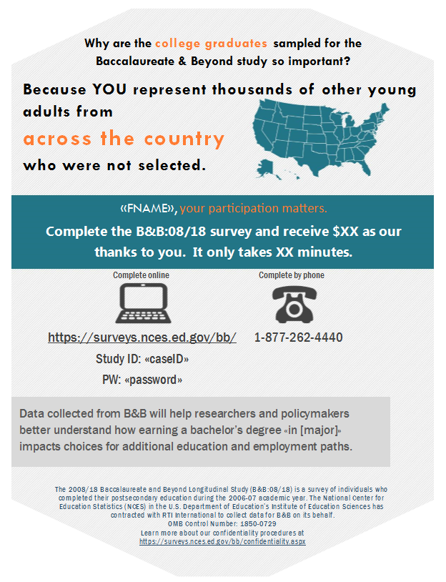
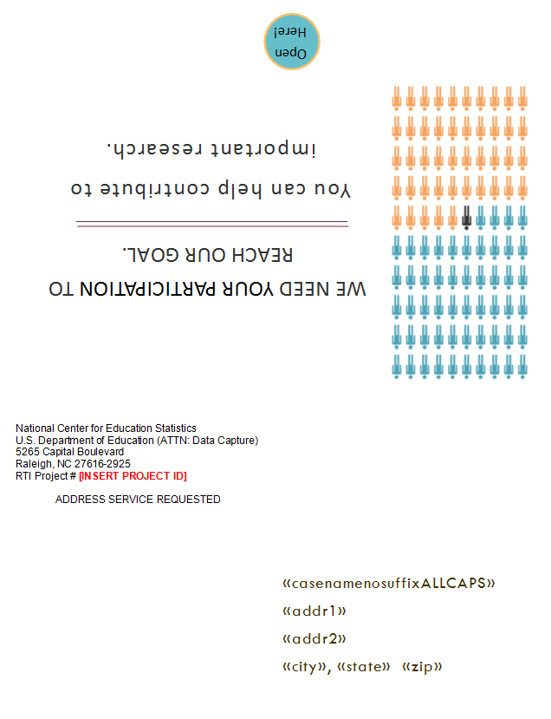

Reminder Postcard 2
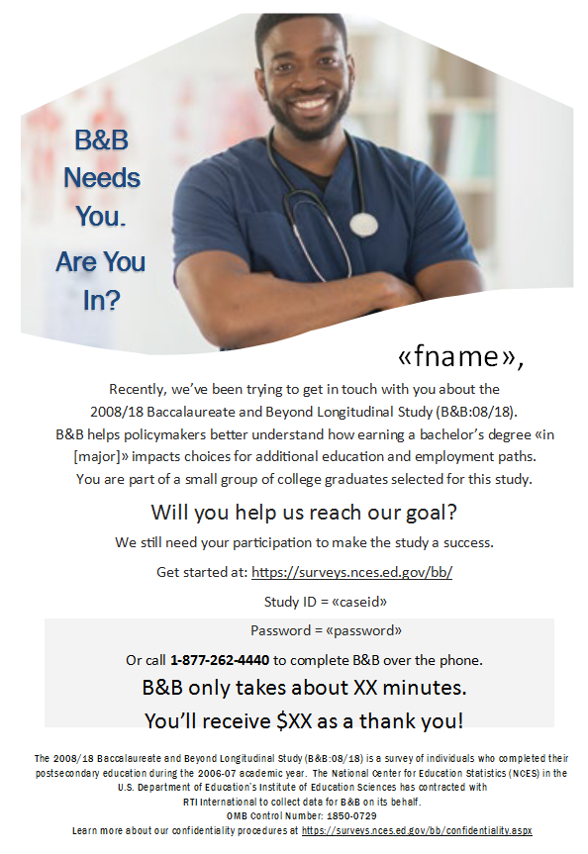

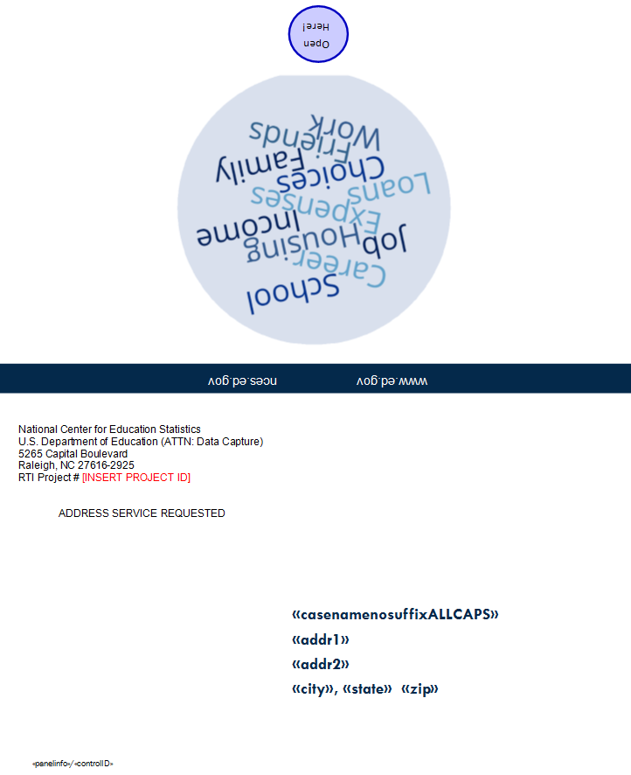

Reminder Postcard 3
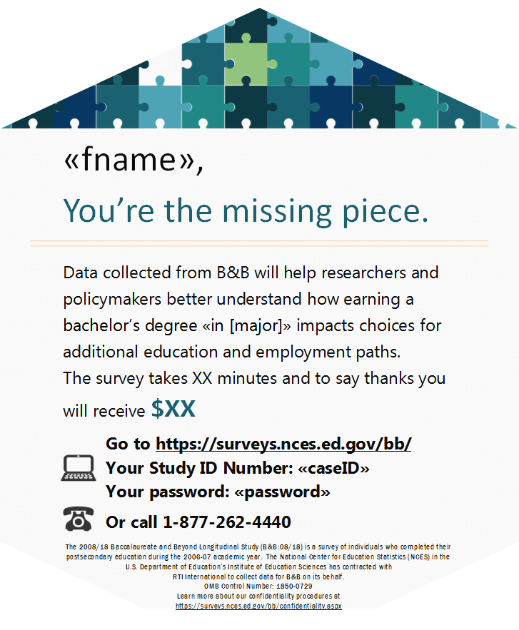

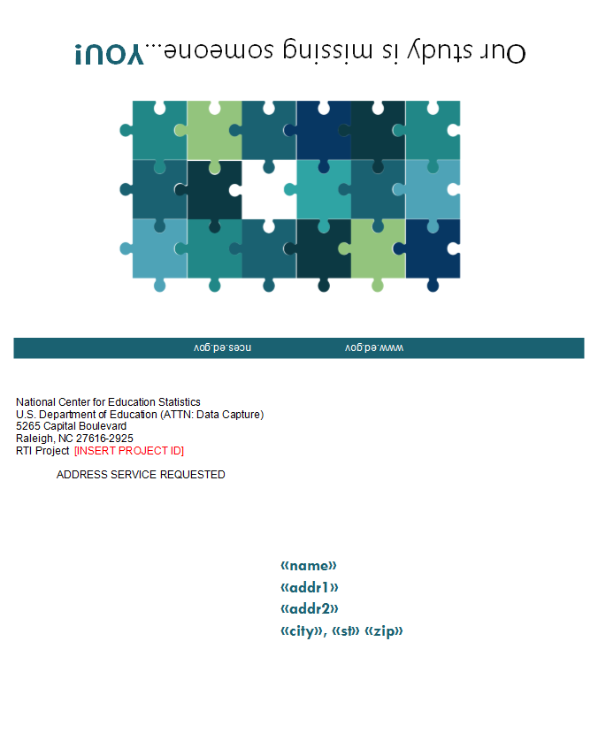

Reminder Postcard 4
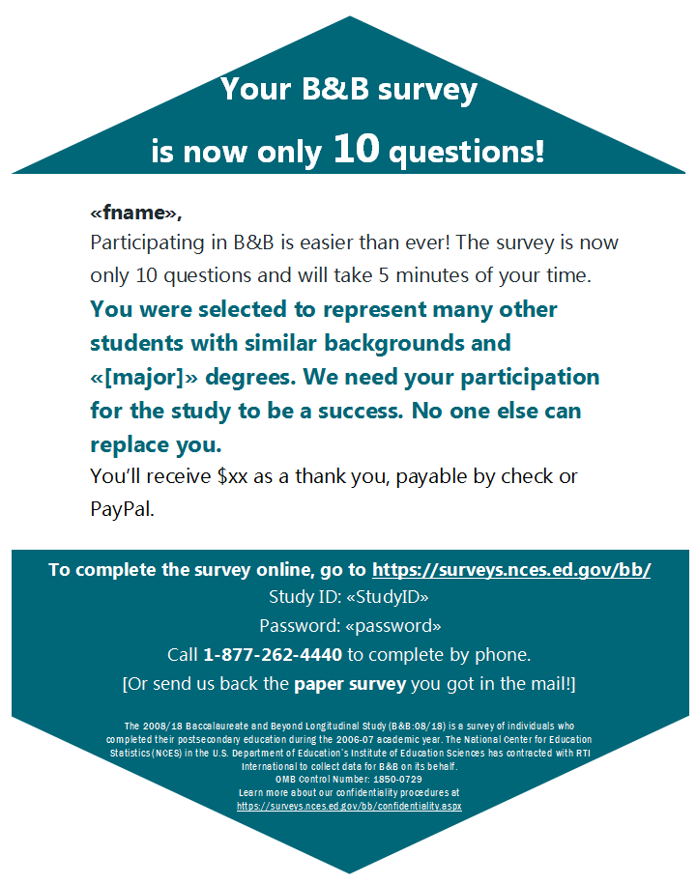

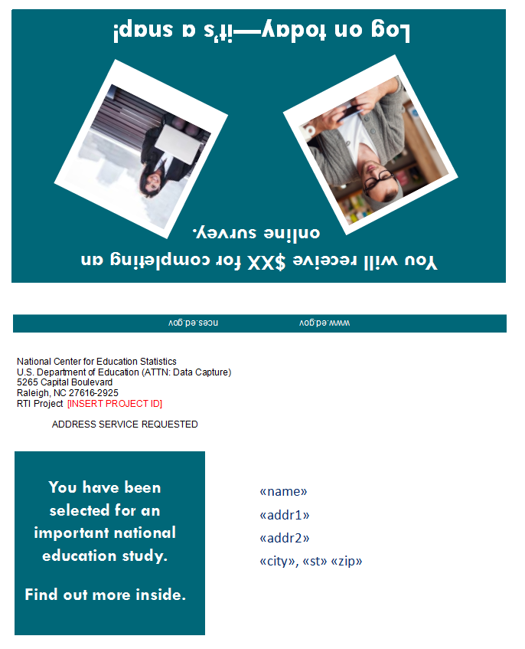

Incentive Selection Card
(To be completed by Respondents to PAPI)

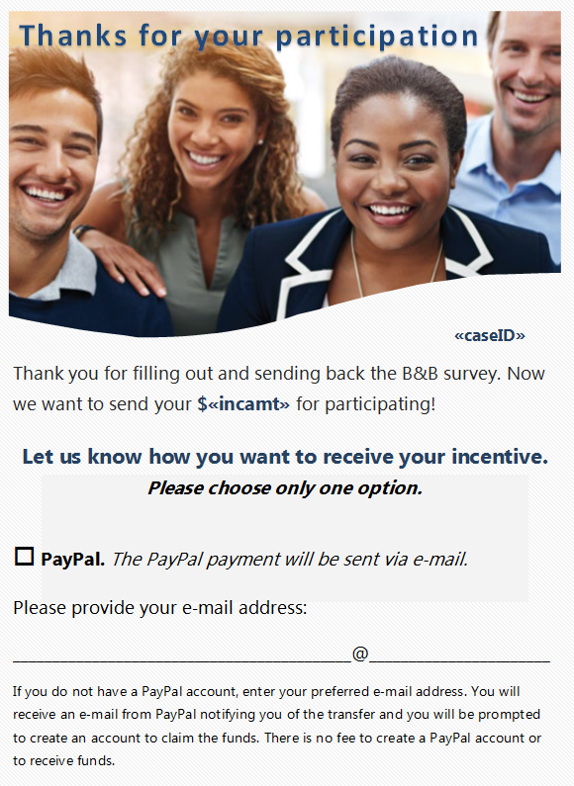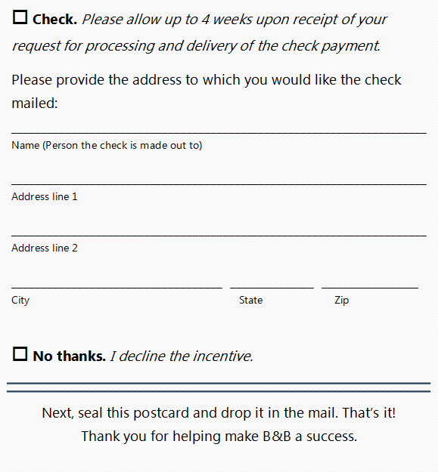

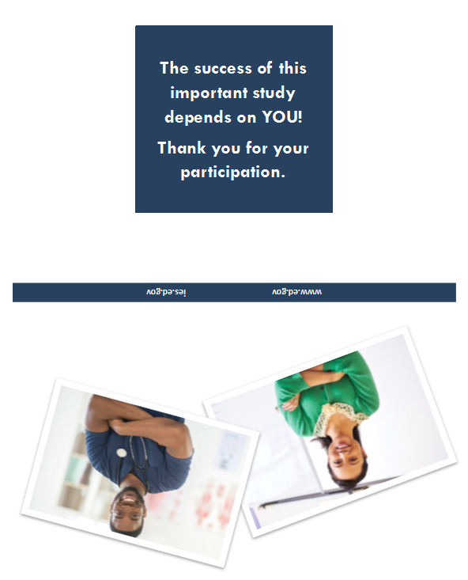
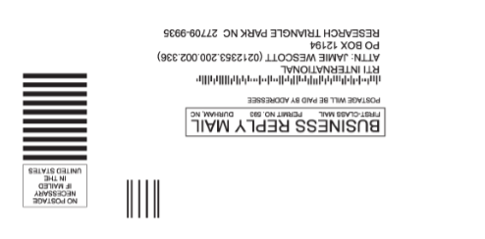

Reminder Postcard 5
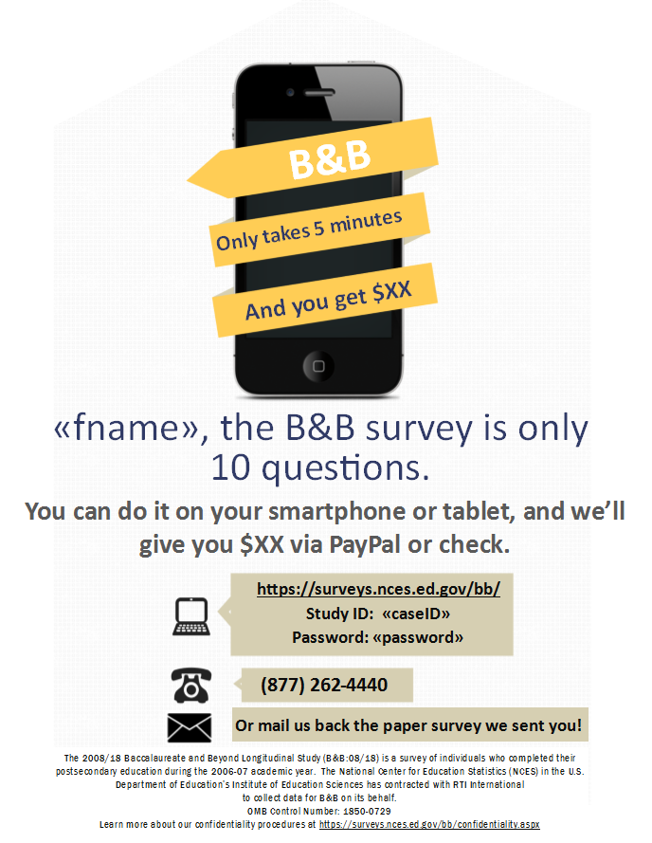
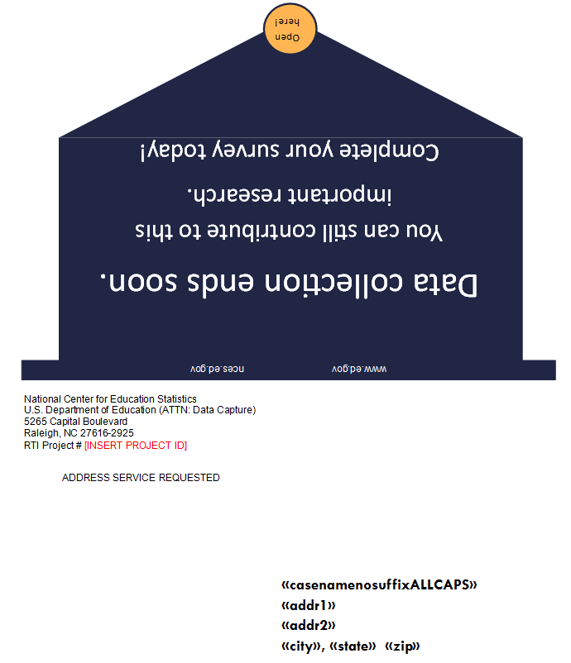

Reminder Postcard 6
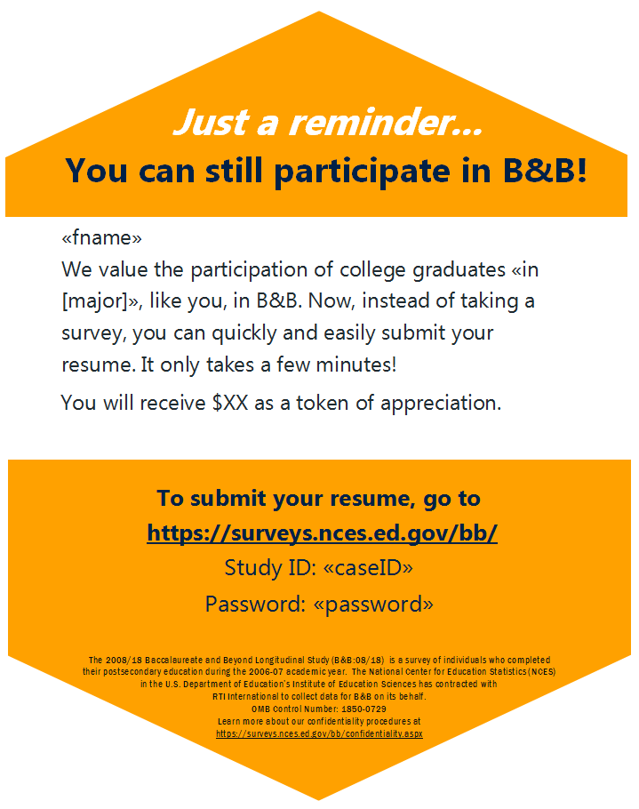

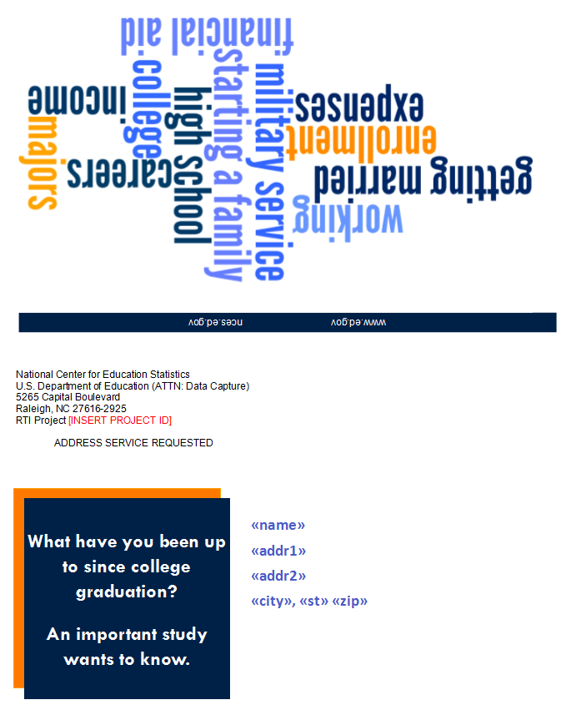

Initial Contact Email

SUBJECT: The 2008/18 Baccalaureate and Beyond Longitudinal Study (B&B:08/18)
Dear «fname» «lname»:

You have been selected to participate in the third round of the Baccalaureate and Beyond Longitudinal Study (B&B), conducted by the National Center for Education Statistics (NCES) in the U.S. Department of Education’s Institute of Education Sciences. B&B is interested in your personal experience since you graduated from college during the 2006–07 school year. Data collected from B&B will help researchers and policymakers better understand how earning a bachelor’s degree in majors such as «[major]» impacts choices for additional education and employment paths.

Before B&B data collection begins, we need to ensure we have the most up to date contact information for you. Please update your contact information online:

https://surveys.nces.ed.gov/bb/
Your Study ID: <<caseID>>

B&B begins in July of 2017. At that time, you will receive a letter in a large white envelope that will provide specific information about how to participate. To say thanks, you will receive $«IncAmt» when you complete the survey.

NCES has contracted with RTI International, a U.S.-based nonprofit research organization, to collect data for B&B on its behalf. Please visit https://surveys.nces.ed.gov/bb/ for a brief description of B&B, findings from past studies, and a summary of our confidentiality procedures. If you have additional questions or concerns about the study after reviewing this material, please call the RTI study director, Melissa Cominole at 1-800-723-8942.

We thank you in advance for your participation in this important study.

Sincerely,

Signature
National Center for Education Statistics

OMB Control Number: 1850-0729
Learn more about our confidentiality procedures at https://surveys.nces.ed.gov/bb/confidentiality.aspx

Data Collection Announcement Email

SUBJECT: The 2008/18 Baccalaureate and Beyond Study (B&B:08/18)
Dear «fname» «lname»:

Data collection for the Baccalaureate and Beyond Longitudinal Study (B&B) is now underway. B&B is interested in understanding how earning a bachelor’s degree «in [major]» impacted your choices about further education and work since graduating from college during the 2006–07 school year.

To complete the survey, log on to our secure website at https://surveys.nces.ed.gov/bb/ using the credentials provided below. (The password is case sensitive; you will need to enter it exactly as it appears here.)
Study ID = «caseid»
Password = «password»

The survey will take about «time» minutes to complete and you will receive $«IncAmt» via check or PayPal as a thank you for your participation. Having your résumé or curriculum vitae handy will help you complete the survey more easily.

The enclosed brochure answers many common questions about the study and contains additional information on laws and procedures that protect the confidentiality of your responses. Data security procedures for B&B are reviewed and approved by NCES data security staff. Your responses will be secured behind firewalls and will be encrypted during internet transmission. All of the information you provide may be used only for statistical purposes and may not be disclosed, or used, in identifiable form for any other purpose except as required by law (20 U.S.C. §9573 and 6 U.S.C. §151).

If you have questions or problems completing your survey online, or prefer to complete the survey over the telephone, simply call the B&B Help Desk at 1-877-262-4440. You can learn more about B&B on our study website, https://surveys.nces.ed.gov/bb/. For other questions or concerns about the study, please contact the B&B Project Director, Melissa Cominole at 1-800-723-8942, mcominole@rti.org, or the NCES Project Officer, Ted Socha, at 1-202-245-7071, ted.socha@ed.gov.

Your participation, while voluntary, is critical to the study’s success. We hope you enjoy the opportunity to share your experiences.

Many thanks,

Ted Melissa
Ted Socha Melissa Cominole
Project Officer, B&B:08/18 Project Director, B&B:08/18
National Center for Education Statistics RTI International
ted.socha@ed.gov mcominole@rti.org
202-245-7071 800-723-8942

OMB Control Number: 1850-0729
Learn more about our confidentiality procedures at https://surveys.nces.ed.gov/bb/confidentiality.aspx

Reminder Email 1
Email is part of Source and Signatory Experiment
SUBJECT: The B&B Survey Needs Your Participation

«fname», we still need you for B&B to be a success!

I noticed that you haven’t yet participated in the 2008/18 Baccalaureate and Beyond Longitudinal Study (B&B:08/18). Your participation is critical to the success of the study, and I hope that you will participate. As a reminder, you can also take the survey on your mobile device. It takes about «time» minutes, and you’ll receive $«IncAmt» for participating, payable by PayPal or check.

Just click here to start the online survey, or go to https://surveys.nces.ed.gov/bb/ and log in:
Study ID = «caseid»
Password = «password»

Or, complete the survey over the phone by calling 1-877-262-4440.

You may still have questions or concerns about B&B – and we’re here to help! I’ve provided the answers to some of the most frequently asked questions about B&B below.

I’m not sure why you want to survey me. Should I participate in B&B?
Yes! B&B includes all types of students who graduated from college during the 2006–07 school year. Your participation «as a [major] major» is important to make sure that the B&B results represent all types of life experiences. No one can replace you in this study.

What if I don’t have time to complete the entire survey right now?
No problem! You can start the survey now and finish it later – you’ll pick up right where you left off.

If you have other questions, please contact the B&B Help Desk at 1-877-262-4440, or email us at bbemail@rti.org.

Thank you in advance for making B&B a success.

[INSERT MERGE FIELD FROM TABLE – SOURCE AND SIGNATORY EXPERIMENT, BELOW]

OMB Control Number: 1850-0729
Learn more about our confidentiality procedures at https://surveys.nces.ed.gov/bb/confidentiality.aspx

MERGE FIELD OPTIONS – SOURCE AND SIGNATORY EXPERIMENT
From NCES | Ted Socha  Project Officer, B&B:08/18  National Center for Education Statistics  ted.socha@ed.gov  202-245-7071
From RTI | Melissa Cominole  Project Director, B&B:08/18  RTI International  mcominole@rti.org  800-723-8942

Reminder Email 2
Email is part of Source and Signatory Experiment
SUBJECT: B&B Data Collection Continues…

…and it won’t be a success without you, «fname»!

Data collection for the 2008/18 Baccalaureate and Beyond Longitudinal Study (B&B:08/18) continues and we are interested in hearing from «[major] majors like» you! The survey – which can easily be completed on your mobile device – takes approximately «time» minutes of your time. When you complete your survey, you will receive $«IncAmt» as a token of our appreciation, payable by PayPal or check.

To access the online survey on our secure website, click here or visit https://surveys.nces.ed.gov/bb/.

Log in using your secure credentials:
Study ID = «caseid»
Password = «password»

Need help accessing the online survey? Prefer to complete the survey by telephone? Please call our Help Desk at 1-877-262-4440.

Thank you in advance for your participation in this very important study.

Sincerely,[INSERT MERGE FIELD FROM TABLE – SOURCE AND SIGNATORY EXPERIMENT, PAGE 32]
OMB Control Number: 1850-0729
Learn more about our confidentiality procedures at https://surveys.nces.ed.gov/bb/confidentiality.aspx

Reminder Email 3
Email is part of Source and Signatory Experiment
SUBJECT: Your B&B Survey is Waiting

«fname», start the B&B survey today!

We still need you to participate in the 2008/18 Baccalaureate and Beyond Longitudinal Study (B&B:08/18) for the U.S. Department of Education. Data collection for B&B:08/18 continues and we are interested in hearing from «[major] majors like» you!

It only takes about «time» minutes and, once you’ve completed the survey, you’ll receive $«IncAmt», payable by PayPal or check!

Click here to get started right away or go to https://surveys.nces.ed.gov/bb/ and log in using:
Study ID = «caseid»
Password = «password»
You can also complete the survey by phone by calling 1-877-262-4440. Find more information on the study website at https://surveys.nces.ed.gov/bb/.
Thanks! [INSERT MERGE FIELD FROM TABLE – SOURCE AND SIGNATORY EXPERIMENT, PAGE 32]
OMB Control Number: 1850-0729
Learn more about our confidentiality procedures at https://surveys.nces.ed.gov/bb/confidentiality.aspx

Reminder Email 4
Email is part of Source and Signatory Experiment
SUBJECT: Don’t Delay! Participate in B&B Today!

«Fname», we’ve been contacting you and other college graduates in «[major]» about participating in B&B!
B&B is an important study that will help policymakers understand how earning a bachelor’s degree impacts choices about further education and work.
We know that you have a lot of demands on your time, but we need your help to make sure that the study is representative - no one can replace you in this study. The survey takes only «time» minutes to complete, and we will send you $«IncAmt» (payable by PayPal or check) for doing it -- just click here to get started!
You can also log on to our secure website https://surveys.nces.ed.gov/bb/ using your study credentials:
Study ID = «caseid»
Password = «password»
Call 1-877-262-4440 to get more information about B&B or complete the survey by phone.
Thank you for considering participating in this important study. We hope you will – B&B won’t be the same without you.
Thank you! [INSERT MERGE FIELD FROM TABLE – SOURCE AND SIGNATORY EXPERIMENT, PAGE 32]
OMB Control Number: 1850-0729
Learn more about our confidentiality procedures at https://surveys.nces.ed.gov/bb/confidentiality.aspx

Reminder Email 5
Email is part of Source and Signatory Experiment
SUBJECT: B&B Needs College Graduates Like You

«fname», B&B needs your help!

B&B only takes about «time» minutes and is easy to complete, even on a mobile device. And, when you complete the survey, you’ll receive $«IncAmt», payable by PayPal or check!

To get started, just click here!

You can also log on to our secure website https://surveys.nces.ed.gov/bb/ using your study credentials:
Study ID = «caseid»
Password = «password»
You can complete the survey by phone by calling 1-877-262-4440 and find more information on the study website at https://surveys.nces.ed.gov/bb/.
We look forward to hearing from «[major] majors like» you!

[INSERT MERGE FIELD FROM TABLE – SOURCE AND SIGNATORY EXPERIMENT, PAGE 32]
OMB Control Number: 1850-0729
Learn more about our confidentiality procedures at https://surveys.nces.ed.gov/bb/confidentiality.aspx

Reminder Email 6
Email is part of Source and Signatory Experiment
SUBJECT: Only You Can Make B&B a Success

B&B is easy to complete, «fname»! You can do it on your mobile device!

The survey only takes about «time» minutes. And, when you complete the survey, you’ll receive $«IncAmt», payable by PayPal or check.

Click here to get started right away.

Use your secure login credentials to access the survey at https://surveys.nces.ed.gov/bb/
Study ID = «caseid»
Password = «password»
You can complete the survey by phone by calling 1-877-262-4440 and find more information on the study website at https://surveys.nces.ed.gov/bb/.
We look forward to hearing about your experiences since graduating from college «with your degree in [major]»!
Thanks! [INSERT MERGE FIELD FROM TABLE – SOURCE AND SIGNATORY EXPERIMENT, PAGE 32]

OMB Control Number: 1850-0729
Learn more about our confidentiality procedures at https://surveys.nces.ed.gov/bb/confidentiality.aspx

Reminder Email 7
Email is part of Source and Signatory Experiment
SUBJECT: $20 for 10 Questions - The B&B Survey Now Takes Only 5 Minutes

«fname»,

Participating in B&B is easier than ever! The survey is now only 10 easy questions which will only take 5 minutes of your time. As a thank you for participating you’ll receive $20, payable by PayPal or check.

[INSERT MERGE FIELD FROM TABLE – HARD COPY, BELOW]

You were selected to represent many other students with similar backgrounds and «[major]» degrees. No one else can replace you. I hope that you will participate in the study, especially now that the survey takes only 5 minutes!

Thank you in advance for making B&B a success.
[INSERT MERGE FIELD FROM TABLE – SOURCE AND SIGNATORY EXPERIMENT, PAGE 32]

OMB Control Number: 1850-0729
Learn more about our confidentiality procedures at https://surveys.nces.ed.gov/bb/confidentiality.aspx

MERGE FIELD OPTIONS – HARD COPY
Hard Copy – Selected | You may have already received a letter from us that contains a paper version of the survey. Simply complete the questionnaire and send it back to us in the return envelope that was provided.  If you did not receive a questionnaire, or if you have any questions, you can call 1-877-262-4440 to get more information about B&B or to complete the survey by phone. Or visit https://surveys.nces.ed.gov/bb/ with your Study ID = «caseid» and Password = «password» to complete the survey online.
Hard Copy – Not Selected | Just click here to start the online survey online. You can also log on to our secure website https://surveys.nces.ed.gov/bb/ using your study credentials:  Study ID = «caseid»  Password = «password»  You can call 1-877-262-4440 to get more information about B&B or to complete the survey by phone.

Reminder Email 8
Email is part of Source and Signatory Experiment
SUBJECT: Don’t Miss Out: Your B&B Survey Now Takes Only 5 Minutes to Complete

«fname», you were selected to receive a shortened B&B survey, which now only takes about 5 minutes to complete. And, you will still receive $20 for participating, payable by PayPal or check!

Participation is easy!

[INSERT MERGE FIELD FROM TABLE – HARD COPY, BELOW]

NCES has contracted with RTI International, a U.S.-based nonprofit research organization (www.rti.org/about-us), to collect data for B&B on its behalf. B&B helps researchers and policymakers understand how earning a bachelor’s degree «in [major]» impacts choices for continuing education and employment paths. We rely on graduates like you to make B&B a success! Visit the B&B home page for more information on the types of data collected and to view published results (https://nces.ed.gov/surveys/bb/).

I hope you will take the time to participate and receive your $20 token of appreciation. If you have any questions, please simply reply to this email or call me directly on my office phone at the number you see below.

Thanks -
[INSERT MERGE FIELD FROM TABLE – SOURCE AND SIGNATORY EXPERIMENT, PAGE 32]

OMB Control Number: 1850-0729
Learn more about our confidentiality procedures at https://surveys.nces.ed.gov/bb/confidentiality.aspx

MERGE FIELD OPTIONS – HARD COPY
Hard Copy – Selected | - Simply complete the paper survey that we sent to you and mail it back to us in the return envelope that was provided. If you did not receive a questionnaire, or if you have any questions, you can call 1-877-262-4440 to get more information about B&B.  - Just click here to start the online survey or go to https://surveys.nces.ed.gov/bb/ and log in with your credentials:  Study ID = «caseid»  Password = «password»  - Or, complete the survey over the phone by calling 1-877-262-4440.
Hard Copy – Not Selected | - Just click here to start the online survey or go to https://surveys.nces.ed.gov/bb/ and log in with your credentials:  Study ID = «caseid»  Password = «password»  - Or, complete the survey over the phone by calling 1-877-262-4440.

Reminder Email 9
Email is part of Source and Signatory Experiment
SUBJECT LINE: Your B&B Survey Takes Only 5 Minutes to Complete

«fname», your B&B survey will take just about 5 minutes to complete – it’s only 10 questions! You will receive $20 for participating, payable by PayPal or check.

[INSERT MERGE FIELD FROM TABLE – HARD COPY, BELOW]
NCES has contracted with RTI International, a U.S.-based nonprofit research organization (www.rti.org/about-us), to collect data for B&B on its behalf. B&B helps policymakers understand how earning a bachelor’s degree «in [major]» impacts choices about further education and work.

If you have any questions about the B&B survey, feel free to reply to this email or call our Help Desk at: 1-877-262-4440.

I hope you decide to participate. We rely on college graduates like you to make B&B a success!

Sincerely,

[INSERT MERGE FIELD FROM TABLE – SOURCE AND SIGNATORY EXPERIMENT, PAGE 32]

OMB Control Number: 1850-0729
Learn more about our confidentiality procedures at https://surveys.nces.ed.gov/bb/confidentiality.aspx

MERGE FIELD OPTIONS – HARD COPY
Hard Copy – Selected | Simply complete the questionnaire that we sent you and your incentive request form and mail both back to us in the return envelope that was provided.  If you did not receive a questionnaire, or if you have any questions, you can call 1-877-262-4440 to get more information about B&B or to complete the survey by phone with one of our trained interviewers. Or visit https://surveys.nces.ed.gov/bb/ with your Study ID = «caseid» and Password = «password» to complete the survey online.
Hard Copy – Not Selected | To participate:  - Just click here to start the online survey or go to https://surveys.nces.ed.gov/bb/ and log in with your credentials:  Study ID = «caseid»  Password = «password»  - Or, complete the survey over the phone by calling 1-877-262-4440.

Reminder Email 10
Email is part of Source and Signatory Experiment
SUBJECT: Limited Time Left to Participate in B&B!

There are only a couple of weeks left to participate in B&B and to receive $20 for your efforts, «fname». We want to hear about your experiences since graduating from college «with your [major] degree»!
[INSERT MERGE FIELD FROM TABLE – HARD COPY, BELOW]
We hope you will decide to participate – the 2008/18 Baccalaureate and Beyond Longitudinal Study (B&B:08/18) won’t be the same without you.
Thanks!
[INSERT MERGE FIELD FROM TABLE – SOURCE AND SIGNATORY EXPERIMENT, PAGE 32]

OMB Control Number: 1850-0729
Learn more about our confidentiality procedures at https://surveys.nces.ed.gov/bb/confidentiality.aspx

MERGE FIELD OPTIONS – HARD COPY
Hard Copy – Selected | The survey takes about «time» minutes to complete, and we will send your $«IncAmt» thank you by PayPal or check for completing it! You can simply complete the paper questionnaire and your incentive request form and mail both back to us in the return envelopes provided.  If you did not receive a questionnaire, or if you have any questions, you can call 1-877-262-4440 to get more information about B&B or to complete the survey by phone with one of our trained interviewers. Or visit https://surveys.nces.ed.gov/bb/ with your Study ID = «caseid» and Password = «password» to complete the survey online.
Hard Copy – Not Selected | The survey takes about «time» minutes to complete, and we will send your $«IncAmt» thank you by PayPal or check for completing it -- click here to get started!  You can also log on to our secure website https://surveys.nces.ed.gov/bb/ using your study credentials:  Study ID = «caseid»  Password = «password»  Or, you can call 1-877-262-4440 to get more information about B&B or to complete the survey by phone with one of our trained interviewers.

Reminder Email 11
Email is part of Source and Signatory Experiment
SUBJECT: Don’t Miss Your Chance to Participate in B&B:08/18

Hi «fname»,

Don’t forget to complete the 2008/18 Baccalaureate and Beyond Longitudinal Study (B&B:08/18) survey and receive your $20 thank you by check or PayPal. Your participation is critical to the success of the study. No one else can tell us about your experiences since graduating «with your degree in [major]».
B&B takes only about 5 minutes to complete. The survey will close on October 30 so don’t delay! Click here to get started!
You can also log on to our secure website https://surveys.nces.ed.gov/bb/ using your study credentials:

Study ID = «caseid»
Password = «password»

Call 1-877-262-4440 to get more information about B&B or to complete the survey by phone with one of our trained interviewers.
We hope you will decide to participate – B&B won’t be the same without you.
[INSERT MERGE FIELD FROM TABLE – SOURCE AND SIGNATORY EXPERIMENT, PAGE 32]

OMB Control Number: 1850-0729
Learn more about our confidentiality procedures at https://surveys.nces.ed.gov/bb/confidentiality.aspx

Reminder Email 12
Email is part of Source and Signatory Experiment
SUBJECT: It's Time to Complete B&B and Receive $20 When you Participate

Dear «fname»,

I haven’t heard from you regarding your participation in the 2008/18 Baccalaureate and Beyond Longitudinal Study (B&B:08/18). I am writing again because of the importance of your responses to help policymakers and researchers understand how earning a bachelor’s degree «in [major]» impacts choices about further education and work. The study won’t be complete unless we hear from young adults like you!
The survey only takes about 5 minutes to complete and you’ll receive $20 for completing it! You can receive your $20 by check or PayPal.
Click here to get started!
You can also log on to our secure website https://surveys.nces.ed.gov/bb/ using your study credentials:

Study ID = «caseid»
Password = «password»

Or, you can call 1-877-262-4440 to get more information about B&B or to complete the survey by phone with one of our trained interviewers.
We hope you will decide to participate.
Thank you!
[INSERT MERGE FIELD FROM TABLE – SOURCE AND SIGNATORY EXPERIMENT, PAGE 32]

OMB Control Number: 1850-0729
Learn more about our confidentiality procedures at https://surveys.nces.ed.gov/bb/confidentiality.aspx

Reminder Email 13
Email is part of Source and Signatory Experiment
SUBJECT: Last Call! Only a Couple Days Left to Complete B&B:08/18

This is it, «fname»! The B&B:08/18 survey by the U.S. Department of Education will end on October 30 and you will miss your chance to receive your $20 token of appreciation if you don’t participate!
We want to hear about your experiences since graduating from college «with a [major] degree» in 2006-07. The survey only takes about 5 minutes to complete. You can receive your $20 by check or PayPal.
Click here to get started right now!
You can also log on to our secure website https://surveys.nces.ed.gov/bb/ using your study credentials:
Study ID = «caseid»
Password = «password»

Or, you can call 1-877-262-4440 to get more information about B&B or to complete the survey by phone with one of our trained interviewers.
We hope you will decide to participate.
Thank you!
[INSERT MERGE FIELD FROM TABLE – SOURCE AND SIGNATORY EXPERIMENT, PAGE 32]

OMB Control Number: 1850-0729
Learn more about our confidentiality procedures at https://surveys.nces.ed.gov/bb/confidentiality.aspx

Reminder Email 14
Email is part of Source and Signatory Experiment
SUBJECT: Final Day! Hurry and Complete Your B&B Survey Now!

TODAY is your last chance to complete your 2008/18 Baccalaureate and Beyond Longitudinal Study (B&B:08/18) survey, «fname»!

Here’s what you need to know:

- The survey closes at midnight TONIGHT – no extensions, this is it!
- You will receive $20 as a thank you, paid via check or PayPal.
- The survey only takes about 5 minutes to complete.
- There are only 10 questions!

There is still time for you to participate and make your voice heard. We need to hear from college graduates «with degrees in [major]» like you. Get started right now by clicking here!

You can also log on to our secure website https://surveys.nces.ed.gov/bb/ using your study credentials:
Study ID = «caseid»
Password = «password»

You can call 1-877-262-4440 to complete the survey by phone with one of our trained interviewers or to get more information about B&B.
We hope you will decide to participate and make B&B a success! Thank you!
[INSERT MERGE FIELD FROM TABLE – SOURCE AND SIGNATORY EXPERIMENT, PAGE 32]

OMB Control Number: 1850-0729
Learn more about our confidentiality procedures at https://surveys.nces.ed.gov/bb/confidentiality.aspx

Text Message Reminders

TEXT MESSAGE REMINDER 1
Hi «fname»! Your B&B survey from the US Department of Education is now online. You will receive $«IncAmt» as a thanks for participating. Click here to take the survey: [LINK]

TEXT MESSAGE REMINDER 2
«fname», this is a reminder to complete your B&B survey. Follow this link to take the survey and get $«IncAmt» as a token of appreciation: [LINK]

TEXT MESSAGE REMINDER 3
Your B&B survey is still available, «fname»! If you participate we will say thank you with $«IncAmt». Click this link to take the survey: [LINK]

TEXT MESSAGE REMINDER 4 (MINI)
Hi «fname»! Your B&B survey is now only 10 questions and you will get $«IncAmt» as a thank you! Take the survey by clicking here: [LINK]

TEXT MESSAGE REMINDER 5 (MINI)
Last chance, «fname»! Your 10-question B&B survey and the $«IncAmt» thank you is only available through October 30. Follow this link to take the survey: [LINK]

TEXT MESSAGE, REMINDER 6 (RÉSUMÉ)
«fname», tomorrow is the last day to participate in B&B by submitting your résumé here: [LINK]. We will thank you with $«IncAmt»!

Résumé Only, Initial Email
Email is part of Source and Signatory Experiment
SUBJECT: Share Your Résumé with B&B – It’s Easy!

«fname»:

There is a new way to participate in the Baccalaureate and Beyond Longitudinal Study (B&B)! Hearing about your experiences since graduating from college «with your [major] degree» is extremely important to us.

Simply submit your résumé or curriculum vitae and receive $20 as a thank you! It only takes a few minutes!

Here’s what you need to do:

- <<Describe process for uploading résumé here>>

https://surveys.nces.ed.gov/bb/
Study ID = «caseid»
Password = «password»

Call 1-877-262-4440 if you need more information about B&B or have questions about uploading your résumé.
We hope you will decide to participate in this important study.
[INSERT MERGE FIELD FROM TABLE – SOURCE AND SIGNATORY EXPERIMENT, PAGE 32]

OMB Control Number: 1850-0729
Learn more about our confidentiality procedures at https://surveys.nces.ed.gov/bb/confidentiality.aspx

Résumé Only, Reminder Email 1
Email is part of Source and Signatory Experiment
SUBJECT: Your $20 From B&B is Waiting

«fname»:

We are ready to send your $20 thank you via PayPal or check. We just need you to submit your résumé or curriculum vitae to B&B! Learning more about your experiences since graduating with your «[major] degree» is extremely important to us.

It only takes a few minutes to upload your résumé!

- <<Describe process for uploading résumé here>>

https://surveys.nces.ed.gov/bb/
Study ID = «caseid»
Password = «password»

Call 1-877-262-4440 if you need more information about B&B or have questions about uploading your résumé.
Last day to participate is November 6. Don’t delay!
[INSERT MERGE FIELD FROM TABLE – SOURCE AND SIGNATORY EXPERIMENT, PAGE 32]

OMB Control Number: 1850-0729
Learn more about our confidentiality procedures at https://surveys.nces.ed.gov/bb/confidentiality.aspx

Résumé Only, Reminder Email 2
Email is part of Source and Signatory Experiment
SUBJECT: LAST CHANCE to Participate in B&B

«fname»:

This is the last day to participate in the Baccalaureate and Beyond Longitudinal Study (B&B). This important study is conducted by the U.S. Department of Education. Data collected from B&B will help researchers and policymakers better understand how earning a bachelor’s degree «in [major]» impacts choices for additional education and employment paths.

Contribute to this important research by submitting your résumé or curriculum vitae to B&B! You will receive $20 as a thank you via PayPal or check. It will only take a few minutes!

To upload your résumé:

- <<Describe process for uploading résumé here>>

https://surveys.nces.ed.gov/bb/
Study ID = «caseid»
Password = «password»

Call 1-877-262-4440 if you need more information about B&B or have questions about uploading your résumé.
Don’t delay!
[INSERT MERGE FIELD FROM TABLE – SOURCE AND SIGNATORY EXPERIMENT, PAGE 32]

OMB Control Number: 1850-0729
Learn more about our confidentiality procedures at https://surveys.nces.ed.gov/bb/confidentiality.aspx

Thank You Letter

«date»

«fname» «mname» «lname» «suffix» Study ID: «caseid»
«addr1»
«addr2»
«city», «state» «zip» «zip4»

Dear «fname»:

On behalf of the National Center for Education Statistics (NCES) in the U.S. Department of Education’s Institute of Education Sciences and the staff of the 2008/18 Baccalaureate and Beyond Longitudinal Study (B&B:08/18), we would like to thank you. Your participation in B&B is very important in helping to ensure the success of the study.

[INSERT MERGE FIELD FROM TABLE – RÉSUMÉ, BELOW]

If you have questions, please do not hesitate to call the B&B Help Desk at 1-877-262-4440.

Thank you for helping make B&B a success!

Sincerely,

Melissa
Melissa Cominole
Project Director, B&B:08/18
RTI International
mcominole@rti.org
800-723-8942

MERGE FIELD OPTIONS – RÉSUMÉ
Résumé – If agreed to submit | Please take a few minutes to submit your résumé so we can have a better understanding of your experiences since college graduation. Uploading your résumé takes only a few minutes and you will receive $«IncAmt» for your effort!  - <<Insert instructions for uploading résumé here>>
Résumé – If did not agreed to submit | Leave blank
Hard Copy – Selected & Completed in paper | At this point we would like to give you the opportunity to upload your résumé. It takes less than 5 minutes and you will receive an additional $«IncAmt» as a token of our appreciation.  - <<Insert instructions for uploading résumé here>>

The 2008/18 Baccalaureate and Beyond Longitudinal Study (B&B:08/18) is conducted by the National Center for Education Statistics (NCES). Under contract with NCES, RTI International, a U.S.-based nonprofit research organization, administers B&B:08/18 on behalf of NCES. NCES is authorized to conduct B&B:08/18 by the Education Sciences Reform Act of 2002 (ESRA 2002, 20 U.S.C. §9543) and to collect students’ education records from education agencies or institutions for the purposes of evaluating federally supported education programs under the Family Educational Rights and Privacy Act (FERPA, 34 CFR §§ 99.31(a)(3) and 99.35). All of the information you provide may be used only for statistical purposes and may not be disclosed, or used, in identifiable form for any other purpose except as required by law (20 U.S.C. §9573 and 6 U.S.C. §151).
According to the Paperwork Reduction Act of 1995, no persons are required to respond to a collection of information unless it displays a valid OMB control number. The valid OMB control number for this voluntary information collection is 1850-0729. The time required to complete this information collection is estimated to average approximately <<time>> minutes per response, including the time to review instructions, gather the data needed, and complete and review the information collection. If you have any comments concerning the accuracy of the time estimate, suggestions for improving this survey, or any comments or concerns regarding the status of your individual submission of this survey, please write directly to: The 2008/18 Baccalaureate and Beyond Longitudinal Study (B&B:08/18), National Center for Education Statistics, Potomac Center Plaza, 550 12th St., SW, Room 4004, Washington, DC 20202.

Thank You Email
Email is part of Source and Signatory Experiment
SUBJECT: Thank You from B&B

Dear «fname» «lname»:

On behalf of the National Center for Education Statistics (NCES) in the U.S. Department of Education’s Institute of Education Sciences and the staff of the 2008/18 Baccalaureate and Beyond Longitudinal Study (B&B:08/18), we would like to thank you for participating in B&B. Your participation is very important in helping to ensure the success of the study.

[INSERT MERGE FIELD FROM TABLE – RÉSUMÉ, PAGE 51]

If you have questions, please do not hesitate to call the B&B Help Desk at 1-877-262-4440.

Thank you for helping make B&B a success!

Sincerely,

[INSERT MERGE FIELD FROM TABLE – SOURCE AND SIGNATORY EXPERIMENT, PAGE 32]

OMB Control Number: 1850-0729
Learn more about our confidentiality procedures at https://surveys.nces.ed.gov/bb/confidentiality.aspx

Résumé Reminder Email 1
(Reminder email sent to cases that completed interview and indicated willingness to upload résumé.)
Email is part of Source and Signatory Experiment
SUBJECT: Don’t Forget- Upload Your Résumé for B&B Today

Dear «fname» «lname»:

On behalf of the U.S. Department of Education and the staff of the 2008/18 Baccalaureate and Beyond Longitudinal Study (B&B:08/18), we would like to thank you for completing your B&B survey.

Now that your survey is complete, it’s time to upload your résumé! It takes less than 5 minutes and you will receive $«IncAmt» as a token of our appreciation. The purpose of uploading your résumé is to provide a more complete picture of your education and employment paths. Seeing what college graduates «with degrees in [major]» like yourself have been up to is an important part of our study!

To upload your résumé, simply <<describe process for uploading résumé here>>.

Please do not hesitate call the B&B Help Desk at 1-877-262-4440 if we can provide any additional information or assistance.

Again, thank you for your time and willingness to participate. Your ongoing participation in this study is very important to ensuring the study’s success. We will contact you again in a couple of weeks if we haven't received your résumé yet.

Thank you for helping to make the B&B:08/18 a success!
[INSERT MERGE FIELD FROM TABLE – SOURCE AND SIGNATORY EXPERIMENT]

OMB Control Number: 1850-0729
Learn more about our confidentiality procedures at https://surveys.nces.ed.gov/bb/confidentiality.aspx

Re-Interview, Initial Letter
«date»

«fname» «mname» «lname» «suffix» Study ID: «caseid»
«addr1»
«addr2»
«city», «state» «zip» «zip4»

Dear «fname»:
You may recall recently completing the Baccalaureate and Beyond Longitudinal Study (B&B) survey. Thank you for your participation! Hearing from «[major]» graduates like you is extremely important to us.

At the end of your survey, you were randomly selected for and agreed to participate in a quality control survey. This second survey will take less than 10 minutes to complete.

[INSERT MERGE FIELD FROM TABLE, BELOW]

[INSERT MERGE FIELD FROM TABLE – RÉSUMÉ, PAGE 51]

If you have any questions or need assistance, you can call us toll-free at 1-877-262-4440 or e-mail us at bbemail@rti.org.

If you have already completed this quality control survey, please disregard this message. Again, thank you for your time and willingness to participate.

Sincerely,
Melissa
Melissa Cominole
Project Director, B&B:08/18
RTI International
mcominole@rti.org
800-723-8942

MERGE FIELD OPTIONS
Interview type - CATI | To complete the quality control survey, please log in to our secure website at https://surveys.nces.ed.gov/bb/ using the Study ID and password provided below:  Study ID = «caseid»  Password = «password»
Interview type - Web | Please call B&B Help Desk at 1-877-262-4440, provide our interviewer with the Study ID number listed below, and inform them that you are calling in reference to the quality control survey.  Study ID = «caseid»

The 2008/18 Baccalaureate and Beyond Longitudinal Study (B&B:08/18) is conducted by the National Center for Education Statistics (NCES). Under contract with NCES, RTI International, a U.S.-based nonprofit research organization, administers B&B:08/18 on behalf of NCES. NCES is authorized to conduct B&B:08/18 by the Education Sciences Reform Act of 2002 (ESRA 2002, 20 U.S.C. §9543) and to collect students’ education records from education agencies or institutions for the purposes of evaluating federally supported education programs under the Family Educational Rights and Privacy Act (FERPA, 34 CFR §§ 99.31(a)(3) and 99.35). All of the information you provide may be used only for statistical purposes and may not be disclosed, or used, in identifiable form for any other purpose except as required by law (20 U.S.C. §9573 and 6 U.S.C. §151).
According to the Paperwork Reduction Act of 1995, no persons are required to respond to a collection of information unless it displays a valid OMB control number. The valid OMB control number for this voluntary information collection is 1850-0729. The time required to complete this information collection is estimated to average approximately <<time>> minutes per response, including the time to review instructions, gather the data needed, and complete and review the information collection. If you have any comments concerning the accuracy of the time estimate, suggestions for improving this survey, or any comments or concerns regarding the status of your individual submission of this survey, please write directly to: The 2008/18 Baccalaureate and Beyond Longitudinal Study (B&B:08/18), National Center for Education Statistics, Potomac Center Plaza, 550 12th St., SW, Room 4004, Washington, DC 20202.

Re-Interview, Initial Email
SUBJECT: B&B Quality Control Survey

Dear «fname» «lname»:
You may recall recently completing the 2008/18 Baccalaureate and Beyond Longitudinal Study (B&B:08/18) survey. Thank you for your participation! Hearing from «[major]» graduates like you is extremely important to us.

At the end of your survey, you were randomly selected for and agreed to participate in a quality control survey. This second survey will take less than 10 minutes to complete.

[INSERT MERGE FIELD FROM TABLE – INTERVIEW TYPE, PAGE 55]
[INSERT MERGE FIELD FROM TABLE – RÉSUMÉ, PAGE 51]

If you have any questions or need assistance, call us toll-free at 1-877-262-4440 or e-mail us at bbemail@rti.org.

If you have already completed this quality control survey, please disregard this message. Again, thank you for your time and willingness to participate.

Sincerely,
Melissa
Melissa Cominole

OMB Control Number: 1850-0729
Learn more about our confidentiality procedures at https://surveys.nces.ed.gov/bb/confidentiality.aspx

Re-Interview, Reminder Email 1
SUBJECT: We Need Your Feedback on B&B

«fname»,
You recently completed the Baccalaureate and Beyond Longitudinal Study (B&B) survey. Thank you! Because of your participation, researchers and policymakers will better understand how earning a bachelor’s degree «in [major]» impacts choices for additional education and employment paths.

At the end of your survey, you were randomly selected for and agreed to participate in a quality control survey. This second survey will take less than 10 minutes to complete and will help us understand how we did. We need your feedback!

[INSERT MERGE FIELD FROM TABLE – INTERVIEW TYPE, PAGE 55]
[INSERT MERGE FIELD FROM TABLE – RÉSUMÉ, PAGE 51]

If you have any questions or need assistance, call us toll-free at 1-877-262-4440 or e-mail us at bbemail@rti.org.

If you have already completed this quality control survey, please disregard this message. Thank you for helping make B&B a success!

Sincerely,
Melissa
Melissa Cominole

OMB Control Number: 1850-0729
Learn more about our confidentiality procedures at https://surveys.nces.ed.gov/bb/confidentiality.aspx

Re-Interview, Reminder Email 2
SUBJECT: Last Chance! B&B Quality Control Survey

Hi «fname»,

Thank you for recently completing the B&B survey. Hearing from «[major]» graduates like you is extremely important to us.
At the end of your survey, you were randomly selected for and agreed to participate in a quality control survey. Again, this second survey will take less than 10 minutes to complete. Time to participate is limited!

[INSERT MERGE FIELD FROM TABLE – INTERVIEW TYPE, PAGE 55]

[INSERT MERGE FIELD FROM TABLE – RÉSUMÉ, PAGE 51]

If you have any questions or need assistance, you can call us toll-free at 1-877-262-4440 or e-mail us at bbemail@rti.org.

If you have already completed this quality control survey, please disregard this message. Thank you for helping make B&B a success!

Sincerely,
Melissa
Melissa Cominole

OMB Control Number: 1850-0729
Learn more about our confidentiality procedures at https://surveys.nces.ed.gov/bb/confidentiality.aspx

FS Panel Maintenance Postcard
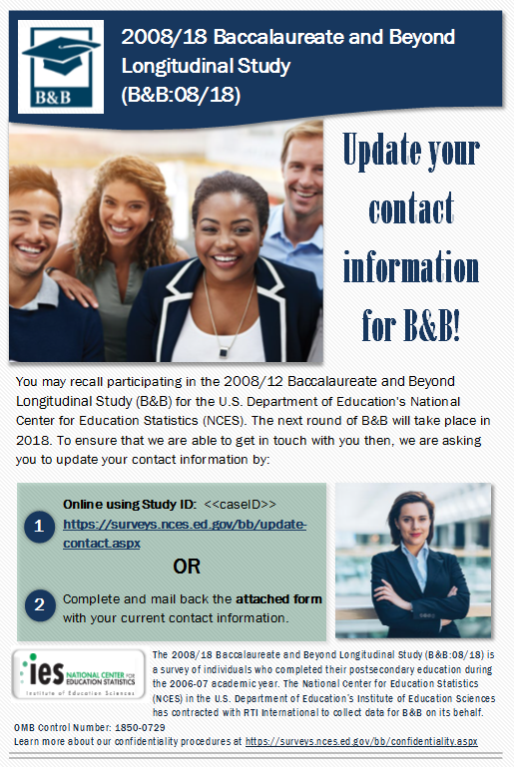

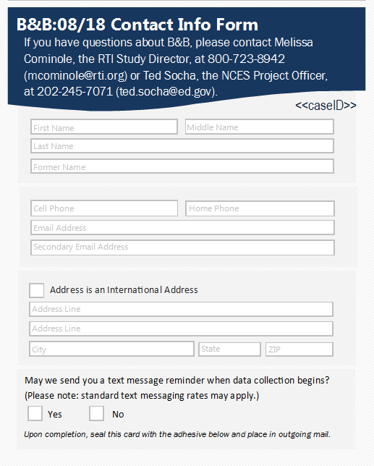

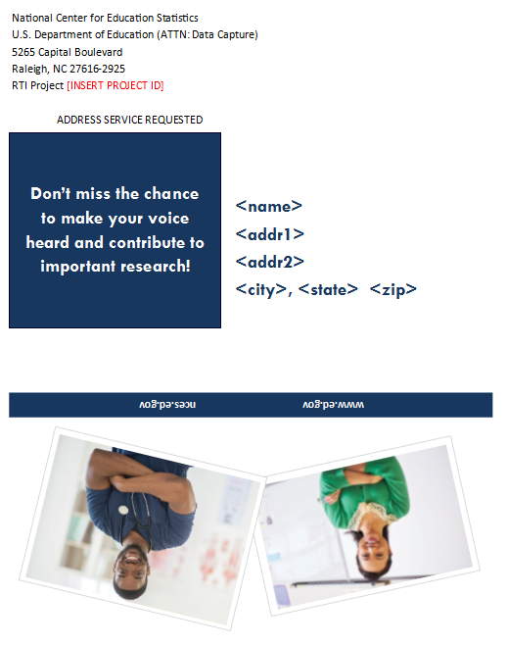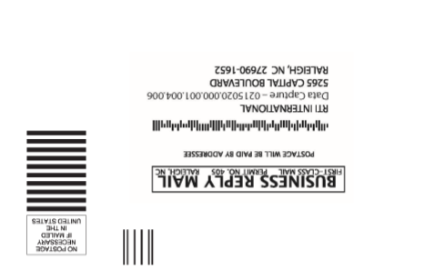

FS Panel Maintenance Email
Email is part of Source and Signatory Experiment
SUBJECT: Update Your Contact Information for B&B

Dear «fname» «lname»:

The third round of data collection for the 2008/18 Baccalaureate and Beyond Longitudinal Study (B&B:08/18) will be starting soon! The National Center for Education Statistics (NCES) in the U.S. Department of Education’s Institute of Education Sciences has contracted with RTI International, a U.S.-based nonprofit research organization, to collect data for B&B on its behalf. Help us inform educators, researchers, and policymakers about how earning a bachelor’s degree «in [major]» impacts choices for continuing education and employment paths.

Before we send you the invitation to complete the survey, we ask you to please take 5 minutes to update your contact information. As a token of our appreciation, we will send you $«IncAmt» after you finish updating your information.

To provide us with your most recent contact information please visit our secure website: https://surveys.nces.ed.gov/bb/ and use the following Study ID and password to log on: (The password is case sensitive; you will need to enter it exactly as it appears here.)
Study ID = «caseid»
Password = «password»
If you have any questions, encounter any difficulty on the website, or would prefer to update this information over the telephone, please call the B&B Help Desk at 1-877-262-4440.
We very much appreciate your help with this study and thank you in advance for helping making B&B a success.

[INSERT MERGE FIELD FROM TABLE – SOURCE AND SIGNATORY EXPERIMENT, PAGE 32]

OMB Control Number: 1850-0729
Learn more about our confidentiality procedures at https://surveys.nces.ed.gov/bb/confidentiality.aspx

