Entrance to the Post Award Draw Down Form on G5

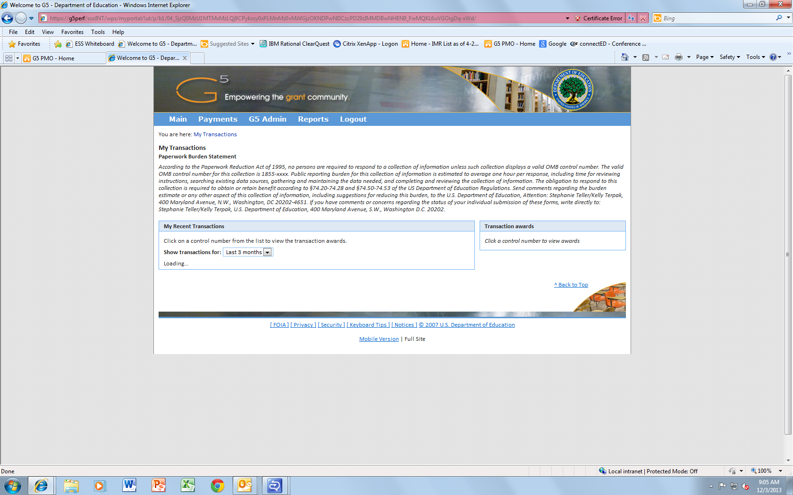

First Page Transaction:

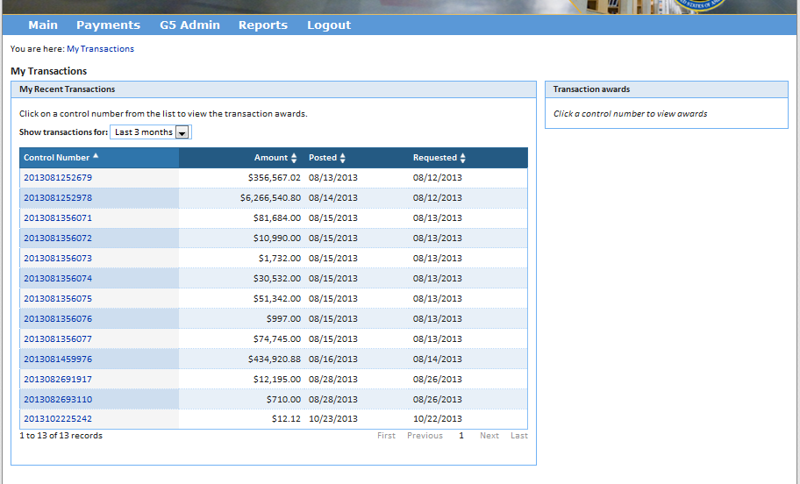

Once you click a control number:

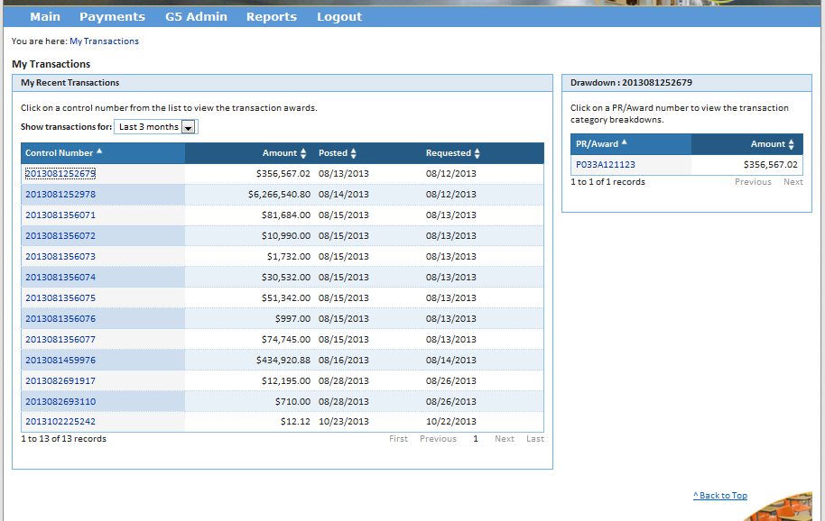

When you click on the PR/Award number:

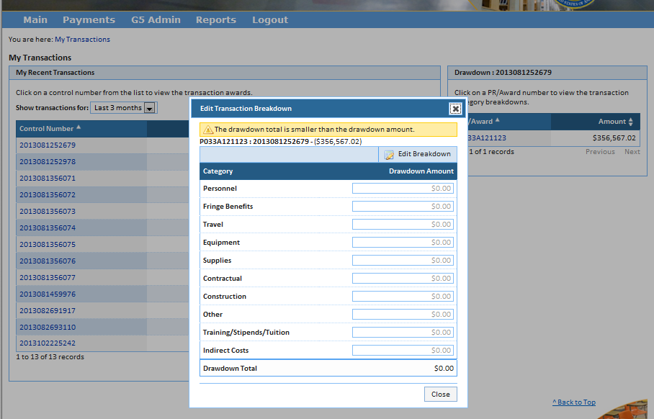

Then click “Edit Breakdown” and the drawdown amounts will become editable.