Entrance to the Post Award Draw Down Form on G5
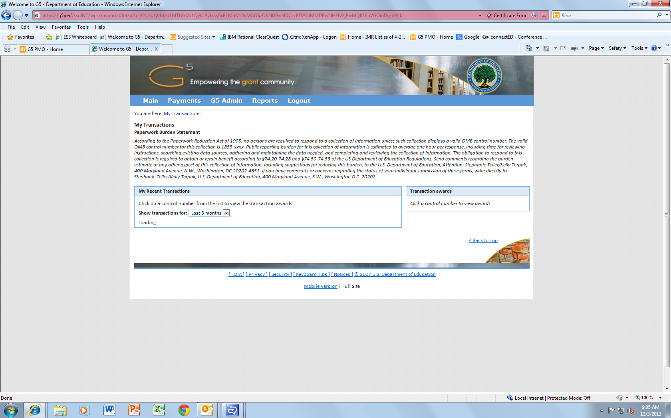
First Page Transaction:
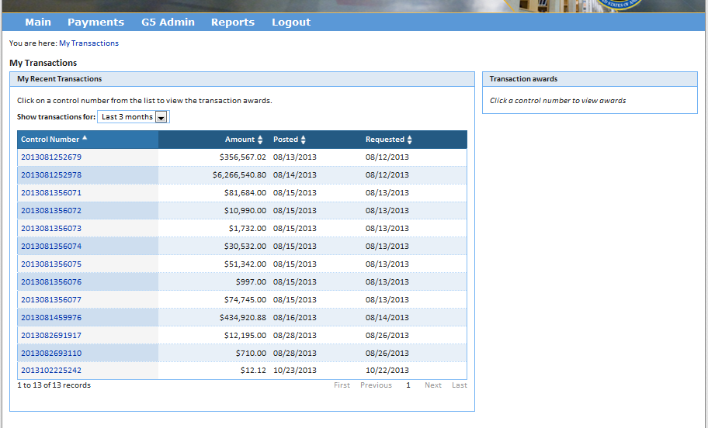
Once you click a control number:
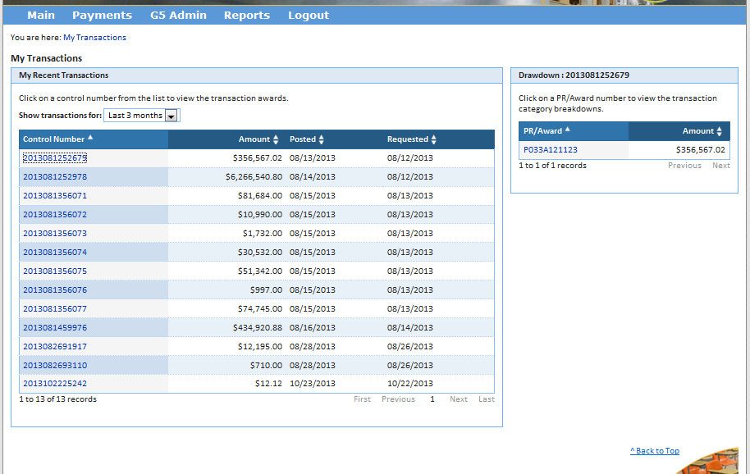
When you click on the PR/Award number:
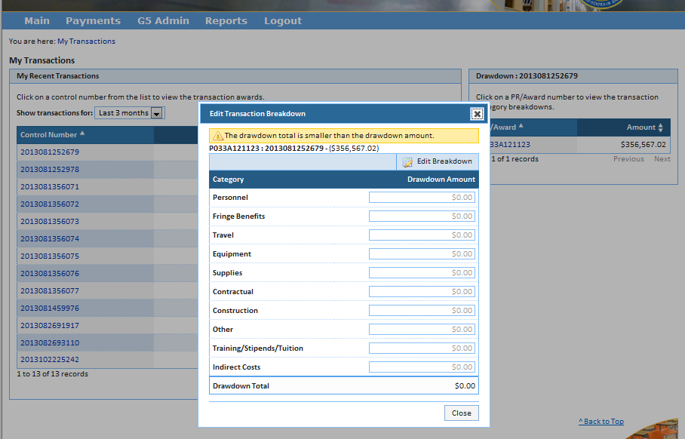
Then click “Edit Breakdown” and the drawdown amounts will become editable.

