Supporting Statement

**AGRICULTURAL LABOR SURVEY**

OMB No. 0535-0109

**B. COLLECTION OF INFORMATION EMPLOYING STATISTICAL METHODS**

**1. Describe (including a numerical estimate) the potential respondent universe and any sampling or other respondent selection method to be used. Data on the number of entities (e.g., establishments, State and local government units, households, or persons) in the universe covered by the collection and in the corresponding sample are to be provided in tabular form for the universe as a whole and for each of the strata in the proposed sample. Indicate expected response rates for the collection as a whole. If the collection has been conducted previously, include the actual response rate achieved during the last collection.**

The universe for the Agricultural Labor Survey is the USDA farm population, about 2.1 million operations (2012 Census of Agriculture). It includes "all operations that sold or would normally sell at least $1,000 worth of agricultural products during the year." A sample of farm operators is surveyed biannually (April and October) in all States except Alaska and California (CA conducts a State survey and provides NASS with administrative data, and AK has too small of a population of farmers with hired workers to sample from and provide State wide estimates). Survey data are used to make estimates of number of workers and wage rates for the population.

The Labor Survey is a multiple frame survey using a list frame of farms identified on the List Sampling Frame (LSF) and non-overlap (NOL) records from the June Agricultural Survey (OMB No. 0535-0213) area frame segments. The list is an efficient sampling frame because it contains most of the farms with hired labor. The area frame provides the completeness missing from the list. The survey's multiple frame expansions are unbiased and more precise than expansions that could be obtained from either frame alone.

The agricultural labor sample is based on three sources: each State’s list frame; each State’s area frame; and for California, their list frames of agricultural services.

(1) In all States except California, a list of farms oriented toward the use of farm labor is selected from the agency's list sampling frame. This list is stratified by peak employment figures or, when that is not available, assignment of monetary values to control data i.e., (number of cattle, hogs, crop acreage, and type of crop). It is expected that farms with higher sales are more likely to have hired workers. In California, the Employment Development Department (EDD) list is sampled; it has approximately 19,000 names of employers filing disability or unemployment insurance forms for workers. Additional NASS-supplied list samples are drawn from approximately 33,000 names classified on an estimated value of sales. The survey data is collected by EDD and is supplied to NASS as administrative data.

(2) In all states except Hawaii, list incompleteness is measured by sampling "resident farm operators" from the June Area Frame Survey (OMB No. 0535-0213) which are non-overlap with the list. The April Labor Survey will utilize the same non-overlap sample as the October Labor Survey, thus it will not be modeled. Hawaii uses a list-only sampling frame because of the uniqueness of their agricultural industry.

(3) California also samples from a list of agricultural service firms. This list contains about 3,000 names.

Response rates for the last two biannual surveys are shown in the table below.

|  |  |  |  |  |  |  |
| --- | --- | --- | --- | --- | --- | --- |
| **Labor Survey Response Rates** | | | | | | |
| **Survey** | | **Target**  **Sample Size 1/** | **Freq.** | **Total Contacts 2/** | **Total Responses** | **Response Rate** |
| Date | Apr. 2014 | 9,848 | 1 | 9,583 | 6,109 | 63.7% |
| Oct. 2014 | 11,682 | 1 | 11,435 | 7,189 | 62.9% |

1/ the target sample does not include the nearly 3,000 operators in CA for which NASS receives administrative data.

2/ the total contacts are the number of records that were in scope for the survey. It excludes office holds, out of business, and known zeros.

**2. Describe the procedures for the collection of information including:**

**• statistical methodology for stratification and sample selection,**

**• estimation procedure,**

**• degree of accuracy needed for the purpose described in the justification,**

**• unusual problems requiring specialized sampling procedures**

*List Frame Design*: The list sample uses a stratified, replicated sample design. The primary list frame strata are based on farms’ peak number of hired worker data; strata of secondary importance are based on calculated farm value of sales (FVS). Sample strata based on peak number of hired workers typically provide most of the labor information we are seeking, so, in order to reduce CV's, records in these strata are sampled with a higher frequency than records with FVS only. Classification categories have been combined into the following sample selection strata.

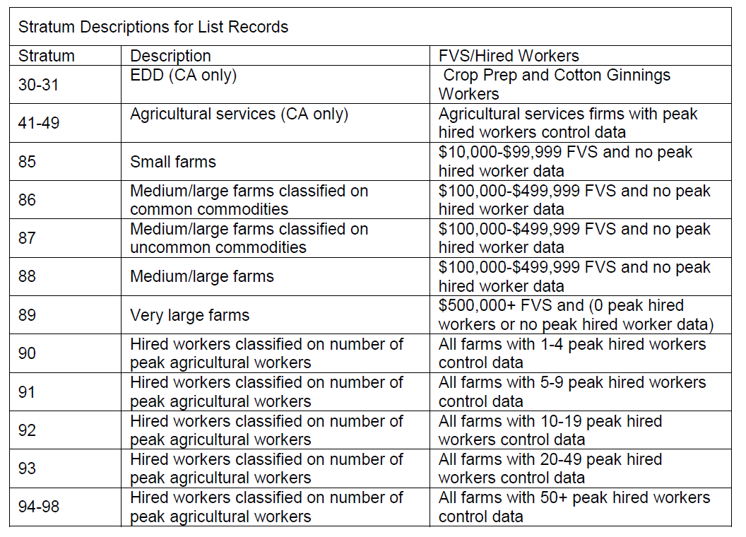

*Area Frame Design*: The U.S. population size for the area frame (Non-Overlap NOL) is about 1,600 tracts. The highest priority for sampling will be given to tracts with positive hired workers. The first-stage, area frame stratification is based on land use. Although the exact stratification differs from State to State, the area frame usually includes strata for:

- Heavily cultivated land

- Less heavily cultivated land

- Residential or ag-urban land with potential for agricultural use

- Pasture or grazing land

- Completely nonagricultural land

June Area Survey records that are non-overlap (NOL) with the list Labor population are determined in late June for the October and April Labor Survey samples. Sales code = 1 (less than $1,000 FVS) records are excluded from the sampling population; nonagricultural tracts are also excluded from the population because they do not meet the farm definition ($1,000 FVS).

Tracts also undergo a second-stage stratification for Labor based on largest number of hired agricultural workers. This second-stage re-stratification into Labor strata is done as follows:

**Area Labor**

**Stratum Description**

3 0 or missing peak workers

11 1-4 peak workers

12 5-9 peak workers

13 10-49 peak workers

14 50-99 peak workers

15 100+ peak workers

21 Labor stratum 3 records with high expansion factors

22 Labor stratum 11 records with high expansion factors

The general intent of area sampling is to select all records above stratum 11 and to sample as many of the records in strata 3 and 11 as possible, given the constraint of overall State and U.S. sample size. In addition, special strata 21 and 22 have been created to sample all operations with high combined June Area expansion factors and farm-tract ratio. Hawaii uses a re-weighted list estimator in all quarters; all other States use the re-weighted list/modified weighted NOL estimator.

*Data Collection*: Generally, a pre-survey letter and sample questionnaire are mailed to the list sample prior to each biannual survey. The letter alerts respondents that they will be contacted at a later date and encourages them to enter data on the sample questionnaire so that it will be readily available when they are contacted by an enumerator. This procedure allows respondents to compile data at their convenience and reduces interview time when they are contacted.

Included with the pre-survey letter, farm operators are also given the opportunity to respond by internet. They are provided a web-site to contact along with a personalized, secure ID that will allow them to access only their account and provide their information in a secure manner.

Field Offices will attempt to contact non-internet respondents by either telephone or personal visits. Telephone data collection is done mostly using a CATI (computer-assisted telephone interviewing) instrument which automatically delivers forms and manages call-backs and appointments for the enumerators. Those farms expected to have a large number of workers are generally surveyed entirely by personal enumeration.

**3. Describe methods to maximize response rates and to deal with issues of non-response. The accuracy and reliability of information collected must be shown to be adequate for intended uses. For collections based on sampling a special justification must be provided for any collection that will not yield "reliable" data that can be generalized to the universe studied.**

Estimates will be generated for number of workers; hours worked, and wage rates. The data will be summarized and published for the 15 Farm Labor Regions along with the States of California, Florida and Hawaii. The sample is designed to provide regional coefficients of variation of about 5 percent for wage rates and 15 percent for hired workers.

The NASS Farm Labor Survey publication will continue to include the same summarized data tables using the Dept. of Labor’s Employment and Training Administration’s (ETA) worker categories that were historically published. Beginning in November, 2015 NASS will expand the publication to also include tables with the farm labor data being summarized using the Standard Occupational Classification (SOC) codes.

Survey data are subject to non-sampling errors such as omissions and mistakes in reporting and in processing the data. While these errors cannot be measured directly, they are minimized by carefully reviewing all reported data for consistency and reasonableness.

**4. Describe any tests of procedures or methods to be undertaken.**

Testing of small groups (9 or less operations) is conducted periodically.

**5. Provide the name and telephone number of individuals consulted on statistical aspects of the design and the name of the agency unit, contractor(s), or other person(s) who will actually collect and/or analyze the information for the agency.**

The survey design and sample size for each State are determined by the Sampling, Editing, and Imputation Methodology Branch, Methodology Division; Branch Chief is Mark Apodaca, (202)720-5805.

Data collection is carried out by NASS Field Offices; Field Operation’s Director is Kevin Barnes (202) 720-8220.

The NASS survey statistician in Headquarters for the Agricultural Labor surveys is Julie Weber (202) 720-7216, in the Environmental and Economic Surveys Section of the Survey Administration Branch, Census and Survey Division. She is responsible for coordination of sampling, questionnaires, data collection, training, Interviewers Manual, Survey Administration Manual, data processing, and other Field Office support.

The NASS commodity statistician in Headquarters for the Agricultural Labor surveys is Theresa Varner, (202) 690-2284, in the Environmental , Economics and Demographics Section of the Environmental, Economics, and Demographics Branch, Statistics Division. She is responsible for national and regional summaries, analysis, and the presentation of data to the Agricultural Statistics Board for final estimates, publication, and the Estimation Manual.

December 2014

Revised March 2015