eDRS Screenshots:

eDRS Welcome Screen (before being redirected to Home page)

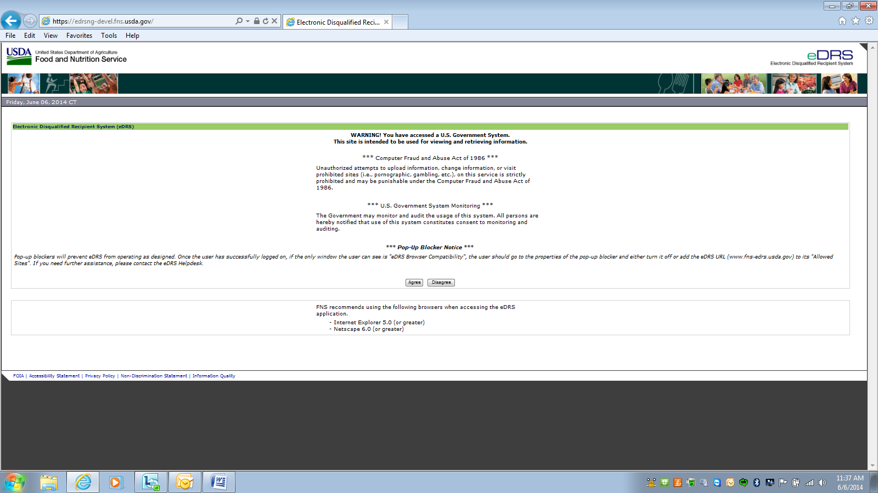

My eDRS – Home

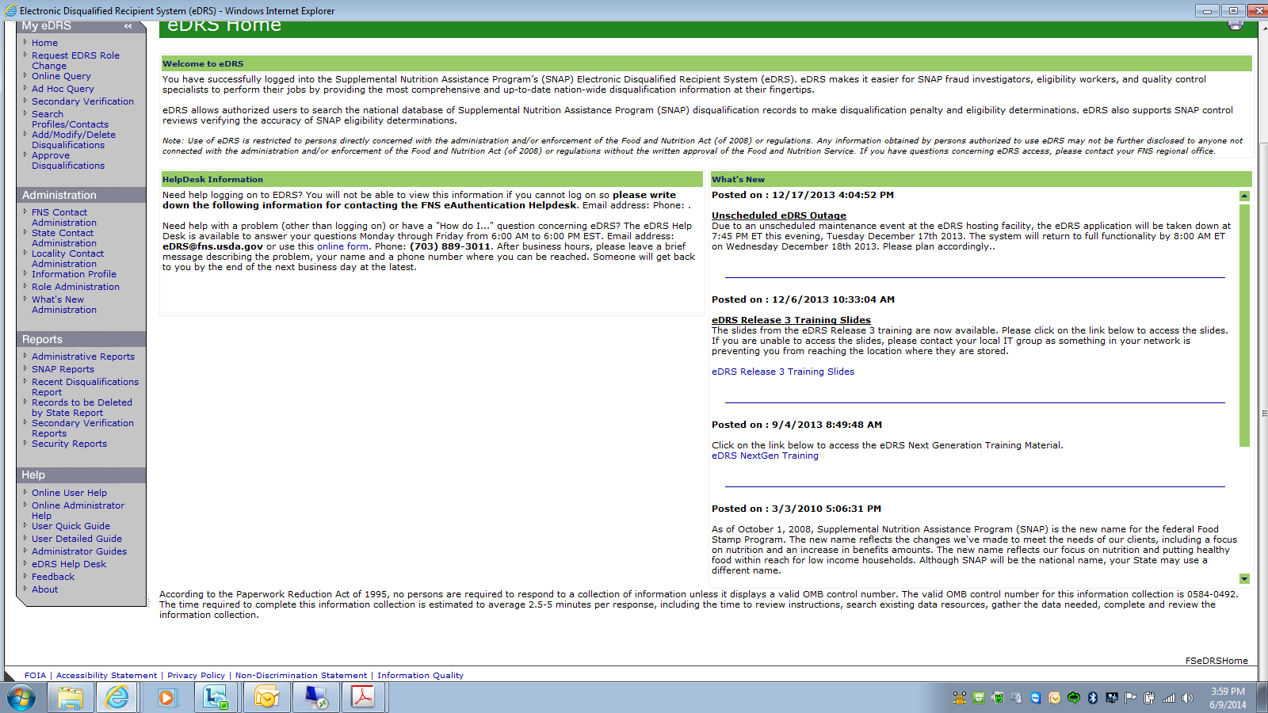

My eDRS – Request eDRS Role Change (this just creates a pop up of the 674 form – whatever other page you were on before clicking this link in the menu, will be displayed behind it)

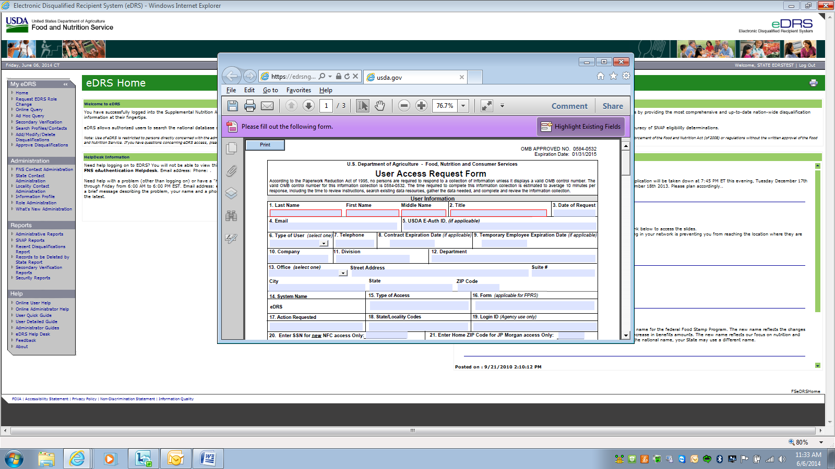

My eDRS – Online Query

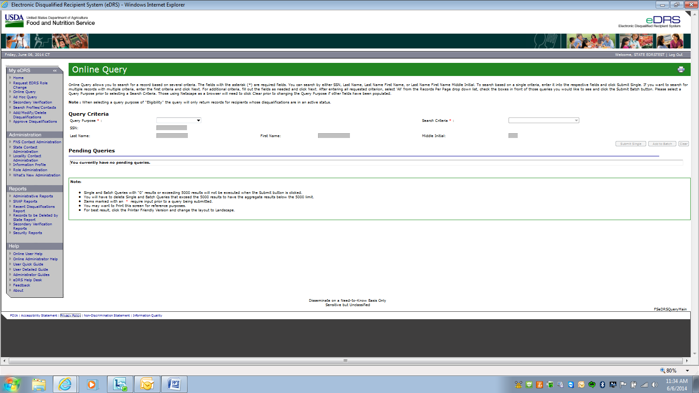

My eDRS – Ad Hoc Query

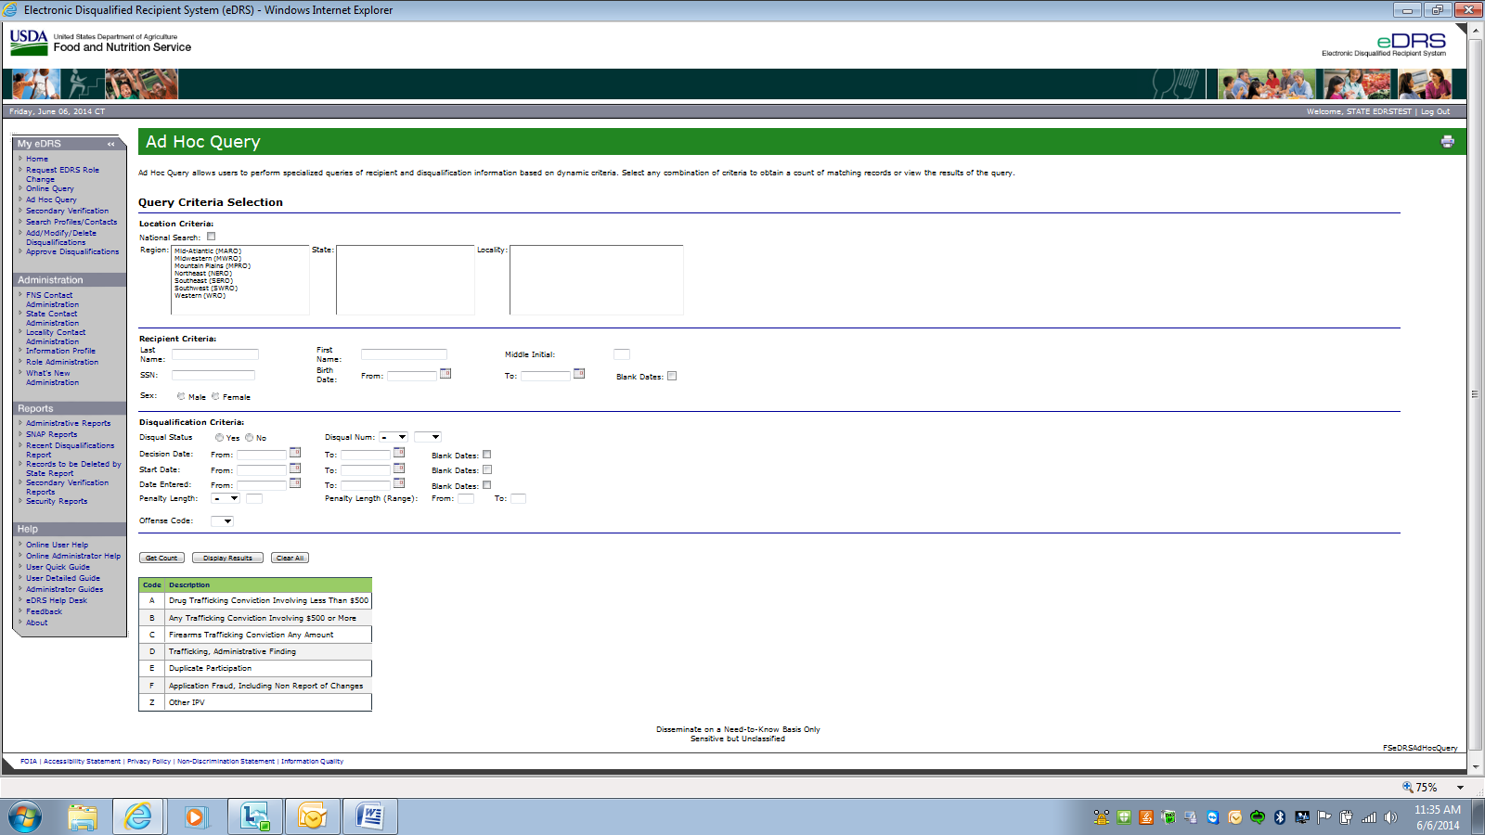

My eDRS – Secondary Verification

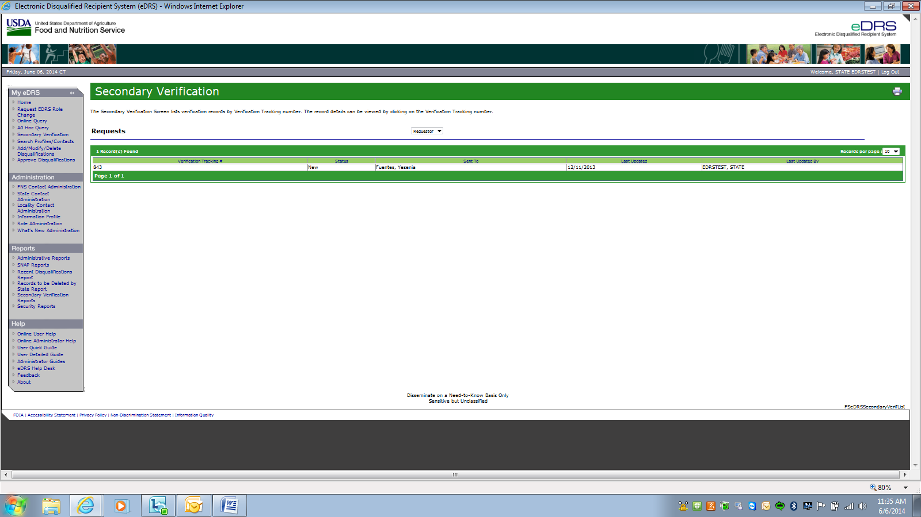

My eDRS – Search Profiles/ Contacts

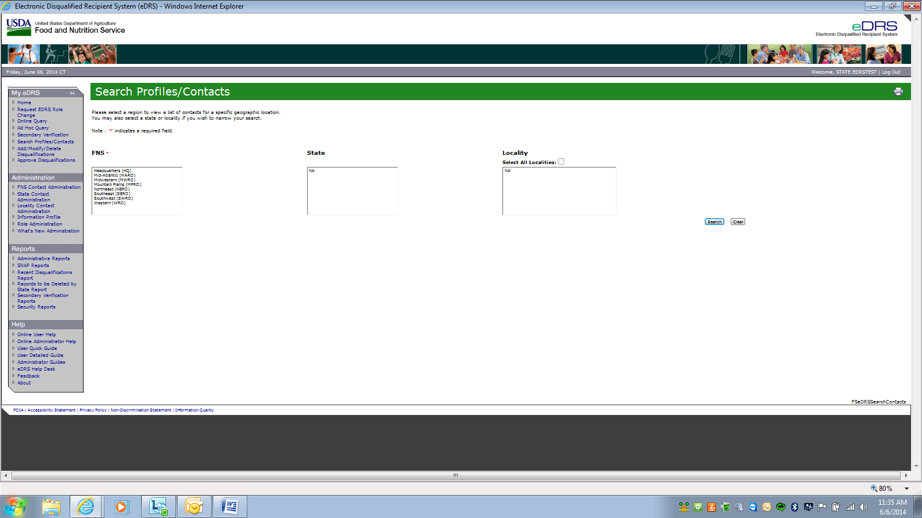

My eDRS – Add/ Modify/ Delete Disqualifications

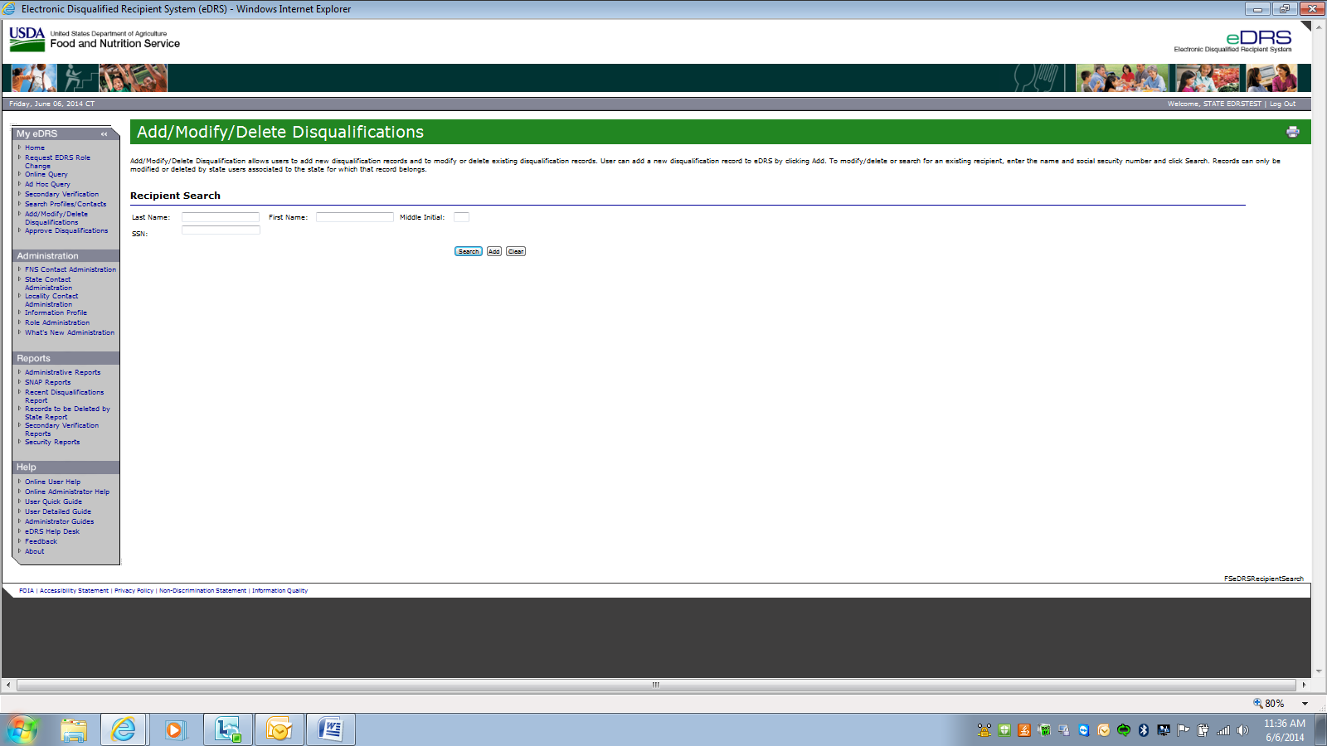

My eDRS – Approve Disqualifications

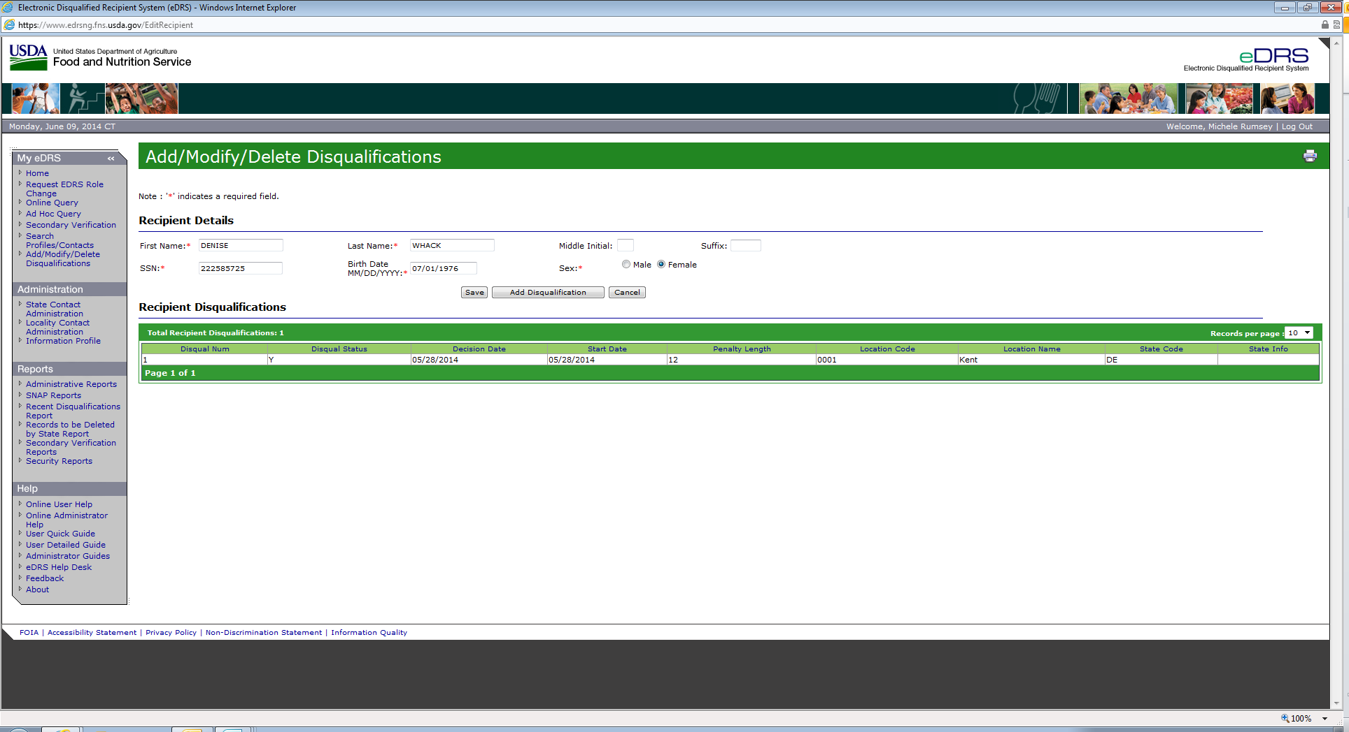

Administration – FNS Contact Administration

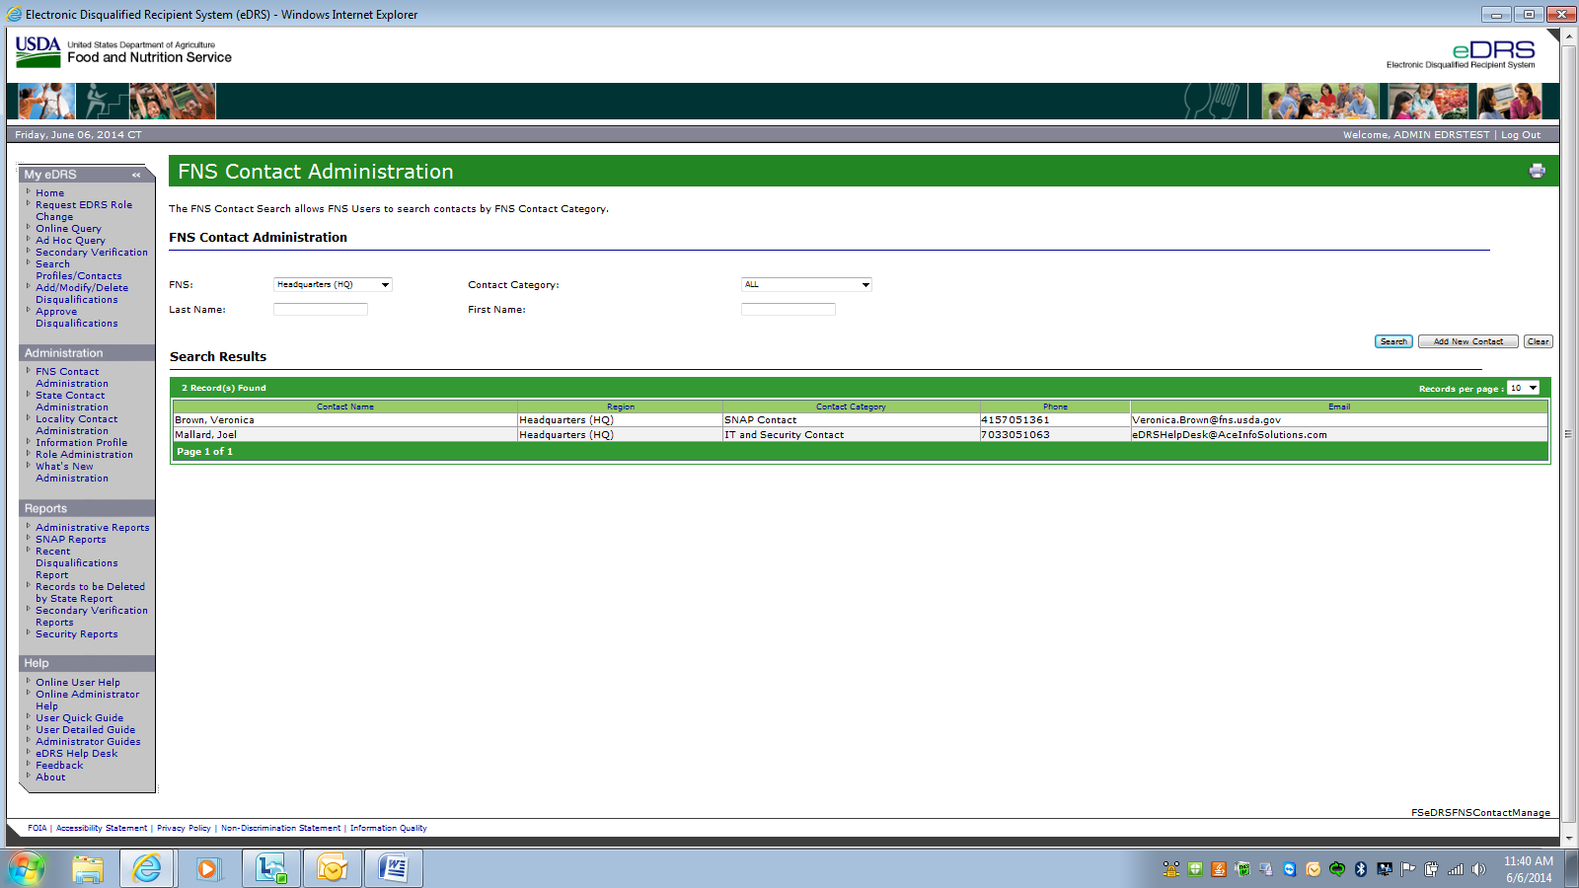

Administration – State Contact Administration

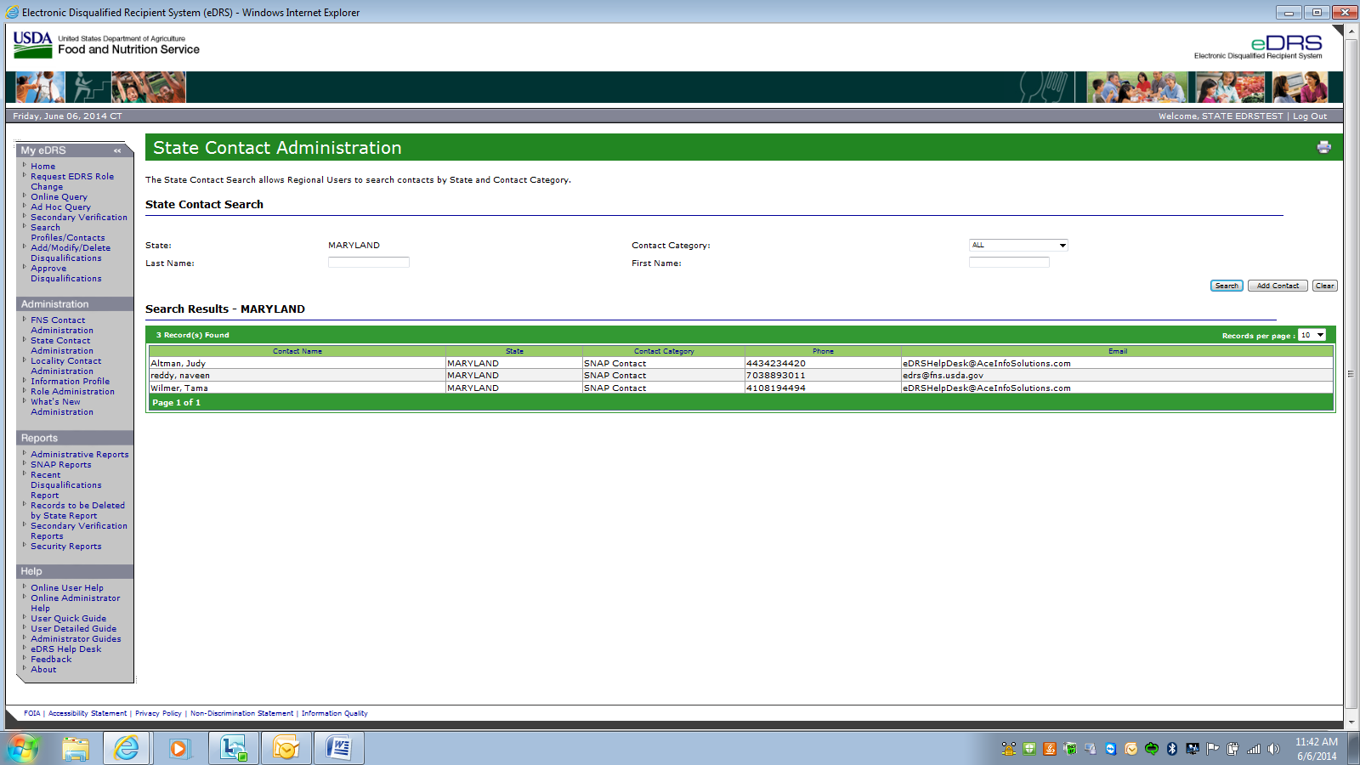

Administration – Locality Contact Administration

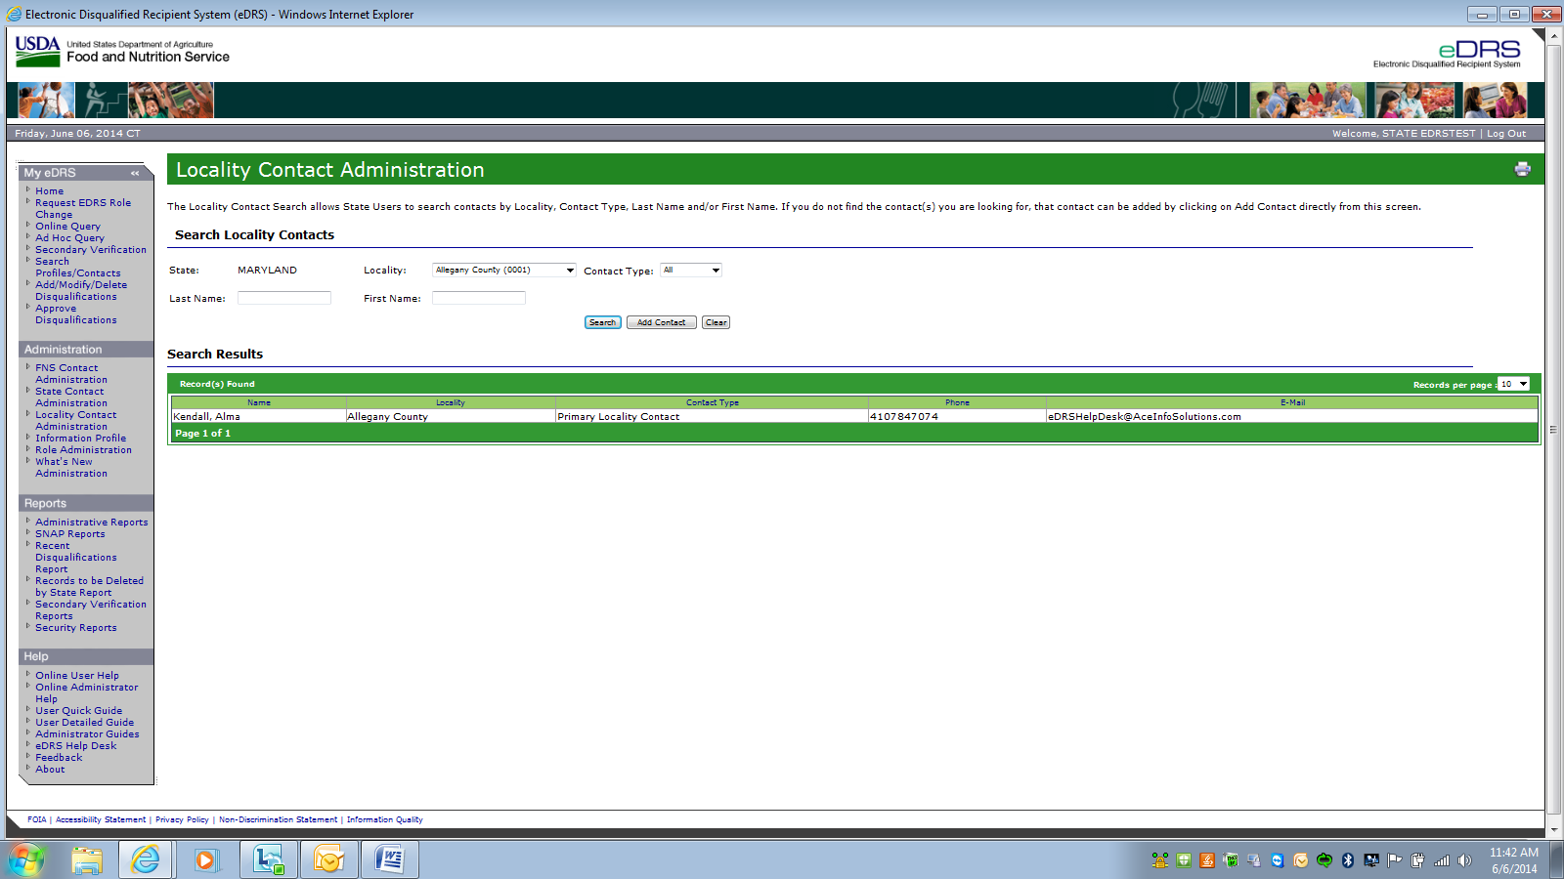

Administration – Information Profile

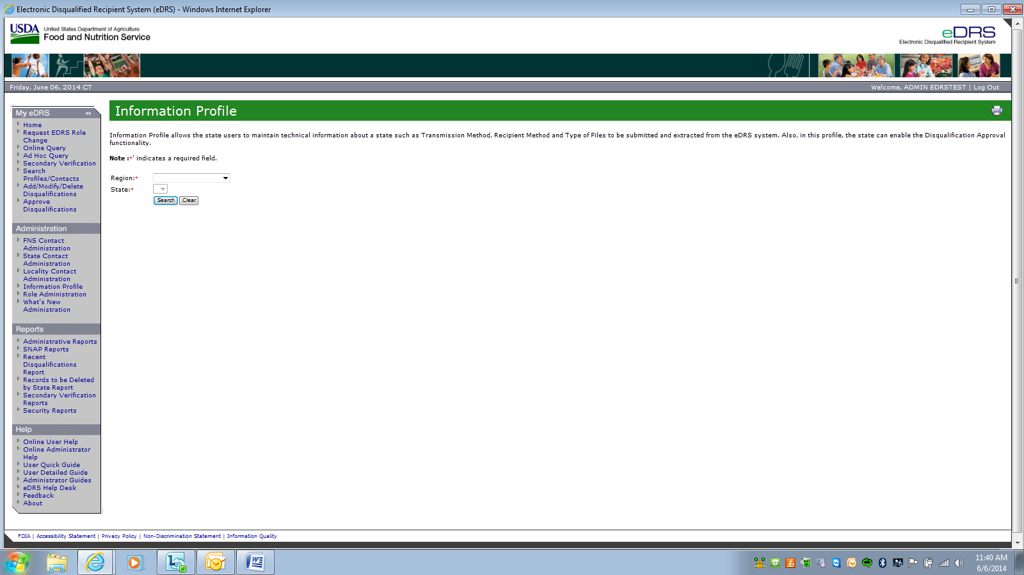

Administration – Information Profile (as state user)

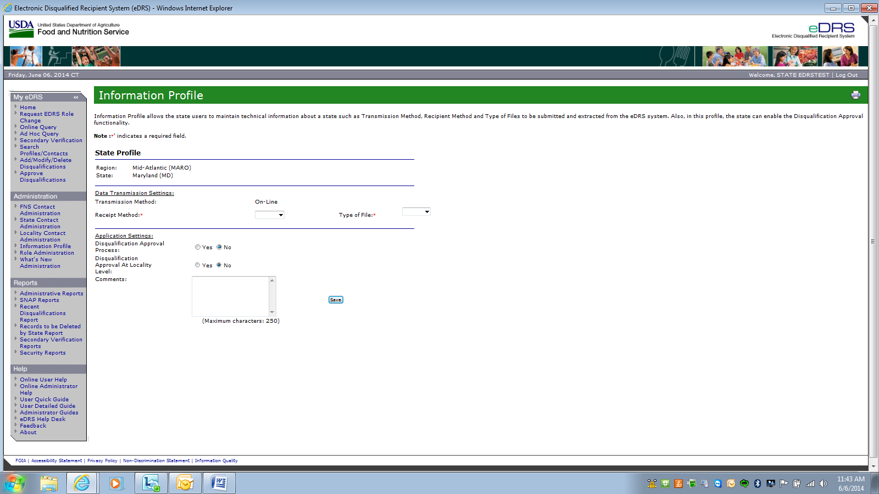

Administration – Role Administration

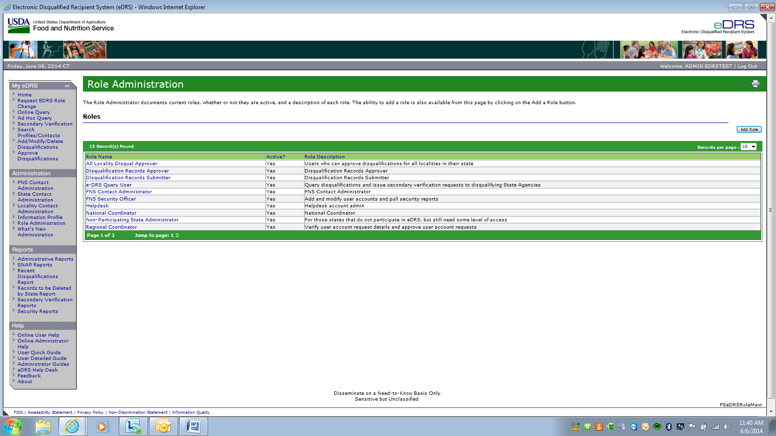

Administration – What’s New Administration 🡪 Cannot retrieve, this page is in the process of being converted to the new eDRS Contractor.

Reports Box - Administrative Reports

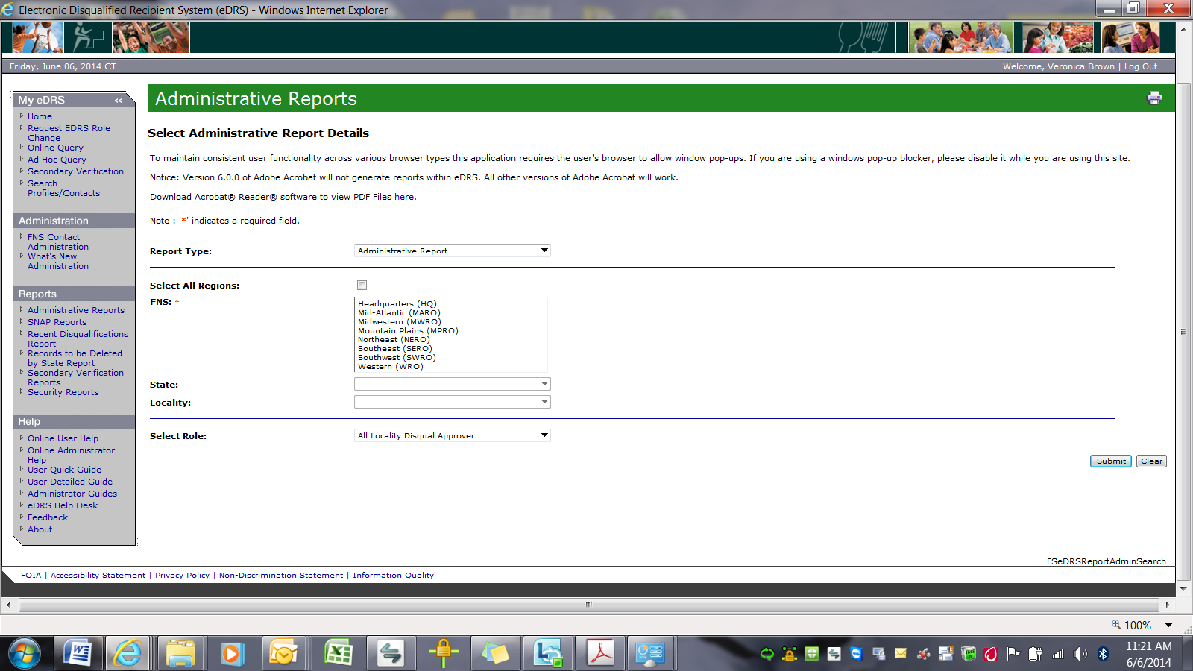

Reports Box - SNAP Report Details can be selected here:

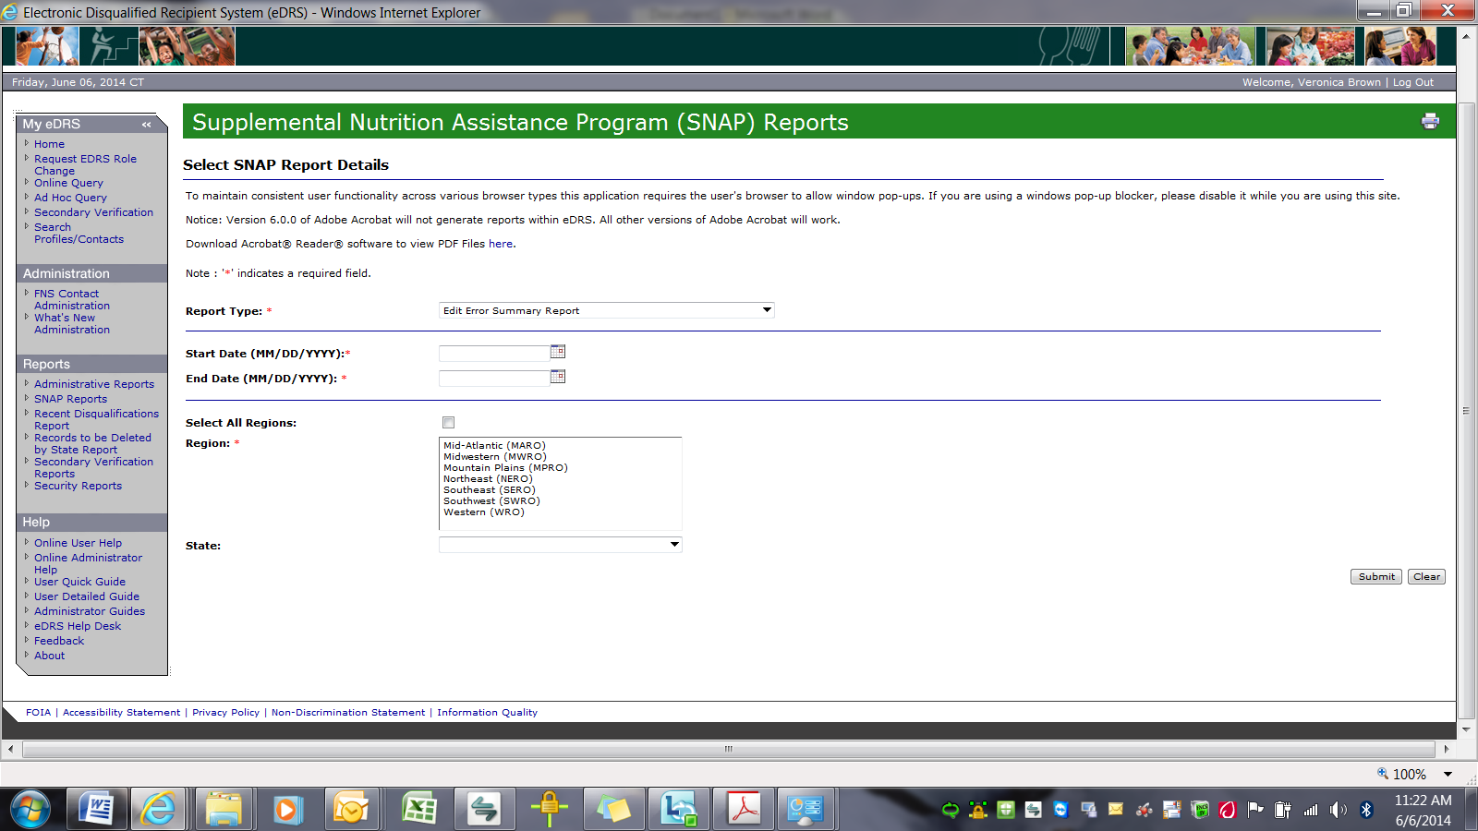

Reports Box - The Recent Disqualification report allows you to determine all DQs for a specific time period within a State: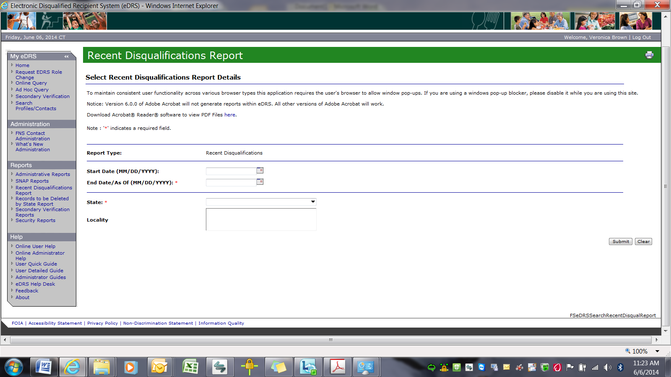

Reports Box - Records to be deleted by States: Notes all records that a State must delete due to regulation requirements: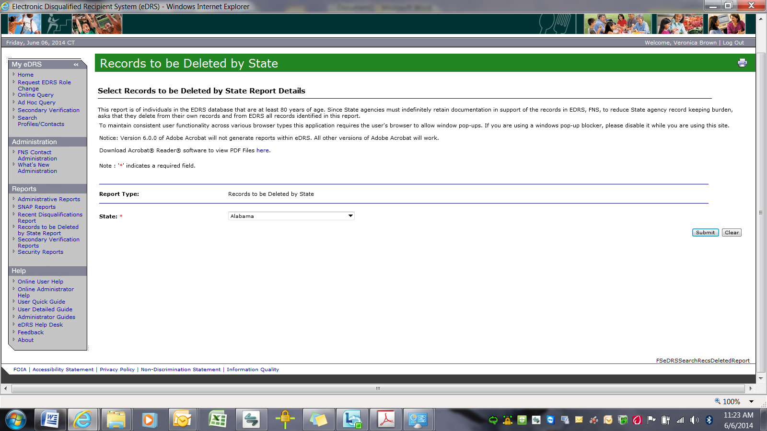

Reports Box - Advises States of who to contact in order to verify the accuracy of a record prior to taking any action against a client: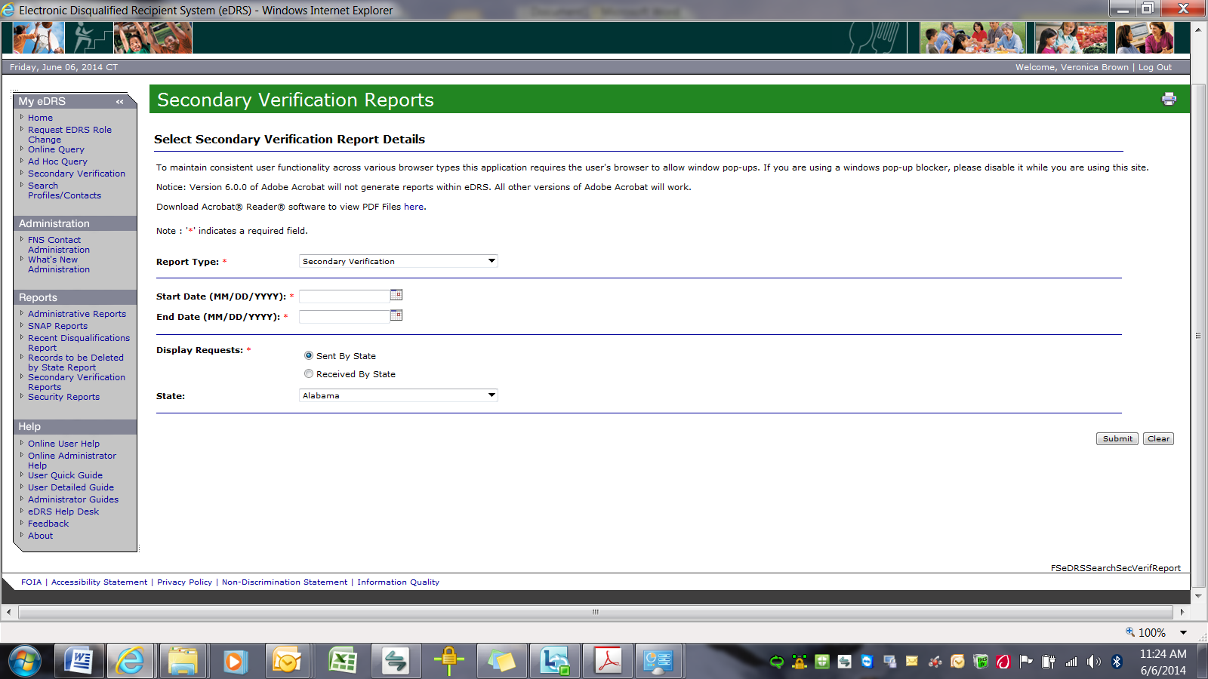

Reports Box - Security Reports allow the Administrators to track system user activities for deactiviation, session duration, user account, user inactivity, and user search:

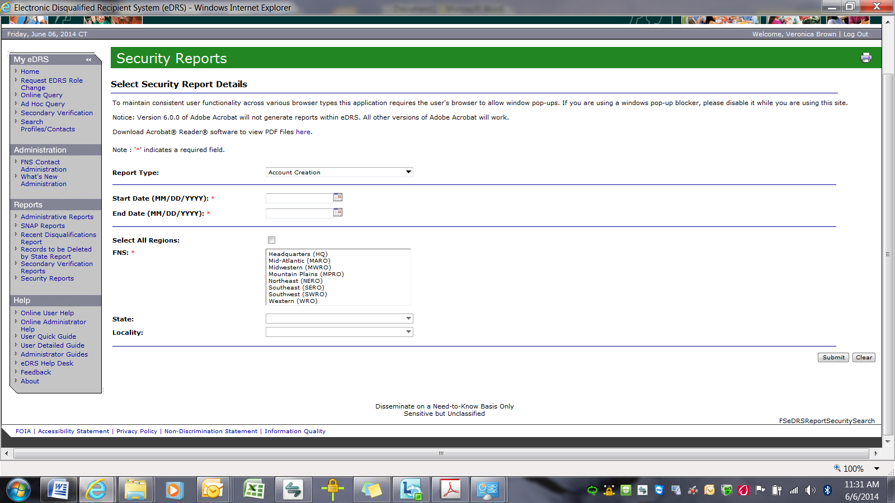

HELP Box - Online User Help and Online Administrator Help are pop-up windows that appear over the Home page…they are the same as the User and Administrator PDF guides provided as an attachment to the screenshots:

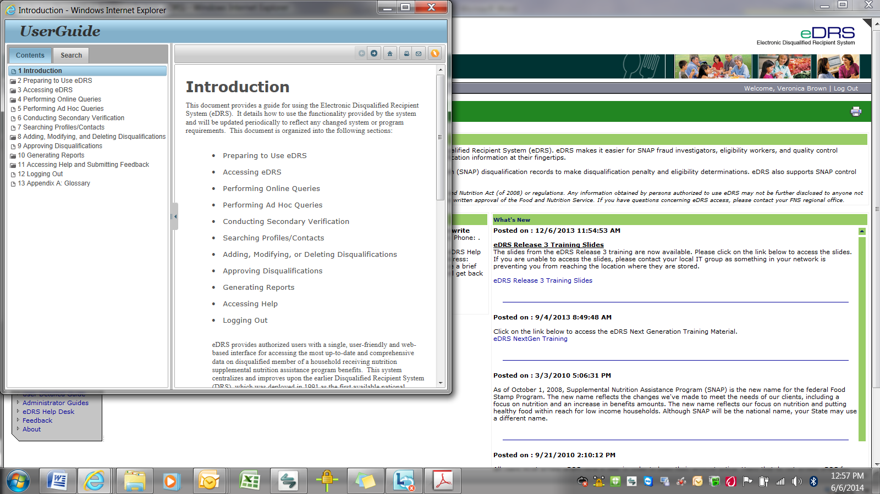

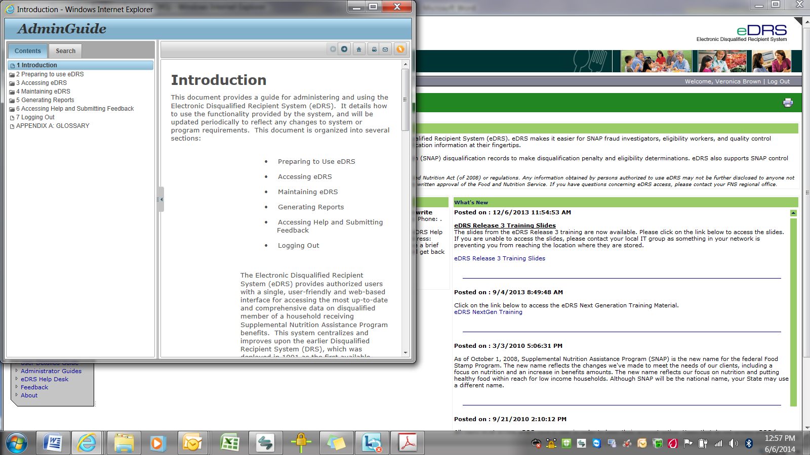

HELP Box - User Quick Guide is a pop-up window the entire guide is provided as an attachment:

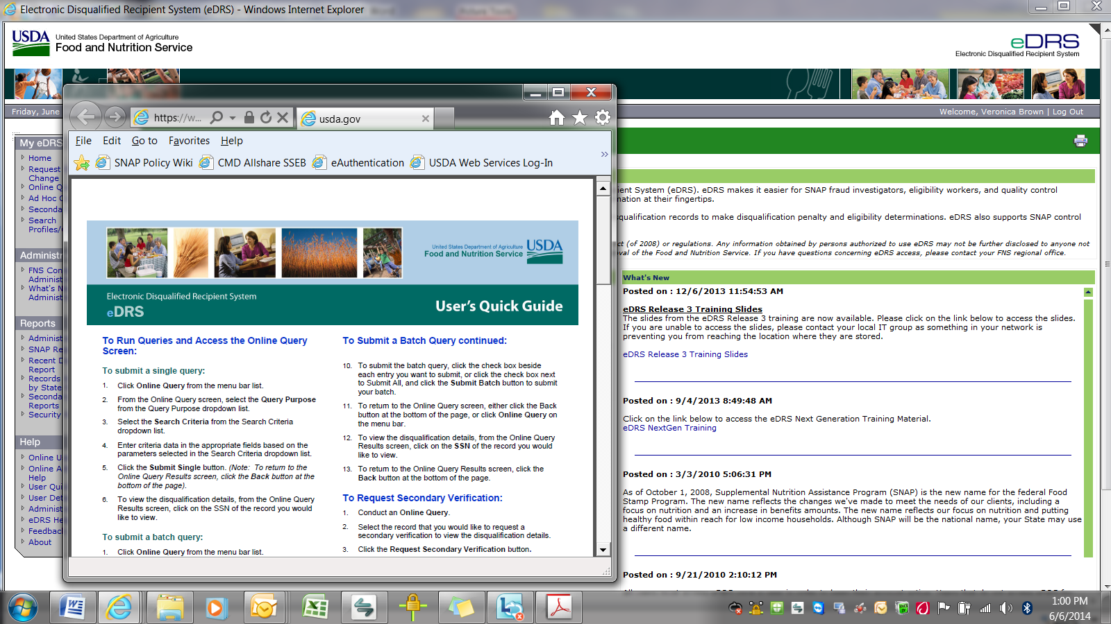

HELP Box - User Detailed Guide is a 95 page pop-up window…the entire guide is downloadable and is being provided as an attachment:

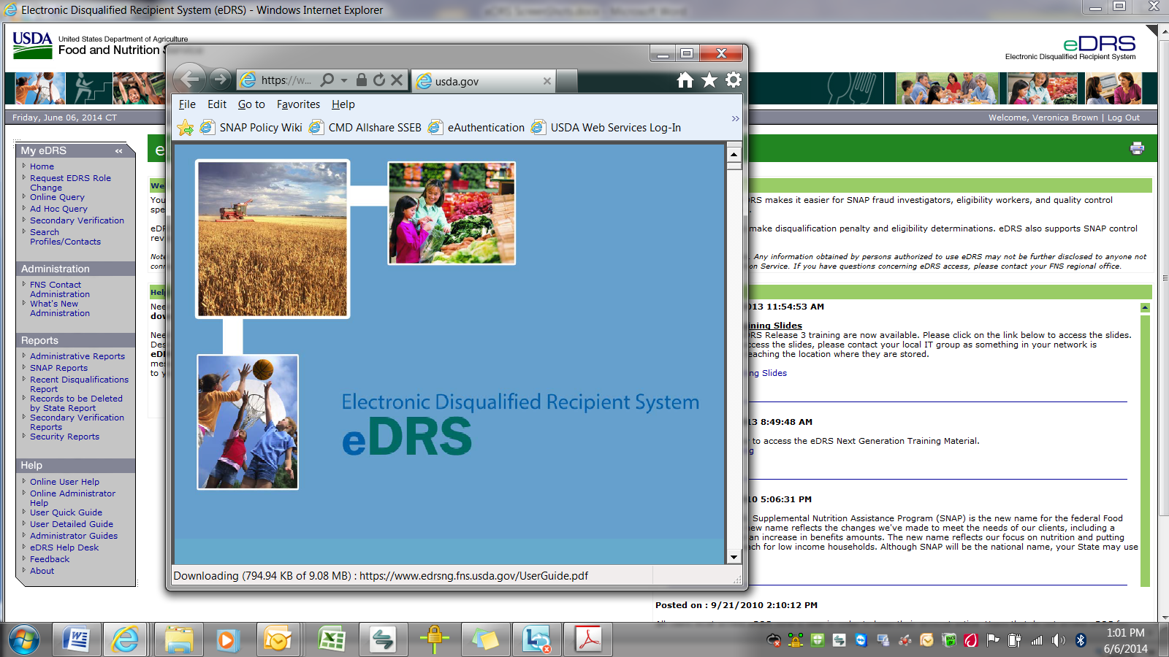

HELP Box - The Administrator’s Guides are a pop-up window over the home page…the pop-up window has two hyperlinks: Administrator’s Quick Guide and Administrator’s Guide. These links are downloadable into PDF and are provided as a separate attachment:

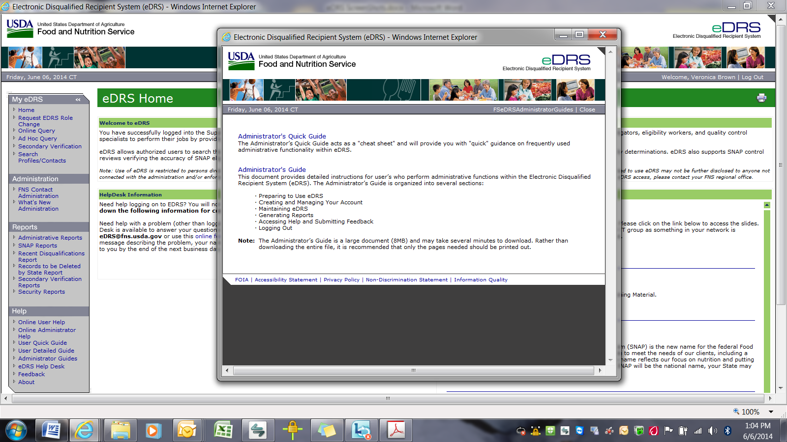

HELP Box - The eDRS HelpDesk allows Users to contact the HelpDesk with a question:

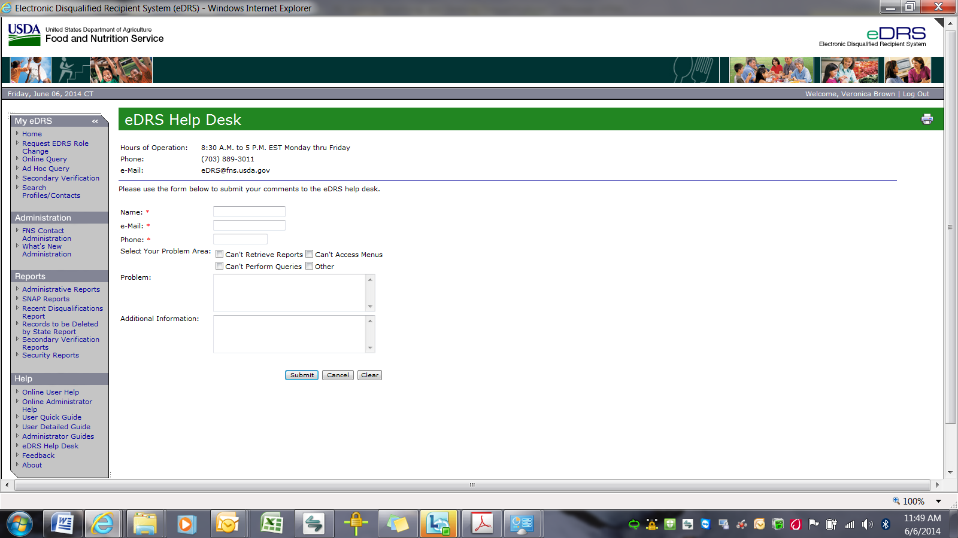

HELP Box - The eDRS Feedback site allows Users to give feedback:

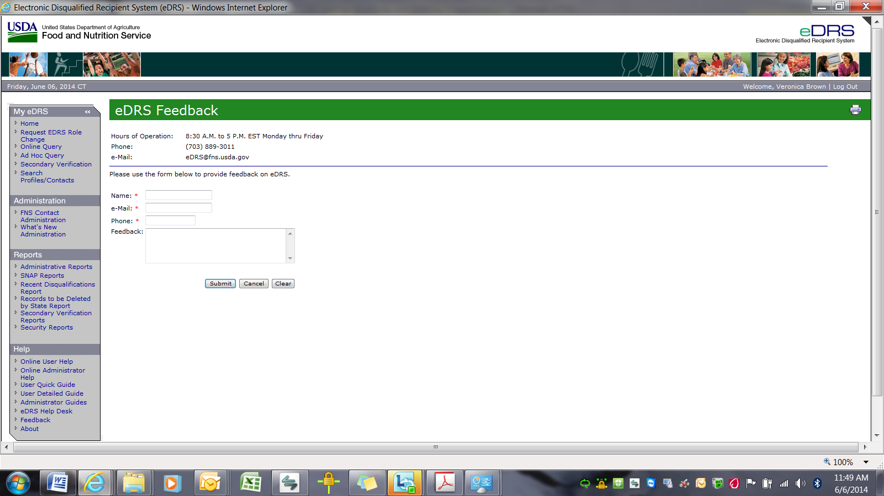

HELP Box - About is a pop-up window on the Home Page: