*This video is designed to be narration only, with graphics and Camtasia capturing of the on-screen examples.

** Please note: the eResponse template has been determined, but the download/upload screens are still under development. Therefore the procedures are still being determined. This script is based on the most recent version.

 | Image:  Census Bureau exterior  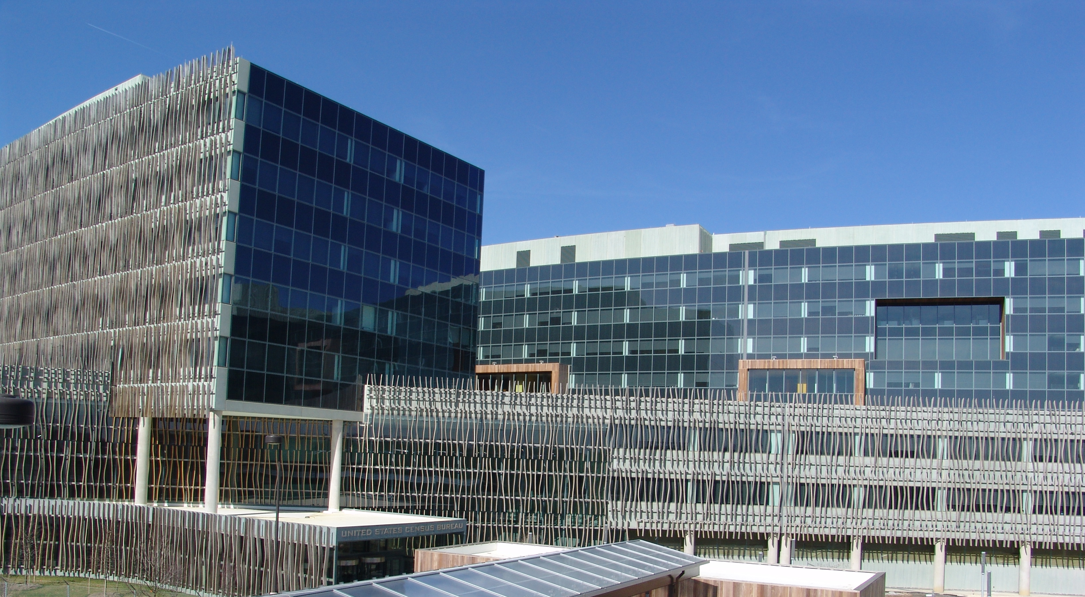 | Narrator:  THANK YOU FOR YOUR PARTICIPATION IN THE 2018 CENSUS TEST. THIS VIDEO WILL WALK YOU THROUGH THE PROCESS OF SENDING ELECTRONIC RESPONSE DATA FOR GROUP QUARTERS TO THE U.S. CENSUS BUREAU. THIS IS CALLED E-RESPONSE, AND IT IS A KEY PART TO MAKING SURE THAT THE INDIVIDUALS WHO LIVE AT YOUR FACILITY ARE COUNTED EFFICIENTLY AND CORRECTLY.  ESTABLISHING AN ACCURATE COUNT IS CRITICAL FOR DETERMINING HOW MANY REPRESENTATIVES A STATE SHOULD HAVE IN CONGRESS. POPULATION COUNTS ARE ALSO FACTORED INTO THE DISTRIBUTION OF HUNDREDS OF BILLIONS OF DOLLARS FROM MORE THAN ONE HUNDRED FEDERAL PROGRAMS.  FIRST, LET’S DISCUSS WHAT WE MEAN BY GROUP QUARTERS.  A GROUP QUARTERS, OR GQ, IS A PLACE WHERE PEOPLE LIVE OR STAY, IN A GROUP LIVING ARRANGEMENT, THAT IS OWNED OR MANAGED BY AN ENTITY OR ORGANIZATION PROVIDING HOUSING AND/OR SERVICES FOR THE RESIDENTS. THIS IS NOT A TYPICAL HOUSEHOLD-TYPE LIVING ARRANGEMENT. THESE SERVICES MAY INCLUDE CUSTODIAL OR MEDICAL  CARE AS WELL AS OTHER TYPES OF ASSISTANCE, AND RESIDENCY IS COMMONLY RESTRICTED TO THOSE RECEIVING THESE SERVICES. PEOPLE LIVING IN GROUP QUARTERS ARE USUALLY NOT RELATED TO EACH OTHER. GROUP QUARTERS INCLUDE PLACES SUCH AS COLLEGE RESIDENCE HALLS, RESIDENTIAL TREATMENT CENTERS, SKILLED NURSING FACILITIES, GROUP HOMES, MILITARY BARRACKS, AND CORRECTIONAL FACILITIES.
 | Image:  Graphic of login screens  Graphic of the template tabs | Narrator:  FIRST, WE WILL TELL YOU HOW TO ACCESS THE CENSUS E-RESPONSE SYSTEM. WE WILL WALK YOU THROUGH THE LOGIN PROCESS AND DOWNLOADING YOUR CENSUS E-RESPONSE TEMPLATE FILE.  THEN WE WILL GO OVER THE CENSUS TEMPLATE AND EXPLAIN HOW TO FILL IN THE DATA. FINALLY, WE WILL EXPLAIN HOW TO SEND THE DATA TO THE CENSUS BUREAU.
 | Image:  Graphic of eResponse letter  Graphic of Login screen  Graphic of Main Menu  Camtasia action of selecting a GQ. Screen changes to Validation screen.  Camtasia of entering in expected population count  Camtasia of download process | Narrator:  THE FIRST STEP TO COMPLETING THE E-RESPONSE PROCESS IS TO ACCESS THE CENSUS E-RESPONSE SYSTEM. YOU WILL NEED TO THE LETTER THAT WE SENT TO YOU CONTAINING YOUR LOGIN DETAILS.  USING YOUR INTERNET BROWSER, GO TO [website] AND ENTER YOUR USERNAME AND PASSWORD.  ONCE YOU HAVE LOGGED ONTO THE SYSTEM, YOU WILL SEE YOUR CONTACT INFORMATION AND THE GROUP QUARTERS YOU ADMINISTER. IF YOU ADMINISTER MORE THAN ONE GROUP QUARTERS, YOU WILL SEE ALL OF THEM LISTED ON THIS SCREEN.  SELECT A GQ BY CLICKING “START” TO THE LEFT OF THE GQ NAME.  ON THE NEXT SCREEN, YOU WILL SEE THE NAME OF THE GQ YOU SELECTED, ITS TYPE CODE AND DESCRIPTION, THE EXPECTED POPULATION ON CENSUS DAY, WHICH IS APRIL FIRST, AND YOUR CONTACT INFORMATION.  PLEASE TAKE A MOMENT ENTER THE EXPECTED POPULATION OF THIS GROUP QUARTERS AS OF CENSUS DAY, APRIL FIRST. THIS IS VERY IMPORTANT, AS IT PROVIDES THE CENSUS BUREAU A BASIS FOR THE RESPONSE DATA YOU WILL PROVIDE IN A FEW MOMENTS.  ALSO TAKE THIS TIME TO VERIFY YOUR NAME, PHONE NUMBER, AND EMAIL ADDRESS.  WHEN YOU HAVE UPDATED THE EXPECTED POPULATION AND VERIFIED YOUR INFORMATION, CLICK “SAVE AND CONTINUE” TO DOWNLOAD THE CENSUS E-RESPONSE TEMPLATE FILE.
 | Image:  Graphic of Census eResponse Template  Graphic of Individual Census Questionnaire | Narrator:  WHAT IS THE CENSUS E-RESPONSE TEMPLATE?  THE CENSUS E-RESPONSE TEMPLATE IS DESIGNED TO COLLECT THE SAME DATA THAT IS ON THE INDIVIDUAL CENSUS QUESTIONNAIRE, WHICH IS THE FORM USED TO COUNT PEOPLE LIVING OR STAYING IN GROUP QUARTERS AND GATHER THEIR DEMOGRAPHIC DATA.
 | Image:  Graphic of first tab of template | Narrator:  THE FIRST TAB SHOWS YOU THE INFORMATION THAT THE CENSUS BUREAU NEEDS.
 | Image:  Graphic of left side of first tab.  Graphic of Race and Ethnicity Question  Graphic of entire tab once again | Narrator:  ON THE LEFT, YOU SEE THE DATA FIELDS THAT THE CENSUS COLLECTS DATA FOR. THESE ARE THE SAME AS THE INDIVIDUAL CENSUS QUESTIONNAIRE.  ON THE RIGHT, YOU SEE THE RACE AND ETHNICITY TABLE. WE WILL COVER THIS IN MORE DETAIL IN A FEW MINUTES.  REMEMBER, THE CENSUS BUREAU DOES NOT ASK FOR ANY HEALTH-RELATED INFORMATION AND IS IN COMPLIANCE WITH REGULATIONS ISSUED UNDER THE HEALTH INSURANCE PORTABILITY AND ACCOUNTABILITY ACT OF THE 1996 PRIVACY RULE. THE ONLY INFORMATION THAT THE CENSUS BUREAU COLLECTS FOR EACH RESIDENT IS NAME, SEX, AGE, DATE OF BIRTH, RACE, ETHNICITY, AND AN ALTERNATE ADDRESS WHERE THEY LIVE OR STAY WHEN NOT AT YOUR FACILITY.  THIS FIRST TAB IS YOUR REFERENCE POINT FOR COMPLETING THE CENSUS E-RESPONSE TEMPLATE. PLEASE REFER BACK TO IT OR COME BACK TO THIS VIDEO IF YOU HAVE ANY QUESTIONS.
 | Image:  Graphic of tab 2, GQ Client Data | Narrator:  NOW WE WILL MOVE TO THE CLIENT DATA TAB OF THE CENSUS TEMPLATE. THIS TAB IS USED TO COLLECT THE RESPONSES TO THE INDIVIDUAL CENSUS QUESTIONNAIRE FOR EACH OF THE PEOPLE WHO WERE LIVING OR STAYING AT YOUR GROUP QUARTERS ON CENSUS DAY, APRIL FIRST.  PLEASE BE SURE THAT YOU ENTER A SEPARATE ROW OF DATA IN THIS TAB FOR EACH PERSON WHO LIVES OR STAYS AT THIS GQ.  LET’S TAKE A CLOSER LOOK AT THE INFORMATION REQUESTED ON THIS TAB.
 | Image:  Graphic showing identical GQ Names from both tabs next to one another. | Narrator:  THE FIRST COLUMN IS FOR THE GQ NAME. PLEASE BE SURE THAT IT MATCHES THE GROUP QUARTERS THAT YOU ARE PROVIDING DATA FOR.  PLEASE REMEMBER EACH GROUP QUARTERS YOU ADMINISTER WILL HAVE ITS OWN FILE, SO ONLY INCLUDE EVERYONE WHO LIVES OR STAYS AT THIS GROUP QUARTERS.
 | Animation:  Cells on worksheet onscreen fill with names. | Narrator:  THE FOLLOWING THREE COLUMNS ARE FOR EACH PERSON’S FIRST NAME, MIDDLE NAME OR INITIAL, AND LAST NAME. ANY SUFFIXES, SUCH AS JUNIOR OR A NUMBER, SHOULD BE INCLUDED IN THE LAST NAME FIELD.
 | Animation:  Cell on worksheet onscreen fills with Male or Female | Narrator:  THE NEXT COLUMN IS FOR THE PERSON’S SEX, MALE OR FEMALE. ENTER MALE OR FEMALE FOR EACH PERSON LIVING OR STAYING AT YOUR GQ IN THIS COLUMN.
 | Animation:  Cell on worksheet onscreen fills with date of birth that matches age and is in format of MM/DD/YYYY. | Narrator:  THE FOLLOWING COLUMN IS FOR DATE OF BIRTH.  PLEASE NOTE THAT THE FORMAT REQUIRES A TWO-DIGIT MONTH, FOLLOWED BY A SLASH, A TWO-DIGIT DAY, FOLLOWED BY ANOTHER SLASH, AND FINALLY THE FOUR-DIGIT YEAR. PLEASE FILL OUT THE DATE OF BIRTH COMPLETELY, WITH THE MONTH, DAY AND YEAR.
 | Animation:  Cell on worksheet onscreen fills with an age | Narrator:  THE COLUMN FOR AGE ON CENSUS DAY REFERS TO THE PERSON’S AGE ON APRIL FIRST. PLEASE ENTER THIS NUMBER INTO THE FIELD.
 | Image:  Graphic of close up of Race Category and Detail columns | Narrator:  THE NEXT TWO COLUMNS ARE FOR RACE AND ETHNICITY.
 | Image:  Race and Ethnicity graphic from tab 1. | Narrator:  THE OPTIONS FOR THESE FIELDS CAN BE FOUND ON THE FIRST TAB OF THIS TEMPLATE IN THE RACE AND ETHNICITY TABLE.  THE OPTIONS FOR RACE OR ETHNICITY CATEGORY ARE ON THE LEFT IN BOLD TYPE, AND OPTIONS FOR RACE OR ETHNICITY DETAILS ARE LISTED TO THE RIGHT.
 | Animation:  Cells on worksheet onscreen fill with race and ethnicity | Narrator:  IN THESE FIELDS, PLEASE ENTER ALL RACES AND ETHNICITIES THAT APPLY TO EACH INDIVIDUAL LIVING OR STAYING IN YOUR GROUP QUARTERS. PLEASE ENTER AS MUCH INFORMATION AS YOU HAVE ON EACH CLIENT.
 | Animation:  Cell on worksheet onscreen fills with Yes or No | Narrator:  IN THE NEXT COLUMN, YOU WILL ANSWER WHETHER THIS PERSON LIVES OR STAYS AT THE GROUP QUARTERS MOST OF THE TIME. PLEASE ENTER YES OR NO.
 | Animation:  Cells on worksheet onscreen fill with address information | Narrator:  THE REMAINING FIELDS ARE FOR AN ALTERNATE ADDRESS WHERE THE PERSON MAY LIVE OR STAY WHEN NOT AT THE GROUP QUARTERS.  PLEASE ENTER THE STREET NUMBER SEPARATE FROM THE STREET NAME. ALSO INCLUDE A UNIT NUMBER, IF IT APPLIES.  THERE IS A COLUMN FOR A RURAL ROUTE ADDRESS, IF IT APPLIES.
 | Animation:  Cells on worksheet onscreen fill with address information | Narrator:  FINALLY, PLEASE COMPLETE THE CITY, STATE, AND ZIP CODE FIELDS, USING FIVE DIGITS FOR THE ZIP CODE.
 | Image:  Graphic of tab 2 | Narrator:  PLEASE REPEAT THIS PROCESS FOR EACH PERSON WHO LIVES OR STAYS AT THE GROUP QUARTERS ON CENSUS DAY.  IN ADDITION TO THE DEMOGRAPHIC DATA, PLEASE BE SURE TO COMPLETE THE ALTERNATE ADDRESS COLUMNS. THIS WILL HELP VERIFY THAT EVERYONE IS COUNTED ONCE AND ONLY ONCE AND IN THE RIGHT PLACE.  MAKE SURE THAT YOU ENTER A LINE FOR EVERYONE THAT LIVES OR STAYS AT YOUR GQ. THE NUMBER OF PEOPLE YOU ENTER MUST MATCH THE POPULATION COUNT YOU ENTERED WHEN YOU DOWNLOADED THE CENSUS TEMPLATE FILE.  TAKE A MOMENT TO CHECK YOUR NUMBERS.
 | Animation:  Mouse moves on screen to save button, file is saved on computer | Narrator:  WHEN YOU HAVE COMPLETED YOUR CENSUS TEMPLATE, BE SURE TO SAVE THE FILE.
 | Animation:  Census eResponse website, with login credentials entered. Mouse clicks “Browse” and Census eResponse template file is selected, then uploaded. | Narrator:  TO SEND YOUR CENSUS TEMPLATE FILE TO THE CENSUS BUREAU, RETURN TO [the website], ENTER YOUR LOGIN INFORMATION, AND FOLLOW THE ON-SCREEN INSTRUCTIONS TO UPLOAD YOUR FILE.
 | Image:  Graphic of web page with alert message notification of mistake. | Narrator:  THE SYSTEM WILL AUTOMATICALLY CHECK YOUR CENSUS TEMPLATE FILE FOR VALID DATA AND ALERT YOU IF ANY CORRECTIONS NEED TO BE MADE.
 | Image:  Graphic of web page with confirmation of successful upload. Then graphic of email inbox with notification email. | Narrator:  ONCE YOU HAVE SUCCESSFULLY SENT YOUR E-RESPONSE DATA, YOU WILL RECEIVE NOTIFICATION VIA EMAIL.
 | Image:  Census HQ, or Census 2018 logo   | Narrator:  IF YOU HAVE ANY QUESTIONS OR CONCERNS, PLEASE CALL THE NUMBER YOU RECEIVED WITH YOUR LOGIN INFORMATION.  AGAIN, WE THANK YOU FOR YOUR PARTICIPATION IN THE 2018 CENSUS TEST AND APPRECIATE YOUR TIME AND EFFORT IN PROVIDING CENSUS DATA.

-X-

