September __, 2011

«POC_1_Name»
«POC_1_Title»
«FIRM»
«STREET»
«CITY», «STATE» «ZIP»

Greetings «POC_1_Name»,

The Bureau of Industry and Security’s (BIS) Office of Technology Evaluation has partnered with the National Aeronautics and Space Administration (NASA), Exploration Systems Mission Directorate, to conduct an industrial base assessment of NASA’s supply chain network. The goal of the survey and assessment is to measure the industrial base impacts resulting from both the retirement of the Space Shuttle Program and NASA’s transition from the Constellation Program.

Your company has been identified by NASA as a U.S.-located supplier for the Space Shuttle and/or the Constellation Programs. To begin, download the Excel formatted survey and corresponding instructions at http://www.bis.doc.gov/NASA_survey. For internal data collection purposes, a PDF version of the survey can also be downloaded at this website. BIS will only accept Excel survey submissions.

If your company has more than one U.S. facility or division supporting NASA-related work and finds it easier to submit individual business unit-level survey responses, please notify BIS. If not, BIS will expect one consolidated Excel survey response from your company.

Information furnished to BIS is business confidential and will not be published or disclosed, other than in aggregate form. Such information is also protected from disclosure from Freedom of Information Act (FOIA) requests. Also note that your company is required by federal law under 50 U.S.C. App Sec 2155 to complete the survey within 30 days of receipt of this letter.

If you have any questions regarding the survey, e-mail NASA_survey@bis.doc.gov or contact BIS staffers: Jason Bolton at 202-482-5936, Michael Finucane at 202-482-3892, Meaghan Archer at 202-482-2081, Valerie Goldman at 202-482-5415, or Erika Maynard at 202-482-5572. Please contact me at 202-482-4060 if you have any questions regarding the overall NASA supply chain assessment.

Thank you for your participation.

Sincerely,

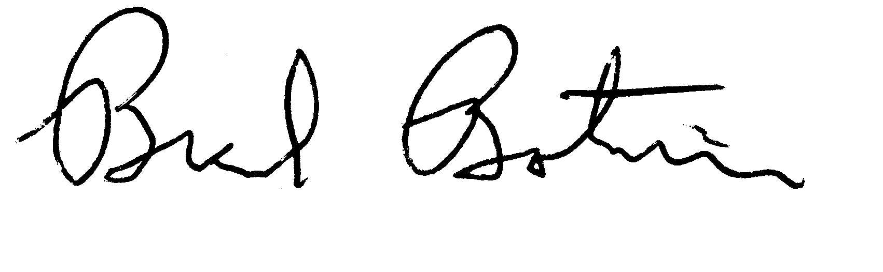
Brad Botwin
Director, Industrial Studies
Office of Technology Evaluation

