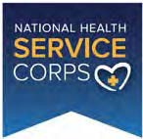
Bureau of Health Workforce
U.S. Department of Health and Human Services Health Resources and Services Administration
OMB No.: 0915-0146
Expiration Date: XX/XX/20XX

National Health Service Corps Scholarship Program
Receipt of Exceptional Financial Need Scholarship

(For School Use Only – Must be completed by a Financial Aid Official)

Name of Student (First, Middle initial, Last) Last 4 Digits of the Applicant’s SSN

The Financial Aid Officer identified below certifies that the above-named student: □ has received
□ has NOT received

a Scholarship for Students of Exceptional Financial Need (EFN) under former section 758 of the Public Health Service Act (applicable to medical and dental students only).

Signature Printed Name Date

Title Phone Email

Name of School

Student may upload signed form to the NHSC SP Online Application: https://programportal.hrsa.gov/

