Attachment E
Screens Retrieving and Refileing Records
State Unintentional Drug Overdose Reporting System (SUDORS)

Form Approved
OMB No. xxx-xxx
Exp. Date: x/xx/xxxx
Public Reporting burden of this collection of information is estimated at 30 minutes per response, including the time for reviewing instructions, searching existing data sources, gathering and maintaining the data needed, and completing and reviewing the collection of information. An agency may not conduct or sponsor, and a person is not required to respond to a collection of information unless it displays a currently valid OMB control number. Send comments regarding this burden estimate or any other aspect of this collection of information, including suggestions for reducing this burden to CDC/ATSDR Reports Clearance Officer, 1600 Clifton Road NW, MS D-74, Atlanta, GA 30333; Attn: PRA (0920-XXXX).

Introduction
This document displays the screens that abstractors use to enter required data elements. The variable name associated with each data entry field is provided to help users interpret and analyze the data.

1.0 Demographic Variables

1.1 Demographics, Race, and Ethnicity
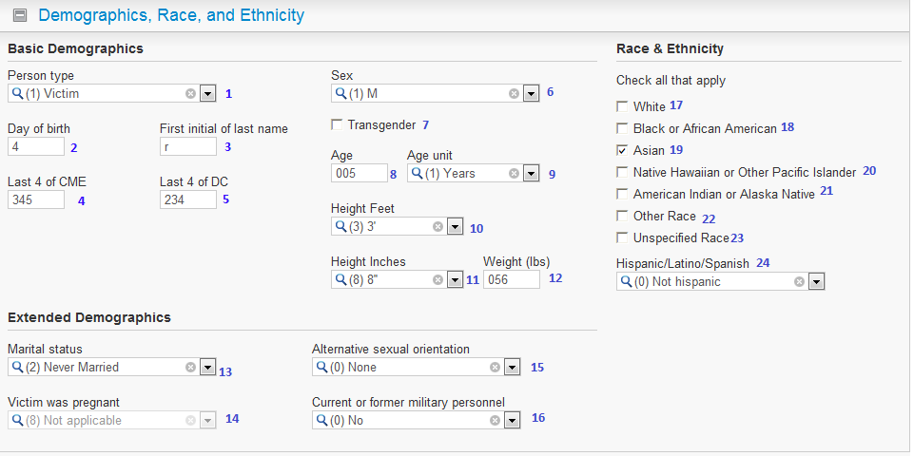
1 | PersonType |  |  | 9 | AgeUnit |  | 17 | RaceWhite
2 | BirthDayofMonth |  |  | 10 | HeightFeet |  | 18 | RaceBlack
3 | LastNameFirstInitial |  |  | 11 | HeightInches |  | 19 | RaceAsian
4 | CMENumberLastFour |  |  | 12 | Weight |  | 20 | RacePacificIslander
5 | DCNumberLastFour |  |  | 13 | MaritalStatus |  | 21 | RaceAmericanIndian
6 | Sex |  |  | 14 | Pregnant |  | 22 | RaceOther
7 | Transgender |  |  | 15 | SexualOrientation |  | 23 | RaceUnspecified
8 | Age |  |  | 16 | Military |  | 24 | Ethnicity

1.2 Place of Residence, Birthplace, Industry, Occupation, and Education
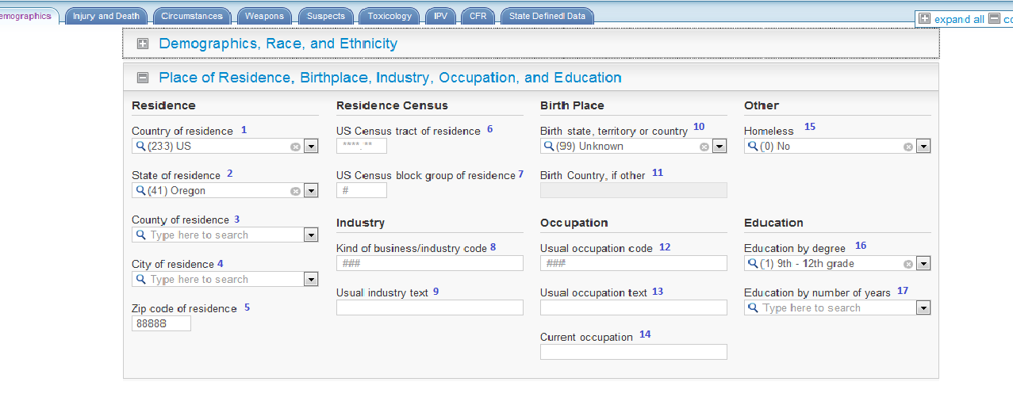
1 | Country |  |  |  |  | 10 | BirthPlace
2 | ResidenceState |  |  |  |  | 11 | BirthCountryOther
3 | ResidenceCounty |  |  |  |  | 12 | UsualOccupation
4 | ResidenceCity |  |  |  |  | 13 | OccupationText
5 | ResidenceZip |  |  |  |  | 14 | OccupationCurrentText
6 | ResidenceCensusTract |  |  |  |  | 15 | Homeless
7 | ResidenceCensusBlock |  |  |  |  | 16 | EducationLevel
8 | Industry |  |  |  |  | 17 | EducationYears
9 | IndustryText

2.0 Injury and Death

2.1 Injury Locations, Time, and Events
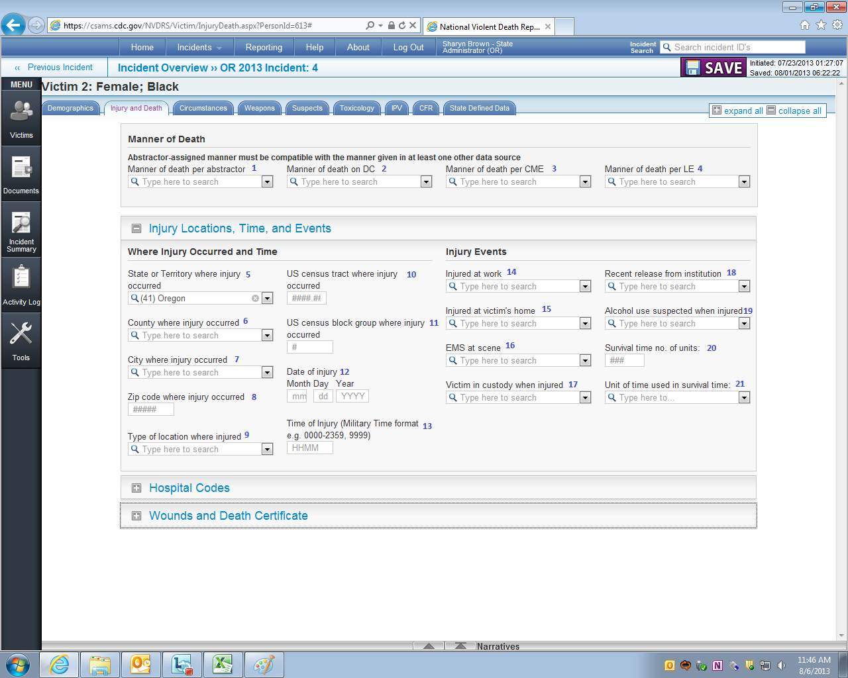
1 | DeathMannerAbstractor |  |  | 9 | InjuryLocationType |  | 17 | VictimInCustody
2 | DeathMannerDC |  |  | 10 | CensusTract |  | 18 | RecentRelease
3 | DeathMannerCME |  |  | 11 | CensusBlock |  | 19 | AlcoholUseSuspected
4 | DeathMannerLE |  |  | 12 | InjuryDate |  | 20 | SurvivalTime
5 | InjuryState |  |  | 13 | InjuryTime |  | 21 | SurvivalTimeUnit
6 | InjuryCounty |  |  | 14 | InjuredAtWork
7 | InjuryCity |  |  | 15 | InjuredAtVictimHome
8 | InjuryZip |  |  | 16 | EMSPresent

2.2 Hospital Codes
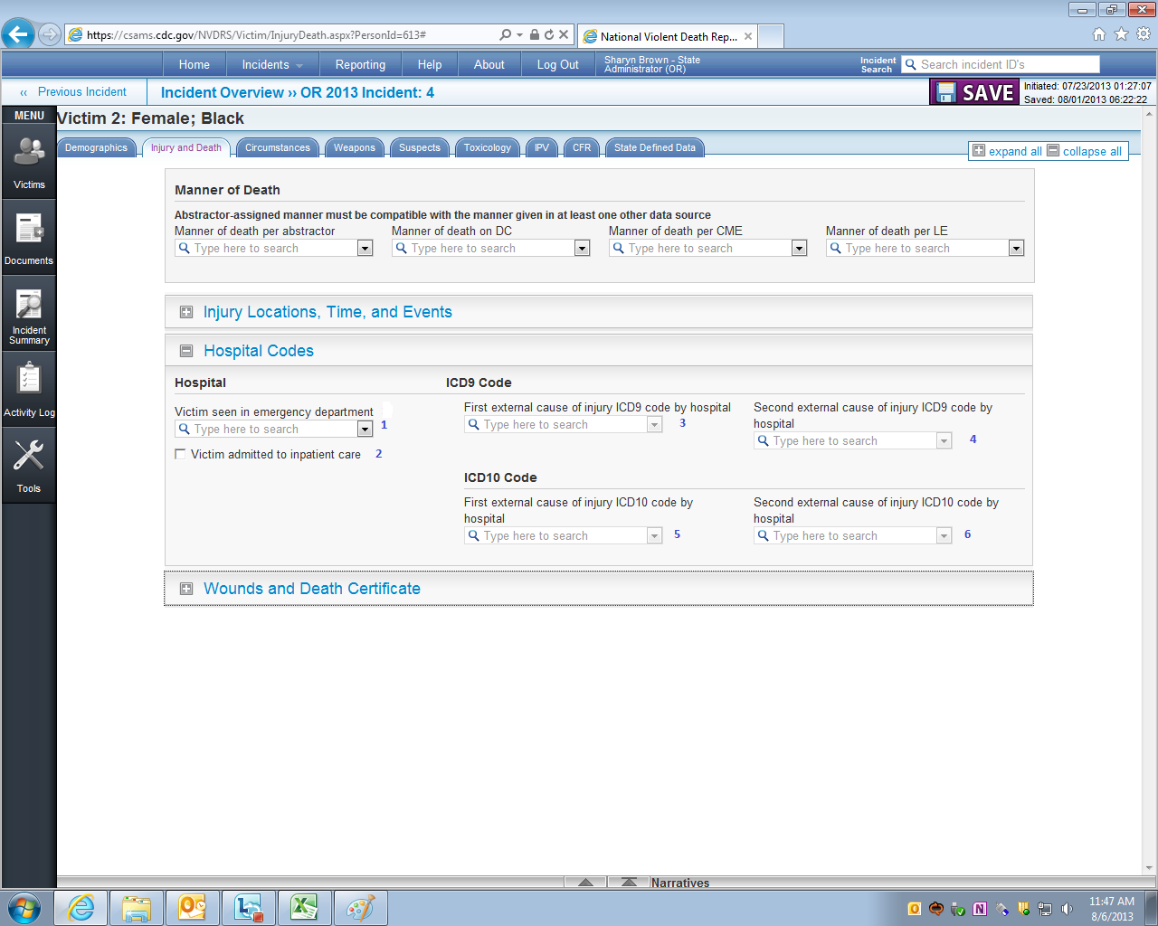
1 | EmergencyDepartment
2 | HospitalAdmit
3 | ExternalCause1ICD9
4 | ExternalCause2ICD9
5 | ExternalCause1ICD10
6 | ExternalCause2ICD10

2.3 Underlying Cause of Death & Location of Death
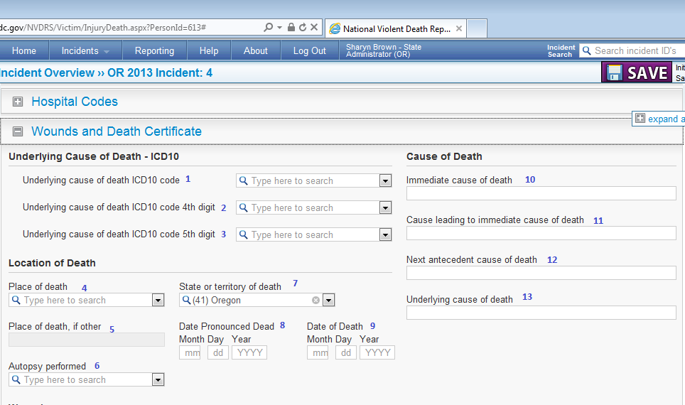
1 | UnderlyingCauseCode | 8 | DatePronouncedDate
2 | UnderlyingCauseCode4thDigit | 9 | DeathDate
3 | UnderlyingCauseCode5thDigit | 10 | DeathCause1
4 | DeathPlace | 11 | DeathCause2
5 | DeathPlaceText | 12 | DeathCause3
6 | AutopsyPerformed | 13 | DeathCause4
7 | DeathState

3.0 Circumstances

3.1 Mental, Health, Substance Abuse, and Other Addiction & Relationship and Life Stressors
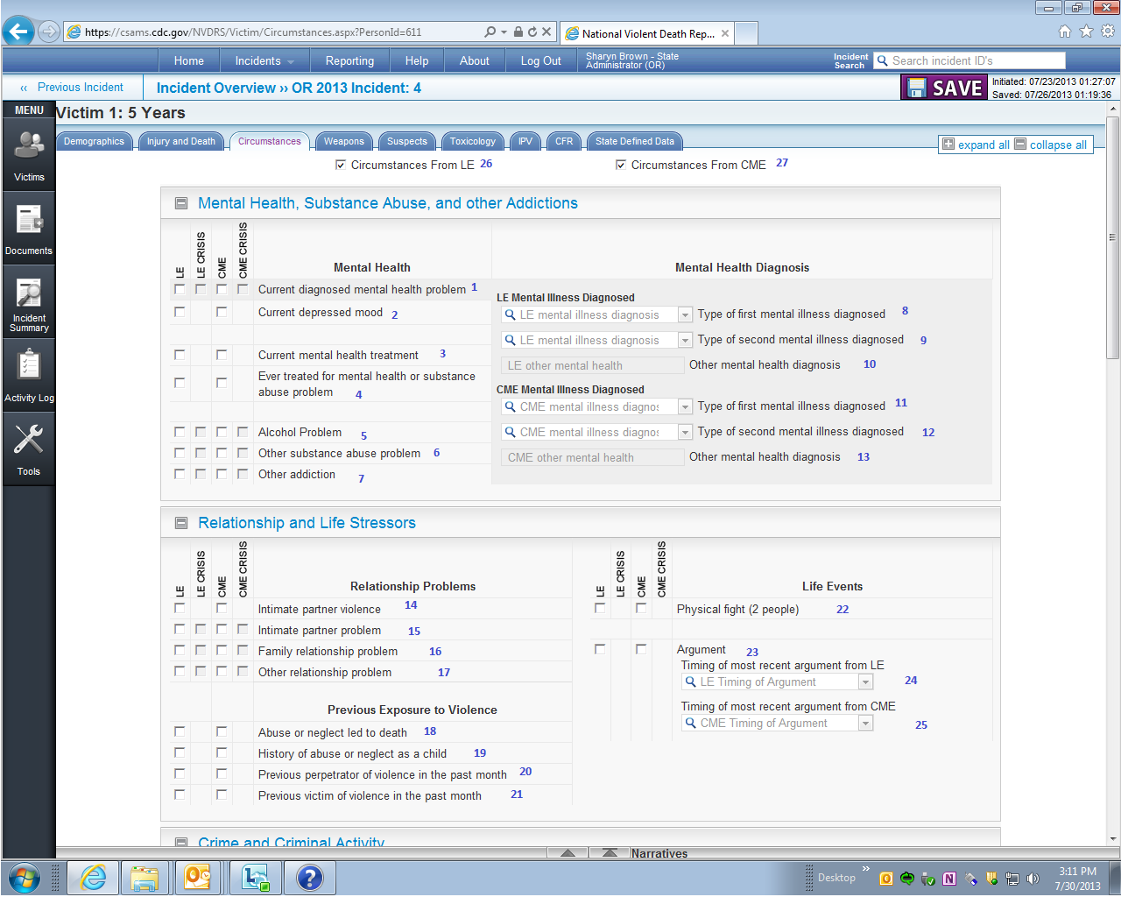
CRISIS VARIABLE NAMES
Whenever a circumstance was a crisis (i.e., occurred within two weeks of the fatal overdose), the CME variable is stored in a separate variable from the circumstance in the export file. Specifically, crisis variables will have the word “crisis” inserted between the data source (i.e., CME) and the circumstance name in the variable label variable (e.g., CME_CrisisVariableName,). For example, the crisis variables for “Stalking” will be CME_CrisisStalking.
CIRCUMSTANCE VARIABLE NAMES BY DATA SOURCE (CME AND LE)
NUDORS only uses variables abstracted from coroner and medical examiners. If the CME report is the source, CME variable names are preceded by “CME_” (e.g., “CME_VariableName”).

 |  |  |  |  | 17 | RelationshipProblemOther
  1 | MentalHealthProblem | 11 | CME_MentalHealthDiagnosis1 | 20 | InterpersonalViolencePerpetrator
  2 | DepressedMood | 12 | CME_MentalHealthDiagnosis2 | 21 | InterpersonalViolenceVictim
  3 | MentalIllnessTreatmentCurrent | 13 | CME_MentalHealthDiagnosisOther | 22 | FightBetweenTwoPeople
  4 | HistoryMentalIllnessTreatment | 14 | IntimatePartnerViolence | 23 | Argument
  5 | AlcoholProblem | 15 | IntimatePartnerProblem | 25 | CME_ArgumentTiming
  6 | SubstanceAbuseOther | 16 | FamilyStressors | 26 | CME_CircumstancesKnown
  7 | OtherAddiction | 17 | RelationshipProblemOther

3.2 Manner Specific Circumstances for Suicide Deaths
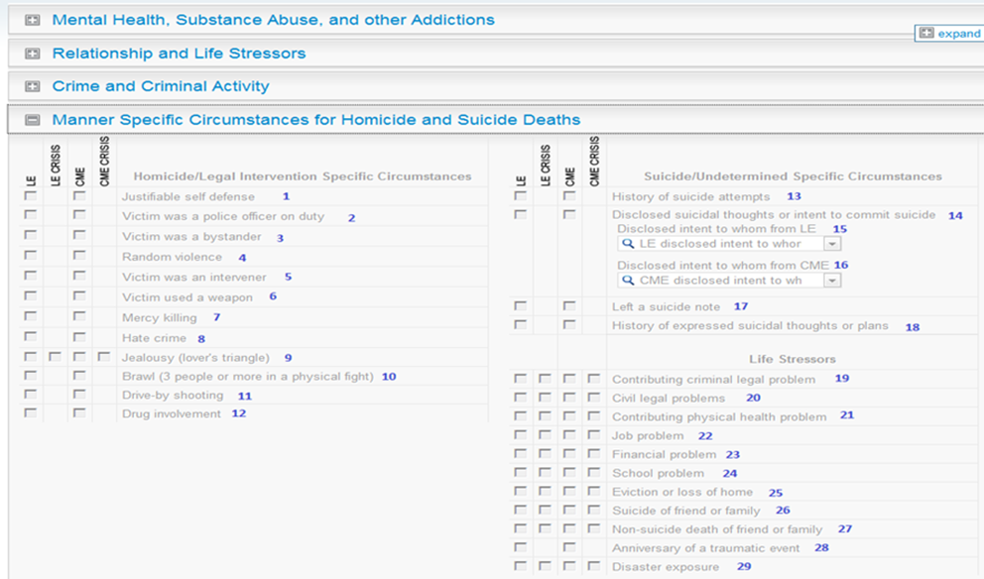
13 | SuicideAttemptHistory | 22 | JobProblem | 29 | DisasterExposure
14 | SuicideIntentDisclosed | 23 | FinancialProblem
16 | CME_DisclosedIntentToWhom | 24 | SchoolProblem
17 | SuicideNote | 25 | EvictionorLossofHome
18 | SuicideThoughtHistory | 26 | RecentSuicideFriendFamily
19 | RecentCriminalLegalProblem | 27 | DeathFriendorFamilyOther
20 | LegalProblemOther | 28 | TraumaticAnniversary
21 | PhysicalHealthProblem | 22 | JobProblem

3.3 Other Circumstances
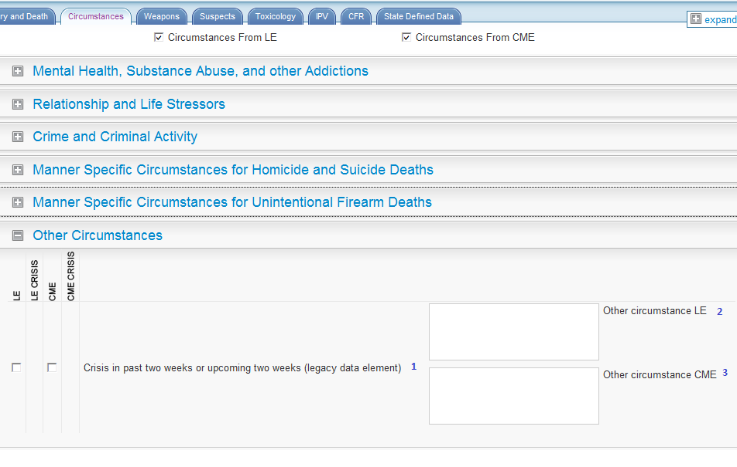
1 | CrisisRecent
2 | LE_CircumstancesOtherText
3 | CME_CircumstancesOtherText

4.0 Toxicology

4.1 Toxicology Specimen Date & Toxicology Findings
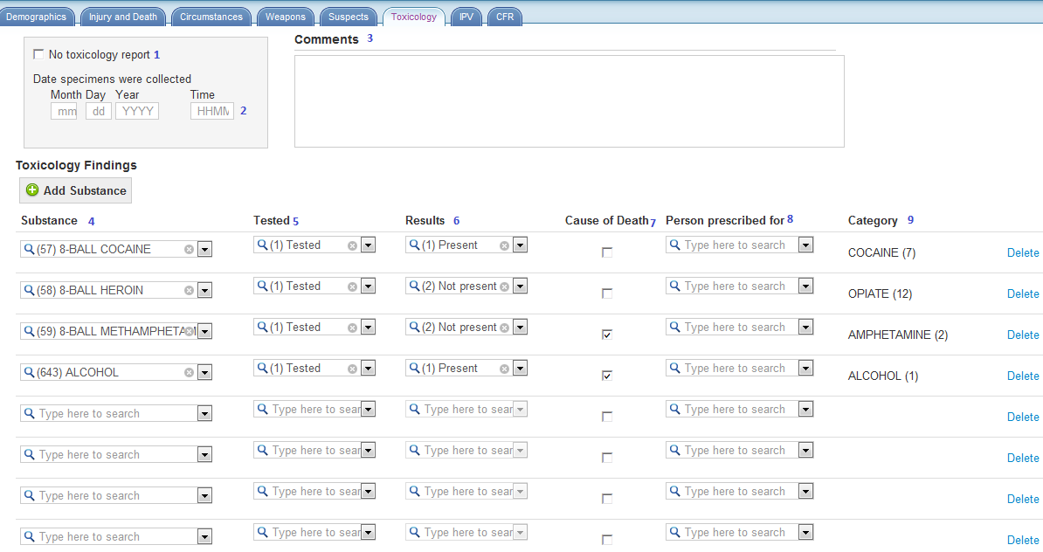
1 | No Toxicology Available |  |  | 7 | SubstanceCausedDeath
2 | SpecimensTime |  |  | 8 | DrugObtainedFor
3 | Comments |  |  | 9 | SubstanceClass
4 | SubstanceName
5 | SubstanceTested
6 | SubstanceResult

4.2 Toxicology Summary
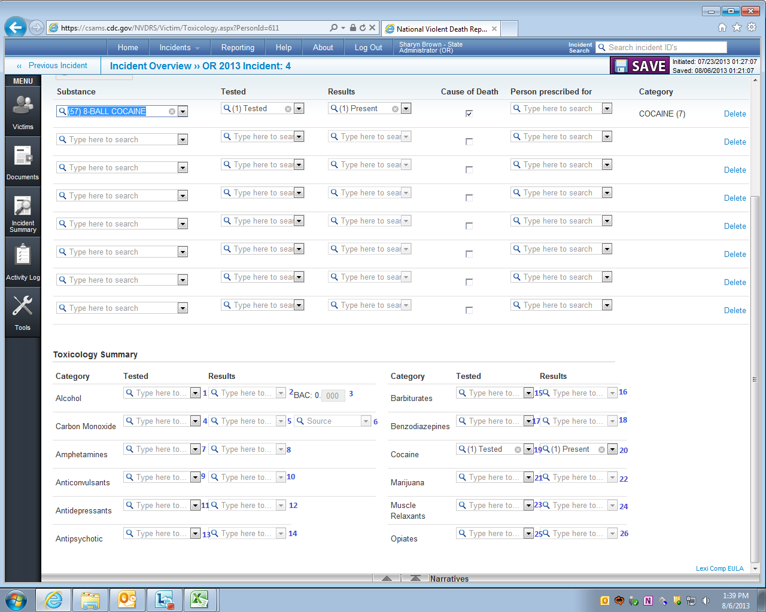
1 AlcoholTested | 9 | AnticonvulsantsTested | 17 | BenzodiazepinesTested | 25 | OpiateTested
2 AlcoholResult | 10 | AnticonvulsantsResult | 18 | BenzodiazepinesResult | 26 | OpiateResult
3 AlcoholLevel | 11 | AntiDepressantTested | 19 | CocaineTested
4 CarbonMonoxideTested | 12 | AntiDepressantResult | 20 | Cocaine test result
5 CarbonMonoxideResult | 13 | AntipsychoticTested | 21 | MarijuanaTested
6 CarbonMonoxideSource | 14 | AntipsychoticResult | 22 | MarijuanaResult
7 AmphetamineTested | 15 | BarbituratesTested | 23 | MuscleRelaxantTested
8 AmphetamineResult | 16 | BarbituratesResult | 24 | MuscleRelaxantResult

5.0 Document
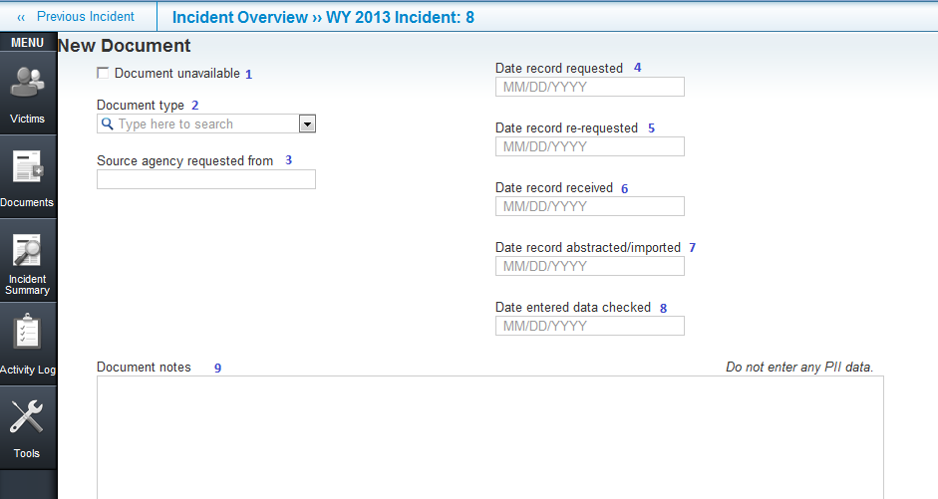
1 | DocumentUnavailable | 5 | Date record re-requested
2 | DocumentType | 6 | Date record received
3 | AgencySource | 7 | AbstractedDate
4 | Date record requested | 8 | Date entered data checked
 |  | 9 | DocumentNotes

6.0 Incident

6.1 Incident Overview
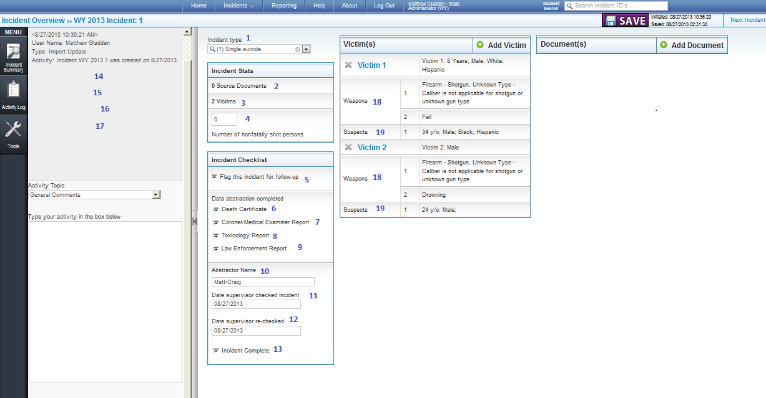
1 IncidentType | 8 | CompleteToxicology | 15 | LastUpdateDate
2 NumberOfDocuments | 9 | CompleteLE | 16 | DateDeleted
3 NumberofVictims | 10 | AbstractorName | 17 | DateMerged
4 NumberNonfatallyShot | 11 | SupervisorCheckedDate | 18 | NumberOfWeapons
5 FollowUp | 12 | SupervisorRecheckedDate | 19 | NumberOfSuspects
6 CompleteDC | 13 | CompleteIncident
7 CompleteCME | 14 | CreateDate

6.2 CME Incident Narratives
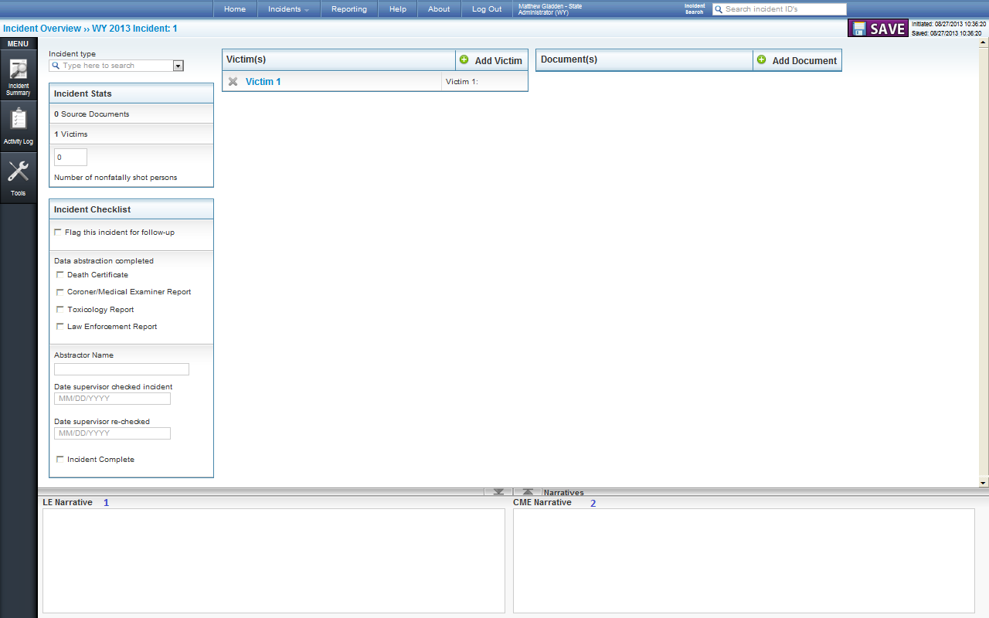

2 | NarrativeCME

7.0 Unintentional Drug Overdose Questions

7.1 Type of Poisoning, Substance Abuse, Response to Drug Overdose, and Other Questions
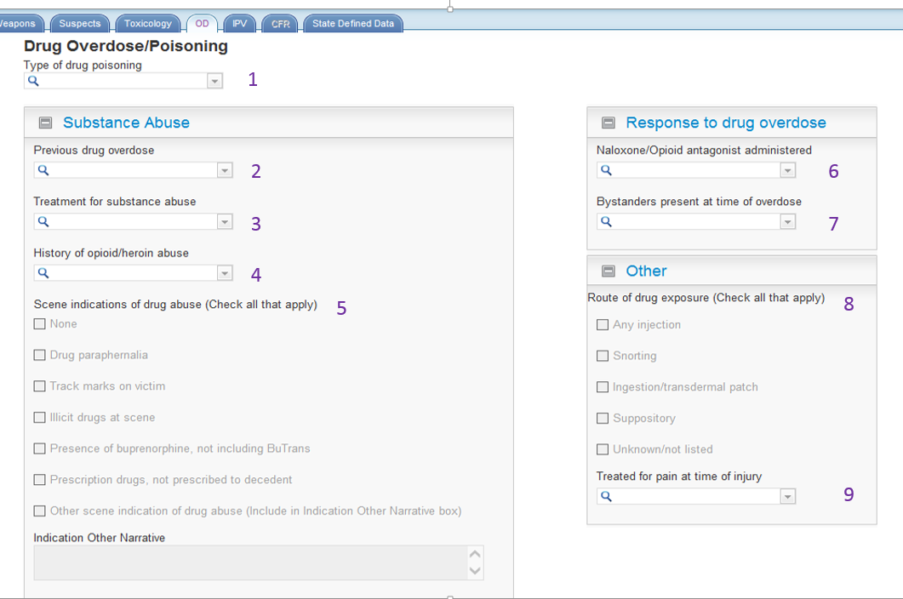
1 | TypeOfPoisoning | 5 | Scene (None, DrugPar, Tracks, Illicit drugs, Burpenorphine, Prescription,  Other)
2 | PreviousOverdose | 6 | NaloxoneAdministered
3 | TreatForSubstanceAbuse | 7 | BystandersPresent
4 | HistoryOpioid | 8 | Route of Exposure (Inject, Snort, Ingest, suppository, Unknown)
 |  | 9 | TreatedforPain

7.2 Type of Poisoning, Substance Abuse, Response to Drug Overdose, and Other Questions

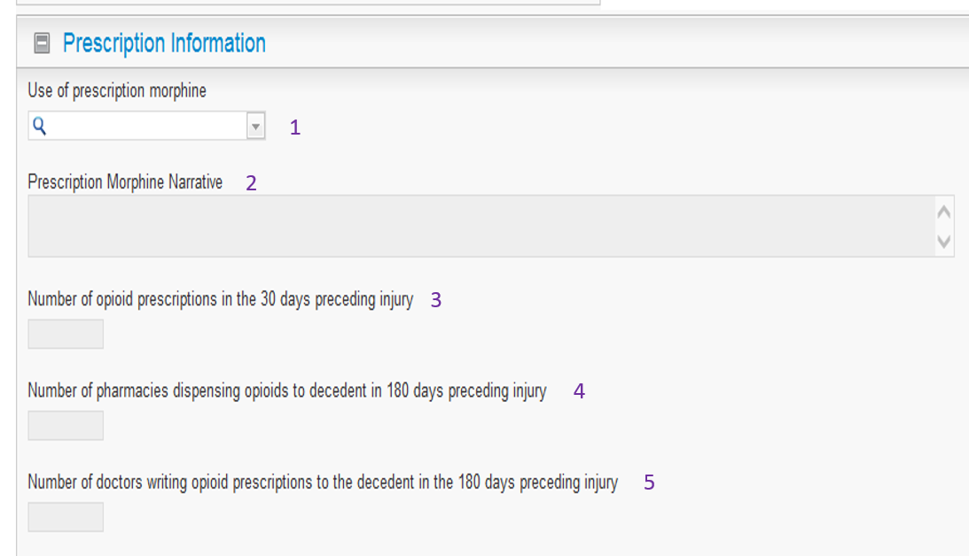
1 | PrescriptionMorphine | 4 | NumPharmaciesPast30Days
2 | MorphineNarrative | 5 | NumDoctorsPrescribing30Days
3 | NumScripsPast30Days

