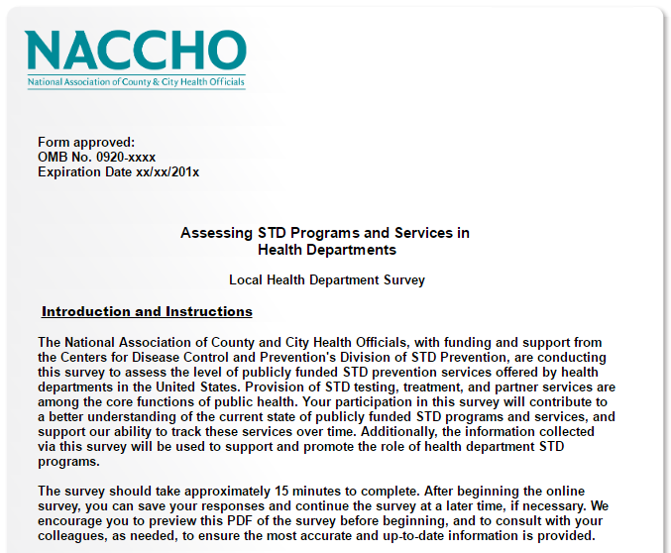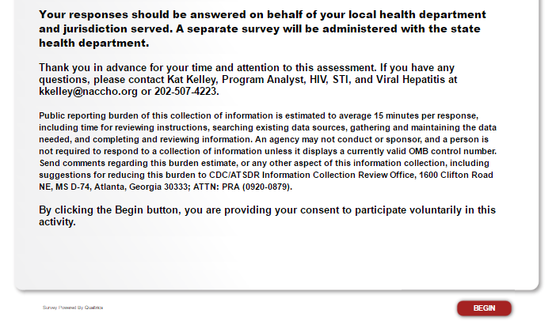

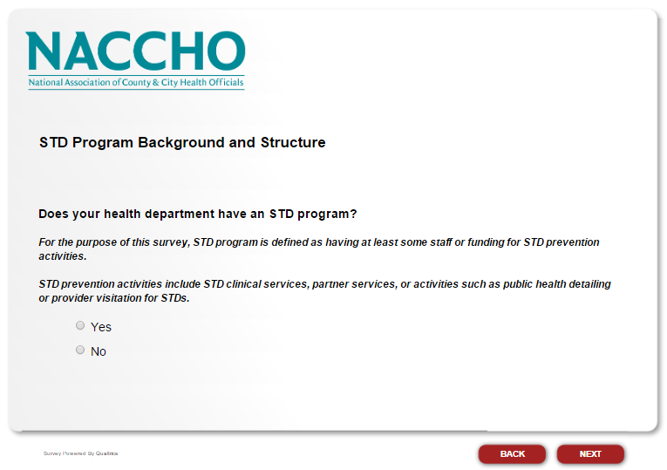

If the respondent selects “Yes” proceed to the next question. If the respondent selects “No,” skip to “Is there a clinic in your jurisdiction that provides safety net STD services?”

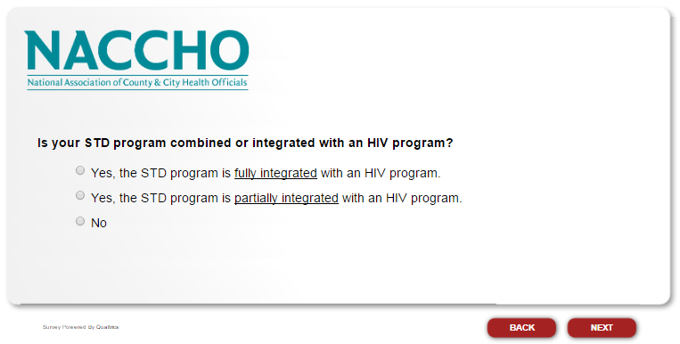

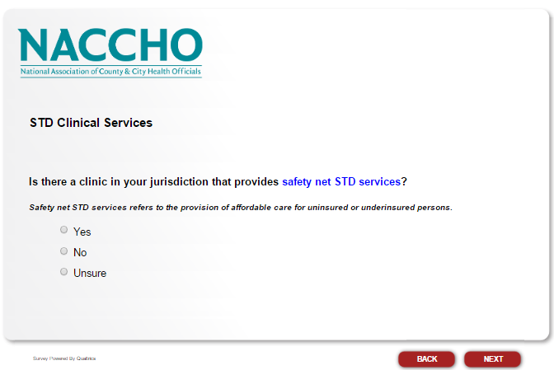

If the respondent selects “Yes” proceed to the next question. If the respondent selects “No” or “Unsure,” and also answered “No” to “Does your health department have an STD program?” skip to “Before submitting your responses, is there anything else you would like to share?” If the respondent selects “No” or “Unsure,” and answered “Yes” to “Does your health department have an STD program?” skip to “Currently, does your STD program provide partner services by health department staff?”

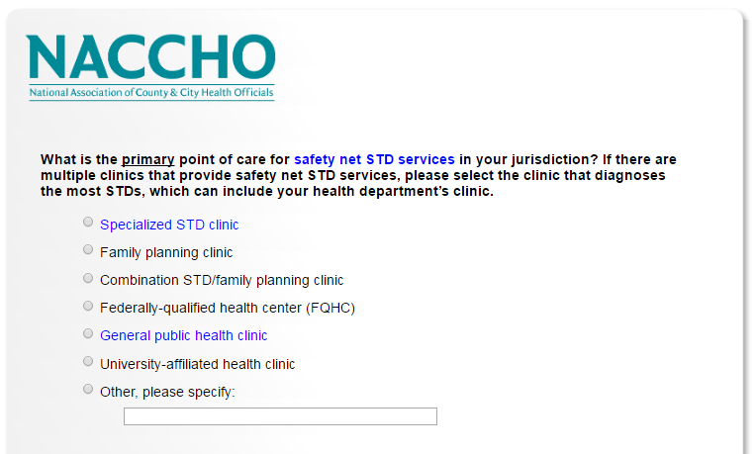

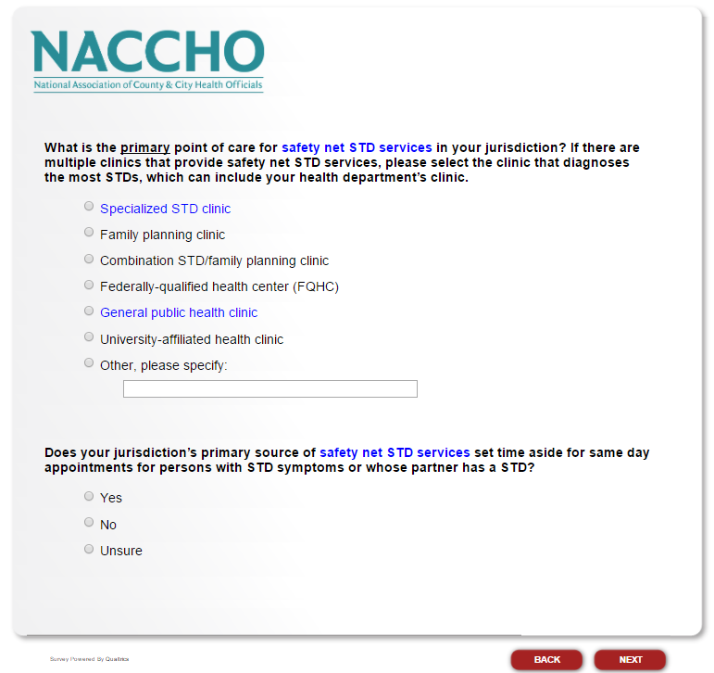

If the respondent selects “Yes” proceed to the next question. If the respondent selects “No” or “Unsure,” skip to “What STD/HIV services are provided at your jurisdiction’s primary source of safety net STD services? Select all that apply.”

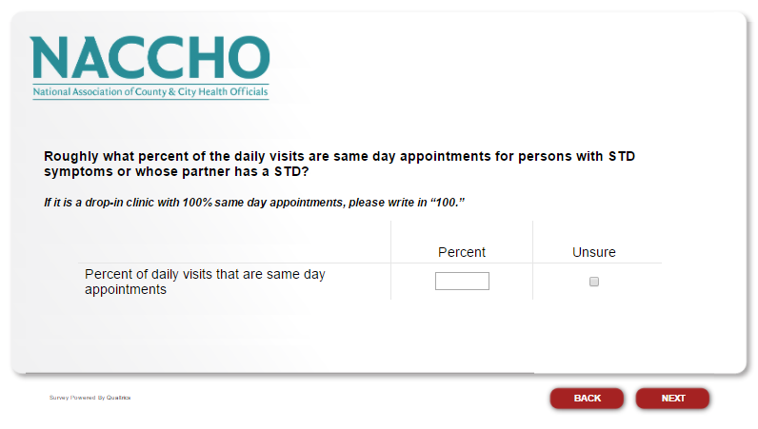

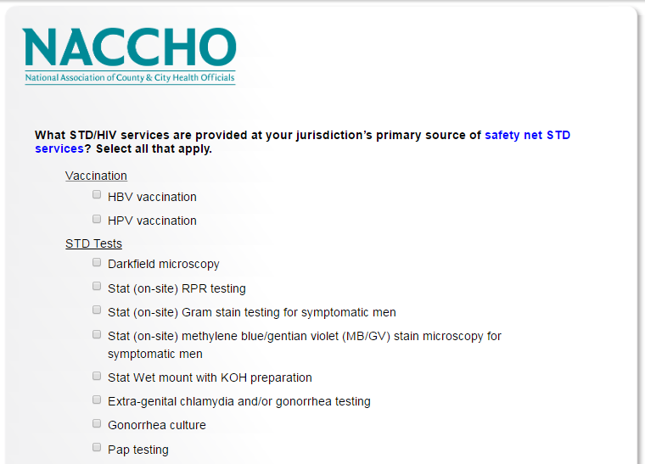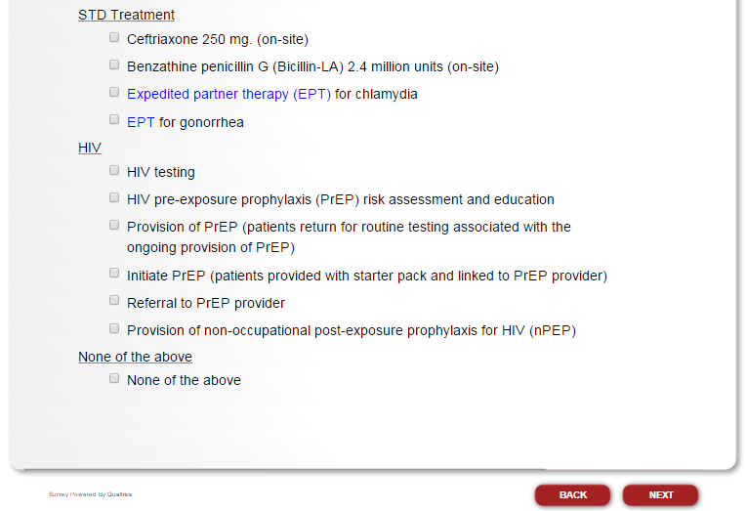

If respondent selects “Provision of PrEP (patients return for routine testing associated with the ongoing provision of PrEP)” proceed to the next question. If respondent does not select this option, skip to “Currently, does your STD program provide partner services by health department staff?”

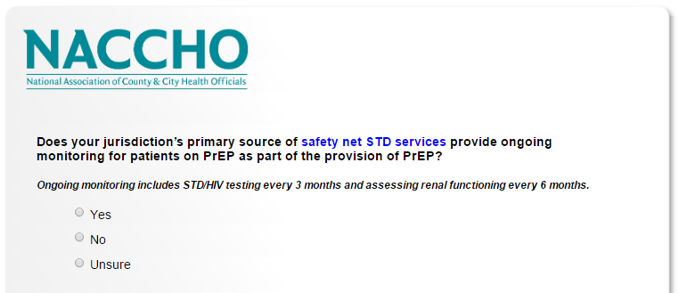

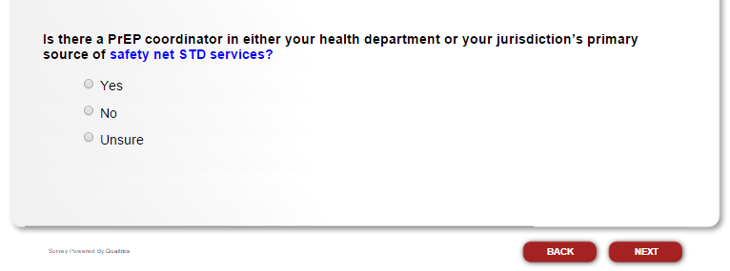

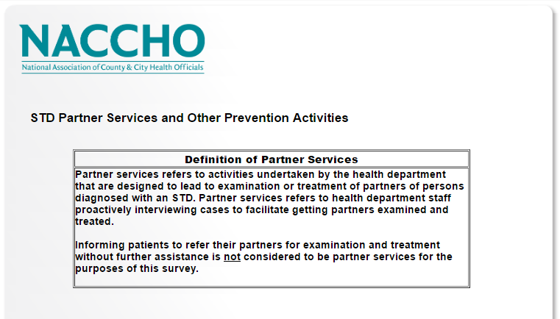

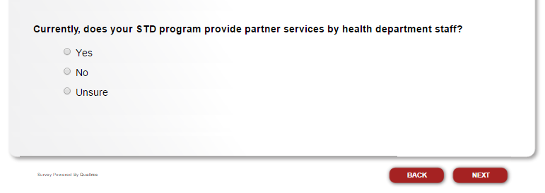

If the respondent selects “Yes.” proceed to the next question. If the respondent selects “No” or “Unsure,” skip to “Does your STD program conduct public health detailing or provider visitation (i.e., health department staff or contractors visit clinical providers in your jurisdiction to market health department services or provide STD information and public health updates)?

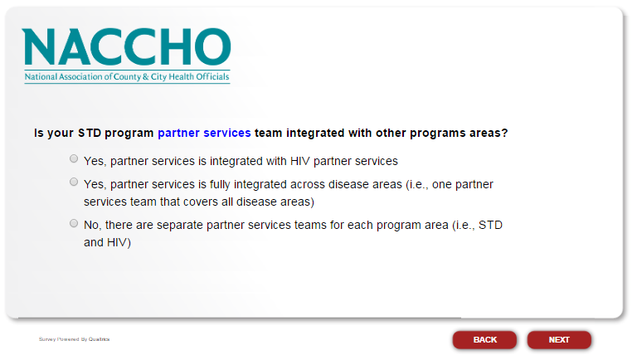

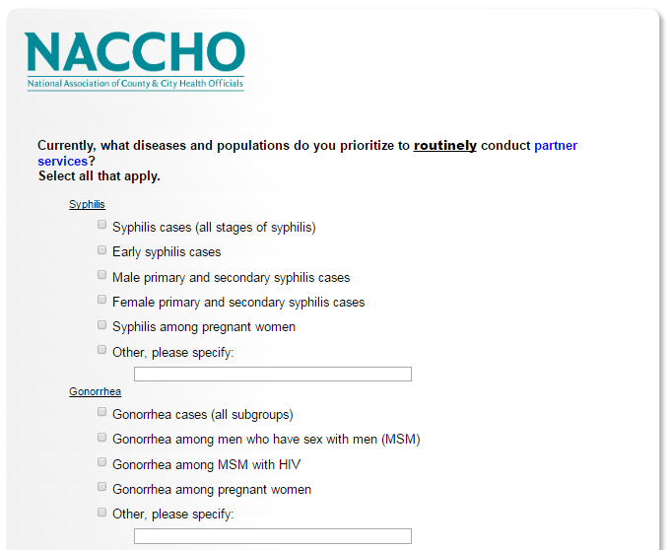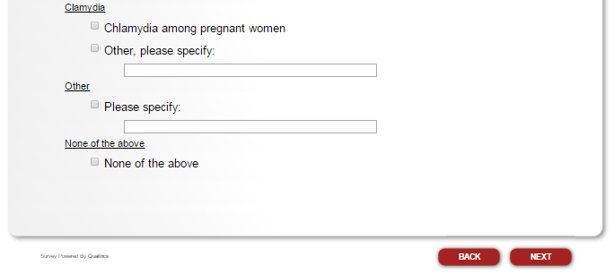

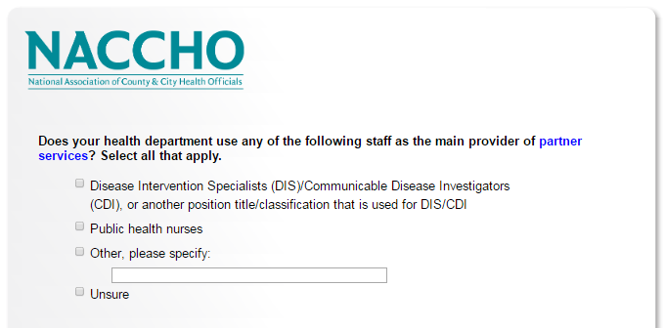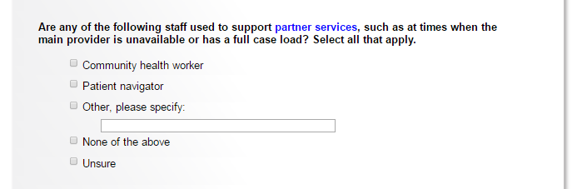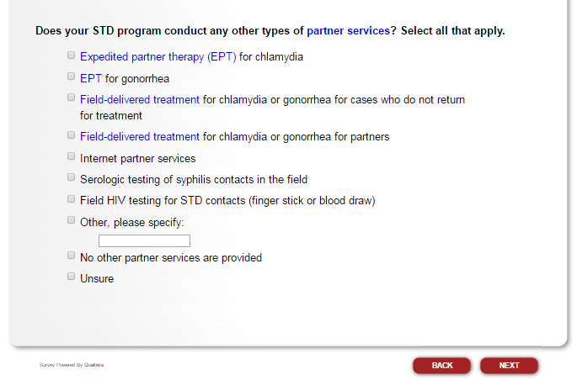

If respondent selects “Field HIV testing for STD contacts (finger stick or blood draw),” proceed to the next question. If respondent does not select this option, skip to “Do the staff in your STD program who are the main providers of partner services do any of the following activities? Select all that apply.”

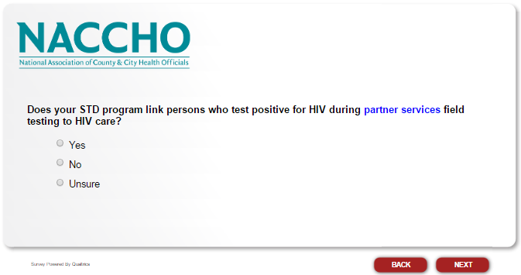

If respondent selects “Yes” proceed to the next question. If respondent selects “No” or “Unsure,” skip to “Do the staff in your STD program who are the main providers of partner services do any of the following activities? Select all that apply.”

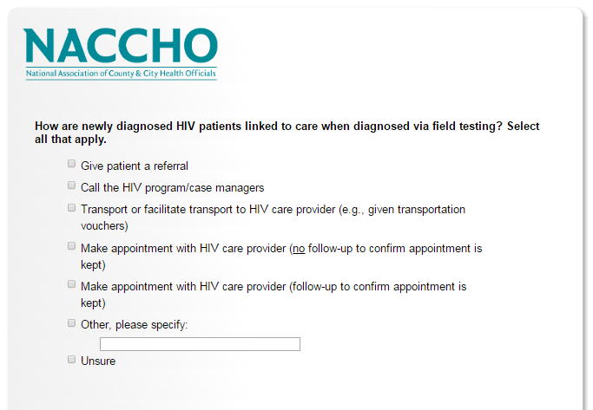

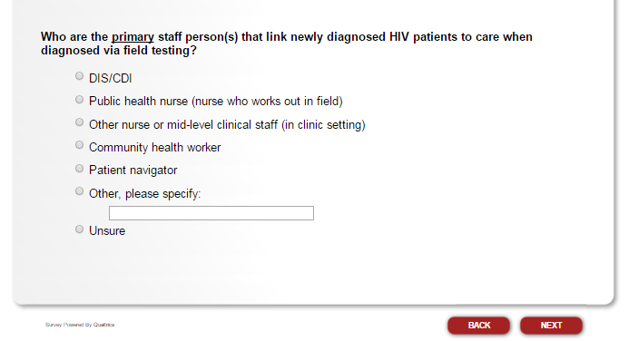

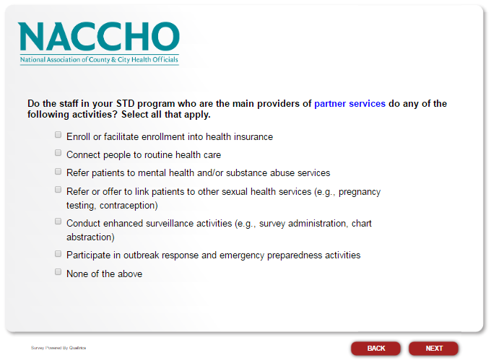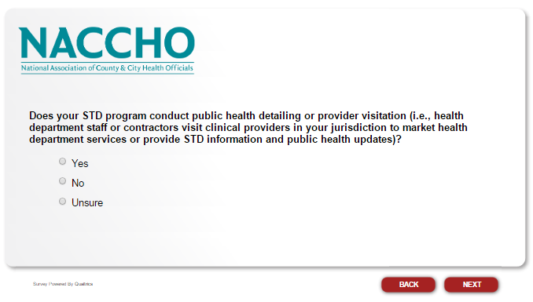

If respondent selects “Yes” proceed to the next question. If respondent selects “No” or “Unsure,” skip to “In calendar year 2016, how many FTEs, including contractors, were in your STD workforce?”

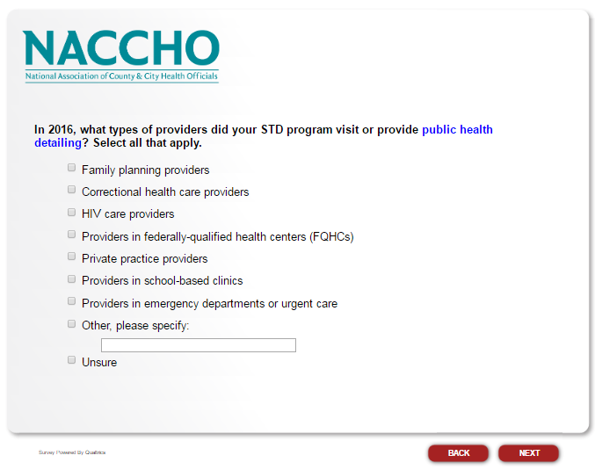

If respondent selects “Private practice providers” proceed to the next question. If respondent does not select this option, skip to “In calendar year 2016, how many FTEs, including contractors, were in your STD workforce?”

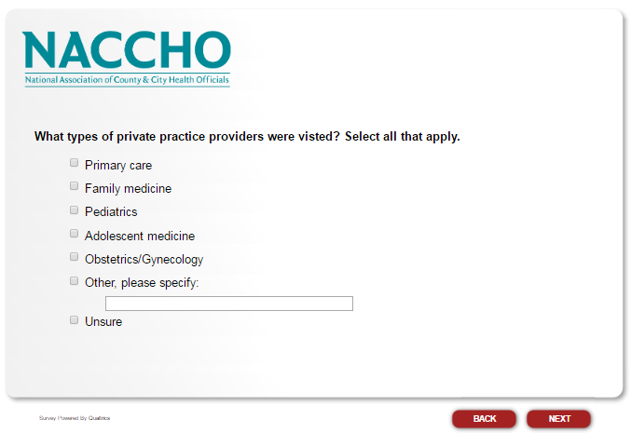

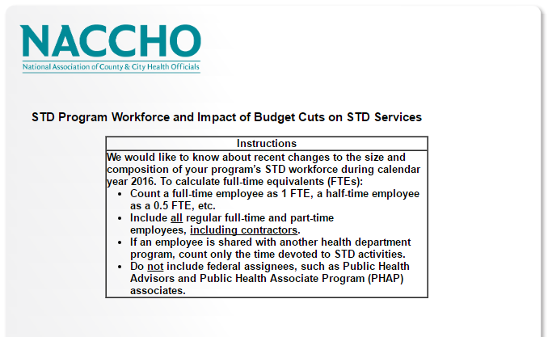

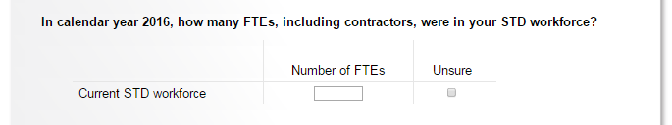

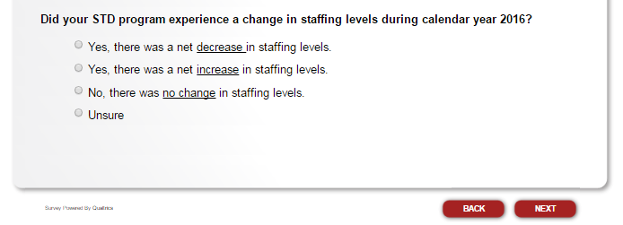

If respondent selects “Yes, there was a net decrease in staffing levels,” or “Yes, there was a net increase in staffing levels,” proceed to the next question. Respondents who select “Yes, there was a net decrease in staffing levels” will also answer “Please indicate any staffing categories in which FTEs, including contractors, decreased in calendar year 2016. Select all that apply,” while respondents who select “Yes, there was a net increase in staffing levels” will skip this question. If respondent selects “No, there was no change in staffing levels” or “Unsure,” skip to “What percentage of your current STD workforce are DIS/CDI?”

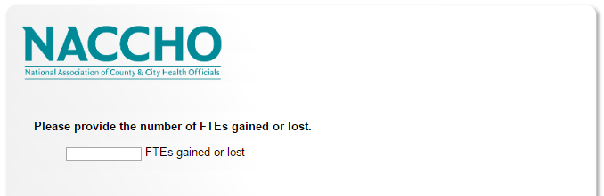

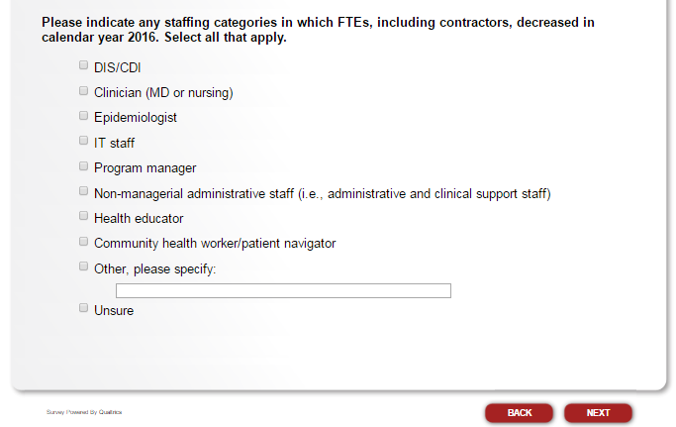

If respondent selects “DIS/CDI,” proceed to the next question. If respondent does not select this option, skip to “What percentage of your current STD workforce are DIS/CDI?”

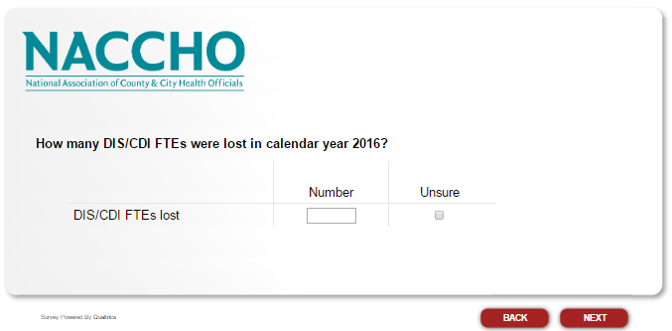

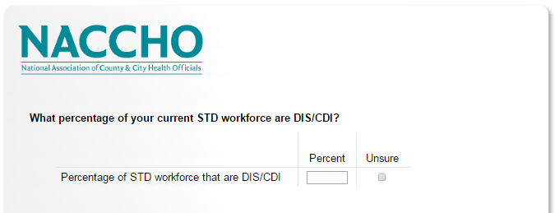

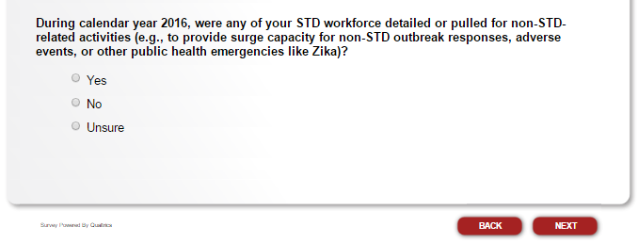

If respondent selects “Yes” proceed to the next question. If respondent selects “No” or “Unsure,” skip to “From January 2016 to the present, has the STD program had any budget cuts?”

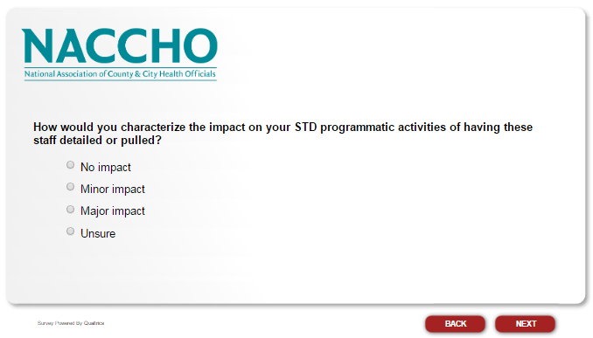

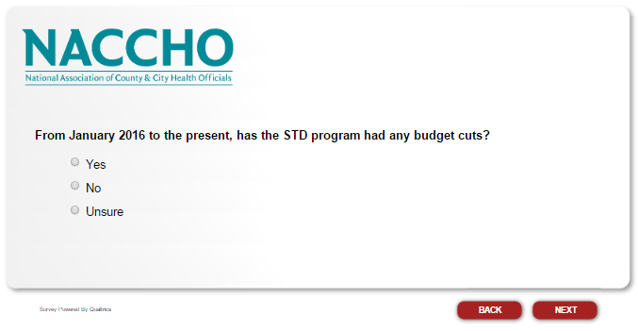

If respondent selects “Yes” proceed to the next question. If respondent selects “No” or “Unsure,” skip to “Please describe your STD program’s greatest success in 2016. If possible, please include the impact of this success, such as impact on local STD rates/cases or the impact on quality of STD services in your jurisdiction.

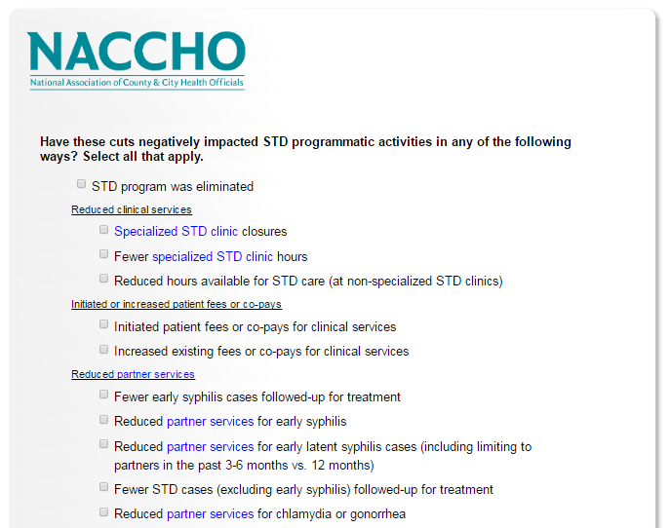

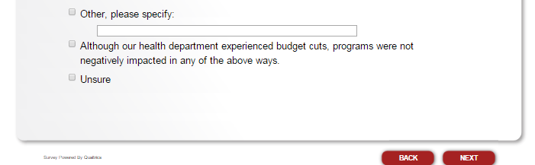

If respondent selects “STD program was eliminated,” skip to “Before submitting your responses, is there anything else you would like to share?” If respondent selects “Specialized STD clinic closures,” proceed to the next question. If respondent does not select either of these options, skip to “How did you determine which programmatic activities to cut? Select all that apply.”

