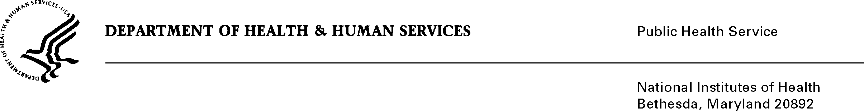
DATE: June 29, 2017

TO: Stephanie Mok
Office of Management and Budget (OMB)
Reports Clearance Officer, DHHS

FROM: Mikia P. Currie
Chief, Project Clearance Branch

SUBJECT: Change Request to a Currently Approved Form
(OMB # 0925-0001, Expiration Date 10/31/2018)

NIH is requesting a non-substantive change to the eRA Commons Personal Profile (Attachment 15) approved under 0925-0001 which does not change the approved data collection or anticipated burden hours. NIH would like to include additional SAMHSA peer reviewer information that is currently collected within the Reviewer Contact Information (RCI) form under 0930-0255. This information will not be collected twice; rather, the goal is to collect this information only once through the eRA Commons Personal Profile, thus eliminating the RCI form altogether.

This information, such as the Licensed Professional in Mental Health or Substance Use Disorder, is also in accordance with requirements in the 21st Century Cures Act, Section 6009. Peer Review.

Please see the following attachments for more information on this change:

Attachment A: eRA Commons Profile Data Elements – new tab for “SAMHSA Reviewer” added

Attachment B: SAMHSA Additional Collected Reviewer Data

Your full consideration is appreciated.

