Supporting Statement for OMB Clearance Request

Appendix J: Previously Approved 36-Month Survey Flyer

Pathways for Advancing Careers and Education (PACE) – Follow-up Data Collection

OMB No. 0970-0397

January 2017

Submitted by:
Nicole Constance
Office of Planning, Research
and Evaluation
Administration for Children
and Families
U.S. Department of Health and Human Services

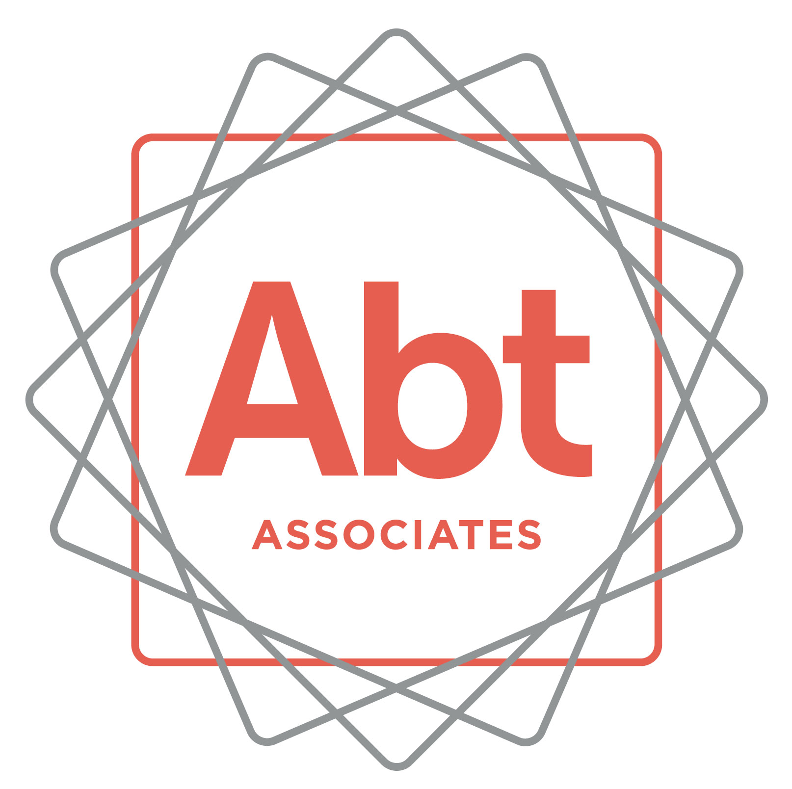
We have been trying to reach you! We’re following up about the Pathways for Advancing Careers and Education (PACE) study (previously known as the Innovative Strategies for Increasing Self-Sufficiency study). You agreed to participate in this study about 36 months ago. This is a very important research study funded by the U.S. Department of Health and Human Services that will help them improve education and employment programs for others.
After you complete the interview, you will receive $40 in appreciation for your participation.
To schedule your interview or to get more information about the study, please call ___________________________
at ___________________________
You may also call my supervisor _____________] at 1-866-491-0770 (toll free).
Thank you and we look forward to speaking with you soon!
ABTSRBIID_____________________________________
Please mention this number when you call

