Thank you for volunteering!
Practitioner Toolkit Feedback

Background

CFED is in the process of developing a toolkit for AFI practitioners to discover their clients' context and perspectives in order to design or improve programs and services. The Toolkit includes resources such as logic modeling and client journey mapping along with an example of how one organization applied these practices to reduce attrition in an IDA program.

Time: 2:00 - 2:30 p.m.
Date: Thursday, September 29th
Location: Penn Quarter on the M3 level

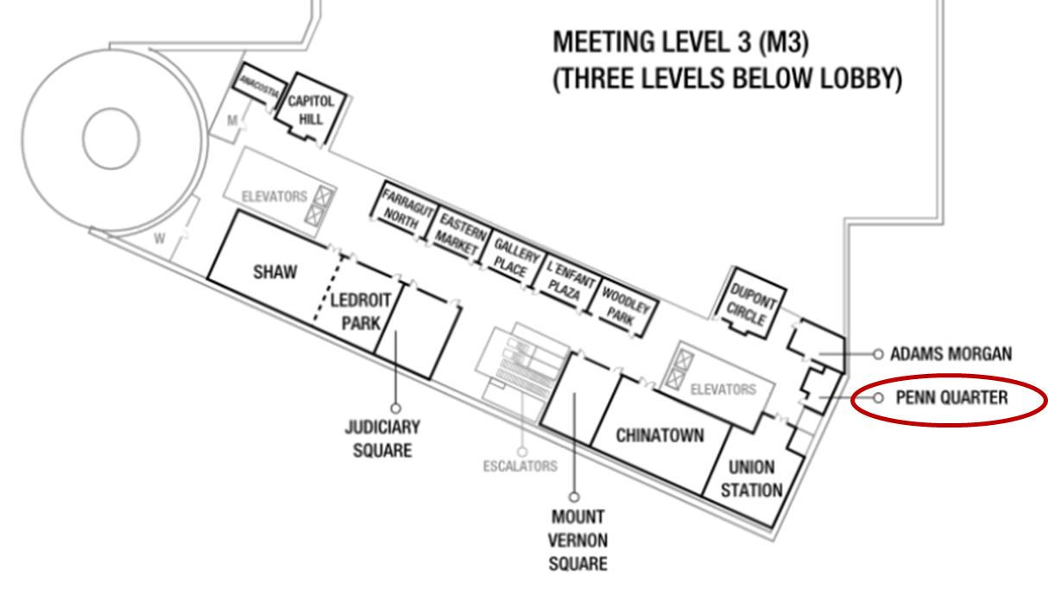
What to expect

After reviewing the toolkit in-person, you will be invited to complete a short survey and will have the option to speak with an interviewer about your feedback. The entire process will take no more than 30 minutes. Participation is voluntary and confidential. You may skip any items in the survey and decline to provide any additional comments.

Contact

Contact Spectra Myers at 202-601-1009 or smyers@cfed.org with any questions, concerns or rescheduling needs.

About this project

Prepared by CFED under the Assets for Independence (AFI) Program Capacity, Innovation, and Performance Resources and Services (CIRPS) for the Administration for Children and Families at the US Department of Health and Human Services (GSA Schedule Contract GS10F0177L Order No HHSP233201400441G_0004)

