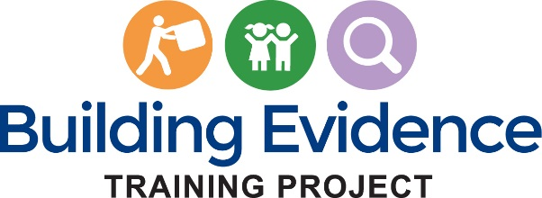

instructor unit survey

Thank you for completing the following unit evaluation. The information you provide will be used to help us improve this unit of the course.
__________________________________________________________________________________
THE PAPERWORK REDUCTION ACT OF 1995 (Pub. L. 104-13)

Public reporting burden for this collection of information is estimated to average .12 hours per response, including the time for reviewing instructions, gathering and maintaining the data needed, and reviewing the collection of information.

An agency may not conduct or sponsor, and a person is not required to respond to, a collection of information unless it displays a currently valid OMB control number.
__________________________________________________________________________________
Instructions:
Please respond to each question. For those questions which do not apply, please select “Not Applicable.”
Please indicate your level of agreement with the following statements:
Difficulty
 | Strongly Agree | Agree | Disagree | Strongly Disagree | Not Applicable
- I was very knowledgeable about the content of this unit before teaching it.
- I needed to learn the content of this unit by reviewing course materials to teach it effectively.
- The difficulty of this unit was appropriate for my students.

E-learning Module
 | Strongly Agree | Agree | Disagree | Strongly Disagree | Not Applicable
- The content of this unit’s e-learning module was well organized.
- The length of the e-learning module was appropriate for the amount of material presented.
- The content of the e-learning module was appropriate for the knowledge and skill level of my students.

Components
(If you did not require students to complete the activity referenced in the question, please select ‘Not Applicable.’)
 | Strongly Agree | Agree | Disagree | Strongly Disagree | Not Applicable
- The transfer-of-learning activities for this unit helped students better understand the course material.
- The transfer-of-learning activities helped students understand how course concepts can be applied in their current or future work.
- The additional readings and learning resources for this unit were useful and appropriate.

Learning/Impact
 | Strongly Agree | Agree | Disagree | Strongly Disagree | Not Applicable
- This unit’s subject matter will help my students in their work or their future careers.
- Students were able to complete the unit assignments within planned timeframes.

- Please identify what you consider to be the strengths of this unit. Please provide as much detail as possible.

- Please identify area(s) where you think this unit could be improved. Please provide as much detail as possible and include suggestions for improvement.

- Overall, how satisfied were you with this unit?

☐ Very Satisfied ☐ Satisfied ☐ Dissatisfied ☐ Very Dissatisfied

- Please share any other feedback you’d like to provide about this unit.

