CONTENTS

A. Facsimile of Form .........................................................................................IV-3-3
B. Purpose..........................................................................................................IV-3-5
C. Due Date and Transmittal .............................................................................IV-3-5
D. General Reporting Instructions ...................................................................IV-3-6
E. Definitions......................................................................................................IV-3-6

 | 1. | Benefit Offset ..........................................................................................IV-3-6
 | 2. | Cases of Agency Employee Benefit Fraud..............................................IV-3-6
 | 3. | Cases Established ..................................................................................IV-3-7
 | 4. | Cases Investigated..................................................................................IV-3-7
 | 5. | Cash........................................................................................................IV-3-7
 | 6. | Claimant Errors. ......................................................................................IV-3-7
 | 7. | Controllable .............................................................................................IV-3-7
 | 8. | Employer Errors ......................................................................................IV-3-7
 | 9. | Federal Income Tax Offset......................................................................IV-3-8
 | 10. | Fictitious Employer Detection Systems ...................................................IV-3-8
 | 11. | Fraud Overpayment ................................................................................IV-3-8
 | 12. | High Dollar (Fraud and Non-fraud) Overpayments..................................IV-3-8
 | 13. | IB Crossmatch.........................................................................................IV-3-10
 | 14. | Joint Claims.............................................................................................IV-3-10
 | 15. | Multi-Claimant Schemes .........................................................................IV-3-10
 | 16. | Multi-Claimant Scheme System ..............................................................IV-3-10
 | 17. | National Directories of New Hires ...........................................................IV-3-11
 | 18. | Noncontrollable Total ..............................................................................IV-3-11
 | 19. | Non-fraud Overpayment..........................................................................IV-3-11
 | 20. | Overpayment...........................................................................................IV-3-11
 | 21. | Penalty ....................................................................................................IV-3-11
 | 22. | Receivables Removed at the End of Period............................................IV-3-13
 | 23. | Recovered for Other States.....................................................................IV-3-14
 | 24. | Reversals ................................................................................................IV-3-14
 | 25. | Special Project ........................................................................................IV-3-14
 | 26. | State Directory of New Hires ...................................................................IV-3-14
 | 27. | State Agency Errors ................................................................................IV-3-14
 | 28. | State Income Tax Offset..........................................................................IV-3-14
 | 29. | UCFE/UCX..............................................................................................IV-3-14
 | 30. | UI ............................................................................................................IV-3-14
 | 31. | Wage/Benefit Crossmatch.......................................................................IV-3-14
 | 32. | Waived ....................................................................................................IV-3-15
 | 33. | Written-Offs .............................................................................................IV-3-15
F. | Item | by Item Instructions..............................................................................IV-3-15
 | 1. | Section A. Overpayments Established - Causes....................................IV-3-15
 | 2. | Section B. Overpayments Established – Method of Detection ...............IV-3-16

3. Section C. Recovery/Reconciliation .......................................................IV-3-18
4. Section D. Criminal/Civil Actions ............................................................IV-3-20
5. Section E. Aging of Benefit Overpayment Accounts ..............................IV-3-22 6. Comments...............................................................................................IV-3-22

- Facsimile of Form
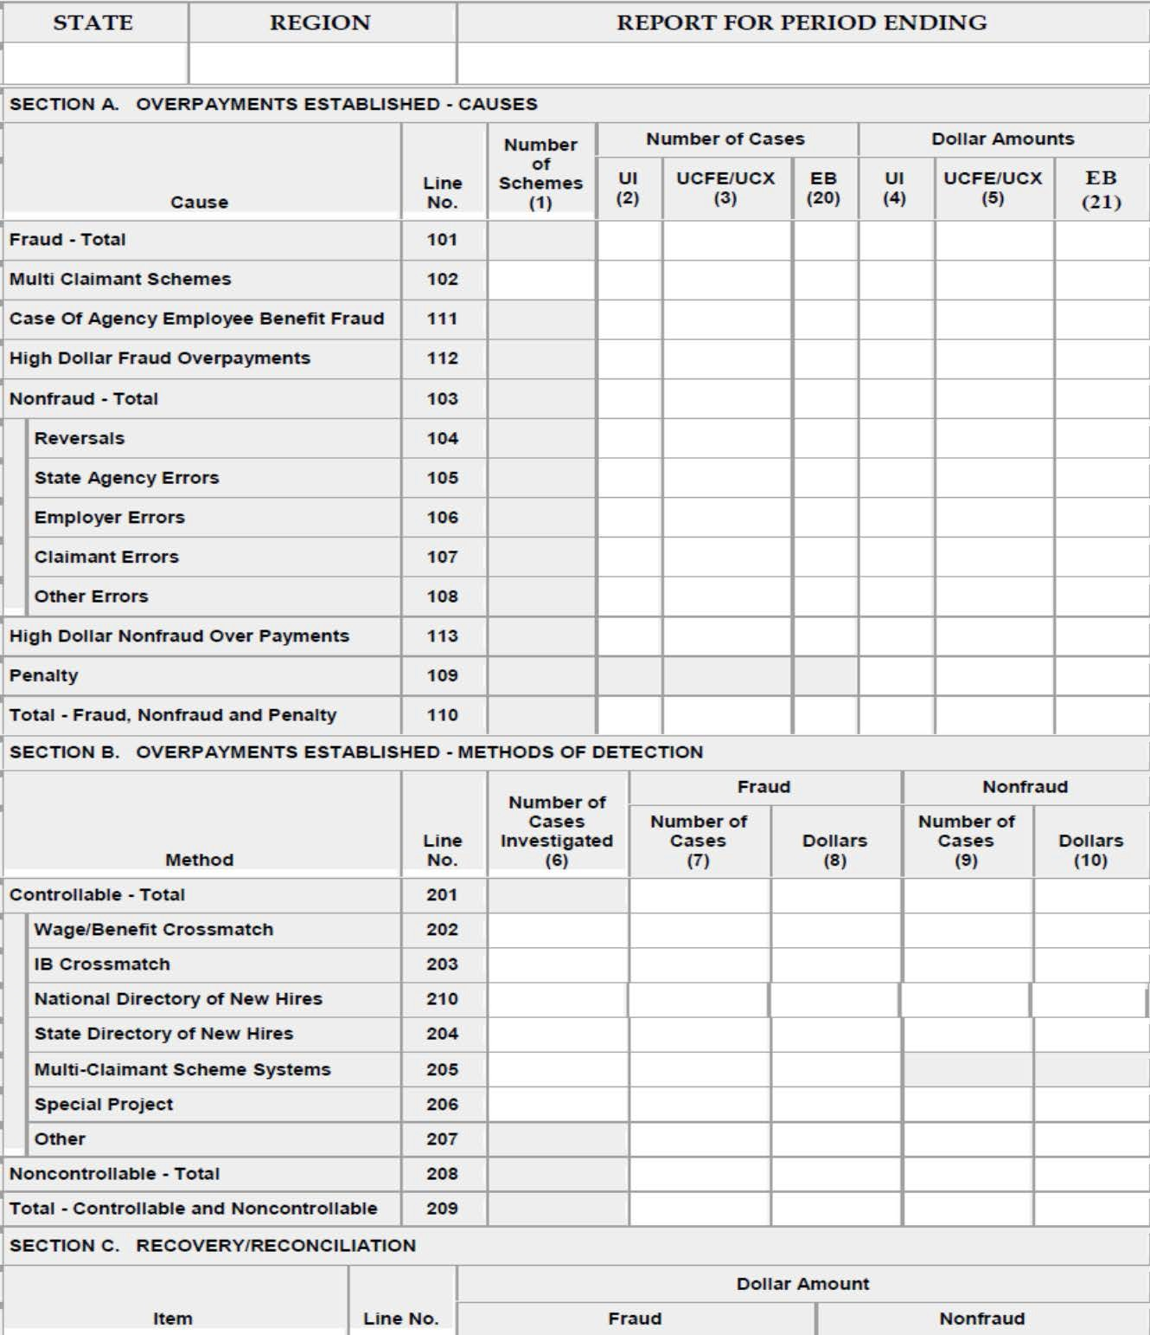
ETA 227 – OVERPAYMENT DETECTION AND RECOVERY

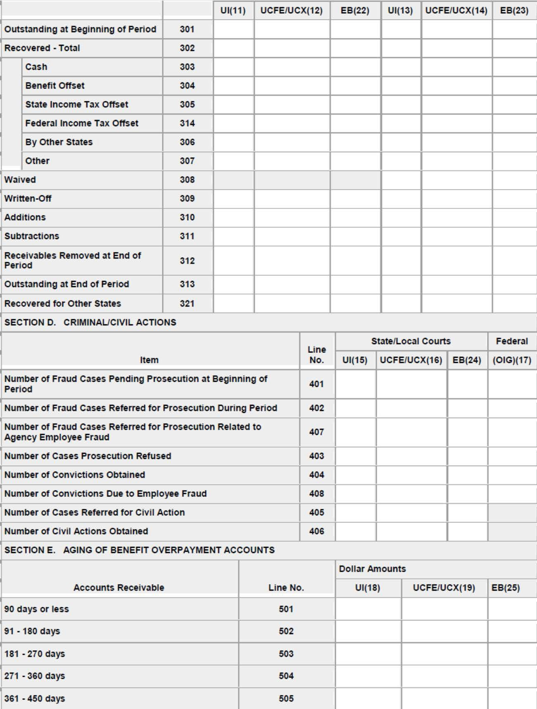

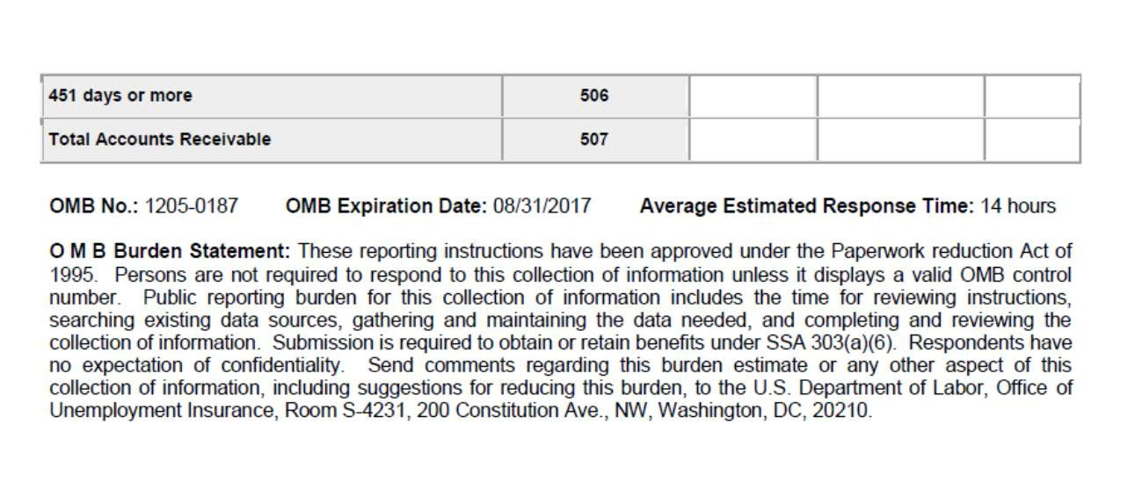

Purpose

The ETA 227 report provides information on overpayments of intrastate and interstate claims under the regular state unemployment insurance (UI) program, and under Federal UI programs including the Unemployment Compensation for Federal Employees (UCFE) and Unemployment Compensation for Ex- Servicemembers (UCX) programs, established under Chapter 85, Title 5, U.S. Code. This report includes claims for regular, state additional (both are reported in the columns indicated as UI), and the permanent federal-state Extended Benefits (EB) programs. This report does not include claims of Trade Readjustment Allowances (TRA), Disaster Unemployment Assistance (DUA), or any other episodic or temporary Federal extension program; such programs have their own separate forms and reporting instructions.

The state agency's accomplishments in principal detection areas of benefit payment control are shown on the ETA 227 report. The Employment and Training Administration (ETA) and state agencies need such information to monitor the integrity of the benefit payment processes in the UI system. Data are provided for the establishment of overpayments, recoveries of overpayments, criminal and civil actions involving overpayments obtained fraudulently, and an aging schedule of outstanding benefit overpayment accounts.

Due Date and Transmittal

The ETA 227 report is due quarterly on the first day of the second month after the quarter of reference.

Report for Quarter Ending | Due the Following
March 31 | May 1
June 30 | August 1

September 30 | November 1
December 31 | February 1

General Reporting Instructions

All applicable data on the ETA 227 report should be traceable to the data regarding overpayments and recoveries in the state's financial accounting system.

  - Amended Reports. If the information changes from that sent on the initial ETA 227 report covering the report period, the state agency will send an amended ETA 227 report electronically.

  - Coverage. Reported activity pertains to regular state UI benefits, benefits paid under the UCFE and UCX programs, federal-state EB, and wholly state financed "additional" benefits.

  - Audits. Dollar figures should be traceable to data regarding overpayments and recoveries in the state agency's financial accounting system.

  - Checking the Report. Entries should be made for all items. If no activity corresponding to the items occurred during the report period, a zero should be entered. A report containing missing data cannot be sent to the National Office but can be stored on the state’s system. Edit checks can be found in ETA Handbook No. 402, Unemployment Insurance Required Reports User’s Manual, Appendix C.

Definitions

  - Benefit Offset. (Line 304) Benefits withheld by the state agency to satisfy the requirement for a claimant to repay an overpayment.

  - Cases of Agency Employee Benefit Fraud (line 111) – Fraudulent activity by agency personnel. Examples include when an agency employee:

    - Continues to file weekly certifications and fails to report earnings on his/her UI claim after being hired/rehired with the state UI agency or later reactivates his/her claim while still working and fails to report earnings.

    - Diverts benefits from another’s claim(s) that may be inactive and which may involve changing the address and name on the claim to his/her own address or issuing checks to a “drop address.”

    - Establishes a claim(s) with fictitious wages and issues benefits to himself/herself or others.

    - Processes a claim(s) for another or others knowing they do not meet eligibility requirements.

    - Extorts money from a claimant(s) for authorizing benefits to which the claimant(s) may or may not be entitled.

    - Participates in other activities, which leads to him/herself receiving UI benefits to which they are not entitled.

  - Cases Established. Any single issue involving an overpayment that has been determined for a claimant within a single calendar quarter and for which a formal notice of determination has been issued. An overpayment that covers one or more weeks (or partial weeks) of benefits shall be counted as one case if all weeks of overpayments are included in the same notice of determination. An overpayment covering consecutive weeks of benefits that span two calendar quarters should be reported for the calendar quarter in which the notice of decision is issued.

  - Cases Investigated. (Column 6) The number of cases emanating from a state initiated overpayment detection process for which an investigation regarding a potential overpayment has been concluded. Example: during a wage/benefit crossmatch process, a state agency produces a printout identifying all benefit payments matched against wages in the same quarter. After the printout is screened, requests are sent to employers to identify which weeks in the quarter were worked. When an employer reply indicates overlap with weeks for which benefits were paid, claims are investigated to determine if they were overpaid.

  - Cash. (Line 303) For the purpose of the ETA 227 report, “cash” means money or ready currency repaid directly by the claimant to the state agency for benefit overpayments.

  - Claimant Errors. (Line 107) Errors attributable to claimants include misrepresentation of the facts, failure to provide timely and/or accurate information to support a claim of benefits, or a general misunderstanding of obligations and benefit rights.

  - Controllable. (Line 201) Actions initiated by the state agency for the purpose of detecting overpayments, e.g., wage/benefit crossmatch, claims audits, National Directories of New Hires and State Directories of New Hires.

  - Employer Errors. (Line 106) Errors attributable to employers include noncompliance with notification and reporting requirements in a timely and/or accurate manner, and incorrect reporting of base period wages.

  - Federal Income Tax Offset. (Line 314) Money from a Federal income tax refund that is withheld from a claimant by the Federal taxing authority and transferred to the state agency to repay a benefit overpayment.

  - Fictitious Employer Detection Systems. (Line 205) A computerized system for detecting fictitious employers as well as fictitious claimants and
multi-claimant schemes. In 1978, a model system was developed and called FEDS (Fictitious Employer Detection System). Any such system that uses a profile to identify characteristics that are common among individual employer accounts involved in fictitious schemes is included in this definition.

  - Fraud Overpayment. An overpayment for which material facts to the determination or payment of a claim are found to be knowingly misrepresented or concealed (i.e., willful misrepresentation) by the claimant in order to obtain benefits to which the individual is not legally entitled. All states have definitions for fraud and impose disqualifications for fraudulent misrepresentation to obtain or increase benefits.

  - High Dollar (Fraud and Non-fraud) Overpayments. (Lines 112 and 113) The total overpayments established for a claim that exceeds $25,000 during the reporting quarter. Overpayments may be for a single payment or for multiple payments made during or prior to the reporting quarter. The high dollar overpayment is reported for the quarter in which the cumulative amount overpaid exceeds $25,000.

    - High Dollar amounts are claim-specific. If an overpayment is established for a claim in the quarter, determine if any other overpayments have been established for that claim for the benefit year. It is not necessary to identify overpayments established for the same individual in prior benefit years.

Example 1: If an overpayment of $10,300 is established during the April - June 2015 reporting quarter and the benefit year beginning (BYB) date is October 12, 2014 (UI claim). There were no overpayments established during the December 2014 quarter, but $17,000 in overpayments was established in the March 2015 quarter. A high dollar overpayment of
$27,300 will be reported on the June report. It is not necessary to query the system for overpayments on claims with benefit years prior to the October 12, 2014 claim for the same individual.

Example 2: An appeals decision results in the establishment of overpayments of $27,600 for a claim with a BYB date of 2/12/2012. Determine whether any other overpayments have been established for that claim, and report the total high dollar amount (the $27,600 from the
appeals decision plus any additional overpayments established). It is not

necessary to query the system for overpayments for other claims that were established prior to or subsequent to the claim affected by the appeal.

Please note that if a single overpayment determination in the reporting quarter affects more than one benefit year (for example as a result of an appeals decision or the confirmation of fraudulent claiming while employed), report the full amount for both claims.

    - High Dollar overpayments are tracked and reported separately for each program. During extended benefit periods, claimants may receive and exhaust regular UI benefits and then qualify for EB, resulting in fraud and nonfraud overpayments established for more than one program. Note: there is no requirement to report High Dollar overpayments for the Emergency Unemployment Compensation (EUC) program.

Example 1: A $25,800 overpayment was established for a UI claim, and a
$2,000 overpayment was established for an EB claim. Only the $25,800 will be reported as a High Dollar overpayment in the UI column. The EB overpayment does not meet the greater than $25,000 threshold and is not reported as a High Dollar overpayment.

Example 2: A $25,100 overpayment was established for a UI claim, and a
$25,700 overpayment was established for an EB claim. Both overpayments will be reported as High Dollar overpayments. The $25,100 will be reported in the UI column, and the $25,700 will be reported in the EB column.

Example 3: An $18,000 overpayment has been established for a UI claim, and a $10,000 overpayment has been established for an EUC claim.
Although the combined overpayment is $28,000, no High Dollar overpayment will be reported, because the overpayment in the state UI program does not meet the High Dollar threshold of more than $25,000.

    - High Dollar overpayments that are totally offset are reported. That an overpayment was offset or subsequently recovered by other means is irrelevant to High Dollar reporting.

    - Cumulative overpayments for a claim are reported in the quarter that they exceed $25,000. Overpayments in subsequent quarters are counted toward a new High Dollar threshold.

Example 1: If an $8,500 overpayment was established in the 1st quarter, a
$12,000 overpayment was established in the 2nd quarter, and a $7,500

fraud overpayment in the 3rd quarter, a High Dollar overpayment of
$28,000 will be reported in 3rd quarter.

Example 2: If an $18,500 overpayment was established in the 1st quarter, an $8,000 overpayment was established in the 2nd quarter, and a $7,500 fraud overpayment in the 3rd quarter, a High Dollar overpayment of
$26,500 will be reported in 2nd quarter.

  - IB Crossmatch. (Line 203) The Interstate (interstate benefits (IB) Crossmatch includes two components -- the Interstate Crossmatch and Claimant Locator. The Crossmatch component is used to match interstate claimants against the agent/residence (and sometimes their border state) wage and benefit files to detect unreported wages and/or duplicate claims. The Locator component is used by states to locate individuals with outstanding overpayment balances that the state is unable to locate using available state records. In either case, the state requesting the match creates and sends a record that includes the claimant’s social security number and a type of request identifier (crossmatch or locator) to the destination state(s). The responding state matches the records against its wage and benefit files. For each “hit,” the responding state creates a response record that includes the reported quarterly wages, employer’s name and address, claimant address (if locator record type), etc., as is appropriate to the type of request.

  - Joint Claims. Any combination of UI, UCFE, and UCX. In all joint claims, involving both state UI trust funds and Federal program funds, the “number of cases” should be reported under UI only. However, the “dollar amounts” of such overpayments should be allocated to the appropriate columns which represent the pro rata share of the weekly benefit amount. Payments made under incorrect programs do not constitute an overpayment when administrative adjustments or transfers are made. However, payments in excess of allowable amounts that cannot be cleared by an administrative adjustment constitute an overpayment.

  - Multi-Claimant Schemes. (Line 102) Any scheme where an individual or group of individuals collects benefits by fraudulently establishing multiple claims (may also involve fictitious employer schemes). If a multi-claimant scheme involves agency staff, also report this scheme on line 111.

  - Multi-Claimant Scheme System. (Line 205) Any proactive, systematic detection activity that uses profiling for the purpose of identifying fictitious employers or fictitious claimants. An example is the Fictitious Employer Detection System, the model computerized system developed in 1978. Also included in this category are systems used to detect legitimate employers involved with schemes that involve “ghost” employees, and multi-claimant
schemes not involving employers such as third party fraud schemes.

  - National Directories of New Hires. (Line 210) The Personal Responsibility and Work Opportunity Reconciliation Act of 1996 (PRWORA), otherwise known as “Welfare Reform,” requires states to maintain New Hires Directories for the purpose of locating parents who are behind in payment of child support. Employers are required to report “new hires” information, including wage information, to states, which is then reported to the National Directory of New Hires maintained by the Department of Health and Human Services. State UI agencies run crossmatches of this information against UI benefit payment records to identify claimants who have failed to report earnings and, therefore, may have been overpaid UI benefits.

  - Noncontrollable Total. (Line 208) All categories of overpayments for which the state agency did not take an active role in detection. For example: tips and leads, employer protests of benefit charges, appeal reversals in favor of the employer, etc.

  - Non-fraud Overpayment. An overpayment which the state agency determines is not due to willful misrepresentation. Non-fraud overpayments include overpayments resulting from reversals, state agency errors, employer errors, and claimant errors.

  - Overpayment. Benefits paid to an individual who is not legally entitled to these benefits, whether or not the amount is later recovered or waived. Losses through embezzlement or by theft, other than through the benefit payment process, should not be counted as overpayments.

  - Penalty. (Line 109) Many states assess penalties for fraud. These penalties can be applied in numerous ways.

    - The only type of penalty reportable on the ETA 227 report is the penalty that meets the following description:

Benefits properly paid that were retroactively included in a penalty assessed for a fraudulent overpayment of another week(s) and are, therefore, subject to recoupment. Example: A claimant has been paid benefits for 18 weeks. The state determines that week number four was a fraud overpayment attributable to the claimant and assesses a penalty of 10 weeks in addition to the overpayment assessed for week number four. Week number four would be reported as Fraud, and weeks 5-14 would be reported as a Penalty.

    - Penalties assessed that are not reportable on the ETA 227 report are:

      - Benefits that were claimed and reduced because of a penalty applied
to future weeks claimed. Example: Week number eight was

fraudulently claimed; this was detected during week number 17. The state disqualifies the claimant for week number eight plus three weeks of future benefits, applied to weeks 17-19. Weeks 17-19 become noncompensable, and the claimant must certify for these weeks in order to purge the disqualification and collect additional benefits. The maximum benefit amount (MBA) is reduced by the dollar amount of these weeks. Week number eight would be reported as fraud and weeks 17-19 are not reported on the ETA 227 Report.

      - Penalties that disqualify a claimant from future weeks of benefits or reduce the MBA, that do not become “overpayments” because those weeks are never claimed.

        - If a state’s law provides that a penalty only delays payment of benefits, i.e., benefits can be collected at the end of the claim and the MBA is not affected, this is not reportable on the ETA 227 report.

        - A penalty (or interest) added to the recoverable amount of fraudulent overpayments that does not represent benefits paid or benefits potentially payable, i.e., penalty/interest that was not paid from the UI Trust Fund but was assessed in conjunction with an overpayment of benefits. These types of penalties could be assessed in different ways, including (1) as a percentage (e.g., state assesses a penalty at the rate of 50% of the benefits obtained by fraud) or (2) as a dollar amount (e.g., state assesses a penalty of $50 for each incidence of a false statement that results in a fraudulent overpayment).

    - Disposition of penalty/interest. The Trade Adjustment Assistance extension Act of 2012 (TAAEA) requires states to assess a mandatory penalty equal to fifteen percent (15%) of any overpayment due to fraud. State laws govern the disposition of penalty/interest assessed on compensation that is paid in conjunction with overpayments of state UI benefits.

      - Section 303(a)(11), SSA requires that states must deposit the Federally mandatory 15% penalty on fraud overpayments into the states’ UI trust funds and not into the fund from which the payment was made.

      - TAAEA also requires, as a condition of administering any Federal UI program, that states assess penalties against claimants that were overpaid due to fraud in the same manner as the state assesses and
deposits the penalties under state law implementing section

303(a)(11), SSA. In other words, states must apply the same federally mandatory 15% to any Federal UC program fraud overpayment and deposit the penalties into the states’ UI trust fund.

      - If state law provides for a penalty greater than the federally mandatory 15% penalty, the state may at their discretion deposit the amount above the 15% penalty, in any amount the states determine, into accounts other than the states’ UI trust fund. The collection of this penalty/interest must be reported on:

- The ETA 191 report – “Statement of Expenditures and Financial Adjustments of Federal Funds for Unemployment Compensation for Federal Employees and Ex-Servicemembers”; and

- The ETA 2112 report – “UI Financial Transaction Summary”

  - Receivables Removed at the End of Period. (Line 312) Receivables for which the prospects of collection are unlikely. Not all states have law provisions that permit write-off of overpayments, and therefore, over the years these states have accumulated very large dollar amounts of receivables on their books, even though the state will not likely recover much of the total. This has created an administrative burden to maintain these records. It has also distorted the amount of overpayments that are shown as collectible, both at the state and national levels.

Formerly, an “allowance for doubtful accounts” had been created for state agencies to enter an amount of receivables for which the prospects of collection were improbable. This item revises “allowance for doubtful accounts” by specifying that receivables will be removed from the report after two years unless recovery is in progress, i.e., currently being offset from a benefit claim, installment repayments in progress, legal/civil action in progress, etc. These are the basic principles to be followed in determining whether an overpayment balance is in active collection status.

    - The state must be actually recovering portions of the balance at the end of the report quarter, and

    - The collection/recovery process must still be underway at the end of the quarter.

    - If these two conditions are not met, the overpayment balance is to be removed at the end of the report quarter, and any subsequent recoveries are to be reported in the appropriate Recovered line of Section C of the

227, with a balancing entry equal to the amount recovered on line 310, Additions.

  - Recovered for Other States. (Line 321) Overpayments, including penalty and/or interest, recovered for and transferred to another state.

  - Reversals. (Line 104) Those overpayments that result from redeterminations or appeal decisions that reverse or overturn earlier determinations under which benefits were paid.

  - Special Project. (Line 206) This category is reserved for special detection methods/projects using new methods or technologies.

  - State Directory of New Hires. (Line 204) The Personal Responsibility and Work Opportunity Reconciliation Act of 1996 (PRWORA), otherwise known as “Welfare Reform,” requires states to establish New Hires Directories for the purpose of locating parents who are behind in payment of child support. Employers are required to report “new hires” information, including wage information, to states, which is then reported to the National Directory of New Hires. State UI agencies run crossmatches of this information against the UI benefit payment records to identify claimants who have failed to report earnings and, therefore, may have been overpaid UI benefits.

  - State Agency Errors. (Line 105) State workforce agency actions or omissions that cause errors in computing the benefit amount, payment for a non- compensable waiting week, incorrect weekly payment for failure to consider deductible amount, payment beyond the expiration of the benefit year ending date or exhaustion of benefits, payment under incorrect program, payment during a period of disqualification, payment to the wrong claimant, etc.

  - State Income Tax Offset. (Line 305) Money from a state income tax refund that is withheld from a claimant by the state taxing authority and transferred to the state agency to repay a benefit overpayment.

  - UCFE/UCX. Claims filed under the UCFE and/or the UCX program, including the federal-state EB program.

  - UI. Claims under regular state UI benefits involving state UI funds, including state additional benefits. Also included in UI are joint claims (see definition for joint claims.)

  - Wage/Benefit Crossmatch. (Line 202) Comparison of state agency benefit payment records with wage records created from quarterly reports submitted by employers to determine if the benefits were overpaid due to failure to
report earnings. This definition includes the “Model Crossmatch System,” any

enhancements to this model system or any similar system developed/purchased by a state agency.

  - Waived. (Line 308) A non-fraud overpayment for which the state agency, in accordance with state law, officially relinquishes the obligation of the claimant to repay. Usually, this is authorized when the overpayment was not the fault of the claimant and requiring repayment would be against equity and good conscience or would otherwise defeat the purpose of the UI law.

  - Written-Offs. (Line 309) An amount of overpayment not subject to further recovery because of a state law provision authorizing cancellation of the overpayment. Usually, write-offs are applied after the statute of limitations expires, bankruptcy has been approved by a court, or the claimant has died.

Item by Item Instructions

Reporting instructions for specific items are given only as necessary to supplement headings on the form and the definitions provided in Section E of these instructions.

  - Section A. Overpayments Established - Causes. Overpayments established are classified into two main categories – fraud and non-fraud, with penalty shown separately. Non-fraud overpayments are broken out into subcategories.

    - Line 101, Fraud - Total. Enter the totals for all overpayments classified as fraud, including and in addition to those reported on lines 102 and 111.

    - Line 102, Multi Claimant Schemes. Report those cases and dollars included in line 101 that involved multi-claimant schemes detected in any manner, i.e., through a fictitious employer detection system, tips/leads, audits conducted for other purposes, etc.

    - Line 111, Cases of Agency Employee Benefit Fraud. Report those fraud cases and dollar amounts that included agency staff as a recipient of the UI benefits, and those where an agency staff member acted in collusion with others to set up fraudulent claims and benefit payments and/or schemes.

    - Line 112. High Dollar Fraud Overpayment. Report those fraud cases and dollar amounts of overpayments for a claim that exceeds $25,000 during the reporting quarter. Overpayments may be for a single payment or for multiple payments made during or prior to the reporting quarter. The high dollar overpayment is reported for the quarter in which the cumulative

amount overpaid exceeds $25,000.

    - If an overpayment exceeds $25,000, but part is fraud and part is non- fraud, report the fraud portion on line 112 and the non-fraud portion on line
113. A case count will be reported on the line with the higher dollar amount. If the amounts are equal, a case count will be reported on the fraud line (112).

    - Line 113 High Dollar Non-Fraud Overpayment. Report those non-fraud cases and dollar amounts of overpayments for a claim that exceeds
$25,000 during the reporting quarter. Overpayments may be for a single payment or for multiple payments made during or prior to the reporting quarter. The high dollar overpayment is reported for the quarter in which the cumulative amount overpaid exceeds $25,000.

    - If an overpayment exceeds $25,000, but part is fraud and part is non- fraud, report the fraud portion on line 112 and the non-fraud portion on line
113. A case count will be reported on the line with the higher dollar amount. If the amounts are equal, a case count will be reported on the fraud line (112).

    - Line 103, Non-fraud - Total. Enter the totals for all overpayments classified as non-fraud, i.e., all items reported on lines 104 -108. For overpayments that can be traced to one or more sources of error; i.e., state agency, employer or claimant, count only once under the primary cause of the error.

    - Line 108, Other Errors. Enter all non-fraud overpayments not included on lines 104, 105, 106, or 107. Examples include monetary redeterminations that cause an overpayment, a back payment of pension or SSA, or other deductible income that was not known to the claimant, agency or employer at the time of filing the new claim or the weekly continued claim.

    - Line 109, Penalty. Enter the dollar amounts of benefits properly paid that were retroactively included in a penalty assessed for a fraudulent overpayment of another week(s) and are, therefore, subject to recoupment. (Refer to the definition of “Penalty” in Section E.)

    - Line 110, Total - Fraud, Non-fraud, and Penalty. Sum the totals for lines 101, 103, and 109.

  - Section B. Overpayments Established - Methods of Detection. Note: The penalty (reported on Section A, line 109) is not applicable and is not reported in Section B. EB data should be included in Section B.

    - Column (6), Number of Cases Investigated. For lines 202-204 and 210, enter the number of cases investigated to conclusion during the reporting quarter. Example: during the crossmatch process, a state agency produces a printout identifying all claimants with wages in the quarter. After the printout is screened, requests are sent to employers to ascertain which weeks were worked. If, for example, an employer reply indicates that there is overlap with the weeks for which benefits were paid, claims are investigated to determine if they were overpaid. The number of such investigations during the quarter is reported in column (6).

For line 205, enter the number of schemes that were detected and for which figures are reported in columns (7) and (8). Note: only report the count for a scheme during the quarter in which it is first detected, i.e., if additional cases/dollars are detected during the quarter for a scheme reported in column (6) for a previous quarter, do not enter a count for that scheme in the current quarter.

    - Column (7) and (9), Number of Cases (established). Enter the number of cases for which a formal notice of determination was issued, after the case has been investigated to conclusion.

    - Line 201, Controllable - Total. Enter the total of all controllable cases and dollars reported on lines 202-207, and 210.

    - Line 202, Wage/Benefit Crossmatch. Enter the number of cases investigated and established through the use of Wage/Benefit Crossmatch.

    - Line 203, IB Crossmatch. Enter the number of cases investigated and established through the use of IB Crossmatch.

    - Line 204, State Directory of New Hires. Enter the total cases investigated and established through the use of the State Directory of New Hires.

    - Line 210, National Directory of New Hires. Enter the total cases investigated and established through the use of the National Directory of New Hires. Note: State Directory of New Hires and National Directory of New Hires programs are sometimes run simultaneously; however, the data should be reported separately on Line 204 and Line 210.

    - Line 205, Multi-Claimant Scheme Systems. Only enter the figures for the multi-claimant schemes detected through proactive, systematic processes designed for this purpose (refer to the definition in section E above).

    - Line 206, Special Project. This line is reserved for special detection methods/projects using new methods or technologies. Please identify the Special Project in the comment section.

    - Line 207, Other. All other controllable detection methods not included on lines 202-206 and 210 above. Examples: verification of low earnings, verification of return-to-work, Systematic Alien Verification Entitlement, workers compensation crossmatch, etc.

    - Line 208, Noncontrollable Total. All categories of overpayments for which the state agency did not take an active role in detection. For example: tips and leads, appeals reversals, employer protests of benefit charges, etc.

    - Line 209, Total – Controllable and Noncontrollable. Enter the totals for lines 201 and 208.

  - Section C. Recovery/Reconciliation. In this section of the report, the penalty (as reported on line 109 of section A) is to be included as non-fraud, columns 13 and 14, as appropriate.

For recoveries, waivers, and write-offs, enter the amounts applicable during the quarter, regardless of when overpayments were established. Any repayment received from a claimant that is refunded during the quarter because of a redetermination, etc., should be subtracted from the amount shown if the original amount had already been entered.

    - Line 301, Outstanding at the Beginning of Period. Enter amounts of overpayments outstanding at the beginning of this report period. The amounts entered will always be the same as the amounts outstanding at the end of the preceding report period – line 313.

    - Line 302, Recovered - Total. Enter the amounts of all overpayments recovered. The amounts will be equal to the totals of lines 303-307 and 314.

    - Line 303, Cash. Enter the amounts of all cash repayments made by the claimant to the state agency, i.e., currency, check, money order, etc. Do not include money received via a third party, i.e., liens, garnishments, etc., that are included in line 307.

    - Line 304, Benefit Offset. Enter the amounts of all dollars recovered through UI benefit offset during the quarter from benefits otherwise payable.

    - Line 305, State Income Tax Offset. Enter the amounts withheld from claimants by the state taxing authority and transferred to the state agency during the quarter to repay benefit overpayments.

    - Line 314, Federal Income Tax Offset. Enter the amounts withheld from claimants by the Federal taxing authority and transferred to the state agency during the quarter to repay benefit overpayments. To compute the quarterly amounts offset, use the monthly payment file sent to the state by the U. S. Department of Treasury’s Financial Management Services.

    - Line 306, By Other States. Enter the amounts recovered by other state agencies under the CWC requirements or voluntarily, including IRORA, and transferred to the state during the quarter.

    - Line 307, Other. Recovery of benefit overpayments from sources not listed on lines 303-306 above, e.g., other types of offsets (disability insurance, workers compensation), court actions (civil, criminal), outsourcing (collection by other components of the state government or by private collection agencies).

    - Line 308, Waived. Enter the overpayment recoveries waived under state law during the report period. Include only overpayments reported in Section A, either for the current quarter or a previous quarter. Do not include overpayments that the state agency no longer has the authority to recover because of expired statute of limitations (write-offs).

    - Line 309, Written-Off. Enter the amounts of all overpayments written-off under the state law during the report period, excluding those dollars that have been previously removed from the reporting system as required by the instructions for line 312.

    - Line 310, Additions. Enter the dollar amounts of overpayments adjusted upward which have been included in Section A either for this report or any prior report period. Such adjustments may be the result of redeterminations or appeal decisions that increase the amount of overpayments previously reported. If overpayments were recovered during this report period after they had been removed from the reporting system during a previous report period (i.e., reported on line 312 – Receivables Removed at End of Period), the amounts recovered are to be entered here in order to reinstate the overpayment and reflect an accurate ending balance for the period on line 313.

    - Line 311, Subtractions. Enter the dollar amounts of overpayments
adjusted downward which have been included in Section A for this report

or any prior report period. Such adjustments are usually the result of redeterminations or appeals decisions that decrease the amount in part or in total of overpayments previously reported.

    - Line 312, Receivables Removed at End of Period. Enter dollar amounts included on line 301 (Outstanding at Beginning of Period) that have been reported in Section E, line 506 (dollar amounts receivable 451 days or more) each of the last three report periods, unless recovery is in progress. This reporting procedure applies only to the ETA 227 report; it does not affect state accounting practices. Note: See instructions for line 310 (Overpayments – Additions) regarding reinstatement of amounts removed during a previous report period.

    - Line 313, Outstanding at the End of Period. Calculate the dollars outstanding as follows:

      - Column 11. (1) Add lines 301 and 310 to line 101, column 4. (2) Add lines 302, 309, 311, and 312. (3) Subtract (2) from (1).

      - Column 12. (1) Add lines 301 and 310 to line 101, column 5. (2) Add lines 302, 309, 311, and 312. (3) Subtract (2) from (1).

      - Column 13. (1) Add lines 301 and 310 to line 103 and 109, column 4. (2) Add lines 302, 308, 309, 311, and 312. (3) Subtract (2) from (1).

      - Column 14. (1) Add lines 301 and 310 to line 103 and 109, column (2) Add lines 302, 308, 309, 311, and 312. (3) Subtract (2) from (1).

      - Column 22. (1) Add lines 301 and 310 to line 101, Column 20. (2) Add lines 302,309, 311 and 312. (3) Subtract (2) from (1).

      - Column 23. (1) Add lines 301 and 310 to lines 103 and 109, Column 21. Add lines 302,308, 309, 311, and 312. Subtract (2) from (1).

    - Line 321, Recovered for Other States. Enter the amounts recovered by the state for other state agencies under the CWC requirements or voluntarily, including IRORA, and transferred out during the quarter. Include penalty/interest. Note: figures on this line are not included in the calculations for line 313.

  - Section D. Criminal/Civil Actions. Report on Lines 401 through 404 and 407, fraud cases referred to state/local/Federal prosecuting authorities. Report in Column 17 all prosecutions referred to the U.S. Department of Justice,

including those referred by the U.S. Department of Labor's Office of the Inspector General (OIG).

    - Line 401, Number of Fraud Cases Pending Prosecution at Beginning of Period. Enter the number of cases referred to state/local/Federal prosecuting authorities where the institution and conduction of legal proceedings is pending at the beginning of the reporting period.

    - Line 402, Number of Fraud Cases Referred for Prosecution during Period. Enter the number of cases referred to state/local/Federal prosecuting authorities during the reporting period.

    - Line 403, Number Cases Prosecution Refused. Include as refusals those cases that were accepted by prosecuting authorities but were not completed before the statute of limitations expired.

    - Line 404, Number Convictions Obtained. Count as convictions such court imposed actions as Probation Before Judgment, Pre-Trial Diversion Agreement, Suspended Imposition, or similar deferred sentencing programs

    - Line 405, Number Cases Referred for Civil Action. Enter the number of cases referred to state/local courts in order to obtain a formal judgment for collection of an outstanding overpayment, e.g., liens, levies, garnishment of wages.

    - Line 406, Number of Civil Actions Obtained. Enter the number of cases where a formal decision was rendered by a court in the reporting quarter to affect recovery of an outstanding overpayment, e.g., liens on real or personal property, or attachments on wages or property.

    - Line 407, Number of Fraud Cases Referred for Prosecution Related to Agency Employee Fraud. Enter the number of cases referred to state/local/Federal prosecuting authorities that involved state agency employee fraud, during the reporting period. Note: Items reported in Line 407 are also included in Line 402.

    - Line 408, Number Convictions Due to Employee Fraud. Count as convictions such court imposed actions resulting from state agency employee fraud, such as Probation Before Judgment, Pre-Trial Diversion Agreement, Suspended Imposition, or similar deferred sentencing programs. Note: Items reported on Line 408 are also included in Line 404.

  - Section E. Aging of Benefit Overpayment Accounts. The aging schedule separates overpayments Outstanding at End of Period on line 313 by the amount in each age category. The age of an overpayment amount is determined from the date the overpayment was established. For purposes of this report, the date an overpayment is established is the date the overpayment determination was issued. The amount to be reported for each benefit overpayment account should reflect the outstanding balance (accounts receivable) at the close of business on the last day of the report period. The sum of Total Accounts Receivable (line 507) must equal the sum of Outstanding at End of Period (line 313).

The amount of overpayments outstanding in each age category under this Section is not a cumulative amount from quarter to quarter. Dollar amounts of overpayment accounts should be reported only once on lines 501-505 for any single reporting period. On each subsequent report, the dollar amount of any remaining balance will move to the next older aging category until it reaches line 506 when it may be reported for three report periods before being removed. For example, an overpayment of $100 was established and became final on January 18, 2002. If a repayment of $50 was made on August 5, 2002, and no further repayment is made, the amount of such overpayment would be reported as follows:

Report Period | Category | Line | $ Report
03/31/2002 | 90 days or less | 501 | $100
06/30/2002 | 91-180 days | 502 | $100
09/30/2002 | 181-270 days | 503 | $50
12/31/2002 | 271-360 days | 504 | $50
03/31/2003 | 361-450 days | 505 | $50
06/30/2003 | 451 days or more | 506 | $50
09/30/2003 | 451 days or more | 506 | $50
12/31/2003 | 451 days or more | 506 | $50
03/31/2004 | 451 days or more | 506 | ---

Note: If an overpayment established during the reporting quarter is for the same claim as an overpayment that has reached the 451 days or more category during that same quarter, the two overpayments would be combined for purposes of determining if the High Dollar threshold is met.

  - Comments. Explain significant variations from the norm.

