Web Collection Instrument Screens (English)
Login Screen
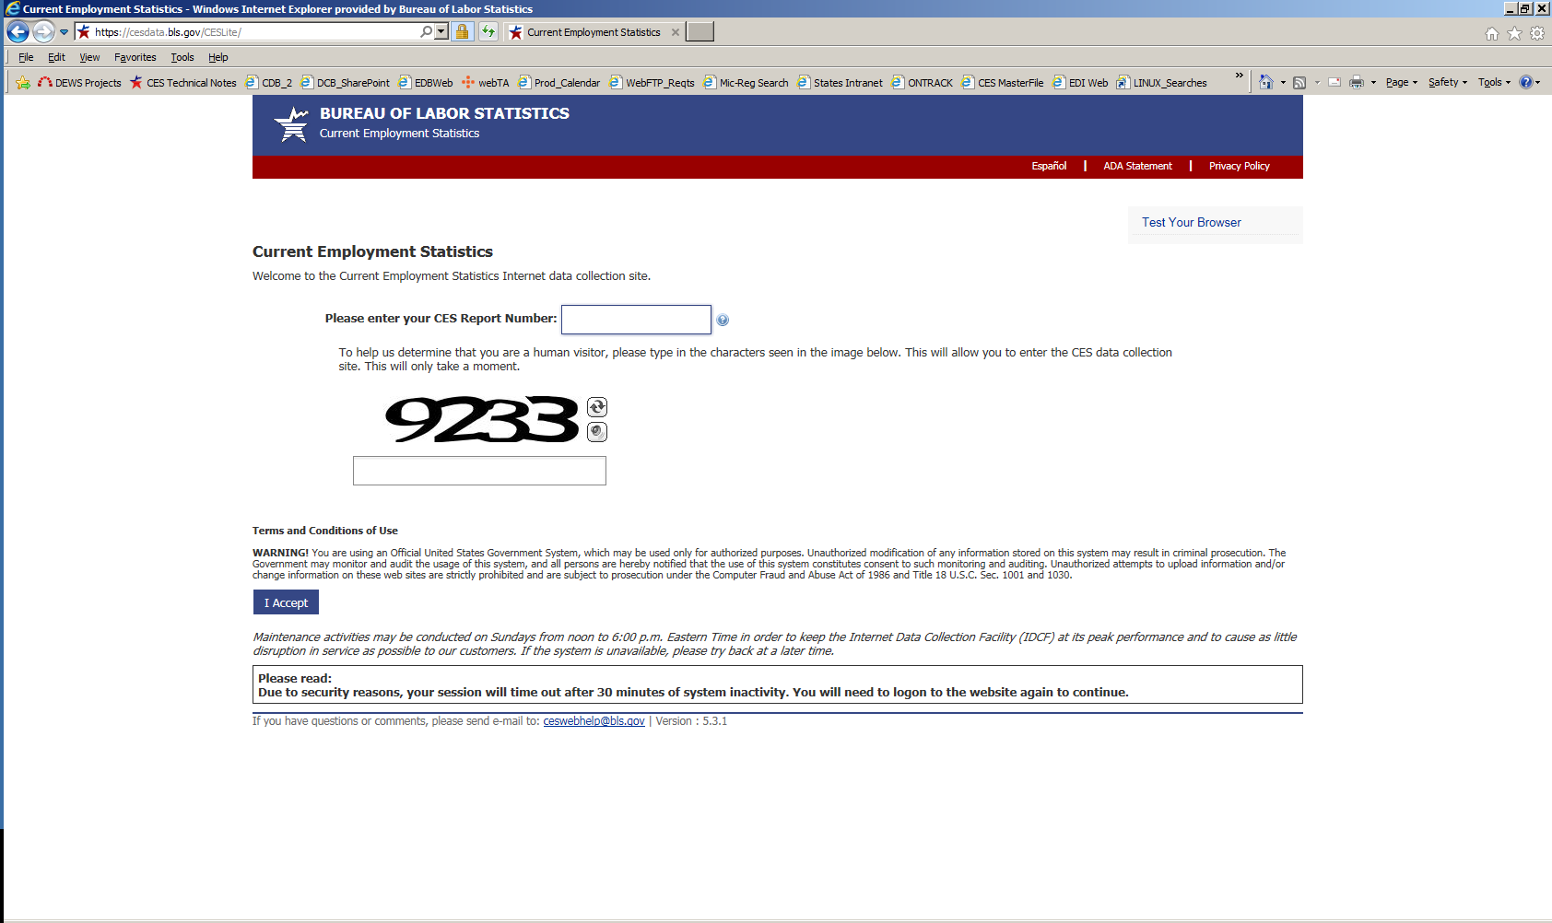

Dear Employer Screen
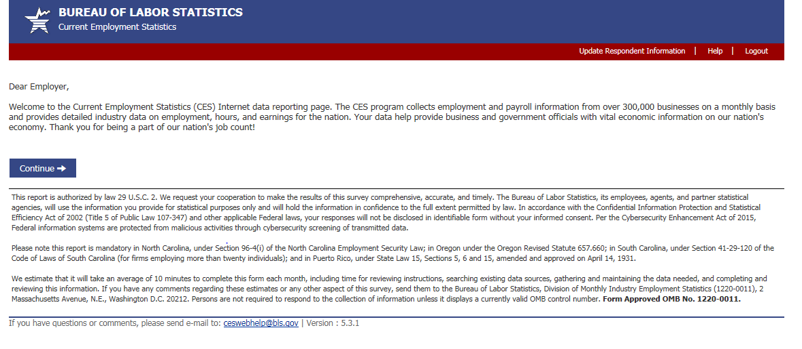

Respondent Information Screen (for first-month Web respondents only)
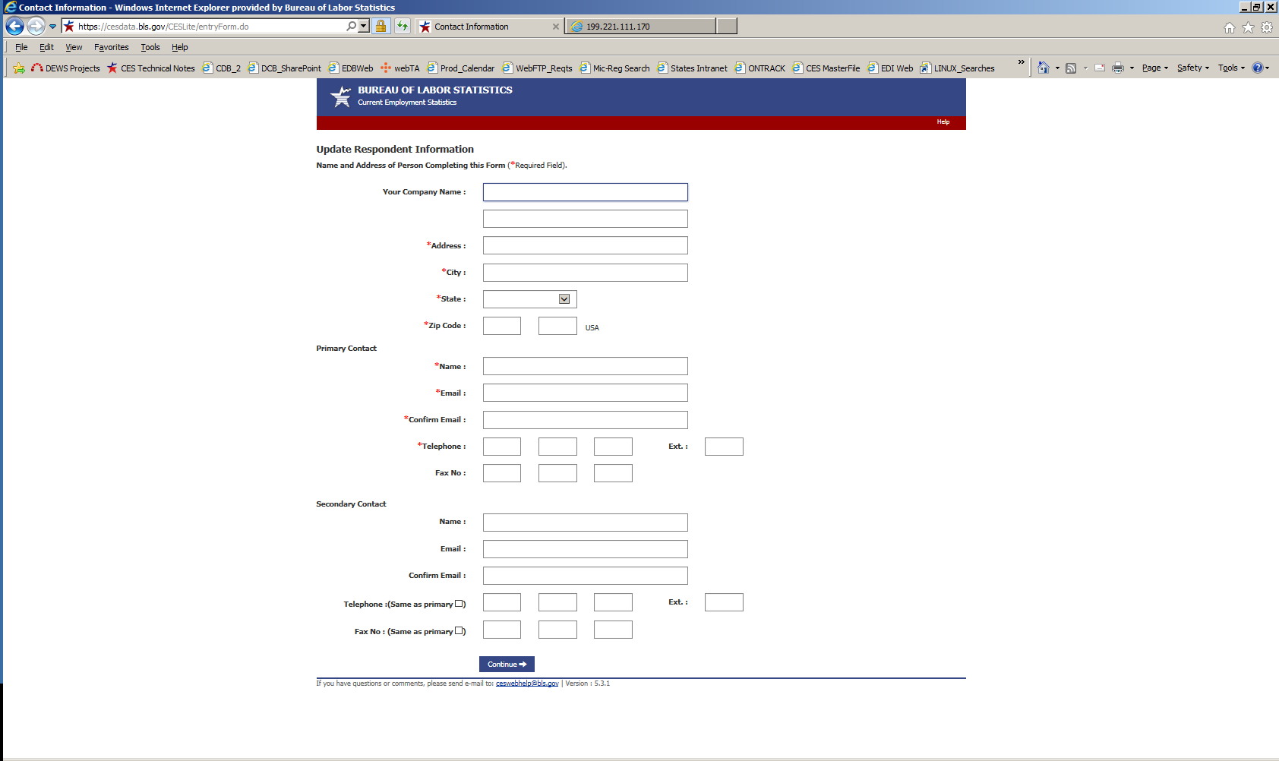
Set Pay and Commissions Frequency Screen (for first-month Web respondents only, private sector)
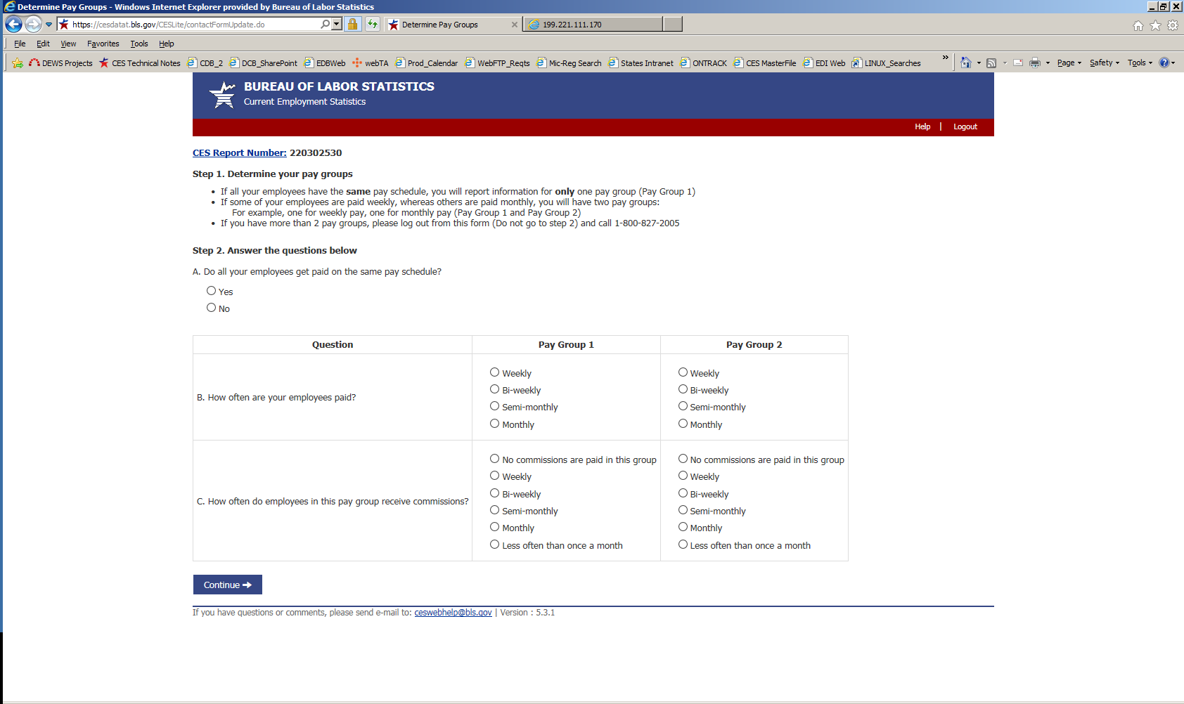

Data Entry Screen (pay group 1)
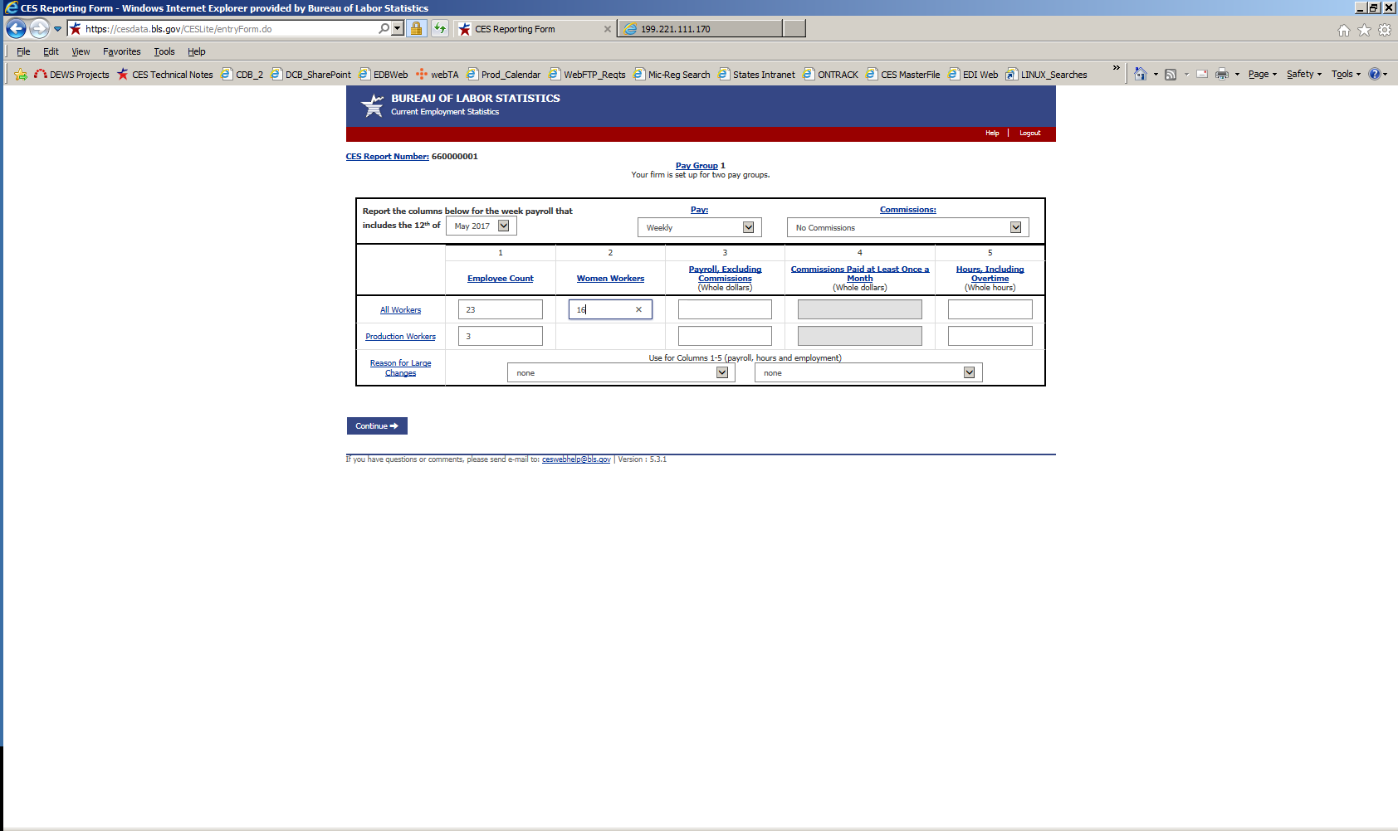

Data Entry Screen (pay group 2, if 2 pay groups)
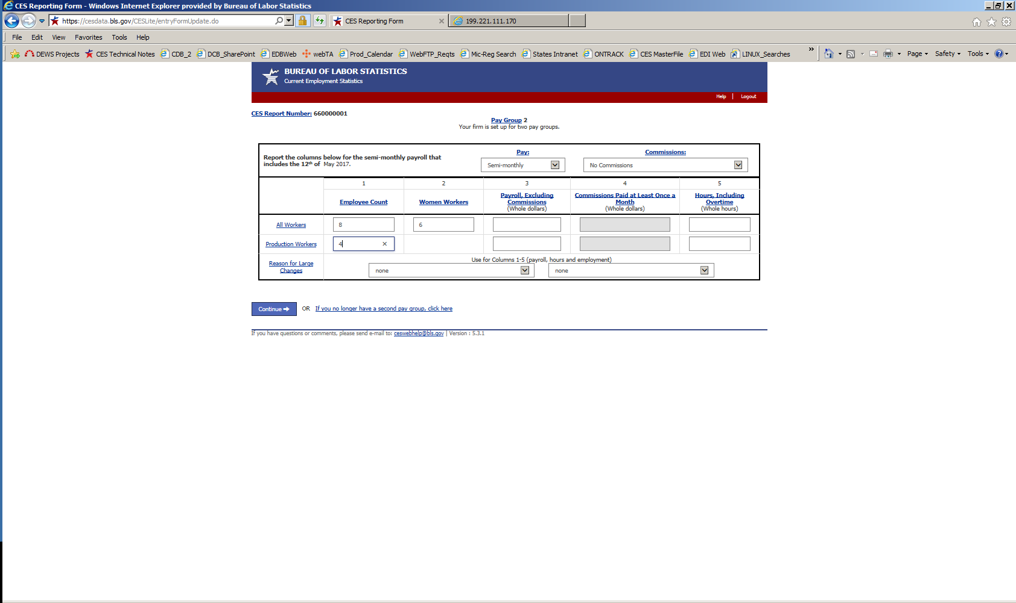

Data Review Screen
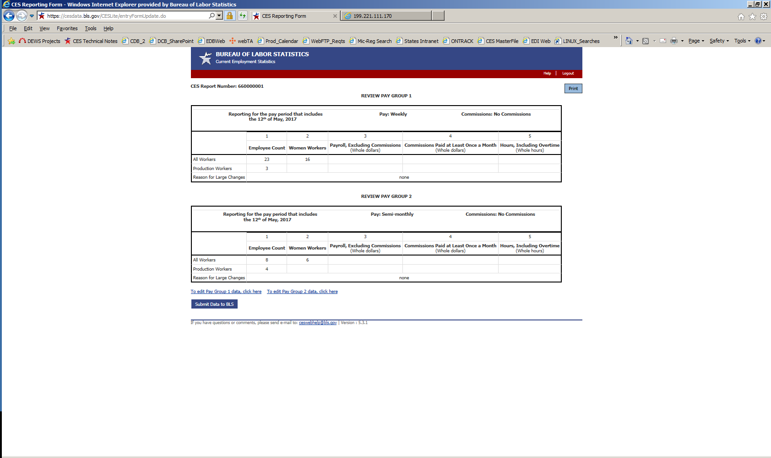

Thank You Screen
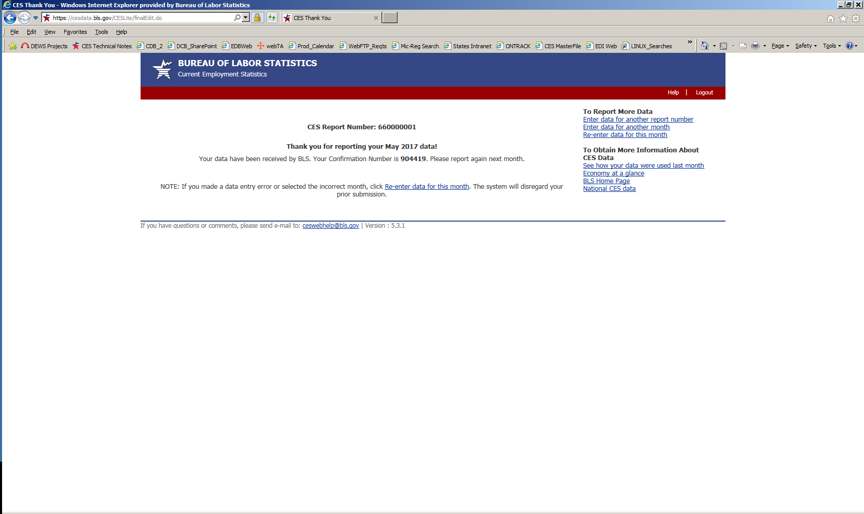

Web Collection Instrument Screens (Spanish)
Login Screen
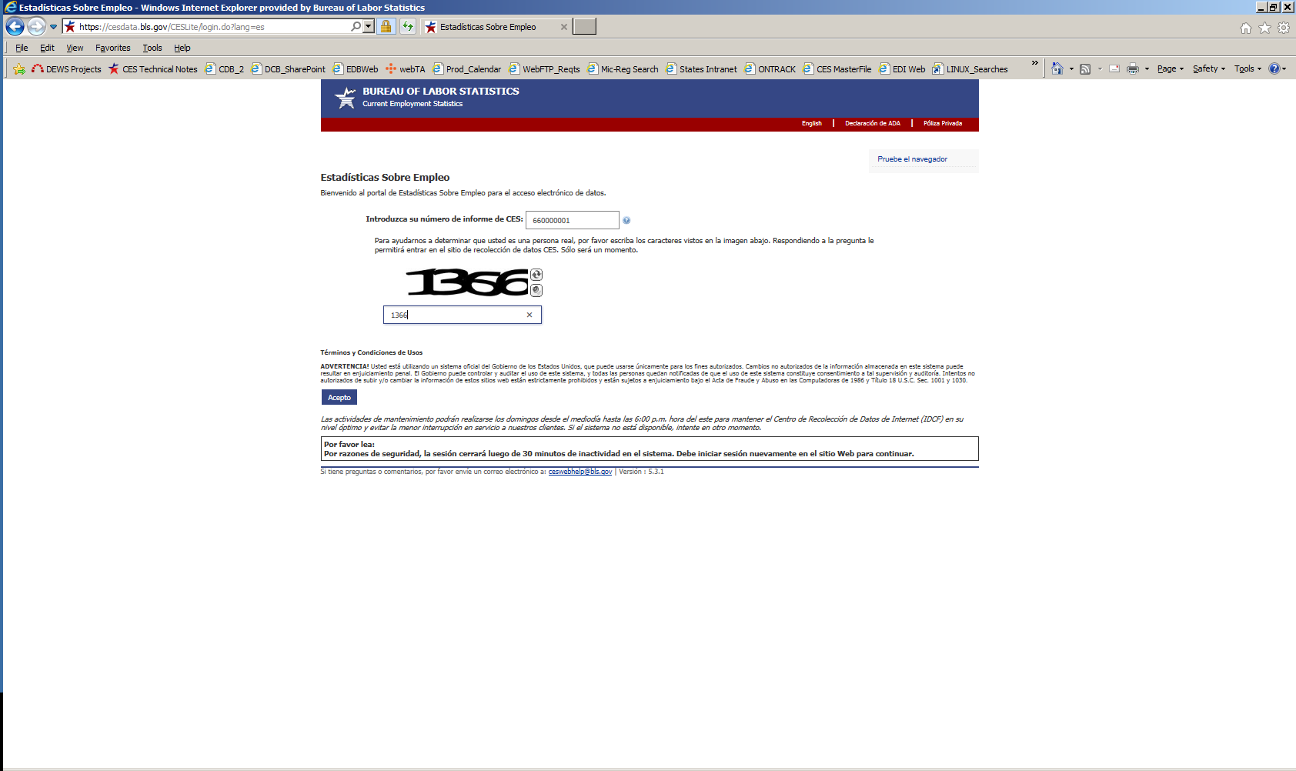

Dear Employer Screen
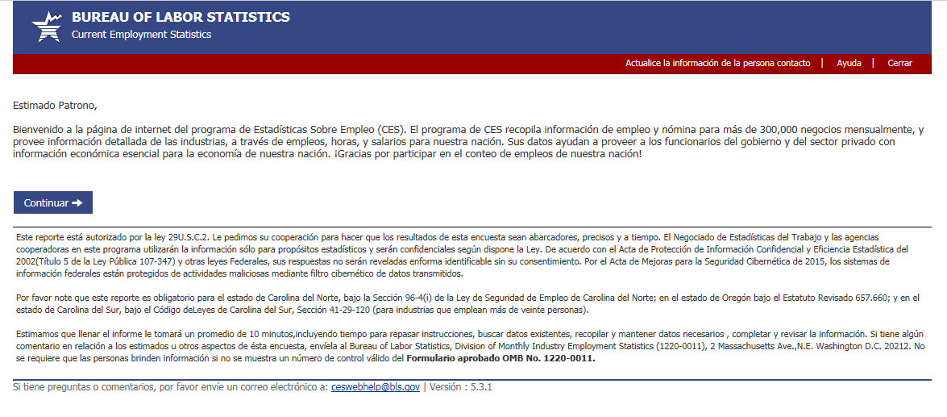

Respondent Information Screen
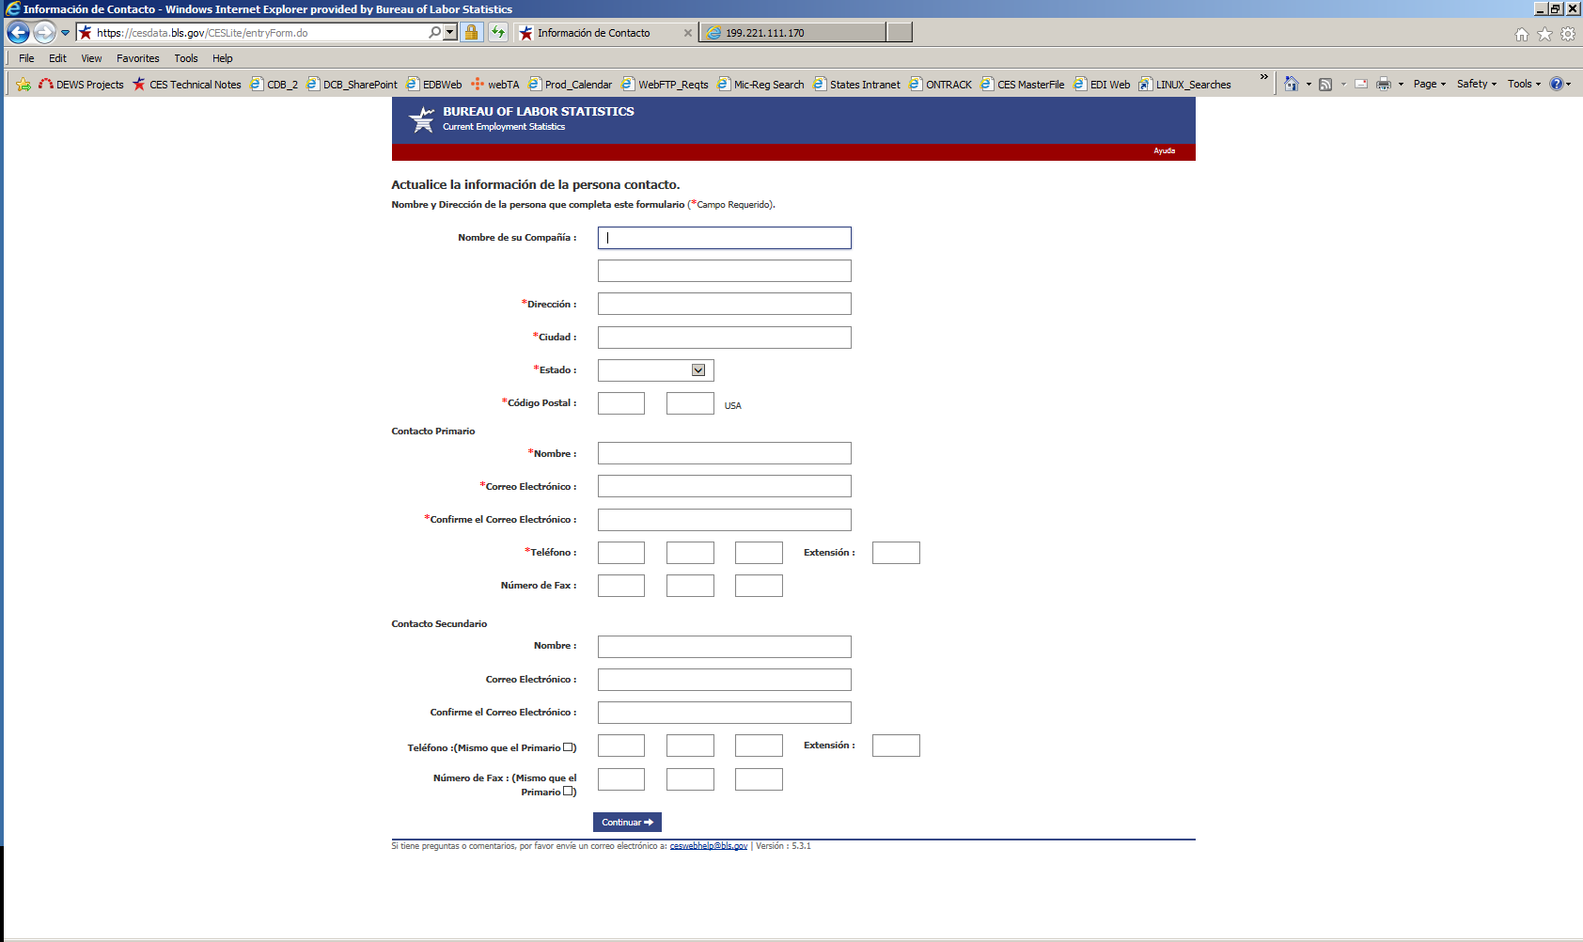

Set Pay and Commissions Frequency Screen (for first-month Web respondents only, private sector)
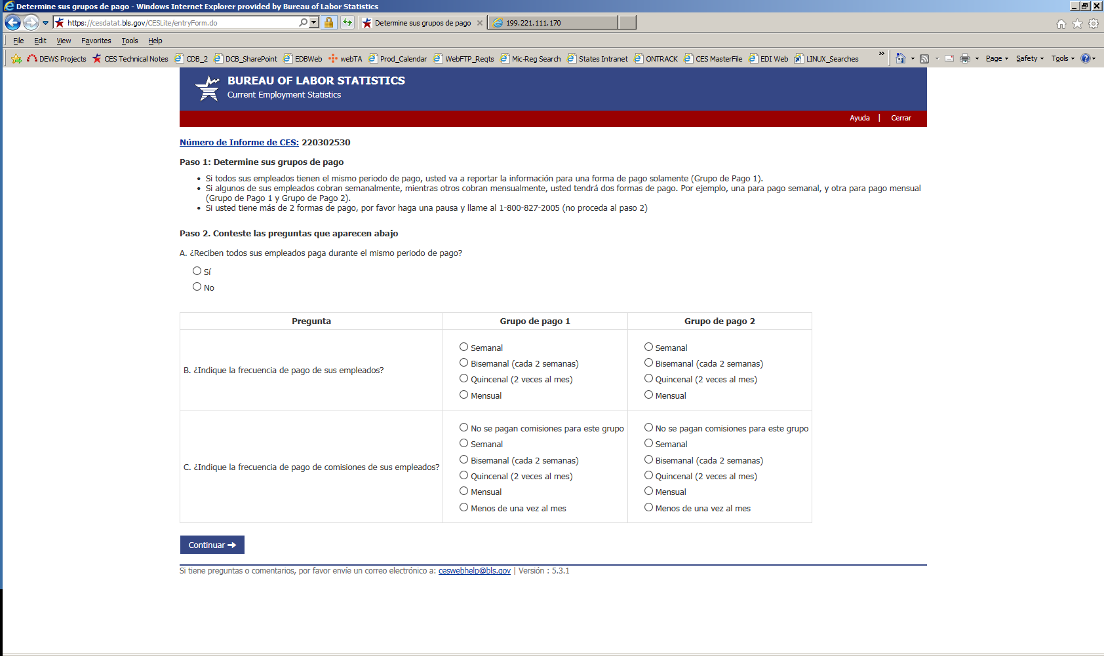
Data Entry Screen (pay group 1)
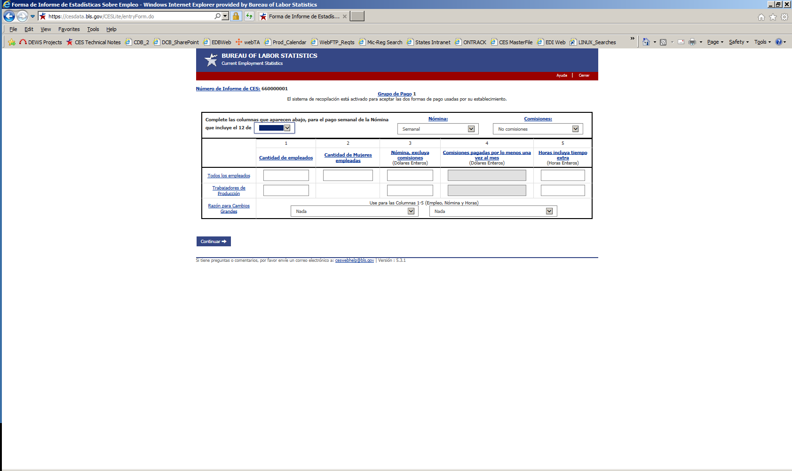

Data Entry Screen (pay group 2, if 2 pay groups)
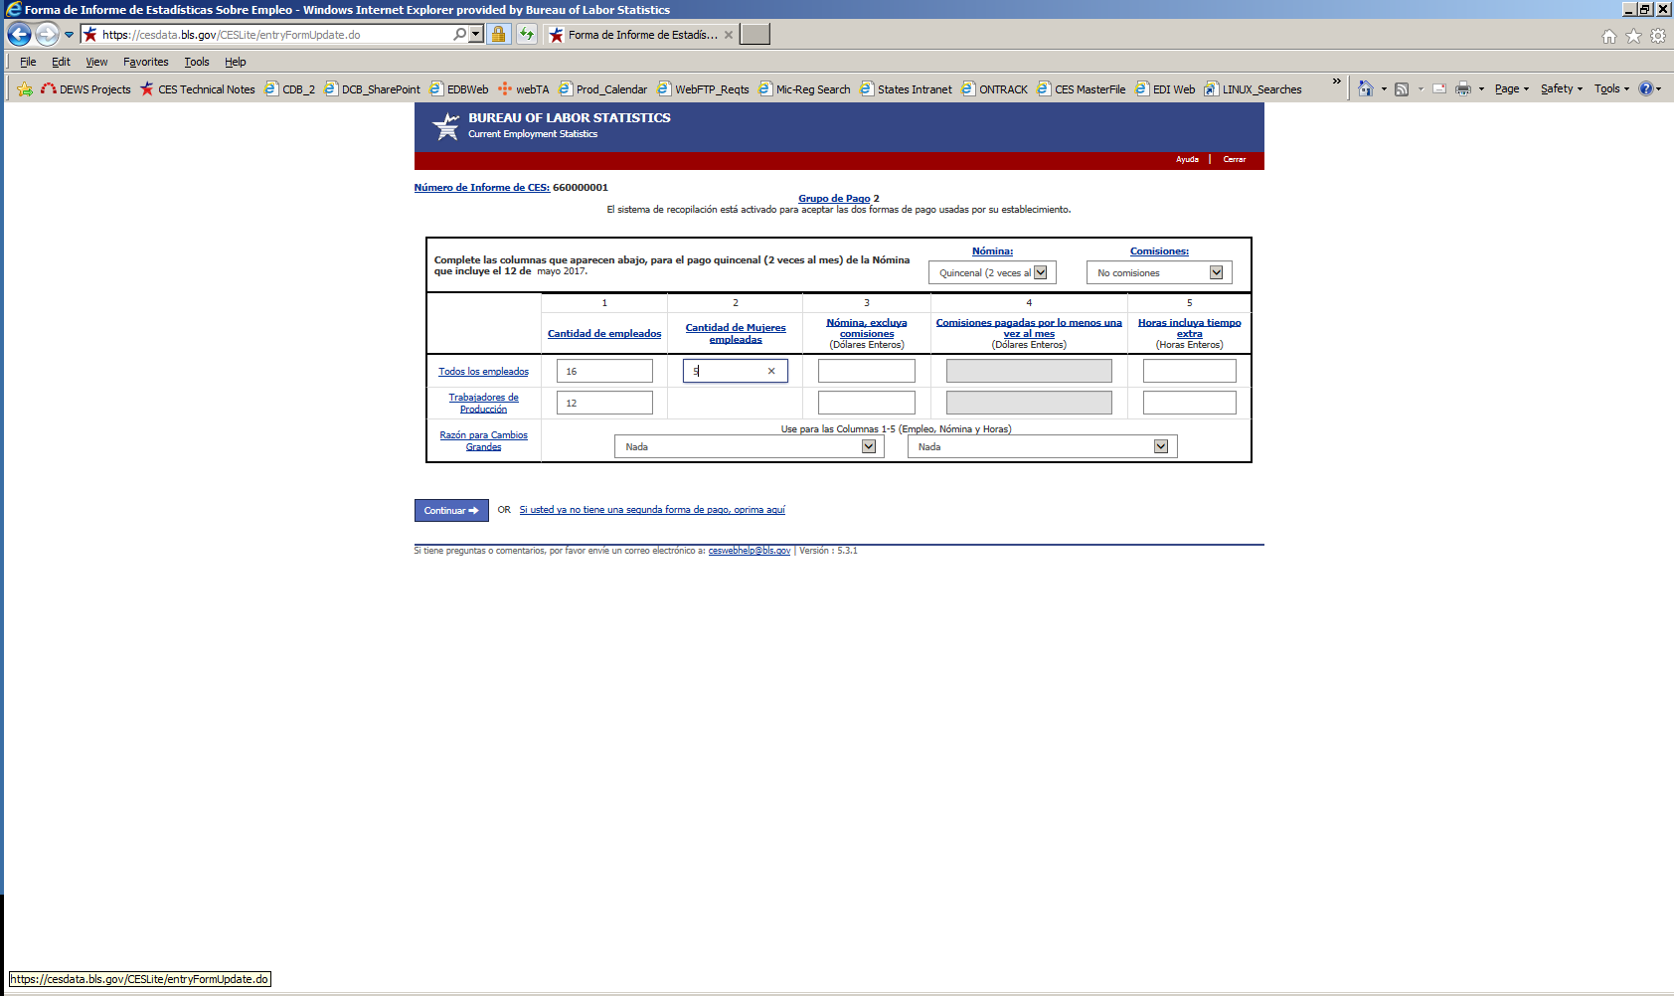

Data Review Screen
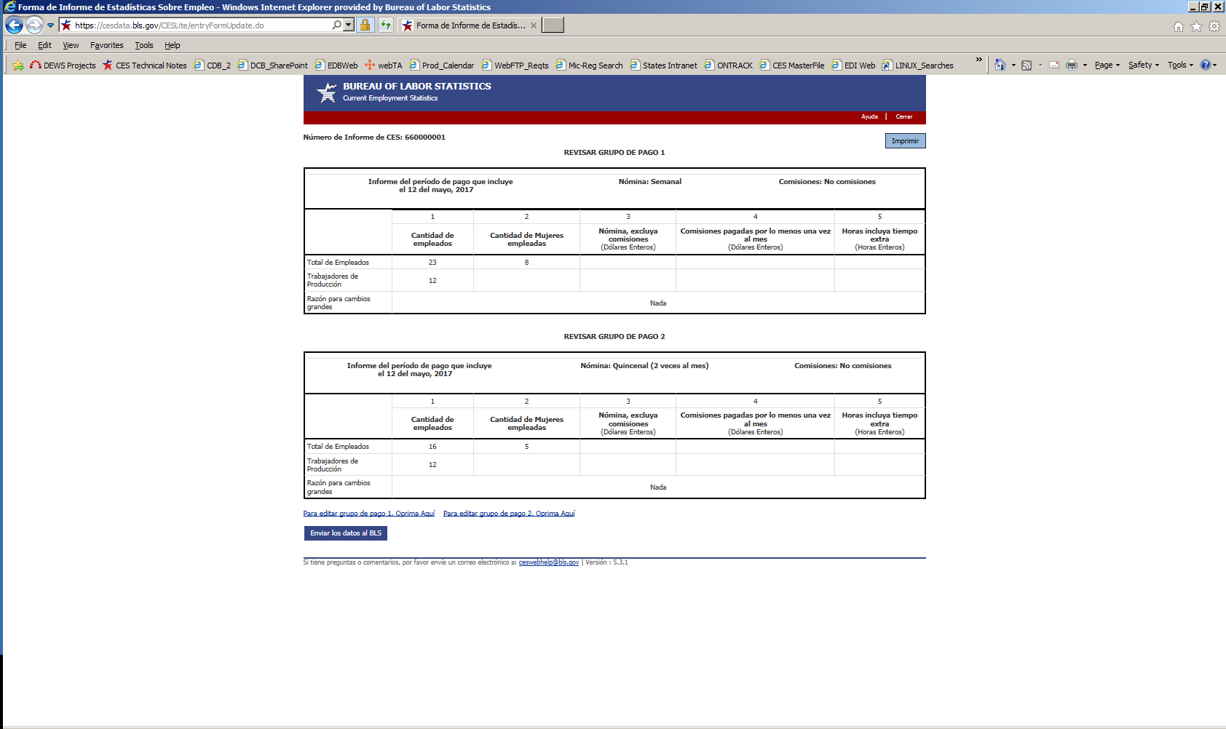

Thank You Screen
