**Appendix A –** ATUS Sleep Measures Online Study Protocol

**Welcome!**

Thanks for your interest in our research. We’re conducting this study to better understand how people spend their time as it relates to…

<Sleep condition>

“…How much sleep people in America get. This survey includes questions about your sleep behavior, including times you typically go to bed and wake up and how much actual sleep you think you get.”

<ATUS condition >

“…How people in America spend their time. This survey includes questions about your time use, used to find out how people balance work, child care, leisure, and other activities in their lives.”

Unlike some surveys or online tasks, we ask that you complete this task all at one time. Please begin only when you are in a quiet place where you won't be disturbed for about 20 minutes.

Please do not use your browser's back button.

*This voluntary study is being collected by the Bureau of Labor Statistics under OMB No. 1220-0141. We will use the information you provide for statistical purposes only. Your participation is voluntary, and you have the right to stop at any time. This survey is being administered by Qualtrics and resides on a server outside of the BLS Domain. The BLS cannot guarantee the protection of survey responses and advises against the inclusion of sensitive personal information in any response. By proceeding with this study, you give your consent to participate in this study.*

Select ‘*Next*’ to continue

---page break---

**Diary Introduction**

On the next few pages, you will be prompted to think back to the last 24 hours, starting at 4 am yesterday morning and continuing through 4 am TODAY <INSERT DATE>. Please think back to each activity you did in as much detail as possible and what time you started and ended each activity. By activity, we mean anything you did during that time frame.

On the next screen, you will be asked to select the type of activity you did from a drop-down list and what time you started and stopped that activity. If you don’t see the activity you were doing, please select ‘Other Activity’.

Please be sure to account for your whole day, so the end time of one activity should be the start time of the next activity. There should not be any gaps.

Below is an example of a completed version of how the activity log should appear:

<Participants will be presented with a 20-row matrix of drop-down menus (as seen in the image of the Activity Log below) where they can enter each activity they did, including start and stop times, for the remainder of the 24-hour period>

Drop-down menu/randomize order of choices, except ‘Other’ is always last]:

* Sleeping
* Grooming
* Watching TV
* Working
* Eating / Drinking
* Household chores
* Shopping
* Traveling /commuting
* Leisure activity
* Sports / exercise / recreation
* Studying / learning
* Socializing
* Other activity

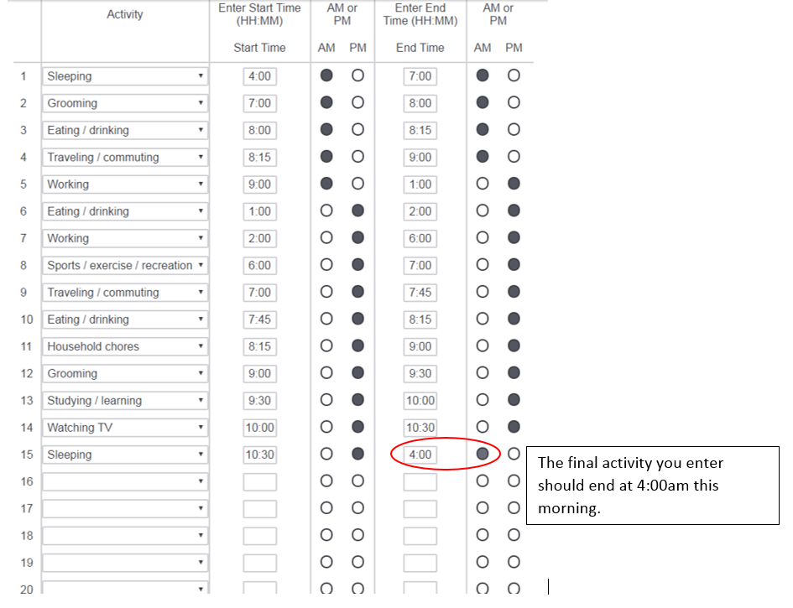

---page break---

[question order on this page will be randomized]

Note: For this set of questions, participants will use a drop down menu. The ‘hours’ drop-down menu will have the numbers 0-24 and the minutes drop down will have the numbers 0-55 in increments of 5.

Thank you for completing the activity log. Next, we’d like to know more about how you spend your time in general. Please think of a **typical day** while answering these questions, not one where you traveled, vacationed, or had family crises.

On average, how many hours per day do you participate in the following activities…?

1.) Working at your main job? ____ hours ____minutes

2.) Exercising (for example, sports, or physical activities) in your free time? ____ hours ____minutes

3.) Household chores and other cleaning activities? ____ hours ____minutes

4.) Watching television? ____ hours ____minutes

5.) Using technological devices connected to the Internet (for example, a personal computer, cell phone, or tablet, excluding television), in your free time? ____ hours ____minutes

6.) Traveling from place to place, such as commuting to and from work? ____ hours ____minutes

7.) Leisure activities, such as reading or other hobbies? ____ hours ____minutes

---page break---

The following questions are about your typical sleep routine on a weekday or workday, in which you work the next day. Please think of a **typical weekday** while answering these questions, not one where you traveled, vacationed, or had family crises.

Note: For this set of questions, participants will use a drop down menu. The hours drop-down menu will have the numbers 1-12 and the minutes drop down will have the numbers 0-55 in increments of 5.

1.) On a typical weekday (or workday) at what time do you get into bed to fall asleep?

____ hour; ____ minute; ____AM/PM

2.) On a typical weekday (or workday) at what time do you actually fall asleep? ____ hour; ____ minute; ____AM/PM

3.) On a typical weekday (or workday) at what time do you wake up?

____ hour; ____ minute; ____AM/PM

4.) On a typical weekday (or workday) at what time do you get out of bed?

____ hour; ____ minute; ____AM/PM

---page break---

The following questions are about your typical sleep routine on a weekend or day off, in which you do NOT work the next day.

Please think of a **typical weekend** while answering these questions, not one where you traveled, vacationed, or had family crises.

1.) On a typical weekend (or day off) at what time do you get into bed to fall asleep?

____ hour; ____ minute; ____AM/PM

2.) On a typical weekend (or day off) at what time do you typically fall asleep? ____ hour; ____ minute; ____AM/PM

3.) On a typical weekend (or day off) at what time do you wake up?

____ hour; ____ minute; ____AM/PM

4.) On a typical weekend (or day off) at what time do you get out of bed?

____ hour; ____ minute; ____AM/PM

---page break---

The following questions are about how many hours you actually spend sleeping.

1.) On average, how many hours of sleep do you get in a 24-hour period? ____ hours

2.) On a typical weekday (or workday) how many hours of sleep do you get in a 24-hour period? ____ hours

3.) On a typical weekend (or day off), how many hours of sleep do you get in a 24-hour period? ____ hours

4.) On average, how long does it take you to fall asleep? ____ hours ____minutes

5.) Do you typically take naps?

* Yes (go to 5)
* No (go to 6)

6.) How long does your typical nap last? ____ hours ____minutes

7.) Do you typically wake up during the night for any reason?

* Yes (go to 7)
* No (skip to next page)

8.) When you wake up during the night, on average, how long are you awake for?

____ hours ____minutes

---page break---

**Follow-up Questions**

1.) Earlier you said that on average you sleep [TEXT FILL] number of hours in a 24-hour period. How confident are you about the accuracy of your answer?

* Not at all confident
* Slightly confident
* Moderately confident
* Very confident
* Extremely confident

2.) How many hours do you think is appropriate for an average person to sleep in one night?

_____ hours

3.) How many hours do you think most people would have to sleep before feeling embarrassed for sleeping too MUCH in one night? ____ hours

4.) How embarrassing do you think it would be for most people to admit they slept ***more than*** <TEXT FILL from #3> hours in one night?

* Not at all embarrassing
* Slightly embarrassing
* Moderately embarrassing
* Very embarrassing
* Extremely embarrassing

5.) How few hours do you think most people would have to sleep before feeling embarrassed for sleeping too LITTLE in one night? ____ hours

6.) How embarrassing do you think it would be for most people to admit they slept ***fewer than*** <TEXT FILL from #5> hours in one night?

* Not at all embarrassing
* Slightly embarrassing
* Moderately embarrassing
* Very embarrassing
* Extremely embarrassing

7.) When you need more time, how often do you tend to cut back on your sleep?

* Never (0 times per week)
* Rarely (1-2 times per week)
* Sometimes (3-4 times per week)
* Frequently (5 or more times per week)

8.) How often do you have time on your hands that you don’t know what to do with?

* Never (0 times per week)
* Rarely (1-2 times per week)
* Sometimes (3-4 times per week)
* Frequently (5 or more times per week)

---page break---

Please answer the following questions about yourself.

*Balanced Inventory of Socially Desirable Responding*

1 2 3 4 5

(strongly disagree) (strongly agree)

1. I sometimes tell lies if I have to.
2. I never cover up my mistakes.
3. I always obey laws, even if I am unlikely to get caught.
4. I have said something bad about a friend behind his or her back.
5. When I hear people talking privately, I avoid listening.
6. I have received too much change from a salesperson without telling him or her.
7. When I was young I sometimes stole things.
8. I have done things that I don’t tell other people about.
9. I never take things that don’t belong to me.
10. I don’t gossip about other people’s business.

---page break---

Please answer the following questions about yourself.

*Maximizer-Satisficer Scale*

1 2 3 4 5

(strongly disagree) (strongly agree)

1. When I am in the car listening to the radio, I often check other stations to see if something better is playing, even if I am relatively satisfied with what I’m listening to.

2. No matter how satisfied I am with my job, it’s only right for me to be on the lookout for better opportunities.

3. I often find it difficult to shop for a gift for a friend.

4. Picking a movie to watch is really difficult. I’m always struggling to pick the best one.

5. No matter what I do, I have the highest standards for myself.

6. I never settle for second best.

---page break---

*Mindfulness Attention Awareness Scale (MAAS)*

1 2 3 4 5

(not at all) (a little) (moderately) (very much) (completely)

Please indicate to what degree you were having each experience described below **while you completed the survey**. Please answer according to what really reflected your experience rather than what you think your experience should have been.

1.) I was finding it difficult to stay focused on the survey.

2.) I was doing the survey without paying attention.

3.) I was preoccupied with the future or the past.

4.) I was doing the survey automatically, without being aware of what I was doing.

5.) I was rushing through the survey without really being attentive to it.

---page break---

[order of pages in this section will be randomized]

1.) How burdensome was it to complete this survey?

* Not at all burdensome
* A little burdensome
* Moderately burdensome
* Very burdensome
* Extremely burdensome

(if answered Moderately, Very, or Extremely) Please explain: _______

2.) How burdensome was it to complete the activity log, where you entered each of your activities from the previous day?

* Not at all burdensome
* A little burdensome
* Moderately burdensome
* Very burdensome
* Extremely burdensome

(if answered Moderately, Very, or Extremely) Please explain: _______

---page break---

1.) How effortful was it to complete this survey?

* Not at all effortful
* A little effortful
* Moderately effortful
* Very effortful
* Extremely effortful

2.) How effortful was it to complete the activity log, where you entered each of your activities from the previous day?

* Not at all effortful
* A little effortful
* Moderately effortful
* Very effortful
* Extremely effortful

---page break---

1.) How interesting did you find this survey?

* Not at all interesting
* A little interesting
* Moderately interesting
* Very interesting
* Extremely interesting

2.) How interesting do you find the topic of how you spend your time?

* Not at all interesting
* A little interesting
* Moderately interesting
* Very interesting
* Extremely interesting

3.) How interesting do you find the topic of sleep?

* Not at all interesting
* A little interesting
* Moderately interesting
* Very interesting
* Extremely interesting

---page break---

1.) How sensitive were the questions in this survey?

* Not at all sensitive
* A little sensitive
* Moderately sensitive
* Very sensitive
* Extremely sensitive

(if answered Moderately, Very, or Extremely) Please explain: _______

2.) How sensitive was it for you to answer questions about how much you sleep?

* Not at all sensitive
* A little sensitive
* Moderately sensitive
* Very sensitive
* Extremely sensitive

(if answered Moderately, Very, or Extremely) Please explain: _______

---page break---

1.) How easy or difficult was it for you to answer the questions in this survey?

* Very difficult
* Difficult
* Neither easy nor difficult
* Easy
* Very easy

2.) How easy or difficult was it to remember the activities you did yesterday?

* Very difficult
* Difficult
* Neither easy nor difficult
* Easy
* Very easy

3.) How easy or difficult was it to answer the questions about how much sleep you get?

* Very difficult
* Difficult
* Neither easy nor difficult
* Easy
* Very easy

(if answered Very difficult or Difficult) Please explain: _______

---page break---

1.) How well-rested do you feel right now?

* Not at all rested
* A little rested
* Somewhat rested
* Very rested

2.) Did you feel the length of this survey was too long, too short, or about right?

* Too long
* About right
* Too short

---page break---

1.) Do you use a wearable device or Smartphone (for example, a Fitbit or Smartphone app) to track your sleep?

* Yes (go to 2)
* No (go to next page)

2.) Did you use the information from that device to answer any of the questions in this survey?

* Yes
* No

---page break---

**Demographic information**

1.) Which of the following best describes you?

* Employed full time
* Employed part time
* Unemployed
* Student
* Retired
* Other, specify: ______________

2.) How many days per week do you usually work?

* [dropdown menu with 0-7]

3.) What is the highest level of education you’ve completed?

* Less than high school
* High school diploma or GED
* Some college
* Associate degree
* Bachelor’s degree
* Graduate school degree

4.) Are you of Hispanic, Latino or Spanish origin?

* Yes
* No

5.) What is your race?

* White
* Black or African American
* American Indian or Alaska Native
* Asian
* Other

6.) What is your gender?

* Male
* Female
* Other

7.) What is your age?

____ years

8.) What is your household size? By household, we mean the number of people currently living in your residence, including yourself.

* 1 person (including yourself)
* 2 people
* 3 people
* 4 people
* 5 or more people

9.) How many of the <TEXT FILL from #7> people in your household are under the age of 16?

10.) How many of the <TEXT FILL from #7> people in your household are under the age of 5?

---page break---

Thank you for your participation! If you have any additional thoughts on this survey, please provide them in the space below. _____________