IP Gateway Landing page upon login.
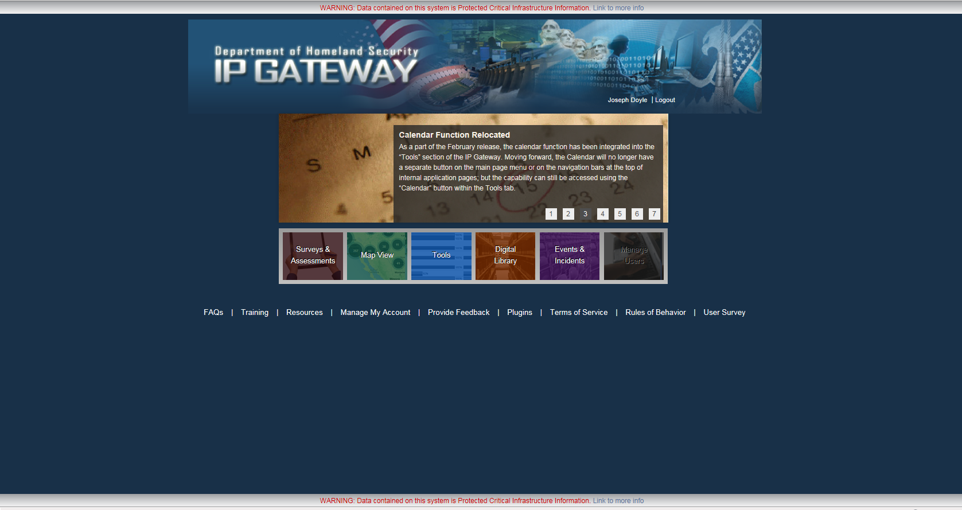
Statement and Control # here.
Link for Survey for Feedback
Click here for to access the assessments.

After clicking the “Surveys and Assessments” button, a user is directed here for viewing assessments. There are multiple ways to find their assessments once here via the search block, or by selecting different filters to locate the assessment.
