­

SITEMAP testing QUESTIONS AND TASKS

FSA Digital Platform

April 10, 2019 | Version 1 | Contract #123456

## Pre-Test Questions

Participants will be asked to respond to the following questions when they first land on the testing web page:

* + Which of the following best describes your role?
    - Prospective Student Borrower
    - Prospective Parent Borrower
    - Student Borrower (not currently repaying loans)
    - Student Borrower (currently repaying loans)
    - Parent Borrower (not currently repaying loans)
    - Parent Borrower (currently repaying loans)
    - Parent of a Student Borrower
    - Other [Please specify]
  + How many times have you visited **StudentAid.gov** (including **FAFSA**)?
    - 1–5 times
    - 6–10 times
    - 11–15 times
    - More than 15 times
    - Never
    - I don’t know
  + How many times have you visited **StudentLoans.gov**?
    - 1–5 times
    - 6–10 times
    - 11–15 times
    - More than 15 times
    - Never
    - I don’t know

## Site Structure Tree Testing

We will enter the new site structure (the names of each page in a hierarchical arrangement) into an unmoderated testing platform called Treejack (from a company called Optimal Workshop). Treejack automatically makes our hierarchical site structure navigable online. That is, participants will be able to click on each node of the site structure in succession in order to find specific pages.

We will ask participants to complete the following tasks, which are common reasons that people visit Federal Student Aid’s websites:

* Complete exit counseling for a loan
* Review the eligibility criteria to receive federal student aid
* Find out if you can get your loan payments deferred
* Consolidate multiple loans into one loan
* Compare your repayment plan options
* Submit a FAFSA
* Review your Student Aid Report
* Learn about public service loan forgiveness
* Sign a loan agreement (or master promissory note)
* Estimate how much federal iad you are likely to receive (based on your financial information)
* Apply for an income-driven repayment plan

For each task, participants navigate the clickable site hierarchy in the Treejack tool in order to find the page on which they believe they can complete the task. Each task is expected to take 1-2 minutes.

Here are the tree testing instructions that will appear to participants

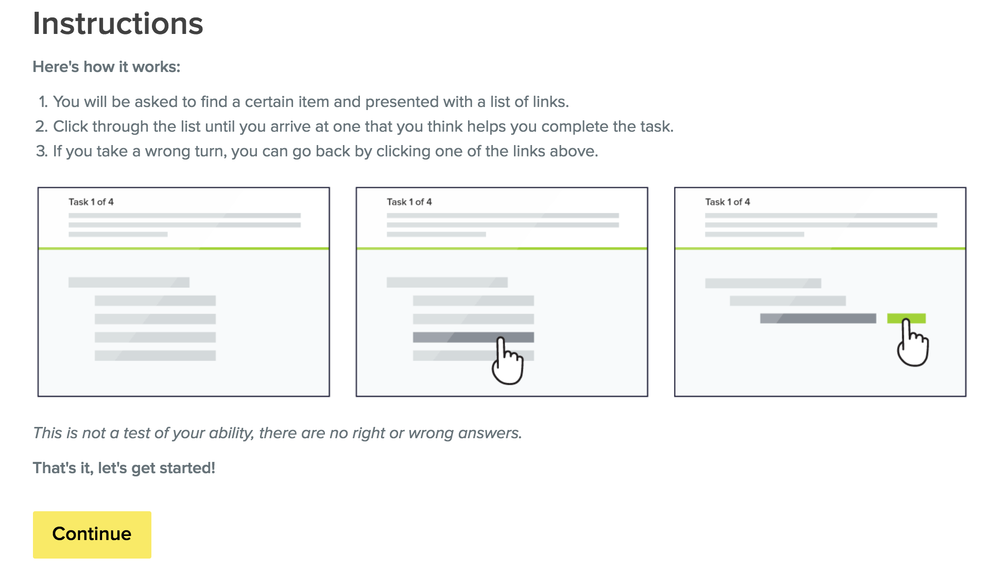

## Post-Test Questions

Participants will be given the opportunity to write responses of any length they choose to one or more of the following questions. These questions are optional and participants can complete the test without providing any responses to them.

* What is your general opinion of the new FederalStudentAid.gov site structure and navigation?
* What do you like best about it? Least?
* What would you like to see improved? Added? Changed?