
Department of Energy
Washington, DC 20585

Resident
[Street Address]
[City, State ZIP]

Dear Resident,

I am writing to ask for your help the 2015 Residential Energy Consumption Survey (RECS), a nationwide study being conducted by the United States Department of Energy. Through this study, we will learn how Americans use energy in their homes—information that is not available anywhere else. This information is critical to understanding future energy needs and improving efficiency.

In the next few weeks, we will be sending an interviewer from RTI International to visit your home. The interviewer will assist you in completing the RECS survey. While your participation is not required by law, your participation in this survey is essential. We hope you will agree to be a part of the 2015 RECS. Upon arrival, the interviewer will have a small gift for you as a token of our appreciation.

In the past, we have found that thinking about a few specific questions ahead of time will reduce the time it takes to complete the interview. This includes the types of energy used in your household (electricity, natural gas, wood, etc.), the age of your heating system, and the number of televisions in your residence. It is also helpful to have copies of recent bills from your electric company and other energy suppliers.

Finally, we encourage you to read the enclosed brochure, which contains facts about energy use in the United States and gives examples of how the information we collect is used. If you have any questions, please call RTI toll-free at 1-877-396-5366 or send an e-mail to RECS@rti.org. To speak to someone at the U.S. Department of Energy, please contact RECS manager Chip Berry at (202) 586-5543 or by email at james.berry@eia.doe.gov. Further information is also available on our web site at www.eia.doe.gov/consumption/residential.

Thank you again for your participation in the 2015 RECS!

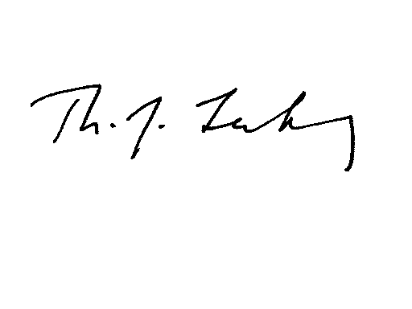
Sincerely,
Tom Leckey
Director, Office of Energy Consumption and Efficiency Statistics
U.S. Energy Information Administration
United States Department of Energy

PRIVACY ACT NOTICE

The Residential Energy Consumption Survey is being conducted by RTI International for the U.S. Department of Energy (DOE). It is authorized under the Federal Energy Administration Act of 1974 (Public Law 93-275), as amended and the Energy Policy Act of 1992.

The purpose of this survey is to collect residential energy consumption statistical information to be used by the DOE and other Federal agencies to administer programs, monitor energy usage, and plan for our nations’ energy future.

As part of this survey, we are requesting permission from you to obtain your energy consumption and expenditures data from your fuel suppliers. RTI, or some other designee of DOE, will need to maintain your name and address in order to collect information from your fuel suppliers.

Your participation in this survey is voluntary.

The information you provide will be used for statistical purposes only and is confidential by law. In accordance with the Confidential Information Protection and Statistical Efficiency Act of 2002 and other applicable Federal laws, your responses will not be disclosed in identifiable form without your consent. Per the Federal Cybersecurity Enhancement Act of 2015, Federal information systems are protected from malicious activities through cybersecurity screening of transmitted data. Every EIA employee, as well as every agent, is subject to a jail term, a fine, or both if he or she makes public ANY identifiable information you reported.

PUBLIC REPORTING BURDEN

You are not required to respond to this collection of information unless it displays a currently valid OMB control number. The OMB control number for this data collection is 1905-0092. The reporting burden on the public for this collection of information is estimated to average 50 minutes for the personal interview. Send comments regarding the public reporting burden or any other aspect of this collection of information, including suggestions for reducing this burden, to:

U.S. Energy Information Administration
Office of Survey Development and Statistical Integration, EI-21
1000 Independence Avenue, SW
Washington, DC 20585

and

Office of Information and Regulatory Affairs
Office of Management and Budget
Washington, DC 20503

