**Lender’s Screen**

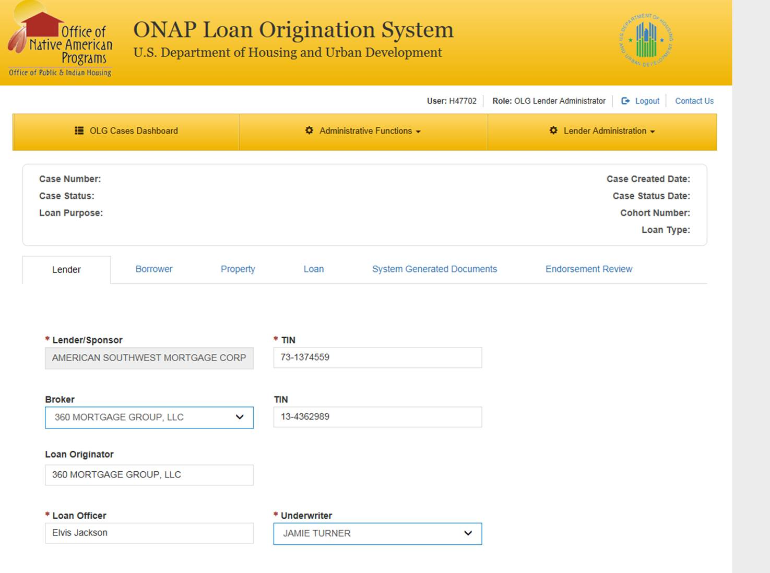

Privacy Act Statement. This statement is provided pursuant to the Privacy Act of 1974, 5 USC § 552a. The authority for collecting personally identifiable information (PII) in the Regulatory Consistency Communication Board (RCCB) Electronic Feedback Form is based in Section 313 of Public Law 112-95.

Public reporting burden for this collection of information is estimated to average .50 hours per response, including the time for reviewing instructions, searching existing data sources, gather and maintaining the data needed, and completing and reviewing the collection of information. HUD may not collect this information, and you are not required to complete this form, unless it displays a currently valid OMB control number.

This information is required in order for an eligible homebuyer to obtain a benefit and for HUD to administer the Loan Guarantee Program for low-income Native Americans, Alaska Natives, and native Hawaiians (24 CFR Parts1000 and 6000). The requested information is necessary to determine the income and credit worthiness of low income homebuyers. If HUD did not collect this information, it would prevent HUD from guaranteeing mortgages to eligible homebuyers. While no assurances of confidentiality are pledged to respondents, HUD generally discloses this data only in response to a Freedom of Information request.

**Borrower’s Screen**

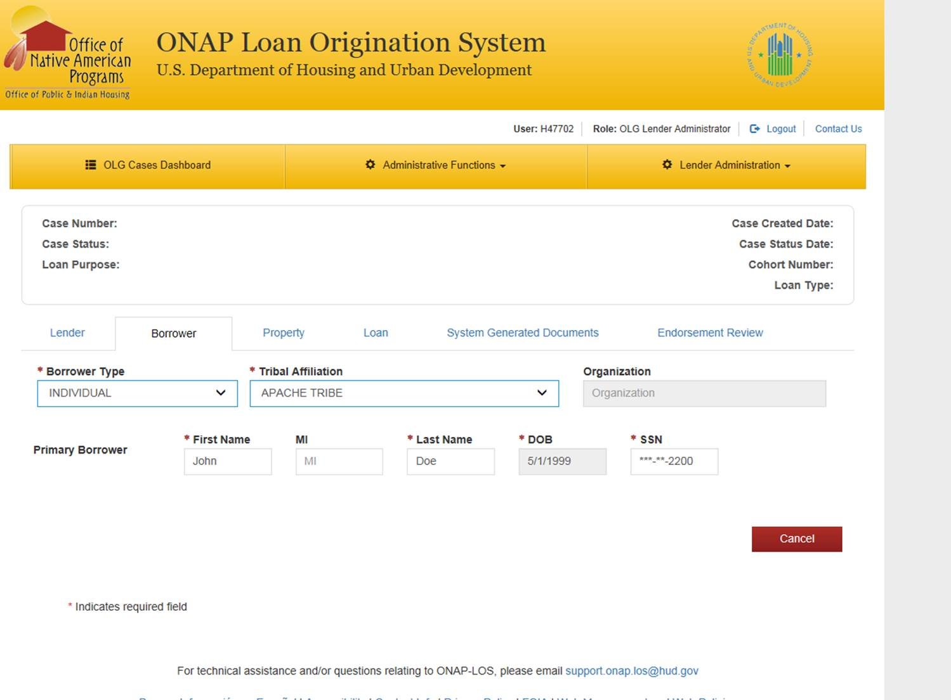

**Loan Screen (Part 1)**

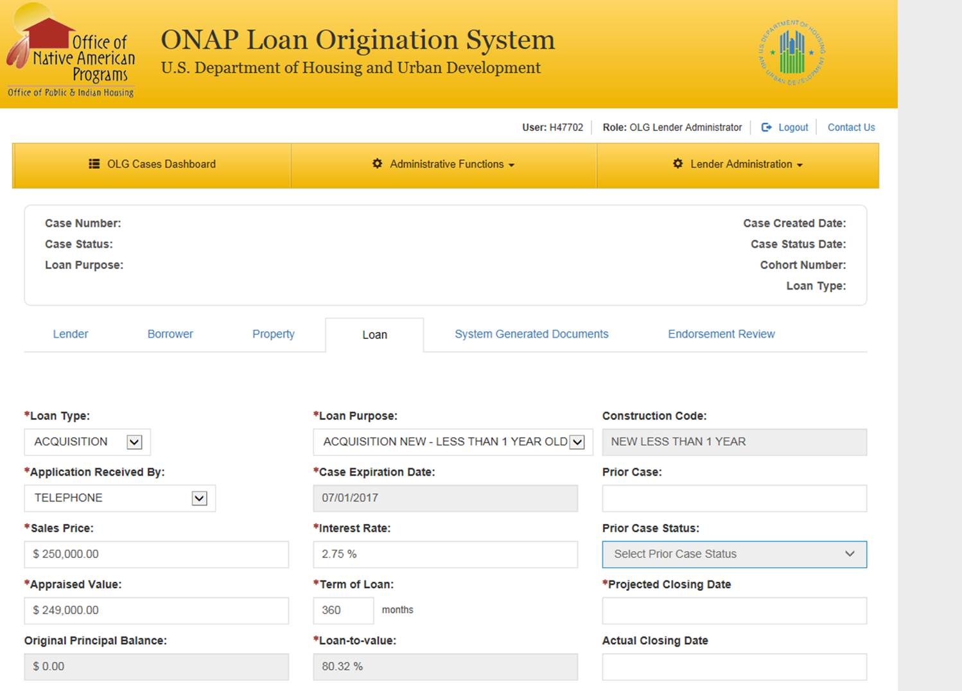

**Loan Screen (Part 2)**

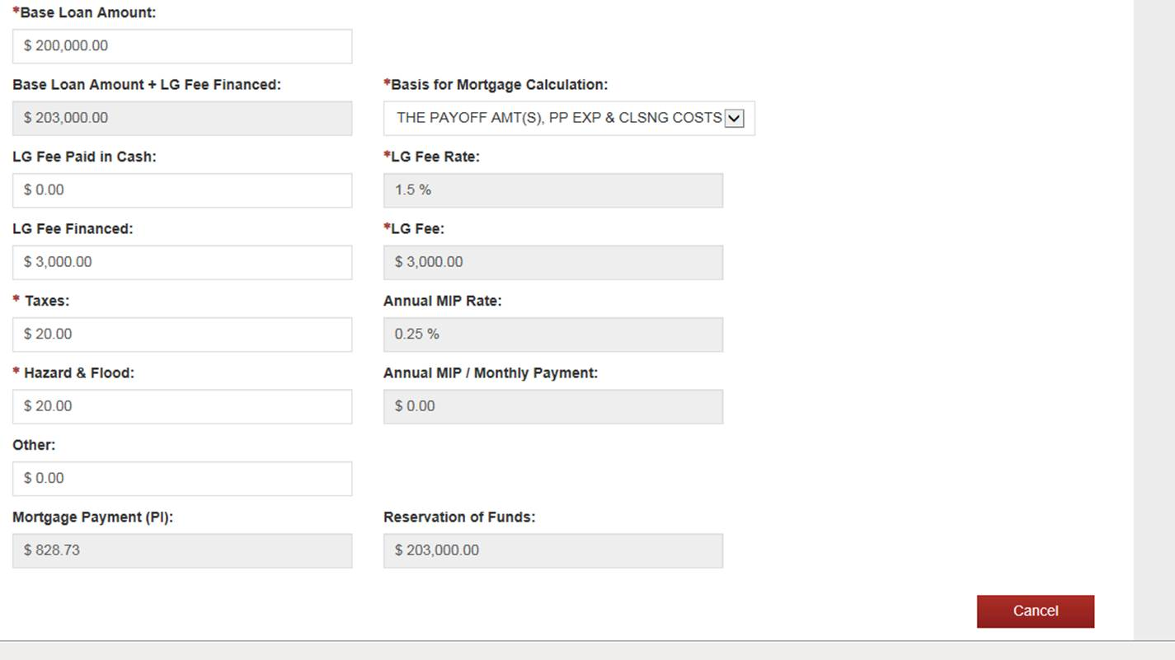

**Loan Screen (Part 3)**

