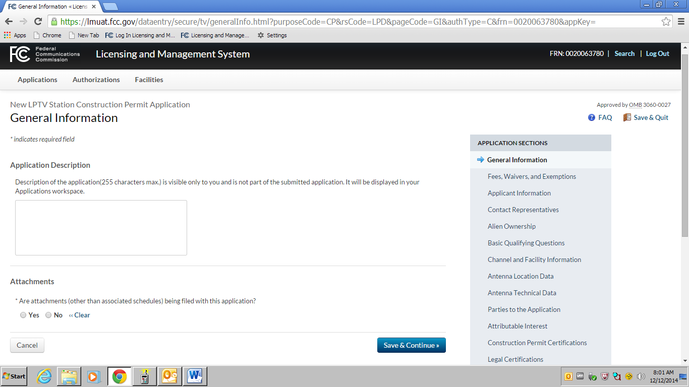

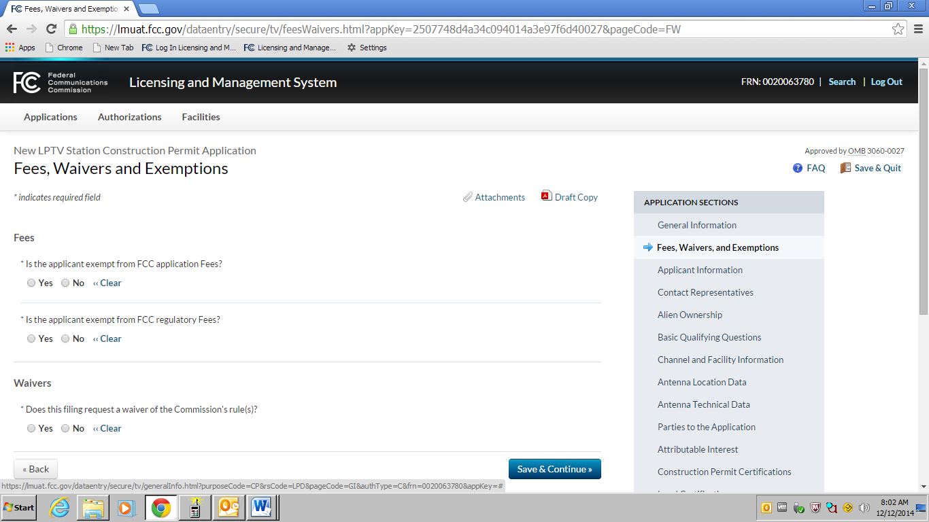

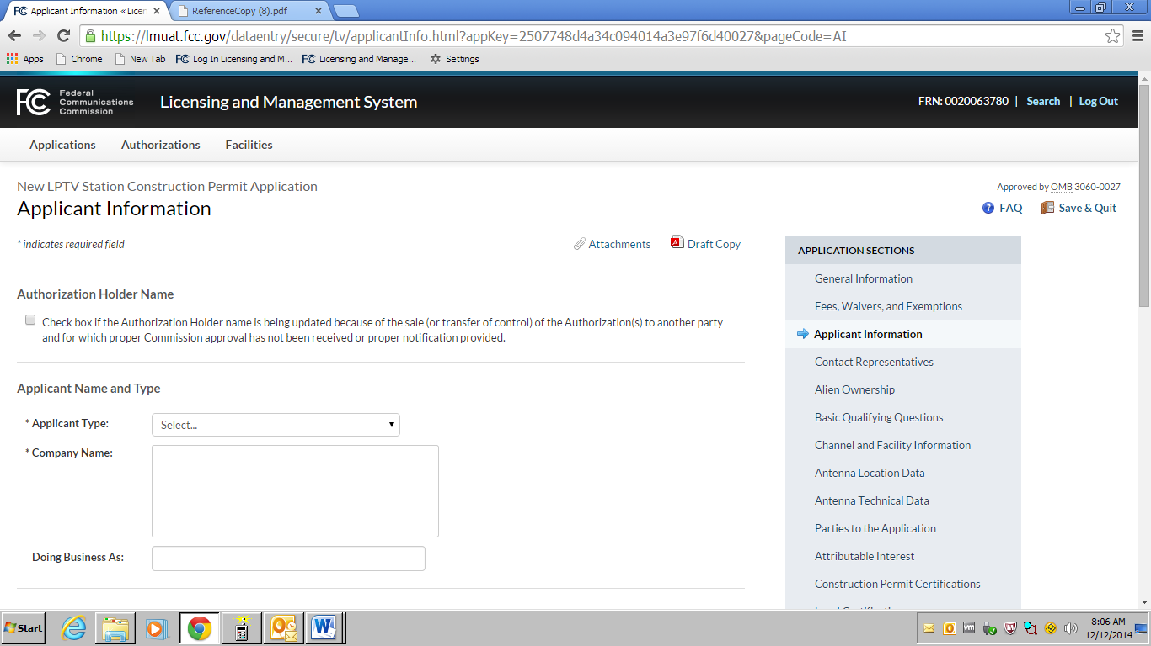

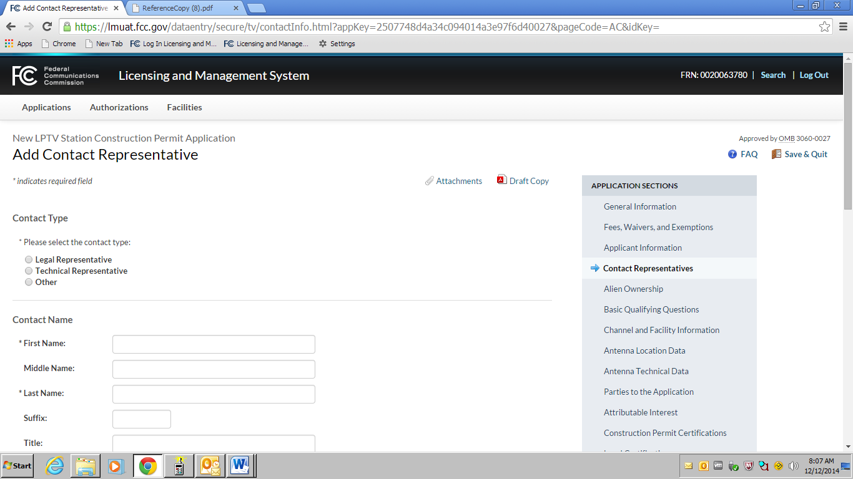

Alien Ownership Screen

1) Is the applicant a foreign government or the representative of any foreign government as specified in Section 310(a) of the Communications Act?

2) Is the applicant an alien or the representative of an alien? (Section 310(b)(1))

3) Is the applicant a corporation, or non-corporate entity, that is organized under the laws of any foreign government? (Section 310(b)(2))

4) Is the applicant an entity of which more than one-fifth of the capital stock, or other equity or voting interest, is owned of record or voted by aliens or their representatives or by a foreign government or representative thereof or by any entity organized under the laws of a foreign country? (Section 310(b)(3))

5) Is the applicant directly or indirectly controlled by any other entity of which more than one-fourth of the capital stock, or other equity or voting interest, is owned of record or voted by aliens, their representatives, or by a foreign government or representative thereof, or by any entity organized under the laws of a foreign country? (Section 310(b)(4))

6) Has the applicant received a declaratory ruling(s) under Section 310(b)(4) of the Communications Act?

6a) Enter the citation of the applicable declaratory ruling by DA/FCC number, FCC Record citation, release date, or any other identifying information.

7) Has there been any change in the applicant's foreign ownership since issuance of the declaratory ruling(s) cited in response to Question 6?

8)Does the applicant certify that it is in compliance with the terms and conditions of the foreign ownership declaratory ruling(s) cited in response to Question 6?

9) In connection with this application, is the applicant filing a foreign ownership Petition for Declaratory Ruling pursuant to Section 310(b)(4) of the Communications Act

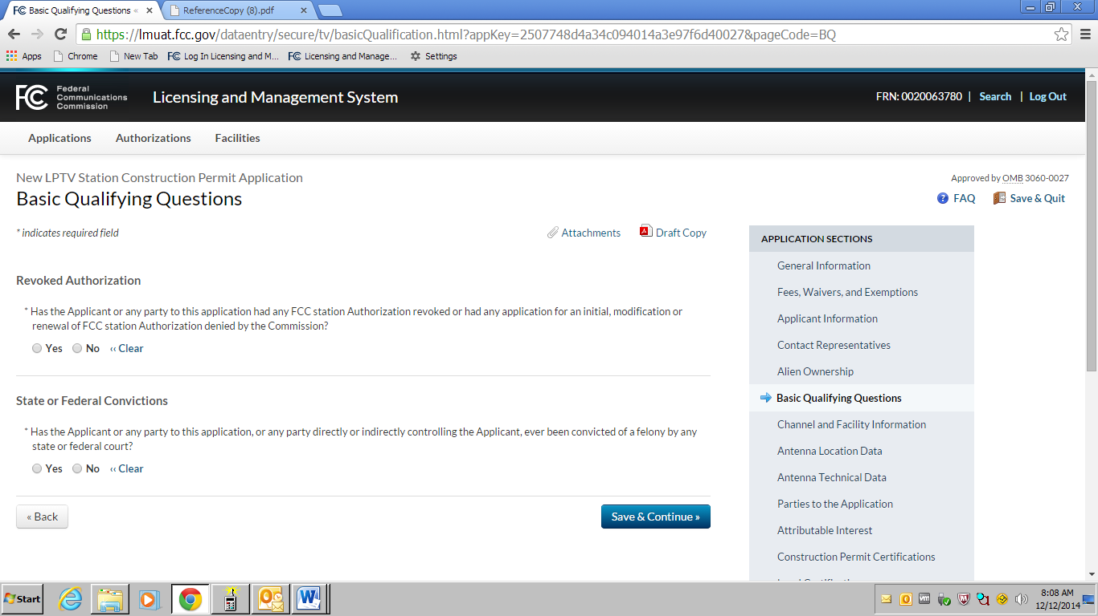



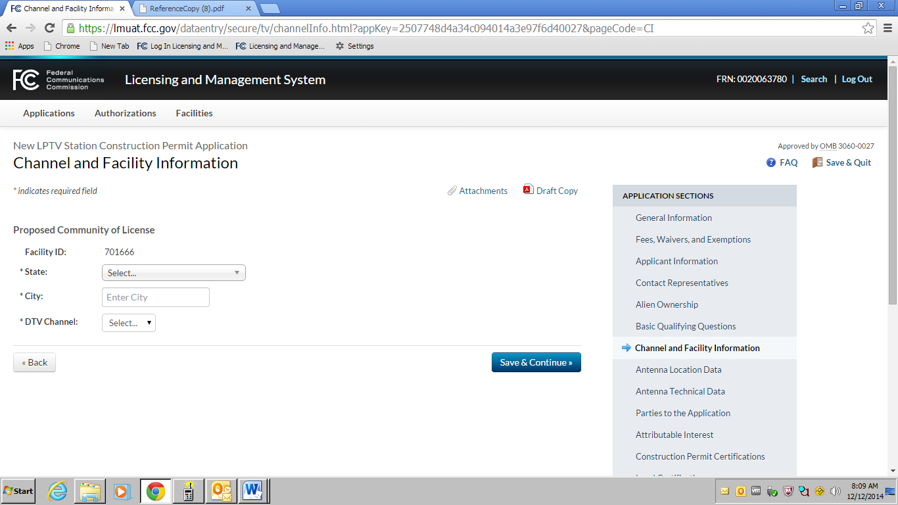

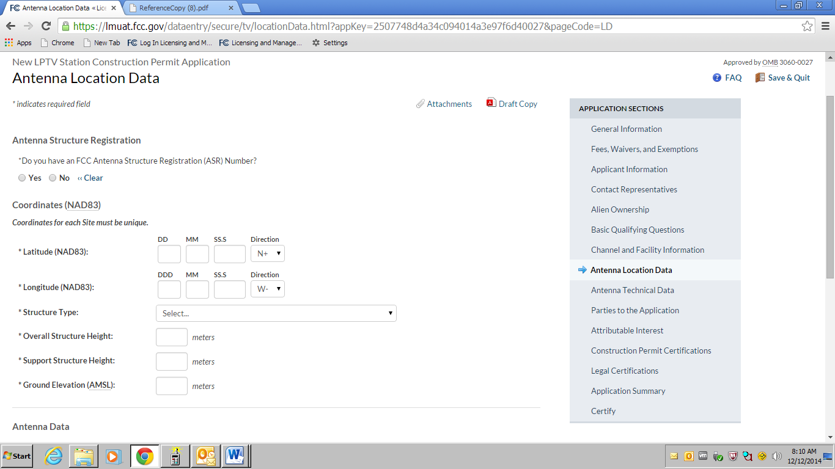

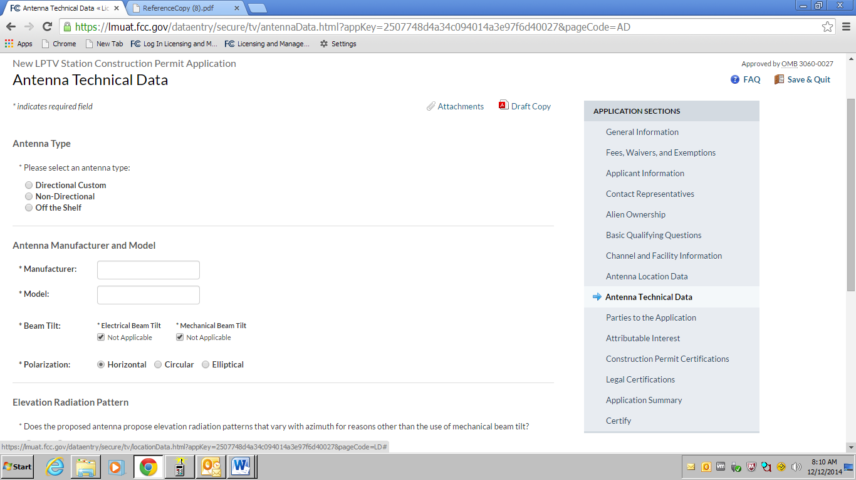

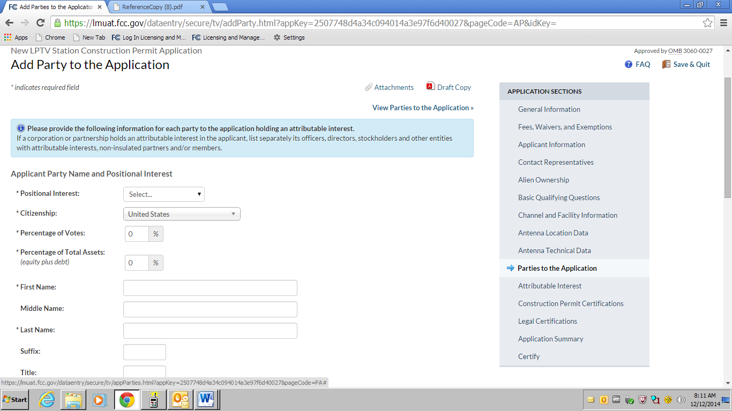

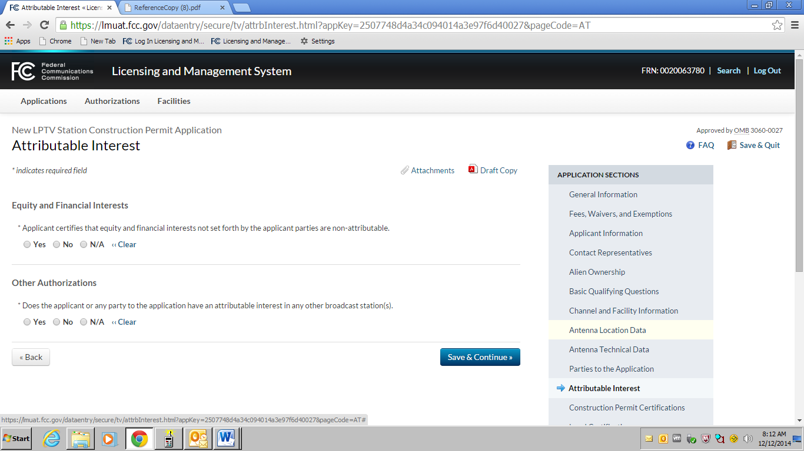

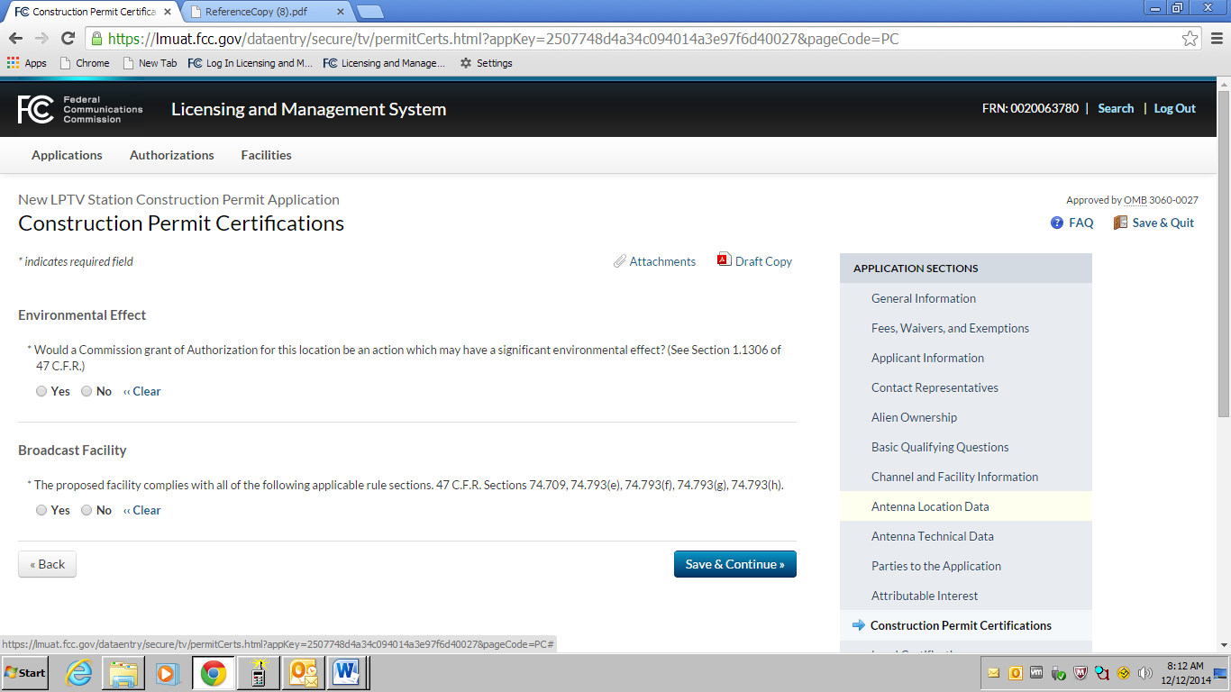

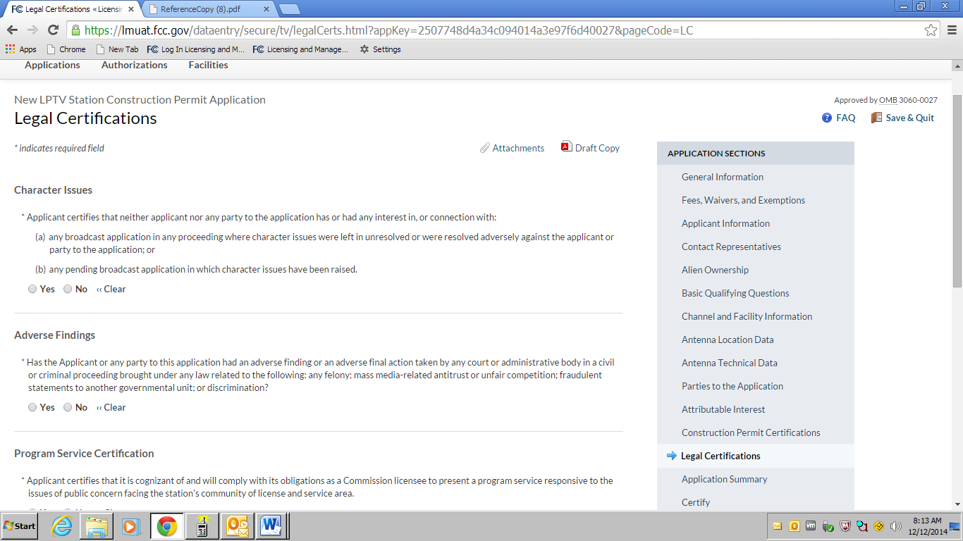

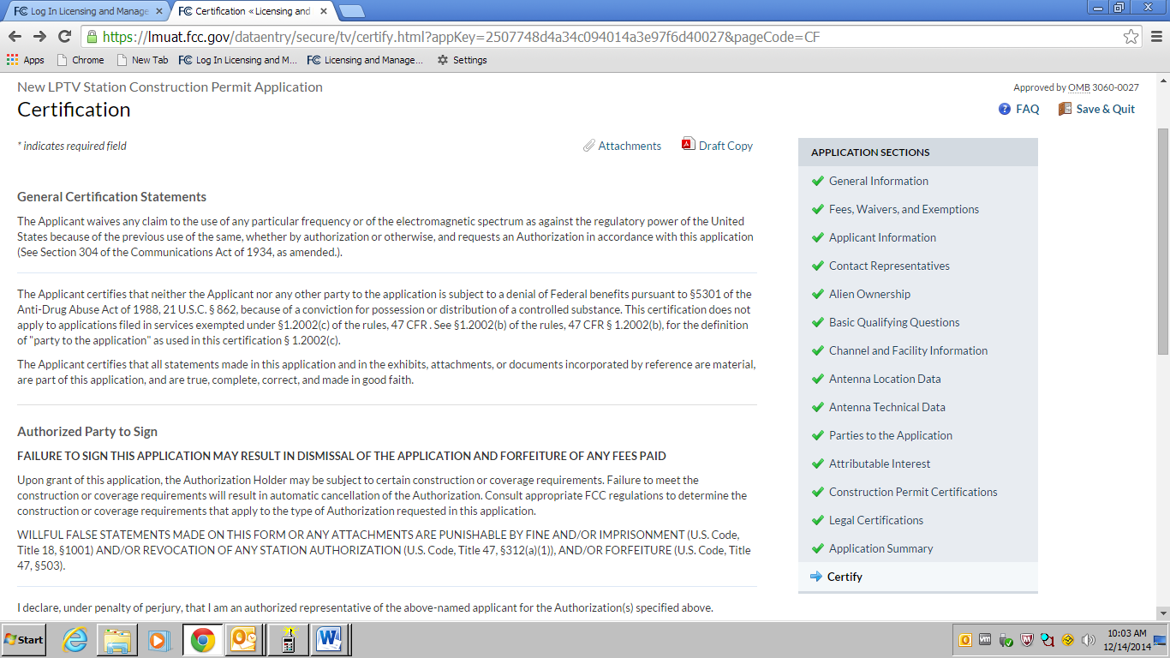

**FCC NOTICE TO INDIVIDUALS REQUIRED BY THE**

**PAPERWORK REDUCTION ACT**

We have estimated that each response to this collection of

information will take 2 hours. Our estimate includes the time to

read the instructions, look through existing records, gather and

maintain the required data, and actually complete and review the

form or response. If you have any comments on this burden

estimate, or on how we can improve the collection and reduce

the burden it causes you, please e-mail them to [**pra@fcc.gov**](mailto:pra@fcc.gov)or

send them to the Federal Communications Commission, AMDPERM,

Paperwork Reduction Project (3060-0016),

Washington, DC 20554. Please DO NOT SEND

COMPLETED APPLICATIONS TO THIS ADDRESS.

Remember - you are not required to respond to a collection of

information sponsored by the Federal government, and the

government may not conduct or sponsor this collection, unless it

displays a currently valid OMB control number of if we fail to

provide you with this notice. This collection has been assigned

an OMB control number of 3060-0016.

**THE FOREGOING NOTICE IS REQUIRED BY THE**

**PAPERWORK REDUCTION ACT OF 1995, P.L. 104-13,**

**OCTOBER 1, 1995, 44 U.S.C. Section 3507.**