Page 1

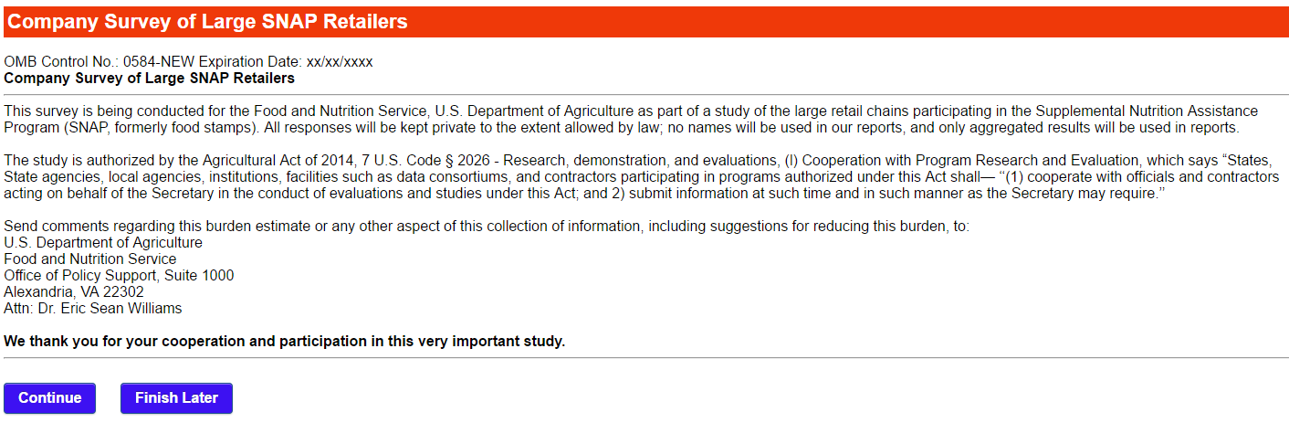

*Please not that skips are invoked automatically conditional upon response. Skip indicators will not appear and are added strictly for the convenience of the reviewer.*

Public reporting burden for this collection of information is 0584-NEW is estimated to average 90 minutes per response, including the time for reviewing instructions, searching existing data sources, gathering and maintaining the data needed, and completing and reviewing the collection of information. An agency may not conduct or sponsor, and a person is not required to respond to, a collection of information unless it displays a currently valid OMB control number. Send comments regarding this burden estimate or any other aspect of this collection of information, including suggestions for reducing this burden, to: U.S. Department of Agriculture, Food and Nutrition Services, Office of Policy Support, 3101 Park Center Drive, Room 1014, Alexandria, VA 22302

Page 2

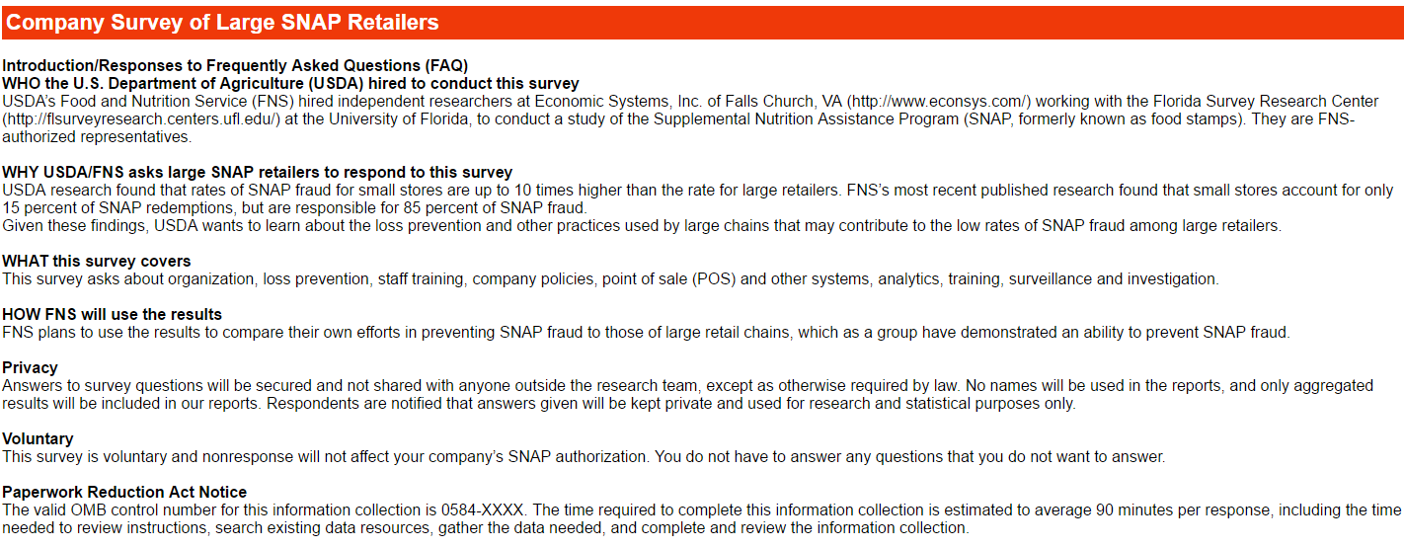

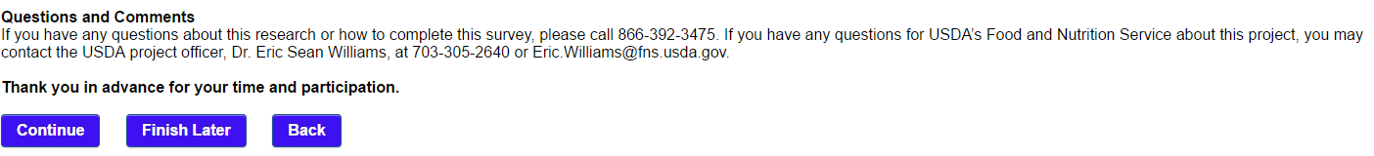

Page 3

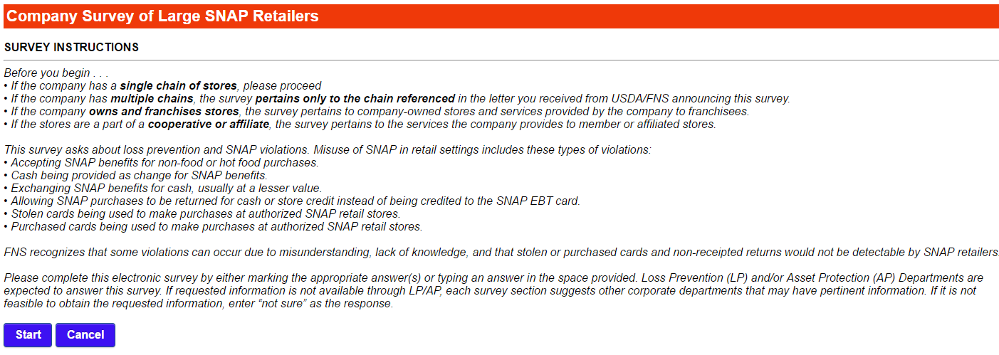

Page 4

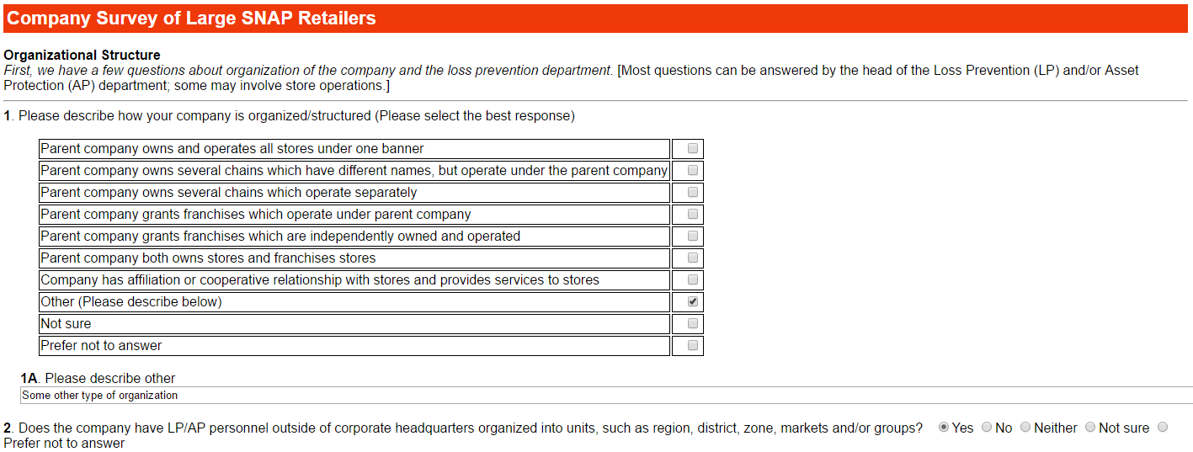

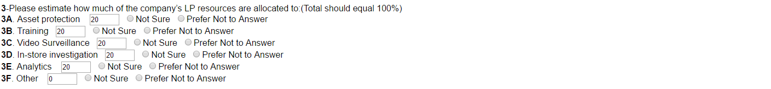

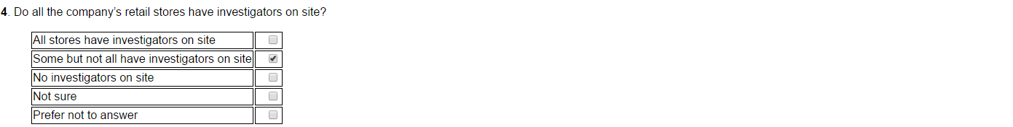

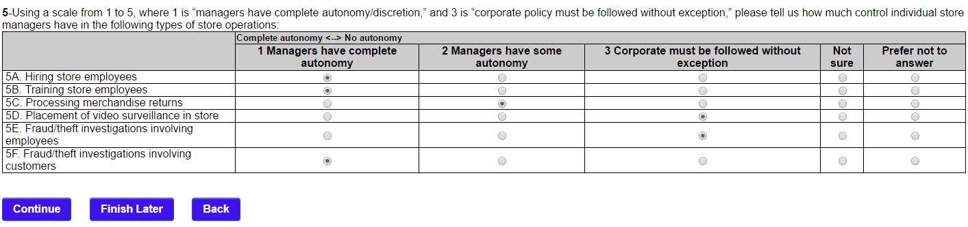

Page 5

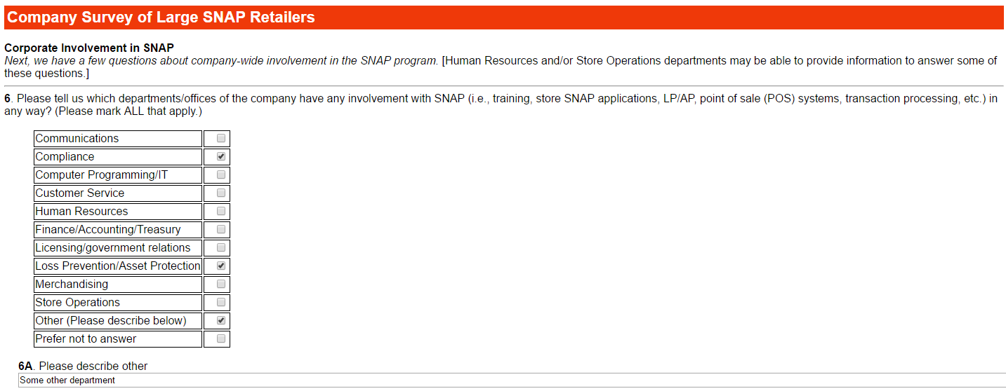

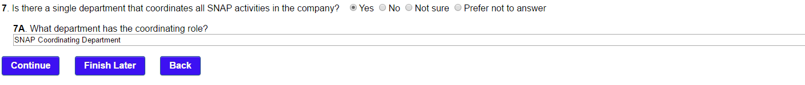

Page 6

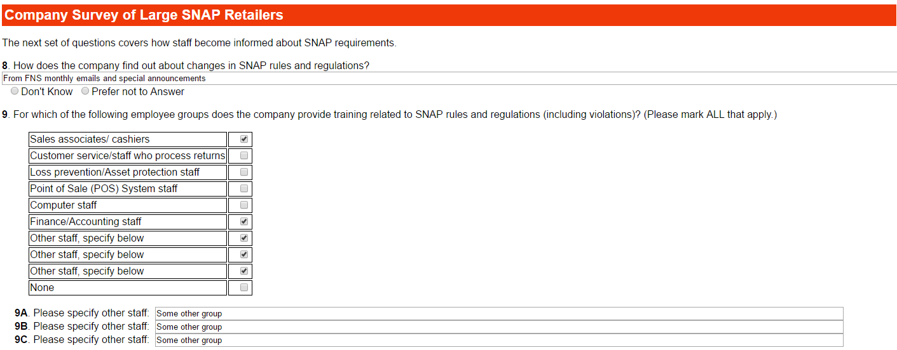

If Q10 is “No SNAP training provided by company”, go to Q14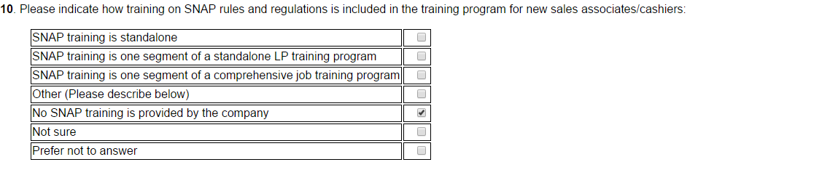



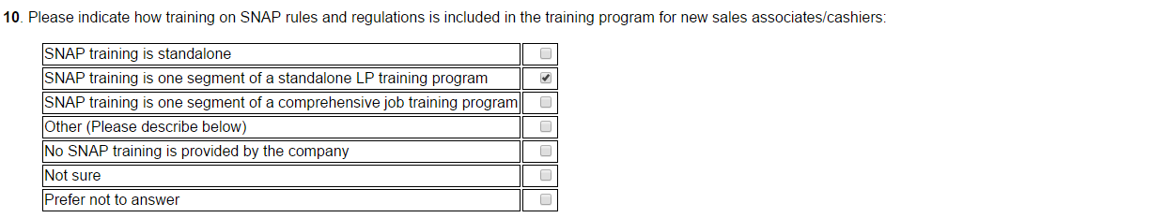

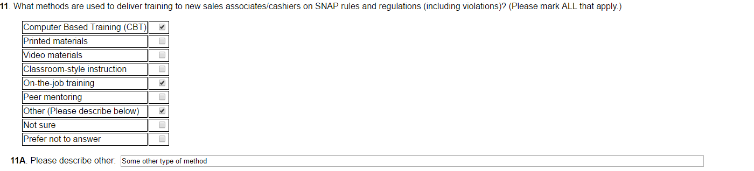

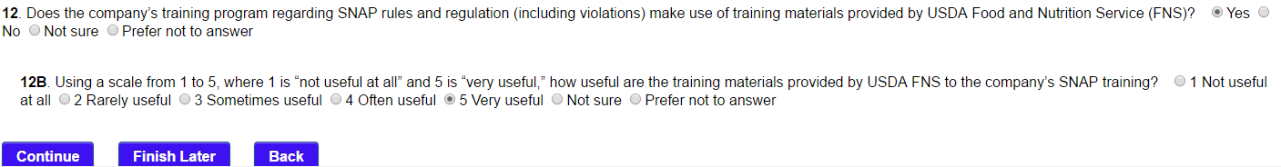

If Q12=NO

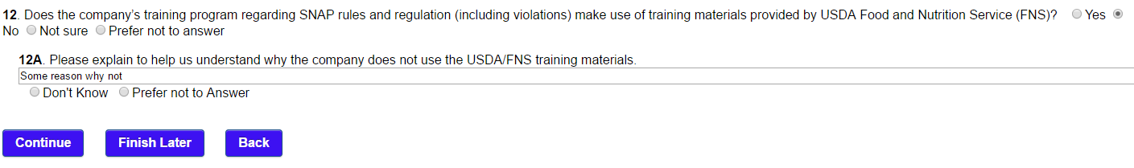

Page 7

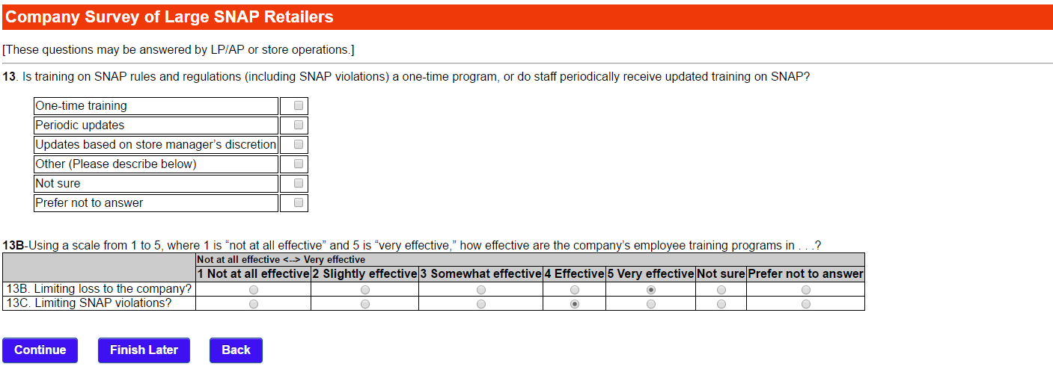

Page 8

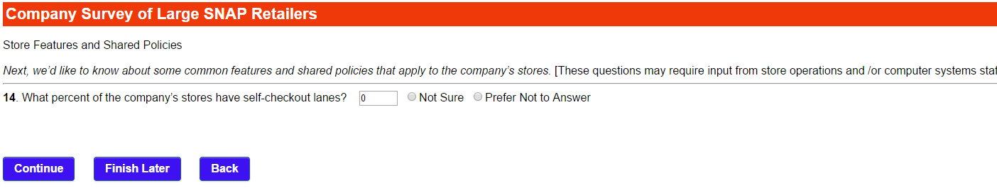

If Q14 > 0:

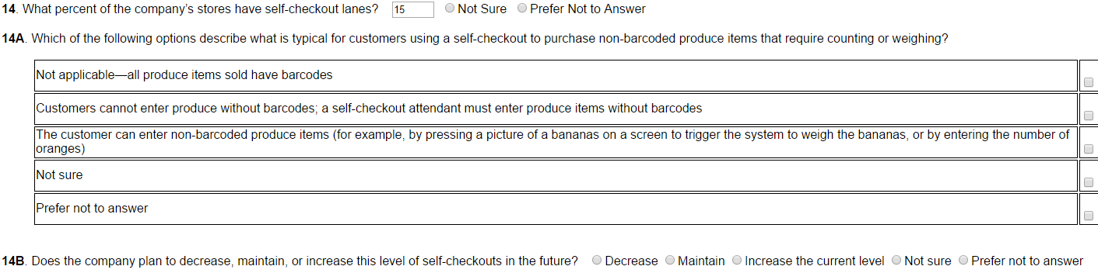



Page 9



If Q15 >0:



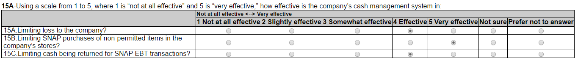



If Q16 >0:



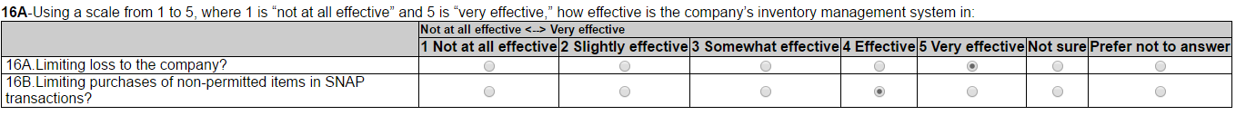



Page 10

If Q17 is 0 continue to Q18

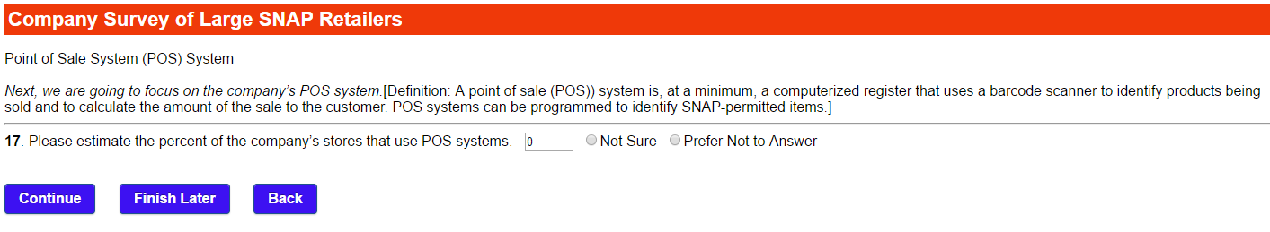

Page 11 (1 of 2)

If Q17>0:



If Q17B is “Most”, “Some” or “Few”:

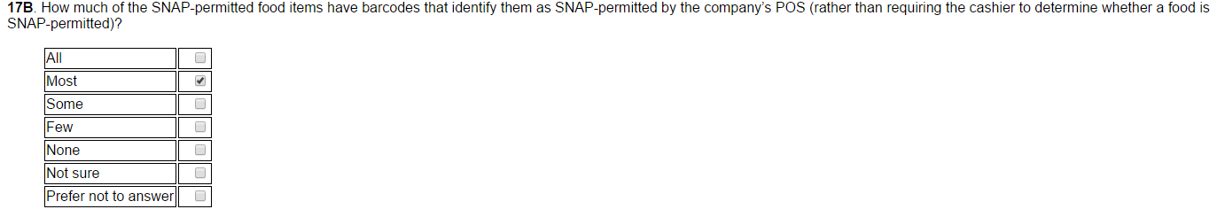

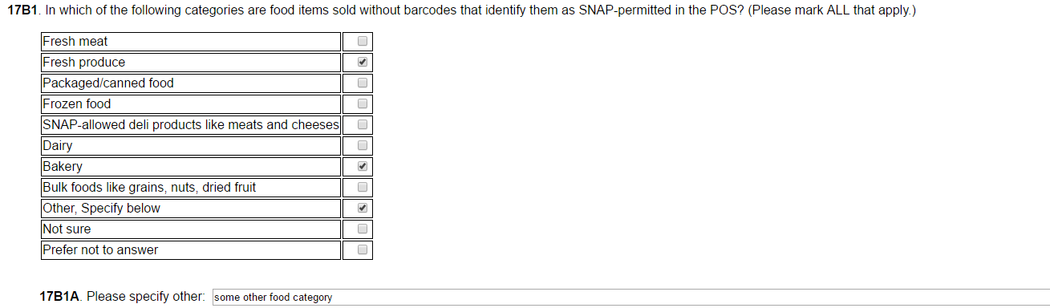

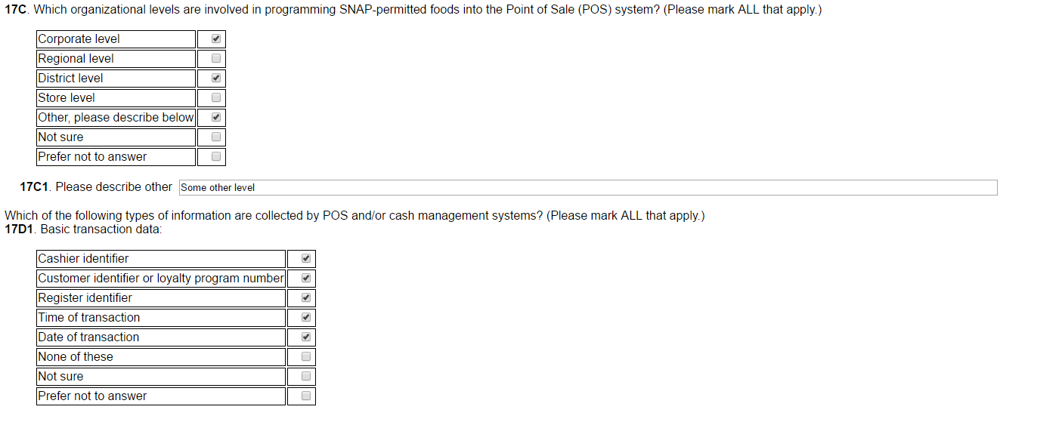

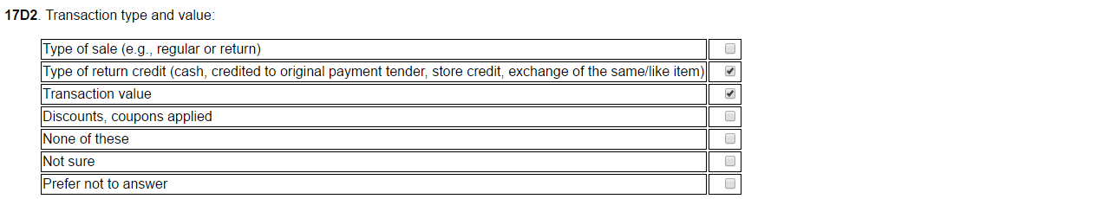

Page 11 cont. (2 of 2)

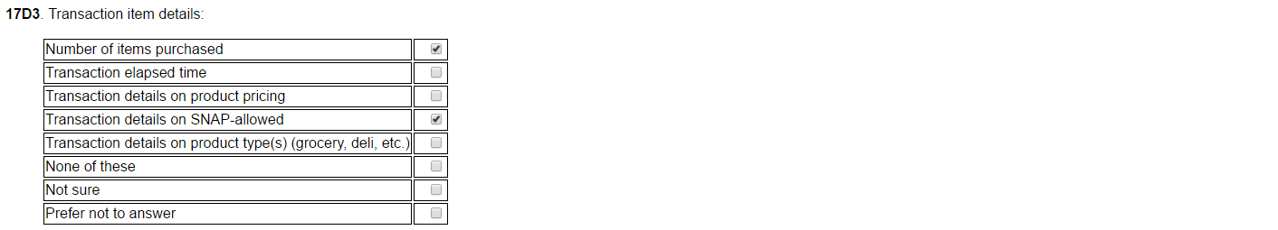

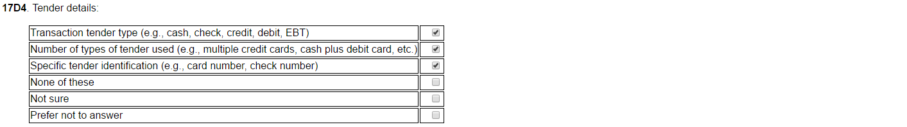

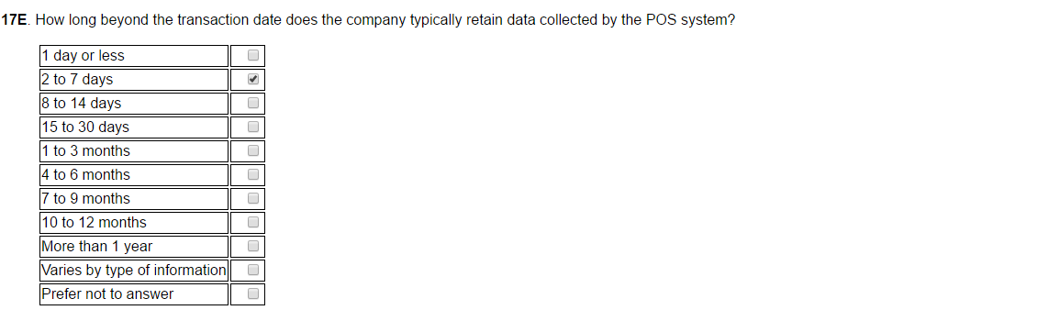

If Q17E is “Varies by type of information”

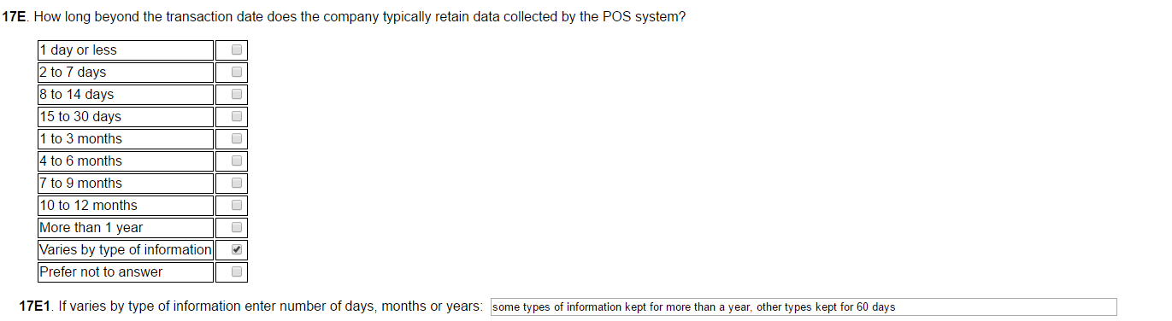

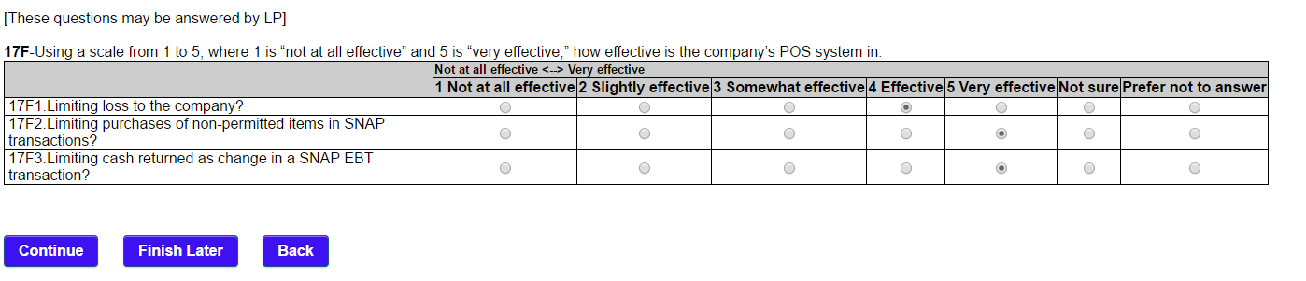

Page 12 (1 of 3)



If Q19= “Yes” or “Varies by store”

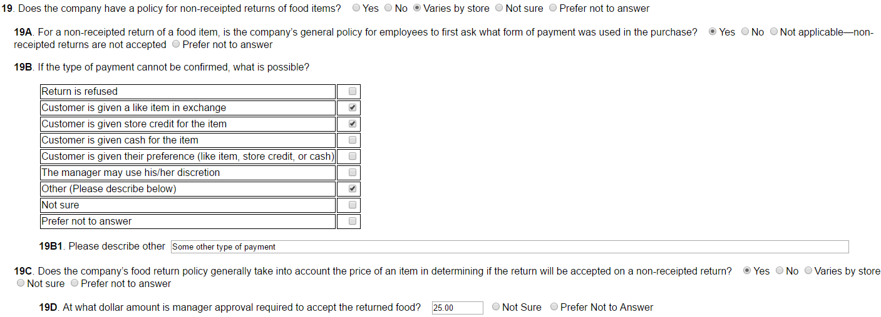

If Q18 is greater than 0

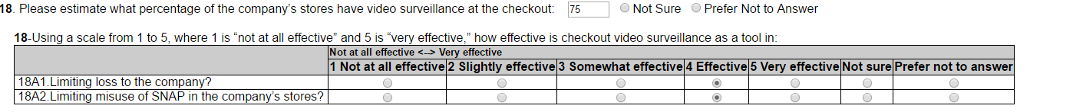



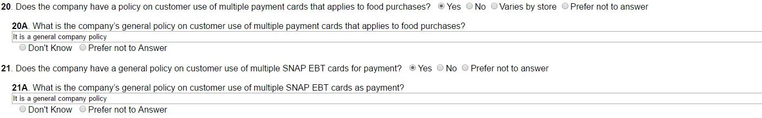



Page 12 cont. (2 of 3)

If Q22 is Yes: complete Q22A-Q22H9

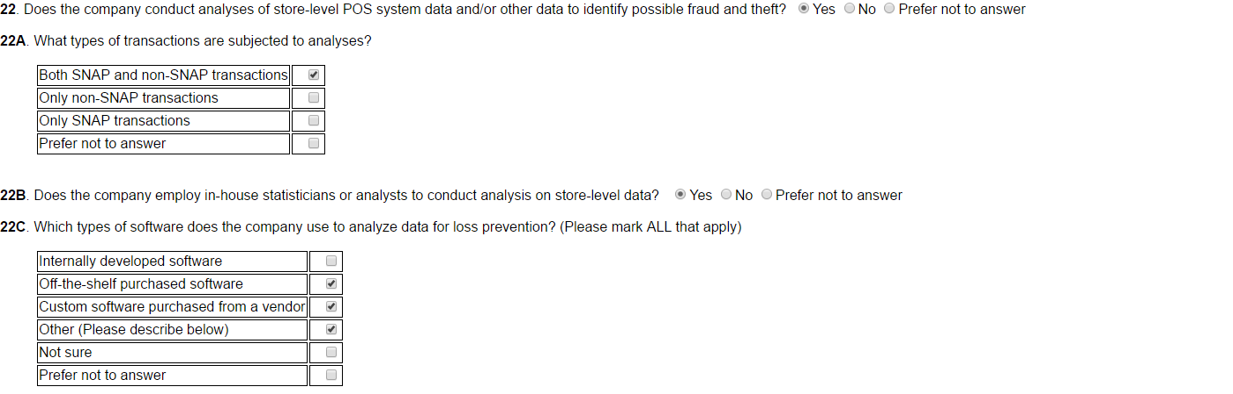

If Q22C is “Off- the- shelf purchased software or “Custom Software purchased from a vendor” or “other”:

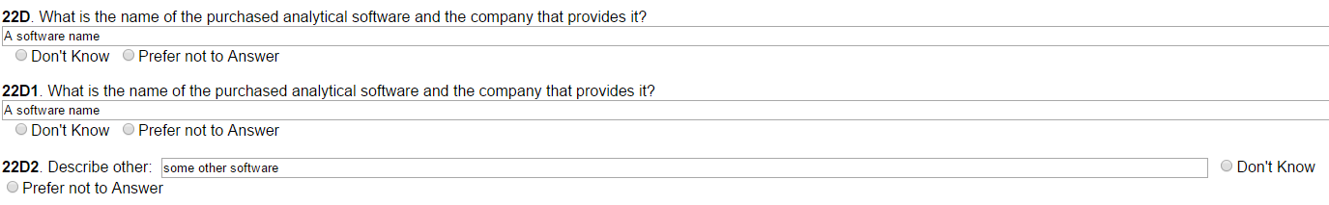

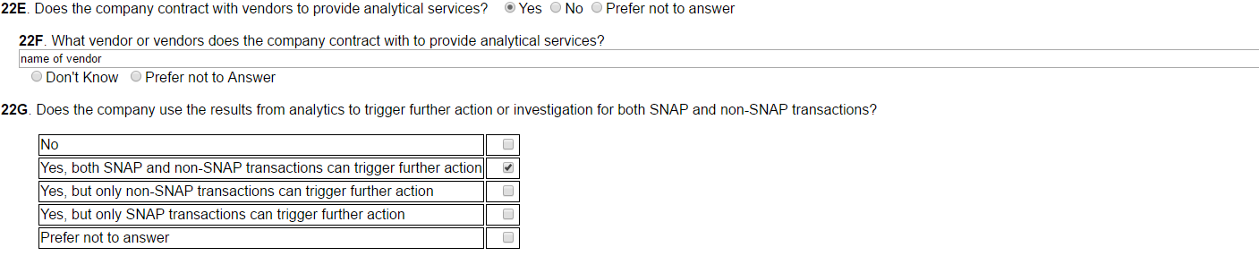

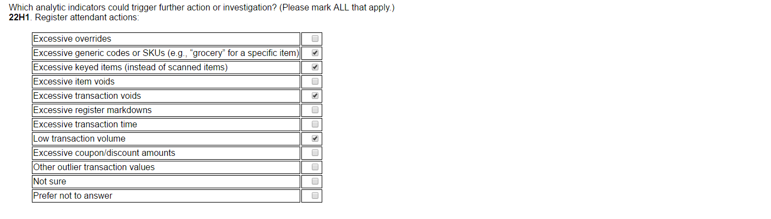

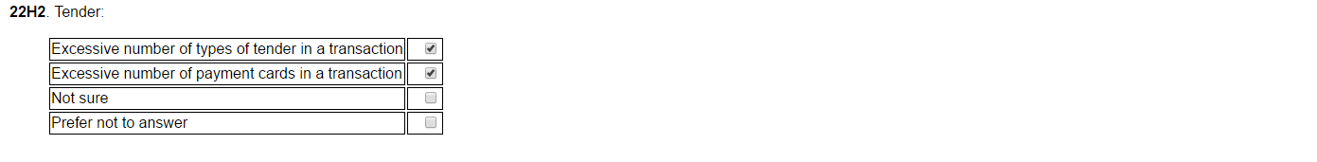

Page 12 cont. (3 of 3)

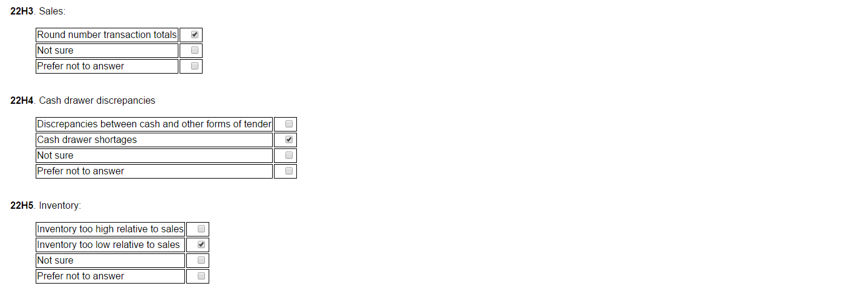

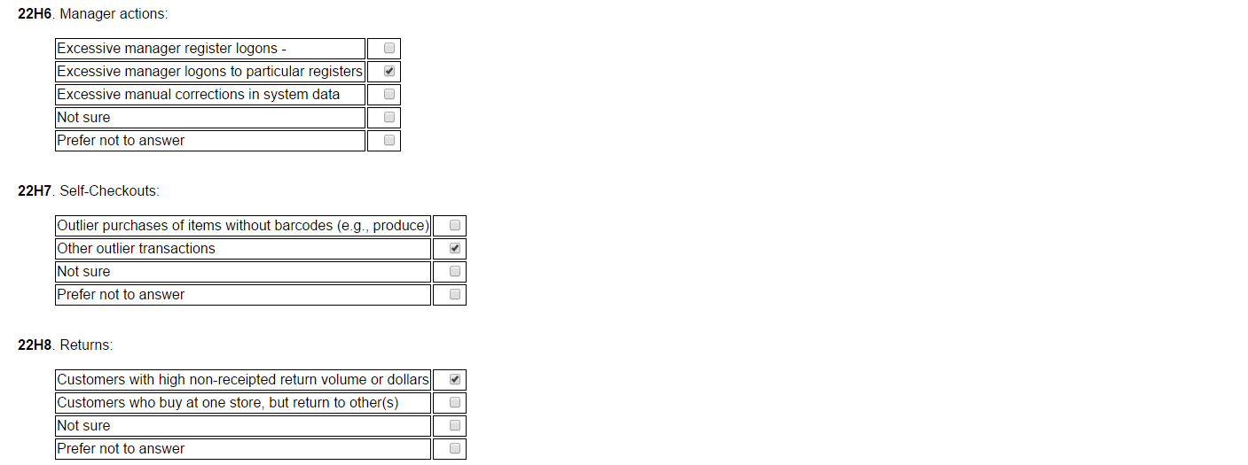

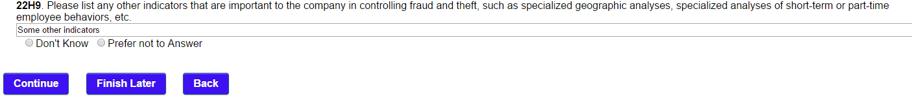

Page 13

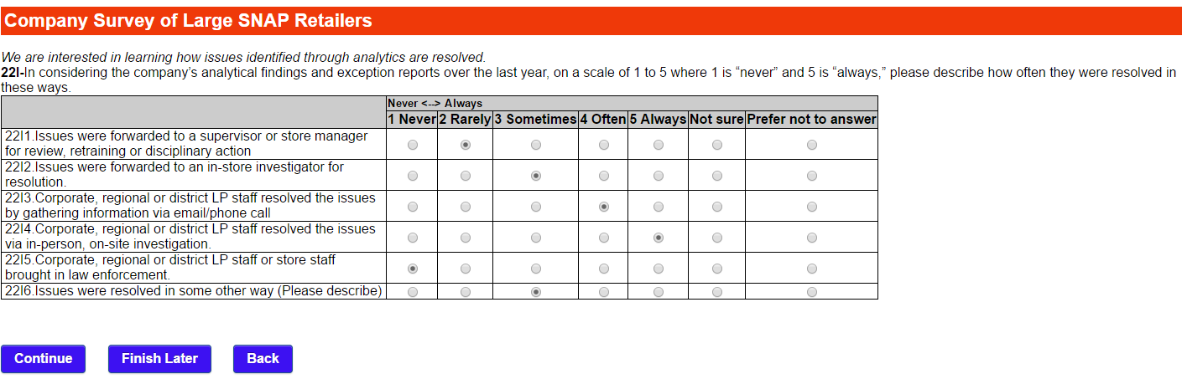

Page 14

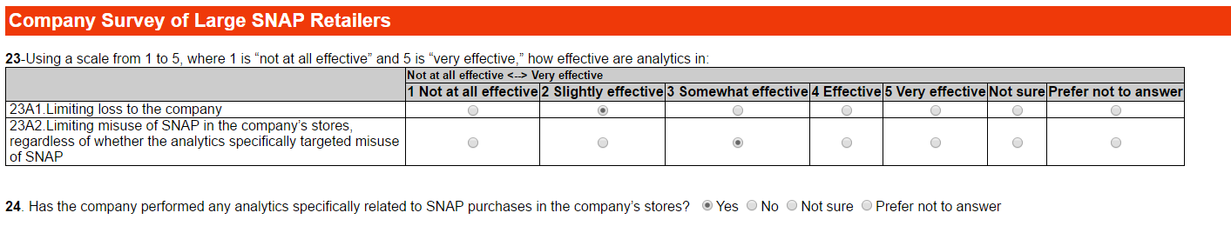

If Q24 is Yes:

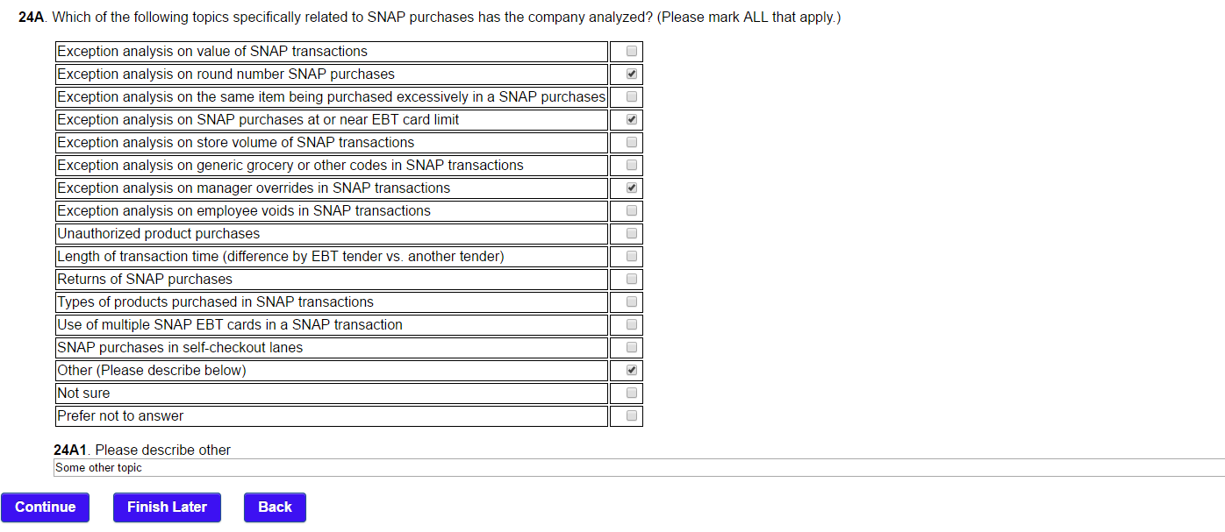

Page 15 (1 of 3)

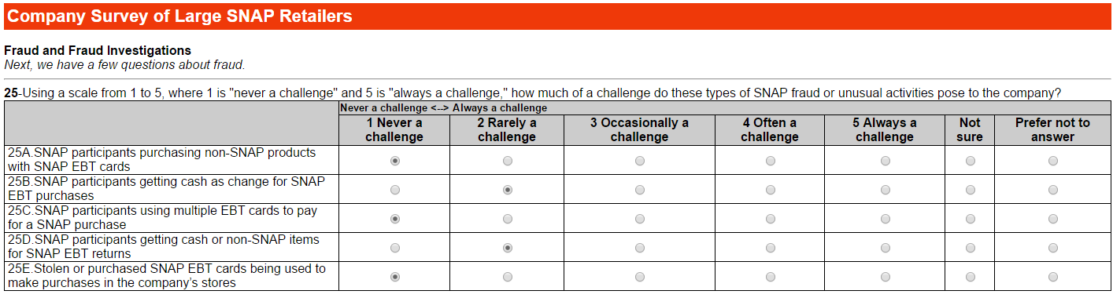

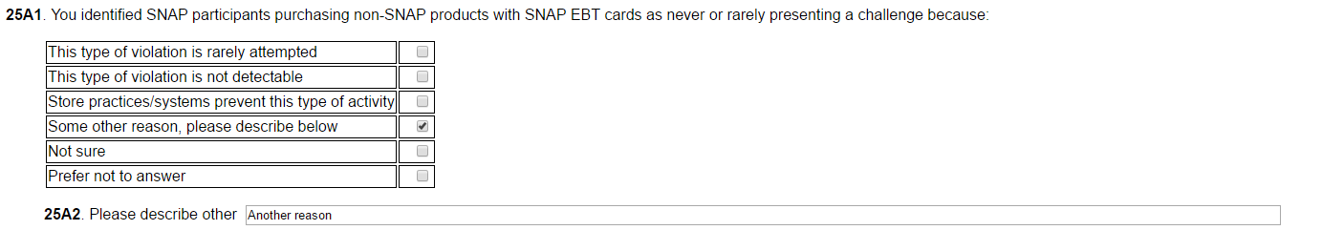

If Q25A1 is “Store practices /systems prevent this type of activity”

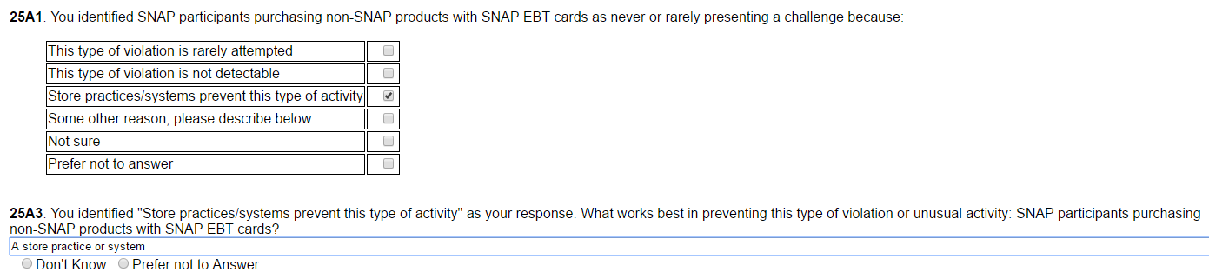

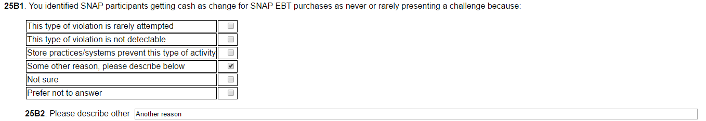

If Q25B1 is “Store practices /systems prevent this type of activity”

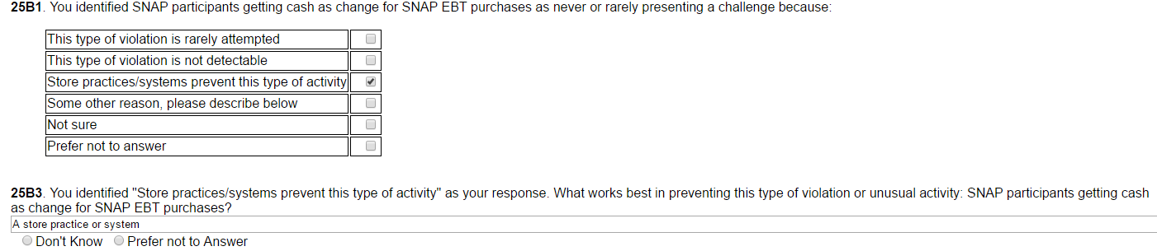



Page 15 cont. (2 of 3)

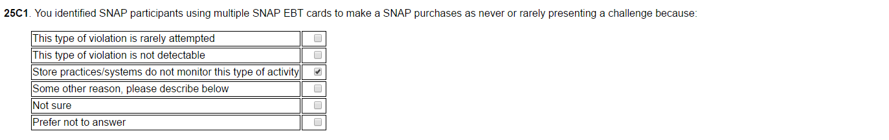

If Q25C1 is “some other reason, please describe.”

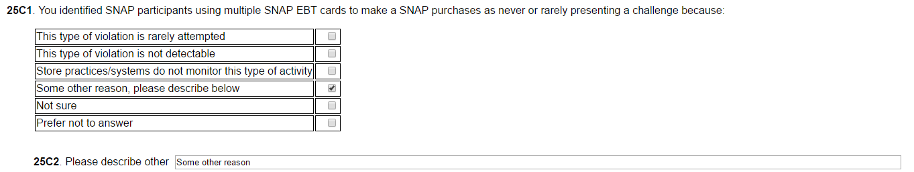

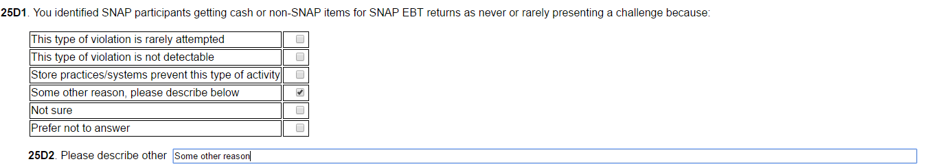

If Q25D1 is “Store practices /systems prevent this type of activity”

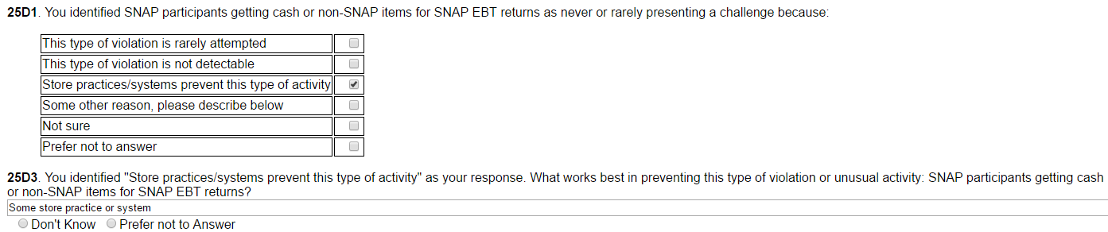

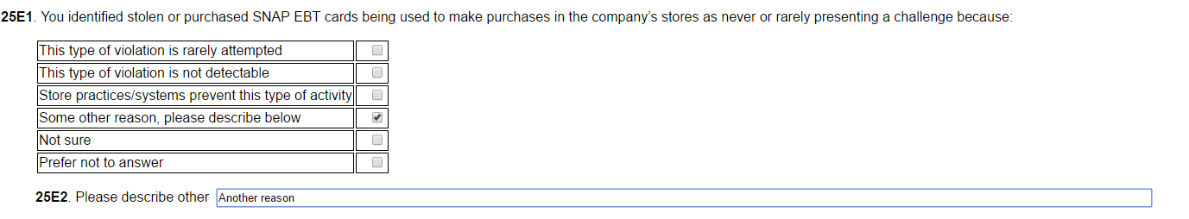

Page 15 cont. (3 of 3)

If Q25E1 is “Store practices /systems prevent this type of activity”

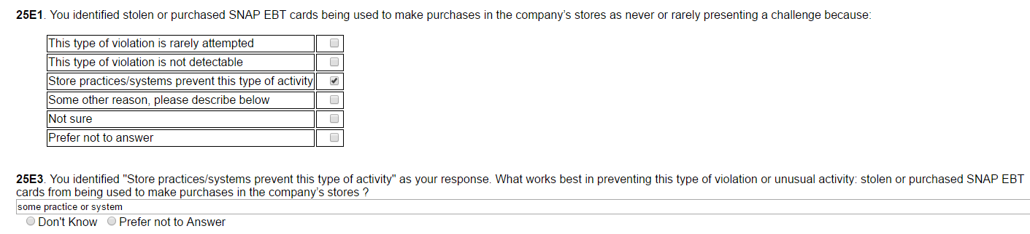





If Q27 is Yes:





If Q28 is Yes:



Page 16

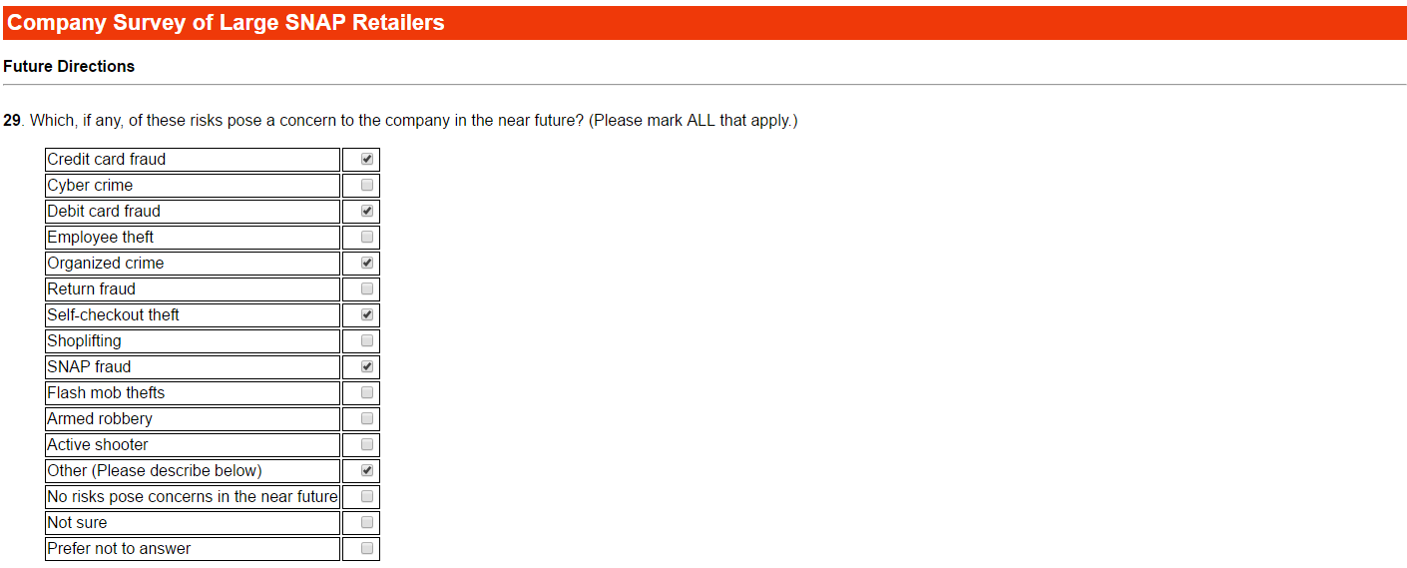

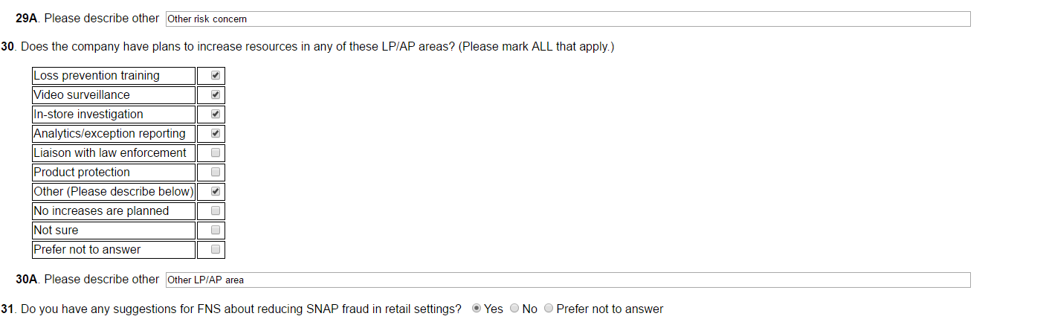



Page 17

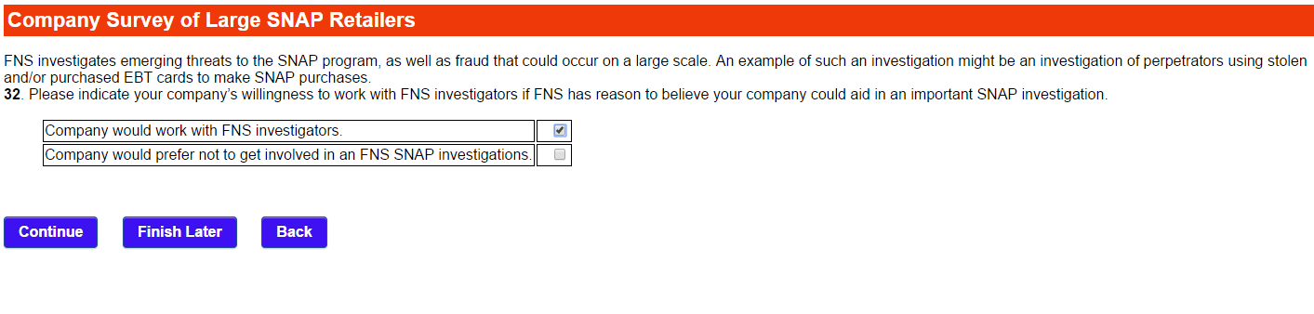

Page 18

