Page 1

*Please not that skips are invoked automatically conditional upon response. Skip indicators will not appear and are added strictly for the convenience of the reviewer.*

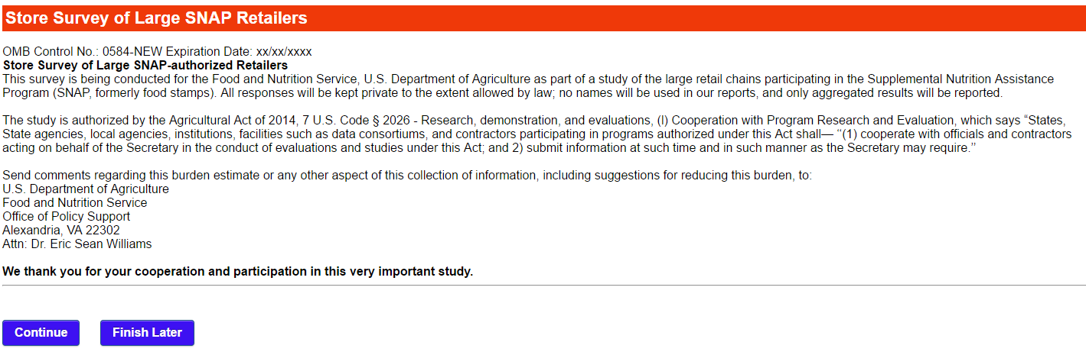

Public reporting burden for this collection of information is 0584-NEW is estimated to average 90 minutes per response, including the time for reviewing instructions, searching existing data sources, gathering and maintaining the data needed, and completing and reviewing the collection of information. An agency may not conduct or sponsor, and a person is not required to respond to, a collection of information unless it displays a currently valid OMB control number. Send comments regarding this burden estimate or any other aspect of this collection of information, including suggestions for reducing this burden, to: U.S. Department of Agriculture, Food and Nutrition Services, Office of Policy Support, 3101 Park Center Drive, Room 1014, Alexandria, VA 22302

Page 2

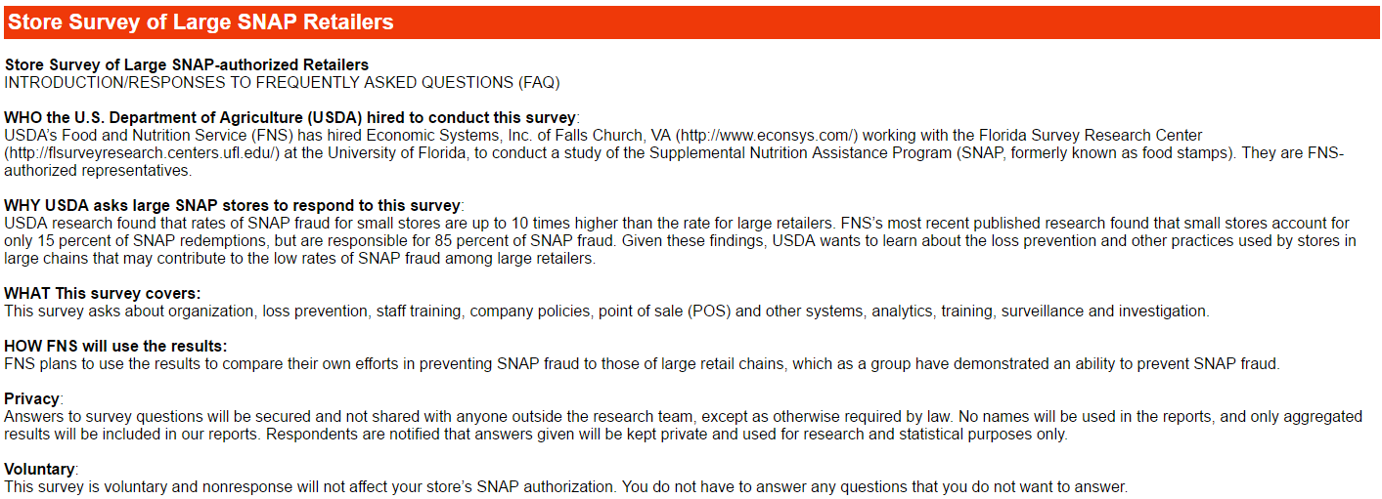





Page 3

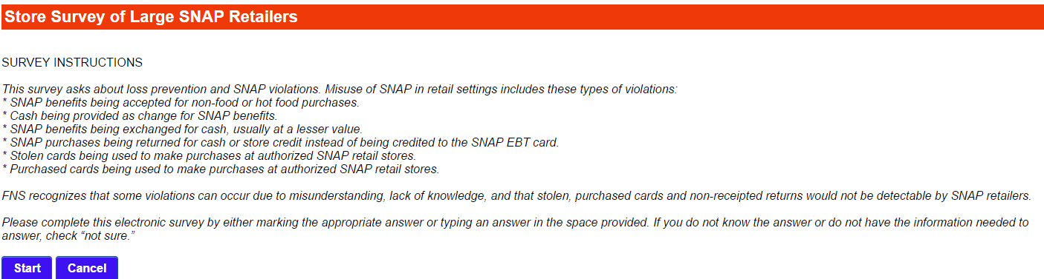

Page 4 (1 of 2)



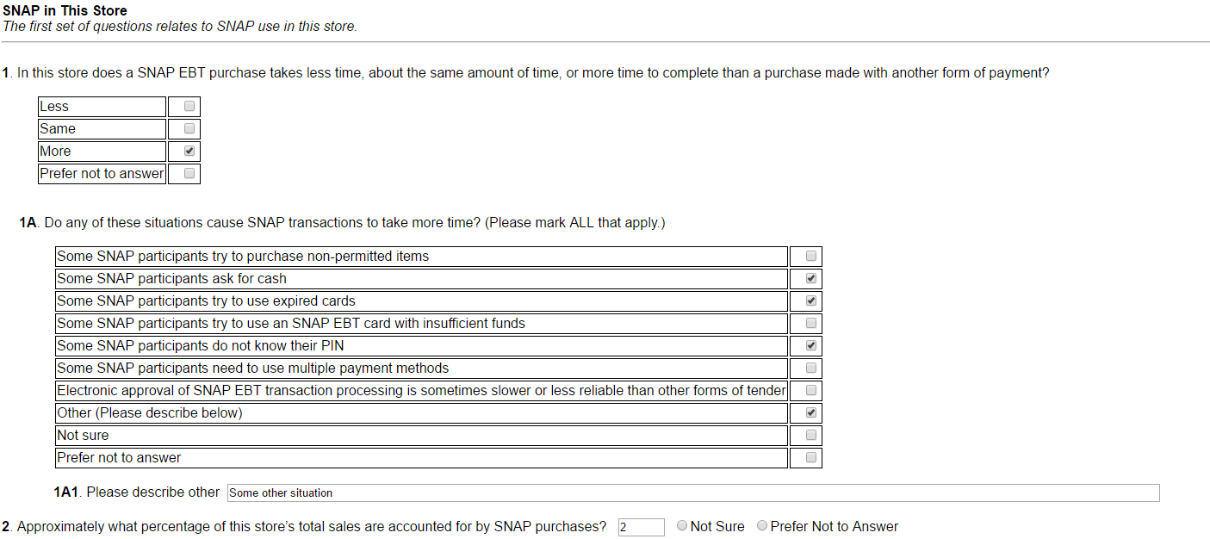

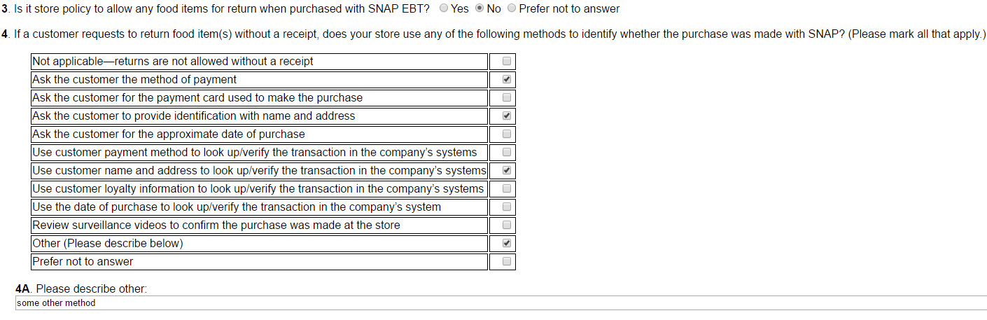

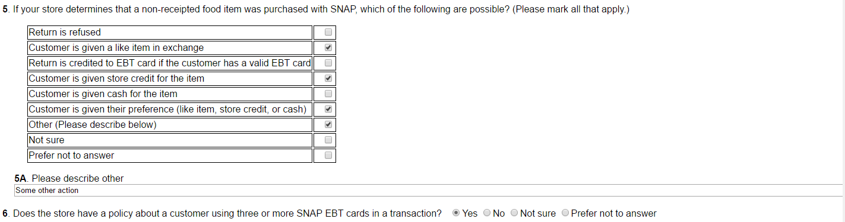

Page 4 cont. (2 of 2)

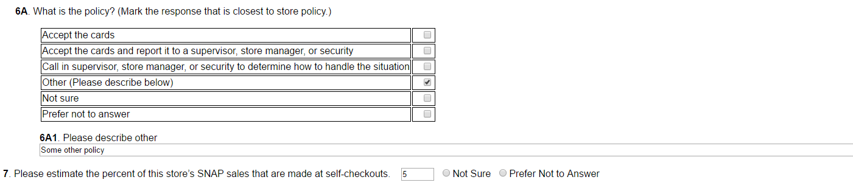

If Q7 is greater than 0



Page 5

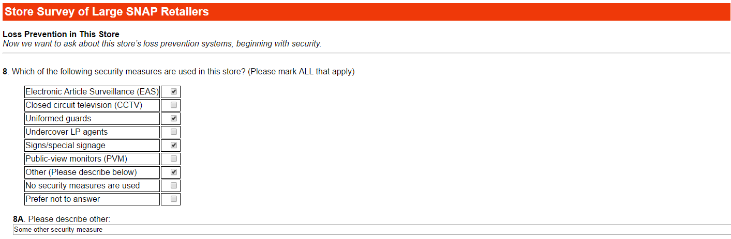

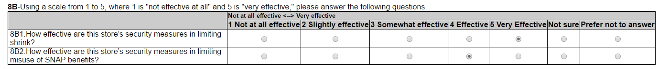



If Q9 is Yes:

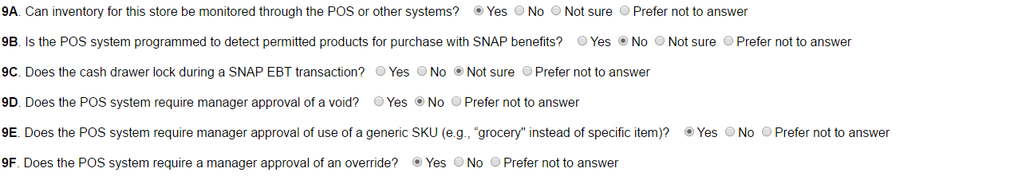



Page 6

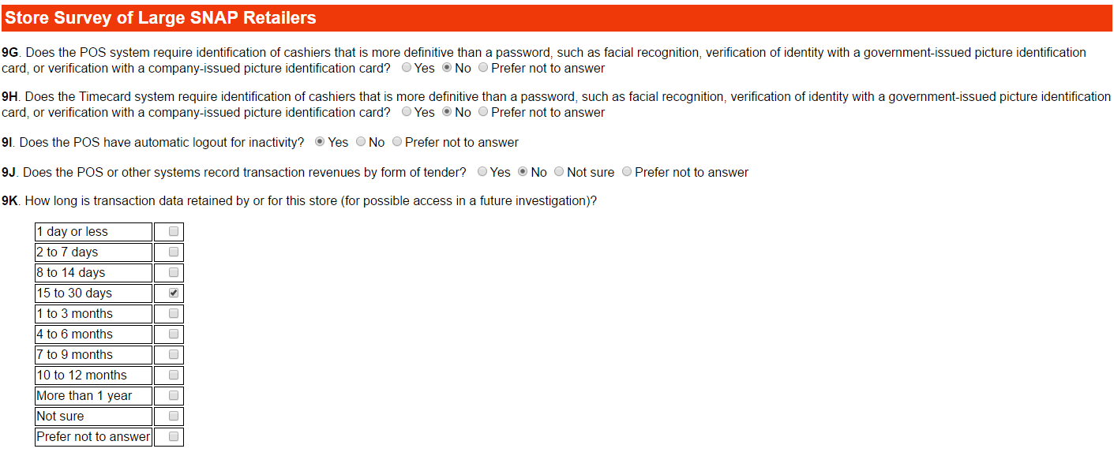





Page 7 (1 of2)

If Q10 is No, continue to Q11

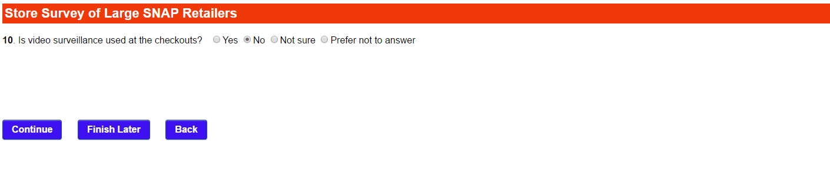If Q10 is Yes

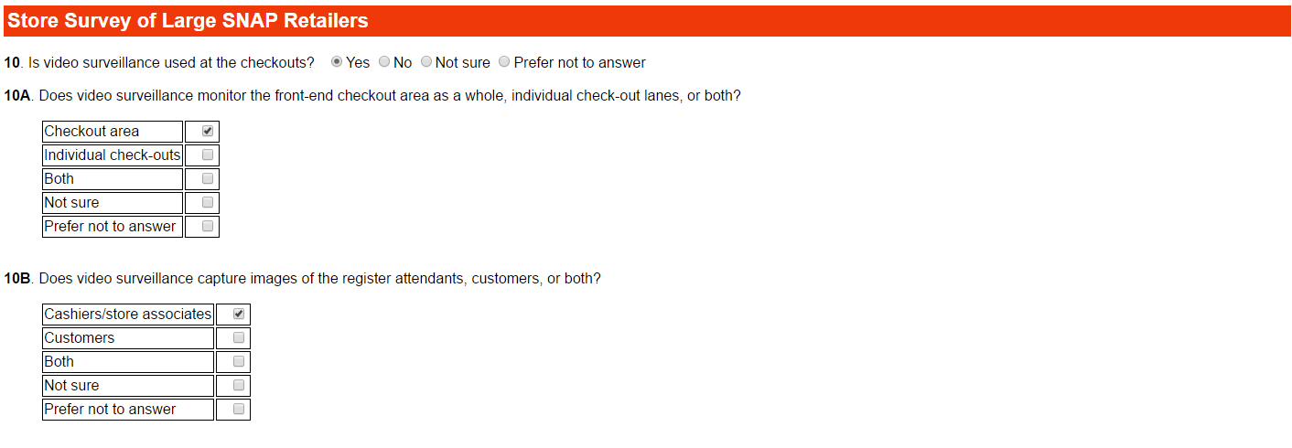

If Q10C is “Monitored in real time only” or “Recorded only”:

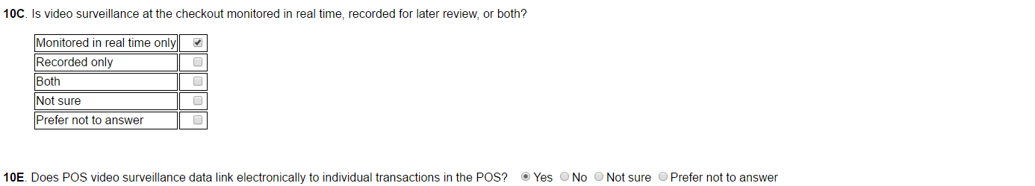

Page 7 (2of2)

If Q10C is “Both”:

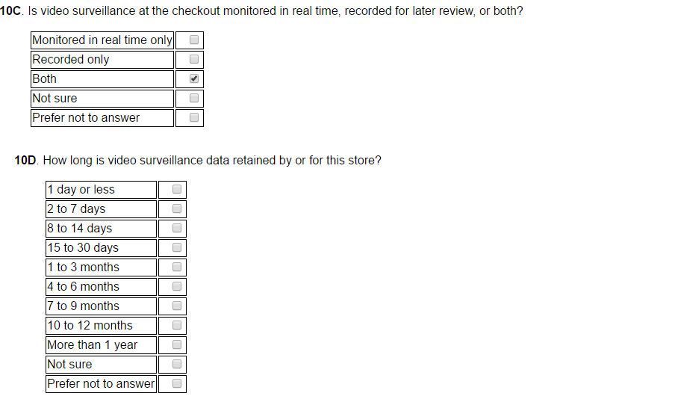





Page 8

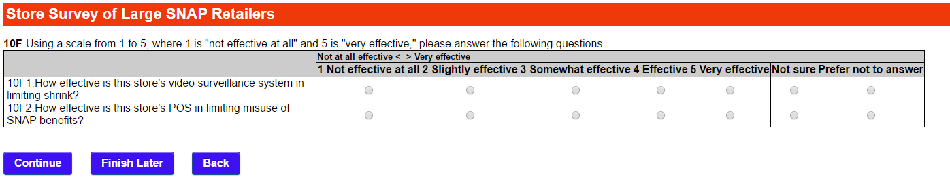

Page 9 (1 of 4)

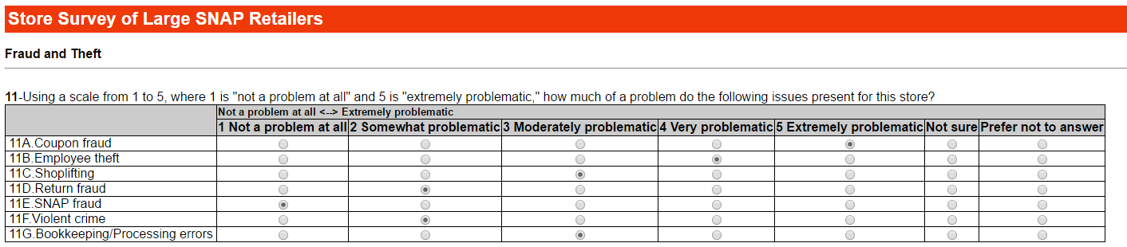

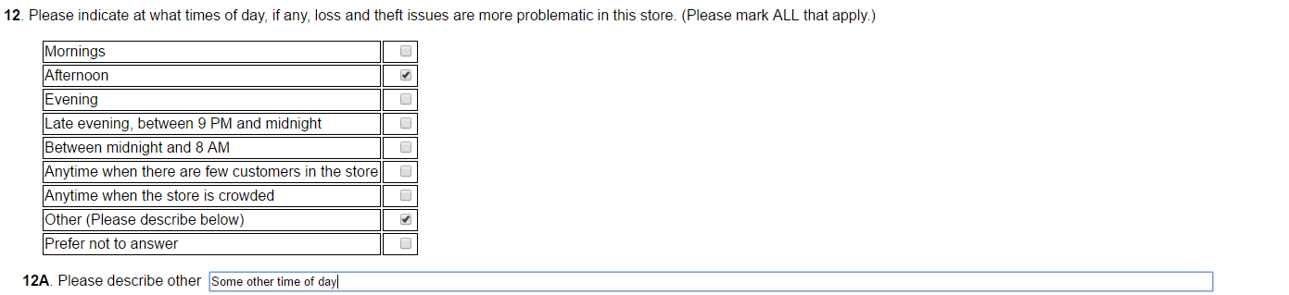

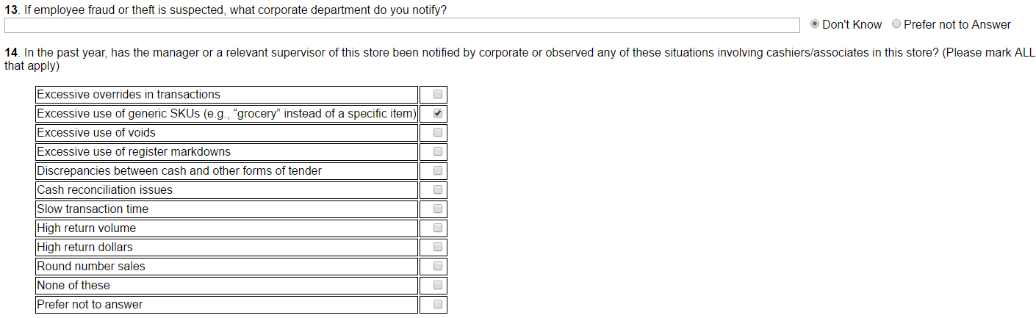

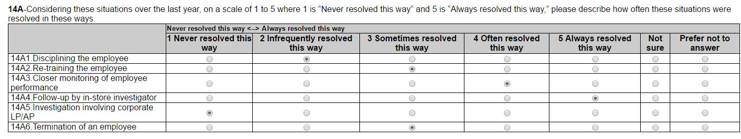

Page 9 cont. (2 of 4)

If Q14 is “None of these” or “Prefer not to answer” go to Q15

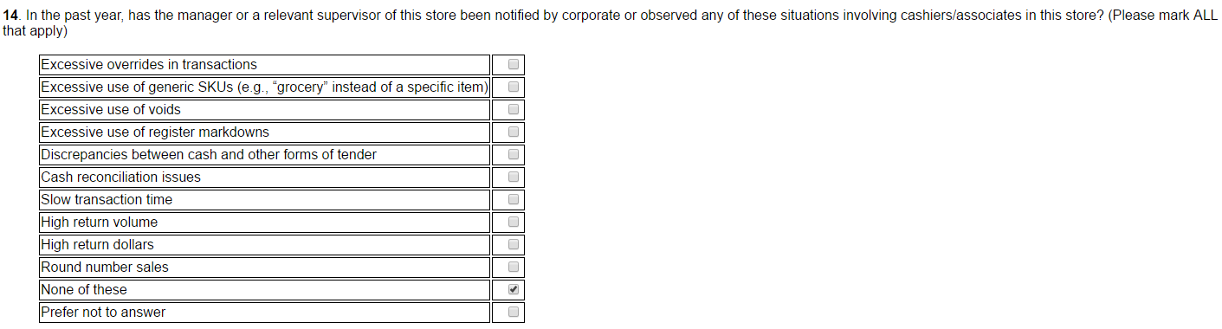

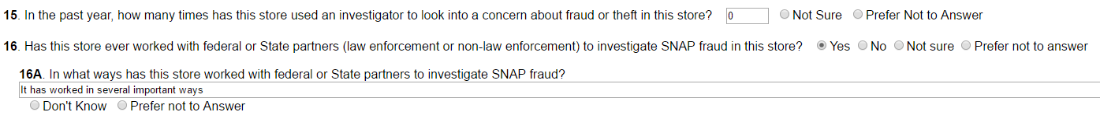

If Q15>0 :

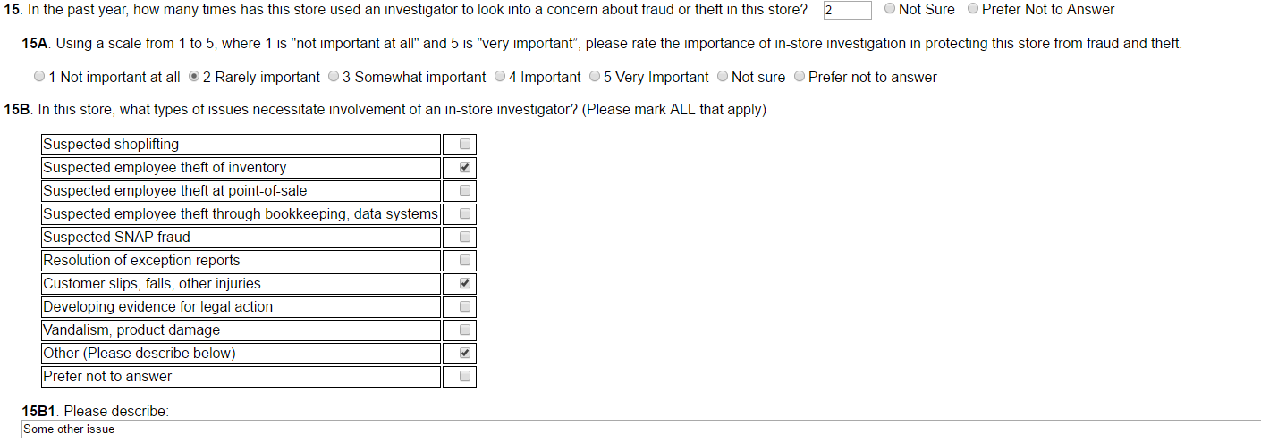

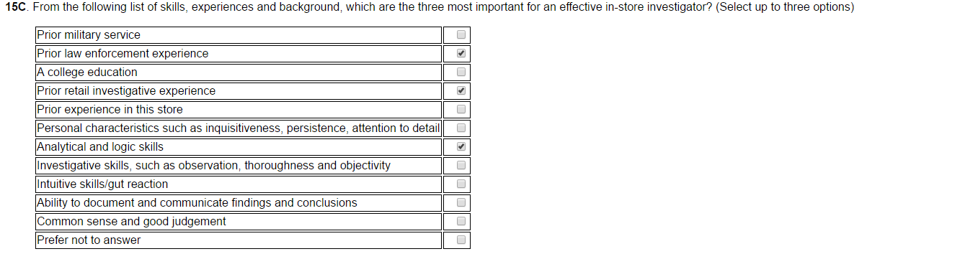

Page 9 cont. (3 of 4)

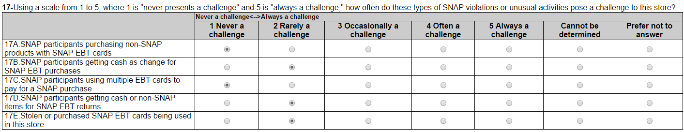



If Q17A1 is “Store practices/systems prevent this type of violation”

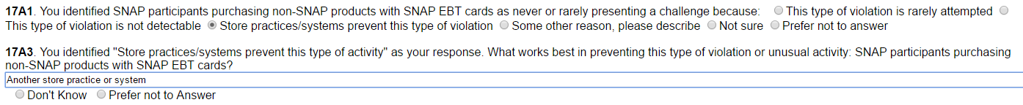



If Q17B1 is “Store practices/systems prevent this type of violation”

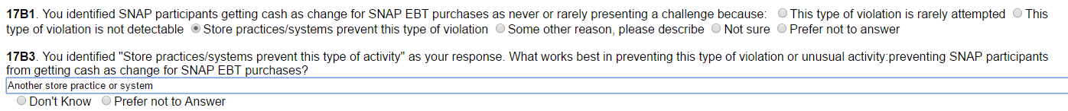



If Q17C1 is “Some other reason, please describe”





If Q17D1 is “Some other reason, please describe”

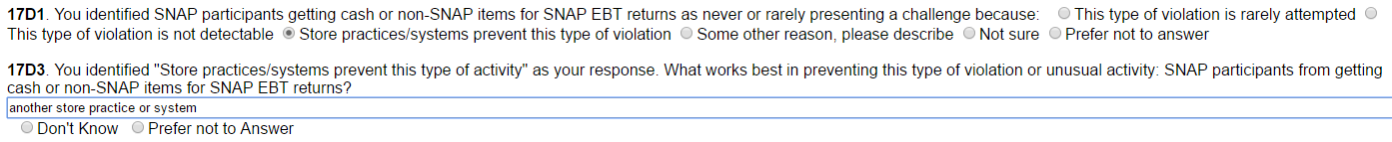



Page 9 cont. (4 of 4)



If Q17E1 is “Store practices/systems prevent this type of violation”



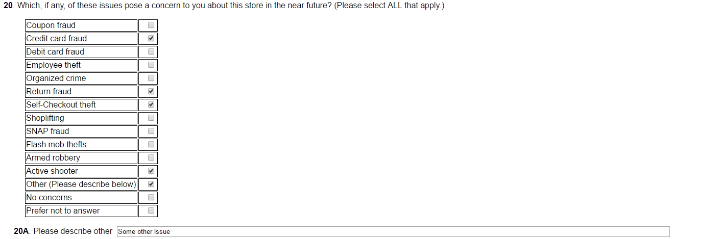

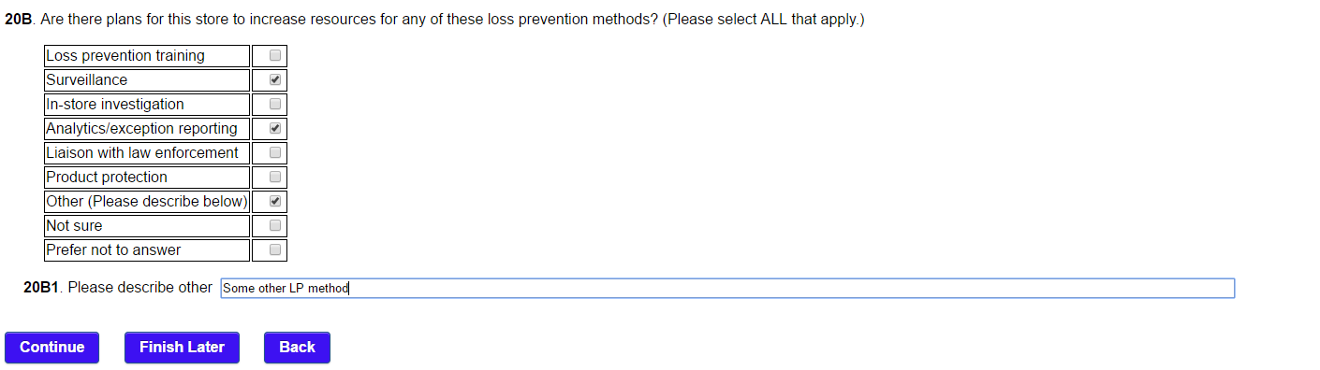

Page 10

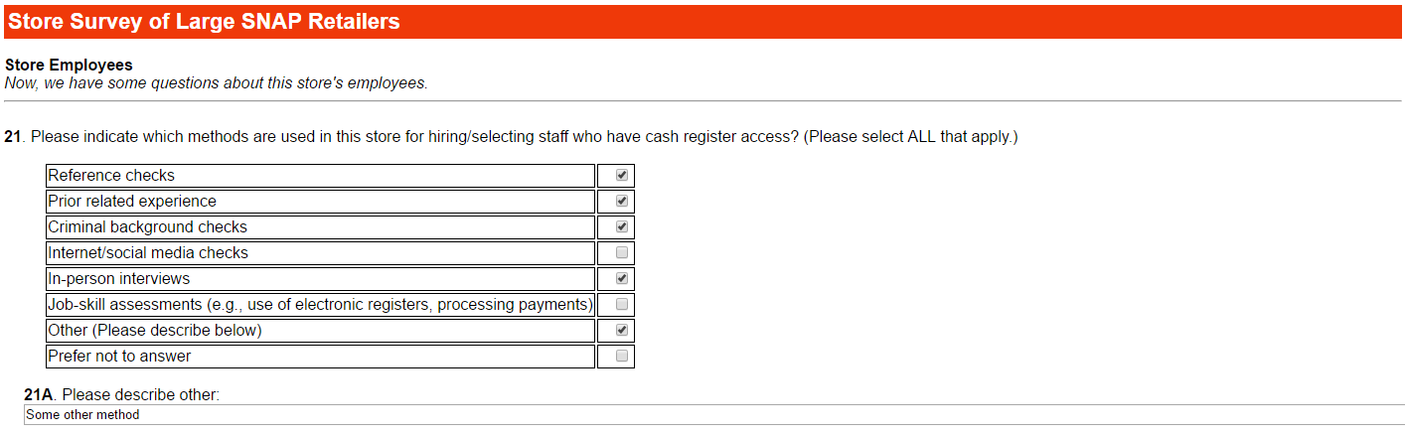



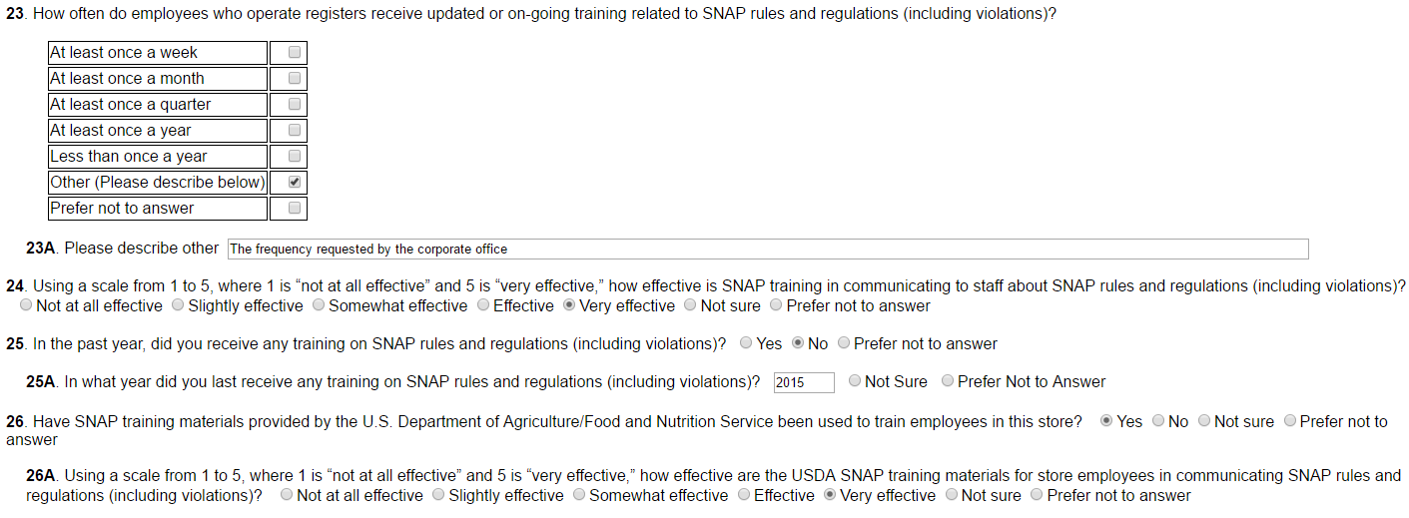

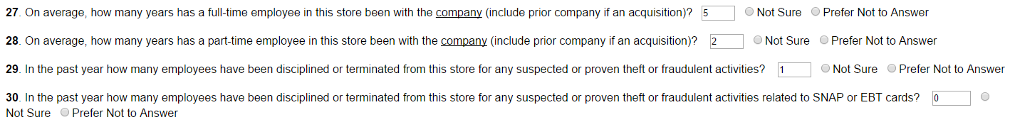



Page 11

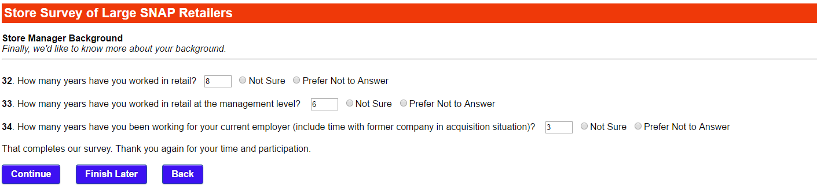

Page 12

