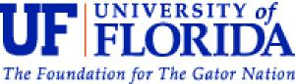

Dear [Corporate Representative]:

Researchers from the Florida Survey Research Center at the University of Florida (FSRC) are conducting a survey on behalf of the U.S. Department of Agriculture’s Food and Nutrition Service (FNS), to better understand policies and practices that may contribute to lower rates of SNAP fraud. You were recently sent a letter from Kathryn Law, Director of the USDA FNS SNAP Research and Analysis Division, Andrea Gold, Director of SNAP Retailer Policy and Management Division, and Neva Terry, Director of SNAP Retail Operations Division regarding this survey. We would greatly appreciate your participation in this research.

On average, it will take about 45 minutes to complete this survey after compiling information. It may take another 45 minutes to compile information, depending on the organization of your company. We estimate that it may take you 4 minutes to read and review this letter. Your participation is very important to FNS so that they may understand policies and practices in your company that may contribute to lower rates of SNAP fraud. This information will be used by FNS to help reduce SNAP fraud.

Please log on to http://survey.gatorzone.com using access code ZVLLFD. There you will find instructions on how to complete the survey. The survey will be available on-line until [Date 19 weeks after OMB clearance]

FNS will also be seeking the input of your affiliated store managers. I will provide you with a list of selected stores shortly and, with your authorization, would like to solicit their participation as well. For your convenience, I am including a sample letter notifying selected stores that you authorize their participation. The letter is provided as a convenience. Please feel free to edit it as you see fit.

Please be assured that any information you or your affiliated stores provide will be private and will only be accessed by the researchers involved in the study, except as otherwise required by law. The data from all survey responses will be used by FNS to improve the integrity of SNAP. You are not obligated to participate in this study and you may withdraw at any time without penalty. There are no direct benefits or risks to you for participating in this study and no compensation will be provided. Participation is voluntary, so you do not have to answer any questions that you do not wish to answer. If you have any questions about this survey, please feel free to contact me, Dr. Michael Scicchitano, toll-free at (866) 392-3475 or at [mscicc@ufl.edu](mailto:mscicc@ufl.edu).

I will call you within a day or two to answer any questions you may have. Thank you in advance for your time and participation.

Sincerely,

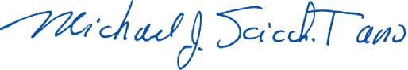

Michael J. Scicchitano, Ph.D. Director

