Dear Store Manager:

Recently, the Florida Survey Research Center at the University of Florida sent you an email regarding a survey on behalf of the U.S. Department of Agriculture’s Food and Nutrition Service (FNS). As described in the email, we are asking you to complete the survey to better understand policies and practices that may contribute to lower rates of SNAP fraud. You were also sent a letter from Kathryn Law, Director of the USDA FNS SNAP Research and Analysis Division, Andrea Gold, Director of SNAP Retailer Policy and Management Division, and Neva Terry, Director of SNAP Retail Operations Division regarding this survey.

To complete the survey, please log on to <http://survey.gatorzone.com> using access code ZVLLFD. There you will find instructions on how to complete the survey. The survey will be available until _________.

If you have any questions about this survey, please feel free to contact me, Dr. Michael Scicchitano, toll-free at (866) 392-3475 or at [mscicc@ufl.edu](mailto:mscicc@ufl.edu).

Thank you in advance for your time and participation.

Sincerely,

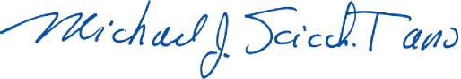

Michael J. Scicchitano, Ph.D. Director

