Dear Participant,
Thank you for participating in this focus group. Your participation is voluntary and any information you provide will be kept anonymous.
The purpose of this research is to understand the need for and interest in forecasts in the 8 to 10 day range and how best to show the probability of long range forecasts. By doing this research, we hope to learn how probabilistic forecasts can improve decision-making in the 8 to 10 day timeframe.
During this focus group, you will be asked questions that relate to what certain products are showing you and your potential use of certain WPC products. You will be asked your understanding and perceptions on ways to show forecasts of probabilities of temperature, precipitation, and winter weather. The amount of time it will take you to participate in this focus group is approximately 1.5-2 hours.
This research is being conducted by an independent contractor, ECS Federal, LLC, on behalf of the National Weather Service. You do not have to take part in this focus group, and you can stop at any time.
Thank you for taking the time to participate.
Notwithstanding any other provisions of the law, no person is required to respond to, nor shall any person be subjected to a penalty for failure to comply with, a collection of information subject to the requirements of the Paperwork Reduction Act, unless that collection of information displays a currently valid OMB Control Number.
If you have any questions, please contact Jennifer Sprague, National Weather Service, Jennifer.sprague@noaa.gov.

Focus Group Protocol

Probabilistic 8-10 day forecast users’ groups

During this session, we will present you with a series of National Weather Service products and discuss your feedback to these products. We will focus on identifying your needs for probabilistic weather information in the 8-10 day range.

Discussion:

We are discussing today the use of day 8-10 probabilistic weather products, to identify how and when these might be useful to decision-making for core partner groups.

We are going to provide you with several visualizations and discuss each one individually.

Graphic #1
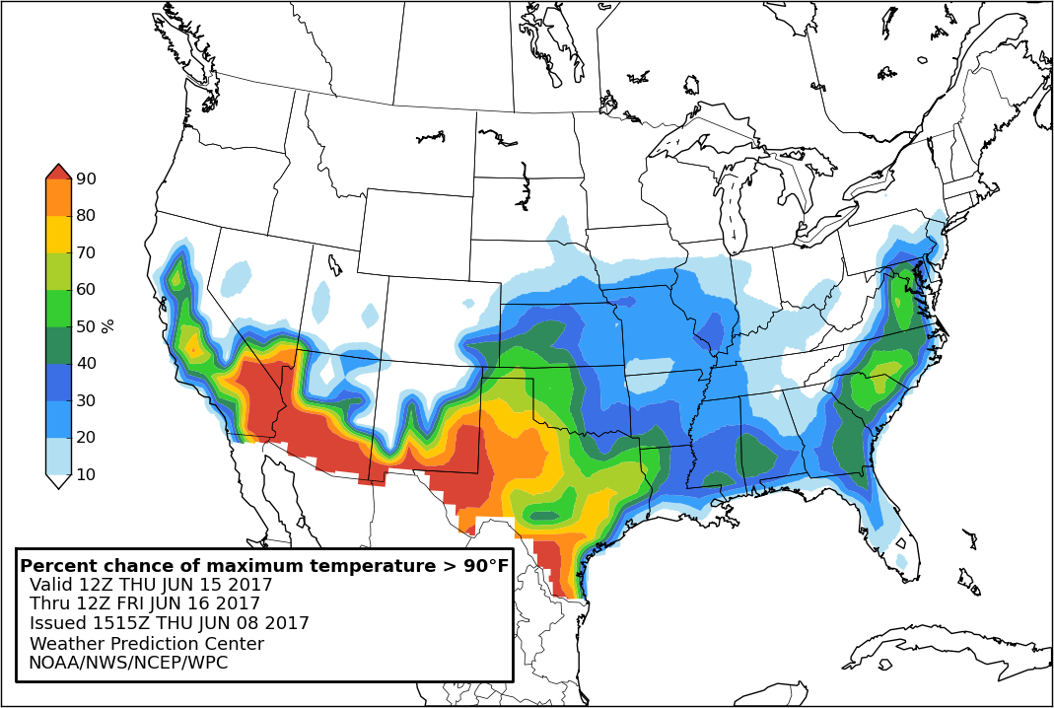

What is this product showing you?

What decisions do you make that could be assisted by the information in this product? When might you use this product?

What is your perception of this product with respect to the following qualities or characteristics?
Information included
Format
Understandability
Graphics
Text
Use of color

How helpful is this product for your day-to-day operations?

What actions would you take based on this product ? (Planning/Preparedness?)

Would you share this information with others in your organization?

Would you share this with your end user audience (if applicable?)

Graphic #2

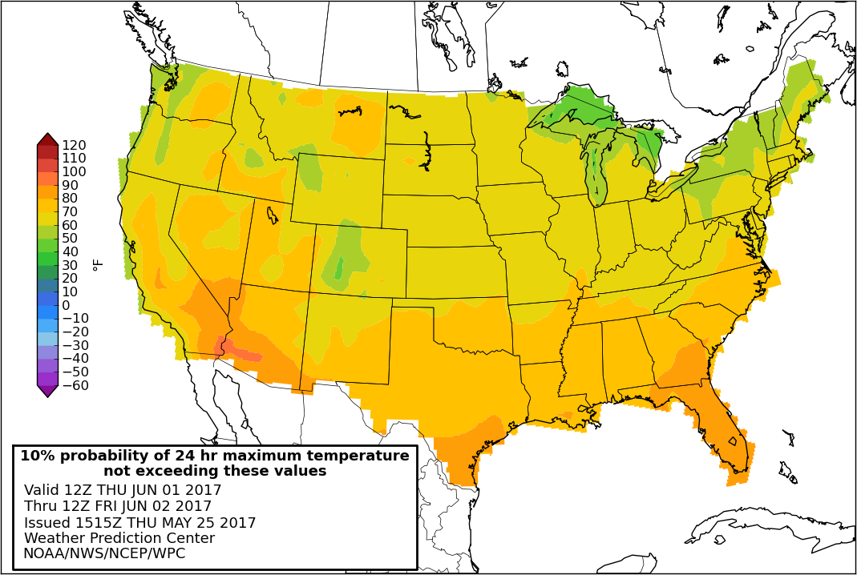

What is this product showing you?

What decisions do you make that could be assisted by the information in this product? When might you use this product?

What is your perception of this product with respect to the following qualities or characteristics?
Information included
Format
Understandability
Graphics
Text
Use of color

How helpful is this product for your day-to-day operations?

What actions would you take based on this product ? (Planning/Preparedness?)

Would you share this information with others in your organization?

Would you share this with your end user audience (if applicable?)

Graphic #3

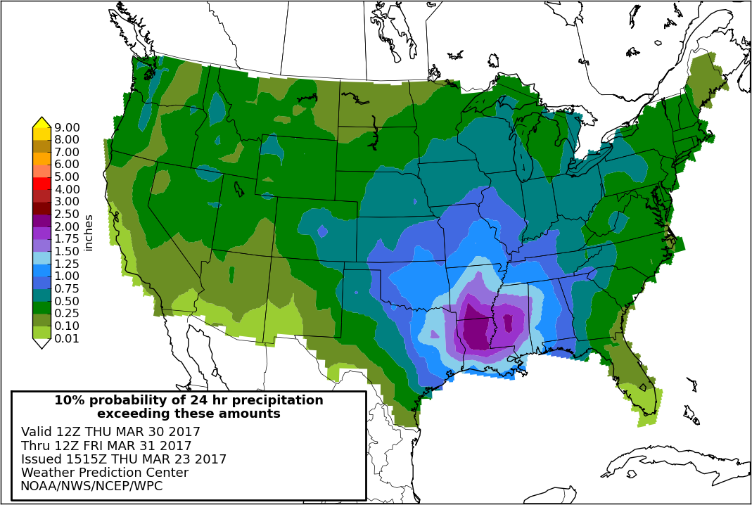

What is this product showing you?

What decisions do you make that could be assisted by the information in this product? When might you use this product?

What is your perception of this product with respect to the following qualities or characteristics?
Information included
Format
Understandability
Graphics
Text
Use of color

How helpful is this product for your day-to-day operations?

What actions would you take based on this product ? (Planning/Preparedness?)

Would you share this information with others in your organization?

Would you share this with your end user audience (if applicable?)

Graphic #4

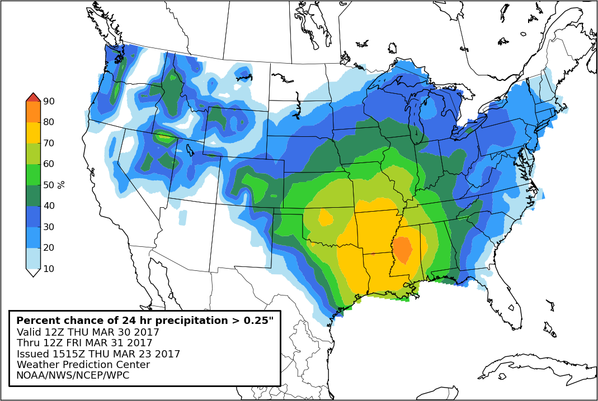

What is this product showing you?

What decisions do you make that could be assisted by the information in this product? When might you use this product?

What is your perception of this product with respect to the following qualities or characteristics?
Information included
Format
Understandability
Graphics
Text
Use of color

How helpful is this product for your day-to-day operations?

What actions would you take based on this product ? (Planning/Preparedness?)

Would you share this information with others in your organization?

Would you share this with your end user audience (if applicable?)

Graphic #5

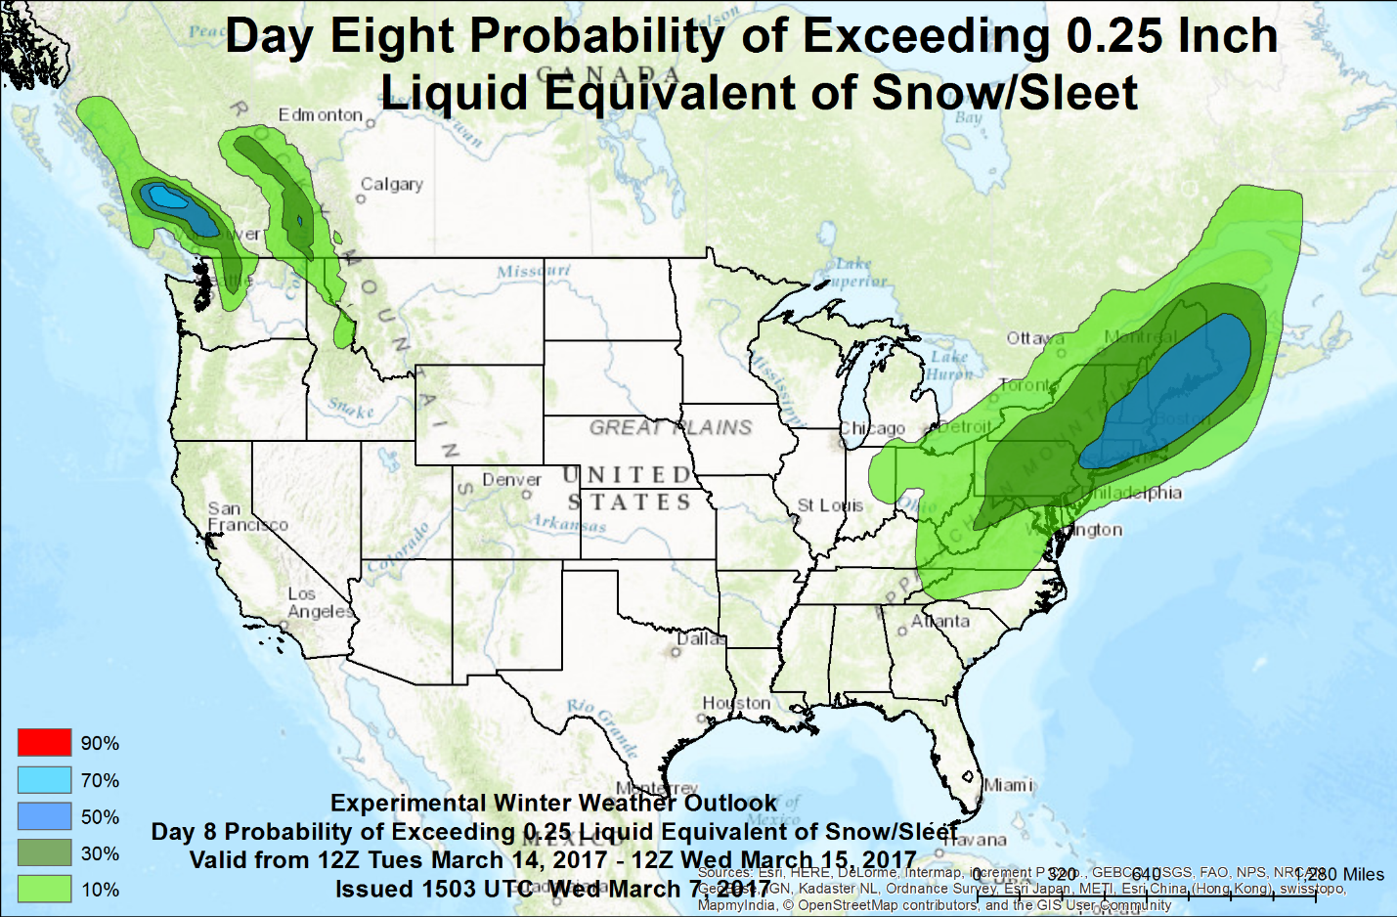

What is this product showing you?

What decisions do you make that could be assisted by the information in this product? When might you use this product?

What is your perception of this product with respect to the following qualities or characteristics?
Information included
Format
Understandability
Graphics
Text
Use of color

How helpful is this product for your day-to-day operations?

What actions would you take based on this product ? (Planning/Preparedness?)

Would you share this information with others in your organization?

Would you share this with your end user audience (if applicable?)

Graphic #6

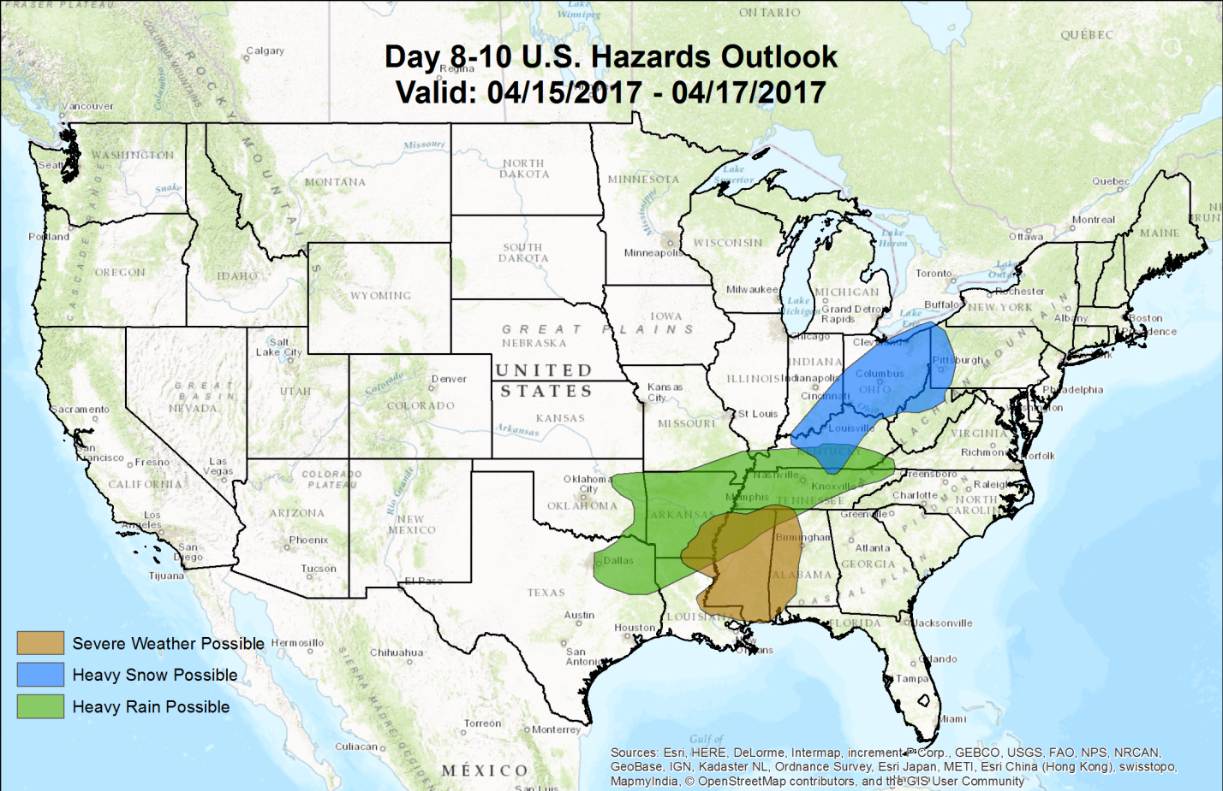

What is this product showing you?

What decisions do you make that could be assisted by the information in this product? When might you use this product?

What is your perception of this product with respect to the following qualities or characteristics?
Information included
Format
Understandability
Graphics
Text
Use of color

How helpful is this product for your day-to-day operations?

What actions would you take based on this product ? (Planning/Preparedness?)

Would you share this information with others in your organization?

Would you share this with your end user audience (if applicable?)

***
After all graphics are shown:

Having seen these prototype products, is there other information you wish you could have in the day 8-10 day range? Or a different range of time?

Ask actions questions product by product, and at the end.

