# Attachment 2_R: Youth FOLLOW-UP 2 INSTRUMENT

Form Approved

OMB No. 0910-0753

Exp. Date 9/30/2019

Evaluation of the Rural Smokeless Tobacco Education Campaign (RuSTEC)

**Programming conventions and specifications notes**

Abbreviations used include ‘R’ for ‘respondent’ and ‘PNTA’ for ‘prefer not to answer’

“Prefer Not To Answer/Don’t Know/Refused/None of these” are not allowed in combination with other responses.

Variable names and section headings are not displayed on screen.

Response options should not be labeled with numbers.

A “back button” will not be offered to respondents except during front-end administrative items.

Bolding conveys emphasis while capital letters convey instructions for programmers or interviewers.

Questionnaire will include a progress bar.

All items are required.

“Next” buttons will be displayed on every survey screen as appropriate.

All images should be arranged in such a way that focus on usability and layout. Images should be aligned and of similar sizes as one another.

“Prefer Not to Answer” should be visible only after a respondent attempts to skip the question without answering. A box will appear instructing them to select PNTA as their option if they mean to skip the item.

**S0a/LOGIN PAGE**. [IF WEB]

Thank you for logging in to the FDA Health and Media Study! Please enter your username and password. Your username is 8 characters such as XXX11111. If you can't find your username call (866) 214-2039.

Username: ___________________(Alpha numeric entry, 16 characters)

Password: ___________________(Alpha numeric entry, 16 characters)

The username and password are CASE SENSITIVE, so please type carefully.

**PROGRAMMER**: IF ENTRIES DON’T AGREE DISPLAY “Invalid username and/or password. Please verify your username and password and try again. Please remember passwords are case sensitive.”

**ASK:** All web respondents.

**LAND.** [IF R IS ON MOBILE DEVICE AND WEB]

It looks like you are viewing this survey on a mobile device. This survey works best in landscape mode.Taking the survey on a mobile device might take longer.

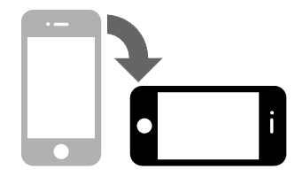

NEXT

**ASK:** All respondents who access the web survey via a mobile device.

Checkpoint: PROGRAMMER: CHECK IF BASELINE AND FU1 DOBS MATCH. IF THEY MATCH, CALCULFATE BLAGE USING DOB FROM BASELINE.

IF DOB FROM BASELINE IS MISSING, USE DOB FROM FU1. IF DOB FROM FU1 IS MISSING , USE DOB FROM BASELINE. IF BOTH DOBS ARE MISSING, USE AGE 17.

IF BASELINE DOB AND FU1 DOB DON’T MATCH, BLAGE SHOULD EQUAL 17.

**WID** [IF WEB AND BLAGE<18]

Our records indicate that [YouthFname] previously participated in our study. Before we begin with the interview, we need the parent or guardian of [YouthFname] to review some information. Are you the parent or guardian of [YouthFname]?

1. Yes -> GO TO STATE
2. No -> GO TO WIDFP

**ASK**: All web respondents.

**DISPLAY**: YouthFname is the respondent’s first name.

**WIDFP** [IF WEB AND WID=NO AND BLAGE<18]

Is [YouthFname]’s parent available to review this information? If not, please log back in to the website when the parent or guardian is available.

1. Yes, parent is available GO TO STATE
2. No, I will log back in when parent is availableSTAY ON THIS SCREEN

Back Next

**ASK:** Web respondents who indicate that the parent is not available in WID

**DISPLAY**: YouthFname is the respondent’s first name.

**WID18** [IF WEB AND BLAGE>=18]

Our records indicate that [YouthFname] previously participated in our study. Are you [YouthFname]?

1. Yes -> GO TO STATE
2. No -> GO TO WIDFP18

**ASK**: All web respondents who are 18 years old or older

**DISPLAY**: YouthFname is the respondent’s first name.

**WIDFP18** [IF WEB AND WID18=NO AND BLAGE>=18]

Is [YouthFname] available to begin the interview? If not, please log back in to the website when he is available.

1. Yes, he is available GO TO STATE
2. No, I will log back in when he is availableSTAY ON THIS SCREEN

Back Next

**ASK:** Web respondents who indicate that the respondent is not available in WID18

**DISPLAY**: YouthFname is the respondent’s first name.

**STATE** [IF WEB]

What state do you currently live in?

PROGRAMMER: DISPLAY AN ALPHABETIZED DROP DOWN OF ALL 50 STATES, WASHINGTON DC, AND AN OPTION FOR “I DON’T LIVE IN THE UNITED STATES”

**ASK:** All respondents who respond via the web

**COUNTY** [IF WEB AND STATE NE I DON’T LIVE IN US]

What county do you currently live in?

PROGRAMMER: DISPLAY DROP DOWN LIST OF ALL COUNTIES WITHIN THE STATE SELECTED FROM STATE. HERE IS THE SOURCE FOR THE CONTENT.

PROGRAMMER: IF STATE=I DON’T LIVE IN US GO TO INELIG. COMPARE COUNTY TO BASELINE COUNTY FROM SAMPLE LIST. IF BASELINE COUNTY=COUNTY, GO TO PEMAIL. IF THE BASELINE COUNTY IS IN A INTERVENTION GROUP AND COUNTY IS IN CONTROL GO TO INELIG. IF THE BASELINE COUNTY IS IN A CONTROL COUNTY AND THE COUNTY IS IN INTERVENTION GO TO INELIG.

ELSE: IF BASELINE COUNTY NE COUNTY, BUT BASELINE COUNTY IS A C OR A D AND COUNTY IS A C OR D, GO TO PEMAIL. IF BASELINE COUNTY NE COUNTY BUT BASELINE COUNTY IS A B AND COUNTY IS A B, GO TO PEMAIL. IF BASELINE COUNTY NE COUNTY AND BASELINE COUNTY IS A C OR D AND COUNTY IS A B OR NOT IN LOOKUP TABLE, GO TO INELIG. IF BASELINE COUNTY NE COUNTY AND BASELINE COUNTY IS A B AND COUNTY IS A C OR D OR NOT IN LOOK UP TABLE, GO TO INELIG.

**ASK:** All respondents who respond via the web and who live in the United States

**PEMAIL** [IF WEB]

In case we need to contact you about the study, please provide your email address.

Email Address:_________________ [ALLOW 50 CHARACTERS. FORMAT AS EMAIL ADDRESS]

Confirm Email Address:__________[MUST MATCH FIRST ENTRY]

Prefer not to answer

PROGRAMMER: VALIDATE FORMAT FOR EMAIL ADDRESS. IF FORMAT IS INCORRECT, PLEASE DISPLAY “Please enter a valid email address.” IF THE EMAIL ADDRESSES DON’T MATCH PLEASE DISPLAY “The email addresses do not match. Please try again. ”

**ASK**: All web respondents

**INELIG** Thank you for your interest in this study.Unfortunately, you are no longer located in the study area.

NEXT

**ASK**: Respondents who do not live in the United States or who do not live in a county that is in the study area or respondents that have moved between treatment and control counties.

**FINISH**

Thank you for taking the survey. Please close this window.

PROGRAMMER: CODE ITEM AS 2244.

**ASK**: Respondents who are ineligible.

# WPERMISS [IF WEB AND BLAGE<18]

# Parent or Guardian Permission for Youth Interview for WEB

**This text is to be read by the survey participant’s parent or guardian**

The FDA Health and Media Study is designed to collect data from boys about their attitudes related to health, health behaviors, and advertisements they may have seen on TV, online, or heard on the radio.

If you recall, previously, your address was randomly chosen to take part in this study. [YOUTHFNAME] was selected to be in this study and has completed at least one survey to date. This study is being conducted again to measure what might have changed over time or what has stayed the same. We are asking your permission for your child’s participation in this next round of the survey.

**Purpose of the Youth Survey**

We want to interview your child about these topics again. The child’s answers combined with the answers of other youth in the study will improve our understanding of how public education campaigns affect youth. The answers may be shared with the FDA but not your child’s personal information.

The interview will last about 45 minutes, depending on responses.

**Voluntary Participation**

Your child’s participation in this study is completely voluntary. He can refuse to answer any or all questions. Your child has the right to stop the interview at any time.

**Risks**

There are no physical risks to your child from participating in this interview. It is possible that some questions might make your child mildly uncomfortable, depending on responses. No absolute guarantees can be made regarding the interception of data sent via the Internet. However, we are taking extensive precautions to protect the privacy of all data.

**Future Contacts**

We will conduct two voluntary follow-up surveys every eight months to understand changes over time.

**Benefits**

There are no direct benefits to your child from answering our questions. However, he will be contributing to important health research.

**Compensation/Payment**

Because your child’s contribution is important, we will offer your child a check for **$25** if he completes the survey by [EARLY BIRD DATE] or a check for $20 after [EARLY BIRD DATE], as a token of appreciation for completing the survey. Your child will receive $20 in cash if he completes the survey in person.

**Privacy**

The survey answers will be entered into a computer and labeled with a case identification number. Your name and that of your child will not be reported with any information your child provides. Information your child provides will be combined with answers of many others and reported in a summary form. All staff involved in this research are committed to privacy and have signed a Privacy Pledge.

**Questions**

If you have any questions about the study, you can call our project assistance line toll-free at (866) 214-2039, or email us at mediastudy@rti.org. If you have any questions about your rights as a study participant, you may call the RTI Office of Research Protection at 1-866-214-2043 (a toll-free number).

If it is all right with you, please ask your child to answer the survey. Please give him privacy so he can answer the questions on his own. If you would rather he take the survey on a different device, he can log in on that device at the link on the study letter.

After you select your answer, please press “Next.”

1 Yes, I agree to allow my child to participate in this study. -> GO TO WASSENT

2 No, I do not want my child to participate in this study. -> GO TO PERMISREF.

**DISPLAY**: EARLY BIRD DATE is the date by which the respondents can receive a larger incentive for responding online. YOUTHFNAME is the respondent’s name.

**ASK**: Parents of minor respondents who are web respondents

**PERMISREF** [IF WPERMISS=2] **Thank you for your time. Please close this window.**

PROGRAMMER: CODE CASE AS REFUSAL.

EXIT

**ASK**: Parents who refuse to provide consent

# WASSENT [IF WEB AND BLAGE<18] Assent for Youth for WEB

**This screen is meant to be read by [YOUTHFNAME]**

We are talking to boys in 30 cities across the United States. This study is sponsored by the U.S. Food and Drug Administration. You have previously taken part in this study by completing a survey. We are asking for you to participate again by completing this web survey.

The survey asks boys ages 11-19 about their attitudes related to health behaviors. The survey asks about advertisements they may have seen on TV or online. The advertisements may have also been heard on the radio. The survey will take about 45 minutes to complete. Up to 2,200 boys will take this survey. This survey is part of a research study being conducted by RTI International. There are no direct benefits for answering our questions but you will be helping with important health research.

**Your parent or legal guardian has given permission for you to complete this survey.**

Your name will be kept private. Your answers will be labeled with a number instead of your name. This makes it so only research staff will know these are your answers. Your answers may be shared with the FDA but not your personal information. We will not share any information you give us with your parents or anyone outside the FDA and RTI research teams. All of your answers will be kept private. It is not completely safe to send data through the Internet but we are doing everything we can protect your data.

There are no physical risks but some questions might make you uncomfortable. If you don't want to take the survey, that is okay. If you don't want to answer a certain question, that is okay too. You may also choose to drop out of the survey at any time, for any reason and you may take a break at any time.

We will offer you a check for **$25** if you take the survey before [EARLY BIRD DEADLINE]. If you complete the survey after that we will offer you a check for $20. You will receive $20 in cash if you complete the survey in person.

We may contact you again in the future. It is up to you to decide if you would like to take any future surveys.

You can call us if you have any questions about the study. The phone number is (866) 214-2039. You can also email us at mediastudy@rti.org. You may also have questions about your rights as a study participant. For those questions call the RTI Office of Research Protection. Their phone number is (866) 214-2043. You can send them an email at orpe@rti.org.

After you select your answer, please press “Next.”

1 Yes, I agree to participate in this study. GO TO PRIV

2 No, I do not wish to participate in this study. GO TO ASSENTREF

**DISPLAY**: EARLY BIRD DATE is the date by which the respondents can receive a larger incentive for responding online. YOUTHFNAME is the respondent’s name.

**ASK**: Web respondents who are younger than 18 years old

**ASSENTREF** [IF WASSENT = 2] **Thank you for your time. Please close this window.**

PROGRAMMER: CODE CASE AS REFUSAL.

**ASK:** Respondents who refuse to provide consent

**WCONSENT** [IF WEB AND BLAGE>=18] Consent for Youth 18 and over for WEB

FDA Health and Media Study

**This screen is meant to be read by [YOUTH FNAME]**

We are talking to boys in 30 cities across the United States. This study is sponsored by the U.S. Food and Drug Administration. You have previously taken part in this study by completing at least one survey. In past surveys, your parent provided permission for you to participate. Now that you are 18 or older, we are asking for your consent to participate in this web survey.

The survey asks boys ages 11-19 about their attitudes related to health behaviors. The survey asks about advertisements they may have seen on TV or online. The advertisements may have also been heard on the radio. The survey will take about 45 minutes to complete. Up to 2,200 boys will take this survey. The survey is part of a research study being conducted by RTI International. There are no direct benefits for answering our questions but you will be helping with important health research.

Your name will be kept private. Your answers will be labeled with a number instead of your name. This makes it so only research staff will know these are your answers. Your answers may be shared with the FDA but not your personal information. We will not share any information you give us with your parents or anyone outside the FDA and RTI research teams. All of your answers will be kept private. It is not completely safe to send data through the Internet but we are doing everything we can to protect your data.

There are no physical risks but some questions might make you uncomfortable. If you don't want to take the survey, that is okay. If you don't want to answer a certain question, that is okay too. You may also choose to drop out of the survey at any time, for any reason and you may take a break at any time.

We will offer you a check for **$25** if you complete the survey before [EARLY BIRD DEADLINE]. If you complete the survey after that we will offer you a check for **$20**. You will receive $20 in cash if you complete the survey in person.

We may contact you again in the future. It is up to you to decide if you would like to take any future surveys.

You can call us if you have any questions about the study. The phone number is (866) 214-2039. You can also email us at mediastudy@rti.org. You may also have questions about your rights as a study participant. For those questions call the RTI Office of Research Protection. Their phone number is (866) 214-2043. You can send them an email at orpe@rti.org.

After you select your answer, please press “Next.”

1 Yes, I agree to participate in this study. – GO TO PRIV

2 No, I do not wish to participate in this study. – GO TO CONSENTREF

**DISPLAY**: EARLY BIRD DATE is the date by which the respondents can receive a larger incentive for responding online. YOUTHFNAME is the respondent’s name.

**ASK**: Web respondents who are 18 years old or older

**CONSENTREF** [IF WCONSENT = 2] Thank you for your time.

PROGRAMMER: CODE CASE AS REFUSAL.

**ASK:** Web respondents who are 18 years old and older and who refuse to provide consent

**PRIV** [IF WEB]Please make sure that you can answer the questions in private where no one can see your answers.

NEXT

**ASK**: Web respondents

**DRIV** [IF WEB]Do not answer the questions while driving.

NEXT

**ASK**: Web respondents

**TUTOR3** [IF WEB] Please click on the answer to each survey question, using a mouse or a touchscreen. If you skip a question, an option for “*Prefer not to answer*” will appear. You can use that option if you don’t know the answer to a question, or if you choose to not answer a question. Remember that your answers will be kept private. We will not share the answers to your questions with your parents or anyone else outside the research team.

NEXT

**ASK**: Web respondents

**FIID**

[DISPLAY DATE OF INSTRUMENT RELEASE]

[IF CAPI] ENTER YOUR FIID. [6 NUMERIC DIGIT ENTRY]

Programmer: allow 6 digits in entry field.

**ASK**: Interviewers of CAPI surveys

**DISPLAY**: The date that the instrument version was released will be displayed on the screen to serve as a version number for the CAPI instrument.

**CID** [IF CAPI AND BLAGE<18]

Our records indicate that [YouthFname] previously participated in our study. Before we begin with the interview, we need the parent or guardian of [YouthFname] to review some information. Are you the parent or guardian of [YouthFname]?

1. Yes -> GO TO PERMISS
2. No -> GO TO CIDFP

**ASK**: All CAPI respondents.

**DISPLAY**: YouthFname is the respondent’s first name.

**CIDFP** [IF CAPI AND CID=NO AND BLAGE<18]

Is [YouthFname]’s parent available to review this information?

1. YES, PARENT IS AVAILABLE 🡪 GO TO PERMISS
2. NO, THEY ARE NOT AVAILABLE **🡪** STAY ON THIS SCREEN

INTERVIEWER: BREAK OFF THE INTERVIEWER AND SCHEDULE A TIME TO RETURN FOR WHEN PARENTS WILL BE AVAILABLE. REMIND HOUSEHOLD ABOUT WEB OPTION FOR COMPLETION.

PROGRAMMER: CODE AS A 1231

Back

**ASK:** CAPI respondents who indicate that the parent is not available in CID

**DISPLAY**: YouthFname is the respondent’s first name.

**CID18** [IF CAPI AND BLAGE>=18]

Our records indicate that [YouthFname] previously participated in our study. Are you [YouthFname]?

1. YES -> GO TO CONSENT
2. NO -> GO TO CIDFP18

**ASK**: All CAPI respondents who are 18 years old or older

**DISPLAY**: YouthFname is the respondent’s first name.

**CIDFP18** [IF CAPI AND CID18=NO AND BLAGE>=18]

Is [YouthFname] available to begin the interview?

1. YES, HE IS AVAILABLE 🡪 GO TO CONSENT
2. NO, HE IS NOT AVAILABLE 🡪STAY ON THIS SCREEN

INTERVIEWER: BREAK OFF THE INTERVIEWER AND SCHEDULE A TIME TO RETURN FOR WHEN HE IS AVAILABLE. REMIND HOUSEHOLD ABOUT WEB OPTION FOR COMPLETION.

Back Next

**ASK:** CAPI respondents who indicate that the respondent is not available in CID18

**DISPLAY**: YouthFname is the respondent’s first name.

# PERMISS [IF CAPI AND BLAGE<18]

# Parent or Guardian Permission for Youth Interview

INTERVIEWER: HAND PINK PERMISSION FORM TO PARENT

The FDA Health and Media Study is designed to collect data from boys about their attitudes related to health, health behaviors, and advertisements they may have seen on TV, online, or heard on the radio.

If you recall, previously, your address was randomly chosen to take part in this study. [YOUTHFNAME] was selected to be in this study and has completed at least one survey to date. This study is being conducted again to measure what might have changed over time or what has stayed the same. We are asking your permission for your child’s participation in this next round of the survey.

**Purpose of the Youth Survey**

We want to interview your child about these topics again. The child’s answers, combined with the answers of other youth in the study, will improve our understanding of how public education campaigns affect youth. The answers may be shared with the FDA but not your child’s personal information.

**Types of Questions for Youth**

The interview will last about 45 minutes, depending on responses. The interviewer will ask the first few questions and then youth respondents will answer questions directly into a laptop. The interviews will be completed in a part of the household that allows your child to answer in private.

**Voluntary Participation**

Your child’s participation in this study is completely voluntary. He can refuse to answer any or all questions. Your child has the right to stop the interview at any time.

**Risks**

There are no physical risks to your child from participating in this interview. It is possible that some questions might make your child mildly uncomfortable, depending on responses. No absolute guarantees can be made regarding the interception of data sent via the Internet. However, we are taking extensive precautions to protect the privacy of all data.

**Future Contacts**

We will conduct two more voluntary follow-up surveys every eight months to understand changes over time.

**Benefits**

There are no direct benefits to your child from answering our questions. However, he will be contributing to important health research.

**Compensation/Payment**

Because your child’s contribution is important, we will offer your child $20 in cash as a token of appreciation for completing the survey.

**Privacy**

The survey answers will be entered into a computer and labeled with a case identification number. Your name and that of your child will not be reported with any information your child provides. Information your child provides will be combined with answers of many others and reported in a summary form. All staff involved in this research are committed to privacy and have signed a Privacy Pledge.

**Questions**

If you have any questions about the study, you can call our project assistance line toll-free at (866) 214-2039, or email us at mediastudy@rti.org. If you have any questions about your rights as a study participant, you may call the RTI Office of Research Protection at 1-866-214-2043 (a toll-free number).

**You will be given a copy of this consent form to keep.**

Do you give him permission to participate in the survey?

1. YES - GO TO ASSENT
2. NO -> GO TO CAPIREF

**ASK**: Parents of minor CAPI respondents

**CAPIREF** [IF PERMISS=REFUSE] Thank you for your time.

PROGRAMMER: CODE AS A REFUSAL.

# ASSENT [IF CAPI AND BLAGE<18]

# Assent for Youth for CAPI

INTERVIEWER: HAND BLUE ASSENT FORM TO RESPONDENT

We are talking to boys in 30 cities across the United States. The study is sponsored by the U.S. Food and Drug Administration. You have previously taken part in this study by completing a survey. We are asking for you to participate again by completing this survey.

The survey asks boys ages 11-19 about their attitudes related to health behaviors. The survey asks about advertisements they may have seen on TV or online. The advertisements may have also been heard on the radio. The survey will take about 45 minutes to complete. Up to 2,200 boys will take this survey. The survey is part of a research study being conducted by RTI International. There are no direct benefits for answering our questions but you will be helping with important health research.

Your parent or guardian has given permission for you to complete this survey.

Your name will be kept private. Your answers will be labeled with a number instead of your name. This makes it so only research staff will know these are your answers. Your answers may be shared with the FDA but not your personal information. We will not share any information you give us with your parents or anyone outside the FDA or RTI research teams. All of your answers will be kept private. It is not completely safe to send data through the Internet but we are doing everything we can to protect your data.

There are no physical risks but some questions might make you uncomfortable. If you don't want to take the survey, that is okay. If you don't want to answer a certain question, that is okay too. You may also choose to drop out of the survey at any time, for any reason and you may take a break at any time.

We will offer you **$20** in cash to thank you for taking time to complete the survey.

We may contact you again in the future. It is up to you to decide if you would like to take any future surveys.

You can call us if you have questions about the study. The phone number is (866) 214-2039. You can also email us at mediastudy@rti.org. You may also have questions about your rights as a study participant. For those questions call the RTI Office of Research Protection. Their phone number is (866) 214-2043. You can send them an email at orpe@rti.org.

Do you agree to take this survey?

1. YES -> GO TO OMB
2. NO -> GO TO CAPIREF2

[PROGRAMMER: IF ITEM IS LEFT BLANK, HARD PROMPT “Interviewer, this is a required item. Please do your best to fill out the item.”]

**ASK:** Minor CAPI respondents

**CAPIREF2 [IF ASSENT=NO]** Thank you for your time.

**PROGRAMMER:** CODE AS REFUSAL

**ASK**: CAPI minor respondents who refuse consent

# CONSENT [IF CAPI AND BLAGE>=18]

# Consent for Youth 18 and over for CAPI

INTERVIEWER: HAND YELLOW CONSENT FORM TO RESPONDENT

We are talking to boys in 30 cities across the United States. The study is sponsored by the U.S. Food and Drug Administration. You have previously taken part in this study by completing at least one survey. In past surveys, your parent provided permission for you to participate. Now that you are 18 or older, we are asking for your consent to participate in this survey.

The survey asks boys ages 11-19 about their attitudes related to health behaviors. The survey asks about advertisements they may have seen on TV or online. The advertisements may have also been heard on the radio. The survey will take about 45 minutes to complete. Up to 2,200 boys will take this survey. The survey is part of a research study being conducted by RTI International. There are no direct benefits for answering our questions but you will be helping with important health research.

Your name will be kept private. Your answers will be labeled with a number instead of your name. This makes it so only research staff will know these are your answers. Your answers may be shared with the FDA but not your personal information. We will not share any information you give us with your parents or anyone outside the FDA and RTI research teams. All of your answers will be kept private. It is not completely safe to send data through the Internet but we are doing everything we can to protect your data.

There are no physical risks but some questions might make you uncomfortable. If you don't want to take the survey, that is okay. If you don't want to answer a certain question, that is okay too. You may also choose to drop out of the survey at any time, for any reason and you may take a break at any time.

We will offer you **$20** in cash to thank you for taking time to complete the survey.

We may contact you again in the future. It is up to you to decide if you would like to take any future surveys.

You can call us if you have questions about the study. The phone number is (866) 214-2039. You can also email us at mediastudy@rti.org. You may also have questions about your rights as a study participant. For those questions call the RTI Office of Research Protection. Their phone number is (866) 214-2043. You can send them an email at orpe@rti.org.

Do you agree to take this survey?

1. YES -> GO TO OMB
2. NO -> GO TO CAPIREF3

[PROGRAMMER: IF ITEM IS LEFT BLANK, HARD PROMPT “Interviewer, this is a required item. Please do your best to fill out the item.”]

**ASK:** CAPI Respondents who are 18 years old or older

**CAPIREF3 [IF CONSENT=NO]** Thank you for your time.

**PROGRAMMER:** CODE AS REFUSAL

**ASK**: CAPI respondents 18 years old and older who refuse consent

**OMB [IF CAPI] [OPTIONAL. READ TEXT ONLY AS NECESSARY]**

OMB No: 0910-0753; Expiration Date: 09/30/2019

Paperwork Reduction Act Statement: The public reporting burden for this collection of information has been estimated to average 45 minutes per response. Send comments regarding this burden estimate or any other aspects of this collection of information, including suggestions for reducing burden to PRAStaff@fda.hhs.gov.

NEXT

**ASK**: Optional question for CAPI respondents

**Y_ACINTRO** [IF CAPI]

Now I'd like you to read the questions and enter your answers into the laptop yourself. This will allow you to answer the questions in complete privacy. I will not be able to see the answers you type into the computer. If you skip a question, an option for “Prefer not to answer” will appear. You can use that option if you don’t know the answer to a question, or if you choose to not answer a question. Let me explain how to use the laptop.

MOVE COMPUTER SO YOUTH CAN USE IT AND POINT OUT THE FOLLOWING:

- NUMBER KEYS

- MOUSE TO CLICK RESPONSES AND NEXT

CAUTION RESPONDENT ABOUT ON/OFF SWITCH.

WHEN RESPONDENT IS READY, SELECT THE CONTINUE RESPONSE OPTION AND CLICK THE “NEXT” BUTTON.

INTERVIEWER: HAND LAPTOP TO RESPONDENT

Continue

Next

**ASK**: CAPI Respondents

**Y_AC1** [IF CAPI]

The next questions are for practice. You will answer these questions on your own, and I will check on you to see if you need help. Select the “Continue” response option and click the “Next ” button to see the first question.

Continue

Next

**ASK**: CAPI Respondents

**Y_AC2a**  [IF CAPI]

In which state do you currently live?

1 Alabama

2 Alaska

3 Arizona

4 Arkansas

5 California

6 Colorado

7 Connecticut

8 Delaware

9 Florida

10 Georgia

11 Hawaii

12 Idaho

13 Illinois

14 Indiana

15 Iowa

16 Kansas

17 Kentucky

18 Louisiana

19 Maine

20 Maryland

21 Massachusetts

22 Michigan

23 Minnesota

24 Mississippi

25 Missouri

26 Montana

27 Nebraska

28 Nevada

29 New Hampshire

30 New Jersey

31 New Mexico

32 New York

33 North Carolina

34 North Dakota

35 Ohio

36 Pennsylvania

37 Rhode Island

38 South Carolina

39 Rhode Island

40 South Carolina

41 South Dakota

42 Tennessee

43 Texas

44 Utah

45 Vermont

46 Virginia

47 Washington

48 West Virginia

49 Wisconsin

50 Wyoming

51 District of Columbia

**ASK**: CAPI Respondents

**Y_AC3a**  [IF CAPI]

You have recorded that you live in [Y_AC2a]. Is this correct?

1 Yes -> GO TO Y_AC4a

2 No -> GO TO Y_C2a

9 Prefer not to answer

PROGRAMMER: IF Y_AC3a=2 OR PNTA DISPLAY A MESSAGE: ‘PLEASE RE-ENTER YOUR ANSWER’ AND RETURN TO Y_C2A

**ASK**: CAPI Respondents

**DISPLAY**: Answer from Y-AC2a

**Y_AC4a** [IF CAPI]

How many times in the **past 6 months** did you go to the movies?

1 1 time

2 2 times

3 3 times

4 4 times

5 5 or more times

8 I have not done this in the past 6 months

9 Prefer not to answer

**ASK:** CAPI Respondents

**Y_AC5a** [IF CAPI]

In the **last 30 days**, on how many days did you eat ice cream?

_______________ (Range: 0-30)

Prefer not to answer

**ASK:** CAPI Respondents

**Y_AC6** [IF CAPI]

Thank you. If you have any questions about how to use the laptop, please feel free to ask your interviewer.

Please select the “Continue” response option and click the “Next >” button to begin the next portion of the interview.

Continue

NEXT

**ASK**: CAPI Respondents

**Y_video** [IF WEB] Please try to view this video to make sure you can see it.

[DISPLAY TEST VIDEO]

Are you able to view this video?

1. Yes -> GO TO DOB
2. No - > GO TO EXIT

IF Y_video IS NO (=2), display this message:

Viewing the videos in this survey is important. Try logging into the survey using a different computer or browser. If that doesn’t work, you will not be able to take the survey online.

EXIT

PROGRAMMER: CODE AS BREAKOFF

PROGRAMMER: IF NO, need to begin with the viewing of the Y_VIDEO when the R comes back to the survey from a different device.

**ASK**: Web respondents

## Section A: Demographic Items

**DOB THIS QUESTION SHOULD BE COMPLETED BY [YOUTHFNAME]**

What is your date of birth?

Month: __________________ Day: ______________ Year: ___________

Confirm your date of birth.

Month: __________________ Day: ______________ Year: ___________

PROGRAMMER:

PROGRAM DROP DOWN LISTS WITH MONTH, DAY AND YEAR. YEAR SHOULD RANGE FROM 1995 – 2007. SPELL OUT MONTHS IN FULL. Please make sure that no invalid dates appear. That is Feb 30, Nov 31, etc. cannot be valid. Do not allow future dates. If the date is not valid, please display a hard error, “Please enter a valid date.” THIS ITEM SHOULD BE A REQUIRED ITEM. Use double entry verification. Both dates must match. If dates do not match, display a hard error, “Entries do not match. Please try again.”

DO NOT ALLOW MISSING DATA FOR THIS ITEM.

CALCULATE FILLAGE= (DATE TODAY)- DOB

**ASK**: All respondents

CHECKPOINT: PROGRAMMER: CHECK DOB AGAINST BLDOB. IF BOTH BLDOB AND FU1_DOB ARE BLANK GO TO B1a. IF DOB MATCHES BLDOB,GO TO B1a. IF THE DOBS DO NOT MATCH, CHECK AGAINST FU1_DOB. IF DOB AND FU1_DOB MATCH,GO TO B1a. IF THOSE DOBS DO NOT MATCH,GO TO DOB2.

**DOB2** [IF (BLDOB OR FU1_DOB NE DOB) AND (BLDOB AND FU1_DOB ARE NOT BLANK)] So that we can ask you the right questions, we need your correct age. Again, what is your date of birth?

__________________MM/ DD/ YYYY

Confirm your date of birth.

**_______________** MM/DD/YYYY

PROGRAMMER: USE DROP DOWN MENU. Only allow 1-12 in MM, 1-31 in DD. Please make sure that no invalid dates appear. That is Feb 30, Nov 31, etc. cannot be valid. Do not allow future dates. If the date is not valid, please display a hard error, “Please enter a valid date.” THIS ITEM SHOULD BE A REQUIRED ITEM. Use double entry verification. Both dates must match. If dates do not match, display a hard error, “Entries do not match. Please try again.”

DO NOT ALLOW MISSING DATA FOR THIS ITEM.

CALCULATE FILLAGE= (DATE TODAY)- DOB2

**ASK**: Respondents who enter a birthday in DOB that doesn’t match their entry from either baseline or follow up 1

**CHECKPOINT**

CHECKPOINT: PROGRAMMER: CHECK DOB2 AGAINST BLDOB. IF THE TWO DOBS MATCH,GO TO B1a. IF THE DOBS DO NOT MATCH, CHECK AGAINST FU1_DOB. IF DOB2 AND FU1_DOB MATCH,GO TO B1a. IF THOSE DOBS DO NOT MATCH AND WEB,GO TO DOBINELIG

**_______________________________________________________________**

**DOBINELIG** [IF WEB AND (DOB2 NE BLDOB OR FU1_DOB)CHECKPOINT We’re sorry, but we are not able to locate your file in our records. For this reason, you will not be able to take this survey online at this time. Please call 866-214-2039 with any questions.

Thank you for your time.

PROGRAMMER: EXIT PROGRAM AND CODE AS INELIGIBLE

[IF CAPI AGE IS INCONSISTENT, ALLOW RESPONSES AND CONTINUE]

**ASK:** Respondents who entered a birthday that doesn’t match any of the birthdays from prior waves

Section B: Tobacco Use Behavior

### Cigarette Use

PROGRAMMER: Please randomize the order in which the tobacco questions are presented in each section (E.G., Cigarette questions in section B would come first sometimes while other times, smokeless tobacco questions would come first).

The following are items that go together:

* B1- B4 == cigarettes
* B5- B9 == smokeless tobacco products
* B10- B11== cigars
* B12- B13 == hookah
* B14- B16 == e-cigs

Please randomize without breaking the blocks of items that go together sequentially.

**B_INTRO.** The next section asks about your experiences with tobacco products.

NEXT

**ASK**: All respondents

_________________________________________________________________________

**Checkpoint:** If BLB1 = 1 OR FU1B1 = 1 then go to B2. Else Ask B1

**B1.**

Have you ever tried cigarette smoking, even one or two puffs?

1 Yes -> GO TO B2

2 No -> GO TO NEXT RANDOM BLOCK IN SECTION B, OR IF THE LAST RANDOM BLOCK GO TO SECTION C

9 Prefer not to answer -> GO TO B2

PROGRAMMER: STARTING WITH THIS ITEM DISPLAY “Prefer not to answer” AFTER RESPONDENT TRIES TO SKIP QUESTION.

**ASK:** Respondents who did not report ever trying cigarette smoking at the follow-up 1 or baseline interviews.

**CHECKPOINT**:If B1 = 2 then go to the next random block in section B, or if the last random block go to section C. Else Ask B2 through B4

**B2.** [IF BLB1=1 OR FU1B1 = 1 ] Previously, you reported that you have tried cigarette smoking.

[IF B1=1 or 9OR BLB1=1 OR FU1B1 = 1] During the past 30 days, on how many days did you smoke cigarettes?

1 0 days

2 1 or 2 days

3 3 to 5 days

4 6 to 9 days

5 10 to 19 days

6 20 to 29 days

7 All 30 days

9 Prefer not to answer

**ASK:** Respondents who reported trying cigarette smoking or did not answer the question about trying cigarette smoking in B1 today or who reported smoking in previous interviews. Respondents who report smoking at the follow-up 1 or baseline interviews receive an additional introductory sentence for flow.

**B3.** [IF (BLB1=1 OR FU1B1=1 OR B1=1 OR 9) AND B2 NE 1]During the past 30 days, on the days you smoked, how many cigarettes did you smoke per day?

1 Less than 1 cigarette per day

2 1 cigarette per day

3 2 to 5 cigarettes per day

4 6 to 10 cigarettes per day

5 11 to 20 cigarettes per day

6 More than 20 cigarettes per day

9 Prefer not to answer

**ASK:** Respondents who reported trying cigarette smoking or did not answer the question about trying cigarette smoking in B1 today or who reported smoking in previous interviews and who reported smoking 1 or more of the past 30 days or did not answer the question about how many of the past 30 days they had smoked in B2 today.

**B4.** [IF (BLB1=1 OR FU1B1=1 OR B1=1 OR 9)] About how many cigarettes have you smoked in your entire life? Your best guess is fine.

1 0 cigarettes

2 1 or more puffs but never a whole cigarette

3 1 cigarette

4 2 to 5 cigarettes

5 6 to 15 cigarettes (about 1/2 a pack total)

6 16 to 25 cigarettes (about 1 pack total)

7 26 to 99 cigarettes (more than 1 pack, but less than 5 packs)

8 100 or more cigarettes (5 or more packs)

9 Prefer not to answer

**ASK:** Respondents who reported trying cigarette smoking or did not answer the question about trying cigarette smoking in B1 today or who report trying cigarettes at the follow-up 1 or baseline interviews.

### Other Tobacco Product Use

**Checkpoint:** If BLB5 = 1 OR FU1B5 = 1 then go to B6. Else Ask B5

**B5.** The next questions are about smokeless tobacco, such as dip, chewing tobacco, snuff, or snus. Common brands include Copenhagen, Grizzly, Skoal, Camel Snus, Kodiak, and Longhorn.



Have you ever used smokeless tobacco even just a small amount?

1 Yes -> GO TO B6

2 No -> GO TO NEXT RANDOM BLOCK IN SECTION B, OR IF THE LAST RANDOM BLOCK GO TO SECTION C

9 Prefer not to answer -> GO TO B6

**ASK:** Respondents who reported never having used smokeless tobacco or did not answer the question about using smokeless tobacco in B5 at the follow-up 1 or baseline interviews.

**CHECKPOINT**:If B5 = 2 go to the next random block in section B, or if the last random block go to section C. Else Ask B6

**B6.** [IF BLB5=1 OR FU1B5=1 OR (B5=1 OR 9)] During the past 30 days, on how many days did you use smokeless tobacco?

1 0 days

2 1 or 2 days

3 3 to 5 days

4 6 to 9 days

5 10 to 19 days

6 20 to 29 days or

7 All 30 days

9 Prefer not to answer

**ASK:** Respondents who reported having used smokeless tobacco in any of the three interviews or did not answer the question about using smokeless tobacco in B5 today.

**B7.** [IF BLB5=1 OR FU1B5=1 OR (B5=1 OR 9)] How many times have you used smokeless tobacco in your entire life?

1 1 time

2 2 to 10 times

3 11 to 20 times

4 21 to 50 times

5 51 to 99 times

6 100 or more times

9 Prefer not to answer

**ASK:** Respondents who reported having used smokeless tobacco in any of the three interviews or did not answer the question about using smokeless tobacco in B5 today.

**B8.** [IF BLB5=1 OR FU1B5=1 OR (B5=1 OR 9)] How often do you swallow smokeless tobacco juices?

1 Always

2 Sometimes

3 Rarely

4 Never

9 Prefer not to answer

**ASK:** Respondents who reported having used smokeless tobacco in any of the three interviews or did not answer the question about using smokeless tobacco in B5 today.

**B9.** [IF BLB5=1 OR FU1B5=1 OR (B5=1 OR 9)] How soon after you wake up do you use smokeless tobacco?

1 Within 5 minutes

2 6 to 30 minutes

3 31 to 60 minutes

4 More than 60 minutes

9 Prefer not to answer

**ASK**: Respondents who reported having used smokeless tobacco in any of the three interviews or did not answer the question about using smokeless tobacco in B5 today.

**Checkpoint:** If BLB10 = 1 OR FU1B10 = 1 then go to the next random block in section B, or if the last random block go to section C. Else Ask B10

**B10.** The next questions are about cigars, cigarillos, or little cigars such as Black & Mild, Swisher Sweets, Dutch Masters, Phillies Blunts, Prime Time, and Winchester.

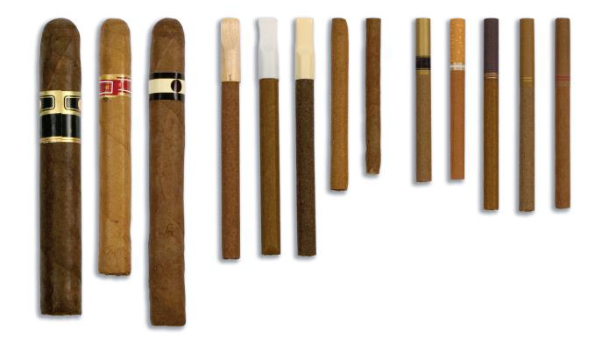

Have you ever smoked cigars, cigarillos, or little cigars even one time?

1 Yes -> GO TO B11

2 No -> GO TO NEXT RANDOM BLOCK IN SECTION B, OR IF THE LAST RANDOM BLOCK GO TO SECTION C

9 Prefer not to answer –> GO TO B11

**ASK:** Respondents who reported never smoking cigars, cigarillos, or little cigars or did not answer the question about smoking cigars, cigarillos, or little cigars in B10 at the follow-up 1 or baseline interviews.

**CHECKPOINT**: If B10 = 2 then go to the next random block in section B, or if the last random block go to section C. Else Ask B11

**B11.** [IF BLB10=1 OR FU1B10=1 OR (B10=1 OR 9)]During the past 30 days, on how many days did you smoke cigars, cigarillos, or little cigars?

1 0 days

2 1 or 2 days

3 3 to 5 days

4 6 to 9 days

5 10 to 19 days

6 20 to 29 days or

7 All 30 days

9 Prefer not to answer

**ASK:** Respondents who reported smoking cigars, cigarillos, or little cigars in any of the three interviews or did not answer the question about smoking cigars, cigarillos, or little cigars in B10 today.

**Checkpoint:** If BLB12 = 1 OR FU1B12 = 1 then go to the next random block in section B, or if the last random block go to section C. Else Ask B12

**B12.** Have you ever tried smoking tobacco out of a water pipe (also called “hookah”), even one time?

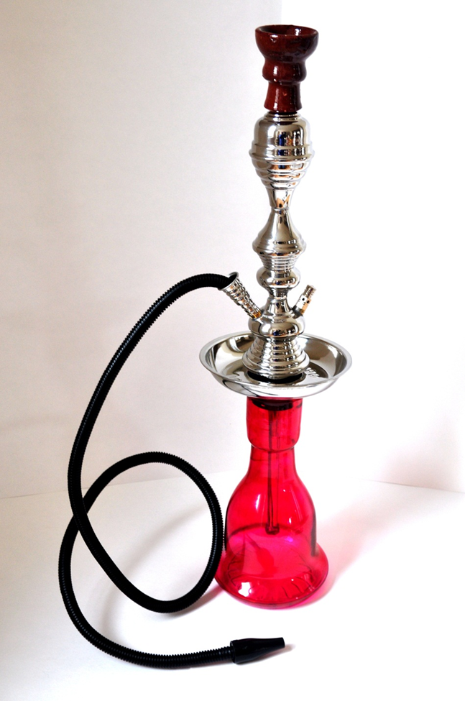

1 Yes -> GO TO B13

2 No - > GO TO NEXT RANDOM BLOCK IN SECTION B, OR IF THE LAST RANDOM BLOCK GO TO SECTION C

9 Prefer not to answer ->GO TO B13

**ASK:** Respondents who reported never having tried smoking tobacco out of a water pipe or did not answer the question about trying smoking tobacco out of a water pipe in B12 at the follow-up 1 or baseline interviews.

**CHECKPOINT**:If B12 = 2 then go to the next random block in section B, or if the last random block go to section C. Else Ask B13

**B13.** [IF BLB12=1 OR FU1B12=1 OR (B12= 1 OR 9)]During the past 30 days, on how many days did you smoke tobacco out of a water pipe (also called “hookah”)?

1 0 days

2 1 or 2 days

3 3 to 5 days

4 6 to 9 days

5 10 to 19 days

6 20 to 29 days or

7 All 30 days

9 Prefer not to answer

**ASK:** Respondents who reported having tried smoking tobacco out of a water pipe in any of the three interviews or did not answer the question about using smokeless tobacco in B12 today.

**Checkpoint:** If BLB14 = 1 OR FU1B14 = 1 then go to the next random block in section B, or if the last random block go to section C. Else Ask B14

**B14.** The next questions are about e-cigarettes (e-cigs), e-hookahs, vape pens, hookah pens and personal vaporizers. Some common brands include Fin, NJOY, Blu, e-Go, and Vuse.

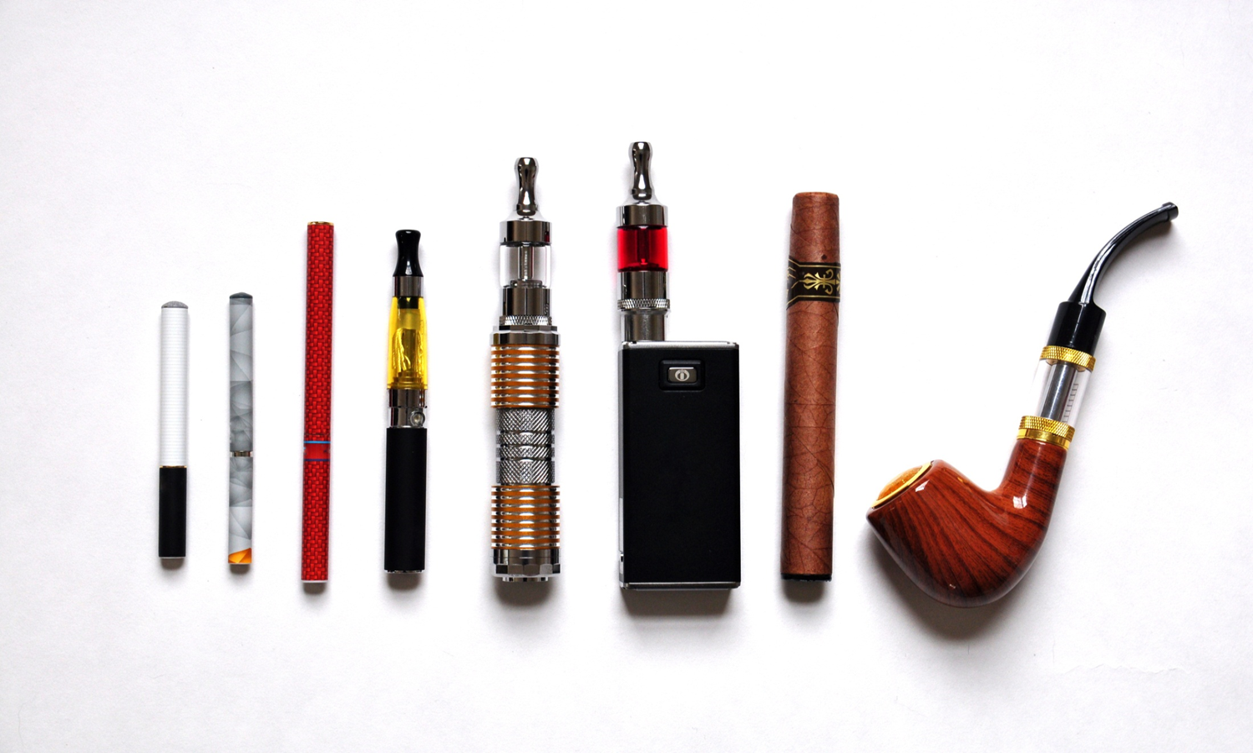

Have you ever tried any e-cigs or vape pens, even one time?

1 Yes –> GO TO B15

2 No -> GO TO NEXT RANDOM BLOCK IN SECTION B, OR IF THE LAST RANDOM BLOCK GO TO SECTION C

9 Prefer not to answer –> GO TO B15

**ASK:** Respondents who reported never having tried any e-cigs or vape pens or did not answer the question about trying any e-cigs or vape pens at the follow-up 1 or baseline interviews.

**CHECKPOINT**:If B14 = 2 then go to the next random block in section B, or if the last random block go to section C. Else Ask B15 and B16

**B15.** [IF BLB14=1 OR FU1B14=1 OR (B14= 1 OR 9)]During the past 30 days, on how many days did you use e-cigarettes?

1 0 days

2 1 or 2 days

3 3 to 5 days

4 6 to 9 days

5 10 to 19 days

6 20 to 29 days or

7 All 30 days

9 Prefer not to answer

**ASK:** Respondents who reported having ever tried any e-cigs or vape pens in any of the three interviews or did not answer the question about ever trying any e-cigs or vape pens in B14 today

**B16.** [IF BLB14=1 OR FU1B14=1 OR (B14= 1 OR 9)] Does the e-cig you usually use contain nicotine?

1 Yes

2 No

3 Don’t Know

9 Prefer not to answer

**ASK:** Respondents who reported having ever tried any e-cigs or vape pens in any of the three interviews or did not answer the question about ever trying any e-cigs or vape pens in B14 today

## Section C: Tobacco Use Intentions and Self-Efficacy

PROGRAMMER: RANDOMIZE THE ORDERING OF THE SETS C1, C2, AND C3.

**C1.** Thinking about the future…

|  |  |  |  |  |  |  |
| --- | --- | --- | --- | --- | --- | --- |
|  |  | **Definitely Yes** | **Probably Yes** | **Probably Not** | **Definitely Not** | **Prefer Not to Answer** |
| **C1_1.** | Do you think that you will smoke a **cigarette** soon? | 1 | 2 | 3 | 4 | 9 |
| **C1_2.** | Do you think you will smoke a **cigarette** at any time in the next year? | 1 | 2 | 3 | 4 | 9 |
| **C1_3.** | If one of your best friends were to offer you a **cigarette**, would you smoke it? | 1 | 2 | 3 | 4 | 9 |
| **C1_4.** | Have you ever been curious about smoking **cigarettes**? | 1 | 2 | 3 | 4 | 9 |

**ASK**: All respondents

**C2.** Thinking about the future…

|  |  |  |  |  |  |  |
| --- | --- | --- | --- | --- | --- | --- |
|  |  | **Definitely Yes** | **Probably Yes** | **Probably Not** | **Definitely Not** | **Prefer Not to Answer** |
| **C2_1.** | Do you think that you will use **smokeless tobacco** soon? | 1 | 2 | 3 | 4 | 9 |
| **C2_2.** | Do you think you will use **smokeless tobacco** at any time in the next year? | 1 | 2 | 3 | 4 | 9 |
| **C2_3.** | If one of your best friends were to offer you **smokeless tobacco** would you use it? | 1 | 2 | 3 | 4 | 9 |
| **C2_4** | Have you ever been curious about using **smokeless tobacco**? | 1 | 2 | 3 | 4 | 9 |

**ASK**: All respondents

**C3.** Thinking about the future…

|  |  |  |  |  |  |  |
| --- | --- | --- | --- | --- | --- | --- |
|  |  | **Definitely Yes** | **Probably Yes** | **Probably Not** | **Definitely Not** | **Prefer Not to Answer** |
| **C3_1.** | Do you think that you will use an **e-cig** soon? | 1 | 2 | 3 | 4 | 9 |
| **C3_2.** | Do you think you will use an **e-cig** at any time in the next year? | 1 | 2 | 3 | 4 | 9 |
| **C3_3.** | If one of your best friends were to offer you an **e-cig**, would you use it? | 1 | 2 | 3 | 4 | 9 |
| **C3_4.** | Have you ever been curious about using **e-cigs**? | 1 | 2 | 3 | 4 | 9 |

**ASK**: All respondents

**C4.** How sure are you that, if you really wanted to, you could say **no** to smokeless tobacco, if…

PROGRAMMER: RANDOMIZE C4_1-C4_3

|  |  |  |  |  |  |  |
| --- | --- | --- | --- | --- | --- | --- |
|  | **Not at all sure** | **Slightly sure** | **Somewhat sure** | **Mostly sure** | **Completely sure** | **Prefer Not to Answer** |
| **C4_1.** You are hanging out where most people are using it? | 1 | 2 | 3 | 4 | 5 | 9 |
| **C4_2.** A friend offers it? | 1 | 2 | 3 | 4 | 5 | 9 |
| **C4_3.** A family member offers it? | 1 | 2 | 3 | 4 | 5 | 9 |

**ASK**: All respondents

Section D: Cessation (Intention, Behavior, Motivation)

PROGRAMMER: RANDOMIZE THE SET:

* D1-D2 ==CIGARETTES
* D3-D4 == SMOKELESS TOBACCO

Cigarette Use

**D1.** [IF B2=2-7 OR 9]

During the past 3 months, did you stop smoking cigarettes for one day or longer because you were trying to quit smoking cigarettes for good?

1 Yes

2 No

9 Prefer not to answer

**ASK:** Respondents who report smoking more than 0 days in the past 30 days in B2, or who report that they don’t know how many days they smoked in the past 30 days.

**D2.** [IF D1 NE BLANK]

How much do you want to stop smoking?

1 Not at all

2 A little

3 Somewhat

4 A lot

9 Prefer not to answer

**ASK:** Respondents who report smoking more than 0 days in the past 30 days in B2, or who report that they don’t know how many days they smoked in the past 30 days.

Other Tobacco Use

**D3.** [IF B6=2-7 OR 9]

During the past 3 months, did you stop using smokeless tobacco for one day or longer because you were trying to quit using smokeless tobacco for good?

1 Yes

2 No

9 Prefer not to answer

**ASK:** Respondents who report using smokeless tobacco more than 0 days in the past 30 days in B6, or who report that they don’t know how many days they used smokeless tobacco in the past 30.

**D4.** [IF D3 NE BLANK]

How much do you want to stop using smokeless tobacco?

1 Not at all

2 A little

3 Somewhat

4 A lot

9 Prefer not to answer

**ASK:** Respondents who report using smokeless tobacco more than 0 days in the past 30 days in B6, or who report that they don’t know how many days they used smokeless tobacco in the past 30.

Section E: Attitudes, Beliefs & Risk Perceptions, Social Norm

**EINTRO.** The next set of questions asks for your opinions on cigarette use and other tobacco products.

NEXT

**ASK:** All respondents

**E1. Smoking cigarettes** is…

PROGRAMMER: RANDOMIZE E1_1-E1_3

PROGRAMMER: DISPLAY ITEM LIKE THAT BELOW. R WILL CLICK BUTTON TO ENTER RESPONSE. FIND A WAY TO DISPLAY A PREFER NOT TO ANSWER.

|  |  |  |  |  |  |  |  |  |  |
| --- | --- | --- | --- | --- | --- | --- | --- | --- | --- |
| **E1_1.** | **Bad** |  |  |  |  |  |  |  | **Good** |
| **E1_2.** | **Unenjoyable** |  |  |  |  |  |  |  | **Enjoyable** |
| **E1_3.** | **Harmful** |  |  |  |  |  |  |  | **Not Harmful** |

**ASK**: All respondents

**E2. Using smokeless tobacco** is…

PROGRAMMER: RANDOMIZE E2_1-E2_3

PROGRAMMER: DISPLAY ITEM LIKE THAT BELOW. R WILL CLICK BUTTON TO ENTER RESPONSE. FIND A WAY TO DISPLAY A PREFER NOT TO ANSWER.

|  |  |  |  |  |  |  |  |  |  |
| --- | --- | --- | --- | --- | --- | --- | --- | --- | --- |
| **E2_1.** | **Bad** |  |  |  |  |  |  |  | **Good** |
| **E2_2.** | **Unenjoyable** |  |  |  |  |  |  |  | **Enjoyable** |
| **E2_3.** | **Harmful** |  |  |  |  |  |  |  | **Not Harmful** |

**ASK**: All respondents

**E3. Using e-cigs or vape pens** is**…**

PROGRAMMER: RANDOMIZE E3_1-E3_3

DISPLAY ITEM LIKE THAT BELOW. R WILL CLICK BUTTON TO ENTER RESPONSE. FIND A WAY TO DISPLAY A PREFER NOT TO ANSWER.

|  |  |  |  |  |  |  |  |  |  |
| --- | --- | --- | --- | --- | --- | --- | --- | --- | --- |
| **E3_1.** | **Bad** |  |  |  |  |  |  |  | **Good** |
| **E3_2.** | **Unenjoyable** |  |  |  |  |  |  |  | **Enjoyable** |
| **E3_3.** | **Harmful** |  |  |  |  |  |  |  | **Not Harmful** |

**ASK**: All respondents

**E4.** How much do you agree or disagree with the following statements? **If I use smokeless tobacco,** I will…

PROGRAMMER: RANDOMIZE E4_1- E4_9

|  |  |  |  |  |  |  |  |
| --- | --- | --- | --- | --- | --- | --- | --- |
|  |  | **Strongly Disagree** | **Disagree** | **Neither Agree or Disagree** | **Agree** | **Strongly Agree** | **Prefer Not to Answer** |
| **E4_1.** | Damage my body | 1 | 2 | 3 | 4 | 5 | 9 |
| **E4_2.** | Be controlled by smokeless tobacco | 1 | 2 | 3 | 4 | 5 | 9 |
| **E4_3.** | Be more attractive | 1 | 2 | 3 | 4 | 5 | 9 |
| **E4_4.** | Develop cancer of the lip, mouth, tongue or throat | 1 | 2 | 3 | 4 | 5 | 9 |
| **E4_5.** | Develop sexual and/or fertility problems | 1 | 2 | 3 | 4 | 5 | 9 |
| **E4_6.** | Fit in | 1 | 2 | 3 | 4 | 5 | 9 |
| **E4_7.** | Be unable to stop when I want to | 1 | 2 | 3 | 4 | 5 | 9 |
| **E4_8.** | Lose my teeth | 1 | 2 | 3 | 4 | 5 | 9 |
| **E4_9.** | Shorten my life | 1 | 2 | 3 | 4 | 5 | 9 |

**ASK**: All respondents

E4_10a. How much do you agree or disagree with the following statements? If I use smokeless tobacco, I will…

PROGRAMMER: RANDOMIZE E4_10- E4_18

|  |  |  |  |  |  |  |  |
| --- | --- | --- | --- | --- | --- | --- | --- |
|  |  | **Strongly Disagree** | **Disagree** | **Neither Agree or Disagree** | **Agree** | **Strongly Agree** | **Prefer Not to Answer** |
| **E4_10 .** | Get sick more often | 1 | 2 | 3 | 4 | 5 | 9 |
| **E4_11.** | End up wasting money on smokeless tobacco | 1 | 2 | 3 | 4 | 5 | 9 |
| **E4_12.** | Feel more relaxed | 1 | 2 | 3 | 4 | 5 | 9 |
| **E4_13.** | Miss out on things I enjoy doing | 1 | 2 | 3 | 4 | 5 | 9 |
| **E4_14.** | Gross out people I want to date | 1 | 2 | 3 | 4 | 5 | 9 |
| **E4_16.** | Develop gum disease | 1 | 2 | 3 | 4 | 5 | 9 |
| **E4_17.** | Develop red or white patches in the mouth | 1 | 2 | 3 | 4 | 5 | 9 |
| **E4_18.** | Consume harmful chemicals | 1 | 2 | 3 | 4 | 5 | 9 |

**ASK**: All respondents

**E5.** How much do you agree or disagree with the following statements? **If I** **smoke cigarettes** I will…

PROGRAMMER: RANDOMIZE E5_1- E5_11

|  |  |  |  |  |  |  |  |
| --- | --- | --- | --- | --- | --- | --- | --- |
|  |  | **Strongly Disagree** | **Disagree** | **Neither Agree or Disagree** | **Agree** | **Strongly Agree** | **Prefer Not to Answer** |
| **E5_1.** | Be controlled by smoking | 1 | 2 | 3 | 4 | 5 | 9 |
| **E5_2.** | Be more attractive | 1 | 2 | 3 | 4 | 5 | 9 |
| **E5_3.** | Develop cancer of the lip, mouth, tongue or throat | 1 | 2 | 3 | 4 | 5 | 9 |
| **E5_4.** | Develop sexual and/or fertility problems | 1 | 2 | 3 | 4 | 5 | 9 |
| **E5_5.** | Be unable to stop when I want to | 1 | 2 | 3 | 4 | 5 | 9 |
| **E5_6.** | Develop skin problems | 1 | 2 | 3 | 4 | 5 | 9 |
| **E5_7.** | Lose my teeth | 1 | 2 | 3 | 4 | 5 | 9 |
| **E5_8.** | Feel more relaxed | 1 | 2 | 3 | 4 | 5 | 9 |
| **E5_9.** | Shorten my life | 1 | 2 | 3 | 4 | 5 | 9 |
| **E5_10.** | End up wasting money on cigarettes | 1 | 2 | 3 | 4 | 5 | 9 |
| **E5_11.** | Be more popular | 1 | 2 | 3 | 4 | 5 | 9 |

**ASK**: All respondents

**E6.** How much do you agree or disagree with the following statements **about smoking cigarettes?**

PROGRAMMER: RANDOMIZE E6_1- E6_5. Keep E6_5 as the last item.

|  |  |  |  |  |  |  |  |
| --- | --- | --- | --- | --- | --- | --- | --- |
|  |  | **Strongly Disagree** | **Disagree** | **Neither Agree or Disagree** | **Agree** | **Strongly Agree** | **Prefer Not to Answer** |
| **E6_1.** | Smoking can cause **immediate** damage to my body. | 1 | 2 | 3 | 4 | 5 | 9 |
| **E6_2.** | Smoking cigarettes helps people relieve stress. | 1 | 2 | 3 | 4 | 5 | 9 |
| **E6_3.** | Cigarette ingredients are disgusting. | 1 | 2 | 3 | 4 | 5 | 9 |
| **E6_4.** | Smoking cigarettes is a manly thing to do. | 1 | 2 | 3 | 4 | 5 | 9 |
| **E6_5** | Please select the option labeled ‘Disagree’ as your answer. | 1 | 2 | 3 | 4 | 5 | 9 |

**ASK**: All respondents

**E7.** How much do you agree or disagree with the following statements **about using smokeless tobacco?**

PROGRAMMER: RANDOMIZE E7_1- E7_9

|  |  |  |  |  |  |  |  |
| --- | --- | --- | --- | --- | --- | --- | --- |
|  |  | **Strongly Disagree** | **Disagree** | **Neither Agree or Disagree** | **Agree** | **Strongly Agree** | **Prefer Not to Answer** |
| **E7_1.** | Using smokeless tobacco can cause **immediate** damage to my body. | 1 | 2 | 3 | 4 | 5 | 9 |
| **E7_2.** | It is safe for me to use smokeless tobacco for only a year or two, as long as I quit after that. | 1 | 2 | 3 | 4 | 5 | 9 |
| **E7_3.** | If I used smokeless tobacco occasionally I would not become addicted. | 1 | 2 | 3 | 4 | 5 | 9 |
| **E7_4.** | Using smokeless tobacco helps people relieve stress. | 1 | 2 | 3 | 4 | 5 | 9 |
| **E7_5.** | Using smokeless tobacco is disgusting. | 1 | 2 | 3 | 4 | 5 | 9 |
| **E7_7.** | Using smokeless tobacco is a way to show others you’re not afraid to take risks | 1 | 2 | 3 | 4 | 5 | 9 |
| **E7_9** | Using smokeless tobacco is a manly thing to do | 1 | 2 | 3 | 4 | 5 | 9 |

**ASK**: All respondents

**E8.** Does **smokeless tobacco such as dip, chewing tobacco, or snuff** contain….

PROGRAMMER: RANDOMIZE E8_1 – E8_8

|  |  |  |  |  |  |  |  |
| --- | --- | --- | --- | --- | --- | --- | --- |
|  |  | **Definitely Yes** | **Probably Yes** | **Probably Not** | **Definitely Not** | **Don’t Know** | **Prefer Not to Answer** |
| **E8_1.** | Arsenic, a substance found in motor oil? | 1 | 2 | 3 | 4 | 5 | 9 |
| **E8_2.** | Beryllium, a substance used in nuclear weapons and nuclear power reactors? | 1 | 2 | 3 | 4 | 5 | 9 |
| **E8_3.** | Cadmium, a substance found in batteries? | 1 | 2 | 3 | 4 | 5 | 9 |
| **E8_4.** | Formaldehyde, a chemical used to preserve dead animals? | 1 | 2 | 3 | 4 | 5 | 9 |
| **E8_5.** | Lead, a substance found in bullets? | 1 | 2 | 3 | 4 | 5 | 9 |
| **E8_6.** | Naphthalene, a chemical found in mothballs? | 1 | 2 | 3 | 4 | 5 | 9 |
| **E8_7.** | Polonium 210, a poison? | 1 | 2 | 3 | 4 | 5 | 9 |
| **E8_8.** | Uranium, a substance used in nuclear weapons and nuclear power reactors? | 1 | 2 | 3 | 4 | 5 | 9 |

**ASK**: All respondents

E9. How many of your four closest friends…

PROGRAMMER: RANDOMIZE E9_1 – E9_3

|  |  |  |  |  |  |  |  |
| --- | --- | --- | --- | --- | --- | --- | --- |
|  |  | **None** | **One** | **Two** | **Three** | **Four** | **Prefer Not to Answer** |
| **E9_1.** | Smoke cigarettes? | 0 | 1 | 2 | 3 | 4 | 9 |
| **E9_2.** | Use smokeless tobacco? | 0 | 1 | 2 | 3 | 4 | 9 |
| **E9_3.** | Use e-cigs? | 0 | 1 | 2 | 3 | 4 | 9 |

**ASK**: All respondents

E10. How many others your age…

PROGRAMMER: RANDOMIZE E10_1 – E10_3

|  |  |  |  |  |  |  |  |
| --- | --- | --- | --- | --- | --- | --- | --- |
|  |  | **None** | **A few** | **Some** | **Most** | **All** | **Prefer Not to Answer** |
| **E10_1.** | Smoke cigarettes? | 0 | 1 | 2 | 3 | 4 | 9 |
| **E10_2.** | Use smokeless tobacco? | 0 | 1 | 2 | 3 | 4 | 9 |
| **E10_3.** | Use e-cigs? | 0 | 1 | 2 | 3 | 4 | 9 |

**ASK**: All respondents

**Section F: Media Use and Awareness**

F1. Next, we’d like to ask you about your use of TV and other media.

How often do you…

PROGRAMMER: RANDOMIZE F1_1 – F1_8

|  |  |  |  |  |  |  |  |  |
| --- | --- | --- | --- | --- | --- | --- | --- | --- |
|  | **Several times a day** | **About once a day** | **3-5 days a week** | **1-2 days a week** | **Every few weeks** | **Less often** | **Never** | **Prefer Not to Answer** |
| **F1_1.** Watch television? | 1 | 2 | 3 | 4 | 5 | 6 | 7 | 9 |
| **F1_2.** Watch videos on YouTube/Twitch? | 1 | 2 | 3 | 4 | 5 | 6 | 7 | 9 |
| **F1_3.** Listen to radio? | 1 | 2 | 3 | 4 | 5 | 6 | 7 | 9 |
| **F1_4.** Listen to streaming radio? | 1 | 2 | 3 | 4 | 5 | 6 | 7 | 9 |
| **F1_5.** Play games on any electronic devices including cell phones/ smartphones, computers, laptops, tablets, consoles (Xbox, Wii, PS) and handheld players (Nintendo DS, Sony PSP, iPod)? | 1 | 2 | 3 | 4 | 5 | 6 | 7 | 9 |
| **F1_6.** Look at or read any magazines on a computer, laptop, or tablet? | 1 | 2 | 3 | 4 | 5 | 6 | 7 | 9 |
| **F1_7.** Watch Netflix, Hulu or Amazon Prime video? | 1 | 2 | 3 | 4 | 5 | 6 | 7 | 9 |
| **F1_8.** Go to the movies at a movie theater? | 1 | 2 | 3 | 4 | 5 | 6 | 7 | 9 |

**ASK**: All respondents

**F2.** Thinking about the social networking sites you use, about how often do you visit or use the following…

PROGRAMMER: RANDOMIZE F2_1 – F2_9

|  |  |  |  |  |  |  |  |  |
| --- | --- | --- | --- | --- | --- | --- | --- | --- |
|  | **Several times a day** | **About once a day** | **3-5 days a week** | **1-2 days a week** | **Every few weeks** | **Less often** | **Never** | **Prefer Not to Answer** |
| **F2_1.**  Facebook | 1 | 2 | 3 | 4 | 5 | 6 | 7 | 9 |
| **F2_2.**  Instagram | 1 | 2 | 3 | 4 | 5 | 6 | 7 | 9 |
| **F2_3.**  Twitter | 1 | 2 | 3 | 4 | 5 | 6 | 7 | 9 |
| **F2_4.**  Periscope | 1 | 2 | 3 | 4 | 5 | 6 | 7 | 9 |
| **F2_5.**  Snapchat | 1 | 2 | 3 | 4 | 5 | 6 | 7 | 9 |
| **F2_7.**  Skype | 1 | 2 | 3 | 4 | 5 | 6 | 7 | 9 |
| **F2_8.**  Google Hangouts | 1 | 2 | 3 | 4 | 5 | 6 | 7 | 9 |
| **F2_9.**  WhatsApp | 1 | 2 | 3 | 4 | 5 | 6 | 7 | 9 |

**ASK**: All respondents

**F3.** Thinking about the following websites, about how often do you visit or use the following…

PROGRAMMER: RANDOMIZE ALL

|  |  |  |  |  |  |  |  |  |
| --- | --- | --- | --- | --- | --- | --- | --- | --- |
|  | **Several times a day** | **About once a day** | **3-5 days a week** | **1-2 days a week** | **Every few weeks** | **Less often** | **Never** | **Prefer Not to Answer** |
| **F3_1.** YouTube  www.youtube.com | 1 | 2 | 3 | 4 | 5 | 6 | 7 | 9 |
| **F3_2.** Facebook  www.facebook.com | 1 | 2 | 3 | 4 | 5 | 6 | 7 | 9 |
| **F3_3.** Twitter  www.twitter.com | 1 | 2 | 3 | 4 | 5 | 6 | 7 | 9 |
| **F3_4.** Spotify  www.spotify.com | 1 | 2 | 3 | 4 | 5 | 6 | 7 | 9 |
| **F3_5.** Bleacher Report  www.bleacherreport.com | 1 | 2 | 3 | 4 | 5 | 6 | 7 | 9 |
| **F3_6.** Major League Gaming  www.majorleaguegaming.com | 1 | 2 | 3 | 4 | 5 | 6 | 7 | 9 |

**ASK**: All respondents

**F4.** We want to ask you about some slogans or themes that might or might not have appeared in the media around here, as part of ads about tobacco.

NEXT

PROGRAMMER: RANDOMIZE F4_1 – F4_6

**ASK**: All respondents

**F4_1**. Since February 1, 2017, have you seen or heard the following slogan or theme?

truth

1 Yes

2 No

3 Not sure

9 Prefer not to answer

**ASK**: All respondents

**F4_2.** February 1, 2017, have you seen or heard the following slogan or theme?

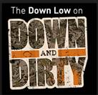Down and Dirty

1 Yes

2 No

3 Not sure

9 Prefer not to answer

**ASK:** All respondents

**F4_3.** Since February 1, 2017, have you seen or heard the following slogan or theme?

Digital Youth Against Tobacco (DYAT)

1 Yes

2 No

3 Not sure

9 Prefer not to answer

**ASK:** All respondents

**F4_4.** Since February 1, 2017, have you seen or heard the following slogan or theme?

C:\Users\ntaylor\AppData\Local\Microsoft\Windows\Temporary Internet Files\Content.Outlook\7AKNJJEU\Real Cost.jpgThe Real Cost

1 Yes

2 No

3 Not sure

9 Prefer not to answer

**ASK:** All respondents

**F4_4a.** Since February 1, 2017, have you seen or heard the following slogan or theme?

*The Real Cost,* Smokeless Doesn’t Mean Harmless

1 Yes

2 No

3 Not sure

9 Prefer not to answer

**ASK**: All respondents

**F4_5.** Since February 1, 2017, have you seen or heard the following slogan or theme?

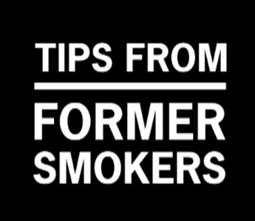Tips from Former Smokers (Tips)

1 Yes

2 No

3 Not sure

9 Prefer not to answer

**ASK**: All respondents

**F4_6.** Since February 1, 2017, have you seen or heard the following slogan or theme?

Fresh Empire

1 Yes

2 No

3 Not sure

9 Prefer not to answer

**ASK**: All respondents

**F4_7**. To show us that you are paying attention, please select Never as your response to this item.

1 Never

2 Rarely

3 Sometimes

4 Often

5 Very Often

9 Prefer not to answer

**ASK**: All respondents

**F5_3.** [IF F4_4a=1 or 3] Where have you seen or heard about *The Real Cost,* Smokeless Doesn’t Mean Harmless Campaign?

PROGRAMMER: RANDOMIZE OPTIONS

|  |  |  |  |  |
| --- | --- | --- | --- | --- |
|  |  | **Yes** | **No** | **Prefer not to answer** |
| **F5_3a.** | On TV or the Internet/online |  |  |  |
| **F5_3b.** | On the radio |  |  |  |
| **F5_3c.** | Billboards or other outdoor ads |  |  |  |
| **F5_3d.** | At the movie theater |  |  |  |

**ASK**: Respondents who report having seen or heard *The Real Cost* theme in F4_4a, or who report they are not sure if they have seen or heard *The Real Cost* theme.

**F6a.** [IF F4_4a=1 or 3]

*The Real Cost,* Smokeless Doesn’t Mean Harmless Campaign is online. Have you ever seen this campaign on…

PROGRAMMER: RANDOMIZE OPTIONS

|  |  |  |  |  |
| --- | --- | --- | --- | --- |
|  |  | **Yes** | **No** | **Prefer not to answer** |
| **F6_1.** | Facebook? |  |  |  |
| **F6_2.** | Twitter? |  |  |  |
| **F6_3.** | YouTube? |  |  |  |
| **F6_4.** | Pandora or Spotify? |  |  |  |
| **F6_5.** | Video games? |  |  |  |

**ASK**: Respondents who report having seen or heard *The Real Cost* theme in F4_4a, or who report they are not sure if they have seen or heard *The Real Cost* theme.

**F7_x.** Now we would like to show you some advertisements that have been shown in the U.S.

PROGRAMMER: RANDOMIZE BATTERIES OF QUESTIONS ABOUT VIDEOS. DON’T ALLOW A RESPONSE UNTIL THE VIDEO HAS PLAYED FOR 15 SECONDS.

PROGRAMMER: EMBED FACE OF DIP VIDEO

Next

**ASK**: All respondents

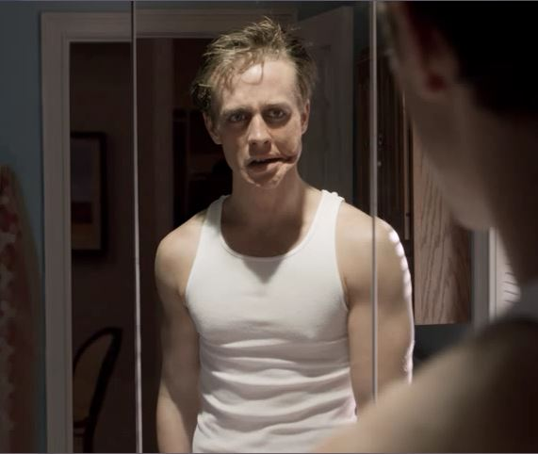

**F8_1.** Apart from this survey, how frequently have you seen this ad since February 1, 2017?

1 Never

2 Rarely

3 Sometimes

4 Often

5 Very Often

9 Prefer not to answer

**ASK**: All respondents



**F19_1**. What is the main message of this ad? Select only one response.

Smokeless tobacco can damage your teeth

1. Smokeless tobacco is addictive
2. Smokeless tobacco can control your life
3. Smokeless tobacco can cause mouth cancer
4. Smokeless tobacco contains cancer-causing chemicals
5. Smokeless doesn’t mean harmless
6. I am not sure

98. Prefer not to answer

**ASK**: All respondents

**F10_1**. How would you describe this advertisement?

|  |  |  |  |  |  |  |  |  |  |
| --- | --- | --- | --- | --- | --- | --- | --- | --- | --- |
| **F10_11** | **Bad** |  |  |  |  |  |  |  | **Good** |

PROGRAMMER: DETERMINE HOW TO DISPLAY PREFER NOT TO ANSWER

**ASK**: All respondents

**F11_1.** Please tell us if you strongly disagree, disagree, neither agree or disagree, agree, or strongly agree with the following statements.

PROGRAMMER: RANDOMIZE ALL

|  |  |  |  |  |  |  |  |
| --- | --- | --- | --- | --- | --- | --- | --- |
|  |  | **Strongly Disagree** | **Disagree** | **Neither Agree or Disagree** | **Agree** | **Strongly Agree** | **Prefer Not to Answer** |
| **F11_11** | This ad is worth  remembering | 1 | 2 | 3 | 4 | 5 | 9 |
| **F11_12** | This ad grabbed my attention | 1 | 2 | 3 | 4 | 5 | 9 |
| **F11_13** | This ad is powerful | 1 | 2 | 3 | 4 | 5 | 9 |
| **F11_14** | This ad is informative | 1 | 2 | 3 | 4 | 5 | 9 |
| **F11_15** | This ad is meaningful to me | 1 | 2 | 3 | 4 | 5 | 9 |
| **F11_16** | This ad is convincing | 1 | 2 | 3 | 4 | 5 | 9 |
| **F11_17** | This ad is terrible | 1 | 2 | 3 | 4 | 5 | 9 |
| **F11_110** | This ad told me things I never knew before about tobacco | 1 | 2 | 3 | 4 | 5 | 9 |
| **F11_112** | This ad gave me good reasons not to use tobacco | 1 | 2 | 3 | 4 | 5 | 9 |

**ASK**: All respondents

**F12_1.** On a scale of 1 to 5, indicate whether the ad made smokeless tobacco look like something you would or wouldn’t want to use.

This ad makes me want to…

|  |  |  |  |  |  |  |
| --- | --- | --- | --- | --- | --- | --- |
| **1 Use** smokeless tobacco | 1 | 2 | 3 | 4 | 5 | **5 Not use** smokeless tobacco |

PROGRAMMER: DETERMINE HOW TO DISPLAY PREFER NOT TO ANSWER

**ASK**: All respondents

**F13_1.** On scale of 1 to 5, where 1 means “not at all” and 5 means “very”, please indicate how much this ad made you feel…

PROGRAMMER: RANDOMIZE ORDER

|  |  |  |  |  |  |  |  |
| --- | --- | --- | --- | --- | --- | --- | --- |
|  |  | **1 Not at all** | **2** | **3** | **4** | **5 Very** | **Prefer not to answer** |
| **F13a_1.** | Afraid | 1 | 2 | 3 | 4 | 5 | 9 |
| **F13b_1.** | Hopeful | 1 | 2 | 3 | 4 | 5 | 9 |
| **F13c_1.** | Motivated | 1 | 2 | 3 | 4 | 5 | 9 |
| **F13d_1.** | Worried | 1 | 2 | 3 | 4 | 5 | 9 |
| **F13e_1.** | Understood | 1 | 2 | 3 | 4 | 5 | 9 |
| **F13f_1.** | Surprised | 1 | 2 | 3 | 4 | 5 | 9 |

**ASK**: All respondents

PROGRAMMER: EMBED JEANS VIDEO

**F8_3.** Apart from this survey, how frequently have you seen this ad since February 1, 2017?

1 Never

2 Rarely

3 Sometimes

4 Often

5 Very Often

9 Prefer not to answer

**ASK:** All respondents

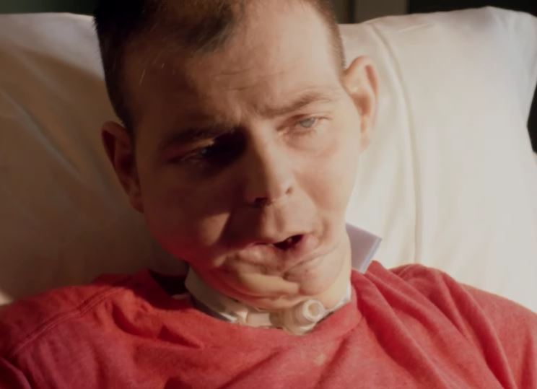

**F19_3**. What is the main message of this ad? Select only one response.

1. Smokeless tobacco can damage your teeth
2. Smokeless tobacco is addictive
3. Smokeless tobacco can control your life
4. Smokeless tobacco can cause mouth cancer
5. Smokeless tobacco contains cancer-causing chemicals
6. Smokeless doesn’t mean harmless
7. I am not sure

98. Prefer not to answer

**ASK**: All respondents



**F10_3**. How would you describe this advertisement?

|  |  |  |  |  |  |  |  |  |  |
| --- | --- | --- | --- | --- | --- | --- | --- | --- | --- |
| **F10_31.** | **Bad** |  |  |  |  |  |  |  | **Good** |

PROGRAMMER: DETERMINE HOW TO DISPLAY PREFER NOT TO ANSWER

**ASK**: All respondents



**F11_3.** Please tell us if you strongly disagree, disagree, neither agree or disagree, agree, or strongly agree with the following statements.

PROGRAMMER: RANDOMIZE ALL

|  |  |  |  |  |  |  |  |
| --- | --- | --- | --- | --- | --- | --- | --- |
|  |  | **Strongly Disagree** | **Disagree** | **Neither Agree or Disagree** | **Agree** | **Strongly Agree** | **Prefer Not to Answer** |
| **F11_31.** | This ad is worth  remembering | 1 | 2 | 3 | 4 | 5 | 9 |
| **F11_32.** | This ad grabbed my attention | 1 | 2 | 3 | 4 | 5 | 9 |
| **F11_33.** | This ad is powerful | 1 | 2 | 3 | 4 | 5 | 9 |
| **F11_34.** | This ad is informative | 1 | 2 | 3 | 4 | 5 | 9 |
| **F11_35.** | This ad is meaningful to me | 1 | 2 | 3 | 4 | 5 | 9 |
| **F11_36.** | This ad is convincing | 1 | 2 | 3 | 4 | 5 | 9 |
| **F11_37.** | This ad is terrible | 1 | 2 | 3 | 4 | 5 | 9 |
| **F11_310.** | This ad told me things I never knew before about tobacco | 1 | 2 | 3 | 4 | 5 | 9 |
| **F11_312.** | This ad gave me good reasons not to use tobacco | 1 | 2 | 3 | 4 | 5 | 9 |

**ASK**: All respondents



**F12_3.** On a scale of 1 to 5, indicate whether the ad made smokeless tobacco look like something you would or wouldn’t want to use.

This ad makes me want to…

|  |  |  |  |  |  |  |
| --- | --- | --- | --- | --- | --- | --- |
| 1. **Use** smokeless tobacco | 1 | 2 | 3 | 4 | 5 | **5 Not use** smokeless tobacco |

PROGRAMMER: DETERMINE HOW TO DISPLAY PREFER NOT TO ANSWER

**ASK**: All respondents



**F13_3.** On scale of 1 to 5, where 1 means “not at all” and 5 means “very”, please indicate how much this ad made you feel…

PROGRAMMER: RANDOMIZE ORDER

|  |  |  |  |  |  |  |  |
| --- | --- | --- | --- | --- | --- | --- | --- |
|  |  | **1 Not at all** | **2** | **3** | **4** | **5 Very** | **Prefer not to answer** |
| **F13a_1.** | Afraid | 1 | 2 | 3 | 4 | 5 | 9 |
| **F13b_1.** | Hopeful | 1 | 2 | 3 | 4 | 5 | 9 |
| **F13c_1.** | Motivated | 1 | 2 | 3 | 4 | 5 | 9 |
| **F13d_1.** | Worried | 1 | 2 | 3 | 4 | 5 | 9 |
| **F13e_1.** | Understood | 1 | 2 | 3 | 4 | 5 | 9 |
| **F13f_1.** | Surprised | 1 | 2 | 3 | 4 | 5 | 9 |

**ASK**: All respondents

**F7_1.** Apart from this survey, how frequently have you seen these ads since February 1, 2017?

1 Never

2 Rarely

3 Sometimes

4 Often

5 Very Often

9 Prefer not to answer

**ASK**: All respondents

**F7_2.** Apart from this survey, how frequently have you seen these ads since February 1, 2017?

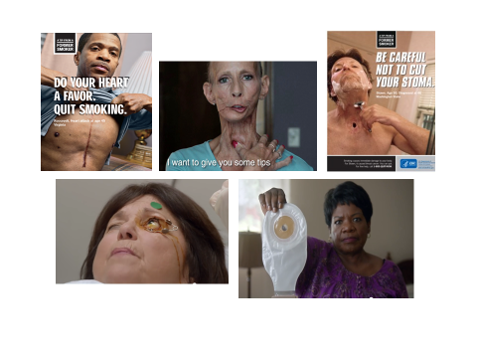

1 Never

2 Rarely

3 Sometimes

4 Often

5 Very Often

9 Prefer not to answer

**ASK**: All respondents

**F7_3.** Apart from this survey, how frequently have you seen these ads since February 1, 2017?

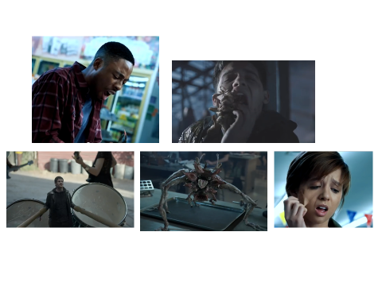

1 Never

2 Rarely

3 Sometimes

4 Often

5 Very Often

9 Prefer not to answer

**ASK**: All respondents

**F7_4.** Apart from this survey, how frequently have you seen these ads since February 1, 2017?

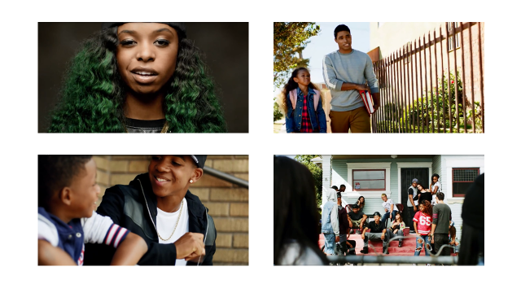

1 Never

2 Rarely

3 Sometimes

4 Often

5 Very Often

9 Prefer not to answer

**ASK**: All respondents

**STREAMING RADIO AWARENESS**

**F24.** Since February 1, 2017, have you heard about *The Real Cost,* Smokeless Doesn’t Mean Harmless Campaign on streaming radio?

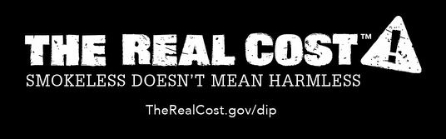

1 Yes

2 No

3 Not Sure

9 Prefer not to answer

**ASK**: All respondents

**F24a.** Now we would like to play you some radio clips that have aired in the U.S. Once you have listened to the clip, please click on the Next arrow below to continue with the survey.

NEXT

PROGRAMMER: RANDOMIZE RADIO CLIPS. DON’T ALLOW A RESPONSE UNTIL THE AD HAS PLAYED FOR 10 SECONDS.

**ASK**: All respondents

PROGRAMMER: EMBED RADIO CLIP COME ON

**F25_1.** Apart from this survey, how frequently have you heard this on the radio since February 1, 2017?

1 Never

2 Rarely

3 Sometimes

4 Often

5 Very Often

9 Prefer not to answer

**ASK**: All respondents

PROGAMMER: EMBED RADIO CLIP SPIT OUT THE FACT

**F25_4.** Apart from this survey, how frequently have you heard this on the radio since February 1, 2017?

1 Never

2 Rarely

3 Sometimes

4 Often

5 Very Often

9 Prefer not to answer

**ASK**: All respondents

PROGRAMMER: EMBED RADIO CLIP FUTURE YOU

**F25_6.** Apart from this survey, how frequently have you heard this on the radio since February 1, 2017?

1 Never

2 Rarely

3 Sometimes

4 Often

5 Very Often

9 Prefer not to answer

**ASK**: All respondents

**F27.**

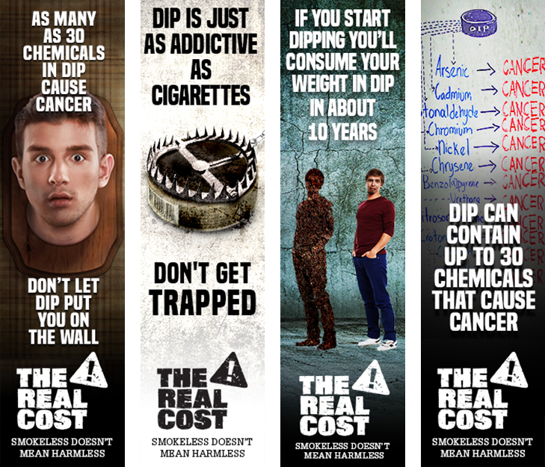

Apart from this survey, how frequently have you seen any of these advertisements on websites you visited since February 1, 2017?

1 Never

2 Rarely

3 Sometimes

4 Often

5 Very Often

9 Prefer not to answer

**ASK**: All respondents

**F18a.** Have you visited www.therealcost.gov/dip since February 1, 2017?

1 Yes

2 No

9 Prefer not to answer

**ASK**: All respondents

**F14_x.** [F8_1 NE 1 OR F8_2 NE 1 OR F8_3 NE 1 OR F8_4 NE 1 OR F8_5 NE 1 OR F25_1 NE 1 OR F25_2 NE 1 OR F25_3 NE 1 OR F25_4 NE 1 OR F25_5 NE 1 OR F25_6 NE 1 OR F25_7 NE 1 OR F25_8 NE 1] Did you talk to anyone in person or online about these ads?

1 Yes

2 No

9 Prefer not to answer

**ASK:** Respondents who did NOT report having never seen or heard Face of Dip in F8_1, Football in F8_2, Jeans in F8_3, Movie Theater in F8_4, Pounds in F8_5, Come On in F25_1, Demands in F25_2, Dip Pinch Chew in F25_3, Spit Out the Fact in F25_4, Surprise Chemicals in F25_5, Future You in F25_6, Pinch in F25_7, or Inside in F25_8 ads.

**F5.** Do your parents have rules about what you are allowed to do on the computer, which video games you are allowed to play, or what music you’re allowed to listen to?

1 Yes, my parents have lots of rules about it.

2 Yes, my parents have a few rules about it.

3 No, my parents don’t have any rules about it.

9 Prefer not to answer

**ASK**: All respondents

**F6.** How often do your parents let you watch movies or videos that are rated R?

1 Never

2 Once in a while

3 Sometimes

4 All the time

9 Prefer not to answer

**ASK**: All respondents

**F7.** Please tell us if you strongly agree, agree, disagree, or strongly disagree with the following statements.

I try to do what my parents want me to do.

1 Strongly agree

2 Agree

3 Disagree

4 Strongly disagree

9 Prefer not to answer

**ASK**: All respondents

**F8.** What my parents think of me is important.

1 Strongly agree

2 Agree

3 Disagree

4 Strongly disagree

9 Prefer not to answer

**ASK**: All respondents

**F9.** I do what my friends want me to do, even if I don’t want to.

1 Strongly agree

2 Agree

3 Disagree

4 Strongly disagree

9 Prefer not to answer

**ASK**: All respondents

**F10.** To keep my friends, I’d even do things I don’t want to do.

1 Strongly agree

2 Agree

3 Disagree

4 Strongly disagree

9 Prefer not to answer

**ASK**: All respondents

Section G: Environment

**G1.** The next section asks some questions about your household and peers.

Other than you, has anyone who lives with you used any of the following during the past 30 days? Select all that apply.

1 Cigarettes

2 Smokeless tobacco

3 Cigars, cigarillos, or little cigars

4 Tobacco out of a water pipe (also called “hookah”)

5 Electronic cigarettes (also called e-cigs)

6 Any other form of tobacco

7 No, no one who lives with me has used any form of tobacco during the past 30 days

9 Prefer not to answer

Programmer: Allow respondents to select more than one response on 1-6.

If response 7 was chosen with ANY other response options, “You indicated that no one who lives with you used any form of tobacco during the past 30 days and also said that in the past 30 days someone has used a form of tobacco. Please choose either someone or no one has smoked any form of tobacco as your response.”

**ASK**: All respondents

**G2.** Do you have any brother(s) and/or sister(s) who have used smokeless tobacco during the past 30 days?

1 Yes

2 No

3 I don’t know

4 I don’t have any brothers or sisters

9 Prefer not to answer

**ASK**: All respondents

**G3.** Which statement best describes the rules about smoking in your home? Would you say…

1 Smoking is not allowed anywhere inside your home

2 Smoking is allowed in some places or at some times

3 Smoking is allowed anywhere inside the home

4 There are no rules about smoking inside the home

9 Prefer not to answer

**ASK**: All respondents

**G4.** Which statement best describes the rules about using smokeless tobacco in your home? Would you say…

1 Smokeless tobacco is not allowed anywhere inside your home

2 Smokeless tobacco is allowed in some places or at some times

3 Smokeless tobacco is allowed anywhere inside the home

4 There are no rules about using smokeless tobacco inside the home

9 Prefer not to answer

**ASK**: All respondents

**G5.** How well would you say you have done in school? Would you say…

1 Much better than average

2 Better than average

3 Average

4 Below average

5 Much worse than average

9 Prefer not to answer

**ASK**: All respondents

**G6.** Please tell us if you strongly disagree, disagree, neither agree nor disagree, agree, or strongly agree with the following statements.

I feel close to people at my school. Would you say you…

1 Strongly disagree

2 Disagree

3 Neither agree nor disagree

4 Agree

5 Strongly agree

9 Prefer not to answer

**ASK**: All respondents

**G7.** I am happy to be at my school. Would you say you…

1 Strongly disagree

2 Disagree

3 Neither agree nor disagree

4 Agree

5 Strongly agree

9 Prefer not to answer

**ASK**: All respondents

**G8.** I feel like I am a part of my school. Would you say you…

1 Strongly disagree

2 Disagree

3 Neither agree nor disagree

4 Agree

5 Strongly agree

9 Prefer not to answer

**ASK**: All respondents

**G9.** How far do you think you will go in school?

1 I don’t plan to go to school anymore

2 9th grade

3 10th grade

4 11th grade

5 12th grade or GED

6 Some college or technical school but no degree

7 Technical school degree

8 College degree

9 Graduate school, medical school, or law school

99 Prefer not to answer

**ASK**: All respondents

**G10.** How many close friends do you have? Close friends include people whom you feel at ease with, can talk to about private matters, and can call on for help.

__________ (Range: 0-7)

PROGRAMMER: NUMERIC STRING. ALLOW A MINIMUM OF 0 AND MAXIMUM OF 7. IF ANYTHING ELSE IS TYPED IN ERROR MESSAGE SHOULD SAY, “You have entered a number outside the allowed range. Please enter an answer between 0 and 7.”

9 Prefer not to answer

**ASK**: All respondents

**G11.** How often do you attend church or religious services? Would you say…

1 Never

2 Less than once a month

3 About once a month

4 About 2 or 3 times a month

5 Once a week

6 More than once a week

9 Prefer not to answer

**ASK**: All respondents

Please tell us if you strongly disagree, disagree, neither agree nor disagree, agree, or strongly agree with the following statements.

**G12.** I would like to explore strange places. Would you say you…

1 Strongly disagree

2 Disagree

3 Neither agree nor disagree

4 Agree

5 Strongly agree

9 Prefer not to answer

**ASK**: All respondents

**G13.** I like to do frightening things. Would you say you…

1 Strongly disagree

2 Disagree

3 Neither agree nor disagree

4 Agree

5 Strongly agree

9 Prefer not to answer

**ASK**: All respondents

**G14.** I like new and exciting experiences, even if I have to break the rules. Would you say you…

1 Strongly disagree

2 Disagree

3 Neither agree nor disagree

4 Agree

5 Strongly agree

9 Prefer not to answer

**ASK**: All respondents

**G15.** I prefer friends who are exciting and unpredictable. Would you say you…

1 Strongly disagree

2 Disagree

3 Neither agree nor disagree

4 Agree

5 Strongly agree

9 Prefer not to answer

**ASK**: All respondents

**G16.**  Thinking about your mental health, which includes stress, depression, and problems with emotions, for how many days during the past 30 days was your mental health not good?

_____ Number of days

33 Don’t know

99 Prefer not to answer

PROGRAMMER: NUMERIC STRING. ALLOW A MINIMUM OF 0 AND MAXIMUM OF 30.

IF ANYTHING ELSE IS TYPED IN, ERROR MESSAGE SHOULD SAY, “You have entered a number outside the allowed range. Please enter a number between 0 and 30.”

RESPONDENTS CAN ONLY RESPOND WITH THE OPTION DON’T KNOW, OR TYPE IN A NUMERIC RESPONSE. IF RESPONDENTS TRY TO DO MULTIPLE THINGS, ERROR MESSAGE SHOULD SAY “You have entered a number and selected Don’t Know. Please choose one or the other as your response.”

**ASK**: All respondents

**G17.** The next section asks some questions about how you feel about your current relationship with your parents or guardians.

Thinking about the adult or adults you live with, would you say you are satisfied with the way you communicate with each other?

1 Strongly disagree

2 Disagree

3 Neither agree nor disagree

4 Agree

5 Strongly agree

9 Prefer not to answer

**ASK**: All respondents

**G18.** How close do you feel to the adult or adults you live with?

1 Not at all close

2 Not very close

3 Somewhat close

4 Quite close

5 Very close

9 Prefer not to answer

**ASK**: All respondents

**G19.** How often has a parent or other adult caregiver said things that really hurt your feelings or made you feel like you were not wanted or loved?

1 One time

2 Two times

3 Three to five times

4 Six to ten times

5 More than ten times

6 This has never happened

7 Don’t know

9 Prefer not to answer

**ASK**: All respondents

**G20.** Has a parent or other adult caregiver ever talked to you about reasons for not using smokeless tobacco?

1 Yes

2 No

9 Prefer not to answer

**ASK**: All respondents

**G21.** During the past 7 days, on how many days did you and one or both of your parents or other adult caregivers do something together just for fun?

__________

9 Prefer not to answer

Programmer: Numeric String. Allow a minimum of 0 and maximum of 7. If anything else is typed in error message should say, “You have entered a number outside the allowed range. Please enter a number between 0 and 7.”

**ASK**: All respondents

**FINAL** [IF CAPI] That was the last question. Once you move past this screen, your responses will be locked. They cannot be seen by your interviewer. Please tell your interviewer that you are finished. Thank you for taking the time to complete the survey.

Next

**CODE** [IF CAPI] INTERVIEWER - ENTER 3 DIGIT CODE TO LOCK RESPONSES.

Programmer: Code is RTI

**ASK**: CAPI respondents

# Section H: Closing Contact Items

**RECON**. Thank you for your responses! We will be conducting two more rounds of this survey in 8 months. Your participation in the next round is really important, so that we can learn what has changed over time. When we contact you again in the future, you will be able to decide if you want to take part in the survey at that time, and you can change your mind at any point.

Can we contact you to invite you to take the next survey?

1. Yes
2. No

**PROGRAMMER**: IF ITEM IS LEFT BLANK, HARD PROMPT CAPI “Interviewer, this is a required item. Please do your best to fill out the item.” WEB “Please provide a response to this item”

**ASK**: All respondents

**RECONREF.** [IF RECON=NO] Your participation is important for the success of this study. We will find a time that works for you to be interviewed, and you will receive an incentive after you complete the interview. Can we contact you for the next survey?

1. Yes
2. No

PROGRAMMER: IF ITEM IS LEFT BLANK, HARD PROMPT CAPI “Interviewer, this is a required item. Please do your best to fill out the item.” WEB “Please provide a response to this item”]

**ASK**: Respondents who say they do not want to be contacted for the next survey in RECON.

**H3.**

[IF RECON=1 OR RECONREF=1 AND CAPI AND FILLAGE <18] INTERVIEWER:

ASK ITEM OF PARENT

[IF RECON=1 OR RECONREF=1 AND CAPI] Please provide an email address where we can contact you about the next two rounds of the survey.

PROGRAMMER: ALLOW OPEN END TEXT

email address:_________________ [ALLOW 50 CHARACTERS]

confirm email address:__________[MUST MATCH FIRST ENTRY]

Prefer not to answer

PROGRAMMER: VALIDATE FORMAT FOR EMAIL ADDRESS. IF FORMAT IS INCORRECT, PLEASE DISPLAY “Please enter a valid email address.” IF THE EMAIL ADDRESSES DON’T MATCH PLEASE DISPLAY “The email addresses do not match. Please try again.”

**ASK**: CAPI Respondents who say they want to be contacted for the next survey in RECON or RECONREF. 18 year old respondents will report their own email address while the item will be asked of the parents of minor respondents.

**H3b**.

[IF RECON=1 OR RECONREF=1 AND CAPI AND FILLAGE <18] INTERVIEWER:

ASK ITEM OF PARENT

**[**IF RECON=1 OR RECONREF=1 AND CAPI] We are interested in making sure that our information is correct. Can you confirm that this is:

[FILL SAMPLE ADDRESS]

1. Yes
2. No

**ASK**: CAPI Respondents or parents of CAPI respondents who say they want to be contacted for the next two surveys in RECON or RECONREF.

**DISPLAY:** SAMPLE ADDRESS is the respondent’s address.

**H3c.** [IF CAPI AND H3b=NO] So that we can update our records, please provide your full address.

Street: **YSTREET1 50 characters**

City: **YCITY1 50 characters**

State: **YSTATE1 2 digit state**

Zip Code: **YZIP1 5 digit zip**

Press “Next” to continue.

**ASK**: CAPI Respondents who say that their address is incorrect in H3b

**H4.** [IF RECON=1 OR RECONREF=1 AND CAPI AND FILLAGE <18] INTERVIEWER: ASK ITEM OF PARENTS

[IF RECON=1 OR RECONREF=1 AND CAPI] Please provide your phone number including area code in case we are unable to reach you by e-mail during the next follow-up survey.

OPEN END NUM

VALIDATION: MIN 0 MAX 9999999999

(__ __ __) __ __ __ - __ __ __ __ Phone Number [ALLOW 10 CHARACTERS]

Prefer not to answer

PROGRAMMER: VALIDATE FORMAT FOR PHONE NUMBER. IF FORMAT IS INCORRECT, PLEASE DISPLAY “The phone number must be a 10-digit number. Do not include dashes or other special characters.”

**ASK**: CAPI Respondents who say they want to be contacted for the next two surveys in RECON or RECONREF

**INCENT01** [IF CAPI]

PROGRAMMER: DISPLAY CASE ID FROM IFMS ON SCREEN.

INTERVIEWER: SIGN COMPENSATION RECEIPT AND HAND $20 TO R

DID YOU GIVE THE RESPONDENT THEIR INCENTIVE?

1. Yes
2. No

PROGRAMMER: HARD PROMPT “Interviewer, this is a required item. Please do your best to fill out the item.”]

**ASK**: CAPI respondents

INCENT02

[IF INCENT01=1 AND CAPI] I have signed this form to indicate that I have given you $20 cash for completing this interview. You may have received an invitation to take this survey on the web.  Since we completed this survey today, there is no need for you to take the web survey. Thanks again!

NEXT

**ASK**: CAPI respondents who have been given the $20 cash incentive by interviewer in INCENT01

**INCENT03** [IF INCENT01=2 AND CAPI] INTERVIEWER, PLEASE INDICATE WHY YOU ARE NOT ABLE TO GIVE THE INCENTIVE TO THE RESPONDENT.

_________________ (1000 Characters)

[PROGRAMMER: HARD PROMPT “Interviewer, this is a required item. Please do your best to fill out the item.”]

**ASK**: CAPI respondents who have NOT been given the $20 cash incentive by interviewer in INCENT01

**FIDBF1** [IF CAPI]

INTERVIEWER: DO NOT READ TO THE RESPONDENT.

Did you have to read any of the questions out loud to the respondent?

1. Yes
2. No

**ASK**: Interviewers of CAPI surveys

**FIDBF2** [IF CAPI]

PLEASE DESCRIBE THE ASSISTANCE THAT YOU PROVIDED TO THE RESPONDENTS. WHAT WERE HIS READING ABILITIES? HOW MUCH HELP DID HE REQUIRE? OTHERWISE, ENTER ANY NOTES YOU HAVE ABOUT THIS CASE

PROGRAMMER: OPEN ENDED. CHARACTER LIMIT: 5000

END

**ASK**: Interviewers of CAPI surveys

**VERIFY** [IF WEB]

Including this one, how many surveys have you completed on this topic?

__________ (Range: 1-10)

**ASK**: Web respondents

**_________________________________________________________________**

**COMMNT** [IF WEB]

Thank you for completing the survey. Please enter any comments that you have about the interview.

PROGRAMMER: PROGRAM OPEN ENDED ITEM WITH 2000 CHARACTER LIMIT. MAKE ITEM OPTIONAL.

**Next**

**ASK**: Web respondents

**WEBTH** [IF WEB]

To thank you for completing the survey, you will receive a check for [$20/$25 IF EARLY BIRD]. We will need to collect some information from you so that we can mail you a check. This information will be kept completely private in a secure and protected data files and will be separate from the responses provided in the survey. If you would like to decline receiving this payment, you can leave the information blank and then simply select “Prefer not to answer” to continue to the next screen.

First name: **YFNAME**

Last name: **YLNAME**

What is the best address where we should mail the check?

Street: **YSTREET**

City: **YCITY**

State: **YSTATE**

Zip Code: **YZIP**

Please provide your **parent’s** phone number including area code in case we are unable to reach you during the next follow-up survey.

OPEN END NUM

VALIDATION: MIN 0 MAX 9999999999

(__ __ __) __ __ __ - __ __ __ __ Phone Number [ALLOW 10 CHARACTERS]

Prefer not to answer

PROGRAMMER: VALIDATE FORMAT FOR PHONE NUMBER. IF FORMAT IS INCORRECT, PLEASE DISPLAY

“The phone number must be a 10-digit number. Do not include dashes or other special characters.”

PROGRAMMER: PLEASE HAVE YFNAME, YLNAME, YCITY YSTATE ONLY ALLOW ALPHA CHARACTERS AND HAVE YZIP ONLY ALLOW NUMERIC CHARACTERS

**ASK**: Web respondents

**THANKS.** Thank you again for your participation.

EXIT

**OMB No: 0910-0753 Expiration Date: 09/30/2019**

Paperwork Reduction Act Statement: The public reporting burden for this collection of information has been estimated to average 45 minutes per response. Send comments regarding this burden estimate or any other aspects of this collection of information, including suggestions for reducing burden to PRAStaff@fda.hhs.gov.

**MIEND.** You may now close your browser or navigate away from this page.