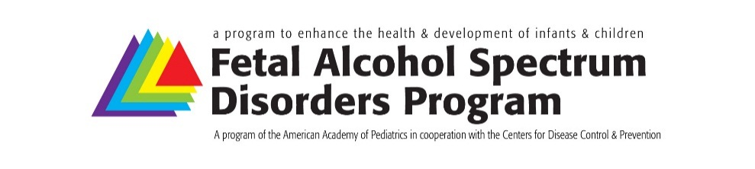
Form Approved
OMB No. 0902-XXXX
Exp.: XX/XX/20XX
Fetal Alcohol Spectrum Disorders
Regional Education and Awareness Liaisons
Improving health outcomes for infants and children diagnosed with one of the FASDs
by addressing stigma and bias and increasing early identification.

Pediatric FASD Regional Liaison/Champion Training Session Evaluation

- Name
- AAP Region
- Which of the following best describes you?
  - Primary care pediatrician
  - Advanced Practice Registered Nurse
  - Pediatric sub-specialist
Please specify:
  - Retired
- On a scale of 1 to 5 (1 strongly disagree to 5 strongly agree) Please rate the extent to which the FASD Regional Liaisons/Champions meeting achieved the stated learning objectives
  - Learning objective 1 1 | 2 | 3 | 4 | 5
  - Learning objective 2 1 | 2 | 3 | 4 | 5
  - Learning objective 3 1 | 2 | 3 | 4 | 5
  - Learning objective 4 1 | 2 | 3 | 4 | 5
- Do you have any additional comments or suggestions related to the learning objectives?

- How would you rate this educational activity overall
☐ Poor
☐ Fair
☐ Good
☐ Very good
☐ Excellent
- Session feedback – On a scale of 1 to 5 (1 strongly disagree) to 5 strongly agree) rate your agreement with each statement
  - I can use the information presented in my practice 1 | 2 | 3 | 4 | 5
  - Format of the session enhanced achievement of 1 | 2 | 3 | 4 | 5
learning objectives
  - Presentation materials/slides helped me to meet my 1 | 2 | 3 | 4 | 5
professional development goals
  - Registration and travel details was straight forward 1 | 2 | 3 | 4 | 5
- Speaker/facilitator feedback – On a scale of 1 to 5 (1 strongly disagree to 5 strongly agree) rate your agreement with each statement
  - Speakers/facilitators presented content that was 1 | 2 | 3 | 4 | 5
relevant to the topic and objectives
  - Speakers/facilitators responded to audience needs 1 | 2 | 3 | 4 | 5
during the presentations
  - Speaker’s/facilitator’s knowledge and expertise was 1 | 2 | 3 | 4 | 5
appropriate for this session
- Rate your knowledge, skills and attitudes related to the identification and treatment for children who have or may have one of the FASDs from 1-below average to 3-above average
  - Before the session 1 below average | 2 average | 3 above average
  - After the session 1 below average | 2 average | 3 above average
- On a scale of 1 to 5 (1 not confident to 5 very confident), rate your perceived ability to provide technical assistance and support to pediatric clinicians regarding the identification and treatment of children who have or may have one of the FASDs
  - My self-rating before the session 1 | 2 | 3 | 4 | 5
  - My self-rating after the session 1 | 2 | 3 | 4 | 5
- How will participating in this session impact your ability to advocate for systems change within your region?
- As a result of participating in this session:
  - What new ideas did you learn?

  - How will those ideas change your work with other pediatricians in your region?

- Was the content free of commercial and personal influence or bias?
  - Do you feel the content was free of commercial influence or bias Yes | No
  - Do you feel a commercial product, device, or service was Yes | No
inappropriately promoted in the educational content?
  - Do you feel the content was free of personal bias? Yes | No
- Do you have any additional comments or questions?

Thank you for participating in this session and for completing this evaluation!
Submit to:
Josh Benke, FASD Program Manager,
American Academy of Pediatrics, Division of Children with Special Needs
V: 847/434-7081 | F: 847/434-8000 | E: jbenke@aap.org

