Attachment B: Questionnaires/Data Collection Instruments

Form Approved  
OMB No. 0935-XXXX  
Exp. Date XX/XX/20XX

The RoPR data collection system is a web-based collection mechanism. The screenshots included in this document represent all sections that will be visible to users who enter information through the self-registration pathway. The online form has 20 sections.

Users who enter information through the ClinicalTrials.gov pathway (which already received OMB approval) will only see sections 1-8 and 20.

1)

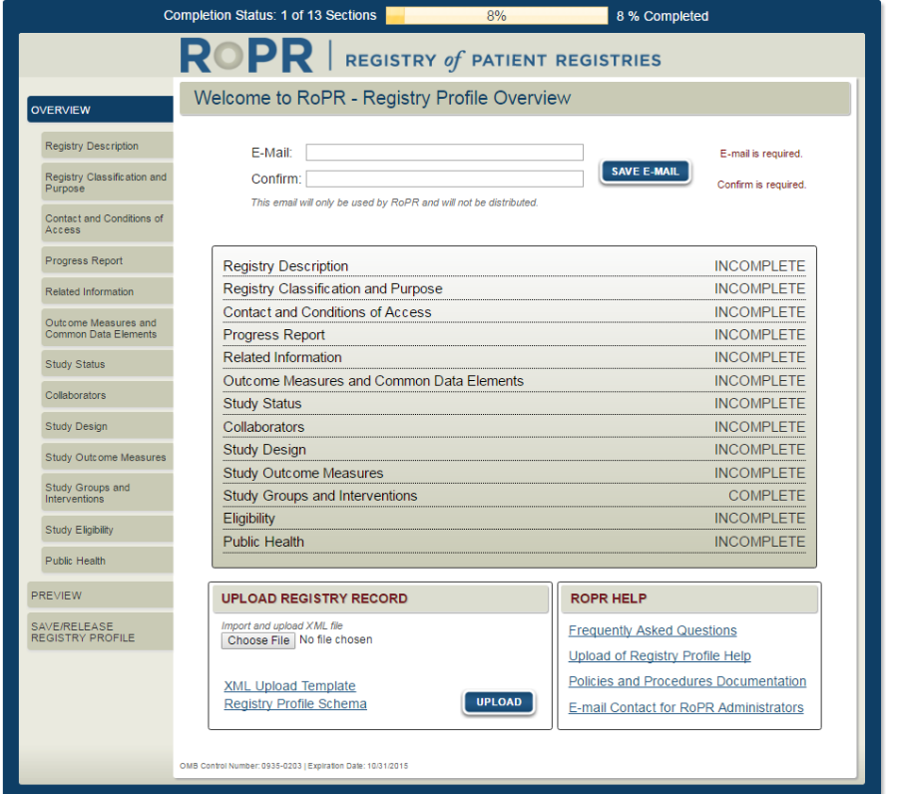

Public reporting burden for this collection of information is estimated to average 55 minutes per response, the estimated time required to complete the survey. An agency may not conduct or sponsor, and a person is not required to respond to, a collection of information unless it displays a currently valid OMB control number. Send comments regarding this burden estimate or any other aspect of this collection of information, including suggestions for reducing this burden, to: AHRQ Reports Clearance Officer Attention: PRA, Paperwork Reduction Project (0935-XXXX) AHRQ, 5600 Fishers Lane, # 07W41A, Rockville, MD 20857.

2)

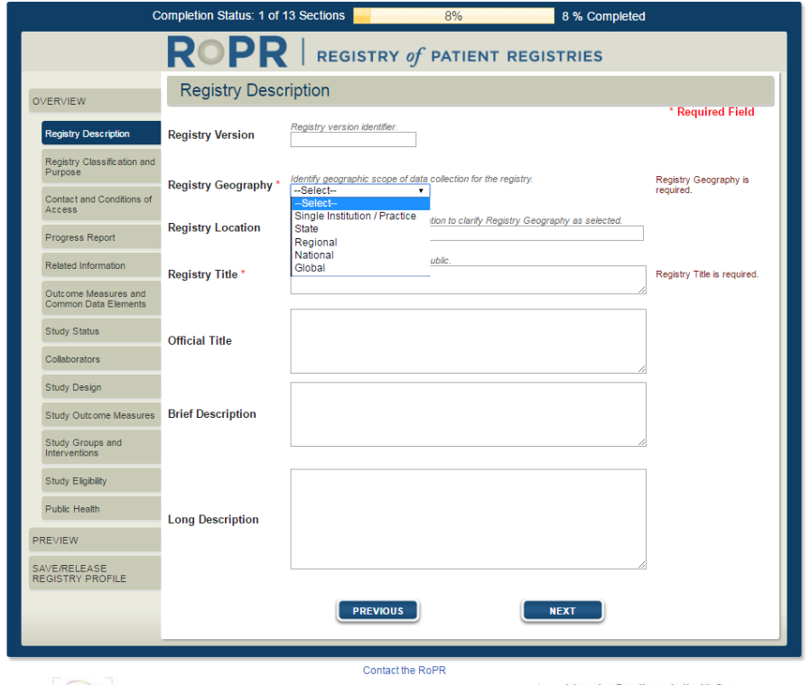

3a)

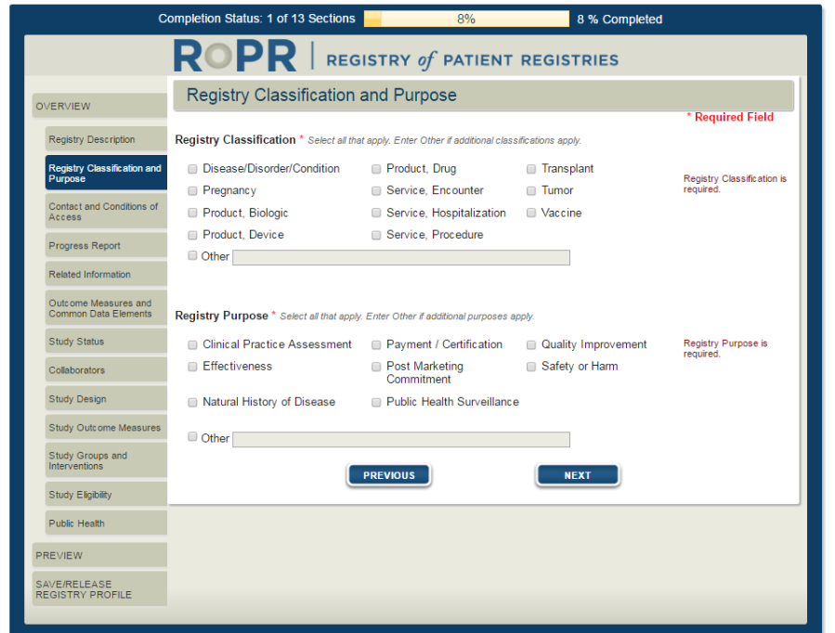

3b) Additional field shown if “quality improvement” purpose is selected

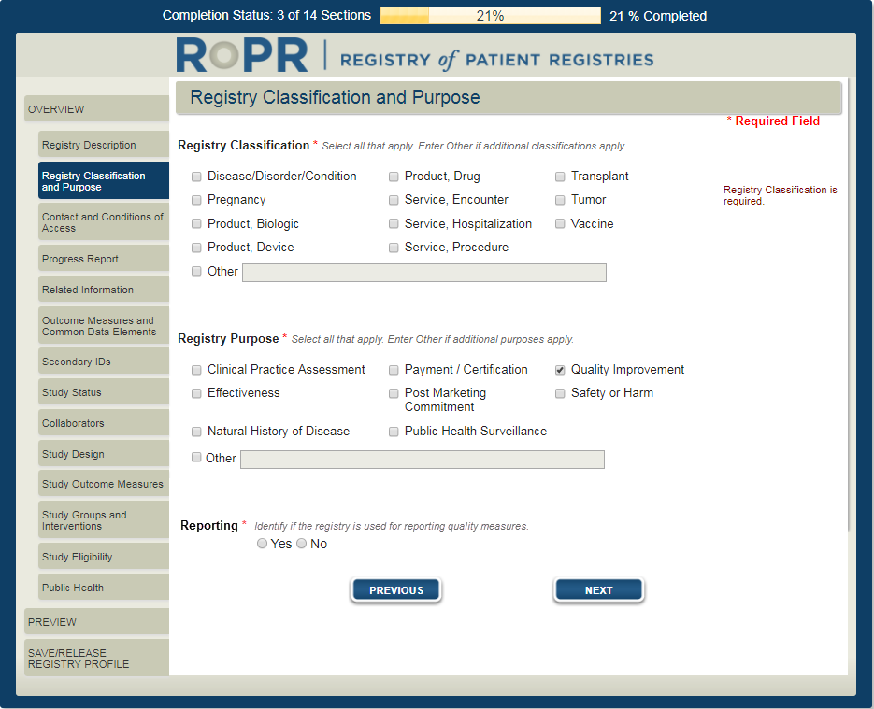

4)

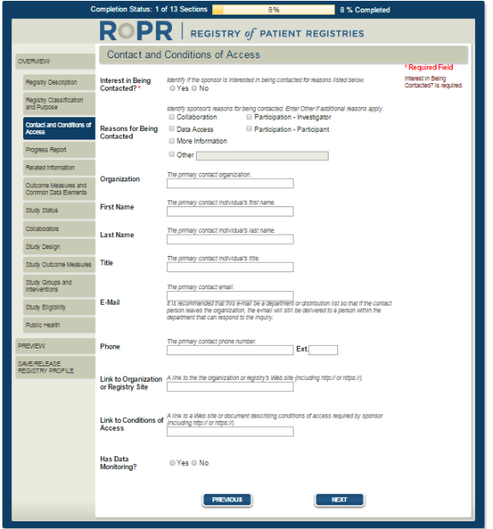

5)

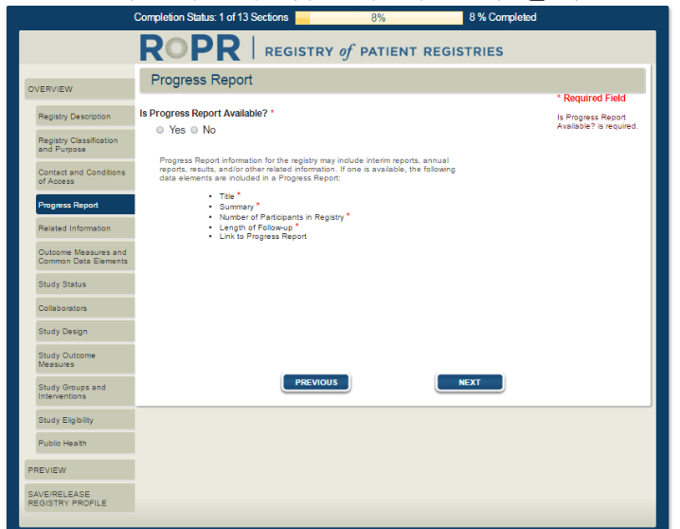

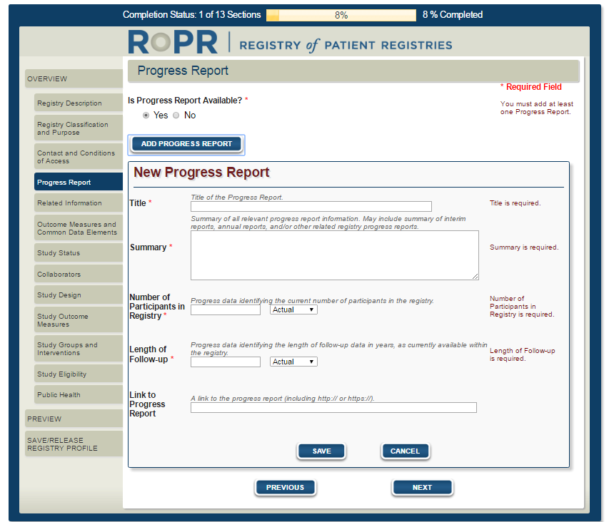

6)

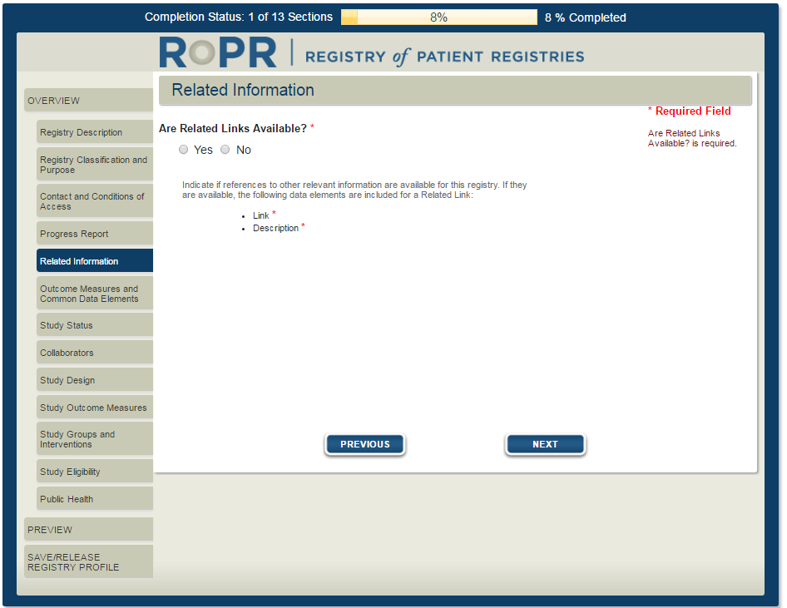

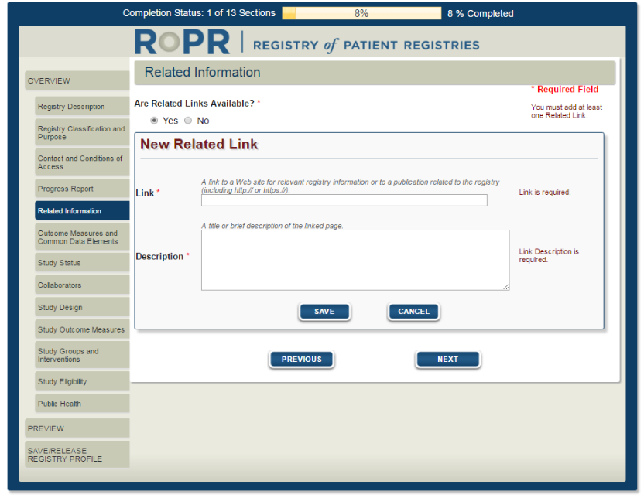

7)

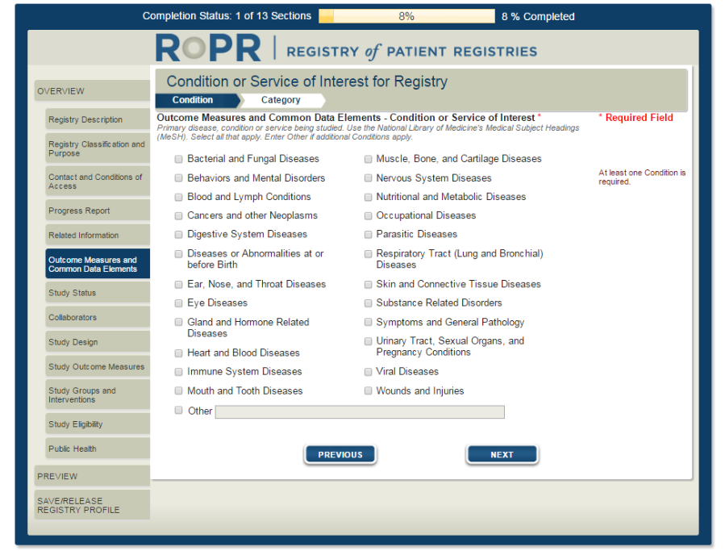

8) 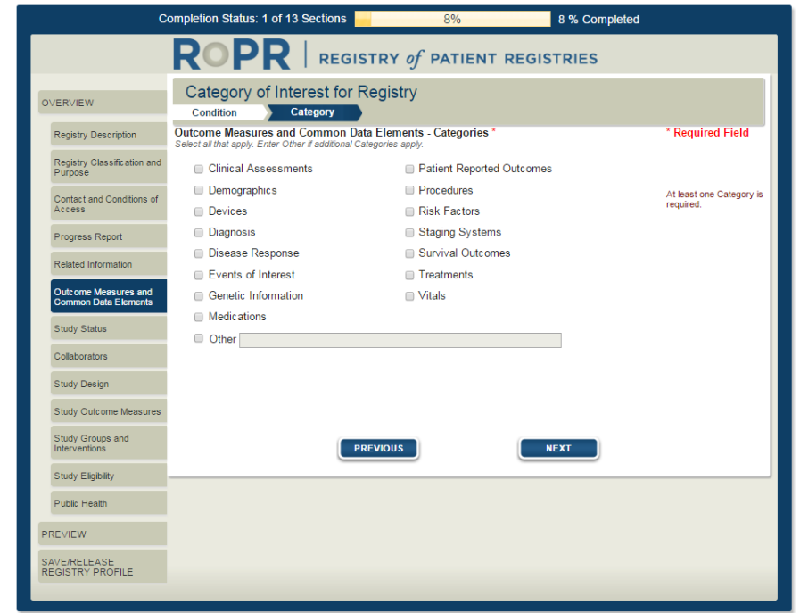

9)

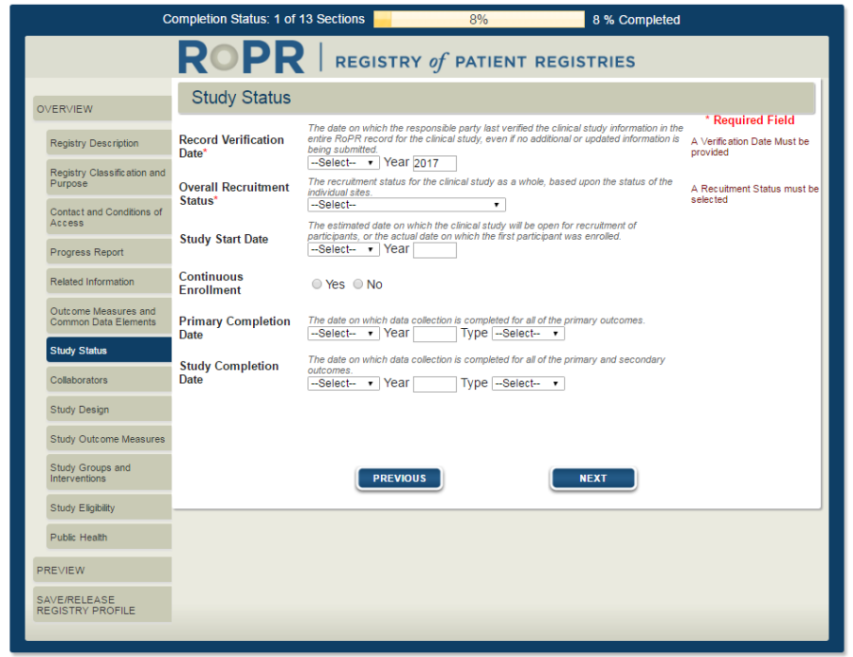

10)

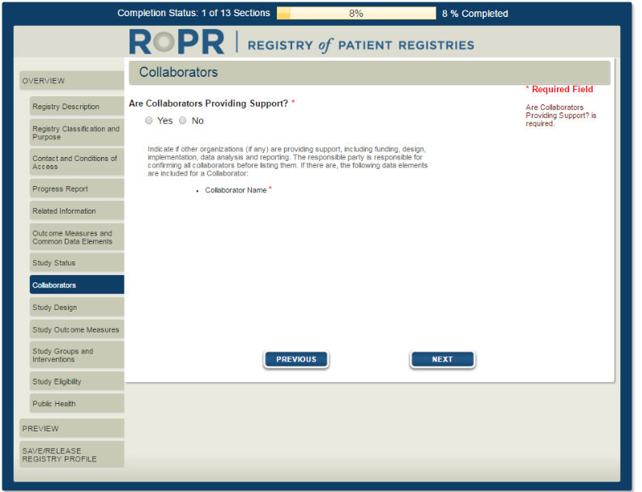

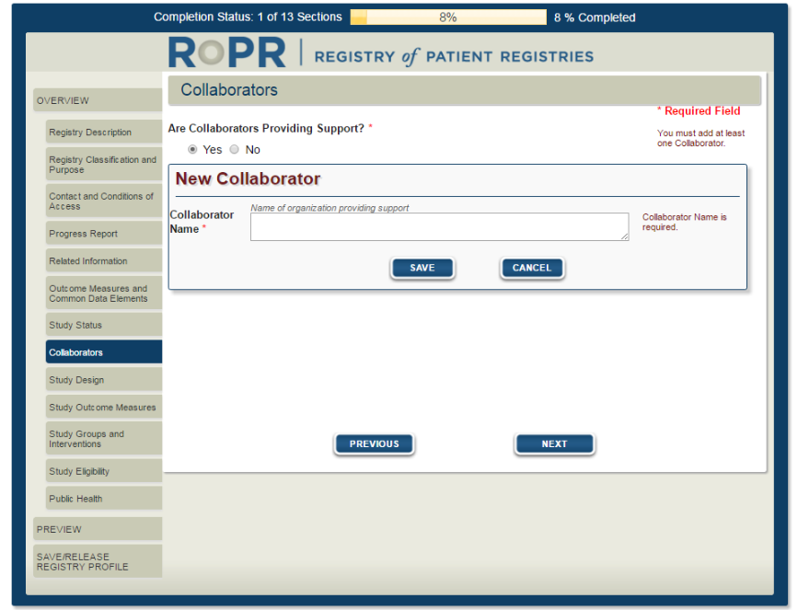

11)

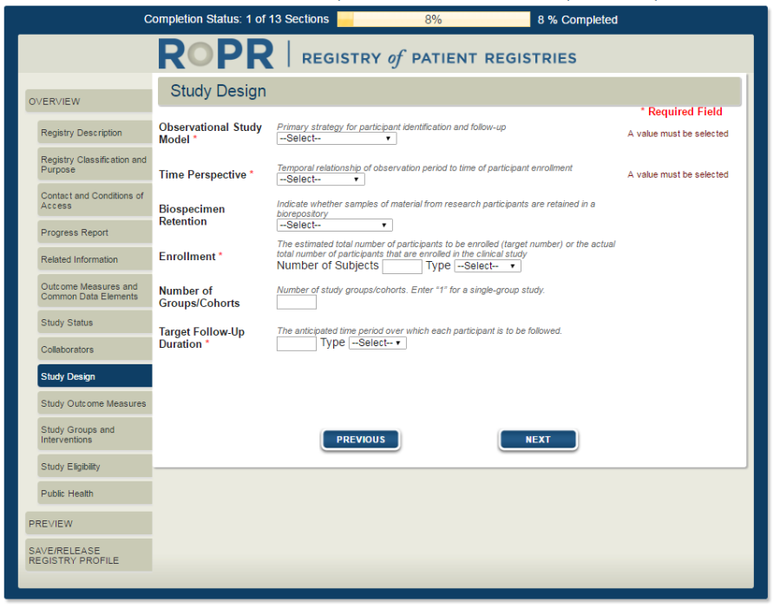

12)

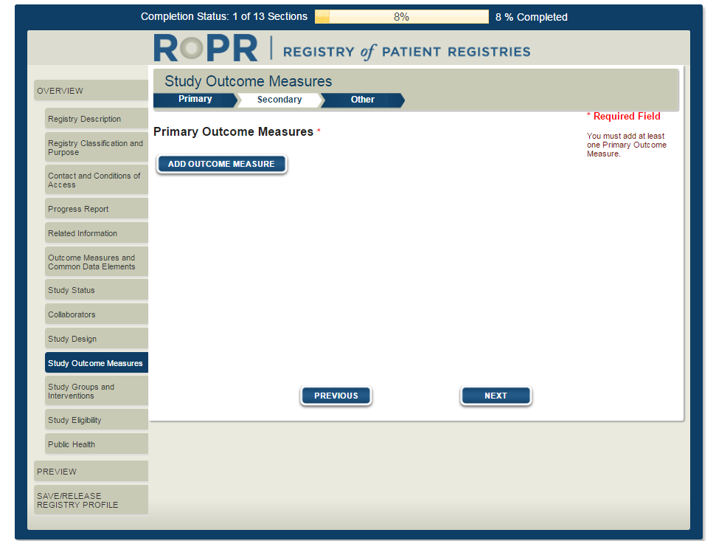

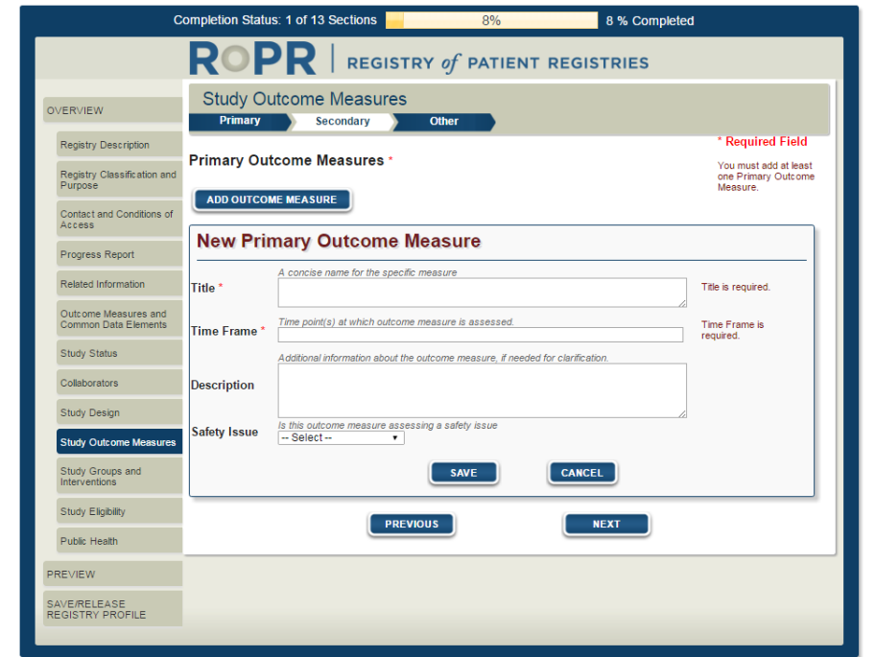

13)

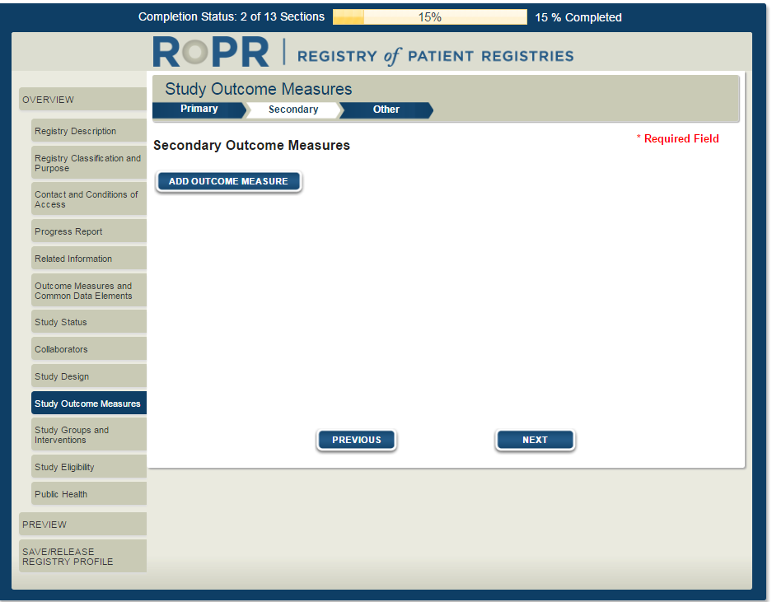

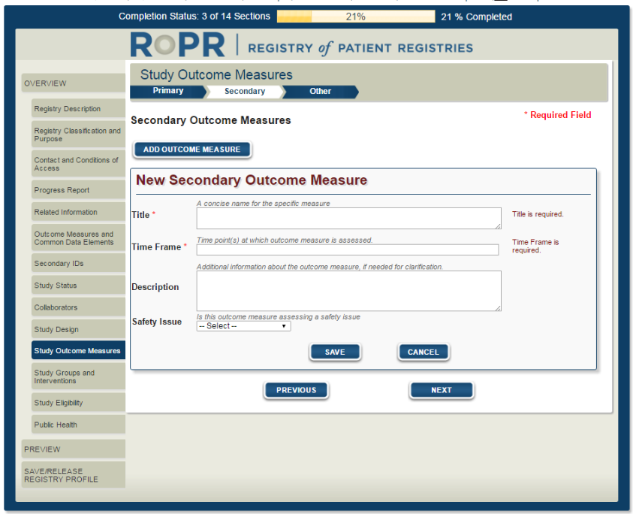

14)

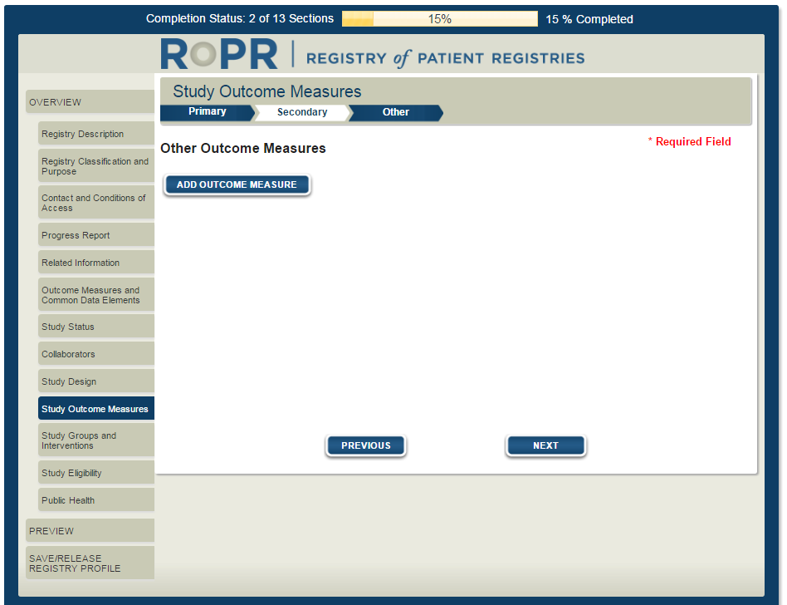

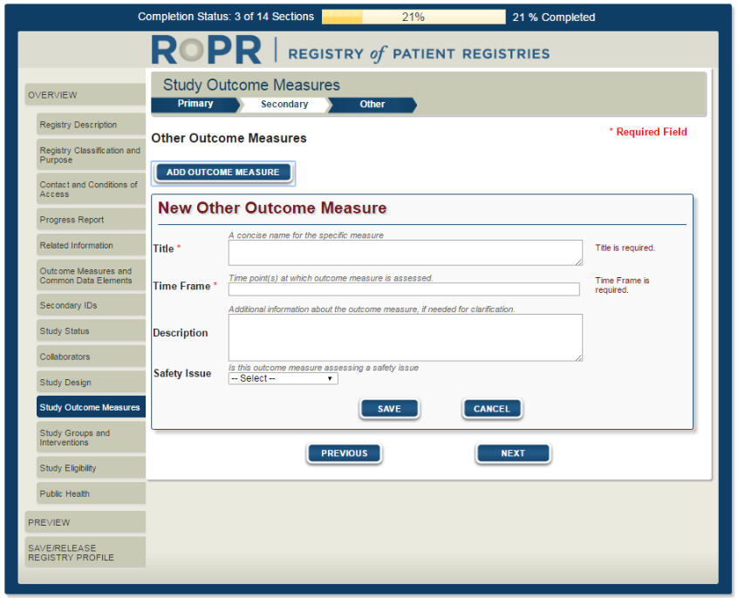

15)

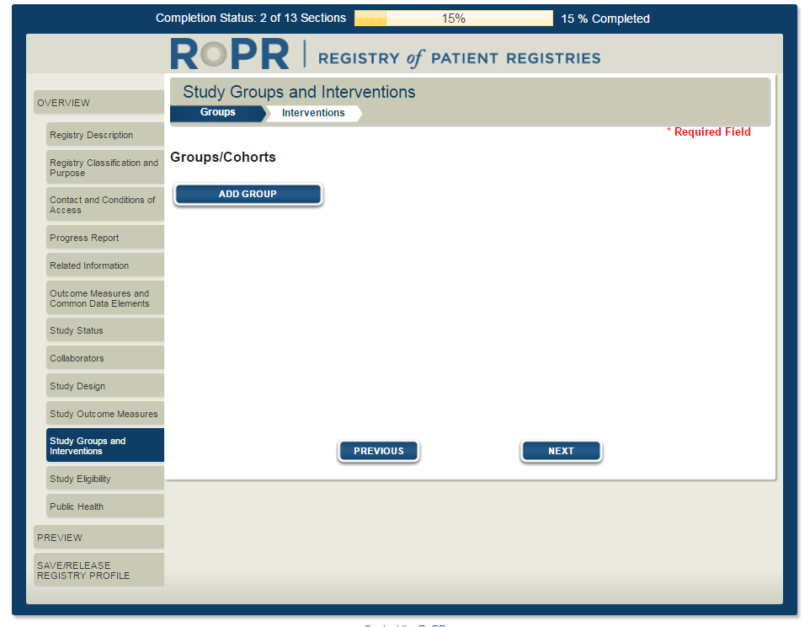

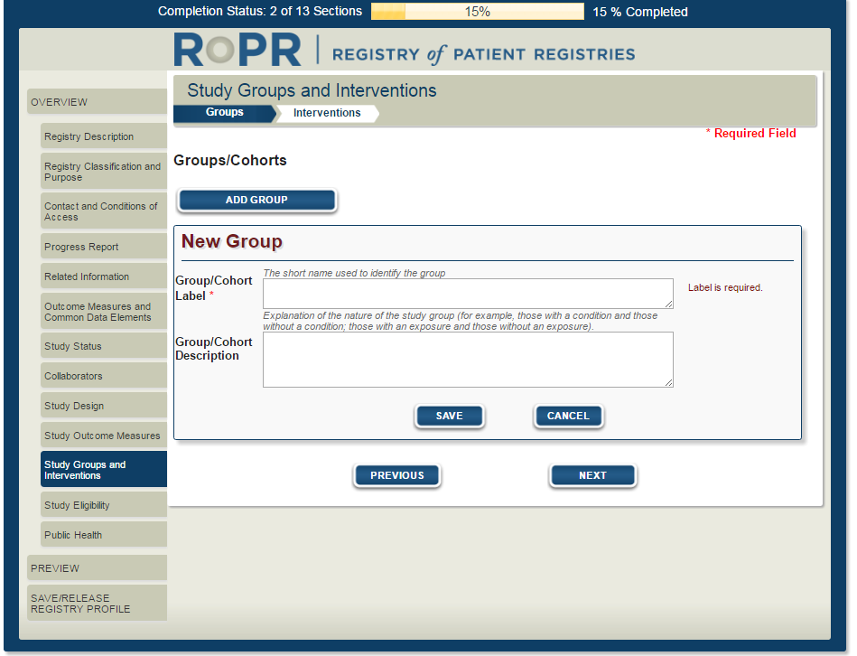

16)

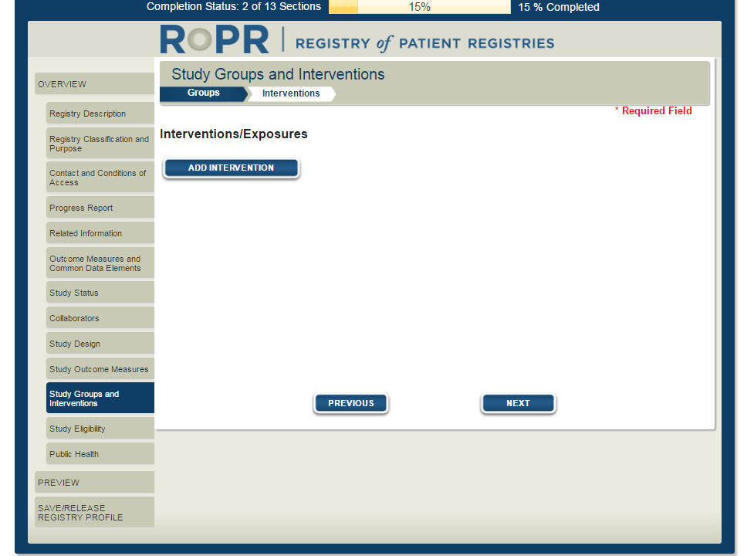

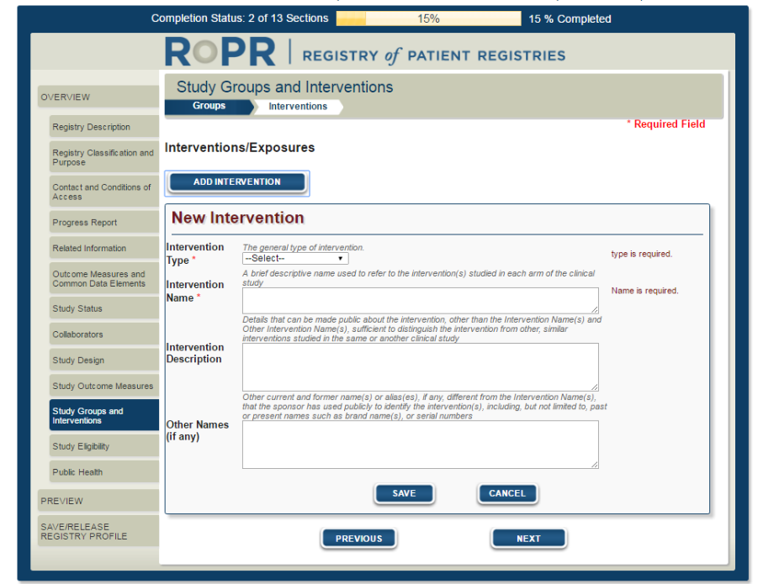

17)

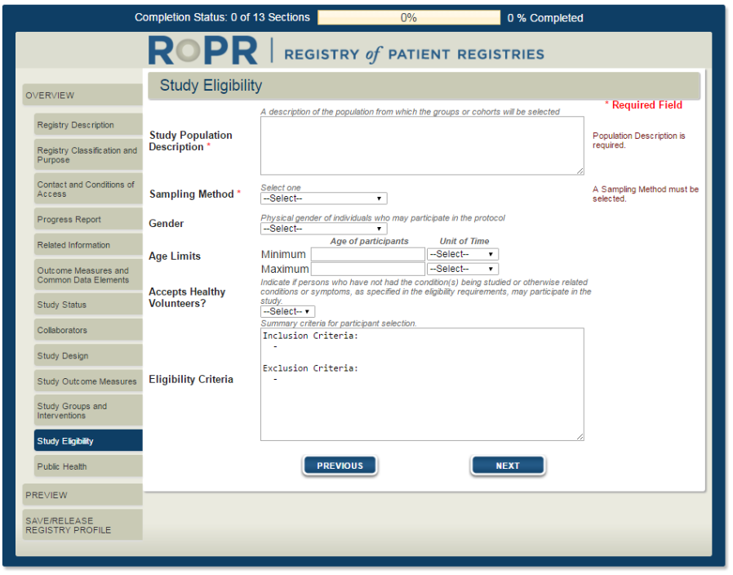

18)

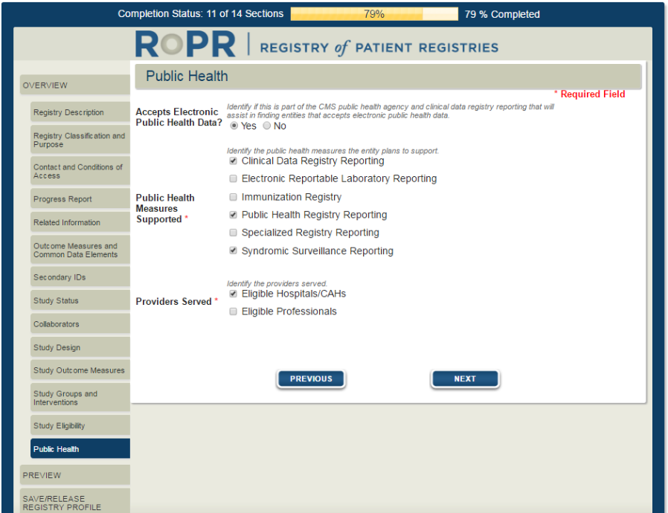

19)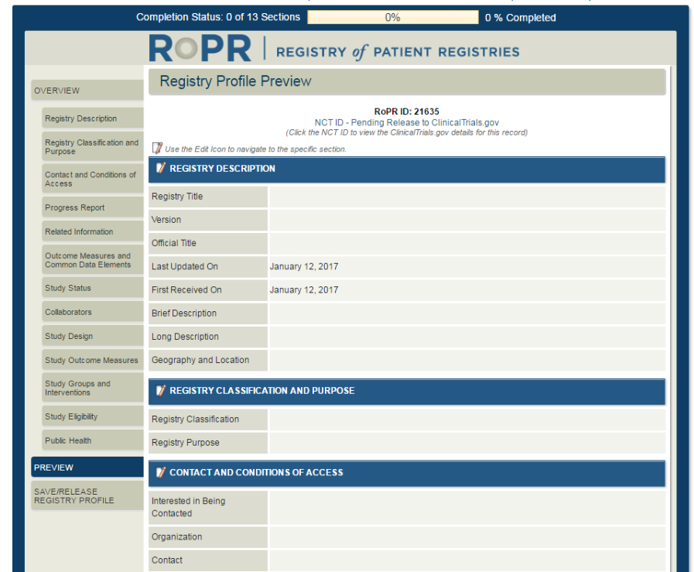

20)

