Attachment B: Hospital Surgery Survey on Patient Safety for the AHRQ Safety Program for Improving Surgical Care and Recovery

Purpose of document: This document will be the language of the Surgery SOPS. Once approved, we will build this survey onto our survey platform. When survey takers open link from email, this is the intro and questions they will see.

Form Approved
OMB No. 0935-XXXX
Exp. Date XX/XX/20XX

Hospital Surgery Survey on Patient Safety

This survey asks for your opinions about patient safety in your surgery area. The survey will take about 15 minutes to complete. If a question does not apply to you or you don’t know the answer, please answer “Does not apply or Don’t know.”

Please read each question carefully before choosing your answer. You may save your work at any time by clicking 'Save and Finish Later' at the bottom of this screen. Please save your work before returning to any previous screens or before closing this webpage.

Definitions
- Doctors means all physicians (MDs or DOs, including residents) who perform surgeries, procedures, or treatments, including delivery of anesthesia, in this facility.
- Staff means ALL others (clinical and nonclinical) who work in your team, whether they are employed directly by your facility or are contract/per diem/agency staff.
- Patient safety is the prevention of harm resulting from the processes of health care delivery. Such prevention includes reducing mistakes, errors, incidents, events, or problems that lead to patient harm or could negatively affect patients.
- Facility refers to your peri-operative service area in which you work.

Public reporting burden for this collection of information is estimated to average 15 minutes per response, the estimated time required to complete the survey. An agency may not conduct or sponsor, and a person is not required to respond to, a collection of information unless it displays a currently valid OMB control number. Send comments regarding this burden estimate or any other aspect of this collection of information, including suggestions for reducing this burden, to: AHRQ Reports Clearance Officer Attention: PRA, Paperwork Reduction Project (0935-XXXX) AHRQ, 5600 Fishers Lane, # 07W41A, Rockville, MD 20857.

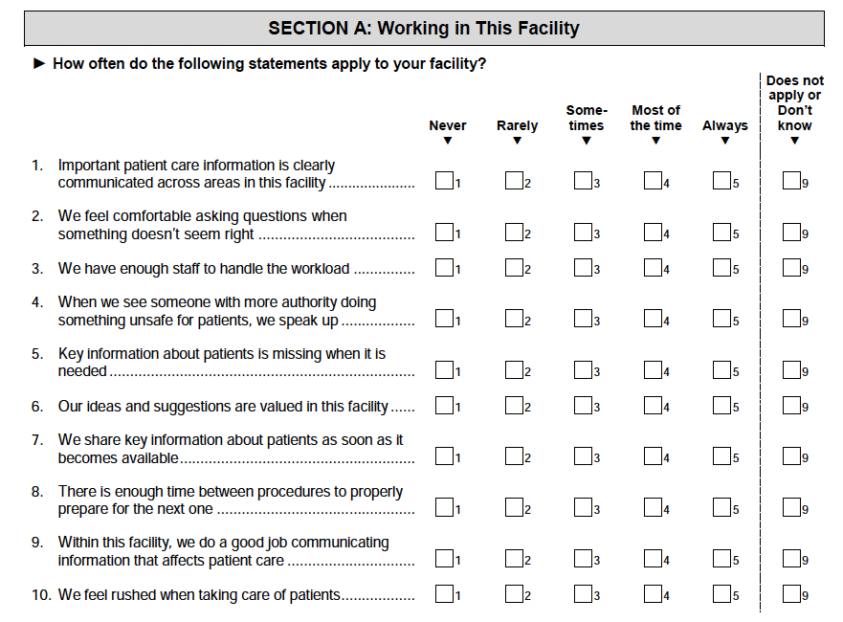

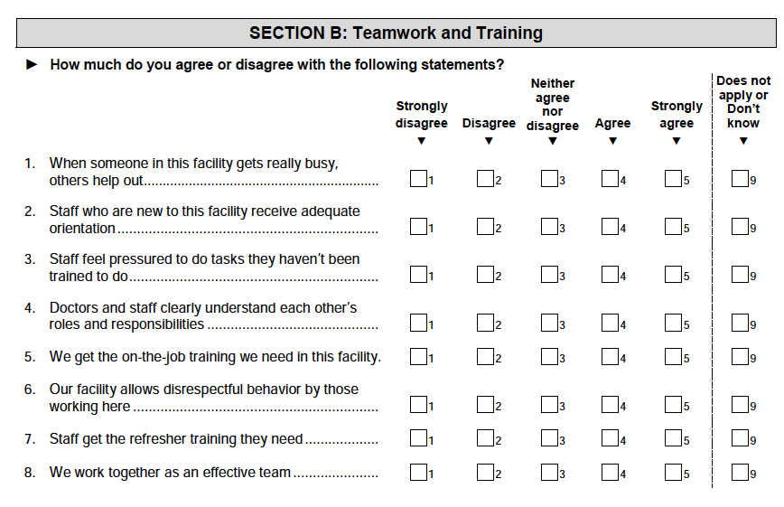
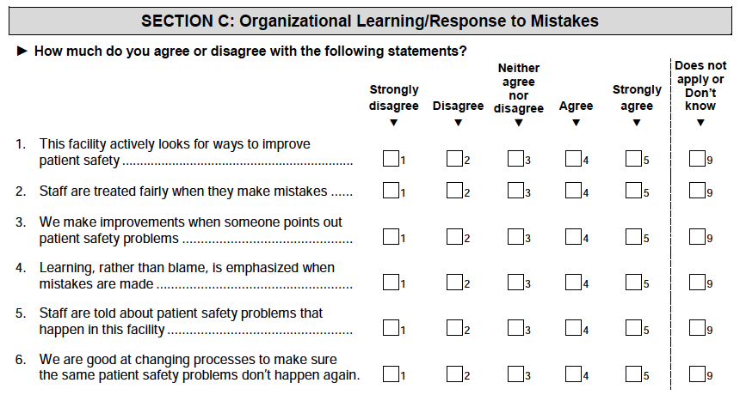

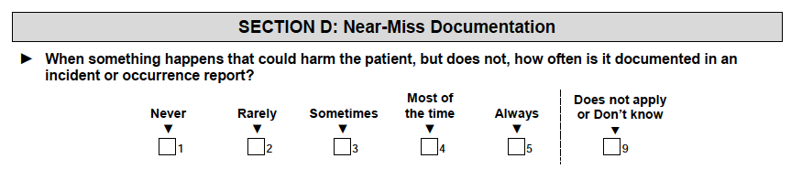

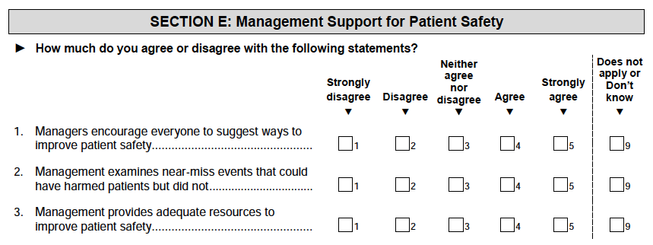
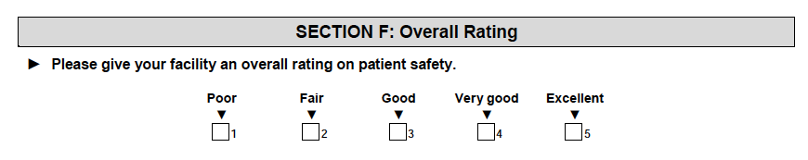
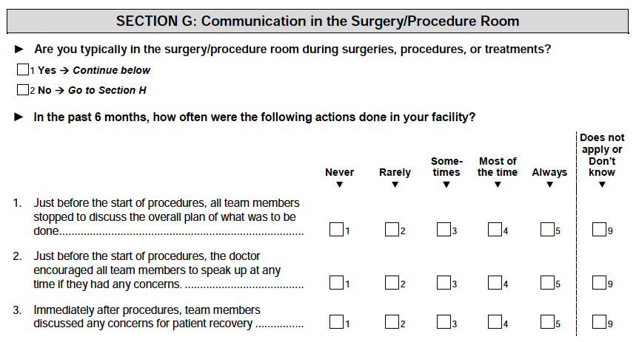
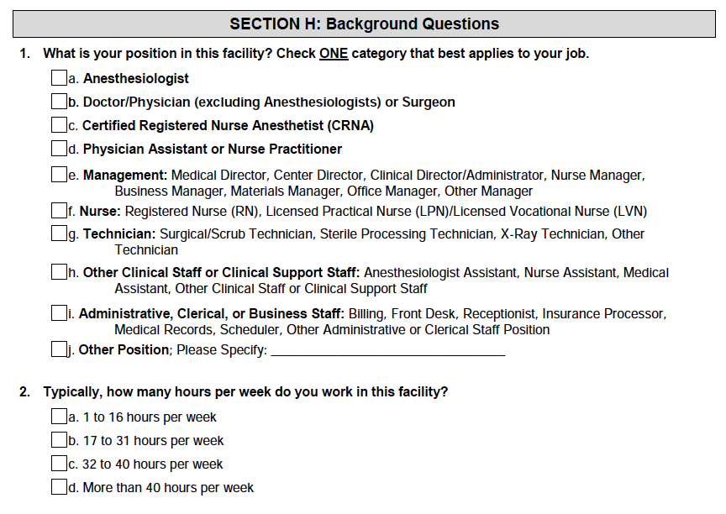

Section J: Additional comments

