CCR 96772 - Require Last Name on all AES entries
Current AES Form:

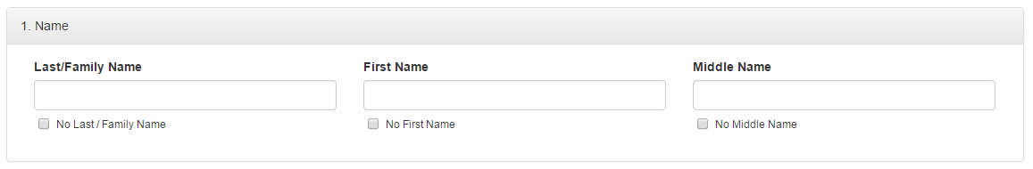

Proposed Change:

