OMB Control Number: 1405-0102
Expiration Date: 8-31-2017
RSC Information Collections Questions which address the information you have in the document
Note: This is an example of the types of questions that RSC case workers ask to elicit all of the required information to input into WRAPS. This is not an exhaustive or authoritative list.
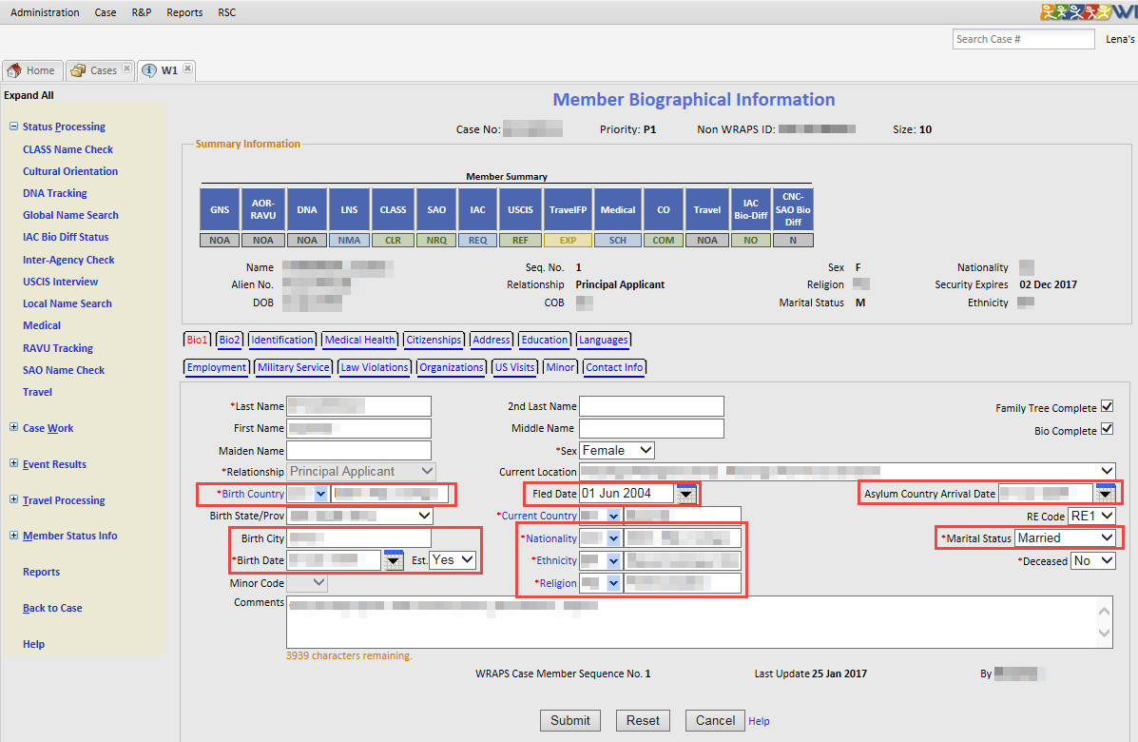
- In which city/country were you born?
- When is your birthday?
- What is your ethnicity or tribe?
- What is your nationality?
- What religion do you practice?
- Are you married and if so how long have you been married?
- When did you flee your country of birth?
  - Where did you go?
  - How long were you there for?
  - What was your immigration status?
  - Who traveled with you?
  - Where did you go next? Why did you leave?
  - Have you ever returned to your country of birth?
- When did you arrive in your first country of asylum?

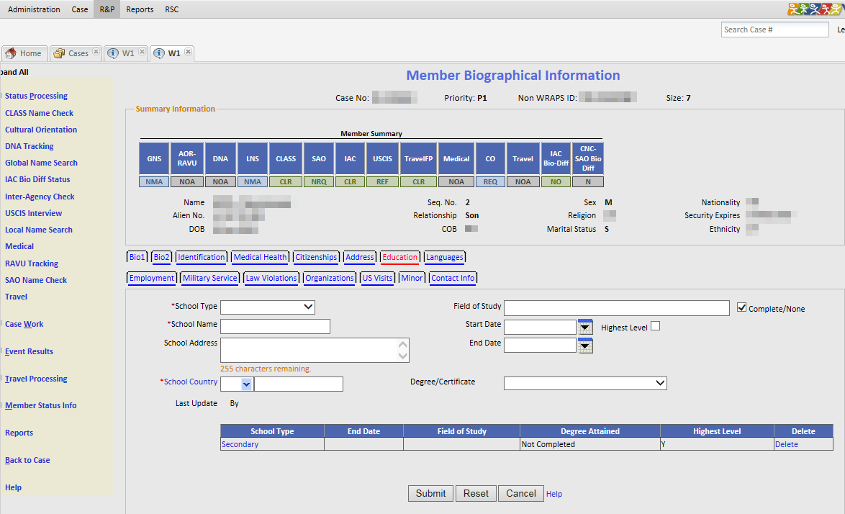
- What is the highest level of school you completed?
  - What is the name of the school and its location?
  - When did you begin/stop attending this school?
  - Did you receive a degree or certificate from the school?
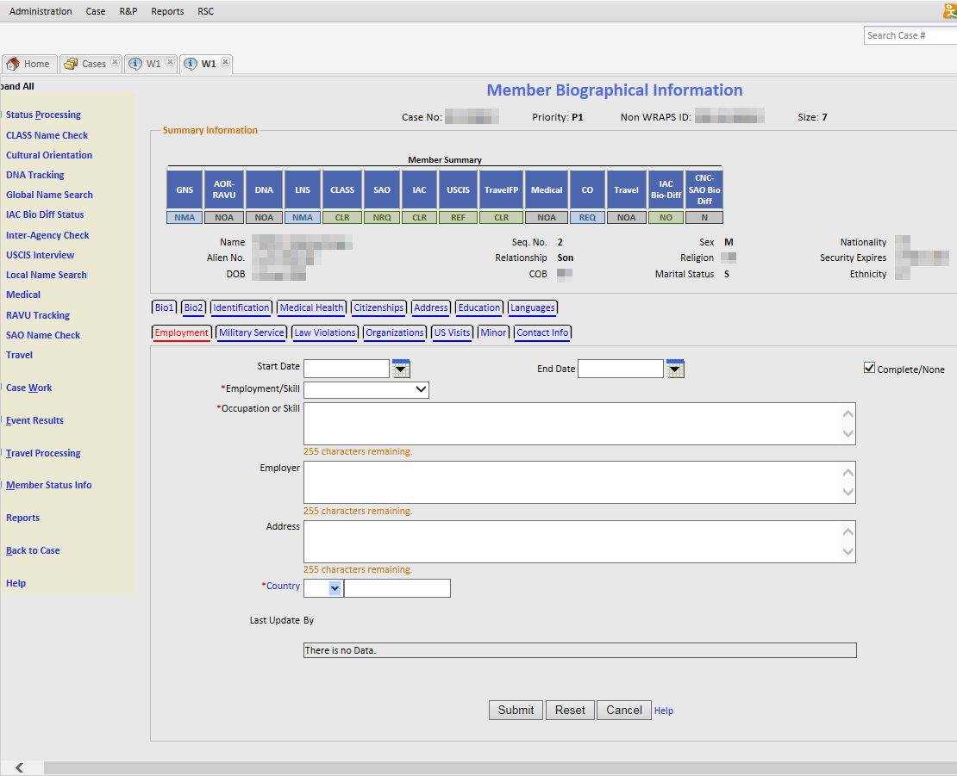
- What jobs have you held for the last 5 years?
  - Who was your employer?
  - What country was this job located in?
  - What is the address of the job?
  - When did you begin and end working at the job?
- Do you have any artisan skills or trade of note?

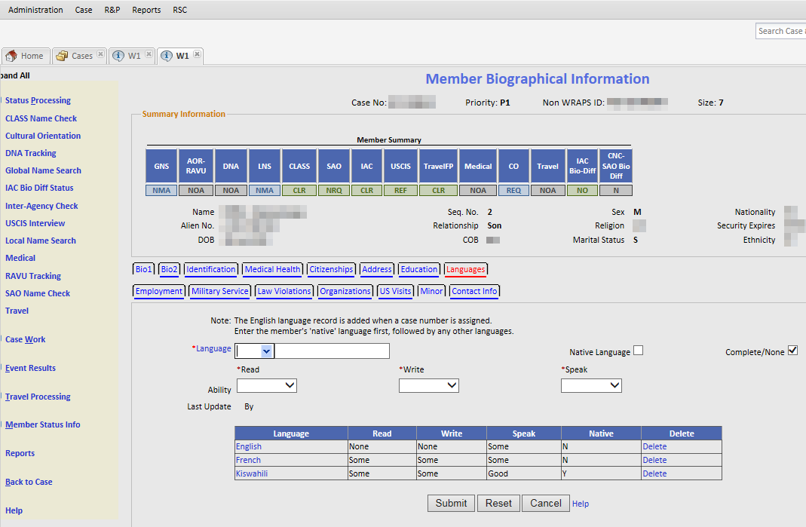
- What language are you most comfortable speaking (native language)?
  - Can you read/write in this language?
- What is your ability to speak English?
  - Can read/write in English?
- Do you know any other languages?
  - Can you read/write in this language?

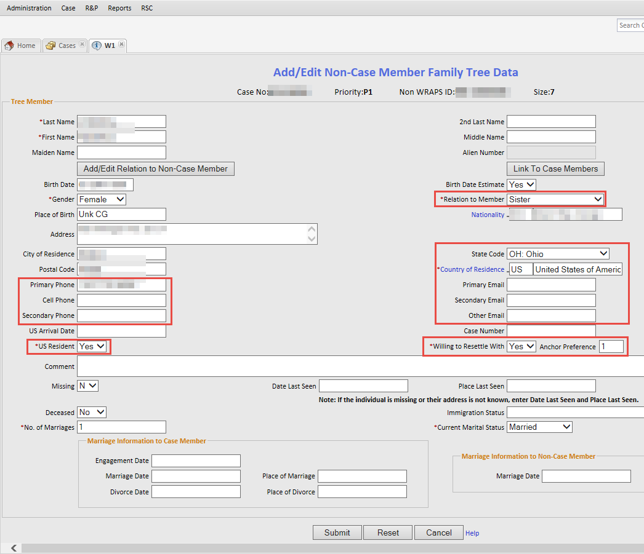
- Do you know anyone in the US who you would like to be resettled near?
  - What is your relationship to this person?
  - Is the person a US resident and where do they live?
  - What is their phone number?
  - What is their email address?
Additional Questions asked during the Prescreening Interview:

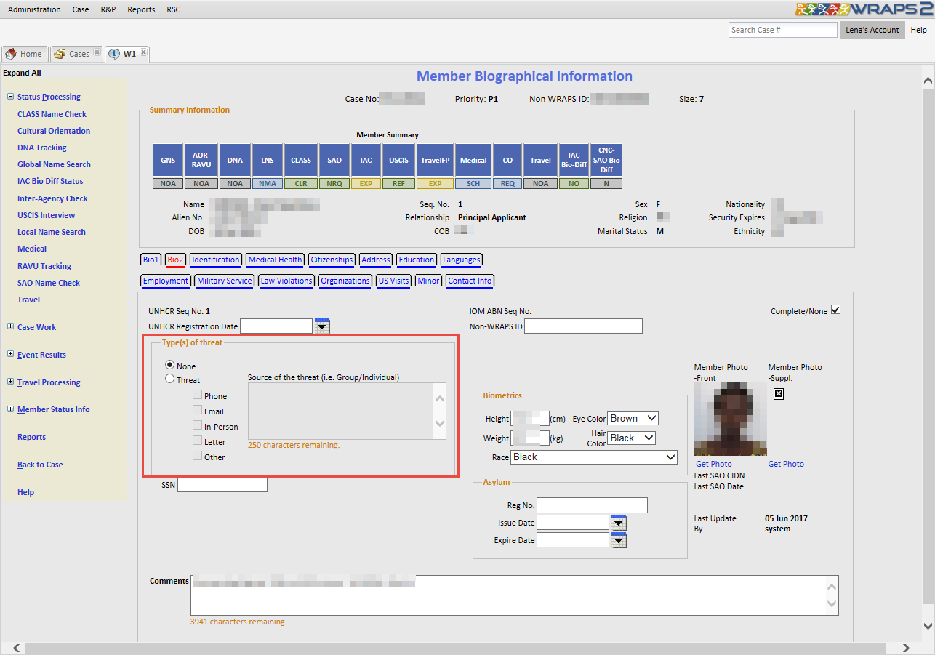
- Bio 2 Tab
  - Have you ever been threatened by a group or individual?
    - If yes, by whom and how was the threat delivered?
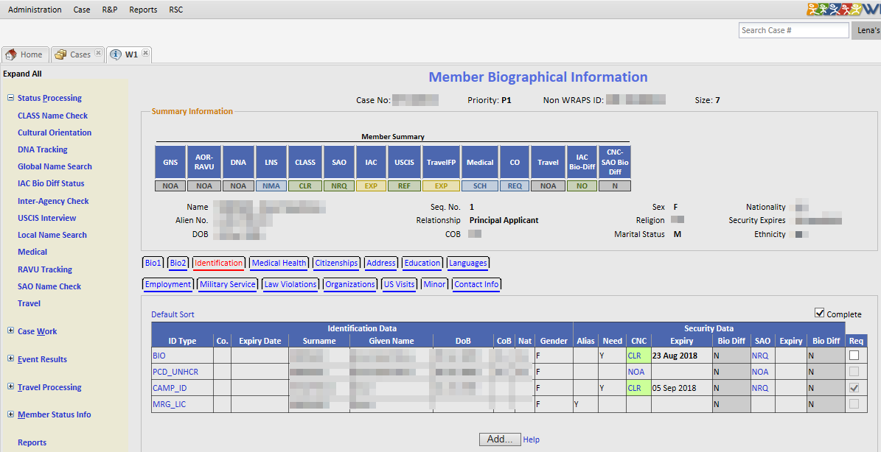
- Identification Tab
  - Have you ever used any other name (nickname) than the one you are presenting today?
  - Do you have any documents with your/other names you might have used?
  - Do you have a passport(s)?
  - Do you have a national ID?
  - Do you have any other identification documents?
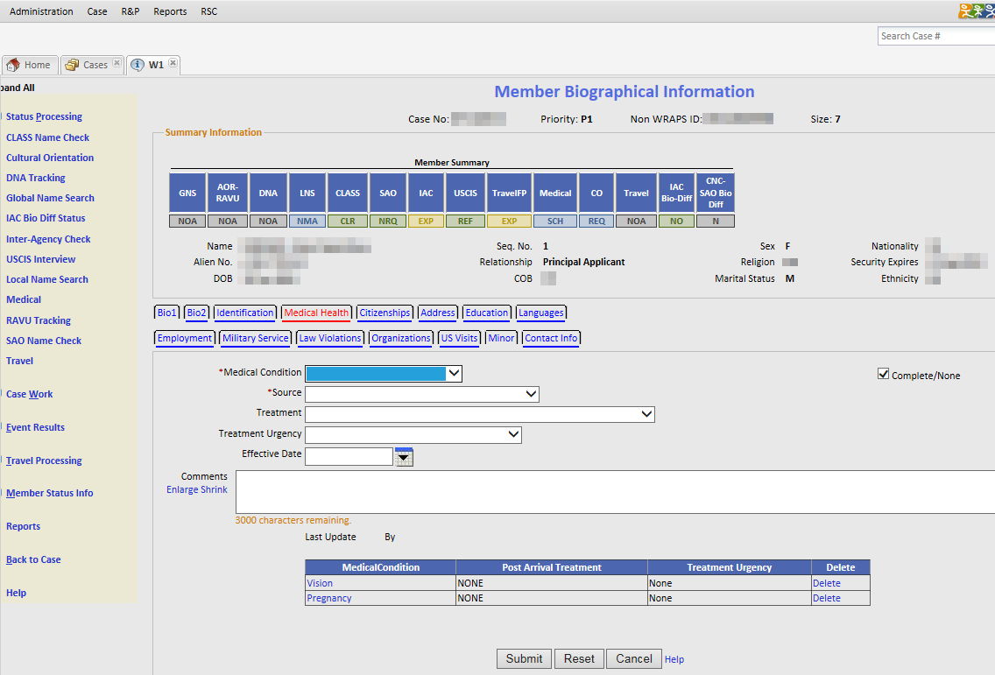
- Medical Health Tab
  - Do you have any medical conditions you would like to report to me?
  - (Female applicants) Are you pregnant?
  - Do you take any medication?

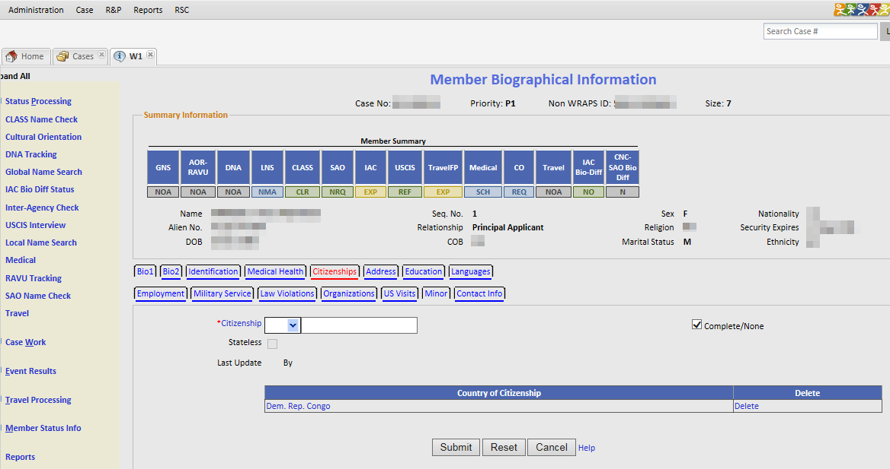
- Citizenship Tab
  - What country are you a citizen of?
  - Do you have any other citizenships?

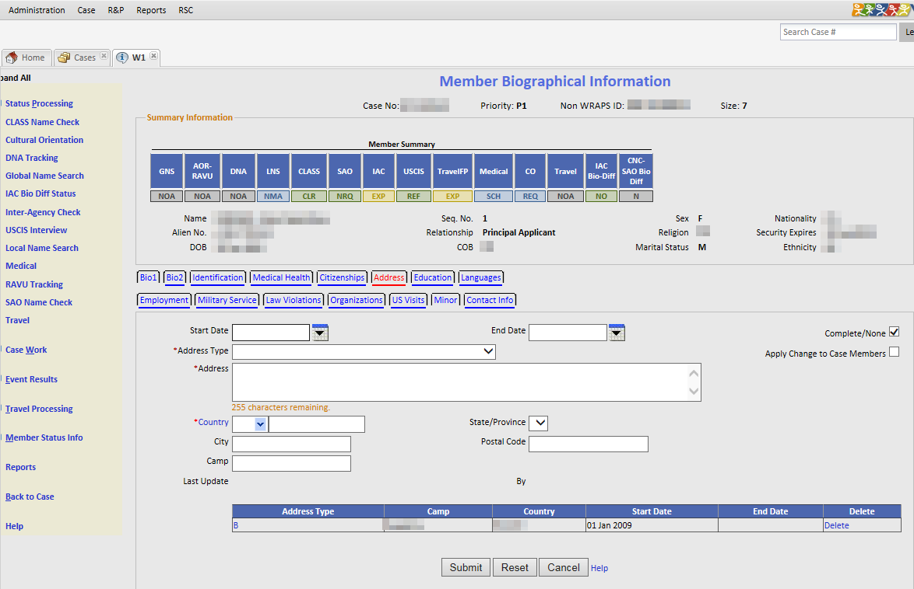
- Address Tab
  - Please provide all addresses you have resided in for the last five years.
  - When did you start/stop residing at the address?

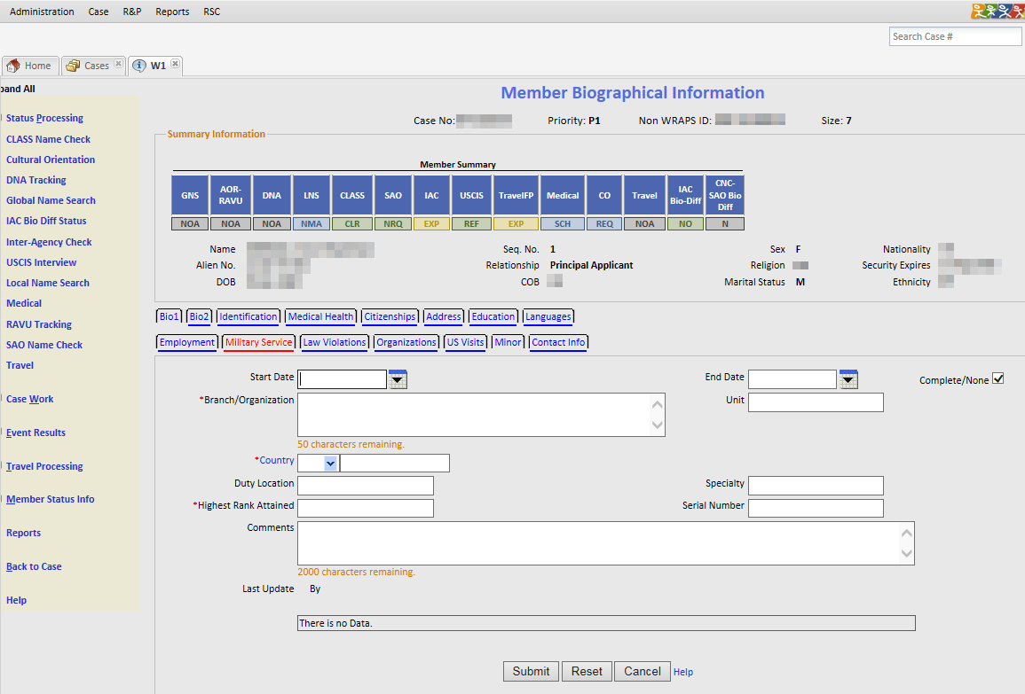
- Military Service Tab
  - Have you ever served in the military? If yes:
    - Which branch of the military were you in?
    - What was your duty location?
    - What was the highest rank attained?
    - What was your specialty?
    - What was your serial number?
    - When did you start/end your military service?
    - What was your status at discharge?
    - What was the name and location of your military registration?
    - What this voluntary service, armed service, compulsory service, unarmed service?
    - What was your military occupation/specialization?
    - Please provide all of your promotion details (starting rank) and dates.
    - Please provide all of your training received (name, location, dates, type of training).
    - Please provide a chronological order of your service details (service unit, commanding officer, rank, dates of service in unit, primary duty and dates, secondary duty and dates, any other duties and dates, exact geographical location of unit, type of unit, type of equipment, any reserve services and dates.
    - Have you ever served in combat?
      - If yes, location and dates.
    - Did you take any extended leave?
      - If yes, please provide reason, location, dates and details of return to unit.
    - Do you have your military booklet or any other documents related to your military service?
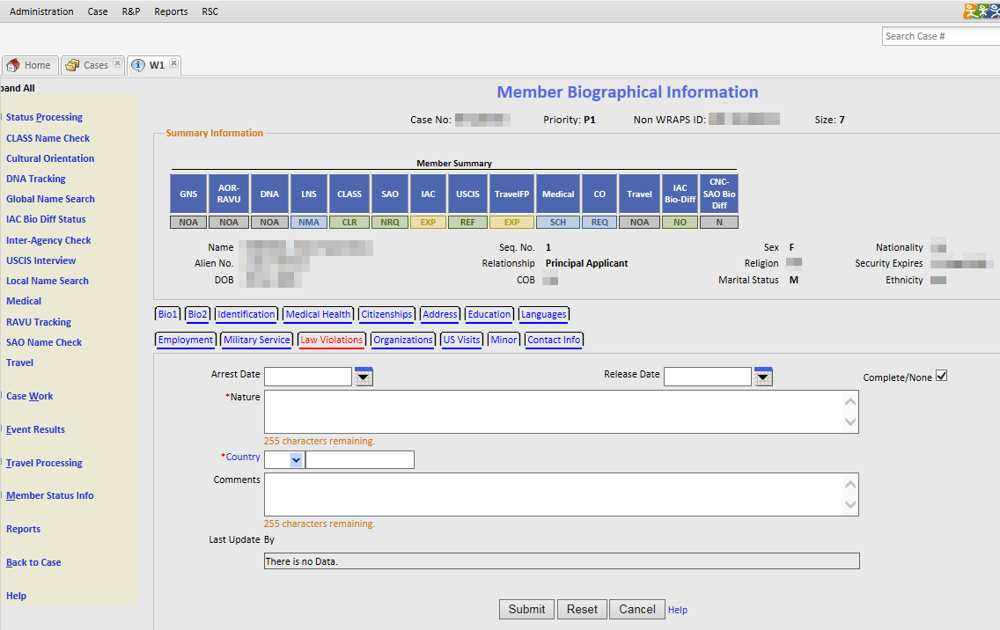
- Law Violations Tab
  - Have you ever been convicted of a crime?
    - What was the nature of the crime?
    - In which country were you convicted?
    - What was the date of your conviction?
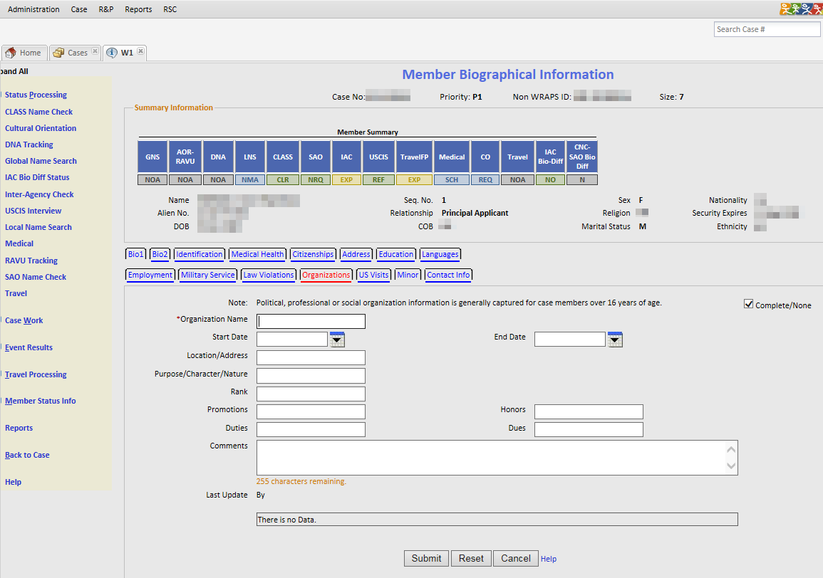
- Organizations Tab
  - Have you ever been a member of a political, professional or social organization?
  - If yes, what was the organization’s name and location?
  - When did you join the organization?
  - When did you stop being a member of the organization?
  - What was the purpose or nature of the organization?
  - What was your rank in the organization?
  - What were your duties in the organization?
  - How much were the organization dues?

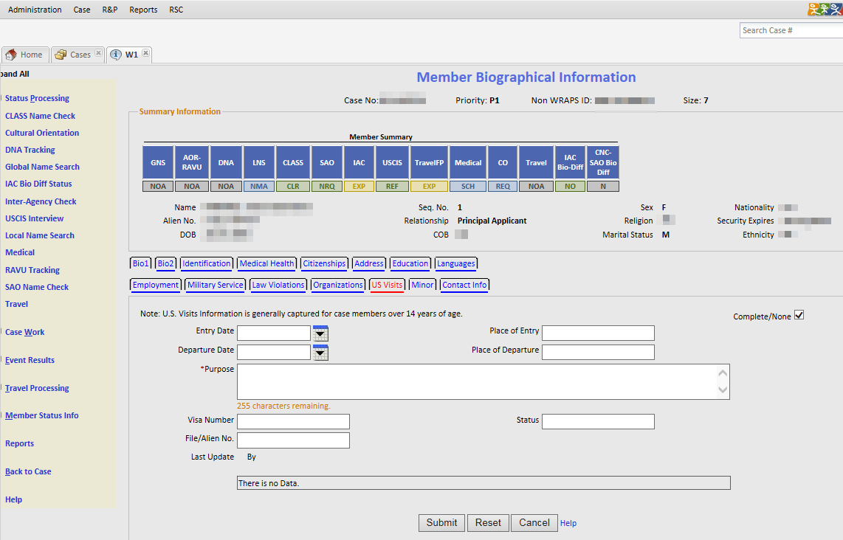
- US Visits Tab
  - Have you ever visited the US?
  - When did you enter/depart the US?
  - What was the purpose of your visit to the US?
  - Do you have an alien number ?
    - If so, do you know what it is?
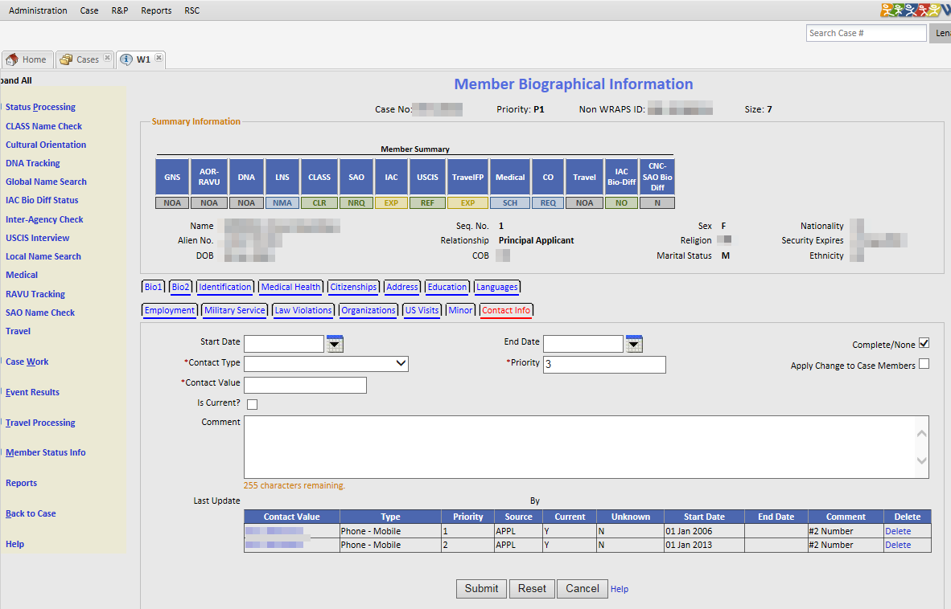
- Contact Info Tab
  - Please provide all phone number and email addresses you have used in the last ten years.
    - When did you start/stop using this contact?
    - Is this contact the best way to reach you?
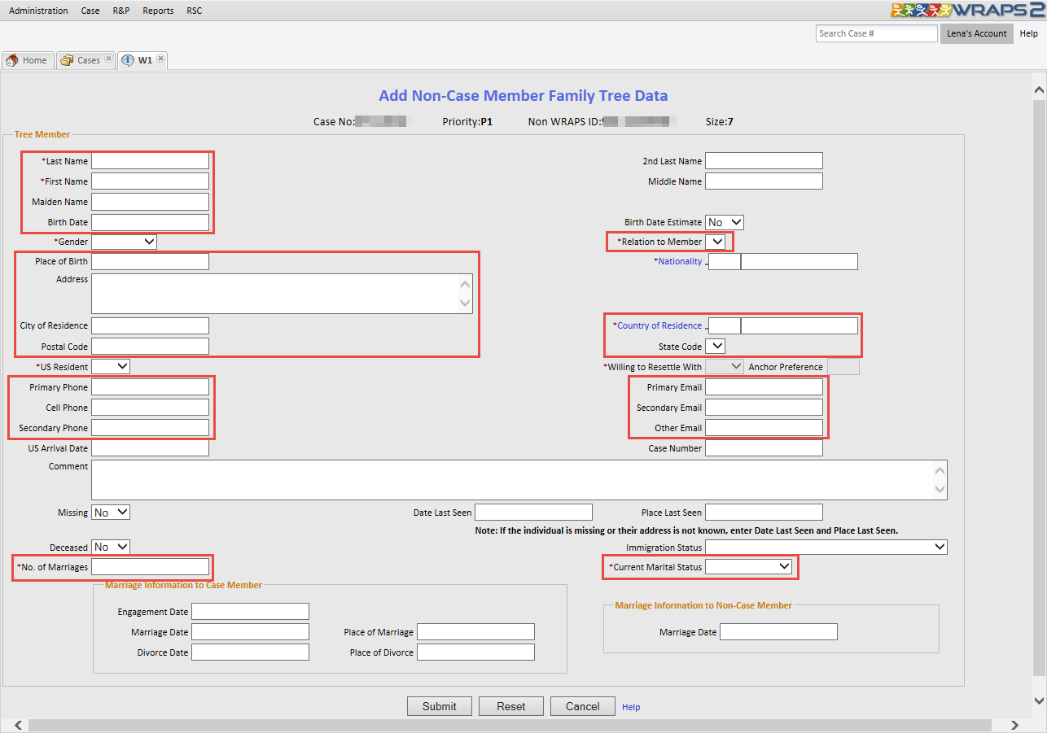
- Family Tree
  - Please provide information about your parents, spouse, siblings and children.
    - Including all half, step, adopted and foster relationships – living and deceased.
  - What is the name of your family member?
  - What is your family member’s date of birth?
  - What is your relationship to this family member?
  - Where was your family member born?
  - Where does your family member live currently (full address)?
  - What is your family members contact information (including phone and email)?
  - Is your family member married?
  - How many times has your family member been married?

PRA Statement
Public reporting burden for this collection of information is estimated to average 30 minutes per response, including time required for searching existing data sources, gathering the necessary documentation, providing the information and/or documents required, and reviewing the final collection. You do not have to supply this information unless this collection displays a currently valid OMB control number. If you have comments on the accuracy of this burden estimate and/or recommendations for reducing it, please send them to: PRM/Admissions, 2025 E Street, NW, SA-9, 8th Floor, Washington, DC 20522-0908.

