2016/17 BACCALAUREATE AND BEYOND (B&B:16/17) MAIN STUDY

OMB # 1850-0926 v.4

Appendix E

Sample Member Communication Materials

Submitted by

National Center for Education Statistics (NCES)

U.S. Department of Education

April 2017

revised May 2017

**Contents**

Contacts Calendar 2

Brochure Text 6

Website Text 8

Initial Contact/Screener Invitation Letter 13

Data Collection Announcement Letter 15

Reminder Postcard 1 17

Reminder Postcard 2 19

Reminder Postcard 3 21

Reminder Postcard 4 23

Reminder Postcard 5 25

Initial Contact/Screener Invitation Email 27

Initial Contact/Screener Reminder Email 28

Data Collection Announcement Email 29

Reminder Email 1 30

Reminder Email 2 31

Reminder Email 3 32

Reminder Email 4 33

Reminder Email 5 34

Reminder Email 6 35

Reminder Email 7 36

Reminder Email 8 37

Reminder Email 9 38

Reminder Email 10 39

Reminder Email 11 40

Reminder Email 12 41

Reminder Email 13 42

Reminder Email 14 43

Reminder Email 15 44

Reminder Email 16 45

Reminder Email 17 46

Reminder Email 18 47

Reminder Email 19 48

Reminder Email from NCES 1 49

Reminder Email from NCES 2 50

Text Message Reminders 51

Thank You Letter 52

Thank You Email - check 53

Thank You Email - PayPal 54

Consent Text 55

B&B:16/20 FT Panel Maintenance Postcard 56

FS Panel Maintenance Email 57

Note: Emails and letters providing similar content to those shown in this appendix will be sent throughout data collection to encourage participation. In addition, sample members that request follow-up reminders via text message will receive text message prompts to complete the survey. The materials included in this appendix reference the full-scale study to be conducted in 2017-18.

# Contacts Calendar

|  |  |  |  |  |
| --- | --- | --- | --- | --- |
| **Contact Name** | **Data Collection Phase** | **Type** | **Approximate Date**  **- Groups 1 & 2** | **Approximate Date**  **- Groups 3 & 4** |
| Initial Contact/Screener Invitation Letter | Pre-data collection | Letter | 7/31/17 | N/A |
| Initial Contact/Screener Invitation Email | Pre-data collection | Email | 7/31/17 | N/A |
| Initial Contact/Screener Reminder Email | Pre-data collection | Email | 8/14/17 | N/A |
| Data collection Announcement Letter | Early Completion | Letter | 9/25/2017 | 7/31/2017 |
| Data collection announcement email | Early Completion | Email | 9/25/2017 | 7/31/2017 |
| Reminder text 1 | Early Completion | Text | 10/2/2017 | 8/7/2017 |
| Reminder email 1 (only those with no text) | Early Completion | Email | 10/2/2017 | 8/7/2017 |
| Reminder postcard 1 | Early Completion | Postcard | 10/9/2017 | 8/14/2017 |
| Reminder email 2 | Production I | Email | 10/18/2017 | 8/23/2017 |
| Reminder email 3 | Production I | Email | 10/31/2017 | 9/5/2017 |
| Reminder text 2 | Production I | Text | 11/6/2017 | 9/11/2017 |
| Reminder email 4 | Production I | Email | 11/8/2017 | 9/13/2017 |
| Reminder postcard 2 | Production I | Postcard | 11/20/2017 | 9/25/2017 |
| Reminder text 3 | Production I | Text | 12/4/2017 | 10/9/2017 |
| Reminder email 5 | Production I | Email | 12/9/2017 | 10/14/2017 |
| Reminder email 6 | Production I | Email | 12/23/2017 | 10/28/2017 |
| Reminder postcard 3 | Production I | Postcard | 1/10/2018 | 11/15/2017 |
| Reminder 7/Abbreviated Announcement Email | Production II | Email | 1/25/2018 | 3/4/2018 |
| Reminder text 4 | Production II | Text | 1/31/2018 | 12/6/2017 |
| Reminder email 8 (only those with no text) | Production II | Email | 1/31/2018 | 12/6/2017 |
| Reminder postcard 4 | Production II | Postcard | 2/10/2018 | 12/16/2017 |
| Reminder email 9 | Production II | Email | 2/24/2018 | 12/30/2017 |
| Reminder email 10 | Production II | Email | 3/3/2018 | 1/6/2018 |
| Reminder text 5 | Production II | Text | 3/19/2018 | 1/22/2018 |
| Reminder email 11 | Production II | Email |  | 1/27/2018 |
| Reminder text 6 | Production II | Text |  | 2/19/2018 |
| Reminder email 12 (only those with no text) | Production II | Email |  | 2/19/2018 |
| Reminder email 13 | Production II | Email |  | 2/27/2018 |
| Reminder postcard 5 | Nonresponse Conversion | Postcard |  | 3/4/2018 |
| Reminder email 14 | Nonresponse Conversion | Email |  | 3/4/2018 |
| Reminder email 15 | Nonresponse Conversion | Email |  | 3/14/2018 |
| Reminder email 16 | Nonresponse Conversion | Email | 3/24/2018 | 3/24/2018 |
| Reminder email 17 | Nonresponse Conversion | Email | 3/27/2018 | 3/27/2018 |
| Reminder email 18 | Nonresponse Conversion | Email | 3/28/2018 | 3/28/2018 |
| Reminder email 19 | Nonresponse Conversion | Email | 3/29/2018 | 3/29/2018 |
| Reminder Email from NCES 1 | As needed | Email | As needed |  |
| Reminder Email from NCES 2 | As needed | Email | As needed |  |

**Confidentiality Pledge Fills:**

**Control:** All of the information you provide may be used only for statistical purposes and may not be disclosed, or used, in identifiable form for any other purpose except as required by law (20 U.S.C. §9573 and 6 U.S.C. §151).

**Homeland Security Version:** All of the information you provide may be used only for statistical purposes and may not be disclosed, or used, in identifiable form for any other purpose except as required by law (20 U.S.C. §9573). By law, any NCES employee or NCES contractor who willfully discloses any identifiable information about you or your school is subject to a jail term of up to 5 years, a fine of up to $250,000, or both. Electronic transmission of your information will be monitored for viruses, malware, and other threats by Homeland Security in accordance with the Cybersecurity Enhancement Act of 2015.

**Federal Employee Version:** All of the information you provide may be used only for statistical purposes and may not be disclosed, or used, in identifiable form for any other purpose except as required by law (20 U.S.C. §9573). By law, any NCES employee or NCES contractor who willfully discloses any identifiable information about you or your school is subject to a jail term of up to 5 years, a fine of up to $250,000, or both. Electronic transmission of your information will be monitored for viruses, malware, and other threat by Federal employees and contractors in accordance with the Cybersecurity Enhancement Act of 2015.

# Brochure Text

**What is B&B?**

The 2016/17 Baccalaureate and Beyond Longitudinal Study (B&B:16/17) is a national study of approximately 29,000 graduates from U.S. colleges and universities who will be asked about their experiences since completing a bachelor’s degree.

The study will collect information on graduate and other education, experiences on the job market and in the labor force, earnings and expenses, family status, and personal and professional goals. In addition to survey responses, we collect related information from sources such as student loan and enrollment databases. There is a particular focus on careers in teaching and other employment outcomes.

**Why am I being asked to participate?**

You have been asked to participate in B&B:16/17 because you completed the requirements for your bachelor’s degree during the 2015-16 academic year.

**Why is my participation important?**

Your survey responses help educators, researchers, and policymakers at the local, state, and national levels understand the experiences of recent college graduates. Your experiences are unique, and if you choose not to participate in B&B:16/17, no one else can be substituted for you.

**What have we learned from previous rounds of B&B?**

In 1994, 79 percent of bachelor’s degree recipients had a full-time job in the year following their graduation, compared to 78 percent in 2001, and 64 percent in 2009. SOURCE: U.S. Department of Education, National Center for Education Statistics (NCES), 1993/94, 2000/01, and 2008/09 Baccalaureate and Beyond Longitudinal Studies (B&B: 93/94, B&B:2000/01, and B&B:08/09).

**What happens to the results?**

Results from the current study are scheduled to be released in 2019 and will be posted on the NCES website (https://nces.ed.gov/) along with results from previous B&B studies. Your responses will be combined with those of other students and will be presented in summary form only. No individually-identifying information will be published.

**Who is conducting B&B?**

The 2016/17 Baccalaureate and Beyond Longitudinal Study (B&B:16/17) is conducted by the National Center for Education Statistics (NCES), in the U.S. Department of Education’s Institute for Education Sciences, with data collection being carried out under contract by RTI International, U.S.-based nonprofit research organization.

NCES is authorized to conduct B&B by the Education Sciences Reform Act of 2002 (ESRA 2002, 20 U.S.C. §9543) and to collect students’ education records from educational agencies or institutions for the purposes of evaluating federally supported education programs under the Family Educational Rights and Privacy Act (FERPA, 34 CFR §§ 99.31(a)(3)(iii) and 99.35).

**How will my information be protected?**

NCES is required to follow strict procedures to protect personal information in the collection, reporting, and publication of data. [PLEDGE FILL]

Data security procedures for B&B are reviewed and approved by NCES data security staff. Your answers are secured behind firewalls and are encrypted during internet transmission using Secure Sockets Layer (SSL) protocol. All data entry modules are password protected and require the user to log in before accessing the data. NCES employees and contractors are subject to large fines or imprisonment if individual responses are disclosed.

**How do I participate?**

You can complete the B&B survey online or over the phone.

ONLINE

Log onto the study website at [<<Website URL>>](https://surveys.nces.ed.gov/bandb/)/ using the Study ID and password provided in your welcome letter.

The survey is mobile-optimized, so it can be easily completed on a mobile device.

PHONE

Call our Help Desk at 877-287-3782 to speak to one of our professional interviewers.

**Contact Us**

**B&B HELP DESK**

**877-287-3782**

[bandb@rti.org](mailto:bbemail@rti.org)

[<<Website URL>>](https://surveys.nces.ed.gov/bandb/)

Ted Socha

B&B Project Officer (NCES)

[Ted.Socha@ed.gov](mailto:Ted.Socha@ed.gov)

202-245-7071

Jennifer Wine, Ph.D.

B&B Project Director (RTI)

[jennifer@rti.org](mailto:jennifer@rti.org)

877-225-8470

# Website Text

**HOME PAGE:**

**Welcome to the 2016/17 Baccalaureate and Beyond Longitudinal Study (B&B:16/17)**

GET STARTED!

Study ID

Password:

□ Show me what I’ve typed

LOG IN

Need your Study ID number or password? (hyperlink)

FOOTER:

NCES is authorized to conduct B&B:16/17 by the Education Sciences Reform Act of 2002 (ESRA 2002, 20 U.S.C. §9543) and to collect students’ education records from education agencies or institutions for the purposes of evaluating federally supported education programs under the Family Educational Rights and Privacy Act (FERPA, 34 CFR §§ 99.31(a)(3)(iii) and 99.35). The data are being collected for NCES by RTI International, a U.S.-based nonprofit research organization. [PLEDGE FILL]

According to the Paperwork Reduction Act of 1995, no persons are required to respond to a collection of information unless it displays a valid OMB control number. The valid OMB control number for this voluntary information collection is 1850-0926. The time required to complete this information collection is estimated to average approximately <<time>> minutes per response, including the time to review instructions, gather the data needed, and complete and review the information collection. If you have any comments concerning the accuracy of the time estimate, suggestions for improving this survey, or any comments or concerns regarding the status of your individual submission of this survey, please write directly to: The 2016/17 Baccalaureate and Beyond Longitudinal Study (B&B:16/17), National Center for Education Statistics, Potomac Center Plaza, 550 12th St, SW, Room 4004, Washington, DC 20202.

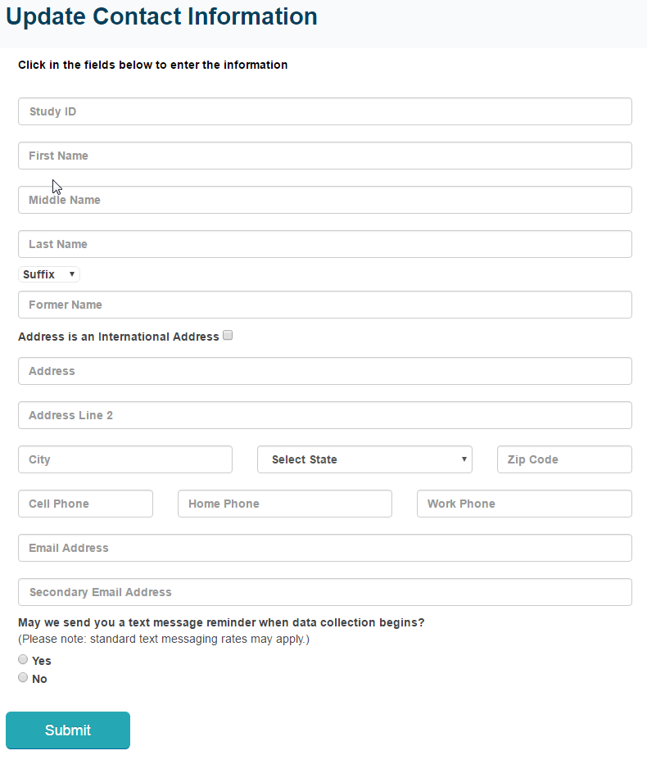

**CONTACT US**

If you need assistance accessing the web survey or wish to complete the survey by phone, call the B&B Help Desk:

**Help Desk Hours**

|  |  |
| --- | --- |
| Monday-Thursday | 9:00 a.m. – midnight. |
| Friday | 9:00 a.m. – 11:00 p.m. |
| Saturday | 9:30 a.m. – 9:00 p.m. |
| Sunday | 1:00 p.m. – 11:00 p.m. |

All times are Eastern time (ET).

**Telephone**

Phone: 877-287-3782

**Email**

bandb@rti.org

**B&B Staff**

B&B project staff are available to respond to your questions Monday through Friday between 9:00 a.m. and 5:00 p.m. ET.

**B&B Staff**

|  |  |
| --- | --- |
| RTI Project Director | Jennifer Wine, Ph.D. |
|  | [jennifer@rti.org](mailto:njanson@rti.org) |
|  | 877-225-8470 |
| NCES Project Officer | Ted Socha |
|  | [Ted.Socha@ed.gov](mailto:Ted.Socha@ed.gov) |
|  | 202-245-7071 |

**WHAT TO EXPECT**

**How can I complete the B&B survey?**

You may complete the B&B survey on the Web – simply Log in from the home page by entering your study ID number and password, which are provided in the B&B letter or e-mail you received. You can even complete it on your mobile device. If you need assistance accessing the survey on the website, or if you want to complete the survey by telephone, contact the B&B Help Desk by calling 877-287-3782 or sending an e-mail to bandb@rti.org.

**How long will the survey take?**

For most people, we expect the survey will take about 30 minutes, depending on your answers. You do not have to complete the survey in one session. You can get started and, if you choose, you can easily log out and resume at a later time. If you are asked to provide a resume, the time to submit the resume is estimated to average 5 minutes.

**Do I have to participate?**

Participation in this study is voluntary; however, your involvement is very important to the success of this study. By participating, you have the opportunity to help policymakers, researchers, and others better understand the experiences of recent bachelor’s degree recipients. You may recall being contacted about or participating in the National Postsecondary Student Aid Study (NPSAS) last year. You can participate in B&B whether or not you completed a survey for NSPAS – we need your participation for the study to be a success!

**Can I refuse to answer a question?**

You may refuse to answer any question at any time. If you choose not to answer or are unable to answer a particular question, you may still continue with the rest of the survey.

**How do I know your website is secure?**

The B&B website is protected by Secure Sockets Layer (SSL; 128-bit encryption) technology. Your survey responses are collected over a secure server and connection is also protected by SSL.

**Should I use a particular web browser to take the web survey?**

The survey needs to use a browser that supports HTML5 and JavaScript. The latest versions of Firefox, Chrome, and Safari will work, as will Internet Explorer 9 and later. If you are having any trouble completing the survey, please call our Help Desk at 877-287-3782 and we will be happy to assist you.

**PREVIOUS RESULTS**

Your Participation Counts!

As with all prior B&B studies, results will be presented in summary form only; no individual results will be published. Data collected from B&B will help researchers and policymakers better understand how earning a bachelor’s degree impacts choices for additional education and employment paths.

Here’s what we learned from the B&B cohort of students who graduated with their bachelor’s degree in the 2007-2008 school year:

1. Pie chart: Bachelor’s degree major: (16% STEM, 16% social sciences, 12% humanities, 23% business, 33% other) [SOURCE: U.S. Department of Education, National Center for Education Statistics, 2008/09 Baccalaureate and Beyond Longitudinal Study (B&B:08/09) <http://nces.ed.gov/pubs2013/2013150.pdf>]
2. Bar chart: Among bachelor’s degree recipients, average amount borrowed, by sector (Public 4-year: $20,800; Private nonprofit 4-year: $28,900; for-profit 4-year: $36,800) [SOURCE: U.S. Department of Education, National Center for Education Statistics, 2008/09 Baccalaureate and Beyond Longitudinal Study (B&B:08/09) <http://nces.ed.gov/pubs2013/2013150.pdf>]
3. Pie chart: Employment and enrollment four years after bachelor degree receipt (69% employed only, 11% both employed and enrolled, 6% enrolled only, 15% neither employed nor enrolled) [SOURCE: U.S. Department of Education, National Center for Education Statistics, 2008/12 Baccalaureate and Beyond Longitudinal Study (B&B:08/12). <http://nces.ed.gov/pubs2014/2014141.pdf> ]

**INFORMATION SECURITY**

The National Center for Education Statistics (NCES) is required to follow strict procedures to protect personal information in the collection, reporting, and publication of data. Your responses will be combined with those of other students and will be presented in summary form only. No individually-identifying information will be published.

Data security procedures for B&B are reviewed and approved by NCES data security staff. Your answers are secured behind firewalls and are encrypted during internet transmission using Secure Sockets Layer (SSL) protocol. All data entry modules are password protected and require the user to log in before accessing confidential data.

Congress has authorized the National Center for Education Statistics (NCES) of the U.S. Department of Education’s Institute of Education Sciences to collect data about the costs of postsecondary education because policymakers at all levels need reliable and current national data in order to make decisions about postsecondary education.

NCES is authorized to conduct the 2016/17 Baccalaureate and Beyond Longitudinal Study (B&B:16/17) by the Education Sciences Reform Act of 2002 (ESRA 2002, 20 U.S.C. §9543) and to collect students’ education records from educational agencies or institutions for the purposes of evaluating federally supported education programs under the Family Educational Rights and Privacy Act (FERPA, 34 CFR §§ 99.31(a)(3)(iii) and 99.35).

The study has been approved by the U.S. Office of Management and Budget (OMB). The valid OMB control number for this information collection is 1850-0926. The expiration date is 5/31/2019.

**ABOUT B&B**

The **2016/17 Baccalaureate and Beyond Longitudinal Study (B&B:16/17)** is a national study of approximately 29,000 graduates from U.S. colleges and universities to find out about their experiences since completing a bachelor’s degree.

The study will collect information on graduate and other education, experiences on the job market and in the labor force, earnings and expenses, family status, and personal and professional goals. In addition to survey responses, we collect related information from sources such as student loan and enrollment databases. There is a particular focus on careers in teaching and other employment outcomes.

B&B:16/17 is the first follow-up survey from a cohort of students who completed their bachelor’s degree requirements during the 2015-2016 academic year. Most study participants were first surveyed in 2016 as part of the National Postsecondary Student Aid Study (NPSAS).

B&B:16/17 is conducted by the National Center for Education Statistics (NCES), in the U.S. Department of Education’s Institute for Education Sciences, with data collection being carried out under contract by RTI International, a U.S.-based nonprofit research organization..

To learn more about the data from previous B&B studies, visit [NCES’s B&B website](https://nces.ed.gov/surveys/b&b/).

# Initial Contact/Screener Invitation Letter

<<date>>

<<name>>

<<addr1>>

<<addr2>>

<<city>>, <<st>> <<zip>>

Dear <<fname>>,

You have been randomly selected to participate in the 2016/17 Baccalaureate and Beyond Longitudinal Study (B&B:16/17), conducted by the U.S. Department of Education’s National Center for Education Statistics (NCES). [IF base-year interview respondent:]<<You may recall participating in the National Postsecondary Student Aid Study (NPSAS) last year.>> B&B will collect education, employment, and other information from you and others like you who earned their bachelor’s degree during the 2015-16 school year. Data collected from B&B will help researchers and policymakers better understand how earning a bachelor’s degree impacts choices for additional education and employment paths. These data are being collected for NCES by RTI International, a U.S.-based nonprofit research organization. Your participation in B&B is critical to the success of the study.

Before B&B data collection begins in a few weeks, we need to update our contact information for you.

**Please answer a few questions about your eligibility for the study, and update your contact information online at** [**<<Website URL>>**](https://surveys.nces.ed.gov/bandb/)**.** <<NPSAS study member, INCENTIVE ELIGIBLE : **To thank you for completing this update, which should take about 10 minutes, we will send you $10 via <<PayPal or>> check!>>**

Go to <<Website URL>>

Enter your Study ID number **<<caseid>>** and

Password: **<<pswd>>**

<<IF NPSAS study member: In the next few weeks we will contact you again with specific information about how to participate in the B&B study.>> You can also find out more about B&B at the website listed above. If you have additional questions or concerns about the study, please call the RTI study director, Jennifer Wine, at 877-225-8470.

We thank you in advance for your participation in this important study. Your cooperation is greatly appreciated.

Sincerely,

National Center for Education Statistics (NCES)

|  |
| --- |
| NCES is authorized to conduct B&B:16/17 by the Education Sciences Reform Act of 2002 (ESRA 2002, 20 U.S.C. §9543*)* and to collect students’ education records from education agencies or institutions for the purposes of evaluating federally supported education programs under the Family Educational Rights and Privacy Act (FERPA, 34 CFR §§ 99.31(a)(3)(iii) and 99.35). The data are being collected for NCES by RTI International, a U.S.-based nonprofit research organization. [PLEDGE FILL]  According to the Paperwork Reduction Act of 1995, no persons are required to respond to a collection of information unless it displays a valid OMB control number. The valid OMB control number for this voluntary information collection is 1850-0926. The time required to complete this information collection is estimated to average approximately <<time>> minutes per response, including the time to review instructions, gather the data needed, and complete and review the information collection. If you have any comments concerning the accuracy of the time estimate, suggestions for improving this survey, or any comments or concerns regarding the status of your individual submission of this survey, please write directly to: The 2016/17 Baccalaureate and Beyond Longitudinal Study (B&B:16/17), National Center for Education Statistics, Potomac Center Plaza, 550 12th St, SW, Room 4004, Washington, DC 20202. |

# Data Collection Announcement Letter

<<date>>

<<name>>

<<addr>>

<<city>>, <<st>> <<zip>>

Dear «fname» «lname»:

Recently, we contacted you about the 2016/17 Baccalaureate and Beyond Longitudinal Study (B&B:16/17), an important study that will collect education, employment, and other information from you and others like you who received their bachelor’s degree during the 2015-16 school year. Data collected from B&B will help researchers and policymakers better understand how earning a bachelor’s degree impacts choices for additional education and employment paths.

Approximately 29,000 recent bachelor’s degree recipients from schools across the nation have been randomly selected to participate in B&B. Sample members like you are being asked to complete a <<time>>survey. Having your resume handy will help you complete the survey more easily. <<IF GROUP 2-3 and incentive-eligible: **If you complete the survey by <<early_comp_date>> we will send you $<<incamt+early_bird>> payable by <<PayPal or>> check. After <<early_comp_date>>, we will send you $<<IncAmt>> once you complete the survey.**>> <<GROUPS 1 & 4 and incentive-eligible: **Once you complete the survey, we will send you $«IncAmt», payable by <<PayPal or>> check. .**>>

Log on to our secure website at [<<Website URL>>](https://surveys.nces.ed.gov/bandb/) to complete your survey on your computer, smartphone, or tablet:

**Study ID** = «caseid»

**Password** = «password»m *(password is case sensitive).*

Your participation is critical to the study’s success. You represent other recent college graduates like you who were not selected for this study. Your participation in B&B is voluntary and will not affect any aid or other benefits you may receive.

The enclosed brochure answers many common questions about the study and contains additional information on laws and procedures that protect the confidentiality of your responses. If you have questions about the study send an email to [bandb@rti.org](mailto:bbemail@rti.org), or, if you prefer to complete the survey over the phone, call the B&B help desk at 877-287-3782. You can also learn more by visiting the study website at [<<Website URL>>](https://surveys.nces.ed.gov/bandb/).

Thank you in advance for making B&B a success.

Sincerely,

Ted Socha

B&B Project Officer

National Center for Education Statistics (NCES)[Ted.Socha@ed.gov](mailto:Ted.Socha@ed.gov)

202-245-7071

Jennifer Wine, Ph.D.

B&B Project Director

RTI International

[jennifer@rti.org](mailto:jennifer@rti.org)

877-225-8470

Enclosure

«panelinfo»/«ctrl»

NCES is authorized to conduct B&B:16/17 by the Education Sciences Reform Act of 2002 (ESRA 2002, 20 U.S.C. §9543) and to collect students’ education records from education agencies or institutions for the purposes of evaluating federally supported education programs under the Family Educational Rights and Privacy Act (FERPA, 34 CFR §§ 99.31(a)(3)(iii) and 99.35). The data are being collected for NCES by RTI International, a U.S.-based nonprofit research organization. [PLEDGE FILL]

According to the Paperwork Reduction Act of 1995, no persons are required to respond to a collection of information unless it displays a valid OMB control number. The valid OMB control number for this voluntary information collection is 1850-0926. The time required to complete this information collection is estimated to average approximately <<time>> minutes per response, including the time to review instructions, gather the data needed, and complete and review the information collection. If you have any comments concerning the accuracy of the time estimate, suggestions for improving this survey, or any comments or concerns regarding the status of your individual submission of this survey, please write directly to: The 2016/17 Baccalaureate and Beyond Longitudinal Study (B&B:16/17), National Center for Education Statistics, Potomac Center Plaza, 550 12th St, SW, Room 4004, Washington, DC 20202.

**Reminder Postcard 1** 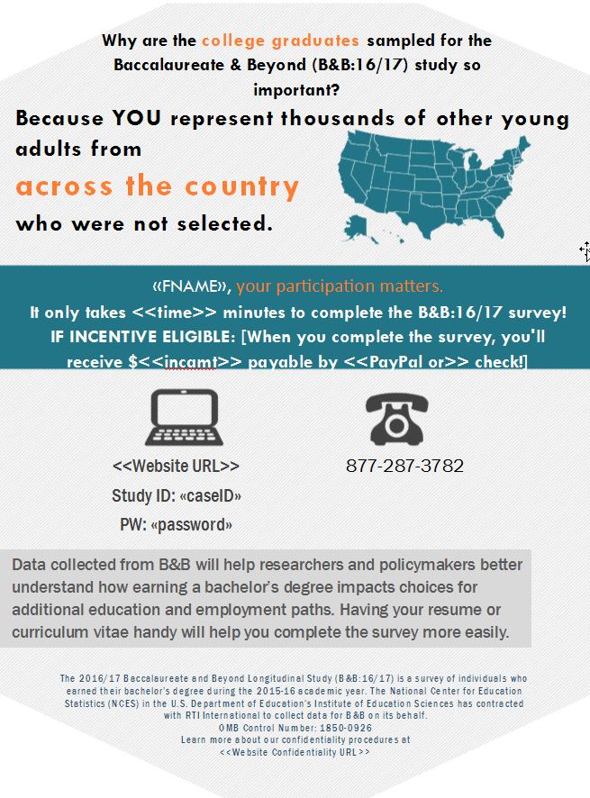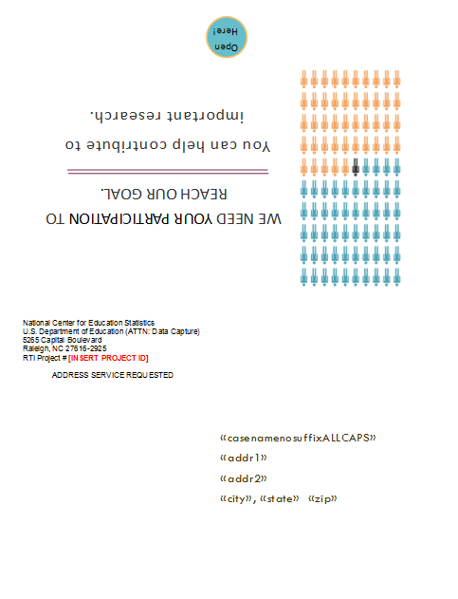

# Reminder Postcard 2

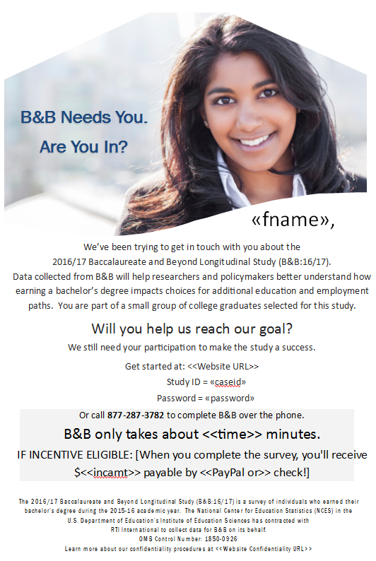

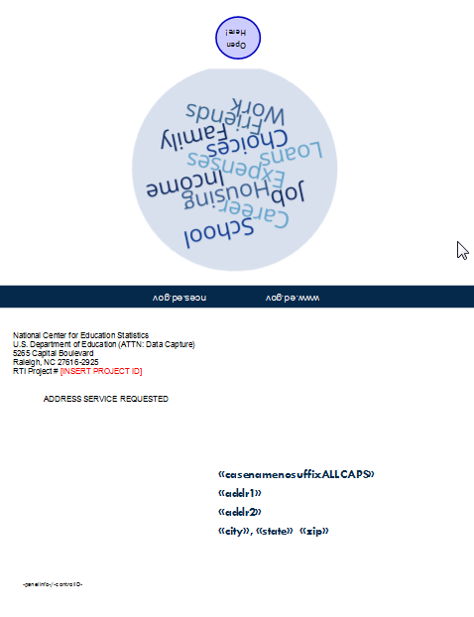

# Reminder Postcard 3

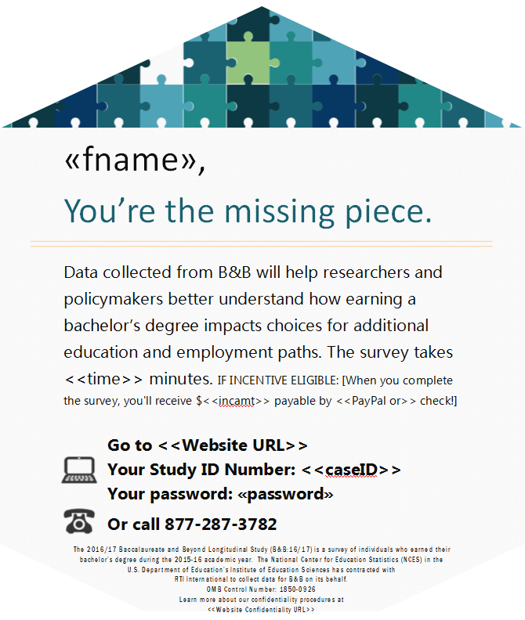

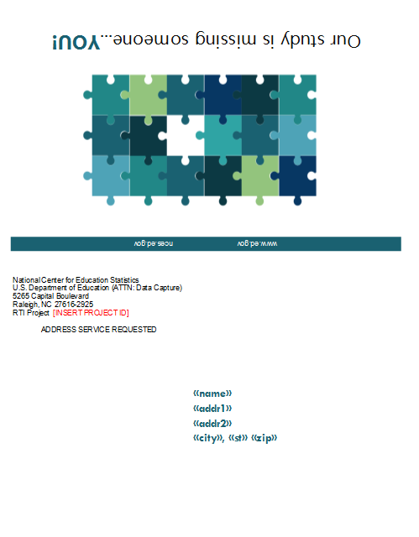

# Reminder Postcard 4

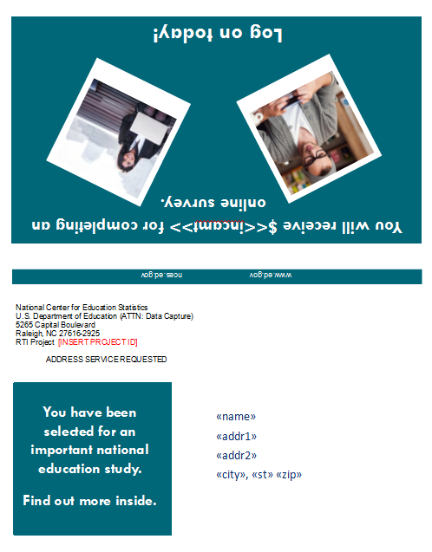

# Reminder Postcard 5

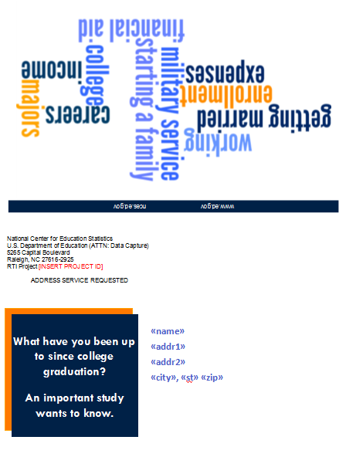

# Initial Contact/Screener Invitation Email

**SUBJECT:** The Baccalaureate and Beyond Study is coming soon

Dear <<fname>>,

You have been randomly selected to participate in the 2016/17 Baccalaureate and Beyond Longitudinal Study (B&B:16/17), conducted by the U.S. Department of Education's National Center for Education Statistics (NCES). <<IF NPSAS:16 FS respondent: You may recall participating in the National Postsecondary Student Aid Study (NPSAS) last year.>> B&B is an important study that follows up with recent bachelor's degree recipients to learn more about their education, employment, and other experiences after graduation. These data are being collected for NCES by RTI International, a U.S.-based nonprofit research organization.

Before B&B data collection begins in a few weeks, we need to update our contact information for you. **Please answer a few questions about your eligibility for the study, and update your contact information online:**

**<<Website URL>>**  
Your Study ID number: <<caseID>>

<<IF NPSAS study member & INCENTIVE ELIGIBLE: **To thank you for completing this update, which should take about 10 minutes, we will send you $10 via <<PayPal or>> check!>>**

<<IF NPSAS study member: In the next few weeks, we will contact you again with specific information about how to participate in the full B&B study.>> Your participation is critical to the success of B&B. If you have additional questions or concerns about the study, please call the study director, Jennifer Wine, at **877-225-8470**.

We thank you in advance for your participation in this important study. Your cooperation is greatly appreciated.

Thank you,

|  |
| --- |
| Jennifer Wine, Ph.D. B&B:16/17 Study Director RTI International |

OMB Control Number: 1850-0926  
*Learn more about our confidentiality procedures at* <<Website URL>>

# Initial Contact/Screener Reminder Email

**SUBJECT**: Update Your Information for an Important U.S. Department of Education Study

B&B data collection will begin soon, and we want to make sure we have the most current contact information for you, <<fname>>!

**Please answer a few questions about your eligibility for the study, and update your contact information online:**

[**<Website**](https://surveys.nces.ed.gov/bandb/update-contact.aspx) **URL>>**

Your Study ID number: <<caseID>>

Password: <<pswd>>

<<IF NPSAS study member: **To thank you for completing this update, which should take approximately 10 minutes or less, we will send you $10 via PayPal or check!>>**

<<IF NPSAS study member: We will contact you again with specific information about how to participate in the full B&B study. Look for an email from us in the coming weeks.>>

If you have additional questions or concerns about the study, please call the study director, Jennifer Wine, at **877-225-8470**.

We thank you in advance for your participation. Your cooperation is greatly appreciated.

Thank you,

|  |
| --- |
| Jennifer Wine, Ph.D. B&B:16/17 Study Director RTI International |

OMB Control Number: 1850-0926  
*Learn more about our confidentiality procedures at <<Website URL>>*

# Data Collection Announcement Email

**SUBJECT:** It’s time to complete your B&B survey!

Dear <<fname>>,

Recently, we contacted you about the 2016/17 Baccalaureate and Beyond Longitudinal Study (B&B:16/17), an important study that will collect education, employment, and other information from you and others like you who completed their bachelor's degree during the 2015-16 school year. Data collected from B&B will help researchers and policymakers better understand how earning a bachelor's degree impacts choices for additional education and employment paths.

Approximately 29,000 recent bachelor’s degree recipients from schools across the nation have been randomly selected to participate in B&B. Sample members like you are being asked to complete a <<time>>survey. Having your resume handy will help you complete the survey more easily. <<IF GROUP 2-3 & INCENTIVE-ELIGIBLE: **If you complete the survey by <<early_comp_date>> we will send you $<<incamt+early_bird>> payable by <<PayPal or>> check. After <<early_comp_date>>, we will send you $<<IncAmt>> once you complete the survey.**>> <<GROUPS 1, 4 & INCENTIVE ELIGIBLE: **Once you complete the survey, we will send you $«IncAmt», payable by <<PayPal or>> check.** >>

**Click here** to complete your survey on your computer, smartphone or tablet.

[<<Website URL>>](https://surveys.nces.ed.gov/bandb)   
Study ID = <<caseid>>  
Password = <<pswd>> *(password is case sensitive)*.

If you have questions about the study send an email to [bandb@rti.org](mailto:bbemail@rti.org), or, if you prefer to complete the survey over the phone, call the B&B help desk at 877-287-3782. You can also learn more by visiting the study website at [<<Website URL>>](https://surveys.nces.ed.gov/bandb/).

Thank you in advance for making B&B a success.

|  |  |  |
| --- | --- | --- |
| Jennifer Wine, Ph.D. B&B Project Director RTI International [jennifer@rti.org](mailto:njanson@rti.org) 877-225-8470 |  | Ted Socha B&B Project Officer National Center for Education Statistics (NCES) [Ted.Socha@ed.gov](mailto:Ted.Socha@ed.gov) 202-245-7071 |

OMB Control Number: 1850-0926   
*Learn more about our confidentiality procedures at <<Website URL>>.*

# Reminder Email 1

**SUBJECT:** The Baccalaureate and Beyond Study Needs Your Participation

<<fname>>, we still need you for B&B to be a success!

Recently, I sent you an invitation to take part in the 2016/17 Baccalaureate and Beyond Longitudinal Study (B&B:16/17). As a recent college graduate, your participation is critical to the success of the study, so I hope you will participate soon.

IF INCENTIVE ELIGIBLE: <<GROUPS 2-3: As a reminder, if you complete the survey by <<Early_comp_date>> you will receive $<<incamt+early_amt>> payable by <<PayPal or>> check. If you complete the survey after <<Early_date>> you will receive $<<incamt>>.>> <<GROUPS 1 & 4: When you complete the survey, we’ll send you $<incamt> via <<PayPal or>> check! >>

It’s easy to complete today! You can:

* **Click here** or go to <<Website URL>> and log in:

Study ID: <<caseID>>  
Password: <<pswd>>

* Or, complete the survey over the telephone at 877-287-3782.

If you don't have time to complete the entire survey right now, that is not a problem! You can start the survey now and finish it later — you'll pick up right where you left off.

If you have other questions, please contact the B&B Help Desk at 877-287-3782 or email us at [bandb@rti.org](mailto:bandb@rti.org). Thank you in advance for making B&B a success.

|  |
| --- |
| Jennifer Wine, Ph.D. B&B Project Director RTI International |

OMB Control Number: 1850-0926  
Learn more about our confidentiality procedures at *<<Website URL>>*

# Reminder Email 2

**SUBJECT:** B&B Data Collection Continues…

**... have you claimed your $<<incamt>>, <<fname>>?**

Data collection for the 2016/17 Baccalaureate and Beyond Longitudinal Study (B&B:16/17) continues! IF INCENTIVE ELIGIBLE: [**The survey — which can easily be completed on your computer or mobile device — takes approximately <<time>>, and when you complete your survey, you will receive $<<incamt>> as a token of our appreciation, payable by <<PayPal or>> check.]** IF NO INCENTIVE: [**The survey — which can easily be completed on your computer or mobile device — takes approximately <<time>>.]**

To access the online survey on our secure website, **click here** and log in using your secure login credentials:

Study ID: <<caseID>>

Password: <<pswd>>

Need help accessing the online survey? Prefer to complete the survey by telephone? Please call our Help Desk at 877-287-3782.

Thank you in advance for your participation in this very important study.

Sincerely,

|  |
| --- |
| Jennifer Wine, Ph.D. B&B Project Director RTI International |

OMB Control Number: 1850-0926   
*Learn more about our confidentiality procedures at <<Website URL>>.*

# Reminder Email 3

**SUBJECT:** Don’t Forget About Your B&B Survey

<<fname>>, your $<<incamt>> awaits!

We still need you to participate in the 2016/17 Baccalaureate and Beyond Longitudinal Study (B&B:16/17) for the U.S. Department of Education.

**Click here** to get started right away! You only need to enter your ID and password:

Study ID: <<caseID>>

Password: <<pswd>>

IF INCENTIVE ELIGIBLE: [As a token of our appreciation, you will receive $<<incamt>> for completing the survey.]

You can complete the survey by phone by calling 877-287-3782, and find more information on the study website at [<<Website URL>>](https://surveys.nces.ed.gov/bandb/).

Thanks!

|  |
| --- |
| Jennifer Wine, Ph.D. B&B Project Director RTI International [jennifer@rti.org](mailto:njanson@rti.org) 877-225-8470 |

OMB Control Number: 1850-0926   
*Learn more about our confidentiality procedures at* [*<<Website URL>>*](https://surveys.nces.ed.gov/bandb/).

# Reminder Email 4

**SUBJECT:** Don’t Delay – Participate in B&B Today

We've been contacting you and other recent college graduates about participating in B&B, <<fname>>!

IF INCENTIVE ELIGIBLE: [Because your participation is so important to us, **we will send you $<<incamt>> when you complete your survey** — just **click here** to get started.]

IF NO INCENTIVE OFFER: [Just **click here** to get started.]

You can also log in at our secure website:  
  
[<<Website URL>>](https://surveys.nces.ed.gov/bandb/)  
  
Study ID: <<caseID>>  
Password: <<pswd>>

B&B is an important study that will help policymakers understand the experiences of students who recently earned their bachelor's degree. We know that you have a lot of demands on your time, but we need your help to make sure we hear from all different types of recent college graduates.

Call 877-287-3782 to get more information about B&B or complete the survey by telephone.

Thank you for considering participating in this important study. B&B won't be the same without you!

|  |
| --- |
| Jennifer Wine, Ph.D. Project Director, B&B  RTI International [jennifer@rti.org](mailto:njanson@rti.org) |

OMB Control Number: 1850-0926   
*Learn more about our confidentiality procedures at* [*<<Website URL>>*](https://surveys.nces.ed.gov/bandb/).

# Reminder Email 5

**SUBJECT:** Take Part In Important Education Research When You Participate in B&B

|  |
| --- |
| https://edsurveys.rti.org/pubimages/bb17/bb17_email_hdr.png |

Hello, <<fname>>! When you complete your survey for the 2016/17 Baccalaureate and Beyond Longitudinal Study (B&B:16/17), sponsored by the National Center for Education Statistics (NCES) in the U.S. Department of Education IF INCENTIVE ELIGIBLE[, you will receive $<<incamt>> via <<PayPal or>> check.]

To get started right away, you'll need:

* about <<time>> minutes (but you don't have to finish it all at once),
* to **click here** or go to [<<Website URL>>](https://surveys.nces.ed.gov/bandb/%20) and enter your personal login information:  
    
  Study ID: <<caseID>>

Password: <<pswd>>

You can call the **B&B Help Desk at 877-287-3782** if you have any questions or problems completing your survey or would like to participate over the telephone.

Thanks in advance for sharing your experiences with us!

|  |
| --- |
| The B&B Team RTI International [bandb@rti.org](mailto:bandb@rti.org) 877-225-8470 |

OMB Control Number: 1850-0926   
*Learn more about our confidentiality procedures at* [*<<Website URL>>*](https://surveys.nces.ed.gov/bandb/).

# Reminder Email 6

**SUBJECT:** Participate in Important U.S. Department of Education Study and Receive $<<incamt>> for a <<time>>Survey

<<fname>>, the 2016/17 Baccalaureate and Beyond Longitudinal Study (B&B:16/17) is an important education study about the experiences of recent college graduates conducted on behalf of the U.S. Department of Education. We sincerely thank you for your participation in the National Postsecondary Student Aid Study (NPSAS) last year, and hope you will help us by completing the B&B survey.

You can find out more about what we've learned from previous B&B studies here:   
[<<Website URL>>prev_results.aspx](https://surveys.nces.ed.gov/bandb/prev_results.aspx)

The survey takes about <<time>>and is easy to complete on your mobile device. IF INCENTIVE ELIGIBLE: [And, when you complete the survey, you'll receive **$<<incamt>>, payable by <<PayPal or>> check!]** To get started right away, just **click here**!

YOUR SECURE LOGIN CREDENTIALS:  
  
[<<Website URL>>](https://surveys.nces.ed.gov/bandb/)  
  
Study ID: <<caseID>>

Password: <<pswd>>

You can also complete the survey by telephone by calling **877-287-3782**, and find more information on the study website at [<<Website URL>>](https://surveys.nces.ed.gov/bandb/).

Thanks!

|  |
| --- |
| Jennifer Wine, Ph.D. Project Director, B&B RTI International [jennifer@rti.org](mailto:njanson@rti.org) 877-225-8470 |

OMB Control Number: 1850-0926   
*Learn more about our confidentiality procedures at* [*<<Website URL>>*](https://surveys.nces.ed.gov/bandb/).

# Reminder Email 7 – Abbreviated Interview Announcement

**SUBJECT:** The B&B Survey Now Takes Only 10 Minutes

<<fname>>, the B&B survey now takes only about 10 minutes to complete IF INCENTIVE ELIGIBLE: [, and you'll receive $<<incamt>> for participating, payable by <<PayPal or>> check.]

Just **click here** to start the survey right away!  
  
Or, go to [<<Website URL>>](https://surveys.nces.ed.gov/bandb/) and log in:   
  
Study ID: <<caseID>>  
Password: <<pswd>>

If you prefer, you may also complete the survey over the telephone by calling the B&B Help Desk at 877-287-3782.

I hope that you will participate in the study, especially now that the survey takes only 10 minutes! Thank you in advance for making B&B a success.

|  |
| --- |
| Jennifer Wine, Ph.D. Project Director, B&B RTI International 877-225-8470 |

OMB Control Number: 1850-0926  
Learn more about our confidentiality procedures at [*<<Website URL>>*](https://surveys.nces.ed.gov/bandb/).

# Reminder Email 8

**SUBJECT:** B&B Needs You, <<fname>>

<<fname>>, B&B only takes <<time>> minutes and is easy to complete on your mobile device. IF INCENTIVE ELIGIBLE: [When you complete the survey, you'll receive $<<incamt>> payable by <<PayPal or>> check!]

To get started, just **click here** or visit the website and log in.

[<<Website URL>>](https://surveys.nces.ed.gov/bandb/)  
  
Study ID: <<caseID>>  
Password: <<pswd>>

You can also complete the survey by telephone by calling 877-287-3782, and find more information on the study website at [<<Website URL>>](https://surveys.nces.ed.gov/bandb/).

Thanks!

|  |
| --- |
| Jennifer Wine, Ph.D. Project Director, B&B RTI International [jennifer@rti.org](mailto:njanson@rti.org) 877-225-8470 |

OMB Control Number: 1850-0926  
Learn more about our confidentiality procedures at [*<<Website URL>>*](https://surveys.nces.ed.gov/bandb/).

# Reminder Email 9

**SUBJECT:** Participate in B&B, an Important Education Study

When you complete your B&B survey, which takes about <<time>> minutes, you'll contribute to important education research. IF INCENTIVE ELGIBLE: [And, you'll receive $<<incamt>>, payable by <<PayPal or>> check!] Just **click here** to get started right away.

YOUR SECURE LOGIN CREDENTIALS:  
[<<Website URL>>](https://surveys.nces.ed.gov/bandb/)  
  
Study ID: <<caseID>>

Password: <<pswd>>

If you have questions or prefer to participate by telephone, call 877-287-3782.

Thanks in advance for your participation.

|  |
| --- |
| Jennifer Wine, Ph.D. Project Director, B&B RTI International [jennifer@rti.org](mailto:njanson@rti.org) 877-225-8470 |

OMB Control Number: 1850-0926  
Learn more about our confidentiality procedures at [*<<Website URL>>*](https://surveys.nces.ed.gov/bandb/).

# Reminder Email 10

**SUBJECT:** Share Your Experiences with B&B for $<<incamt>>

<<fname>>, The B&B survey takes about <<time>> minutes IF INCENTIVE ELIGIBLE[, and when you complete it, you'll receive $<<incamt>>, payable by <<PayPal or>> check]!

This is your chance to contribute to important education research about recent college graduates. B&B:16/17 is conducted by the National Center for Education Statistics (NCES), in the U.S. Department of Education's Institute for Education Sciences, with data collection being carried out under contract by RTI International, a U.S.-based nonprofit research organization.

Just **click here** to get started right away, or log in at [<<Website URL>>](https://surveys.nces.ed.gov/bandb/):   
  
Study ID: <<caseID>>  
Password: <<pswd>>

If you have questions or prefer to participate by telephone, call 877-287-3782.

Thanks in advance for your participation.

|  |
| --- |
| Jennifer Wine, Ph.D. Project Director, B&B RTI International [jennifer@rti.org](mailto:njanson@rti.org) 877-225-8470 |

OMB Control Number: 1850-0926  
Learn more about our confidentiality procedures at [*<<Website URL>>*](https://surveys.nces.ed.gov/bandb/).

# Reminder Email 11

**SUBJECT:** Please complete our B&B survey

The survey takes about <<time>> minutes IF INCENTIVE ELIGIBLE [and you'll receive $<<incamt>>, payable by <<PayPal or>> check when you complete]!

To get started right away just **click here**, or log in at [<<Website URL>>](https://surveys.nces.ed.gov/bandb/)   
  
Study ID: <<caseID>>  
Password: <<pswd>>

If you prefer to participate by telephone, have questions, or would like more information, just call 877-287-3782.

Thanks in advance for your participation.

|  |
| --- |
| Jennifer Wine, Ph.D. Project Director, B&B RTI International [jennifer@rti.org](mailto:njanson@rti.org) 877-225-8470 |

OMB Control Number: 1850-0926  
Learn more about our confidentiality procedures at [*<<Website URL>>*](https://surveys.nces.ed.gov/bandb/).

# Reminder Email 12

**SUBJECT:** B&B Surveys are Still Underway

<<fname>>, when you participate in B&B, which takes about <<time>> minutes, IF INCENTIVE ELIGIBLE [you'll receive $<<incamt>> as a thank you, payable by <<PayPal or>> check, *and*] you’ll contribute to important research sponsored by the U.S. Department of Education.

To get started right away, **click here**, or go to [<<Website URL>>](https://surveys.nces.ed.gov/bandb/) and log in:   
  
Study ID: <<caseID>>  
Password: <<pswd>>

If you prefer, you may also complete the survey over the telephone by calling the B&B Help Desk at 877-287-3782.

Thank you!

|  |
| --- |
| Jennifer Wine, Ph.D. Project Director, B&B RTI International |

OMB Control Number: 1850-0926  
Learn more about our confidentiality procedures at [*<<Website URL>>*](https://surveys.nces.ed.gov/bandb/).

# Reminder Email 13

**SUBJECT:** We Need Your Help with B&B

GROUPS 1-2: <<fname>>, just **click here**, or go to [<<Website URL>>](https://surveys.nces.ed.gov/bandb/) and log in:   
GROUPS 3-4: <<fname>>, the B&B interview now takes just 10 minutes! To start your survey, **click here**, or go to [<<Website URL>>](https://surveys.nces.ed.gov/bandb/) and log in:

Study ID: <<caseID>>  
Password: <<pswd>>

GROUPS 1-2, INCENTIVE ELIGIBLE: The B&B survey takes about <<time>> minutes to finish, and you'll receive $<<incamt>> via PayPal or check! You are one of a few selected people and the study won't be a success without you, <<fname>>!

GROUPS 3-4, INCENTIVE ELIGIBLE: When you finish, you'll receive $<<incamt>> via PayPal or check! You are one of a few selected people and the study won't be a success without you, <<fname>>!

GROUPS 1-2, NO INCENTIVE: The B&B survey takes about <<time>> minutes to finish. You are one of a few selected people and the study won't be a success without you, <<fname>>!

GROUPS 3-4, NO INCENTIVE: You are one of a few selected people and the study won't be a success without you, <<fname>>!

If you have questions or would prefer to complete over the telephone, call the B&B Help Desk at 877-287-3782.

Thank you!

|  |
| --- |
| Jennifer Wine, Ph.D. Project Director, B&B RTI International |

OMB Control Number: 1850-0926  
Learn more about our confidentiality procedures at [*<<Website URL>>*](https://surveys.nces.ed.gov/bandb/).

# Reminder Email 14

**SUBJECT:** B&B is Ending Soon – Don’t Miss Your Chance to Participate

<<fname>>, data collection for the U.S. Department of Education's 2016/17 Baccalaureate and Beyond Longitudinal Study (B&B:16/17) will end soon, and we need your help to make the study a success!

Go to [<<Website URL>>](https://surveys.nces.ed.gov/bandb/) and log in or **click here** to get started right away:  
  
Study ID: <<caseID>>  
Password: <<pswd>>

It only takes about <<time>> minutes to complete the B&B survey. IF INCENTIVE ELIGIBLE: [You'll receive $<<incamt>> via <<PayPal or>> check!]

Our professional interviewers can answer any questions you have, and can complete the interview over the telephone with you, if you prefer. Just call the B&B Help Desk at 877-287-3782.

Thank you!

|  |
| --- |
| Jennifer Wine, Ph.D. Project Director, B&B RTI International |

OMB Control Number: 1850-0926  
Learn more about our confidentiality procedures at [*<<Website URL>>*](https://surveys.nces.ed.gov/bandb/).

# Reminder Email 15

**SUBJECT**: B&B Is Coming to a Close!

Only one more week to participate, <<fname>>!

The B&B study ends on <<end_date>>, so we hope that all questionnaires will be completed by then. IF INCENTIVE ELIGIBLE: [If you finish the survey by then, you'll receive $<<incamt>> via <<PayPal or>> check!]

**Click here** to go right to the survey!

If you have any questions, please contact the B&B help desk at 877-287-3782.

Thank you for your participation!

Best,

|  |
| --- |
| Jennifer Wine, Ph.D. Project Director, B&B RTI International |

[<<Website URL>>](https://surveys.nces.ed.gov/bandb/)  
Study ID: <<caseID>>  
Password: <<pswd>>

OMB Control Number: 1850-0926  
Learn more about our confidentiality procedures at [*<<Website URL>>*](https://surveys.nces.ed.gov/bandb/).

**Reminder Email 16**

**SUBJECT**: B&B ends March 9 - Just 5 days left!

<<fname>>, we don't want you to miss out on your opportunity to contribute to this important study and make your voice heard. B&B ends on <<end_date>>, so there are only **5 days left** for you to participate in this <<time>>-minute survey.

IF INCENTIVE ELIGIBLE: [When you complete the survey, you will receive $<<incamt>> via <<PayPal or>> check.]

Ready to get started? **Click here** or use the following information:  
  
[<<Website URL>>](https://surveys.nces.ed.gov/bandb/)  
Study ID: <<caseID>>  
Password: <<pswd>>

Please call the **B&B Help Desk** at 877-287-3782 or visit the study website at [<<Website URL>>](https://surveys.nces.ed.gov/bandb/) if you have any questions or problems completing your survey or would like to participate by telephone.

Thank you!

|  |
| --- |
| Jennifer Wine, Ph.D. Project Director, B&B RTI International |

OMB Control Number: 1850-0926  
Learn more about our confidentiality procedures at [*<<Website URL>>*](https://surveys.nces.ed.gov/bandb/).

**Reminder email 17**

**SUBJECT**: Just Two More Days to Participate in B&B!

<<fname>>, B&B ends Friday! Complete your **<<time>>-minute** survey today IF INCENTIVE ELIGIBLE [, and receive **$<<incamt>>** as a token of our appreciation!]

**Click here** to start the survey right away!   
  
Your manual login credentials are:  
[<<Website URL>>](https://surveys.nces.ed.gov/bandb/)  
Study ID: <<caseID>>  
Password: <<pswd>>

Thanks in advance for participating! Have a great day.

|  |
| --- |
| Jennifer Wine, Ph.D. Project Director, B&B RTI International |
|  |

OMB Control Number: 1850-0926  
Learn more about our confidentiality procedures at [*<<Website URL>>*](https://surveys.nces.ed.gov/bandb/).

# Reminder email 18

# SUBJECT: B&B Ends Tomorrow – Help Us Learn About Your Experiences Since Graduation!

The U.S. Department of Education's 2016/17 Baccalaureate and Beyond Longitudinal Study (B&B:16/17) ends tomorrow, <<fname>>!

IF INCENTIVE ELIGIBLE: [When you complete your **<<time>>-minute** survey you'll receive **$<<incamt>>** as a token of our appreciation.]

Your secure login credentials are:  
[<<Website URL>>](https://surveys.nces.ed.gov/bandb/)  
Study ID: <<caseID>>  
Password: <<pswd>>

Or, just **click here** to start the survey right away!

If you have questions, or if you would prefer to complete the survey over the telephone, call 877-287-3782.

Thanks in advance for participating! Have a great day.

|  |
| --- |
| Jennifer Wine, Ph.D. Project Director, B&B RTI International |

OMB Control Number: 1850-0926  
Learn more about our confidentiality procedures at [*<<Website URL>>*](https://surveys.nces.ed.gov/bandb/).

# Reminder email 19

# SUBJECT: Your Last Chance to Participate… Don’t Miss Out on B&B!

<<fname>>, this is the last email message we will be sending you about this survey. We want you to know how very important your participation is to the success of the 2016/17 Baccalaureate and Beyond Longitudinal Study (B&B:16/17), which is why we've been so persistent in reminding you to complete your survey!

Before the study comes to a close, please consider logging in to participate - just **click here** to take the survey now!

IF INCENTIVE ELIGIBLE: [It takes **about <<time>> minutes**, can be completed **on a smartphone or tablet**, and **you'll receive $<<incamt>>** via <<PayPal or>> check when you finish!]

IF NO INCENTIVE: [It takes **about <<time>> minutes**, and can be completed **on a smartphone or tablet.]**

You can learn more about results from previous round of B&B at   
[<<Website URL>>prev_results.aspx](https://surveys.nces.ed.gov/bandb/prev_results.aspx)  
  
If you have questions, or if you would prefer to complete the survey over the telephone, call 877-287-3782.

Thanks in advance for participating! Have a great day.

|  |
| --- |
| Jennifer Wine, Ph.D. Project Director, B&B RTI International |

Your manual login credentials are:  
[<<Website URL>>](https://surveys.nces.ed.gov/bandb/)  
Study ID: <<caseID>>  
Password: <<pswd>>

OMB Control Number: 1850-0926  
Learn more about our confidentiality procedures at [*<<Website URL>>*](https://surveys.nces.ed.gov/bandb/).

# Reminder email from NCES 1

**SUBJECT**: Message from the U.S. Department of Education

Dear <<fname>>,

My name is Ted Socha. As the Project Officer for the 2016/17 Baccalaureate and Beyond Longitudinal Study (B&B:16/17), from the National Center for Education Statistics (NCES), I hope that you will take time out of your busy schedule to complete the B&B survey today. It is an important study of college graduates and their lives after college. The U.S. Department of Education, Congress, and the White House use data from this study to inform policy decisions regarding student loans and other critical issues.

On average, the survey takes only about <<time>> minutes IF INCENTIVE ELIGIBLE: [and you **will receive $<<incamt>> as a token of appreciation** for completing it.]

To complete the B&B survey online, go to our secure website:

[<<Website URL>>](https://na01.safelinks.protection.outlook.com/?url=https%3a%2f%2fsurveys.nces.ed.gov%2fbandb%2f&data=01%7c01%7cTJH52%40PITT.EDU%7cbbe70b95ca2b4e3e2a3608d3c6d7c7a2%7c9ef9f489e0a04eeb87cc3a526112fd0d%7c1&sdata=WXWkGo0XCeLiv53Szlwk5ulA9f22aMED6sY2z8RFJV8%3d)

Study ID number = <<caseID>>

Password = <<pswd>>

If you have questions or prefer to complete the survey over the telephone with one of our professional telephone interviewers, you can call us at 877-287-3782.

Thank you for helping to make B&B a success. For further information and findings from previous B&B studies, go to <<Website URL>>.

Ted Socha

B&B Project Officer

National Center for Education Statistics (NCES)

U.S. Department of Education

[Ted.Socha@ed.gov](mailto:Ted.Socha@ed.gov)

OMB Control Number: 1850-0926   
*Learn more about our confidentiality procedures at* [*<<Website URL>>*](https://na01.safelinks.protection.outlook.com/?url=https%3a%2f%2fsurveys.nces.ed.gov%2fbandb%2f&data=01%7c01%7cTJH52%40PITT.EDU%7cbbe70b95ca2b4e3e2a3608d3c6d7c7a2%7c9ef9f489e0a04eeb87cc3a526112fd0d%7c1&sdata=WXWkGo0XCeLiv53Szlwk5ulA9f22aMED6sY2z8RFJV8%3d)

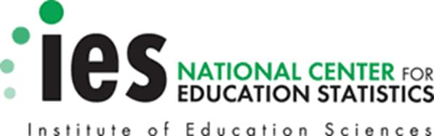

# Reminder email from NCES 2

**SUBJECT**: U.S. Department of Education Message About Baccalaureate and Beyond

Dear <<fname>>--

My name is Ted Socha. You may recall receiving an email from me a couple weeks ago. As the Project Officer for the 2016/17 Baccalaureate and Beyond Longitudinal Study (B&B:16/17), from the [National Center for Education Statistics (NCES)](https://nces.ed.gov/), I hope that you will take time out of your busy schedule to complete the B&B survey today. It is an important study of college graduates and their lives after college. The U.S. Department of Education, Congress, and the White House use data from this study to inform policy decisions regarding student loans and other critical issues.

On average, the survey takes only about <<time>> minutes IF INCENTIVE ELIGIBLE:[ and you **will receive $<<incamt>> as a token of appreciation** for completing it.]

 To complete the B&B survey online, go to our secure website:

[<<Website URL>>](https://surveys.nces.ed.gov/bandb/)

Study ID number = <<caseID>>

Password  = <<pswd>>

If you have questions or prefer to complete the survey over the telephone with one of our professional telephone interviewers, you can call us at [877-287-3782](tel:877-287-3782).

Thank you for helping to make B&B a success. For further information and findings from previous B&B studies, go to <<Website URL>>.

Ted Socha

B&B Project Officer

National Center for Education Statistics (NCES)

U.S. Department of Education

[Ted.Socha@ed.gov](mailto:Ted.Socha@ed.gov)

OMB Control Number: 1850-0926   
*Learn more about our confidentiality procedures at* [*<<Website URL>>*](https://surveys.nces.ed.gov/bandb/)

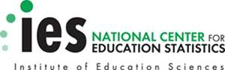

**Text Message Reminders**

**TEXT MESSAGE REMINDER 1**

Hi «fname»! Your B&B survey from the U.S. Department of Education is now online. [You will receive $«IncAmt+Early_AMT» to complete the survey today!]Click here to take the survey: [LINK]

**TEXT MESSAGE REMINDER 2**

«fname», this is a reminder to complete your B&B survey. Follow this link to take the survey [and get $«IncAmt» as a token of appreciation]: [LINK]

**TEXT MESSAGE REMINDER 3**

Your B&B survey is still available, «fname»! [If you participate we will say thank you with $«IncAmt».] Click this link to take the survey: [LINK]

**TEXT MESSAGE REMINDER 4**

Hi «fname»! Your B&B survey now takes only 10 minutes[ and you will get $«IncAmt» as a thank you]! Take the survey by clicking here: [LINK]

**TEXT MESSAGE REMINDER 5**

Last chance, «fname»! Your B&B survey [and the $«IncAmt» thank you] is only available through March 9. Follow this link to take the survey: [LINK]

**TEXT MESSAGE, REMINDER 6**

«fname», tomorrow is the last day to participate in B&B! [We will thank you with $«IncAmt»!] Take the survey by clicking here: [LINK]

# Thank You Letter – sent with check

<<date>>

<<name>>

<<addr1>>

<<addr2>>

<<city>>, <<st>> <<zip>>

Dear «fname» «lname»:

On behalf of the National Center for Education Statistics (NCES) in the U.S. Department of Education’s Institute of Education Sciences and the staff of the 2016/17 Baccalaureate and Beyond Longitudinal Study (B&B:16/17), we would like to thank you. Your participation in B&B is very important in helping to ensure the success of the study.

Enclosed you will find a check for $«IncAmt» as a token of our appreciation.

If you have any questions, please do not hesitate to contact us at 877-225-8470.

Sincerely,

Jennifer Wine, Ph.D. Ted Socha

B&B Project Director NCES Project Officer

RTI International National Center for Education Statistics (NCES)

# Thank You Email – Check Incentive

**SUBJECT:** Thank you for your participation in B&B

Dear <<fname>>,

On behalf of the National Center for Education Statistics (NCES) in the U.S. Department of Education's Institute of Education Sciences and the staff of the 2016/17 Baccalaureate and Beyond Longitudinal Study (B&B:16/17), we would like to thank you for your participation in the B&B survey. Your participation in this study is very important to its success! Our records indicate that you selected a check. Your check is being processed and should arrive in a few weeks. Please contact us with any concerns.

If you have additional questions, please do not hesitate to contact B&B project staff at 877-225-8470.

Again, thank you for your time and willingness to participate.

B&B Data Collection Team

|  |
| --- |
| Study ID: <<caseID>> |

OMB Control Number: 1850-0926  
*Learn more about our confidentiality procedures at* [*<<Website URL>>*](https://surveys.nces.ed.gov/bandb/)

# Thank You Email – PayPal Incentive

Dear <<fname>>,

On behalf of the National Center for Education Statistics (NCES) in the U.S. Department of Education's Institute of Education Sciences and the staff of the 2016/17 Baccalaureate and Beyond Longitudinal Study (B&B:16/17), we would like to thank you for your participation in the B&B survey. Your participation in this study is very important to its success!

Our records indicate that you chose to receive your token of appreciation via PayPal. Please note it can take up to a full business day to process. Please look for an email from PayPal indicating that you have received funds from RTI International. (You may need to check your SPAM folder as well!) Please contact us with any concerns.

If you have additional questions, please do not hesitate to contact B&B project staff at 877-225-8470.

Again, thank you for your time and willingness to participate.

B&B Data Collection Team

|  |
| --- |
| Study ID: <<caseID>> |

OMB Control Number: 1850-0926  
*Learn more about our confidentiality procedures at* [*<<Website URL>>*](https://surveys.nces.ed.gov/bandb/)

# B&B:16/17 Information Page Text

READ VERBATIM:

Recently, we sent you material about the U.S. Department of Education’s 2016/17 Baccalaureate and Beyond Longitudinal Study (B&B:16/17). (This survey is being conducted to better understand the education and employment experiences of recent college graduates.) IF INCENTIVE ELIGIBLE: [As a token of our appreciation, you will receive $ <<INC_AMOUNT>> once you complete the survey.]

The survey takes about <<time>> minutes and may be monitored or recorded for quality assurance purposes. Your participation is voluntary and you may skip any question or stop the survey at any time. If you would like to learn more about your rights as a participant, let me know. [PAUSE] May we begin the survey now?

(At your request, we can re-mail the material to you. For questions about your rights as a study participant, please contact RTI's Office of Research Protection at 1-866-214-2043.)

**If sample member indicates they would like to learn more about their rights as a participant:**

READ UNTIL SAMPLE MEMBER INTERRUPTS:

In addition to your survey responses, we are authorized by law to collect other information, such as financial aid data, student records, and related information from colleges you have attended and sources such as student loan databases and admissions testing agencies. Your responses, combined with other data sources, may be used only for statistical purposes and may not be disclosed, or used, in identifiable form for any other purpose except as required by law. (20 U.S.C. §9573 and 6 U.S.C. §151)

(You are one of approximately 29,000 recent college graduates selected for this study.)

Your participation is voluntary and will not affect any financial aid or other benefits that you may receive. You may decline to answer any question or stop the survey at any time. The risk of participating in this study is small and relates to data security. However, there are strict security procedures in place. If you would like us to re-mail the material to you, please let me know. May we begin the survey now?

(For questions about your rights as a study participant, please contact RTI's Office of Research Protection at 1-866-214-2043.)

# B&B:16/20 FT Panel Maintenance Postcard

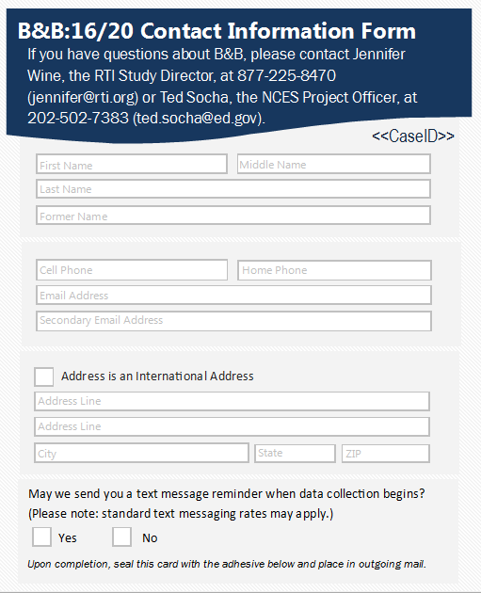

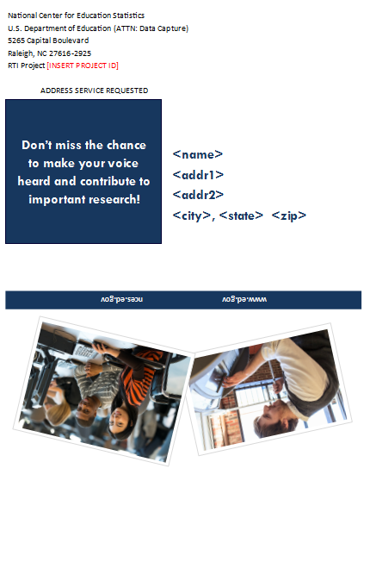   
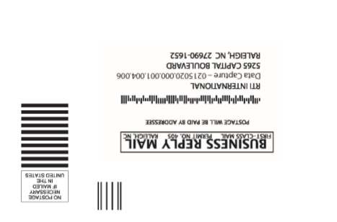

# B&B:16/20 Panel Maintenance Email

**SUBJECT:** Update Your Contact Information for B&B

Dear «fname» «lname»:

The second round of data collection for the 2016/20 Baccalaureate and Beyond Longitudinal Study (B&B:16/20) will be starting in Summer of 2019! The National Center for Education Statistics (NCES) in the U.S. Department of Education’s Institute of Education Science has contracted with RTI International to collect data for B&B on its behalf. Help us inform educators, researchers, and policymakers about how a **bachelor’s degree «in [major]»** impacts choices for continuing education and employment paths.

Please take about 5 minutes to update your contact information so we can contact you when data collection begins.

You can update your information on our secure website: [<<Website URL>>](https://surveys.nces.ed.gov/bandb/) - just use your unique study ID and password to log on.

**Study ID** = «caseid»

**Password** = «password»

If you have any questions, encounter any difficulty on the website, or would prefer to update this information over the telephone, please call us at **877-225-8470**.

Thank you in advance for helping making B&B a success!

OMB Control Number: 1850-0926

*Learn more about our confidentiality procedures at* [<<Website URL>>confidentiality.aspx](https://surveys.nces.ed.gov/bandb/confidentiality.aspx%20%20)