

Evaluation of Alternative Sources of Motor Gasoline Prices and Volumes


October 31, 2017
Independent Statistics & Analysis
www.eia.gov
U.S. Department of Energy
Washington, DC 20585

This report was prepared by the U.S. Energy Information Administration (EIA), the statistical and analytical agency within the U.S. Department of Energy. By law, EIA’s data, analyses, and forecasts are independent of approval by any other officer or employee of the United States Government. The views in this report therefore should not be construed as representing those of the U.S. Department of Energy or other federal agencies.

Table of Contents
Executive Summary 4
Introduction 6
Data 7
Description of station-level gasoline price data 7
EIA-878 7
Oil Price Information Service 7
GasBuddy.com 8
Results from comparison of data sources on key dimensions 9
Data linkage methods 13
Findings 15
Evaluation of internal consistency of the OPIS data feed 15
Key findings from comparing OPIS daily data feeds 15
Key findings from matched comparisons of prices between timed daily feeds 15
Key findings from investigating instances of largest price differences by pairwise comparison 21
Comparison of survey and alternative price data at the station level 22
Key findings from comparison of EIA-878 and OPIS price data over 12 weeks 22
EIA-878 and OPIS price estimates for publication cells over 12 weeks 25
Point-in-Time comparison of EIA-878 price data with OPIS and GasBuddy price data 28
Comparing EIA and AAA city definitions 30
New York City 31
Chicago 31
Predicting Midgrade and Premium Motor Gasoline Prices at the Aggregate Level 33
Background and rationale 33
Predicting midgrade and premium prices with EIA-878 data 33
Predicting midgrade and premium prices with AAA data 36
Predicting AAA midgrade and premium prices with EIA-878 regular prices 36
Predicting Midgrade and Premium Motor Gasoline Prices at the Station Level 37
Background and rationale for leveraging external data to identify potential useful gasoline price predictors using a regression tree. 37
Methods and key findings. 37
Discussion and Recommendations 42
Data quality of third-party sources and incorporation into EIA-878 42
Assessment of data quality in commercial data 42
Comparability of estimates 42
Modeling midgrade and premium prices from regular prices 42
Recommendations 43
Future Areas for Research 44
Appendix 46

Executive Summary
The objective of this project was to evaluate alternative sources for weekly motor gasoline prices produced from the EIA-878, “Motor Gasoline Price Survey.” The project was motivated by:
- EIA’s business need to be able to obtain motor gasoline prices in a cost and time efficient manner.
- Availability of a number of private data sources that provide up to a 30 minute frequency of publication for motor gasoline prices.
- OMB’s Paperwork Reduction Act that requires agencies to investigate other sources of comparable data in order to reduce respondent burden.
This research is a continuation of Evaluation of Alternative Sources for Motor Gasoline Prices and Volumes, completed in June 2017. In the first report, the study team concluded that the EIA-878 price data are consistent with both GasBuddy and OPIS at higher levels of aggregation (e.g., national and PADD estimates). The current report compares EIA-878 station level prices to GasBuddy and OPIS station level prices and conducts additional analyses on obtaining model-based price estimates.
Third-Party Data Quality: The project team evaluated OPIS and GasBuddy data in terms of geographic and product coverage, data collection methodology, data editing and processing, cash vs credit pricing and the treatment of price discounts, product definitions, timeliness, internal consistency, and missing data elements. Key findings include:
- Coverage: SDSI matched 98% of current EIA-878 stations to the OPIS database and 99% to the GasBuddy website.
- Internal consistency: SDSI analyzed multiple daily feeds of OPIS data to assess internal consistency and found that the most similar data sets came from the 4 p.m. and 8 p.m. data feeds. In general, less than 1% of the gas stations from different feeds were mismatched on either name, address, zip code, or city. Mismatches in prices did occur and are described in detail in the sections below.
- Missing data: While the vast majority of EIA-878 stations were identified in OPIS and GasBuddy databases, OPIS had less missing product pricing data,(6%) compared to GasBuddy (22%) for regular grade gasoline.
Comparability of Estimates: The project team compared station-level weekly motor gasoline prices from EIA, OPIS, and GasBuddy at the national, PADD, and selected state and city levels for regular, midgrade, and premium. Conclusions of these comparisons over the 12 week study period include:
- Pairwise comparisons show that EIA and OPIS regular gasoline prices were within 5¢ for almost half of the EIA-878 sample (45%). Regular gasoline prices matched exactly for 22% of stations over the 12 week study period.
- National estimates calculated from OPIS data were within 1¢ of estimates calculated from EIA-878 data for regular, midgrade, and premium for comparable stations. Results at the PADD level were within 3¢ for regular and 4¢ for midgrade and premium, with OPIS prices generally higher than EIA’s.
- Very large price differences (15 cents or more) between EIA-878 and OPIS were identified during the 12 week study period, but were limited to approximately 10% of stations.
The project team also compared the weekly station-level motor gasoline prices from EIA and OPIS to AAA aggregated prices to further research discrepancies identified in the first report.
- New York City: Differences between EIA and AAA prices are largely due to the city definition issues. EIA’s definition of New York City encompasses the much larger metropolitan area compared to AAA’s definition of New York City as just the 5 city boroughs.
- Chicago: Discrepancies in gasoline prices between EIA and AAA-Chicago Metro are largely due to the station level reporting issues.
Predicting Midgrade and Premium Prices: SDSI used both aggregate and station level regular gasoline prices, along with a number of key variables from external data sources, to predict midgrade and premium prices. Key findings include:
- Using aggregate data from 2013 to 2017, EIA-878 data-based models had lower error measures than AAA data-based models. Even though using a mixture of EIA regular prices and AAA midgrade and premium prices is one possibility in the future, the accuracy of the estimates for some publication cells might not reach the desired level.
- SDSI successfully identified a number of external variables that have utility in predicting prices of midgrade and premium grade motor gasoline by using regression tree models and station-level data. Findings from this initial research effort are very encouraging and indicate that it may be worthwhile to continue developing these models to investigate further the potential for using external data along with the EIA-878 survey data to improve the accuracy of future published estimates.
Key Recommendations
This research suggests a number of promising applications of using third-party price data at the station level from OPIS and GasBuddy to enhance the EIA-878. A conservative approach may include incorporating third-party data into the current EIA-878 validation process, utilizing outside data sources to identify potential reporting errors in real time. Other techniques, such as utilization of third-party data for imputation or replacement of survey data collection with third-party sources for selected respondents, require a heavier reliance on third-party data vendors. Further methodological research is needed to determine if the findings identified over the 12 week study period hold over seasonal changes and market disruptions in either the upstream petroleum supply conditions or downstream markets. SDSI recommends an extension of the OPIS price subscription as well as continued data extraction from GasBuddy to conduct this analysis.

Introduction
As a part of ongoing modernization efforts and the implementation of the Statistical Methodology Improvement Plan, the Office of Survey Development and Statistical Integration (SDSI) is conducting research on utilizing third-party sources to supplement publicly available data. EIA is uniquely situated since a number of its surveys collect information that is also compiled and sold by commercial vendors. These commercial vendors can provide almost real-time frequency of data that when linked with surveys, have the potential to reduce respondent burden and enhance data products. However, much is unknown about the vendor’s sector visibility into the data elements of interest, data definitions, processing, and overall data quality. In an effort to increase understanding of the impact of integrating survey and commercial records for a weekly business survey, this study undertakes an in-depth examination of the quality of data from commercial vendors and attempts to integrate it with current EIA survey data.
The EIA-878 “Motor Gasoline Price Survey” is a mandatory survey on retail gasoline stations, integral to the publication of weekly gasoline price estimates. Data collection, processing, and dissemination are completed within the same day. In summer 2017, EIA obtained two commercial sources of gasoline price data for research purposes. EIA purchased gasoline price data from a commercial vendor for about 110,000 gas stations. SDSI staff also created a web data extraction tool to obtain gas prices via a crowdsourced website.
SDSI staff analyzed the quality of data from these sources and, in a parallel effort, also researched the utility of other external data for the existence of possible relationships to gasoline grade prices. Together these efforts were directed to predicting midgrade and premium gasoline prices, which expanded EIA’s previous efforts to predict these values based on EIA-878 regular prices (using both aggregate and station-level data).
Organization of the Report:
The report begins with a detailed description of the data sources and relevant data. This is followed by a comparison of various data sources, which were investigated in an attempt to identify relevant potential predictors of gasoline prices. Descriptions of detailed findings follow, including a description of the specific methodologies used prior to summaries of the results. The report concludes with key recommendations and potential future research objectives.

Data

Description of station-level gasoline price data

EIA-878
The Motor Gasoline Price Survey (EIA-878) is a weekly mandatory survey of approximately 800 retail gasoline stations across the country. The data collected are used to create point-in-time estimates of gasoline prices at the national, regional, and selected state and city levels by grade and formulation, resulting in 276 published price estimates.
Data collection, processing, and dissemination are completed within the same day. EIA defines “gasoline price” as the station’s cash price (including taxes) as of 8:00 a.m. local time each Monday. This price represents the self-serve price except in areas having only full-serve. The majority of respondents comply with the mandatory survey via telephone reporting (CATI, Computer-assisted telephone interviewing); however, other submission methods are also available. Prices are published by 5:00 p.m. EST on Monday, except in the case of government holidays.

Oil Price Information Service
The Oil Price Information Service (OPIS), an IHS Markit company, is a commercial source for petroleum pricing and news information. The company collects daily gasoline and diesel prices for nearly 140,000 retail outlets in the U.S. and Canada. According to company materials, OPIS prices are used by AAA, Microsoft (MSN Autos), Garmin, and MapQuest. In March 2013, OPIS acquired GasBuddy.com, a crowdsourcing website which publishes retail motor gasoline and diesel prices.
From May 15, 2017 to July 31, 2017, EIA purchased weekly feeds of gasoline price data from OPIS for $24,000. Each feed included the following pertinent information:
- station name
- physical location
- unique OPIS identification number
For each gasoline grade (regular, midgrade, and premium):
- price per gallon
- date and time associated with the price
- source of the information
OPIS provided a single value for the price without making a distinction between cash or credit prices. OPIS collected the data through either electronic submission directly from credit card transactions or from user submissions. On average, each file consisted of about 110,000 records; however, the exact number varied from feed to feed and from week to week (see Table A.1). The weekly feed was transferred as a text file to EIA via a secure FTP site. Staff in the Office of Petroleum and Biofuels Statistics (PBS) were responsible for downloading the file and saving it to the EIA network.
For the first four weeks, EIA obtained a single data feed from OPIS as of approximately 12:00 p.m. on Monday. EIA selected this time for consistency with EIA’s price definition. For the remaining weeks, OPIS transferred four feeds with data, at no additional cost, at 8:00 a.m., 12:00 p.m., 4:00 p.m., and 8:00 p.m. The multiple feeds were used by SDSI staff to compare the internal consistency of the data and gain insights into OPIS’ data quality. The analysis will impact the determination around which feed should be used bearing in mind the importance of maintaining consistency with EIA’s definition (prices as of 8 a.m. local time) and EIA’s ability to utilize the data in a timely manner to maintain the time frame of regular estimate publications.
During the 12 week period of the available noon data feed, 83,910 stations, from approximately 110,000 records (76%), appeared consistently each week. Each of these stations reported at least one price value for regular, midgrade, or premium gasoline. The remainder of the stations appeared inconsistently from week to week (Table A.1).

GasBuddy.com
GasBuddy.com is a crowdsourced website that allows users to submit real-time regular, midgrade, premium, and diesel prices. Based on SDSI analysis, the site collects prices for about 144,000 outlets in the U.S. Users can submit both cash and credit prices to GasBuddy and the information is displayed on the website, tagged by the user’s ID. Some stations also submit price information directly to GasBuddy; these prices are denoted as “GB_Direct.” GasBuddy provides users with definitions for regular, midgrade, and premium, as well as how to capture information on price discounts. In addition to submitting prices, users can also add gas stations to the GasBuddy master list. Users earn points for completing certain activities, such as posting or updating a gas price or participating in a user forum. Points can be redeemed in price raffles.
SDSI collaborated with Mike Scott (EIA/OEA) to develop a tool to systematically collect price information for stations included in the EIA-878 sample. This tool was initially developed to collect information on the number of gas stations for frame development purposes; SDSI worked with OEA to add an additional feature to also capture prices. The tool streamlined the data collection process, since GasBuddy makes data for each station available from an associated unique webpage (Figure 1). The data set obtained from the tool contained information on the station name and physical location. For each gasoline grade (regular, midgrade, and premium), SDSI collected the following information:
- price per gallon (cash and credit)
- date and time submitted
- source of the information (user submitted or direct data transmission from the outlet).
Gas prices submitted to the website within the last 24 hours include additional information on the exact time of the submission. In contrast, prices reported outside of 24 hours are categorized merely as “1 day old” without additional information about exact time of submission.
SDSI staff obtained data for 798 EIA-878 sample stations, which is 99% of the sample (the matching procedure used to identify EIA-878 sample stations on the GasBuddy website is described in detail in the next section). The data extraction process occurred only once, on Monday, July 31, which overlapped OPIS data availability, because it required substantial additional time commitments from SDSI staff. SDSI did not attempt to obtain gas prices for all stations on GasBuddy.com.
Figure 1. Screenshot of GasBuddy.com website for an individual gas station.
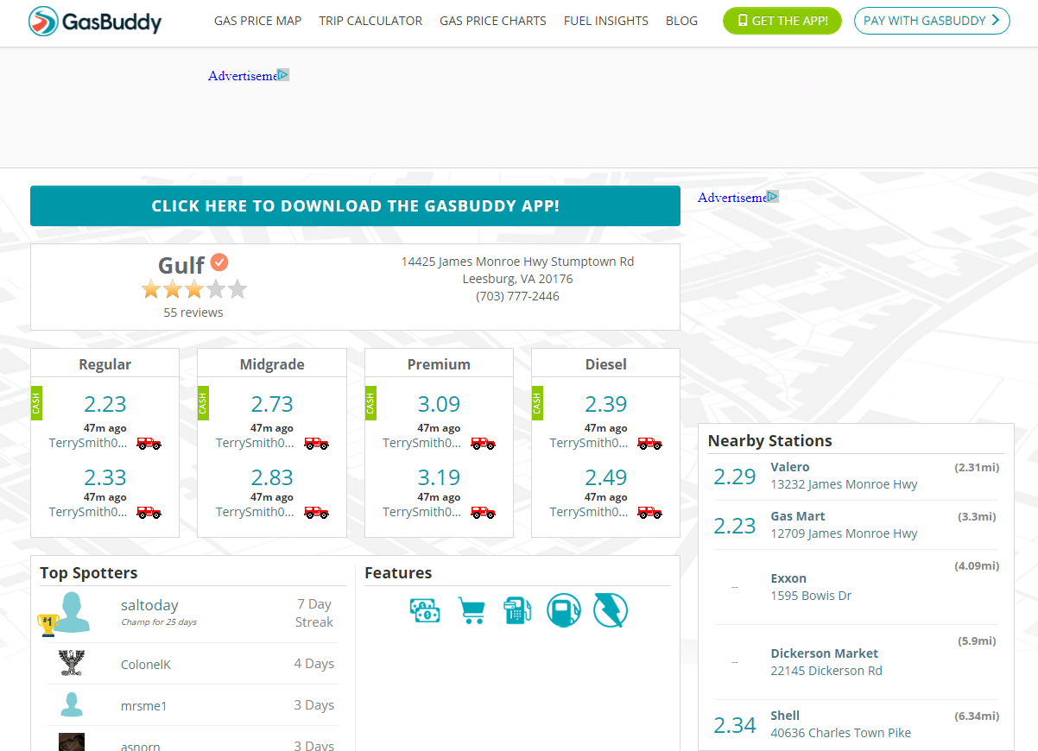

Of the 798 stations from EIA-878 identified on GasBuddy, 619 (78%) reported a price for regular gasoline, 450 (56%) reported a price for midgrade gasoline, and 451 (57%) reported a price for premium. There were 58 instances of a discrepancy between the cash and the credit cards prices of regular gasoline that were reported on GasBuddy. On average, cash purchases of regular gasoline resulted in an 8¢ reduction of price. Unless noted otherwise, SDSI used cash prices where available in all comparisons to EIA-878 data.

Results from comparison of data sources on key dimensions

Table 1 compares OPIS and GasBuddy data sources with EIA-878 survey data on a number of key dimensions, including coverage, timeliness, cost, and data collection method.

Table 1. Summary of the comparison of EIA-878, OPIS, and GasBuddy data sources on a multitude of key dimensions, including information on timeliness, missing data, and associated costs.
 | EIA-878 | OPIS | GasBuddy
Availability of prices | 802 stations | On average, 110,000 stations per week | Based on SDSI analysis, web pages exist for approximately 144,000 stations
Coverage with EIA-878 |  | 98% | 99%
Frequency of updates | Prices collected weekly on Mondays as of 8:00 a.m. local time. Published same day by 5:00 p.m. EST | Feed contains most recent data point. From analysis of the weekly feeds, the oldest prices were as of 12:00 a.m. Sunday. | Updated by users in real-time. Prices stay online for a maximum of one day
Time period available |  | 12 weekly feeds covering May 15, 2017– July 31, 2017 | Single dataset for Monday, July 31, 2017
Cost |  | $24,000/12 week feed | No cost
Data collection method | Probability based survey with data collected mainly via computer assisted telephone survey (CATI) | Compiles data from universe of stations from credit card swipes, direct submission from stations, and user reports (via GasBuddy) | Reported by GasBuddy.com members for universe of stations
Timeliness | Prices reported as of 8:00 a.m. local time | OPIS data feed can be delivered at any date/time specified | Prices are updated in real-time
Cash vs. credit price | Cash price, unless only credit card is accepted | SDSI analysis suggests that OPIS provides credit price | Users can submit two prices: cash and credit
Data editing and processing | Uses edit rules to identify outlier prices. Conducts respondent follow-up with station or imputes price | Unknown | Site uses “automated algorithms” to detect “obviously wrong information.” Site also allows users to report other users who submit incorrect information
Item missing | In general, fewer than 10 stations are missing and imputed for regular | On average, about 6% missing for regular gasoline | For July 31, 2017, 22% of matched stations did not provide a cash or credit price for regular gasoline
Price discounts | Price excludes discounts | Unknown | Instructions request that users submit price prior to discount
Gasoline grades collected and definitions | - Regular: 85-87 Octane and E0 or E10  - Midgrade: 88, 89, 90 Octane and E0 – E10  - Premium: 91 Octane or higher and E0 – E10  - Does not collected E15 or E85 | Unknown | - Regular: 85-87 Octane  - Midgrade: 89 Octane  - Premium: 91-93 Octane  - E-85  - For stations in Iowa, Illinois, Nebraska, and Kentucky, E0 should be reported as Regular and E10 should be reported in the Midgrade spot
Number of grades sold | EIA maintains station-level records on grades sold | Not available. No distinction between missing and not sold. | Not available. No distinction between missing and not sold.
Sources: https://help.gasbuddy.com/hc/en-us/articles/225454887-Report-Prices; https://www.eia.gov/survey/form/eia_878/faqs.php
SDSI also analytically compared OPIS and GasBuddy prices for stations included in the EIA-878 sample for July 31, 2017. As described above, OPIS acquired GasBuddy.com in 2013 and incorporates user submitted information into OPIS proprietary price information; however, the extent to which this occurs is unknown. Therefore, it is not clear to what extent the two sources may overlap in information.
For July 31, 2017, SDSI obtained regular gasoline prices from OPIS for 747 stations and 619 stations from GasBuddy. There was a high amount of overlap with 613 stations in common between the series. 134 regular gasoline prices were only available in OPIS, while 6 regular gasoline prices were only available through GasBuddy. SDSI compiled GasBuddy prices in two ways to compare with OPIS:
- Using cash price where available and credit price otherwise
- Using credit price as a default unless the station is cash-only
Key findings include:
- For July 31, 2017, OPIS has a lower item missing data rate (5%) compared to GasBuddy (22%) for regular gasoline
- Figure 2 compares GasBuddy price (cash or credit) on the x-axis with OPIS price on the y-axis Results indicate that the series are very highly correlated. These findings are consistent for midgrade and premium prices (see appendix figures A.1 and A.2)
- Since GasBuddy credit prices are more highly correlated than GasBuddy cash prices, it is likely that OPIS defaults to credit prices

SDSI also compared the source of information to determine if there was any relationship between information tagged as ‘electronic’ vs. ‘user-submitted’ in OPIS with GasBuddy user reports. For July 31, 2017, the average difference between OPIS and GasBuddy for OPIS prices tagged as user-submitted prices was $0.004, compared to $0.001 for prices tagged as electronic submission on OPIS. There also did not appear to be a relationship with whether the price was submitted GB_Direct on GasBuddy with OPIS source (‘electronic’ or ‘user submitted’). Roughly half of these prices were tagged as ‘electronic submitted’ on OPIS, while the remainder were ‘user submitted.’

Figure 2. Station-level OPIS prices vs. station-level GasBuddy regular gasoline prices for July 31, 2017

Data linkage methods
A method for linking records between the EIA gas station sample and the OPIS and GasBuddy data sets was established before any subsequent analyses could proceed. The biggest challenge in linking these three sets of data was the absence of a common primary identification key. The only commonly shared elements identified by SDSI staff were the station names and addresses. SDSI staff decided not to attempt linking datasets using station names due to differences in station naming conventions, alternative spellings, and station name changes that have occurred since the EIA-878 sample was drawn. EIA staff determined address matching would produce better results than simply linking on names. SDSI staff identified obstacles to this process, which included differences amongst the address identification conventions and other issues (e.g., misspellings, alternative spellings, alternative addresses, etc.). Due to the limitations for text matching presented by these differences, SDSI staff decided on using a geographic information systems (GIS) approach, specifically nearest neighbor analysis on geolocated stations (illustrated in Figure 3), as a way to link the data sources and avoid the issues described above. Nearest neighbor analysis is a process through which records from separate databases are joined based on the geographical proximity to each other. In short, addresses from two databases are mapped as points and the closet two records from the respective databases are joined.
SDSI staff geocoded the EIA-878 sample to generate spatial data for station locations. Most of the 802 entries in the EIA-878 sample geocoded on the first attempt with the remainder needing correction in address fields entries (e.g., PO Boxes preceding street numbers, alternative spellings, etc.). Six stations were not able to be geocoded due to bad or unclear addresses. The OPIS and GasBuddy databases contained existing coordinates, and therefore, they did not need geocoding. For the initial round, SDSI staff performed nearest neighbor analysis on the EIA-878 sample and OPIS database, and matches between addresses and stations’ names were compared to confirm stations were the same. In the first round of matching, approximately 75% of the stations were matched.
Figure 3. Illustration of the concept of GIS Nearest Neighbor Analysis
After the first round, SDSI staff checked the remaining unmatched stations to determine reasons for mismatches and resolve them to continue matching. The primary reasons for initial mismatches were:
- Close Station Spacing: Most mismatches occurred around road intersections where multiple gas stations exist and some EIA-878 sample geolocated station points ended up being closer to incorrect stations than the correct gas stations. Once these station location points were corrected, matching was possible.
- Bad Geolocated Points: For a few stations, the EIA-878 sample geolocated station points were not near the exact locations of the station and corrections were performed manually so matches could be made.
- Non-Weekly Respondents in OPIS: A few stations did not initially show up in the early weekly OPIS data feeds received, but did appear in later data feeds. Matches were made when the stations appeared in a data feed.
- Not included in OPIS: A few small stations did not appear to be present in the OPIS database.
SDSI staff ran a few more rounds of nearest neighbor analysis as new weekly data feeds were received to capture further stations that did not appear in the initial weekly OPIS data feeds. EIA completed the same process with the GasBuddy database for stations that were not previously matched by PBS staff. For a few cases, SDSI staff identified multiple GasBuddy.com websites for the same station; in those cases, staff selected the website with the most up-to-date information. As with the OPIS database, similar results and shortcomings were experienced. In total, the process was able to match 785 EIA-878 sample stations (98%) with the OPIS database and 798 EIA-878 sample stations (99%) with the GasBuddy database. Possible reasons for not identifying EIA-878 stations in OPIS and/or GasBuddy files include:
- Non-Physical Station Addresses: For some stations, EIA-878 records contained mailing addresses that did not match the physical locations of gas stations, such as PO Box addresses.
- Bad address: EIA-878 records contained some inaccurate addresses that were not able to be geocoded or the other information did not match the station located at that physical address.
- No OPIS or GasBuddy record: OPIS and/or GasBuddy did not have a record for some stations in the EIA-878 gas station sample set.

Findings

Evaluation of internal consistency of the OPIS data feed

Key findings from comparing OPIS daily data feeds
Four daily data feeds of prices for regular, midgrade, and premium motor gasoline were compared using SAS PROC COMAPRE, which makes comparisons between observations identified by a common variable one pair at a time, to make an assessment about similarities and differences between key data set characteristics. In this comparison, PROC COMPARE was used to identify instances of differences in gas station name or address, as well as differences in reported address or zip code to identify possible discrepancies between the OPIS records and the EIA-878 records. PROC COMPARE matched gas stations based on their locations, using a uniquely assigned station ID. Matched comparisons of the four daily OPIS feeds identified a range of 106,432 – 118,987 exact matches based on the location identifier. The highest number of matches occurred during comparison of the 4 p.m. to the 8 p.m. daily data feed and feeds during these two times consistently produced the most matches based on the location identifier.
A number of mismatches in key characteristics were identified during the pairwise comparison of timed daily feeds. These included:
- Mismatches in gas station name, with instances of mismatches ranging from 0 to 53 (median = 6)
- Mismatches in gas station address, with 4 being the largest number of instances
- Mismatches in city listed for the gas station, with 23 being the largest number of instances. The 23 instances of mismatch occurred in only 3 pairwise comparisons and the rest of the pairwise comparisons revealed at most only 1 mismatch
- Mismatches in the zip code listed, with 2 mismatches being the largest number of occurrences
There were three instances where two of the daily data feeds provided by OPIS were identical: July 3 (12:00 p.m. and 4 p.m.), July 17 (12:00 p.m. and 4 p.m.) and July 10 (8 a.m. and 12:00 p.m.) Outside of these three occurrences, the data feeds at all other times exhibited some differences, which suggests that there is some natural variability occurring in the values collected by OPIS during different times of day. SDSI staff suspect that the three instances where the data in pairwise comparisons of daily feeds was identical is due to a possible transmission of an incorrect data feed or to the overwriting of the file, as opposed to a true instance of complete concurrence in the data collected by OPIS.
Overall, comparison of the four OPIS daily data feeds revealed no substantial or persistent differences in the characteristics examined by SDSI staff.

Key findings from matched comparisons of prices between timed daily feeds
Along with the comparisons detailed above, one of the main objectives of the procedure was to identify instances of price differences from a gas station providing a data report to OPIS at different times during the day. Regular, midgrade, and premium gasoline prices were considered separately in pairwise comparisons of daily data feeds. The two series of graphs below illustrate 1) the largest price differences identified and 2) the number of instances that these price differences were identified in the pairwise comparison.
Summary of results:
- Most observed differences in price were below $1, with the largest identified difference in price observed in data feeds reporting prices of regular motor gasoline
- 4% of the gas stations in the sample were reported more than once of having the largest observed price difference by pairwise comparison; of these, 70% repeated for the same grade of gasoline
- On average, the largest price differences are found in the comparison between the 8 a.m. and 8 p.m. feeds and for premium motor gasoline

Regular motor gasoline
Comparisons of four data feeds of regular motor gasoline revealed that the largest observed difference in price reported by the same station on the same day was $1.19, occurring 9,345 times within a single pairwise comparison. The largest number in instances of an observed price discrepancy reported by gas stations in one day occurred 25,403 times for the price of $0.89. Overall, no consistent discrepancies between gas station reports were observed for prices of regular motor gasoline and the range of the discrepancies spanned $0.70 to $1.19 occurring between 5,141 to 25,403 times. Figures 4a and 4b below illustrate the relationships described in this paragraph.
Figure 4a. Largest price differences, of regular motor gasoline, observed between daily OPIS data feeds.

Figure 4b. Number of instances the observed largest difference in price of regular motor gasoline occurred between daily OPIS data feeds.

Midgrade motor gasoline
Comparisons of four data feeds of midgrade motor gasoline revealed that the largest observed difference in price reported by the same station on the same day was $0.89, occurring 11,699 times within a single pairwise comparison. The largest number of instances of an observed price discrepancy reported by gas stations in one day occurred 17,126 times for the price of $0.70. Overall, no consistent discrepancies between gas station reports were observed for prices of midgrade motor gasoline and the range of the discrepancies spanned $0.55 to $0.89 occurring between 7,101 to 17,126 times. Figures 5a and 5b below demonstrate the relationships described in this paragraph.

Figure 5a. Largest price differences of midgrade motor gasoline observed between daily OPIS data feeds.

Figure 5b. Number of instances of observed largest difference in price of midgrade motor gasoline occurred between daily OPIS data feeds.

Premium motor gasoline
Comparisons of four data feeds of premium motor gasoline revealed that the largest observed difference in price reported by the same station on the same day was $1.08, occurring in multiple pairwise comparisons between 6,057 to 15,438 times. The largest number of instances of an observed price discrepancy reported by gas stations in one day occurred 16,936 times for the price of $0.84. Overall, no consistent discrepancies between gas station reports were observed for prices of premium motor gasoline and the range of the discrepancies spanned $0.68 to $1.08 occurring between 4,356 to 15,438 times. Figures 6a and 6b below demonstrate the relationships described in this paragraph.

Figure 6a. Largest price differences of premium motor gasoline observed between daily OPIS data feeds.

Figure 6b. Number of instances of observed largest difference in price of premium motor gasoline occurring between daily OPIS data feeds.

Key findings from investigating instances of largest price differences by pairwise comparison
Data on differences in price between timed daily feeds indicate instances of price differences greater than $1.00 occurring on the same day and appearing more than once in weekly pairwise comparison of the four daily feeds. SDSI staff deemed these price differences as significant and ‘flagged’ them for further investigation. Pairwise comparisons performed over the eight week period, during which data were available, revealed 10 instances of ‘flagged’ price differences. Four of these instances were identified in the comparison of noon to 4 p.m. feeds.
Investigating the instances of the largest price differences, in the subset of OPIS gas stations that also appeared in the EIA-878 sample, revealed that a few of these gas stations should be monitored, as they exhibit the largest price differential between feeds multiple times. The investigation revealed that 33 gas stations (4%), present in both the OPIS feeds and in the EIA-878 sample, report the largest price difference between feeds at least twice. One gas station was identified as reporting the largest price difference between data feeds a total of six distinct times. This observation was particularly revealing in that this large difference in price reported for this station by different feeds was reported for the same grade of motor gasoline. Further investigation into the presence of such discrepancies revealed that 30% of gas stations exhibit a large difference in price from a pairwise comparison between data feeds and these stations may need to be more closely monitored to elucidate the driver(s) of these reporting discrepancies.
The largest average price difference, without gasoline grade distinction and observed in the subset of OPIS gas stations that also appeared in the EIA-878 sample, was 84¢ and occurred in the comparison between the 8 a.m. and 8 p.m. feeds. Premium motor gasoline stood out as having the highest price differential on average among gasoline grades (86¢).

Comparison of survey and alternative price data at the station level

Key findings from comparison of EIA-878 and OPIS price data over 12 weeks
Linking respondent-level EIA-878 data with purchased price data from OPIS allowed SDSI to conduct pairwise comparisons of station-level reported prices for regular, midgrade, and premium gasoline over a 12 week period. While SDSI staff obtained OPIS data at four different time points during the day in some weeks, SDSI consistently used the 12 p.m. feed for comparison purposes.
Table 2 summarizes the findings over 12 weeks. SDSI obtained consistent non-missing prices from both EIA-878 and OPIS for about 75% of stations over the 12 week analysis period (N = 596). In the subset of stations with non-missing data, regular gasoline prices matched exactly for about 30% of stations over 12 weeks. Among the remaining stations with non-missing data, about a third (32%) had prices within 5¢. The remaining third exhibited price differences of 5¢ or greater during the analysis period.
Table 2. Summary of matched EIA and OPIS regular gasoline price data for 12 week study period
 | N | Percent of non-missing data
Number of stations selling regular gasoline | 802
Number of stations with non-missing EIA-878 and OPIS data over 12 week study period | 596
Exact Match | 176 | 30%
Non Match | 420 | 70%
Total Row | 596 | 100%
Non Match
Less than 5¢ difference in any week | 188 | 32%
Less than 10¢ difference in any week | 107 | 18%
Less than 15¢ difference in any week | 81 | 14%
At least one instance of 15¢ difference or more | 44 | 7%
Total Row | 420 | 70%

SDSI conducted similar analysis for midgrade and premium gasoline and obtained consistent non-missing midgrade and premium price data for about 300 stations. While this is a significantly lower value compared to regular gasoline, it reflects the fact that not all stations sell midgrade and/or premium gasoline. Congruence between survey prices and OPIS data is strongest for regular gasoline, followed by midgrade, and then premium. Midgrade and premium prices matched for 58 and 47 stations, respectively. See A.2 and A.3 for detailed results for midgrade and premium prices.
SDSI also compared results by date stamp of OPIS price (Sunday vs. Monday) and OPIS source (electronic vs. user submitted). Neither variable appeared to affect the relationship between OPIS price and EIA price.

Exact price matches
Stations present in both the OPIS and the EIA-878 data and reporting identical regular prices had substantial mismatch in reported midgrade and/or premium prices, with only a small number reporting identical prices at those grades. Specifically, of the 176 stations with matching regular prices between EIA-878 and OPIS, 33 stations also had the same premium prices and 43 had the same midgrade prices. Only 27 stations had the matching regular, midgrade, and premium prices with EIA-878 data over the entire 12 week period.

Non-Matches
SDSI staff examined 232 stations present in both the OPIS dataset and the EIA-878 sample reporting a difference in regular gasoline price of at least 5¢ to discern possible patterns or identify noteworthy cases. The following describes one such case geographically isolated to Illinois and related to a specific station brand (referred to as ‘Brand A’ in this report). Brand A was noted to exhibit a notably high occurrence of price differences of greater than 5¢ between EIA-878 data and OPIS data at the station level. Brand A is a larger gas station chain operating more than two thousand locations with 35,000 employees across more than 20 U.S. states.
The high occurrence of price differences greater than 5¢ between EIA and OPIS among Brand A stations were seen consistently in weekly datasets. At its peak, Brand A stations had accounted for more than 10% of all regular grade price differences of greater than 5¢ in a given week and almost 70% of those occurrences were from stations in Illinois. There were eight Brand A stations in Illinois reporting on EIA surveys, with five of them (62%) reporting prices with a greater than 5¢ difference from prices reported to OPIS until June 19.
This brand and geographic concentration was not due to a greater ratio of Brand A stations or more Illinois-based locations. On average, less than 12% of the Brand A stations were located in Illinois but more than a third (32%) of the brand’s discrepancies originated from stations located within that state. It is worthwhile to mention that the EIA-878 data were obtained from the brand’s regional offices, not from individual gas station respondents via telephone interviews. The geography showing these discrepancies aligned with reporting structures within the company. After EIA discussed this discrepancy with Brand A representatives, this trend among Brand A stations within Illinois was no longer observed. The variability between EIA prices and OPIS prices for this brand’s stations in Illinois decreased to below 5¢ in following weeks, a trend which was not similarly exhibited in stations of other brands (Figure 7).
Figure 7. Comparison of count of observed weekly differences between EIA and OPIS prices, exceeding 5¢, in regular motor gasoline in gas stations from Brand A compared to other brands.

Stations with incomplete data
Despite an overall high presence of EIA-878 sample’s stations in the OPIS data feeds (98%), there was also a cycling of stations in and out of the weekly price feeds. The observed station cycling led to an incomplete longitudinal set of price data for 30% of stations reporting prices of regular motor gasoline and for over 60% of stations reporting prices of midgrade or premium motor gasoline.
Table 3 below shows the percentage of missing data by gasoline grade and week. Regular gasoline prices were most consistently reported, averaging only 6% missing across all weeks among the matched stations. Item missing rates for midgrade and premium gasoline prices were substantially higher, averaging around 30% for both grades during the 12 week period. OPIS data feeds do not differentiate between a grade not being available at a station or a missing price point.
Table 3. Percent item missing data from OPIS by gasoline grade and week (May 15, 2017 to July 31, 2017)
Week | 1 | 2 | 3 | 4 | 5 | 6 | 7 | 8 | 9 | 10 | 11 | 12
Regular | 8% | 10% | 14% | 6% | 7% | 3% | 4% | 4% | 4% | 3% | 4% | 5%
Midgrade | 35% | 37% | 39% | 32% | 33% | 30% | 26% | 28% | 27% | 24% | 27% | 28%
Premium | 33% | 38% | 37% | 31% | 32% | 28% | 27% | 27% | 27% | 25% | 26% | 27%

EIA-878 and OPIS price estimates for publication cells over 12 weeks

National estimates
In contrast to the price differences observed at the station level between the stations present in both the EIA-878 sample and the OPIS data feeds (described in sections above), aggregate prices at the national level show few differences over the analysis time period. This is particularly evident in the comparison between the national average gasoline prices for regular gasoline, all formulations (Figure 8). The estimates were calculated without survey weights and include 596 stations with non-missing values over the analysis time period. Price differences do not exceed 0.8¢. In all cases, OPIS prices are slightly higher than EIA-878 prices.
Figure 8. Average weekly national prices between EIA and OPIS data (both unweighted) for regular motor gasoline (596 stations)

Similar findings can be seen for both midgrade and premium prices (Figures 9 and 10, respectively). In all but one case, OPIS prices are higher than EIA-878 prices. Differences do not exceed 1.5¢ for midgrade motor gasoline and 1.3¢ for premium motor gasoline.
Figure 9. Average weekly national prices between EIA and OPIS data (both unweighted) for midgrade motor gasoline (302 stations)

Figure 10. Average weekly national prices between EIA and OPIS data (both unweighted) for premium motor gasoline (298 stations)

Estimates at the PADD, state, and city levels
Larger price differences are apparent at finer levels of geography. Key finding from the graphical analysis for PADDs are described below and depicted in Figure 11 and appendix figures A.3 (highlighting key states) and A.4 (highlighting key cities). Figures in this section (and relevant section of appendix), illustrate the difference in average prices over time between OPIS and EIA unweighted data.
Key findings at the PADD level (refer to Figure 11 below):
- Price differences do not exceed 4¢. EIA and OPIS aggregate prices are closer for regular gasoline (price differences do not exceed 3¢) compared to midgrade and premium prices.
- Most of the differences are positive, indicating that OPIS aggregate prices are higher than EIA-878 aggregate prices. SDSI staff suspect this is due to different price definitions (cash price versus credit price).

Key findings for states and cities (refer to appendix Figures A.3 and A.4):
- Across all states and cities, differences between OPIS and EIA aggregate prices were generally smaller for regular gasoline in comparison to midgrade and premium.
- With the exception of Hawaii, price differences for all states are within 5¢.
- OPIS prices were generally higher for all grades in Denver, Houston, Miami, San Francisco, and Seattle and did not exceed 5¢.
- Chicago, Cleveland, Los Angeles, and New York exhibited the largest deviations between OPIS and EIA-878 aggregate prices, however the direction of the differences varied by city.

Figure 11. Differences in prices between EIA and OPIS data (both unweighted) by PADD for regular, midgrade, and premium gasoline
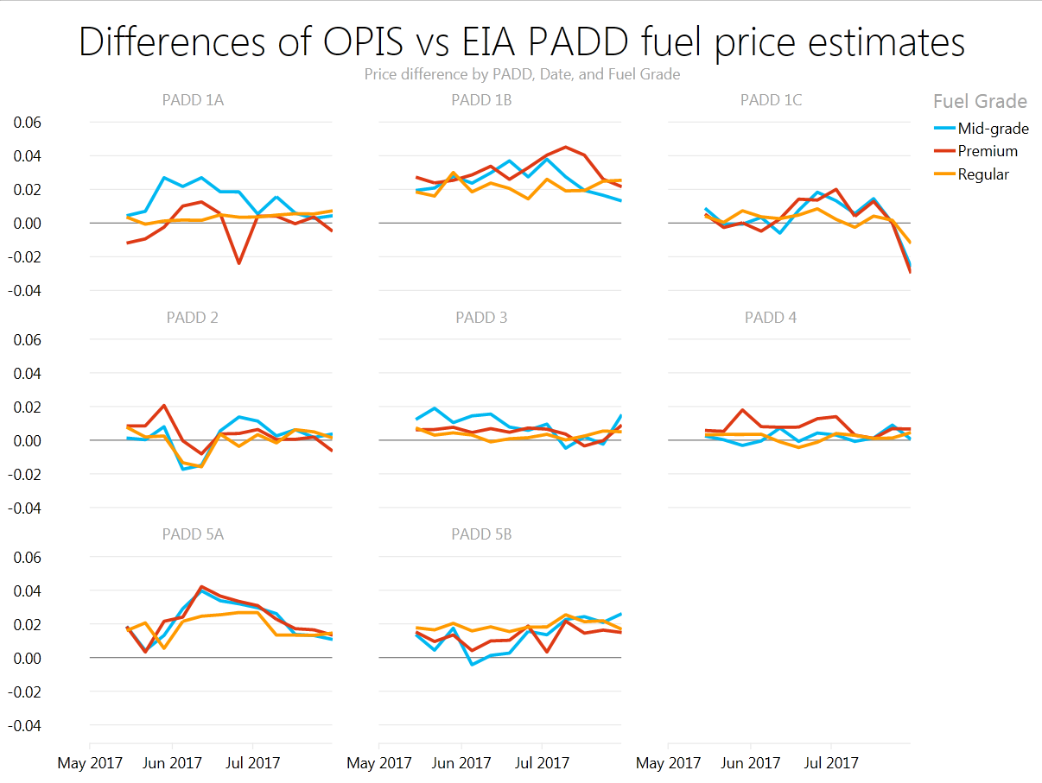
Note: Difference is calculated as OPIS price minus EIA price

Point-in-Time comparison of EIA-878 price data with OPIS and GasBuddy price data

As a final comparison, SDSI staff compared EIA survey data to OPIS and GasBuddy data for the one date where all three data sources were available (July 31, 2017). Overall, EIA-878 survey data is very highly correlated with both data sources. Figures 12 shows a scatterplot of EIA-878 data plotted against OPIS and GasBuddy data for regular gasoline. In both cases, the R² correlation factor was greater than 0.97. The correlation for GasBuddy is slightly higher than that for OPIS, likely due to better alignment with EIA-878 data in terms of cash over credit prices. However, OPIS data had a lower rate of item missing values.

Figure 12. EIA station-level prices vs. GasBuddy station-level or OPIS station-level prices for July 31, 2017, all U.S. prices

Figure 13 below shows the unweighted average prices calculated from stations that have data available across the three sources (612 stations for regular, 435 stations for midgrade, and 435 stations for premium). The results indicate that prices calculated from these stations are within 2¢ across all grades. 95% confidence intervals also overlap, indicating no statistical difference between prices calculated from GasBuddy, OPIS, and EIA sources. These results are also consistent when examining the distribution of regular gasoline prices at the PADD level (Figure 14).

Figure 13. Unweighted U.S. average price by gasoline grade and data source for July 31, 2017.

Figure 14. Boxplot of regular gasoline prices by PADD and data source for July 31, 2017.
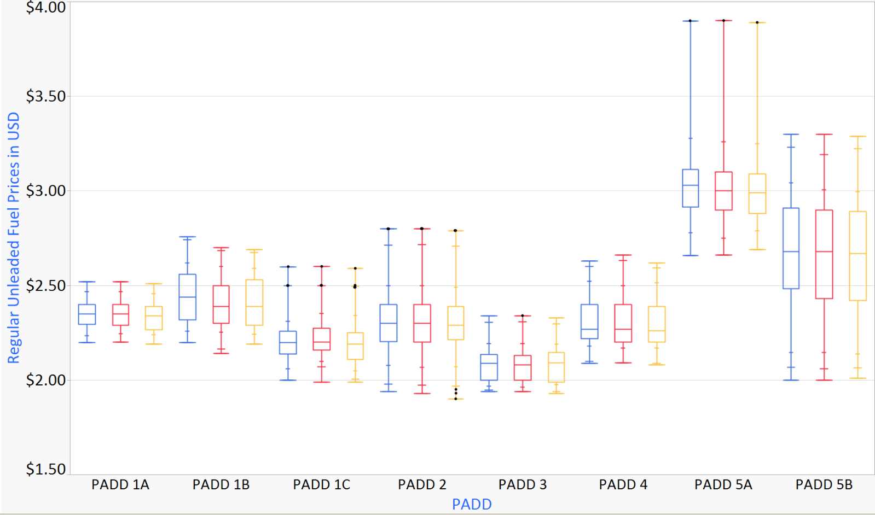
OPIS EIA GasBuddy

Comparing EIA and AAA city definitions
In Evaluation of Alternative Sources for Motor Gasoline Prices and Volumes (June 2017), EIA observed large discrepancies between the aggregate prices published by AAA and EIA’s published prices for New York City and Chicago. SDSI staff investigated further to determine if the differences were due to the city definition or reporting discrepancies at the station level.
SDSI staff identified stations that met the criteria for New York City and Chicago, based on the EIA definition (Table 4), using the station location information provided by OPIS (full description of data appears earlier in this report). About 4,500 stations were identified within the EIA definition of “New York City” and 3,000 were within EIA’s “Chicago” definition. For the purposes of this analysis, SDSI staff considered these stations as the census of all stations within the city definition and their unweighted average as the population estimate.
The “population” estimate was then compared against the three series detailed below. Sample size information for the series can be found in Tables A.4 and A.5.
- AAA average published prices
- Unweighted average of station-level EIA prices from the EIA-OPIS matched file
- Unweighted average of station-level OPIS prices from the EIA-OPIS matched file
Table 4. EIA and AAA city definition for New York City and Chicago (city and metro).
City | State | EIA | AAA
New York City | Connecticut | Fairfield County, Litchfield County (partial), New Haven County (partial)
New York City | New Jersey | Bergen County, Essex County, Hudson County, Hunterdon County, Middlesex County, Monmouth County, Morris County, Ocean County, Passaic County, Sussex County, Union County, Somerset County
New York City | New York | Bronx County, Kings County, Westchester County, Nassau County, New York County, Orange County, Putnam, Queens County, Richmond County, Rockland County, Suffolk County | Bronx County, Kings County, New York County, Queens County, Richmond County
Chicago City | Illinois | Cook County, Du Page County, Grundy County (partial), Kane County, Kendall County (partial), Lake County, McHenry County, Will County | City of Chicago (partial Cook and DuPage Counties)
Chicago City | Indiana | Lake County, Porter County
Chicago Metro | Illinois | Cook County, Du Page County, Grundy County (partial), Kane County, Kendall County (partial), Lake County, McHenry County, Will County | Cook County, DuPage County, Kane County, Lake County, McHenry County, Will County
Chicago Metro | Indiana | Lake County, Porter County
Notes: Counties used in both AAA and EIA definitions are bolded.
Source: U.S. Energy Information Administration, "Gasoline and Diesel Fuel Update"; Email communication with AAA

New York City
EIA’s definition of New York City encompasses an area much larger compared to the area covered by AAA’s definition of New York City. Analysis revealed that the gasoline price discrepancies, between EIA and AAA (the difference between the yellow line and the brown line in Figure 15), for regular, midgrade and premium gasoline are largely due to the city definition issues. As described above, the average price calculated from the full OPIS price file (blue line in Figure 15 following) may be considered as the pseudo-census of all stations defined in New York City. Following from that logic, the EIA/OPIS matched sample can be thought of as a pseudo-random sample from the population. The green line represents the average gasoline price calculated from OPIS data for those stations included in the EIA-878. These station level reporting discrepancies (mainly, the difference between the green line and the brown line in Figure 15) play a small role in the average gasoline price discrepancy in the 12 week span. Results are similar for midgrade and premium (see A.5 and A.6). Sample size information is also available in the appendix.
Figure 15. Average weekly New York City regular motor gasoline prices from EIA, OPIS, and AAA.

Chicago
As shown in table 4 above, AAA produces two estimates for Chicago: city of Chicago and Chicago Metro. EIA’s definition of Chicago is closer in concept to AAA’s “Chicago Metro;” however, EIA covers two more partial counties in Illinois and two counties in Indiana, which is an area that matches the EPA Reformulated Gasoline region for Chicago. As described above, the average price calculated from the full OPIS price file (blue line in Figure 16 following) may be considered as the pseudo-census of all stations defined in Chicago. Following from that logic, the EIA/OPIS matched sample can be thought of as a pseudo-random sample from the population. Discrepancies in gasoline prices between EIA and AAA-Chicago Metro are largely due to the station level reporting issues. The green line represents the average gasoline price calculated from OPIS data for those stations included in the EIA-878. Results are similar for midgrade and premium (see A.7 and A.8). Sample size information is also available in the appendix.

Figure 16. Average weekly Chicago regular motor gasoline prices from EIA, OPIS, and AAA.

Predicting Midgrade and Premium Motor Gasoline Prices at the Aggregate Level

Background and rationale
The first phase of the Evaluation of Alternative Sources for Motor Gasoline Prices and Volumes project reported that price estimates for publication cells across grades are highly correlated. The highly correlated relationship was observed to exist between aggregated price data from EIA, AAA, and GasBuddy. This finding led to a proposal for further research, during the second phase of the project, to predict midgrade and premium motor gasoline prices for publication cells using aggregated regular motor gasoline prices. Specifically, the survey could collect regular motor gasoline prices exclusively and use them to predict midgrade and premium prices with high accuracy.
The benefits of being able to predict midgrade and premium prices, with a high level of accuracy, would diminish the scale of the EIA-878 survey operation and make it more efficient. This change would diminish the reporting burden of survey respondents, since not all gasoline outlets sell midgrade/premium gasoline in addition to regular. Negating the need to collect data on midgrade and premium prices would decrease the sample size reducing the data collection and processing burden for the survey staff.
There is also potential for more precision from model estimates than from data collected on midgrade and premium motor gasoline prices by the survey. Historical data indicate that estimates for midgrade and premium prices, derived from survey data, have higher associated standard errors than data associated with survey-collected regular motor gasoline prices. This may be due to generally lower numbers of reported midgrade and premium reported prices, as compared to the number of reported prices for regular motor gasoline.

Predicting midgrade and premium prices with EIA-878 data
Midgrade and premium prices were highly correlated with regular prices over the period from 2009 through the beginning of 2017; however, the relationship patterns of midgrade and premium prices to regular price changed near the end of 2012. The change in relationship is captured in figure 17 below, where a greater interval is observed between the line depicting the delta in prices between midgrade and regular and the delta in prices between premium and regular beginning near the end of 2012. It is not clear what caused that change in the correlation patterns. One possibility is a change in gasoline specifications for product shipped on the Magellan Pipeline in 2013. This change resulted in a highly significant shift from midgrade to regular gasoline in PADD 2 and may have influenced the prices.
Figure 17. EIA-878 price differential between grades - U.S.

To capture the observed change in the relationships between regular and midgrade/premium prices and generate accurate estimates, two separate sets of models were developed for the periods of 2009-2012 and 2013-2017. The data used for modeling are weekly price series, therefore one modeling option considered was a time series model. However, the weekly price movement (weekly change), influenced by supply and demand balance among other factors, is quite random and shows no strong sign of seasonality and trend. Therefore, this research takes advantage of the high correlation among prices of different grades and fits the data with linear regression models, instead of a time series model. Figures 18a-c below depict scatter plots illustrating the high correlation between regular motor gasoline prices and midgrade gasoline prices and support the rationale of using linear regression models. The depicted relationships also illustrate the need to model the two data series separately, because they follow different patterns.
Figure 18a. EIA-878 midgrade price vs. regular price - U.S. (2009-2017).

Figure 18b. EIA-878 midgrade price vs. regular price - U.S. (2009-2012).

Figure 18c. EIA-878 midgrade price vs. regular price - U.S. (2013-2017).

Results from the linear regression equations from the midgrade or the premium models distinctly covering either the period from 2009-2012 or from 2013-2017 show differences between the values of both the intercepts (α) and the coefficient parameters (β) of regular price (refer to the Appendix Table A.6 for the complete list of values for the intercepts and coefficients).
Performance of the models was evaluated from summary statistics on the residuals (where: residual = observed value – predicted value) and the details (including mean absolute values, standard deviations, minimums, and maximums of the residuals) may be found in Table A.7 for 2009 - 2012in the Appendix. A summary of the models’ predicted values for 2013 - 2017 may be found in Table A.8 in the Appendix. Evaluation of the models’ performances led us to conclude the following:
- Models covering the period of 2009-2012 generally perform better than models covering the period of 2013-2017. Most models in the first group (2009-2012) have a mean absolute residual below 2¢ and a residual standard deviation below 2¢, the highest residual standard deviation is 3.5¢ (New York), and the highest extreme residual is 11¢ (Chicago). It is much more common for models in the second group (2013-2017) to have a mean absolute residual over 2¢ and/or a residual standard deviation over 2¢, the highest residual standard deviation is 6.7¢ (Chicago), and the highest extreme residual is 20.2¢ (Chicago). The less fluctuation of the price differential series over the period of 2009-2012 shown in Figure 17 is the main reason for this finding.
- Midgrade models perform better than premium models. For most pairs of midgrade and premium models (refer to Tables A.7 and A.8 in the Appendix) the three statistics for a midgrade model are lower than those of its corresponding premium model. The fact that the midgrade minus the regular series in general fluctuated less than the premium minus the regular series contributes to this finding.
- Models for big regions (U.S. and PADDs) perform better than models for small regions (states and cities). In both Tables A.7 and A.8, the statistics of the models (mean absolute value, standard deviation, minimum, and maximum) for U.S. and PADDs are significantly lower than those for states and cities, in general. The reason for this finding is that the fluctuation of price differentials for large regions are usually lower than those for small regions.

Predicting midgrade and premium prices with AAA data
SDSI staff also attempted to predict midgrade and premium gasoline prices from regular gasoline prices (state and city averages) reported by AAA. In general, the overall performance of the AAA data models are similar to that of the EIA-878 data models. There is no evidence to suggest that AAA regular prices are better at predicting midgrade and premium prices than regular prices collected by EIA. In fact, there are notable instances of models from AAA prices having higher standard deviations and appearance of extreme value statistics in the prediction residuals (refer to values from the Chicago and Cleveland models in Table A.9 in the Appendix).

Predicting AAA midgrade and premium prices with EIA-878 regular prices
SDSI also researched the feasibility of collecting only regular gasoline prices and relying on models to produce estimates for midgrade and premium. In this case, an outside data source would be needed to periodically validate the models and evaluate the quality of the estimated values. In this case, midgrade and premium prices from AAA can be used as a benchmark to assess the quality of model estimates. Models predicting midgrade and premium AAA prices from EIA regular prices were assembled and assessed as potential tools for validation estimation of midgrade and premium prices.
Overall, the performance of these models was not as robust as performance of models drawing on data from a single source, such as either the all-EIA-878 data models or the all-AAA data models (Table A.10 in the Appendix). The decrease in performance in these models is likely due to lower correlations between prices from different sources across grades compared to prices from a single source (data not shown).

Predicting Midgrade and Premium Motor Gasoline Prices at the Station Level

Background and rationale for leveraging external data to identify potential useful gasoline price predictors using a regression tree.
Despite an observed high correlation between regular motor gasoline prices and midgrade or premium prices, it is intuitive to assume that there are other factors that may impact these prices, at the station level, and would therefore play a useful role in predicting these prices. SDSI staff undertook a research effort to identify some of these factors and investigate their potential utility. A variety of factors were considered and were subsequently narrowed down to a set for which data could be obtained for inclusion in a regression tree (see Appendix Table A.9).

Methods and key findings.
Regression trees are a popular variation of decision trees, a machine-learning technique used for predictive modeling. In particular, they are used for models in which the dependent variable takes ordered discrete or continuous values. Because of this characteristic, regression trees are commonly used to approximate real-valued functions from data, rather than for classification purposes as other types of decision trees. An advantage of using regression trees is that they allow independent (or input) variables to be a mixture of numerous continuous and categorical variables, while maintaining simplicity and efficiency. In fact, a key reason for using regression trees is their interpretability.
The prediction models are obtained through ‘binary recursive partitioning’, an algorithm which iteratively splits the data space into mutually exclusive regions – or “branches” – which get smaller as the process moves forward. Each branch originates from a “node” of the tree, which is a logical test on an input variable. As the method moves down each branch, the models are constructed by fitting a simple linear prediction model to each of the partitions of the data space. Typically, regression tree modelers then use the root mean squared error (RMSE) or mean absolute error (MAE) as prediction error metrics. This iterative partitioning technique allows to represent the result graphically as a decision tree, thus making the results easy to interpret.
The most complete set of EIA-878 weekly data was identified for each regression tree by selecting the week with the least missing values of midgrade and premium gasoline prices, respectively. The data from the week of March 20, 2017 was identified as having the fewest missing observations (32 missing values for premium gasoline prices and 44 missing values for midgrade gasoline prices). In each instance, data points with missing values for either midgrade gasoline prices or premium gasoline prices, depending on the model, were excluded, so that a complete set of outcomes could be leveraged by the regression tree to identify useful relationships. The process to obtain the best regression trees for both the midgrade and the premium motor gasoline data was similar and the procedure will be described mostly for premium gasoline, with key differences to midgrade gasoline highlighted when necessary.
Initially the data set was divided into training and test sets using random assignment. The regression tree was subsequently utilized to select variables of interest from the training data set and then applied to the test data set to determine similarities and differences in variables selected. Variables used in the construction of the regression tree from the training set included ‘median household income,’ ‘percent of population in labor force,’ ‘number of registered vehicles,’ ‘price of regular motor gasoline,’ and ‘vehicle miles traveled.’ The variables included in the regression tree from the test data set included ‘median household income,’ ‘percent of population in labor force,’ ‘price of regular motor gasoline,’ and ‘population estimate’ and did not include ‘number of registered vehicles’ or ‘vehicle miles traveled.’
Following this initial assessment the regression tree was applied to the full data set from March 20, 2017 (without missing price values, as described earlier) and reviewed to identify the smallest complexity parameter (CP). The ‘best’ CP was included in the procedure to produce a ‘pruned’ tree with the number of variables limited by the ability of the ‘best’ CP to increase the overall R² value of the model. The variables identified by the regression tree procedure utilizing the ‘best’ CP included ‘median household income,’ ‘percent of population in labor force,’ ‘population estimate,’ ‘number of registered vehicles,’ ‘price of regular motor gasoline,’ and ‘vehicle miles traveled’ in both midgrade and premium gasoline models and pruning the trees reduced the values of their RMSE (0.08 and 0.12 for midgrade and premium, respectively). Other variables included in the pruned tree were indicator variables marking observations belonging to specific PADDs or states and these differed depending on the weekly feed from which the data were obtained. The cumulative R² values for the midgrade and premium gasoline models were 0.85 and 0.81, respectively. Graphs of the residuals from both tree models are included in the Appendix Figures A.9 and A.10. The two figures below depict the final pruned trees.

Figure 19. Depiction of the pruned tree, based on inclusion of the ‘best’ CP value in the model, for midgrade motor gasoline prices.
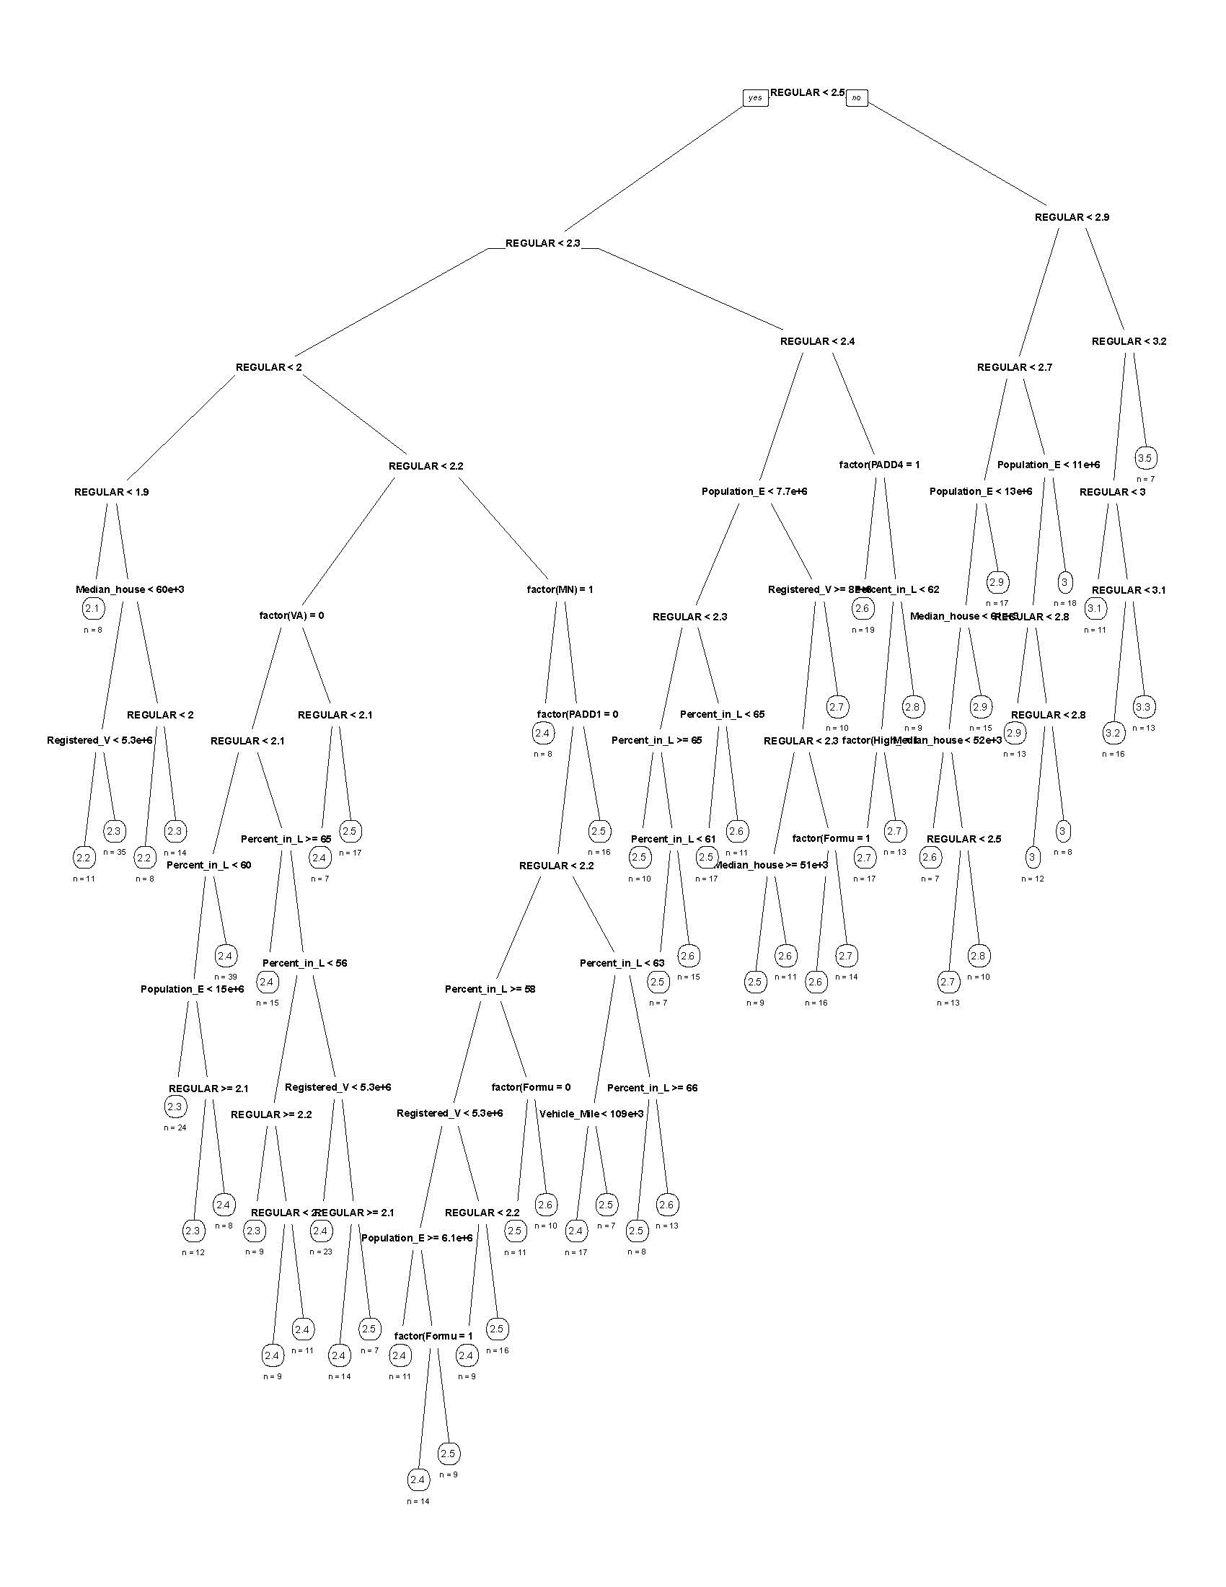

Figure 20. Depiction of the pruned tree, based on inclusion of the ‘best’ CP value in the model, for premium motor gasoline prices.
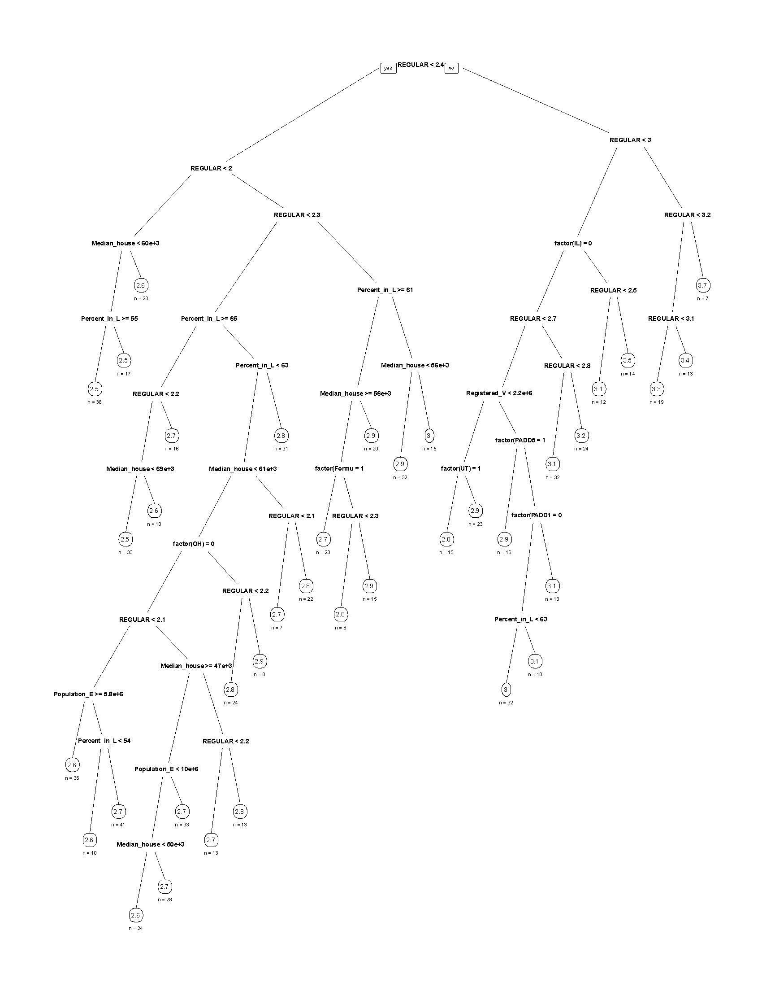

The primary purpose for the regression tree procedures was to identify variables with the most utility in predicting midgrade and premium gasoline prices at the station level, and these observations were tested by including the variables identified by the regression trees in linear regression models for both midgrade and premium motor gasoline prices. A number of the variables were found to be significant for predicting either midgrade or premium motor gasoline prices; however, these variables were not all consistently present in models for different weeks.
It seems that indicator variables marking presence of observations in different states or PADDs were oftentimes more significant than continuous variables selected by the regression tree at the earlier nodes (for example, number of registered vehicles); however, excluding these indicator variables consistently elevated the significance of the other variables in the linear models for any of the weeks considered.
It is important to note that the linear models signify the first step in the process of using additional, external data sources to more accurately predict the prices of midgrade and premium gasoline. This report does not attempt to suggest that these models are the most accurate; it only seeks to point out a wealth of additional, external data that could be utilized to predict these prices and which has not been utilized prior to this undertaking. Future research in this area should return to the regression tree models and more closely examine the relationships being identified for all of the weeks of price data that has been made available by OPIS. One possible approach may be to limit the regression trees to a certain number of nodes that would select variables consistently for the different weeks of price data and subsequently use these in future models to predict midgrade and premium gasoline prices. The analysis in this section demonstrates a successful first step to moving beyond existing methodology and leveraging the relationships between prices and a variety of variables available from external data sources that have not been considered prior to this undertaking.

Discussion and Recommendations

Data quality of third-party sources and incorporation into EIA-878

Statistical agencies across the federal government have a strong interest and directed effort to investigate the use of alternative and blended data. This report documents one potential application of combining commercial data from OPIS and GasBuddy with traditional survey-based methods used on the EIA-878. Below, key findings and recommendations are presented from this analysis. The findings and recommendations conclude with suggestions for future research efforts to enhance EIA’s data collection and publication efforts.

Assessment of data quality in commercial data
SDSI assessed OPIS and GasBuddy on a number of indicators of data quality. Both OPIS and GasBuddy exhibited high levels of coverage compared with the current EIA-878 sample. OPIS price feeds were internally consistent in terms of both station information and prices, as well as highly correlated with GasBuddy prices. Analysis also suggests an added value of purchasing data from OPIS rather than obtaining GasBuddy prices via web based methods in terms of item missing data.
Neither third-party data source supplied information to explain item or unit nonresponse, such as availability of midgrade/premium gasoline or temporary or permanent station closures. GasBuddy does collect information on power outages or lack of supply, but only extreme circumstances. Third-party sources also did not provide transparent information on data collection, processing, and validation.

Comparability of estimates
OPIS, GasBuddy, and EIA differed on a number of key issues that affected measurement, including price definition, data collection mode, and reference period for the prices. Despite these differences, EIA and OPIS regular gasoline prices were within 5¢ for almost half of the EIA-878 sample (45%). Prices matched exactly for 22% of EIA-878 stations over the 12 week study period for regular grade gasoline. Correlations between EIA and third-party data were also very strong, particularly for regular gasoline prices.
When comparisons are limited to stations reporting across both EIA-878 and OPIS, national and PADD level estimates were within 1¢ and 4¢ cents, respectively, across all grades over the 12 week study period. OPIS prices were generally higher at the national and PADD level, likely due to the utilization of credit prices rather than cash prices. City and state-level estimates exhibited larger differences, however, this is likely due to small sample sizes within the publication cells.

Modeling midgrade and premium prices from regular prices
Previous research indicated a high level of correlation between regular, midgrade, and premium gasoline prices. In this report, SDSI designed and executed several approaches to leverage this relationship and examine the feasibility of predicting midgrade and premium prices using regular gasoline price data.
Using aggregate data from 2013 to 2017, EIA-878-based models had lower error measures than AAA data-based models. In some selected cities and states, EIA-878-based models had a moderate or high level of error measurement, indicating these models should be only used if their potential prediction errors remain below EIA’s desired threshold. Even though using a mixture of EIA regular prices and AAA midgrade and premium prices is one possibility in the future, the accuracy of the estimates for some publication cells might not reach desired level.
SDSI utilized regression tree models, a novel approach for attempting to predict midgrade and premium motor gasoline prices, in an effort to advance efforts towards utilizing alternative or blended data. The findings from this initial research effort are very encouraging in that SDSI staff have successfully identified variables from external data sources that function as good indicators, in conjunction with prices of regular motor gasoline, for predicting midgrade and premium prices. The conclusions from these preliminary models suggest that it would be worthwhile to continue investing effort into the endeavor to develop robust prediction models that leverage outside data sources along with EIA-878 survey data.

Recommendations
This research suggests that there may be various options for incorporating the use of OPIS and/or GasBuddy data with EIA-878. Below, options for incorporating third-party data sources into the EIA-878 are discussed, starting with the most conservative approach.
- Validation Tool: This study demonstrated the ability of third-party data to identify price discrepancies. By using third-party data for validation in real-time, potential reporting errors could be identified and investigated during data collection, improving data quality for EIA-878. Both AAA aggregate prices and GasBuddy station level data are already leveraged as a part of the EIA-878 validation process. SDSI could develop tools to leverage these data sources further during validation in an automated fashion.
- Imputation: The high levels of comparability between survey and commercial data also may support new methods for handling missing data. A sizeable proportion of stations supplied the same regular prices to both EIA-878 and OPIS during the 12 week study period. EIA could identify these stations on the EIA-878 data files and utilize OPIS prices, rather than model-based imputation, in cases of nonresponse.
- Replace survey data collection with third-party sources for selected stations: About 22% of regular stations supplied the same prices to both EIA-878 and OPIS during the study period. To reduce respondent burden, EIA could suspend data collection from these stations and instead purchase from OPIS to develop weekly price estimates. This will involve cost/trade off considerations before a decision can be made. Further, more work is needed to investigate if these “regular” reporters have other abilities to provide EIA with data automatically as they do with OPIS.
- Hybrid approach: The current EIA-878 consists of approximately 800 stations, and the next planned sample is anticipated to increase to 1,000 stations. In future iterations, EIA could further expand the sample size and utilize both commercial and survey data collection in tandem, increasing the number of states and cities with published estimates and decreasing sampling variability. In this paradigm, EIA could designate some stations to report via traditional survey-based methods, while relying on third-party data for others. The distinction could be made at random or geographically. If the latter, EIA could publish some areas as “EIA-878” states/cities, and other areas as “third-party” states/cities. Alternatively, EIA could use third-party data sources as the default and then follow-up with any stations with missing data using a survey data collection. While EIA could utilize third-party sources for price data, there is no known third-party source for motor gasoline volumes, which are used in deriving both estimates and standard errors. Further methodological research is needed in this area, as well as an understanding of cost implications, legal restrictions on republishing third-party data, and the needs of the data user community.

Future Areas for Research
Future work includes the following:
- Extend OPIS subscription and continue price monitoring to validate current conclusions about OPIS price data.
- In contrast to the current report, which only examines GasBuddy prices from a single point in time, SDSI can collect GasBuddy prices, both across weeks and at multiple times during the day, in an effort to examine this data’s internal consistency and correlation with EIA-878 over time.
- Continue research on modeling midgrade and premium prices using regular prices from the OPIS price feeds in conjunction with relevant variables from external data sources already identified in this report. The OPIS datasets consist of prices from approximately 110,000 stations, a number much larger than the EIA-878 sample, and should be leveraged to develop more robust models.
- Continue investigating relationships between relevant variables and gasoline prices initiated in this report in an effort to develop robust prediction models
- Continue exploring additional modeling options to take to advance the current state of research into predicting prices at the station level.
- Collect OPIS and GasBuddy data during times of supply shortages or weather events and compare to EIA-878 data.

Appendix

Table A.1 Total number of stations included in weekly OPIS feeds and number of stations in common between different weekly feeds.
 | 15-May-17 | 22-May-17 | 29-May-17 | 5-Jun-17 | 12-Jun-17 | 19-Jun-17 | 26-Jun-17 | 3-Jul-17 | 10-Jul-17 | 17-Jul-17 | 24-Jul-17 | 31-Jul-17
15-May-17 |  | 99,076 | 94,250 | 102,224 | 101,470 | 103,963 | 103,923 | 103,728 | 103,832 | 103,758 | 103,165 | 103,283
22-May-17 |  |  | 94,544 | 102,398 | 101,520 | 104,063 | 103,934 | 103,793 | 103,857 | 103,833 | 103,260 | 103,283
29-May-17 |  |  |  | 97,475 | 96,631 | 98,825 | 98,769 | 98,728 | 98,750 | 98,630 | 98,124 | 98,185
5-Jun-17 |  |  |  |  | 106,598 | 109,665 | 109,541 | 109,169 | 109,262 | 109,308 | 108,576 | 108,694
12-Jun-17 |  |  |  |  |  | 108,738 | 108,670 | 108,340 | 108,468 | 108,454 | 107,737 | 107,726
19-Jun-17 |  |  |  |  |  |  | 112,888 | 112,466 | 112,543 | 112,585 | 111,610 | 111,684
26-Jun-17 |  |  |  |  |  |  |  | 112,670 | 112,718 | 112,738 | 111,749 | 111,710
3-Jul-17 |  |  |  |  |  |  |  |  | 112,665 | 112,631 | 111,566 | 111,596
10-Jul-17 |  |  |  |  |  |  |  |  |  | 112,940 | 111,848 | 111,819
17-Jul-17 |  |  |  |  |  |  |  |  |  |  | 112,164 | 112,094
24-Jul-17 |  |  |  |  |  |  |  |  |  |  |  | 111,565
31-Jul-17
Total | 107,277 | 107,263 | 101,418 | 113,550 | 112,350 | 117,537 | 117,620 | 117,285 | 117,481 | 117,713 | 116,517 | 116,643

Source: OPIS weekly price feeds from May 15, 2017- July 31, 2017. If multiple feeds were available for the date, SDSI selected the feed as of 12:00 p.m.

Figure A.1. Station-level OPIS prices vs. station-level GasBuddy midgrade gasoline prices for July 31, 2017, U.S. stations.

Note: GasBuddy cash price used when available

Figure A.2. Station-level OPIS prices vs. station-level GasBuddy premium gasoline prices for July 31, 2017, U.S. stations.

Note: GasBuddy cash price used when available

Table A.2 Summary of matched EIA and OPIS midgrade gasoline price data for 12-week study.
 | N | Percent of non-missing data
Number of stations selling midgrade gasoline | 802
Number of stations with non-missing EIA-878 and OPIS data over 12 week study period | 302
Exact Match | 58 | 19%
Non Match | 244 | 81%
Total Row | 302 | 100%
Non Match
Less than 5¢ difference in any week | 72 | 24%
Less than 10¢ difference in any week | 54 | 18%
Less than 15¢ difference in any week | 66 | 22%
At least one instance of 15¢ difference or more | 52 | 17%
Total Row | 244 | 81%

Table A.3 Summary of matched EIA and OPIS premium gasoline price data for 12-week study.
 | N | Percent of non-missing data
Number of stations selling premium gasoline | 802
Number of stations with non-missing EIA-878 and OPIS data over 12 week study period | 298
Exact Match | 47 | 16%
Non Match | 251 | 84%
Total Row | 298 | 100%
Non Match
Less than 5¢ difference in any week | 71 | 24%
Less than 10¢ difference in any week | 62 | 21%
Less than 15¢ difference in any week | 63 | 21%
At least one instance of 15¢ difference or more | 55 | 18%
Total Row | 251 | 84%

Figure A.3. Differences in prices between EIA and OPIS data (both unweighted) by selected states for regular, midgrade, and premium gasoline.
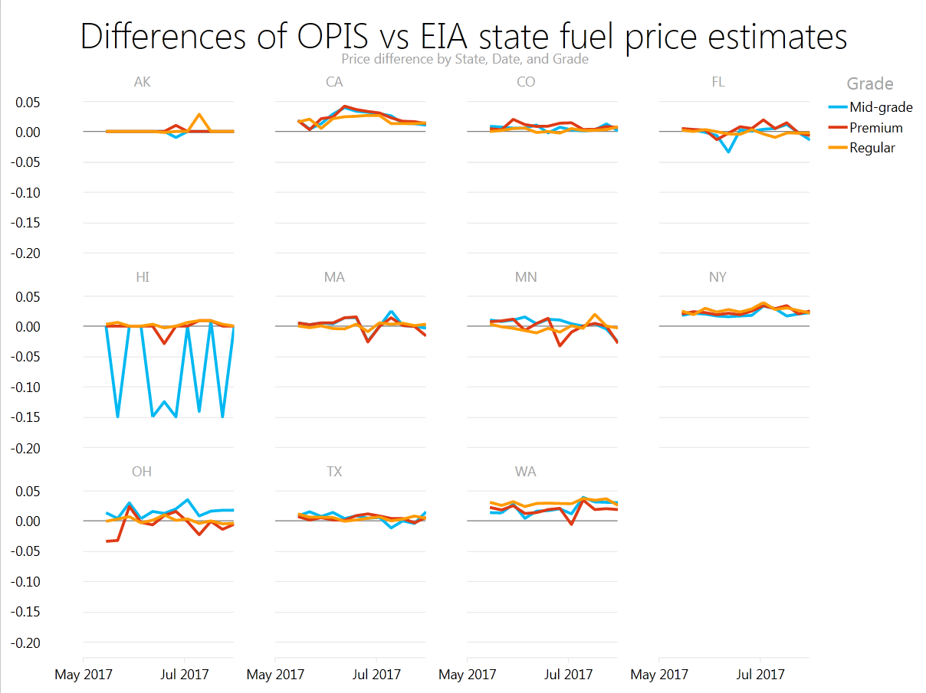
Note: Difference is calculated as OPIS price minus EIA price

Figure A.4. Differences in prices between EIA and OPIS data (both unweighted) by selected cities for regular, midgrade, and premium gasoline.
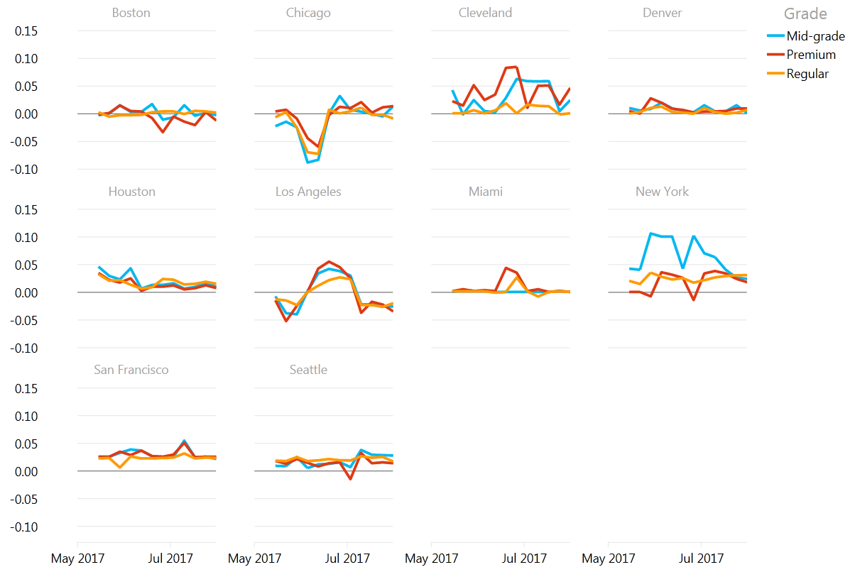
Note: Difference is calculated as OPIS price minus EIA price

Table A.4 Sample sizes for New York City for OPIS (Census), EIA (Matched Sample), and OPIS (Matched Sample to EIA).
 | 15-May | 22-May | 29-May | 5-Jun | 12-Jun | 19-Jun | 26-Jun | 3-Jul | 10-Jul | 17-Jul | 24-Jul | 31-Jul
New York City Regular
OPIS (Census) | 4,231 | 4,246 | 3,850 | 4,377 | 4,110 | 4,561 | 4,569 | 4,511 | 4,552 | 4,552 | 4,497 | 4,479
EIA (Matched Sample) | 30 | 30 | 30 | 30 | 30 | 30 | 30 | 30 | 30 | 30 | 30 | 29
OPIS (Matched Sample to EIA) | 24 | 23 | 21 | 27 | 24 | 27 | 28 | 27 | 26 | 26 | 27 | 24
New York City Midgrade
OPIS (Census) | 2,735 | 2,679 | 2,405 | 2,902 | 2,616 | 3,042 | 3,045 | 3,045 | 3,098 | 3,125 | 3,047 | 3,104
EIA (Matched Sample) | 30 | 30 | 30 | 30 | 30 | 30 | 30 | 30 | 30 | 30 | 30 | 29
OPIS (Matched Sample to EIA) | 17 | 17 | 9 | 19 | 19 | 21 | 24 | 20 | 19 | 20 | 21 | 20
New York City Premium
OPIS (Census) | 2,848 | 2,857 | 2,584 | 3,080 | 2,769 | 3,283 | 3,290 | 3,226 | 3,286 | 3,350 | 3,229 | 3,236
EIA (Matched Sample) | 30 | 30 | 30 | 30 | 30 | 30 | 30 | 30 | 30 | 30 | 30 | 29
OPIS (Matched Sample to EIA) | 18 | 20 | 17 | 21 | 21 | 23 | 22 | 20 | 22 | 22 | 21 | 19
Note: Sample sizes are not available for AAA prices

Table A.5. Sample sizes for Chicago for OPIS (Census), EIA (Matched Sample), and OPIS (Matched Sample to EIA).
 | 15-May | 22-May | 29-May | 5-Jun | 12-Jun | 19-Jun | 26-Jun | 3-Jul | 10-Jul | 17-Jul | 24-Jul | 31-Jul
Chicago Regular
OPIS (Census) | 2,222 | 2,208 | 2,165 | 1,982 | 2,221 | 2,256 | 2,264 | 2,260 | 2,258 | 2,247 | 2,262 | 2,253
EIA (Matched Sample) | 37 | 37 | 37 | 37 | 37 | 37 | 37 | 37 | 37 | 37 | 37 | 37
OPIS (Matched Sample to EIA) | 36 | 33 | 35 | 36 | 36 | 36 | 37 | 37 | 37 | 37 | 36 | 36
Chicago Midgrade
OPIS (Census) | 1,785 | 1,788 | 1,747 | 1,611 | 1,772 | 1,839 | 1,866 | 1,842 | 1,816 | 1,835 | 1,861 | 1,832
EIA (Matched Sample) | 37 | 36 | 36 | 36 | 36 | 36 | 36 | 36 | 36 | 36 | 36 | 36
OPIS (Matched Sample to EIA) | 33 | 29 | 29 | 32 | 31 | 30 | 33 | 35 | 32 | 32 | 33 | 32
Chicago Premium
OPIS (Census) | 1,783 | 1,783 | 1,736 | 1,598 | 1,779 | 1,851 | 1,856 | 1,844 | 1,825 | 1,844 | 1,833 | 1,843
EIA (Matched Sample) | 37 | 36 | 36 | 36 | 36 | 36 | 36 | 36 | 36 | 36 | 36 | 36
OPIS (Matched Sample to EIA) | 34 | 31 | 31 | 33 | 32 | 33 | 34 | 35 | 32 | 34 | 35 | 33
Note: Sample sizes are not available for AAA prices

Figure 5. Average weekly New York City midgrade motor gasoline prices (dollars per gallon) from EIA, OPIS, and AAA.

Figure 6. Average weekly New York City premium motor gasoline prices (dollars per gallon) from EIA, OPIS, and AAA.

Figure 7. Average weekly Chicago midgrade motor gasoline prices (dollars per gallon) from EIA, OPIS, and AAA.

Figure 8. Average weekly Chicago premium motor gasoline prices (dollars per gallon) from EIA, OPIS, and AAA.

Table A.6. Linear regression equation specifications (ŷ=α+βx).
 | Midgrade Model |  |  |  | Premium Model
 | 2009-2012 |  | 2013-2017 |  | 2009-2012 |  | 2013-2017
Region | α | β | α | β | α | β | α | β
U.S. | 0.105 | 1.007 | 0.363 | 0.944 | 0.195 | 1.018 | 0.655 | 0.906
1 | 0.111 | 1.007 | 0.377 | 0.944 | 0.201 | 1.022 | 0.703 | 0.904
1a | 0.079 | 1.020 | 0.369 | 0.949 | 0.157 | 1.032 | 0.657 | 0.908
1b | 0.123 | 1.004 | 0.406 | 0.935 | 0.204 | 1.018 | 0.644 | 0.912
1c | 0.104 | 1.013 | 0.371 | 0.951 | 0.203 | 1.026 | 0.748 | 0.900
2 | 0.076 | 1.002 | 0.367 | 0.932 | 0.174 | 1.016 | 0.722 | 0.880
3 | 0.115 | 1.007 | 0.320 | 0.956 | 0.215 | 1.019 | 0.642 | 0.911
4 | 0.117 | 0.997 | 0.283 | 0.955 | 0.213 | 1.003 | 0.558 | 0.916
5 | 0.100 | 1.009 | 0.237 | 0.976 | 0.215 | 1.006 | 0.377 | 0.968
5b | 0.100 | 1.009 | 0.279 | 0.963 | 0.238 | 1.006 | 0.468 | 0.948
CA | 0.109 | 1.000 | 0.154 | 0.989 | 0.210 | 1.000 | 0.284 | 0.983
CO | 0.112 | 1.001 | 0.377 | 0.933 | 0.216 | 1.003 | 0.729 | 0.871
FL | 0.089 | 1.019 | 0.334 | 0.966 | 0.171 | 1.032 | 0.666 | 0.923
MA | 0.063 | 1.026 | 0.349 | 0.955 | 0.142 | 1.036 | 0.614 | 0.913
MN | 0.082 | 1.000 | 0.186 | 0.978 | 0.155 | 1.024 | 0.461 | 0.961
NY | 0.058 | 1.026 | 0.348 | 0.960 | 0.144 | 1.033 | 0.608 | 0.928
OH | 0.099 | 1.002 | 0.379 | 0.925 | 0.192 | 1.007 | 0.793 | 0.841
TX | 0.117 | 1.008 | 0.336 | 0.952 | 0.218 | 1.018 | 0.626 | 0.913
WA | 0.104 | 1.007 | 0.268 | 0.963 | 0.202 | 1.011 | 0.439 | 0.950
Boston | 0.061 | 1.027 | 0.360 | 0.951 | 0.140 | 1.038 | 0.642 | 0.906
Chicago | 0.088 | 1.010 | 0.501 | 0.916 | 0.170 | 1.019 | 1.016 | 0.828
Cleveland | 0.101 | 1.003 | 0.446 | 0.910 | 0.202 | 1.006 | 0.908 | 0.817
Denver | 0.126 | 0.999 | 0.414 | 0.924 | 0.231 | 1.001 | 0.782 | 0.857
Houston | 0.128 | 1.011 | 0.398 | 0.945 | 0.231 | 1.020 | 0.784 | 0.881
Los Angeles | 0.112 | 0.997 | 0.122 | 0.995 | 0.212 | 0.997 | 0.232 | 0.992
Miami | 0.078 | 1.028 | 0.415 | 0.953 | 0.180 | 1.029 | 0.836 | 0.880
New York | 0.109 | 1.017 | 0.433 | 0.939 | 0.197 | 1.025 | 0.689 | 0.907
San Francisco | 0.132 | 0.995 | 0.194 | 0.979 | 0.241 | 0.993 | 0.336 | 0.969
Seattle | 0.096 | 1.009 | 0.193 | 0.984 | 0.195 | 1.010 | 0.306 | 0.982

Table A.7. EIA-878 midgrade and premium motor gasoline price predicted value statistics (2009-2012).
 | Midgrade Price Residual |  |  |  | Premium Price Residual
Region | Mean Absolute Value | Standard Deviation | Minimum | Maximum | Mean Absolute Value | Standard Deviation | Minimum | Maximum
U.S. | 0.007 | 0.010 | -0.020 | 0.036 | 0.012 | 0.017 | -0.032 | 0.065
1 | 0.008 | 0.010 | -0.020 | 0.026 | 0.016 | 0.022 | -0.039 | 0.069
1a | 0.015 | 0.020 | -0.041 | 0.068 | 0.021 | 0.026 | -0.052 | 0.090
1b | 0.012 | 0.015 | -0.029 | 0.040 | 0.021 | 0.026 | -0.049 | 0.065
1c | 0.007 | 0.010 | -0.023 | 0.036 | 0.013 | 0.019 | -0.028 | 0.072
2 | 0.005 | 0.008 | -0.020 | 0.037 | 0.009 | 0.012 | -0.025 | 0.046
3 | 0.005 | 0.007 | -0.012 | 0.031 | 0.008 | 0.012 | -0.030 | 0.047
4 | 0.011 | 0.013 | -0.027 | 0.029 | 0.007 | 0.009 | -0.021 | 0.023
5 | 0.005 | 0.006 | -0.012 | 0.032 | 0.005 | 0.006 | -0.014 | 0.017
5b | 0.004 | 0.005 | -0.013 | 0.021 | 0.008 | 0.010 | -0.022 | 0.042
CA | 0.003 | 0.004 | -0.009 | 0.033 | 0.003 | 0.005 | -0.009 | 0.029
CO | 0.002 | 0.002 | -0.005 | 0.009 | 0.002 | 0.003 | -0.006 | 0.010
FL | 0.009 | 0.011 | -0.022 | 0.034 | 0.013 | 0.017 | -0.029 | 0.056
MA | 0.019 | 0.025 | -0.057 | 0.074 | 0.024 | 0.029 | -0.062 | 0.096
MN | 0.002 | 0.004 | -0.016 | 0.017 | 0.015 | 0.021 | -0.043 | 0.071
NY | 0.020 | 0.026 | -0.050 | 0.062 | 0.025 | 0.032 | -0.064 | 0.083
OH | 0.002 | 0.003 | -0.006 | 0.010 | 0.005 | 0.007 | -0.017 | 0.028
TX | 0.005 | 0.007 | -0.013 | 0.031 | 0.008 | 0.011 | -0.026 | 0.043
WA | 0.007 | 0.010 | -0.018 | 0.041 | 0.010 | 0.015 | -0.019 | 0.104
Boston | 0.019 | 0.024 | -0.056 | 0.070 | 0.024 | 0.030 | -0.065 | 0.098
Chicago | 0.007 | 0.012 | -0.024 | 0.048 | 0.014 | 0.025 | -0.029 | 0.110
Cleveland | 0.006 | 0.009 | -0.020 | 0.044 | 0.007 | 0.010 | -0.025 | 0.057
Denver | 0.002 | 0.003 | -0.009 | 0.007 | 0.003 | 0.004 | -0.013 | 0.015
Houston | 0.010 | 0.013 | -0.027 | 0.054 | 0.014 | 0.019 | -0.036 | 0.091
Los Angeles | 0.003 | 0.005 | -0.013 | 0.064 | 0.004 | 0.006 | -0.014 | 0.064
Miami | 0.020 | 0.026 | -0.065 | 0.078 | 0.023 | 0.030 | -0.062 | 0.086
New York | 0.024 | 0.029 | -0.048 | 0.078 | 0.029 | 0.035 | -0.071 | 0.101
San Francisco | 0.007 | 0.009 | -0.019 | 0.027 | 0.008 | 0.010 | -0.027 | 0.038
Seattle | 0.005 | 0.006 | -0.013 | 0.016 | 0.005 | 0.006 | -0.017 | 0.016
Note: Rows in red indicate estimates with relatively low accuracy.

Table A.8. EIA -878 midgrade and premium motor gasoline price predicted value statistics (2013-2017).
 | Midgrade Price Residual |  |  |  | Premium Price Residual
Region | Mean Absolute Value | Standard Deviation | Minimum | Maximum | Mean Absolute Value | Standard Deviation | Minimum | Maximum
U.S. | 0.012 | 0.015 | -0.047 | 0.031 | 0.021 | 0.028 | -0.076 | 0.059
1 | 0.013 | 0.017 | -0.044 | 0.032 | 0.022 | 0.029 | -0.077 | 0.061
1a | 0.021 | 0.027 | -0.066 | 0.062 | 0.024 | 0.032 | -0.097 | 0.055
1b | 0.014 | 0.018 | -0.050 | 0.031 | 0.019 | 0.025 | -0.074 | 0.046
1c | 0.016 | 0.020 | -0.048 | 0.042 | 0.030 | 0.037 | -0.093 | 0.080
2 | 0.022 | 0.026 | -0.064 | 0.055 | 0.035 | 0.044 | -0.122 | 0.080
3 | 0.011 | 0.015 | -0.034 | 0.032 | 0.023 | 0.029 | -0.074 | 0.062
4 | 0.016 | 0.020 | -0.056 | 0.046 | 0.030 | 0.038 | -0.111 | 0.063
5 | 0.012 | 0.016 | -0.040 | 0.055 | 0.012 | 0.015 | -0.039 | 0.051
5b | 0.012 | 0.015 | -0.044 | 0.026 | 0.012 | 0.016 | -0.047 | 0.040
CA | 0.005 | 0.007 | -0.017 | 0.023 | 0.009 | 0.011 | -0.027 | 0.040
CO | 0.023 | 0.029 | -0.079 | 0.044 | 0.045 | 0.058 | -0.165 | 0.093
FL | 0.013 | 0.017 | -0.050 | 0.030 | 0.028 | 0.036 | -0.086 | 0.075
MA | 0.026 | 0.033 | -0.077 | 0.084 | 0.027 | 0.036 | -0.109 | 0.074
MN | 0.010 | 0.013 | -0.043 | 0.039 | 0.026 | 0.033 | -0.072 | 0.103
NY | 0.019 | 0.025 | -0.059 | 0.089 | 0.021 | 0.026 | -0.059 | 0.065
OH | 0.024 | 0.031 | -0.078 | 0.071 | 0.048 | 0.062 | -0.173 | 0.140
TX | 0.012 | 0.015 | -0.037 | 0.040 | 0.020 | 0.025 | -0.069 | 0.053
WA | 0.014 | 0.018 | -0.056 | 0.056 | 0.019 | 0.024 | -0.068 | 0.069
Boston | 0.026 | 0.033 | -0.080 | 0.092 | 0.029 | 0.040 | -0.120 | 0.085
Chicago | 0.026 | 0.033 | -0.095 | 0.081 | 0.052 | 0.067 | -0.202 | 0.147
Cleveland | 0.024 | 0.031 | -0.095 | 0.073 | 0.047 | 0.061 | -0.166 | 0.139
Denver | 0.025 | 0.032 | -0.090 | 0.047 | 0.049 | 0.063 | -0.189 | 0.091
Houston | 0.015 | 0.021 | -0.050 | 0.066 | 0.021 | 0.027 | -0.069 | 0.075
Los Angeles | 0.004 | 0.006 | -0.011 | 0.031 | 0.007 | 0.010 | -0.019 | 0.057
Miami | 0.021 | 0.025 | -0.062 | 0.051 | 0.030 | 0.040 | -0.117 | 0.070
New York | 0.022 | 0.028 | -0.077 | 0.079 | 0.025 | 0.031 | -0.079 | 0.068
San Francisco | 0.010 | 0.013 | -0.027 | 0.047 | 0.013 | 0.016 | -0.043 | 0.059
Seattle | 0.011 | 0.013 | -0.035 | 0.030 | 0.015 | 0.018 | -0.048 | 0.042
Note: Rows in red indicate estimates with relatively low accuracy.

Table A.9. AAA midgrade and premium motor gasoline price predicted value statistics (2013-2017).
 | Midgrade Price Residual |  |  |  | Premium Price Residual
Region | Mean Absolute Value | Standard Deviation | Minimum | Maximum | Mean Absolute Value | Standard Deviation | Minimum | Maximum
CA | 0.008 | 0.010 | -0.029 | 0.025 | 0.010 | 0.012 | -0.035 | 0.029
CO | 0.022 | 0.027 | -0.075 | 0.042 | 0.042 | 0.054 | -0.151 | 0.087
FL | 0.015 | 0.019 | -0.048 | 0.035 | 0.022 | 0.028 | -0.074 | 0.044
MA | 0.023 | 0.028 | -0.059 | 0.052 | 0.025 | 0.032 | -0.079 | 0.059
MN | 0.016 | 0.021 | -0.054 | 0.080 | 0.031 | 0.041 | -0.107 | 0.143
NY | 0.015 | 0.019 | -0.037 | 0.043 | 0.018 | 0.023 | -0.056 | 0.059
OH | 0.024 | 0.030 | -0.089 | 0.068 | 0.046 | 0.060 | -0.179 | 0.128
TX | 0.012 | 0.015 | -0.039 | 0.037 | 0.019 | 0.024 | -0.064 | 0.045
WA | 0.010 | 0.013 | -0.035 | 0.040 | 0.013 | 0.017 | -0.054 | 0.045
Boston | 0.023 | 0.028 | -0.061 | 0.053 | 0.025 | 0.033 | -0.082 | 0.059
Chicago | 0.039 | 0.051 | -0.147 | 0.096 | 0.073 | 0.095 | -0.282 | 0.151
Cleveland | 0.033 | 0.043 | -0.122 | 0.121 | 0.057 | 0.074 | -0.232 | 0.137
Denver | 0.024 | 0.030 | -0.083 | 0.053 | 0.046 | 0.059 | -0.176 | 0.102
Houston | 0.016 | 0.021 | -0.049 | 0.059 | 0.022 | 0.027 | -0.086 | 0.058
Los Angeles | 0.005 | 0.007 | -0.042 | 0.019 | 0.007 | 0.009 | -0.022 | 0.020
Miami | 0.023 | 0.029 | -0.064 | 0.079 | 0.025 | 0.032 | -0.082 | 0.058
New York | 0.019 | 0.023 | -0.050 | 0.067 | 0.026 | 0.033 | -0.058 | 0.099
San Francisco | 0.009 | 0.012 | -0.030 | 0.030 | 0.013 | 0.018 | -0.045 | 0.052
Seattle | 0.011 | 0.015 | -0.045 | 0.037 | 0.013 | 0.018 | -0.062 | 0.042
Note: Rows in red indicate estimates with relatively low accuracy.

Table A.10 AAA midgrade and premium predicted motor gasoline prices statistics, benchmarked with EIA-878 regular prices (2013-2017).
 | Midgrade Price Residual |  |  |  | Premium Price Residual
Region | Mean Absolute Value | Standard Deviation | Minimum | Maximum | Mean Absolute Value | Standard Deviation | Minimum | Maximum
CA | 0.013 | 0.021 | -0.188 | 0.063 | 0.014 | 0.021 | -0.175 | 0.061
CO | 0.024 | 0.030 | -0.085 | 0.054 | 0.044 | 0.056 | -0.143 | 0.091
FL | 0.021 | 0.025 | -0.068 | 0.053 | 0.026 | 0.033 | -0.098 | 0.061
MA | 0.026 | 0.032 | -0.065 | 0.070 | 0.028 | 0.035 | -0.078 | 0.074
MN | 0.021 | 0.028 | -0.082 | 0.102 | 0.036 | 0.047 | -0.130 | 0.165
NY | 0.023 | 0.029 | -0.062 | 0.079 | 0.025 | 0.033 | -0.077 | 0.095
OH | 0.029 | 0.037 | -0.105 | 0.093 | 0.048 | 0.063 | -0.192 | 0.145
TX | 0.015 | 0.019 | -0.043 | 0.056 | 0.021 | 0.026 | -0.067 | 0.059
WA | 0.019 | 0.024 | -0.077 | 0.073 | 0.022 | 0.027 | -0.087 | 0.073
Boston | 0.027 | 0.033 | -0.066 | 0.074 | 0.029 | 0.036 | -0.083 | 0.075
Chicago | 0.070 | 0.091 | -0.268 | 0.221 | 0.095 | 0.123 | -0.390 | 0.258
Cleveland | 0.036 | 0.048 | -0.155 | 0.144 | 0.057 | 0.076 | -0.262 | 0.170
Denver | 0.026 | 0.032 | -0.102 | 0.056 | 0.048 | 0.061 | -0.183 | 0.097
Houston | 0.020 | 0.024 | -0.051 | 0.072 | 0.024 | 0.030 | -0.088 | 0.070
Los Angeles | 0.020 | 0.031 | -0.280 | 0.074 | 0.020 | 0.030 | -0.260 | 0.074
Miami | 0.024 | 0.032 | -0.142 | 0.088 | 0.027 | 0.034 | -0.089 | 0.077
New York | 0.066 | 0.082 | -0.154 | 0.186 | 0.058 | 0.072 | -0.148 | 0.163
San Francisco | 0.020 | 0.025 | -0.070 | 0.058 | 0.024 | 0.028 | -0.076 | 0.069
Seattle | 0.022 | 0.026 | -0.073 | 0.065 | 0.024 | 0.029 | -0.089 | 0.062
Note: Rows in red indicate estimates with relatively low accuracy.

Figure A.9. Plot of the residuals obtained from the regression tree model for midgrade motor gasoline.
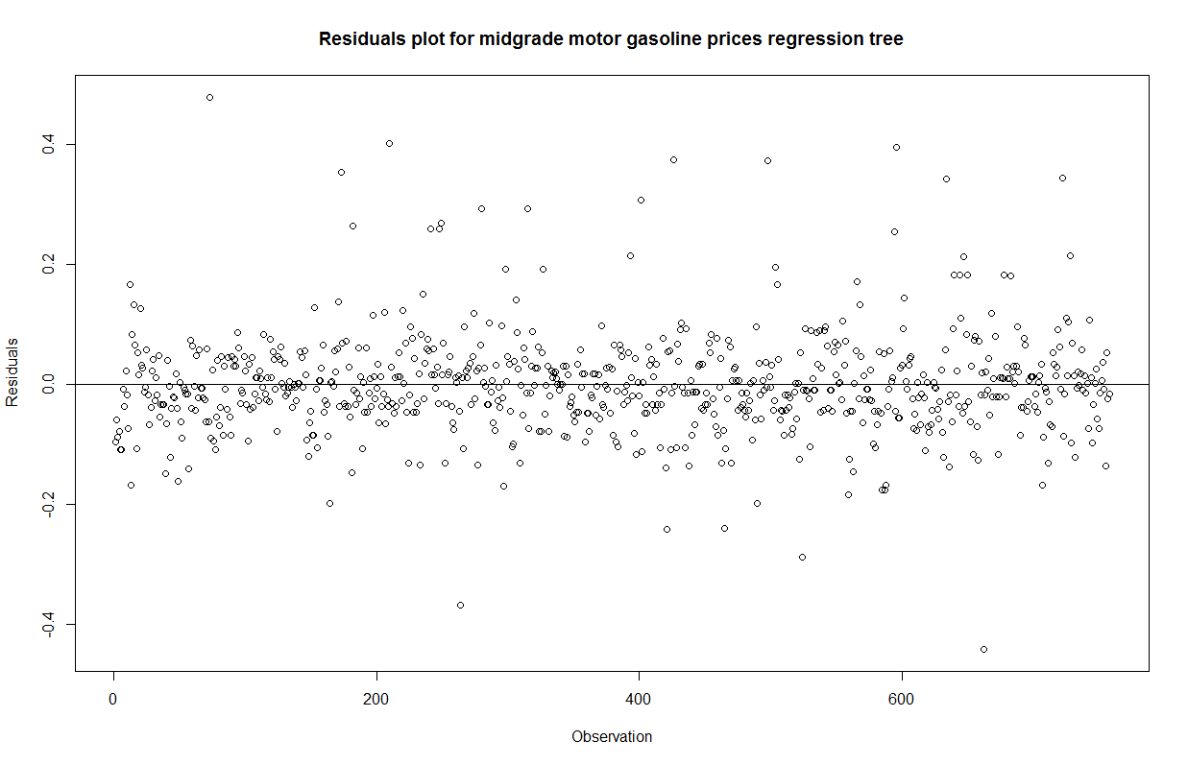

Figure A.10. Plot of the residuals obtained from the regression tree model for premium motor gasoline.
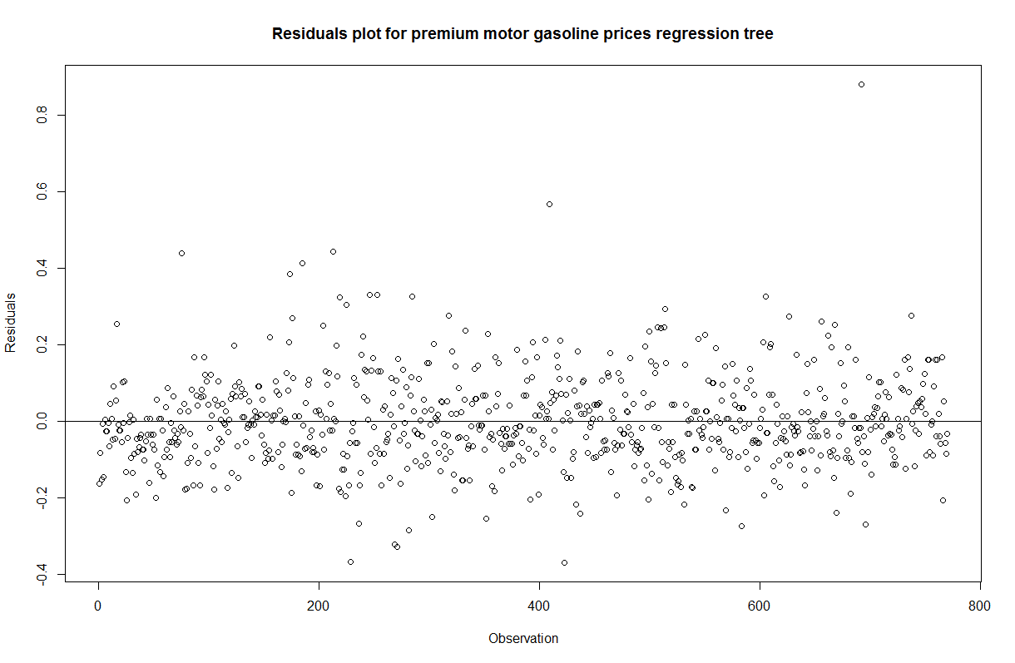

Table A.11. List of explanatory variables used in regression tree analysis.
Explanatory Variables | Description | Recoding | Linking | Source
Economic Conditions
Index of Consumer Sentiment | Measure of consumer sentiment | None | Month/year | University of Michigan, Survey of Consumer Attitudes
Inflation | Inflation rate | None | Month/year | Bureau of Labor Statistics, CPI-All Urban Consumers (Current Series)
Geography
PADD | Dummy variable for PADD | None | PADD | EIA-878
State | Dummy variable for State | None | State | EIA-878
Petroleum Industry
Gasoline formulation | Dummy variable to indicate reformulated | None | Station-specific | EIA-878
Proximity to refinery | Dummy variable indicating presence of refinery in the state | Original dataset indicates the count of refineries in the state, recoded as dummy | State | U.S. Energy Information Administration, Number and Capacity of Petroleum Refineries as of January 2017, Form EIA-820, "Annual Refinery Report"
Crude spot price | WTI spot price | None | Month/year | Thomson Reuters
Number of grades sold at station | Dummy variable to indicate whether station sells three grades | Coded dummy variable based on EIA-878 respondent information | Station-specific | EIA-878
Population
Population | State-level population estimate | None | State | U.S. Census Bureau, 2011 - 2015, American Community Survey 5-Year Estimates
Income | Median Household Income | None | State | U.S. Census Bureau, 2011 - 2015, American Community Survey 5-Year Estimates
Transportation
Vehicle miles traveled | Average miles travelled annually by state. | None | State | Federal Highway Administration, Annual Vehicle-Miles by Functional System, Total, October 2015
Registered vehicles | Number of vehicles (commercial and government) registered in a state. | None | State | Federal Highway Administration, Total Vehicle Registration, Total, December 2015
Use of public transportation | Dummy variable to indicate states with high public transport usage | States with percentages above the median (31%) were recoded as high public transport; 0 otherwise | State | U.S. Census Bureau, 2011 - 2015, American Community Survey 5-Year Estimates

https://www.opisnet.com/about/opis.aspx
Prices were obtained from gasprices.aaa.com on Mondays to align with EIA-878 price definition. Note that AAA’s data source is OPIS. Per email communication with AAA, the last credit card swipe before midnight is collected and compiled by computer.
http://www.stat.wisc.edu/~loh/treeprogs/guide/wires11.pdf
https://cran.r-project.org/web/packages/tree/tree.pdf
https://www.r-bloggers.com/part-4a-modelling-predicting-the-amount-of-rain/
http://tracker.gasbuddy.com

