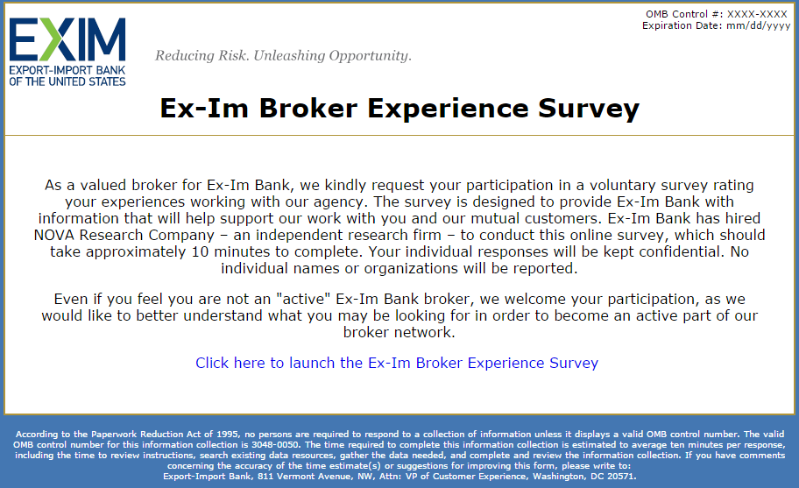

IPHONE 4s Display

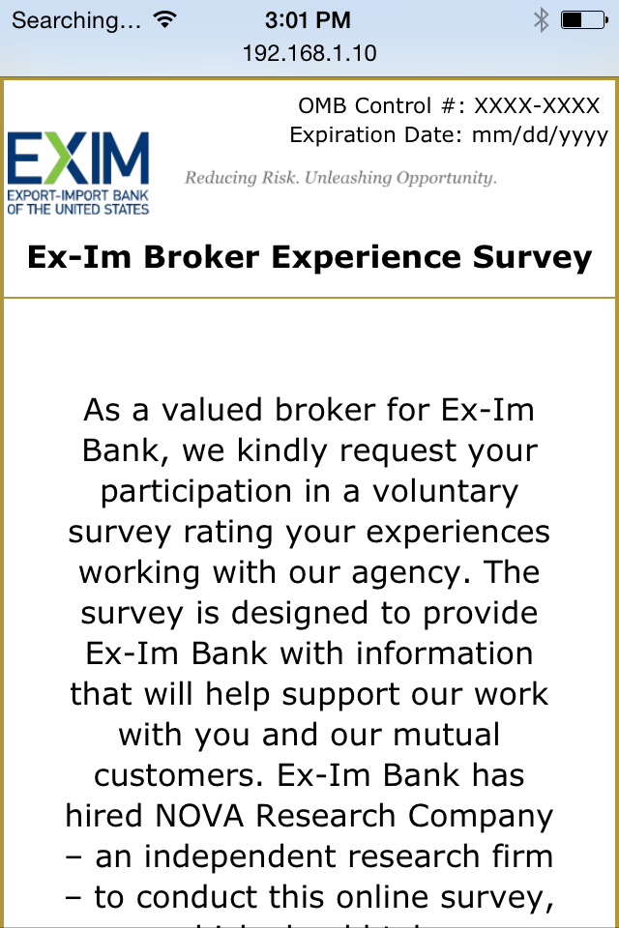

LG Display

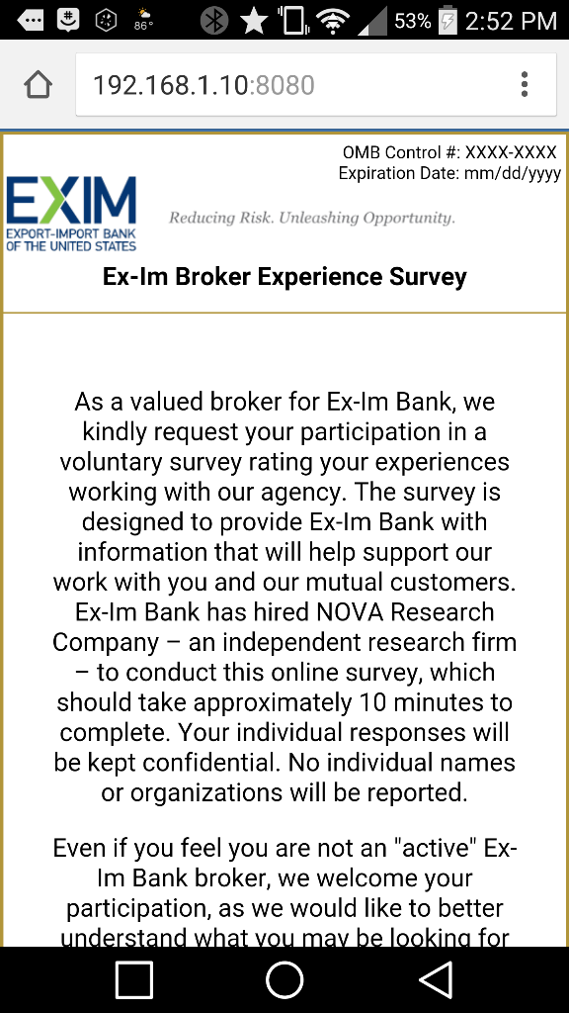

EXIM Bank Broker Experience Survey

[LAUNCH SCREEN]

As a valued broker for EXIM Bank, we kindly request your participation in a voluntary survey rating your experiences working with our agency. Even if you feel you are not an “active” EXIM Bank broker, we welcome your participation, as we would like to better understand what you may be looking for in order to become an active part of our broker network.

The survey is designed to provide EXIM Bank with information that will help support our work with you and our mutual customers. EXIM Bank has hired NOVA Research Company—an independent research firm—to conduct this online survey, which should take approximately 10 minutes to complete.

Click here to launch the EXIM Bank Broker Experience Survey

[INSTRUCTIONS IN BRACKETS ARE FOR THE SURVEY PROGRAMMER.]

We would like to ask a few questions about your work with EXIM Bank. These questions refer to you individually, not your firm.

Q1. Have you brokered any policies with EXIM Bank within the past 5 years?

> Yes

> No

[If Q1 = No, continue to Q1a.]

[If Q1 = Yes, skip to Q2.]

Q1a. We are interested in understanding why some brokers may not have brokered any policies recently. Please describe any circumstances that may have prevented you from brokering policies with our agency in the past 5 years. [OPEN-ENDED]

Q1b. What could EXIM Bank do to encourage you to broker policies with our agency? [OPEN-ENDED]

[Go to end of survey thank you screen.]

Q2. Approximately how many active policies with EXIM Bank do you currently broker (you individually, not the total number brokered by your firm)?

> 1

> 2-9

> 10-49

> 50 or more

> No active policies at this time

[If Q2 = "No active policies at this time," continue to Q2a. Otherwise, skip to Q3.]

Q2a. How long has it been since you brokered a policy with EXIM Bank?

> Less than 1 year

> 1 year to less than 2 years

> 2 years to less than 5 years

> 5 or more years

Q2b. We are interested in understanding why some brokers may not have brokered any policies recently. Please describe any circumstances that may have prevented you from brokering policies with our agency recently. [OPEN-ENDED]

Q2c. What could EXIM Bank do to encourage you to broker policies with our agency? [OPEN-ENDED]

[Go to end of survey thank you screen.]

Q3. When did you broker your first policy with EXIM Bank?

> One year ago or less

> 2-5 years ago

> 6-10 years ago

> 11-15 years ago

> 16-20 years ago

> More than 20 years ago

Q4. What percentage of your current book of business is with EXIM Bank (in terms of number of policies)?

> 75-100%

> 50-74%

> 25-49%

> Less than 25%

The next set of questions refers to marketing resources EXIM Bank offers to brokers.

Q5. Do you (you personally, not your firm) use EXIM Bank’s product fact sheets?

> Yes

> No, I do not use EXIM Bank’s product fact sheets

> Don't know

[If Q5=Yes, skip to Q6.]

[If Q5=Don’t know, skip to instruction before Q7.]

Q5a. Why don’t you use EXIM Bank’s product fact sheets? (Check all that apply.)

> I have my own resources for these purposes

> EXIM Bank’s fact sheets do not cover the topics I need

> EXIM Bank’s fact sheets are biased

> EXIM Bank’s fact sheets are not accurate

> The fact sheets are difficult for a new user to understand

> I was not aware of this resource

> Other: _______________

[If Q5 =No, skip to Q6b.]

[If Qa5 ="I was not aware of this resource", skip to Instruction before Q7.]

Q6. How satisfied are you with the following aspects of EXIM Bank’s product fact sheets for brokers:

Aspect Very Satisfied Satisfied Neither Satisfied nor Dissatisfied Dissatisfied Very Dissatisfied

Value message ð ð ð ð ð

Accuracy ð ð ð ð ð

Topics covered ð ð ð ð ð

Level of detail ð ð ð ð ð

Overall satisfaction ð ð ð ð ð

Q6b. Please describe any topics that are not covered by existing fact sheets that you believe would be useful. [OPEN-ENDED]

The following questions refer to your experience using EXIM Online, EXIM Bank's online transaction system. For this section, we are interested in your feedback on the system rather than the actions of any specific underwriter or relationship manager.

Q7. How satisfied are you with the following features of EXIM Online? (Consider your own use of EXIM Online, not that of your clients.)

Feature Very Satisfied Satisfied Neither Satisfied nor Dissatisfied Dissatisfied Very Dissatisfied

Ability to access information without

assistance from EXIM Bank staff ð ð ð ð ð

Ability to perform tasks on line without

assistance from EXIM Bank staff ð ð ð ð ð

Ease of navigation ð ð ð ð ð

Feature Very Satisfied Satisfied Neither Satisfied nor Dissatisfied Dissatisfied Very Dissatisfied

System speed ð ð ð ð ð

Use of easy-to-understand language ð ð ð ð ð

Ease of submitting a new application

(policy, SBCL, amendment, etc.) ð ð ð ð ð

Amount of time it takes to submit an

application ð ð ð ð ð

Ability to check the status of an

application ð ð ð ð ð

Ability to check the status of a claim ð ð ð ð ð

Automated email messages sent to

customers ð ð ð ð ð

Accessibility of FAQs and "Help"

instructions ð ð ð ð ð

Overall satisfaction with EXIM Online ð ð ð ð ð

Q8. Please describe any additional feedback you would like to share regarding EXIM Online. [OPEN-ENDED]

The next section refers to your interactions with EXIM Bank staff at our regional offices. When answering these questions, please refer to your most recent experiences with our regional office staff.

Q9. With which EXIM Bank regional office(s) do you communicate most frequently? (Check all that apply.)

> Chicago, IL

> Detroit, MI

> Minneapolis, MN

> Dallas, TX

> Houston, TX

> Miami, FL

> Atlanta, GA

> New York, NY

> Irvine, CA

> San Diego, CA

> San Francisco, CA

> Seattle, WA

> Don't Know

Q10. Thinking back to your most recent interactions with EXIM Bank’s regional office staff, how satisfied were you with their:

Staff Characteristic Very Satisfied Satisfied Neither Satisfied nor Dissatisfied Dissatisfied Very Dissatisfied

Responsiveness ð ð ð ð ð

Knowledge of EXIM Bank processes and

policies ð ð ð ð ð

Availability ð ð ð ð ð

Consistency of service ð ð ð ð ð

Understanding of customers' time

constraints ð ð ð ð ð

Overall satisfaction with regional office

staff ð ð ð ð ð

The next section refers to interactions with EXIM Bank staff in Washington, DC. When answering these questions, please refer to your most recent experiences with EXIM Bank staff in DC.

Q11. Thinking back to your most recent transactions with EXIM Bank underwriters in Washington, DC, how satisfied were you with their:

Staff Characteristic Very Satisfied Satisfied Neither Satisfied nor Dissatisfied Dissatisfied Very Dissatisfied

Responsiveness via phone or email ð ð ð ð ð

Knowledge of EXIM Bank processes and

policies ð ð ð ð ð

Availability ð ð ð ð ð

Ability to make decisions in a timely

manner ð ð ð ð ð

Willingness to help ð ð ð ð ð

Willingness to explain decisions ð ð ð ð ð

Ability to process transactions in a

timely manner ð ð ð ð ð

Ability to deal with conflict/problem

resolution ð ð ð ð ð

Willingness to modify policy language

to customer needs ð ð ð ð ð

Willingness to customize a policy to

meet exporter needs ð ð ð ð ð

Understanding of customers' time

constraints ð ð ð ð ð

Quality of customer service ð ð ð ð ð

Overall satisfaction with underwriters ð ð ð ð ð

Q12. How many different underwriters have you worked with in the past 12 months? (If you do not know the exact number, please provide your best estimate.)

______ (Number of underwriters)

[If Q12 =1, skip to Q14.]

Q13. Based on your own experiences, please rate the degree of consistency in the services provided by the various underwriters with whom you have worked in the past 12 months:

> Very consistent

> Somewhat consistent

> Somewhat variable

> Highly variable

Q14. Please let us know if you have any suggestions for improving your relationship with and services from underwriters: [OPEN ENDED]

The next section refers to interactions with EXIM Bank claims staff in Washington, DC. When answering these questions, please refer to your most recent experiences with EXIM Bank claims staff in DC.

Q15. Thinking back to your most recent transactions with EXIM Bank’s claims process and claims processing staff, how satisfied were you with:

Aspect Very Satisfied Satisfied Neither Satisfied nor Dissatisfied Dissatisfied Very Dissatisfied

Ease of submitting a claim ð ð ð ð ð

Staff responsiveness ð ð ð ð ð

Staff availability ð ð ð ð ð

Staff ability to make decisions in a

timely manner ð ð ð ð ð

Consistency in decision making ð ð ð ð ð

Overall satisfaction with claims process ð ð ð ð ð

Overall satisfaction with claims staff ð ð ð ð ð

The next set of questions refers to broker commission and fees.

Q16. To what extent do you agree or disagree that the EXIM Bank commission structure on multi-buyer policies encourages you to find small business exporters?

> Strongly agree

> Agree

> Neither agree nor disagree

> Disagree

> Strongly disagree

Q16a. You responded that you [PROVIDE TEXT CORRESPONDING TO RATING PROVIDED BY RESPONDENT] that the EXIM Bank commission structure on multi-buyer policies encourages you to find small business exporters. Please tell us why you chose this rating. [OPEN-ENDED]

Q17. To what extent do you agree or disagree that the EXIM Bank commission structure on single-buyer policies encourages you to find small business exporters?

> Strongly agree

> Agree

> Neither agree nor disagree

> Disagree

> Strongly Disagree

Q17a. You responded that you [PROVIDE TEXT CORRESPONDING TO RATING PROVIDED BY RESPONDENT] that the EXIM Bank commission structure on single-buyer policies encourages you to find small business exporters. Please tell us why you chose this rating. [OPEN-ENDED]

Q18. What suggestions do you have for how EXIM Bank can help you or other brokers expand the number of small businesses with EXIM Bank policies? [OPEN-ENDED]

Q19. How satisfied are you with the following aspects of EXIM Bank?

Aspect Very Satisfied Satisfied Neither Satisfied nor Dissatisfied Dissatisfied Very Dissatisfied

Range of product offerings ð ð ð ð ð

Consistency of pricing ð ð ð ð ð

Consistency of risk appetite ð ð ð ð ð

Predictability of decision-making process ð ð ð ð ð

Processing time ð ð ð ð ð

Clarity of policy documents ð ð ð ð ð

Ease of amending a policy ð ð ð ð ð

Overall satisfaction with EXIM Bank ð ð ð ð ð

Q19a. You rated your overall satisfaction with EXIM Bank as [PROVIDE TEXT CORRESPONDING TO RATING PROVIDED BY RESPONDENT]. Please tell us why you chose this rating. [OPEN-ENDED]

Q20. Thinking back to your most recent transactions, overall, how much effort did you personally have to put forth in getting the deals done with EXIM Bank?

> Far less than I expected

> Slightly less than I expected

> About what I expected

> Slightly more than I expected

> Far more than I expected

Q21. Based on your experience, what suggestions can you provide to improve the ease of doing business with EXIM Bank? [OPEN-ENDED]

Thank you for your participation.

To submit this survey, please click the "Next" button below.

According to the Paperwork Reduction Act of 1995, no persons are required to respond to a collection of information unless it displays a valid OMB control number. The valid OMB control number for this information collection is ####-####. The time required to complete this information collection is estimated to average (10 minutes) per response, including the time to review instructions, search existing data resources, gather the data needed, and complete and review the information. If you have comments concerning the accuracy of the time estimate(s) or suggestions for improving this form, please write to: Export-Import Bank, 811 Vermont Ave, NW, Attn: PRA Reports Clearance Officer, Washington, DC 20571.