**Attachment D**

**Screen Shot of Web Survey**

OMB CONTROL NO.: 0584-NEW

EXPIRATION DATE: 00/00/20XX

**FNS SNAP Supporting Statement – Attachment D**

State-Administered Website:

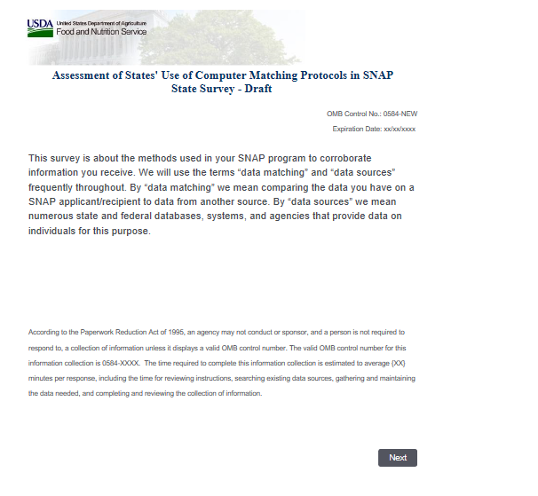

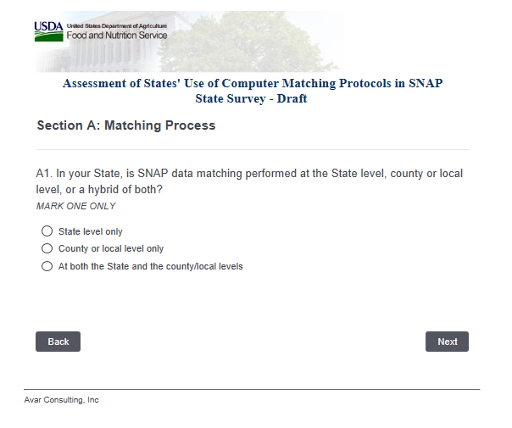

County-Administered Website

