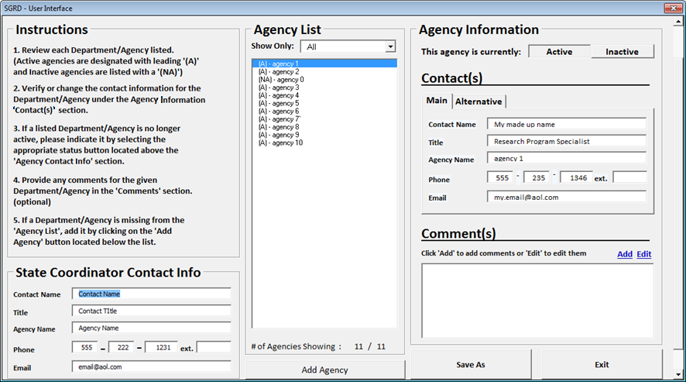

**Attachment A**

**Attachment A**

|  |  |  |  |  |  |  |  |  |  |
| --- | --- | --- | --- | --- | --- | --- | --- | --- | --- |
| OMB Number | |  |  |  |  |  |  |  |  |
| This collection has been approved by the Office of Management and Budget (OMB). The eight-digit | | | | | | | | | |
| OMB approval number is 0607-0933. Without this approval, we could not conduct this survey. | | | | | | | | |  |
|  |  |  |  |  |  |  |  |  |  |
| Authority and Confidentiality | | |  |  |  |  |  |  |  |
| Title 13 United States Code, Section 8(b) and Title 42 United States Code, Sections 1861-76 (National | | | | | | | | | |
| Science Foundation Act of 1950, as amended) authorizes the Census Bureau to conduct this | | | | | | | | |  |
| collection on behalf of the National Science Foundation and to request your voluntary assistance. | | | | | | | | | |
| These data are subject to provisions of Title 13, United States Code, Section 9(a) exempting data that | | | | | | | | | |
| are customarily provided in public records from rules of confidentiality. | | | | | | |  |  |  |
|  |  |  |  |  |  |  |  |  |  |
| Burden Estimate Statement | | |  |  |  |  |  |  |  |
| Public reporting burden for this collection of information is estimated to average 1 hour per | | | | | | | | |  |
| response. Send comments regarding this burden estimate or any other aspect of this collection of | | | | | | | | | |
| information, including suggestions for reducing this burden to: ECON Survey Comments 0607-0933, | | | | | | | | | |
| U.S. Census Bureau, 4600 Silver Hill Road, Room EMD-6K064, Washington, DC 20233. You may email | | | | | | | | | |
| comments to ECON.Survey.Comments@census.gov. Be sure to use ECON Survey Comments | | | | | | | | |  |
| 0607-0933 as the subject. | | |  |  |  |  |  |  |  |
|  |  |  |  |  |  |  |  |  |  |
|  |  |  |  |  |  |  |  |  |  |
|  |  |  |  |  |  |  |  |  |  |