attachment 2: evaluation of the FRESH EMPIRE campaign on tobacco

MAIL SCREENER survey

Form Approved
OMB No. 0910-0788
Exp. Date 05/31/2018
[Control No.]

Dear Parent or Guardian,

Do you have a young person living in your home who is at least 12 years old, and not older than 17 years old? We would like to invite this young person to complete this voluntary survey about himself or herself and friends.

- If yes, please ask this 12 to 17 year old household member to complete the enclosed survey and mail it back using the enclosed postage-paid envelope.
- If there is more than one person of this age living in the household, please share this survey with the youth who has the next birthday coming up. This child with the next birthday is invited to complete the survey.

This short survey determines whether your child is eligible for an in-person interview on tobacco use and media use. The in-person interview offers $25 as a token of appreciation for your child’s time. So that we can contact you if your child is eligible, please provide your name and the best phone number to reach you. Then mail this form back to us along with your child’s completed survey. We may contact you again to request your permission for your child to participate in two additional surveys every six months. At that point, you can decide whether or not to allow your child to participate. Your child will also be able to choose whether or not to participate in those surveys.

Your Name _____________________ Phone Number _________________________

If there are no young people between the ages of 12 and 17 living in your household, please check the box below and return this packet to us using the enclosed postage-paid envelope.

I don’t have a youth between the ages of 12 and 17 living in my household.

The enclosed materials are for a study related to youth tobacco use and media use conducted by the U.S. Food and Drug Administration’s Center for Tobacco Products (CTP) called the Evaluation of the Fresh Empire Campaign on Tobacco (EFECT). For more information about the EFECT study, you can call our project assistance line toll-free at [CONTACT NUMBER] extension [CONTACT EXTENSION]. If you have a question about your rights as an EFECT study participant, you can call RTI’s Office of Research Protection toll-free at (866) 214-2043.

Your help is very important to this study’s success. Thank you for your cooperation.

Sincerely,
XXXXX
Youth: We would like to ask you some questions about yourself and your friends. Your participation is voluntary, and your answers to these questions will be kept private. There are no physical risks to you from completing this survey. It is possible that some questions might make you mildly uncomfortable, depending on your responses. There are no direct benefits to you from answering our questions. However, you will be contributing to important research related to tobacco use among youth. If you meet our criteria to participate in the study, you will be invited to complete an in-person interview that offers $25 upon completion.
I understand that I will be answering some questions about myself, and if I meet the criteria, I will be invited at a future date to participate in the study.

__Agree
__Disagree

Evaluation of the Fresh Empire Campaign on Tobacco- Screener (EFECT-S)

Subjects for Questionnaire:
Section S: Study Screener

S1. How old are you?
₁ Younger than 12 -- STOP. SKIP TO S8.
₂ 12 years old
₃ 13 years old
₄ 14 years old
₅ 15 years old
₆ 16 years old
₇ 17 years old
₈ 18 years old or older -- STOP. SKIP TO S8.

₉ Prefer not to answer

S2. What is your gender?
₁ Female
₂ Male
₃ Other (Please specify _______________)

₉ Prefer not to answer

S3. Are you of Hispanic, Latino/a, or Spanish origin? (One or more categories may be selected)
₁ No, not of Hispanic, Latino, Latina, or Spanish origin
₂ Yes, Mexican, Mexican American, Chicano or Chicana
₃ Yes, Puerto Rican
₄ Yes, Cuban
₅ Yes, Another Hispanic, Latino/a or Spanish origin

₉ Prefer not to answer

S4. What race or races do you consider yourself to be? (You can CHOOSE ONE ANSWER or MORE THAN ONE ANSWER or YOU MAY SKIP THIS QUESTION)
₁ American Indian or Alaska Native
₂ Asian
₃ Black or African American
₄ Native Hawaiian or Other Pacific Islander
₅ White
₆ Other (specify)___________________

₉ Prefer not to answer

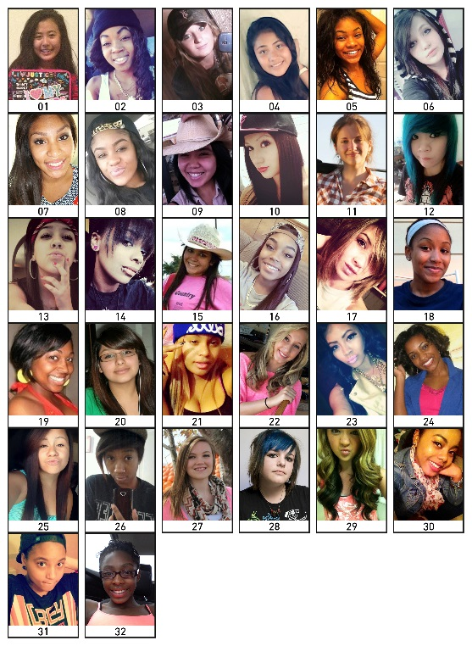

S5a. Rank the three people that would BEST FIT in your main group of friends, starting with the best fit.
1st Best Fit 2nd Best Fit 3rd Best Fit

S5b. Rank the three people that would LEAST FIT in your main group of friends, starting with the worst fit.
1st Worst Fit 2nd Worst Fit 3rd Worst Fit

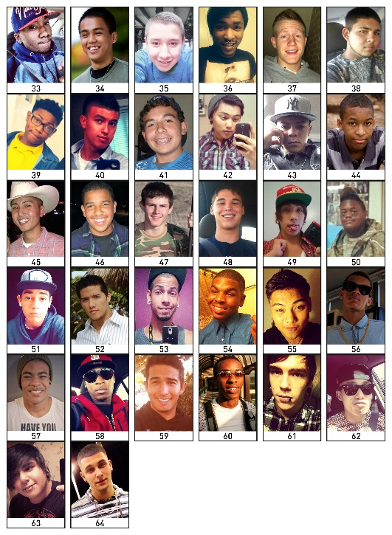

S6a. Rank the three people that would BEST FIT in your main group of friends, starting with the best fit.
1st Best Fit 2nd Best Fit 3rd Best Fit

S6b. Rank the three people that would LEAST FIT in your main group of friends, starting with the worst fit.
1st Worst Fit 2nd Worst Fit 3rd Worst Fit

S7. What is your first name? ______________________________

S8. Thank you for your time. Please place your completed survey in the postage paid envelope and return it to us.

Paperwork Reduction Act Statement: The public reporting burden for this information collection has been estimated to average 5 minutes per response to complete the mail screener (the time estimated to read, review, respond). Send comments regarding this burden estimate or any other aspects of this information collection, including suggestions for reducing burden, to PRAStaff@fda.hhs.gov.

