Attachment 1c

National Health and Nutrition Examination Survey (NHANES)
Social Media Pilot Study

NHANES Social Media Advertisement

Persons in the exposed group will receive one advertisement per week through the Facebook and Instagram newsfeed. These ads will be targeted based on age, race/ethnicity and gender.

The advertisements can only be seen by Facebook and Instagram users through their newsfeed. The exposed group will have advertising running over the course of 12 weeks (2 weeks prior to the survey being administered in a particular location and 10 weeks during the study period).

Advertisements will be shown on both Facebook and Instagram simultaneously. Three videos and five still-shots will be used in the pilot (see images below). The ads use a combination of wording and images and will be rotated and switched on and off in response to ad performance and spending targets. Interested individuals who click on the Facebook/Instagram advertisement will be directed to the NHANES website that will contain description of NHANES and study information.

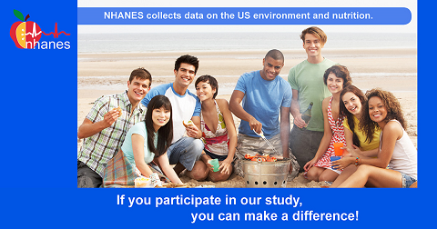

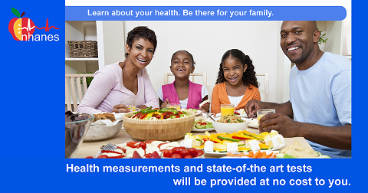

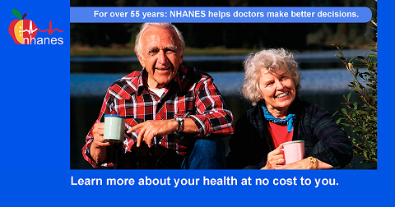

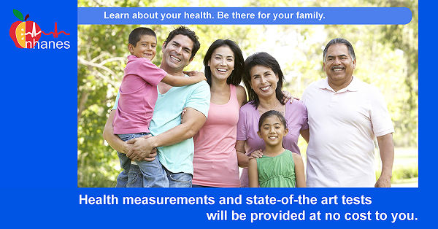

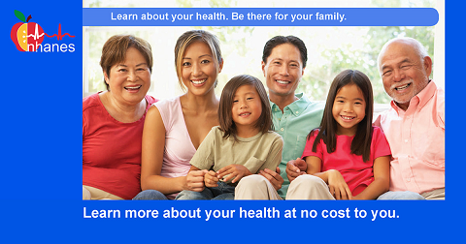

The content of the three videos is described below (videos are large files and can be accessed through the links below):

- NHANES FB Engagement – This video is a shortened version of the NHANES recruitment video that has been used for several years on the interviewer tablet. It shows organizations who use NHANES data, summarizes the number of participants, summarizes the sampling process, and lists the health topics included in the interview, describes our confidentiality and privacy pledge, and provides the 800 and website link if they want more information.

- NHANES FB Your Community – This video is a shortened version of the Advance Arrangements video which is an introductory video shown to health department officials. The video includes newer pictures of the Mobile Examination Center (MEC); it summarizes recent data findings, the sampling process and shows actual video of some of the MEC components. The end of the video features Dr. Kathryn Porter asking them to participate and provides the website link if they want more information.

- New NHANES FB Outreach – This is a new video developed by the CDC’s Division of Communication Services. The video runs 30-second and highlights NHANES coming to the community and its benefits using clip art images.

https://tinyurl.com/NHANESFBRecruit
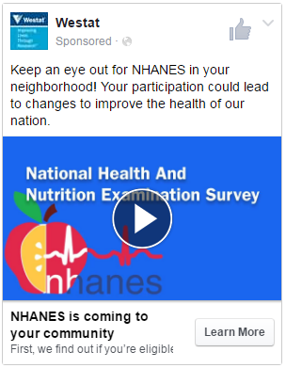
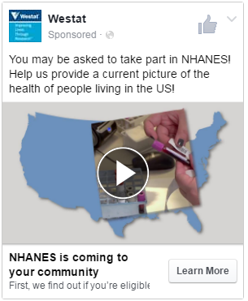
https://tinyurl.com/NHANESFByourcommunity

https://youtu.be/3RMzExODRas
