Attachment K:
Closeout for Health Hazard Evaluations without an On-site
Evaluation - Followback Survey Cover Letter and Form

Form Approved OMB No.: 0920-0260
Expiration Date: xx/xx/20xx
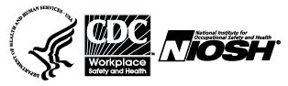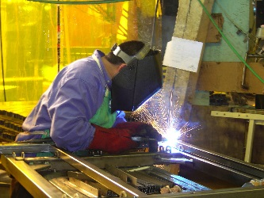
Followback Survey – After the Health Hazard Evaluation Final Letter

The National Institute for Occupational Safety and Health (NIOSH) surveys people involved with its health hazard evaluations. We want to learn your thoughts about the evaluation NIOSH recently completed. Your responses will be kept securely according to federal laws. Our reports include only summary information and will not identify you. If NIOSH made specific workplace recommendations, we will send you one more survey, in about one year.

Thank you for completing this survey !

Please fill in circles completely like this:
- Did NIOSH issue the final letter in a reasonable time after the health hazard evaluation request was made? | - Yes  - No
2. Is the final letter helpful? | - Yes, very helpful  - Yes, somewhat helpful  - No, not very helpful  - No, not at all helpful  - I didn’t read it
3. Do the NIOSH recommendations address the workplace concerns well? | - Yes  - No  - Recommendations were not made  - I don’t know
4. Overall, do you think the NIOSH recommendations are practical? | - Yes  - No  - Recommendations were not made  - I don’t know
5. Did the employer post the final letter at the workplace? | - Yes  - No  - Not applicable - NIOSH did not send the final letter to the employer
6. Did you share the final letter with others at the workplace? | - Yes  - No

Public reporting burden of this collection of information is estimated to average 10 minutes per response, including the time for reviewing instructions, searching existing data sources, gathering and maintaining the data needed, and completing the collection of information. An agency may not conduct or sponsor, and a person is not required to respond to a collection of information unless it displays a currently valid OMB control number. Send comments regarding this burden estimate or any other aspect of this collection of information, including suggestions for reducing this burden to CDC/ATSDR Information Collection Review Office, 1600 Clifton Road NE, MS D-74, Atlanta, Georgia 30333; ATTN: PRA (0920-0260).

Followback Survey Form 2A – 33825

7. If NIOSH suggested contacting another agency or organization for assistance, did you or anyone else do this? | - Yes  - No  - I don’t know  - No such suggestion was made
8. Did the NIOSH response change your thinking about your workplace concerns? | - Yes  - No
9. Please explain your answer.
10. What do you think about the health hazard evaluation? |  | - It was Excellent  - It was Good  - It was Fair  - It was Poor
11. Please tell us more of your thoughts about the health hazard evaluation.

12. If you were concerned about a new possible workplace health hazard, would you request a NIOSH health hazard evaluation? |  | - Yes  - No
13. Are you still associated with the workplace that NIOSH evaluated? |  | - Yes  - No
Please make any corrections to this label

8/31/2017

Please mail the completed survey to NIOSH in the enclosed postage paid envelope.
Call Pita Gomez at 513-458-7186 if you have any questions about this survey.
