Attachment L:
One Year Later for Health Hazard Evaluations without an On-site
Evaluation – Followback Survey Cover Letter and Form

NIOSH Health Hazard Evaluation Survey: One Year Later
This survey asks what has happened at the work place in the year since NIOSH completed
the health hazard evaluation. Please mark one response for each question.
- Do you think NIOSH helped make things better at the work place? | - Yes  - No  - Nothing needed to change
- If yes to Question 2, please describe the positive changes.

- Do you still use, refer, to or discuss the NIOSH letter? | O Yes  O No
- Did the NIOSH evaluation change your behaviors about workplace health and safety? | O Yes  O No
- If yes, please explain.

- Did the NIOSH evaluation change your thinking overall about workplace health and safety? | O Yes  O No
- If yes, please explain.

The recommendations NIOSH made are in the left column below.
Please mark one response for each.
Recommendation | Was Action Taken?
8A. | - Yes  - No  - I don’t know  - No longer applies
8B. | - Yes  - No  O I don’t know  O No longer applies
8C. | - Yes  - No  - I don’t know  - No longer applies
8D. | - Yes  - No  - I don’t know  O No longer applies
8E. | - Yes  - No  - I don’t know  O No longer applies
8F. | - Yes  - No  - I don’t know  - No longer applies
8G. | - Yes  - No  - I don’t know  - No longer applies

Recommendation | Was Action Taken?
8H. | - Yes  - No  - I don’t know  - No longer applies
8I. | - Yes  - No  - I don’t know  O No longer applies
8J. | - Yes  - No  - I don’t know  O No longer applies
8K. | - Yes  - No  - I don’t know  O No longer applies
8L. | - Yes  - No  - I don’t know  - No longer applies
8M. | - Yes  - No  - I don’t know  - No longer applies
9. Please provide details about actions taken and not taken regarding the NIOSH recommendations.

8/31/2017

Form Approved OMB No.: 0920-0260
Expiration Date: xx/xx/20xx

Form Approved OMB No.: 0920-0260
Expiration Date: xx/xx/20xx
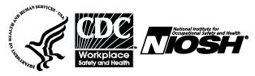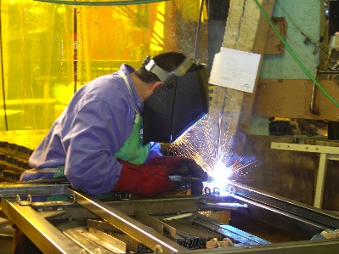

Followback Survey ‒ Health Hazard Evaluation

One Year After the Final Letter

The National Institute for Occupational Safety and Health (NIOSH) surveys people involved with its health hazard evaluations. We want to learn about your workplace now and actions taken regarding our recommendations.

Your responses will be kept securely according to federal laws. Our reports include only summary information and will not identify you.

Thank you for completing this survey.
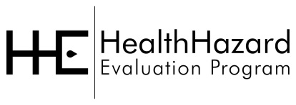

Please mail the completed survey to NIOSH in the enclosed postage paid envelope.
Call Pita Gomez at 513-458-7143 if you have any questions about the survey

Public reporting burden of this collection of information is estimated to average 15 minutes per response, including the time for reviewing instructions, searching existing data sources, gathering and maintaining the data needed, and completing and reviewing the collection of information. An agency may not conduct or sponsor, and a person is not required to respond to a collection of information unless it displays a currently valid OMB control number. Send comments regarding this burden estimate or any other aspect of this collection of information, including suggestions for reducing this burden to CDC/ATSDR Information Collection Review Office, 1600 Clifton Road NE, MS D-74, Atlanta, Georgia 30333; ATTN: PRA (0920-0260).

Followback Survey Form 3A
14722

