Attachment J:
One Year Later for Health Hazard Evaluations with an On-site Evaluation – Followback
Survey Cover Letter and Form

Recommendations to Employees | Was Action taken?
9A. | - Yes  - No  - I don’t know  O No longer applies
9B. | - Yes  - No  - I don’t know  O No longer applies
9C. | - Yes  - No  - I don’t know  O No longer applies
9D. | - Yes  - No  - I don’t know  O No longer applies
9E. | - Yes  - No  - I don’t know  O No longer applies
9F. | - Yes  - No  - I don’t know  O No longer applies
10. Please provide details about actions taken and not taken regarding the NIOSH recommendations.

8/31/2017

Form Approved OMB No.: 0920-0260
Expiration Date: xx/xx/20xx

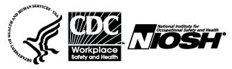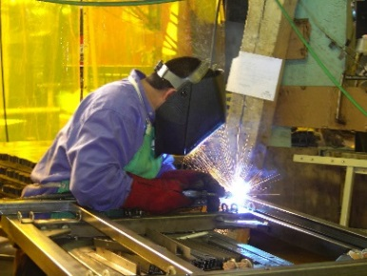

Followback Survey – Health Hazard Evaluation

One Year After the Final Report

The National Institute for Occupational Safety and Health (NIOSH) surveys people involved with its health hazard evaluations. We want to learn about your workplace now and actions taken regarding our recommendations.

Your responses will be kept securely according to federal laws. Our reports include only summary information and will not identify you.

Thank you for completing this survey.
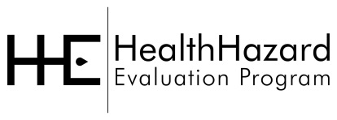

Please mail the completed survey to NIOSH in the enclosed postage paid envelope.
Call Pita Gomez at 513-458-7186 if you have any questions about the survey.

Public reporting burden of this collection of information is estimated to average 15 minutes per response, including the time for reviewing instructions, searching existing data sources, gathering and maintaining the data needed, and completing and reviewing the collection of information. An agency may not conduct or sponsor, and a person is not required to respond to a collection of information unless it displays a currently valid OMB control number. Send comments regarding this burden estimate or any other aspect of this collection of information, including suggestions for reducing this burden to CDC/ATSDR Information Collection Review Office, 1600 Clifton Road NE, MS D-74, Atlanta, Georgia 30333; ATTN: PRA (0920-0260).

Followback Survey Form 3B
18782

NIOSH Health Hazard Evaluation Survey: One Year Later
This survey asks what has happened at the workplace in the year since NIOSH completed the health hazard evaluation. Please mark one response for each question.
- Do you think NIOSH helped make things better at the work place? |  | - Yes  - No  - Nothing needed to change
- If yes to Question 1, please describe the positive changes.

- Do you still use, refer to, or discuss the NIOSH letter? |  | O Yes  O No
- Did the NIOSH evaluation change your behaviors about workplace health and safety? |  | O Yes  O No
- If yes, please explain.

- Did the NIOSH evaluation change your thinking overall about workplace health and safety? |  | O Yes  O No
- If yes, please explain.

The NIOSH recommendations are in the left column. First are recommendations to the Employer, then those to Employees. Please answer all questions, marking one response for each.
Recommendations to the Employer | Was Action taken?
8A. | - Yes  - No  - I don’t know  O No longer applies
8B. | - Yes  - No  - I don’t know  - No longer applies
8C. | - Yes  - No  - I don’t know  - No longer applies
8D. | - Yes  - No  - I don’t know  - No longer applies
8E. | - Yes  - No  - I don’t know  O No longer applies
8F. | - Yes  - No  - I don’t know  O No longer applies
8G. | - Yes  - No  - I don’t know  O No longer applies
8H. | - Yes  - No  - I don’t know  O No longer applies
8I. | - Yes  - No  - I don’t know  O No longer applies

