Attachment I
Followback Survey

NIOSH Health Hazard Evaluation Survey: Final Report
This survey asks your thoughts about the health hazard evaluation NIOSH recently completed
concerning your workplace. Please fill in circles completely like this:
- Have any changes been made at the workplace based on the NIOSH recommendations? | - Yes  - No  - I don’t know
- Do you think NIOSH helped make things better at the workplace? | - Yes  - No  O No changes were needed
- If “Yes” to Question 2, please describe the positive changes.

- After the site visit(s), did NIOSH keep you well informed about the health hazard evaluation progress? | - Yes  - No
- Did NIOSH issue the final report in a reasonable amount of time? | - Yes  - No  - I don’t know
- Did the employer post the final report so employees could see it? | - Yes  - No  - I don’t know
- Did you read the final report? | - Yes  - No
- If “No” to Question 7, please explain why you did not read the final report.
- Overall, how would you describe the quality of the report you received? | - Excellent  - Good  - Fair  - Poor

NIOSH Health Hazard Evaluation Survey: Final Report
For Questions 10-20, please rate your agreement with the following statements.
 | Strongly Agree | Mostly Agree | Neither Agree/  Disagree | Mostly Disagree | Strongly Disagree
- The report was helpful.
- I could easily find the information I needed in the report.
- The Main Report contained all the information I needed.
- The Supporting Technical Sections were useful to me.
- I trust the information in the report.
- I understood the key findings in the Main Report.
- I understood the report’s recommendations.
- I agree with the report’s key findings.
- After reading the report, I was convinced that my workplace should follow the recommendations.
- I found the graphs helpful in understanding the findings.
(Skip this question if your report did not contain graphs).
- The look of the report made it easy to read.
- Is there anything you especially liked about the report?
- Is there anything you would change about the report?

NIOSH Health Hazard Evaluation Survey: Final Report
- Did the NIOSH response change your thinking about the workplace concerns? | - Yes  - No
- Please explain your answer.

- Which best describes what you think NIOSH found? | - NIOSH found a health hazard  - NIOSH did not find a health hazard  - NIOSH did not decide whether there was a health hazard  - NIOSH findings were not clear to me  - I don’t know
- Overall, do you think the NIOSH recommendations address the workplace concerns well? | - Yes  - No  - I don’t know
- Overall, do you think the NIOSH recommendations are practical? | - Yes  - No  - I don’t know
- What do you think about the health hazard evaluation? | - It was Excellent  - It was Good  - It was Fair  - It was Poor
- Please tell us more of your thoughts about the health hazard evaluation.

- Will you be part of decision making related to the NIOSH recommendations? | - Yes; I have final authority  - Yes; I provide input  - No
- Are you still associated with the workplace that NIOSH evaluated? | - Yes  O No
Please make any corrections to this label.

8/31/2017

Administrative area

Followback Survey Form 2B

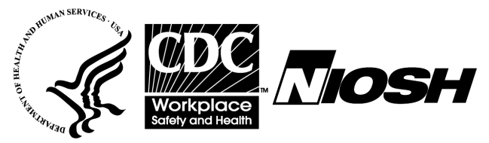

Followback Survey
Final Report

The National Institute for Occupational Safety and Health (NIOSH) surveys people involved with its health hazard evaluations. We want to learn your thoughts about the evaluation and the report.

Your responses will be kept securely according to federal laws. Our reports include only summary information and will not identify you. About one year from now, we will send you the last survey, which asks about our recommendations.

Thank you for completing this survey
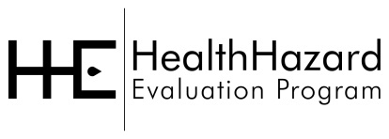
Please mail the completed survey to NIOSH in the enclosed postage paid envelope.
Call Barbara Jenkins at 513-458-7132 if you have any questions about the survey.

Public reporting burden of this collection of information is estimated to average 20 minutes per response, including the time for reviewing instructions, searching existing data sources, gathering and maintaining the data needed, and completing and reviewing the collection of information. An agency may not conduct or sponsor, and a person is not required to respond to a collection of information unless it displays a currently valid OMB control number. Send comments regarding this burden estimate or any other aspect of this collection of information, including suggestions for reducing this burden to CDC/ATSDR Information Collection Review Office, 1600 Clifton Road NE, MS D-74, Atlanta, Georgia 30333; ATTN: PRA (0920-0260).

Form Approved
OMB No.: 0920-0260
Expiration Date: 11/30/20xx

