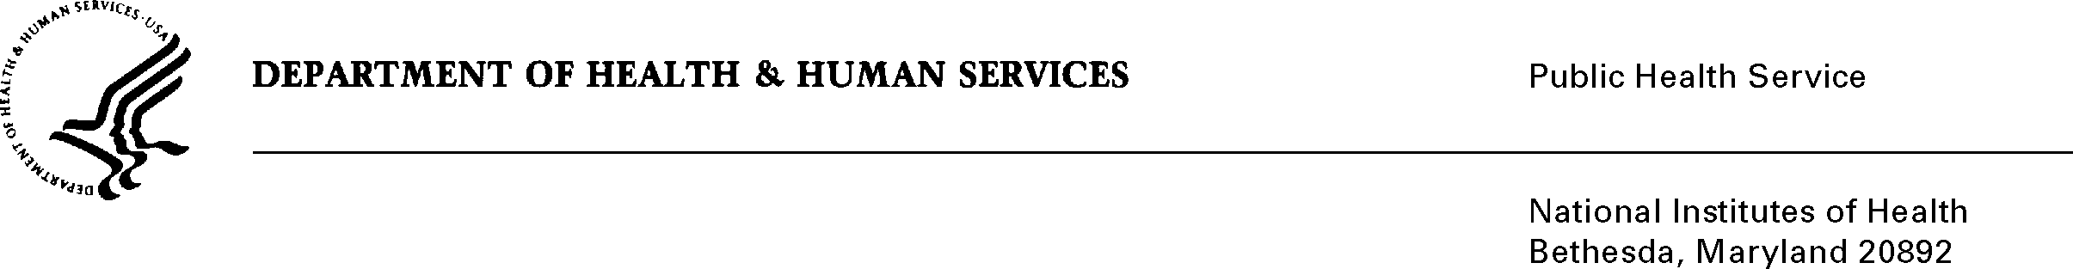

DATE: August 24, 2017

TO: Stephanie Mok, OMB

Through: Darius Taylor, DHHS

Mikia P. Currie, NIH

Celia Wolfman, FIC

FROM: Mikia Currie

Chief, Project Clearance Branch

SUBJECT: Change Request to a Currently Approved Form

(OMB #0925-0001 and #0925-0002, Expiration Date 03/31/2020)

In March 2017, NIH received approval of all pre-award application forms under OMB Collection number 0925-0001, as well as post-award forms in OMB Collection 0925-0002. Per the supporting statement for both collections:

“NIH has been engaged in a multi-year effort to examine how clinical trials are supported and the level of oversight needed. The collection of more structured information about proposed clinical trials in the PHS applications and pre-award reporting requirements will facilitate the NIH's oversight of clinical trials as well as assist in understanding where needs in the NIH research portfolio may exist. In addition, some of the data collected here will ultimately be accessible to investigators to pre-populate certain sections of forms when registering their trials with ClinicalTrials.gov.”

NIH is requesting non-substantive changes to the new PHS Human Subjects and Clinical Trial Information form and instructions (5F, 5G in 0925-0001; 5B in 0925-0002), which do not change the approved data collection or anticipated burden hours. Note: there are no changes being made to Attachment 5F PHS Human Subjects and Clinical Trial Information - Inclusion Enrollment Report.

NIH has worked with Grants.gov in order to develop this new form so that it will be usable for applicants in October 2017. As part of this process, the following minor changes have been made:

* Finalized all field and question types (e.g., open text, attachment, etc.) as appropriate.
* Made corrections to field and section names related to grammar and other technical verbiage, as well as aligning all terms and phrases with ClinicalTrials.gov.
* Included the addition of two exemptions to Section 1 of the form in compliance with 45 CFR 46 Subpart A, The Federal Policy for the Protection of Human Subjects (Common Rule).
* The Clinical Trial Milestone Plan will continue to be included as part of the RPPR (attachment 5 of the 0925-0002 package), and this data collection will not change, but final screen shots are not yet available. A separate change request memo will be submitted once this is complete.

We have updated and finalized these form instructions to reflect these changes.

Please see the following attachments for more information:

**Attachment A:** Changes to PHS Human Subjects and Clinical Trials Information form, which are currently located in attachment 5F of the 0925-0001 package and attachment 5B of the 0925-0002 package.

**Attachment B:** Changes to PHS Human Subjects and Clinical Trials Information form instructions, which are currently located in attachment 5G of the 0925-0001 package.

Your full consideration is appreciated.